Problem 1:

Problem 2:

To compile:

**cd problem2**

**make**

To run:

**./aggsum 200000 20**

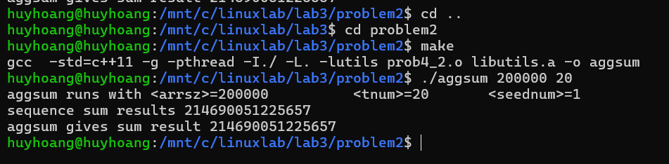

Problem 3:

The logger implementation successfully manages log data in a shared buffer, handles buffer overflow, and periodically flushes the buffer to the screen. The use of mutex locks, semaphores, and separate threads ensures thread safety and efficient log management. Further development could extend the logger's functionality to handle additional events and signals, enhancing its robustness and flexibility in real-world scenarios.

To compile:

**cd problem3**

**make**

To run:

**./problem3**

