

**SOCIAL NETWORK**

**Team 3 – Software Requirement Specification**

– Hanoi, March 13 , 2021 –

**Table of Contents**

I. Project Report **6**

1. Status Report 6

2. Team Involvements 6

3. Issues/Suggestions 6

II. Software Requirement Specification **7**

1. Overall Description 7

1.1 Product Overview 7

1.2 Business Rules 7

2. User Requirements 10

2.1 Overview 10

a. Use Case Diagram 10

Admin 10

Guest & Mentee 11

Mentor 12

Staff 13

b. System Actors 13

c. Use Cases List 14

2.2 Use Case Specification 15

2.2.1. Guest 15

2.2.1.1. Sign up 15

2.2.2. Admin 16

2.2.2.1. View dashboard 16

2.2.2.2 View user info 17

2.2.2.3 View mentor info 17

2.2.2.4 View request info 18

2.2.2.5 View Report 19

2.2.2.6 View technology/skill 19

2.2.2.7 Create technology/skill 20

2.2.2.8 Update technology/skill 20

2.2.2.9 Delete technology/skill 21

2.2.2.10 Ban user 22

2.2.2.11 Unban user 23

2.2.2.12 View Question info 23

2.2.2.13 Search mentor 24

2.2.3. Staff 24

2.2.3.1 View point 24

2.2.3.2 Create point 25

2.2.3.3 Update point transaction 26

2.2.3.4 Confirm Register Mentor 27

2.2.4. Mentor 27

2.2.4.1. Register as mentor 27

2.2.4.2. Sign in 28

2.2.4.3. Sign out 29

2.2.4.4. Edit profile 30

2.2.4.5 Call Audio/Video 30

2.2.4.6. Share screen 31

2.2.4.7. Code on IDE 32

2.2.4.8. Matching 32

2.2.5. Mentee 33

2.2.5.1. Sign in 33

2.2.5.2. Sign out 34

2.2.5.3. Change password 34

2.2.5.4. Forgot password 35

2.2.5.5. View profile info 36

2.2.5.6. Edit profile info 36

2.2.5.7. View Dashboard 37

2.2.5.8. Create Question 38

2.2.5.9. View list created question 38

2.2.5.10 Payment Method 39

2.2.5.11 View list notification 39

2.2.5.12 Join Session room with Mentor 40

2.2.5.13. Rate Mentor 41

2.2.5.14 Report Mentor 42

2.2.5.15 View list favourite Mentor 42

2.2.5.16 View point in transaction 43

2.2.5.17 View point out transaction 44

2.2.5.18 Delete question 44

2.2.5.19 Update question 45

3. Functional Requirements 46

3.1 System Functional Overview 46

a. Screen Flow 46

b. Screen Details 46

c. Screen Authorization 47

d. Non-Screen Functions 49

e. Entity Relationship Diagram 49

3.2 Home 50

a. Sign in 50

b. Manage Skills 51

c. Create Request 52

e. Session 53

f. Matching 54

g. View All Mentor 55

h. View All Category 56

3.3 User Setting 56

a. User Profile 56

b. Register as Mentor 57

c. View All Category 58

3.4 Mentor Info 59

a. Profile CV 59

b. View Comment and Rating of User 59

3.5 Manage Mentee 60

a. Manage Mentee 60

b. View Mentee Info 61

3.6 Manage Mentor 62

a. Manage Mentor 62

b. View Mentor Info 62

3.7 Dashboard 63

a. View List Created Request 63

3.8 Join Session Room 64

a. Share screen 64

b. Call Audio/Video 65

c. Code on IDE 66

a. Chat Box 67

3.6 Register 68

4. Non-Functional Requirements 69

4.1 External Interfaces 69

a. User Interfaces 69

b. Software Interfaces 69

c. Hardware Interfaces 70

d. Communications Interfaces 70

4.2 Quality Attributes 70

a. Usability 70

b. Reliability 71

c. Performance 71

d. Dependability 72

d1. Security 72

d2. Safety 73

e. Supportability 73

f. Design Constraints 73

g. Support Documents 73

5. Other Requirements 73

5.1 Appendix1 - Notification List 73

# I. Project Report

## 1. Status Report

| **#** | **Work Item** | **Status** | **Notes (Work Item in Details)** |
| --- | --- | --- | --- |
| 1 | Overall Description | Completed |  |
| 2 | User Requirements | Completed |  |
| 3 | Functional Requirements | Completed |  |
| 4 | Non-functional requirements | Completed |  |
| 5 | Other Requirements | Completed |  |

## 2. Team Involvements

| **#** | **Task** | **Member** | **Notes (Task Details, etc.)** |
| --- | --- | --- | --- |
| 1 | Overall Description | NghiaHC |  |
| 2 | User Requirements | NghiaHC |  |
| 3 | Functional Requirements | NghiaHC, AnhBC, DatLT |  |
| 4 | Non-functional requirements | NghiaHC |  |
| 5 | Other Requirements | NghiaHC |  |

## 3. Issues/Suggestions

| **#** | **Issue** | **Status** | **Notes (Solution, Suggestion, etc.)** |
| --- | --- | --- | --- |
| 1 |  | Pending |  |
| 2 |  | In Progress |  |
| 3 |  | Completed |  |

# II. Software Requirement Specification

## 1. Overall Description

### 1.1 Product Overview

A social network can be understood as a website or online platform with many different formats and features, making it easy for people to connect from anywhere. Social networks can be easily accessed from many means and devices such as computers, phones,... Social networks will connect user accounts with individual accounts and other organisations through virtual accounts. created by the user. The goal of a social network is to create a system that allows users to connect, exchange and share useful information on the Internet platform. In addition, social networks also have the goal of creating a valuable community, enhancing the role of users in building relationships. So along with the development of the internet, this project will bring good mentors to students who need to improve their coding skills. Ask and answer in real-time. Everything you think is hard will come easier when you can ask someone who already knows about it.

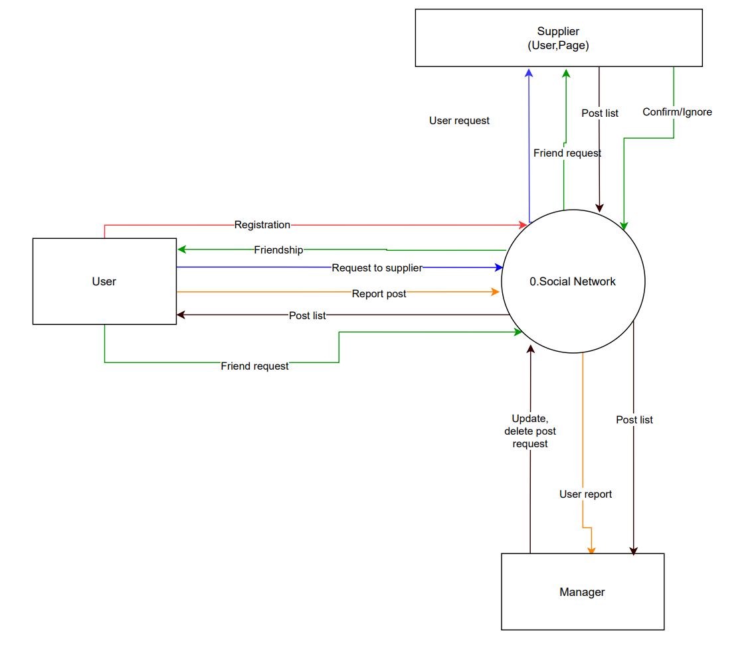

### 1.2 Business Rules

| **ID** | **Description** |
| --- | --- |
| 1 | The email address must be valid |
| 2 | Each user must verify phone or email address when registering |
| 3 | OTP is required for registering an account |
| 4 | Password must be at least 8 characters in length and no special characters |
| 5 | When registering or changing password, a user must enter the new password twice |
| 6 | Usernames cannot be duplicated |
| 7 | User must provide username (email) and password when logging into the website |
| 8 | When changing a password, a new password must not be the same as the current password |
| 9 | A user must belong to one of 2 roles: User, Manager |
| 10 | When an account is registered, the initial role of the account is User |
| 11 | The image upload for the avatar must be 5MB or less. |
| 12 | The user can drop emotions into posts, posts, comments, photos,... |
| 13 | The account after getting banned has 30 days for appeal. |
| 14 | Different users can make friends through the site's accounts |
| 15 | The users can report a post when it violates the rules of the social network |
| 16 | The admin of the site is authorised to browse articles suitable for the site |
| 17 | If users comment too much, the user may be spam commenting |
| 18 | Video uploaded from user will set 720p as default |
| 19 | Users can search for friends to add in friend list |
| 20 | Users can create pages to serve personal or community interests |
| 21 | Only admin of group can add new manager and delete group |
| 22 | The user can manually disable or delete the account |
| 23 | Users can send message to any contact |
| 24 | When sharing temporary moments, users can post to stories with a duration of 24 hours |

### 2. User Requirements

### 2.1 Overview

#### a. Use Case Diagram

##### Admin

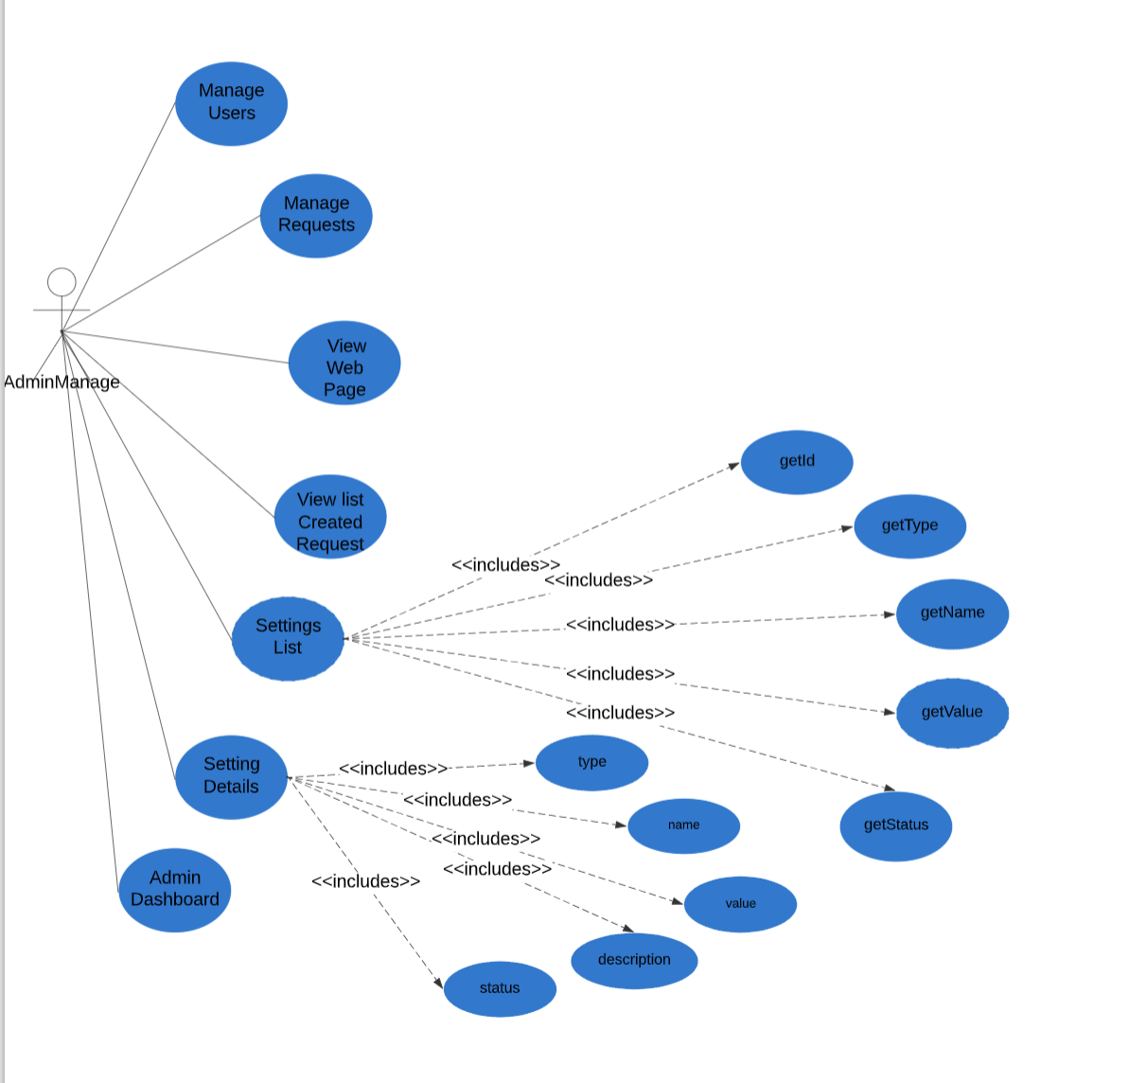

##### User

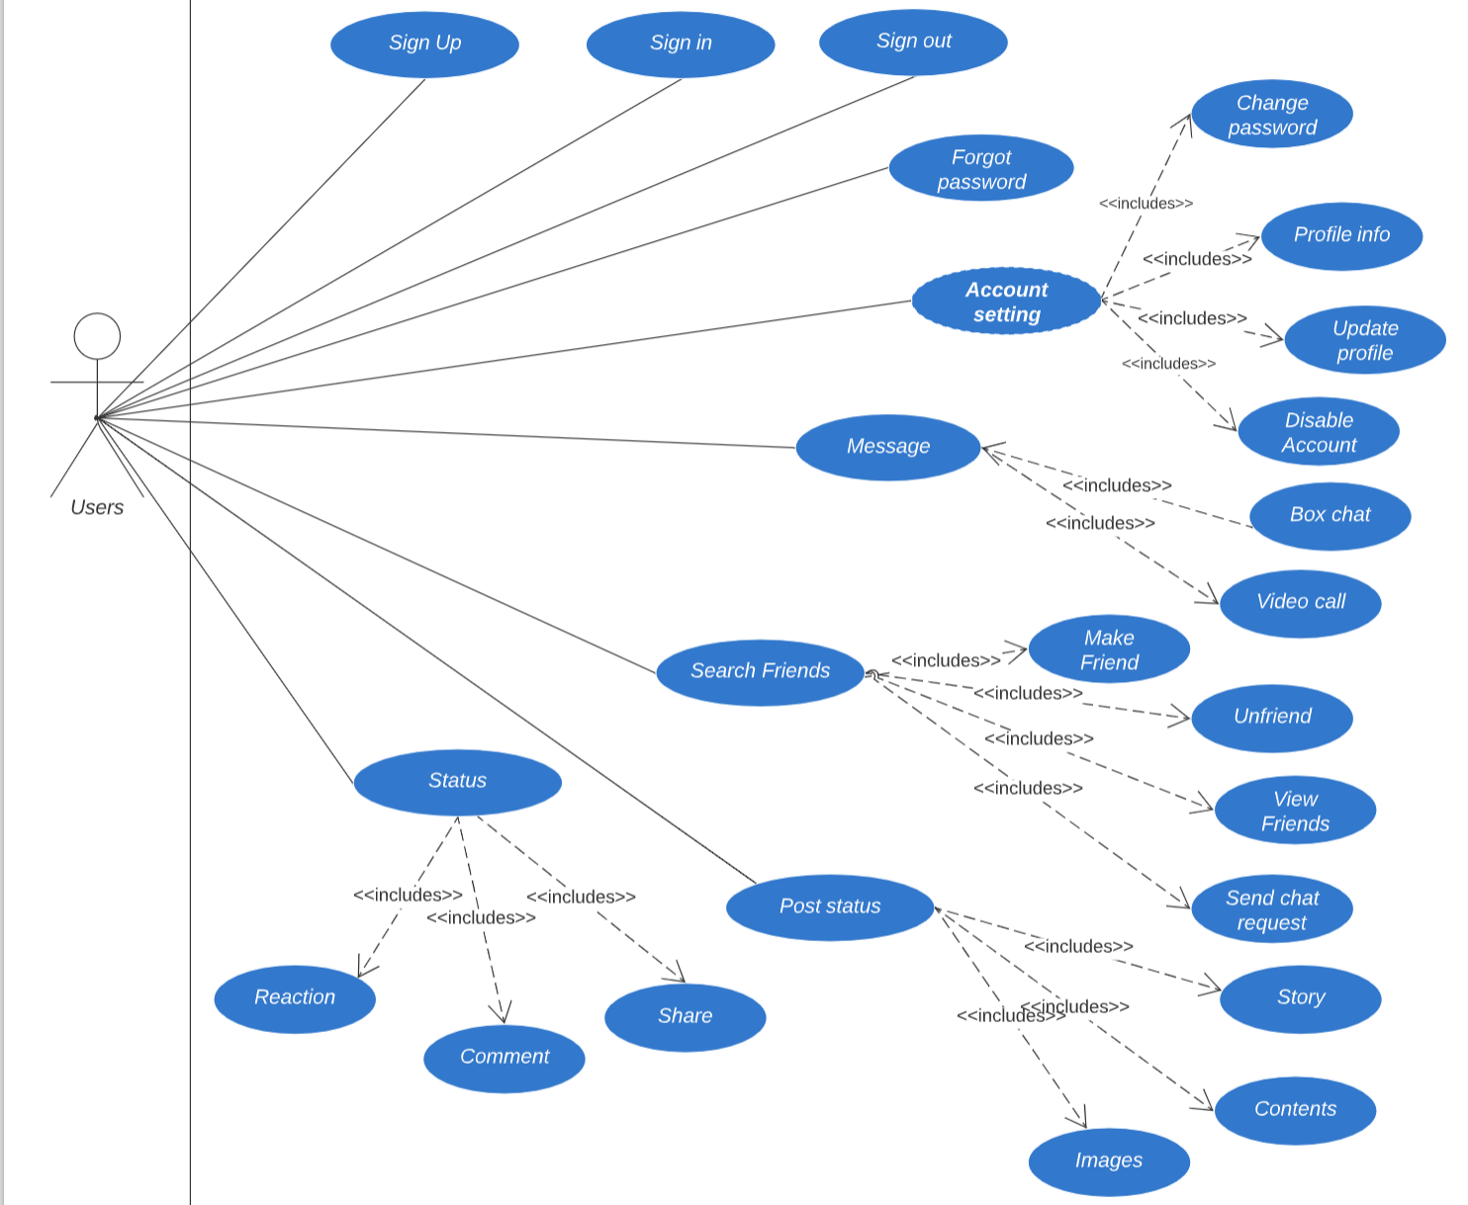

##### Manager

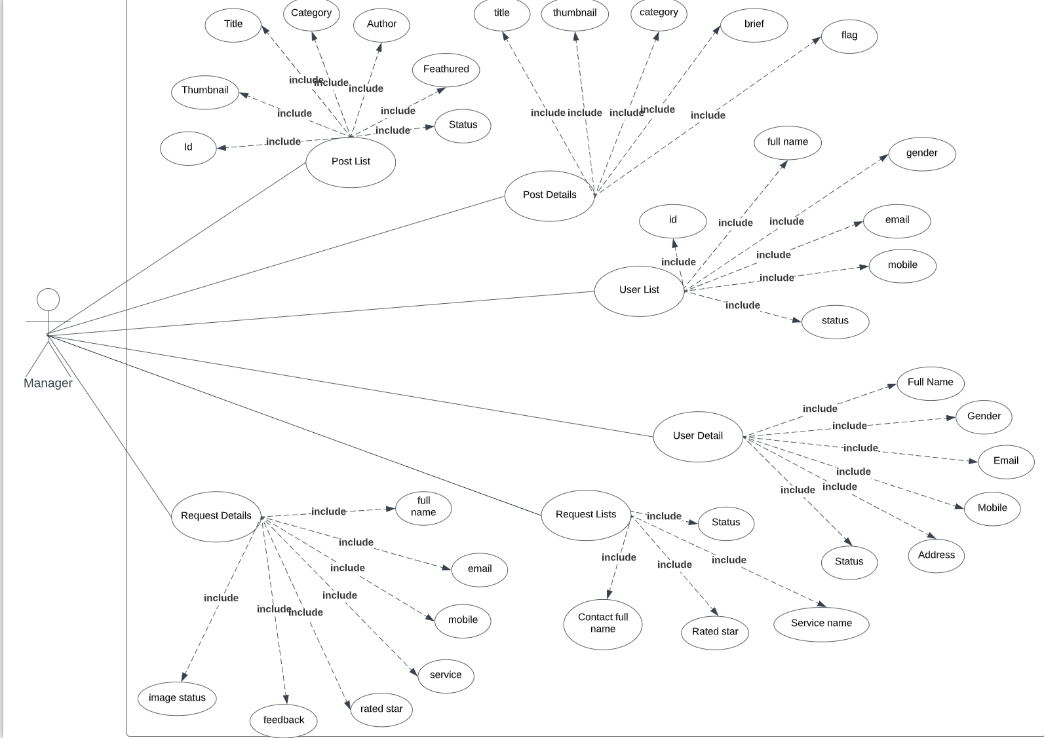

##### 

#### b. System Actors

| **#** | **Actors** | **Description** |
| --- | --- | --- |
| 1 | Admin | People who manage the Social Network |
| 2 | User | The user that has an account and can contact with the web |
| 3 | Manager | People who manage user lists, posts and requests |

#### c. Use Cases List

| **ID** | **Use Case** | **Primary Actors** | **Secondary Actor** |
| --- | --- | --- | --- |
| UC-01 | Sign up | User | N/A |
| UC-02 | View dashboard | Admin | N/A |
| UC-03 | View user info | Admin | N/A |
| UC-04 | View manager info | Admin | N/A |
| UC-05 | View request info | Admin | N/A |
| UC-06 | View Report | Admin | N/A |
| UC-07 | View settings list | Admin | N/A |
| UC-08 | View setting details | Admin | N/A |
| UC-09 | View posts list | Manager | N/A |
| UC-10 | View post details | Manager | N/A |
| UC-11 | Manage posts list | Manager | N/A |
| UC-12 | Manage post details | Manager | N/A |
| UC-13 | View users list | Manager | N/A |
| UC-14 | View user details | Manager | N/A |
| UC-15 | Manage users list | Manager | N/A |
| UC-16 | Manage user details | Manager | N/A |
| UC-17 | View requests list | Manager | N/A |
| UC-18 | View request details | Manager | N/A |
| UC-19 | Manage requests list | Manager | N/A |
| UC-20 | Manage request details | Manager | N/A |
| UC-21 | Sign in | User | N/A |
| UC-22 | Sign out | User | N/A |
| UC-23 | Forgot password | User | User |
| UC-24 | Account setting | User | User |
| UC-25 | Message | User | User |
| UC-26 | Search friend | User | N/A |
| UC-27 | Make friend | User | N/A |
| UC-28 | Post status | User | N/A |
| UC-29 | Share status | User | N/A |
| UC-30 | Comment status | User | N/A |
| UC-31 | Reaction status | User | N/A |

### 2.2 Use Case Specification

##### 

| **Use Case ID** | UC - 01 | **Use Case Name** | Sign up |
| --- | --- | --- | --- |
| **Created By** |  | **Created Date** | 13/03/2022 |
| **Primary Actor** | User | **Secondary Actor** | N/A |
| **Description** | Sign up for an account on the system. | | |
| **Pre-conditions** | N/A | | |
| **Post-conditions** | When the normal flow completes successfully, a new account will be created with the role of the user and saved into a database. | | |
| **Normal Flow** | 1. Go to the Home Page. 2. Click “Sign Up”. 3. System displays Sign up form. 4. Input full name, username, email, password, re-password. 5. Click the Sign up button. 6. System displays a toast success message. 7. Redirect to Login Screen. | | |
| **Alternative Flow** | N/A | | |
| **Exceptions** | The system displays an error message when:   1. Not input all fields in Sign up form. 2. Username or Email existed. 3. Cannot connect to the server. | | |
| **Priority** | Medium | | |
| **Frequency of Use** | Medium | | |
| **Business Rules** |  | | |
| **Other Information** | N/A | | |
| **Assumptions** | N/A | | |

##### 

| **Use Case ID** | UC - 02 | **Use Case Name** | View dashboard |
| --- | --- | --- | --- |
| **Created By** |  | **Created Date** | 13/03/2022 |
| **Primary Actor** | Admin | **Secondary Actor** | N/A |
| **Description** | View dashboard screen about general information. | | |
| **Pre-conditions** | Admin has signed into the admin website. | | |
| **Post-conditions** | N/A | | |
| **Normal Flow** | 1. Go to the Admin Page. 2. Click on “Dashboard” on the sidebar. 3. The system displays all the number of users, number of posts in a month, number of requests, number of feedbacks. | | |
| **Alternative Flow** | N/A | | |
| **Exceptions** | The system displays an error message when:   1. Cannot connect to the server. | | |
| **Priority** | High | | |
| **Frequency of Use** | High | | |
| **Business Rules** |  | | |
| **Other Information** | N/A | | |
| **Assumptions** | N/A | | |

##### 

| **Use Case ID** | UC – 03 | **Use Case Name** | View user info |
| --- | --- | --- | --- |
| **Created By** |  | **Created Date** | 13/03/2022 |
| **Primary Actor** | Admin | **Secondary Actor** | N/A |
| **Description** | View information of all registered users in the system. | | |
| **Pre-conditions** | Admin has signed into the admin website. | | |
| **Post-conditions** | N/A | | |
| **Normal Flow** | 1. Go to the Admin Page. 2. Click on Manage Users on the sidebar. 3. The system displays a list of all users with email, role, and action. 4. Admin click the user name, the system displays all the information of registered users. | | |
| **Alternative Flow** | N/A | | |
| **Exceptions** | The system displays an error message when:   1. Cannot connect to the server. | | |
| **Priority** | High | | |
| **Frequency of Use** | High | | |
| **Business Rules** |  | | |
| **Other Information** | N/A | | |
| **Assumptions** | N/A | | |

##### 

| **Use Case ID** | UC – 04 | **Use Case Name** | View manager info |
| --- | --- | --- | --- |
| **Created By** |  | **Created Date** | 13/03/2022 |
| **Primary Actor** | Admin | **Secondary Actor** | N/A |
| **Description** | View information of all managers in the system. | | |
| **Pre-conditions** | Admin has signed into the admin website. | | |
| **Post-conditions** | N/A | | |
| **Normal Flow** | 1. Go to the Admin Page. 2. Click on Manage Managers on the sidebar. 3. The system displays a list of all managers with email, role, and action. 4. Admin click manager name, the system displays all the information of registered users, rate. | | |
| **Alternative Flow** | N/A | | |
| **Exceptions** | The system displays an error message when:   1. Cannot connect to the server. | | |
| **Priority** | High | | |
| **Frequency of Use** | High | | |
| **Business Rules** |  | | |
| **Other Information** | N/A | | |
| **Assumptions** | N/A | | |

##### 

| **Use Case ID** | UC – 05 | **Use Case Name** | View request info |
| --- | --- | --- | --- |
| **Created By** |  | **Created Date** | 13/03/2022 |
| **Primary Actor** | Admin | **Secondary Actor** | N/A |
| **Description** | View all requests in the system | | |
| **Pre-conditions** | Admin has signed into the admin website. | | |
| **Post-conditions** | N/A | | |
| **Normal Flow** | 1. Go to Admin Page 2. Click Manage Requests in sidebar 3. The system displays all the information of existing requests in the system. | | |
| **Alternative Flow** | N/A | | |
| **Exceptions** | The system displays an error message when:   1. Cannot connect to the server. | | |
| **Priority** | High | | |
| **Frequency of Use** | High | | |
| **Business Rules** |  | | |
| **Other Information** | N/A | | |
| **Assumptions** | N/A | | |

##### 

| **Use Case ID** | UC – 06 | **Use Case Name** | View Report |
| --- | --- | --- | --- |
| **Created By** |  | **Created Date** | 25/01/2021 |
| **Primary Actor** | Admin | **Secondary Actor** | N/A |
| **Description** | View all requests in the system. | | |
| **Pre-conditions** | 1. Admin has signed into the admin website. 2. Having at least 1 conflict request on the system. | | |
| **Post-conditions** | When the normal flow completes successfully, the request will be updated in the database. | | |
| **Normal Flow** | 1. Go to Admin Page 2. Click Manage Feedback in sidebar 3. The system displays all the information of existing feedbacks in the system 4. Select Feedback. 5. Click the Accept button. 6. System displays status in request change Not yet to Accepted. | | |
| **Alternative Flow** | N/A | | |
| **Exceptions** | The system displays an error message when:   1. Cannot connect to the server. | | |
| **Priority** | High | | |
| **Frequency of Use** | High | | |
| **Business Rules** |  | | |
| **Other Information** | N/A | | |
| **Assumptions** | N/A | | |

##### 

| **Use Case ID** | UC – 07 | **Use Case Name** | View Settings List |
| --- | --- | --- | --- |
| **Created By** |  | **Created Date** | 13/03/2022 |
| **Primary Actor** | Admin | **Secondary Actor** | N/A |
| **Description** | View all settings in the system. | | |
| **Pre-conditions** | Admin has signed into the admin website. | | |
| **Post-conditions** | N/A | | |
| **Normal Flow** | 1. Go to the Admin Page. 2. Click Settings List in the sidebar. 3. The system displays the list of all settings existing | | |
| **Alternative Flow** | N/A | | |
| **Exceptions** | The system displays an error message when:   1. Cannot connect to the server. | | |
| **Priority** | High | | |
| **Frequency of Use** | High | | |
| **Business Rules** |  | | |
| **Other Information** | N/A | | |
| **Assumptions** | N/A | | |

##### 

| **Use Case ID** | UC – 08 | **Use Case Name** | View setting details |
| --- | --- | --- | --- |
| **Created By** |  | **Created Date** | 13/03/2022 |
| **Primary Actor** | Admin | **Secondary Actor** | N/A |
| **Description** | View the information of each setting in the system. | | |
| **Pre-conditions** | Admin has signed into the admin website. | | |
| **Post-conditions** | N/A | | |
| **Normal Flow** | 1. Go to the Admin Page. 2. Click Settings List in the sidebar. 3. Click the name of the setting you want to view and edit. 4. The screen of the setting's information will be shown. | | |
| **Alternative Flow** | N/A | | |
| **Exceptions** | The system displays an error message when:   1. Cannot connect to the server. | | |
| **Priority** | High | | |
| **Frequency of Use** | High | | |
| **Business Rules** |  | | |
| **Other Information** | N/A | | |
| **Assumptions** | N/A | | |

##### 

| **Use Case ID** | UC – 09 | **Use Case Name** | View posts list |
| --- | --- | --- | --- |
| **Created By** |  | **Created Date** | 13/03/2022 |
| **Primary Actor** | Manager | **Secondary Actor** | N/A |
| **Description** | View the list of posts on the web. | | |
| **Pre-conditions** | Manager has signed into the manager website. | | |
| **Post-conditions** | N/A | | |
| **Normal Flow** | 1. Go to the Manager Page. 2. Click the Posts List in the sidebar. 3. The web will show the list of posts | | |
| **Alternative Flow** | N/A | | |
| **Exceptions** | The system displays an error message when:   1. Cannot connect to the server. | | |
| **Priority** | High | | |
| **Frequency of Use** | High | | |
| **Business Rules** |  | | |
| **Other Information** | N/A | | |
| **Assumptions** | N/A | | |

##### 

| **Use Case ID** | UC – 10 | **Use Case Name** | View post details |
| --- | --- | --- | --- |
| **Created By** |  | **Created Date** | 13/03/2022 |
| **Primary Actor** | Manager | **Secondary Actor** | N/A |
| **Description** | View detailed information of post | | |
| **Pre-conditions** | Manager has signed into the manager website. | | |
| **Post-conditions** | N/A | | |
| **Normal Flow** | 1. Go to the Manager Page. 2. Click the Posts List in the sidebar. 3. Click the name of the post you want to view and edit. 4. The screen of the setting's information will be shown. | | |
| **Alternative Flow** | N/A | | |
| **Exceptions** | The system displays an error message when:   1. Cannot connect to the server. | | |
| **Priority** | High | | |
| **Frequency of Use** | High | | |
| **Business Rules** |  | | |
| **Other Information** | N/A | | |
| **Assumptions** | N/A | | |

##### 

| **Use Case ID** | UC - 11 | **Use Case Name** | Manage posts list |
| --- | --- | --- | --- |
| **Created By** |  | **Created Date** | 13/03/2022 |
| **Primary Actor** | Manager | **Secondary Actor** | N/A |
| **Description** | Manage the list of posts on the web. | | |
| **Pre-conditions** | Manager has signed into the manager website. | | |
| **Post-conditions** | N/A | | |
| **Normal Flow** | 1. Go to the Manager Page. 2. Click the Posts List in the sidebar. 3. The web will show the list of posts | | |
| **Alternative Flow** | N/A | | |
| **Exceptions** | The system displays an error message when:   1. Cannot connect to the server. | | |
| **Priority** | High | | |
| **Frequency of Use** | High | | |
| **Business Rules** |  | | |
| **Other Information** | N/A | | |
| **Assumptions** | N/A | | |

##### 

| **Use Case ID** | UC - 12 | **Use Case Name** | Manage post details |
| --- | --- | --- | --- |
| **Created By** |  | **Created Date** | 13/03/2022 |
| **Primary Actor** | Manager | **Secondary Actor** | N/A |
| **Description** | Manage the information of posts on the web. | | |
| **Pre-conditions** | Manager has signed into the manager website. | | |
| **Post-conditions** | N/A | | |
| **Normal Flow** | 1. Go to the Manager Page. 2. Click the Posts List in the sidebar. 3. Click the name of the post you want to view and edit. | | |
| **Alternative Flow** | N/A | | |
| **Exceptions** | The system displays an error message when:   1. Cannot connect to the server. | | |
| **Priority** | High | | |
| **Frequency of Use** | High | | |
| **Business Rules** |  | | |
| **Other Information** | N/A | | |
| **Assumptions** | N/A | | |

##### 

| **Use Case ID** | UC - 13 | **Use Case Name** | View users list |
| --- | --- | --- | --- |
| **Created By** |  | **Created Date** | 13/03/2022 |
| **Primary Actor** | Manager | **Secondary Actor** | N/A |
| **Description** | Manager can view a list of user information. | | |
| **Pre-conditions** | Manager has signed into the admin website. | | |
| **Post-conditions** | N/A | | |
| **Normal Flow** | 1. On the page screen dashboard of the manager. 2. Manager click “Quản lý danh sách người dùng”. 3. System show list all users info. | | |
| **Alternative Flow** | N/A | | |
| **Exceptions** | N/A | | |
| **Priority** | High | | |
| **Frequency of Use** | High | | |
| **Business Rules** |  | | |
| **Other Information** | N/A | | |
| **Assumptions** | N/A | | |

##### 

| **Use Case ID** | UC - 14 | **Use Case Name** | View user details |
| --- | --- | --- | --- |
| **Created By** |  | **Created Date** | 13/03/2022 |
| **Primary Actor** | Manager | **Secondary Actor** | N/A |
| **Description** | Manager can see the details information of user | | |
| **Pre-conditions** | Manager has signed into the admin website. | | |
| **Post-conditions** | Show the details information of user | | |
| **Normal Flow** | 1. On the page screen dashboard of manager. 2. Manager click “Quản lý danh sách người dùng”. 3. Manager click “Thông tin chi tiết” | | |
| **Alternative Flow** | N/A | | |
| **Exceptions** | The system displays an error message when:   1. Cannot connect to the server. | | |
| **Priority** | Medium | | |
| **Frequency of Use** | Medium | | |
| **Business Rules** |  | | |
| **Other Information** | N/A | | |
| **Assumptions** | N/A | | |

##### 

| **Use Case ID** | UC – 15 | **Use Case Name** | Manage users list |
| --- | --- | --- | --- |
| **Created By** |  | **Created Date** | 13/03/2022 |
| **Primary Actor** | Manager | **Secondary Actor** | N/A |
| **Description** | Manager can add, edit and delete a list of users' information. | | |
| **Pre-conditions** | The staff has signed into the staff website. | | |
| **Post-conditions** | N/A | | |
| **Normal Flow** | 1. On the page screen dashboard of the manager. 2. Manager click “Quản lý danh sách người dùng”. 3. System show list all users info. 4. Manager can add, edit and delete a list of users' information. | | |
| **Alternative Flow** | N/A | | |
| **Exceptions** | The system displays an error message when:   1. Cannot connect to the server. | | |
| **Priority** | High | | |
| **Frequency of Use** | High | | |
| **Business Rules** |  | | |
| **Other Information** | N/A | | |
| **Assumptions** | N/A | | |

##### 

| **Use Case ID** | UC – 16 | **Use Case Name** | Manage user details |
| --- | --- | --- | --- |
| **Created By** |  | **Created Date** | 13/03/2022 |
| **Primary Actor** | Manager | **Secondary Actor** | N/A |
| **Description** | Manager can add, edit and delete details information of user | | |
| **Pre-conditions** | The manager has logged into the Manager Website. | | |
| **Post-conditions** | N/A | | |
| **Normal Flow** | 1. On the page screen dashboard of Manager. 2. Manager click “Quản lý danh sách người dùng”. 3. Manager click “Thông tin chi tiết” 4. Manager can add, edit and delete the details information of user | | |
| **Alternative Flow** | N/A | | |
| **Exceptions** | The system displays an error message when:   1. Cannot connect to the server. | | |
| **Priority** | High | | |
| **Frequency of Use** | High | | |
| **Business Rules** |  | | |
| **Other Information** | N/A | | |
| **Assumptions** |  | | |

##### 

| **Use Case ID** | UC – 17 | **Use Case Name** | View requests list |
| --- | --- | --- | --- |
| **Created By** |  | **Created Date** | 13/03/2022 |
| **Primary Actor** | Manager | **Secondary Actor** | N/A |
| **Description** | Manager can view the requested information of the user | | |
| **Pre-conditions** | The manager has logged into the Manager Website. | | |
| **Post-conditions** | N/A | | |
| **Normal Flow** | 1. On the page screen dashboard of the manager. 2. Manager click “Danh sách thông tin yêu cầu”. 3. System show list all request info. | | |
| **Alternative Flow** | N/A | | |
| **Exceptions** | The system displays an error message when:  1. Cannot connect to the server. | | |
| **Priority** | High | | |
| **Frequency of Use** | High | | |
| **Business Rules** |  | | |
| **Other Information** | N/A | | |
| **Assumptions** | N/A | | |

##### 

| **Use Case ID** | UC - 18 | **Use Case Name** | View request details |
| --- | --- | --- | --- |
| **Created By** |  | **Created Date** | 13/03/2022 |
| **Primary Actor** | Manager | **Secondary Actor** | N/A |
| **Description** | Manager can see the details requested of user | | |
| **Pre-conditions** | The manager has logged into the Manager Website. | | |
| **Post-conditions** | N/A | | |
| **Normal Flow** |  | | |
| **Alternative Flow** | N/A | | |
| **Exceptions** | The system displays an error message when:   1. Cannot connect to the server | | |
| **Priority** | High | | |
| **Frequency of Use** | Medium | | |
| **Business Rules** |  | | |
| **Other Information** | N/A | | |
| **Assumptions** | N/A | | |

##### 

| **Use Case ID** | UC - 19 | **Use Case Name** | Manage requests list |
| --- | --- | --- | --- |
| **Created By** |  | **Created Date** | 13/03/2022 |
| **Primary Actor** | Manager | **Secondary Actor** | N/A |
| **Description** | Manager can reply or delete the request list. | | |
| **Pre-conditions** | The manager has logged into the Manager Website. | | |
| **Post-conditions** | N/A | | |
| **Normal Flow** | 1. On the page screen dashboard of Manager. 2. Manager click “Quản lý danh sách thông tin yêu cầu”. 3. Manager click “Reply” or “Delete” | | |
| **Alternative Flow** | N/A | | |
| **Exceptions** | 1. The system displays an error message when:   Cannot connect to the server | | |
| **Priority** | High | | |
| **Frequency of Use** | Medium | | |
| **Business Rules** |  | | |
| **Other Information** | N/A | | |
| **Assumptions** | N/A | | |

##### 2.2.4.2. Sign in

| **Use Case ID** | UC - 20 | **Use Case Name** | Manage request details |
| --- | --- | --- | --- |
| **Created By** |  | **Created Date** | 13/03/2022 |
| **Primary Actor** | Manager | **Secondary Actor** | N/A |
| **Description** | Show request details for manager and edit | | |
| **Pre-conditions** | The manager can access the manager system. | | |
| **Post-conditions** | N/A | | |
| **Normal Flow** | 1. On the page screen dashboard of Manager. 2. Manager click “Quản lý danh sách thông tin yêu cầu”. 3. Manager click “Reply” or “Delete” 4. Manager can reply and delete the details information of user | | |
| **Alternative Flow** | N/A | | |
| **Exceptions** | The system displays an error message when:   1. Cannot connect to the server. 2. Account is not exist in database | | |
| **Priority** | High | | |
| **Frequency of Use** | High | | |
| **Business Rules** |  | | |
| **Other Information** | N/A | | |
| **Assumptions** | N/A | | |

##### 

| **Use Case ID** | UC - 21 | **Use Case Name** | Sign in |
| --- | --- | --- | --- |
| **Created By** |  | **Created Date** | 13/03/2022 |
| **Primary Actor** | User, Manager, Admin | **Secondary Actor** | N/A |
| **Description** | Sign in the system. | | |
| **Pre-conditions** | 1. Account is exist in database | | |
| **Post-conditions** | N/A | | |
| **Normal Flow** | 1. On the login screen,the user fills the username and password. 2. User clicks “Sign in”. 3. The system will redirect user to the home page. | | |
| **Alternative Flow** | N/A | | |
| **Exceptions** | The system displays an error message when:   1. Cannot connect to the server. 2. Account is not exist in database | | |
| **Priority** | Weak | | |
| **Frequency of Use** | Weak | | |
| **Business Rules** |  | | |
| **Other Information** | N/A | | |
| **Assumptions** | N/A | | |

##### 

| **Use Case ID** | UC - 22 | **Use Case Name** | Sign out |
| --- | --- | --- | --- |
| **Created By** |  | **Created Date** | 13/03/2022 |
| **Primary Actor** | User | **Secondary Actor** | N/A |
| **Description** | User can sign out from web | | |
| **Pre-conditions** | 1. Users access the system. 2. The mentor is currently Logged in. | | |
| **Post-conditions** | N/A | | |
| **Normal Flow** | 1. On the home page screen. 2. User clicks “Log out”. 3. The user will be taken back to the Login page. | | |
| **Alternative Flow** | N/A | | |
| **Exceptions** | The system displays an error message when:   1. Cannot connect to the server. 2. User not input in the edit form. | | |
| **Priority** | Weak | | |
| **Frequency of Use** | Weak | | |
| **Business Rules** |  | | |
| **Other Information** | N/A | | |
| **Assumptions** | N/A | | |

##### 

| **Use Case ID** | UC - 23 | **Use Case Name** | Forgot password |
| --- | --- | --- | --- |
| **Created By** |  | **Created Date** | 13/03/2022 |
| **Primary Actor** | User | **Secondary Actor** | N/A |
| **Description** | User can recover forgotten or lost password | | |
| **Pre-conditions** | Account exists in database | | |
| **Post-conditions** | N/A | | |
| **Normal Flow** | 1. On the login screen. 2. User clicks “Forgot password”. 3. The user will be asked to enter a confirmation email on a pop up screen. 4. A captcha code will be sent to confirm the email. 5. After successful confirmation, the user will be updated with a new password. | | |
| **Alternative Flow** | N/A | | |
| **Exceptions** | The system displays an error message when:   1. Cannot connect to the server. 2. Account is not exist in database | | |
| **Priority** | Weak | | |
| **Frequency of Use** | Weak | | |
| **Business Rules** |  | | |
| **Other Information** | N/A | | |
| **Assumptions** | N/A | | |

##### 

| **Use Case ID** | UC - 24 | **Use Case Name** | Account setting |
| --- | --- | --- | --- |
| **Created By** |  | **Created Date** | 13/03/2022 |
| **Primary Actor** | User | **Secondary Actor** | N/A |
| **Description** | User can view his/her information and edit | | |
| **Pre-conditions** | The user must be signed in. | | |
| **Post-conditions** | N/A | | |
| **Normal Flow** | 1. On the home page screen. 2. Click to Setting. 3. Click to Personal Information. 4. The information of user will be shown | | |
| **Alternative Flow** | N/A | | |
| **Exceptions** | The system displays an error message when:   1. Cannot connect to the server. | | |
| **Priority** | Weak | | |
| **Frequency of Use** | Weak | | |
| **Business Rules** |  | | |
| **Other Information** | N/A | | |
| **Assumptions** | N/A | | |

##### 

| **Use Case ID** | UC - 25 | **Use Case Name** | Message |
| --- | --- | --- | --- |
| **Created By** |  | **Created Date** | 13/03/2022 |
| **Primary Actor** | User | **Secondary Actor** | N/A |
| **Description** | User can chat with other users | | |
| **Pre-conditions** | The user must be signed in. | | |
| **Post-conditions** | N/A | | |
| **Normal Flow** | 1. On the home page screen. 2. Click Messenger to go to the Chat screen. 3. Here will show your chat boxes with different users. | | |
| **Alternative Flow** | N/A | | |
| **Exceptions** | The system displays an error message when:   1. Cannot connect to the server. | | |
| **Priority** | Weak | | |
| **Frequency of Use** | Weak | | |
| **Business Rules** |  | | |
| **Other Information** | N/A | | |
| **Assumptions** | N/A | | |

##### 

| **Use Case ID** | UC - 26 | **Use Case Name** | Search friend |
| --- | --- | --- | --- |
| **Created By** |  | **Created Date** | 13/03/2022 |
| **Primary Actor** | User | **Secondary Actor** | N/A |
| **Description** | User can search friend in web | | |
| **Pre-conditions** | The user must be signed in. | | |
| **Post-conditions** | N/A | | |
| **Normal Flow** | 1. Go to Home Page 2. Click Search. 3. Enter the username you want to search for | | |
| **Alternative Flow** | N/A | | |
| **Exceptions** | Cannot connect to the server. | | |
| **Priority** | Weak | | |
| **Frequency of Use** | Weak | | |
| **Business Rules** |  | | |
| **Other Information** | N/A | | |
| **Assumptions** | N/A | | |

##### 

| **Use Case ID** | UC - 27 | **Use Case Name** | Make friend |
| --- | --- | --- | --- |
| **Created By** |  | **Created Date** | 13/03/2022 |
| **Primary Actor** | User | **Secondary Actor** | N/A |
| **Description** | User can make many friends in web | | |
| **Pre-conditions** | 1. The user can access the system. | | |
| **Post-conditions** | N/A | | |
| **Normal Flow** | 1. Go to Home Page 2. Click Search. 3. Enter the username you want to search for 4. Click on their profile 5. Click Add button 6. Wait for the other user to accept your friend request | | |
| **Alternative Flow** | N/A | | |
| **Exceptions** | 1. Cannot connect to the server 2. User already has enough friends slot | | |
| **Priority** | Weak | | |
| **Frequency of Use** | Weak | | |
| **Business Rules** |  | | |
| **Other Information** | N/A | | |
| **Assumptions** | N/A | | |

##### 

| **Use Case ID** | UC - 28 | **Use Case Name** | Post status |
| --- | --- | --- | --- |
| **Created By** |  | **Created Date** | 13/03/2022 |
| **Primary Actor** | User | **Secondary Actor** | N/A |
| **Description** | User can post a status | | |
| **Pre-conditions** | 1. Mentee accesses the system. 2. User is currently signed in. | | |
| **Post-conditions** | N/A | | |
| **Normal Flow** | 1. On the home page screen. 2. A popup screen of posting status will be shown. 3. Users can write something and post it. | | |
| **Alternative Flow** | N/A | | |
| **Exceptions** | Cannot connect to the server | | |
| **Priority** | Weak | | |
| **Frequency of Use** | Weak | | |
| **Business Rules** |  | | |
| **Other Information** | N/A | | |
| **Assumptions** | N/A | | |

##### 

| **Use Case ID** | UC - 29 | **Use Case Name** | Share status |
| --- | --- | --- | --- |
| **Created By** |  | **Created Date** | 13/03/2022 |
| **Primary Actor** | User | **Secondary Actor** | N/A |
| **Description** | User can share the status | | |
| **Pre-conditions** | 1. User access to the system. 2. The user is currently signed in. | | |
| **Post-conditions** | N/A | | |
| **Normal Flow** | 1. On the home page screen. 2. Many statues will be showed,. 3. Users can share that statuses. | | |
| **Alternative Flow** | N/A | | |
| **Exceptions** | Cannot connect to the server. | | |
| **Priority** | Weak | | |
| **Frequency of Use** | Weak | | |
| **Business Rules** |  | | |
| **Other Information** | N/A | | |
| **Assumptions** | N/A | | |

##### 

| **Use Case ID** | UC - 30 | **Use Case Name** | Comment status |
| --- | --- | --- | --- |
| **Created By** |  | **Created Date** | 13/03/2022 |
| **Primary Actor** | User | **Secondary Actor** | N/A |
| **Description** | User gives comment to the status | | |
| **Pre-conditions** | 1. User access to the system. 2. The user is currently signed in. | | |
| **Post-conditions** | N/A | | |
| **Normal Flow** | 1. On the home page screen. 2. Many statues will be showed,. 3. Users can give a comment to that statuses. | | |
| **Alternative Flow** | N/A | | |
| **Exceptions** | Cannot connect to the server. | | |
| **Priority** | Weak | | |
| **Frequency of Use** | Weak | | |
| **Business Rules** |  | | |
| **Other Information** | N/A | | |
| **Assumptions** | N/A | | |

##### 

| **Use Case ID** | UC - 31 | **Use Case Name** | Reaction Status |
| --- | --- | --- | --- |
| **Created By** |  | **Created Date** | 13/03/2022 |
| **Primary Actor** | User | **Secondary Actor** | N/A |
| **Description** | User gives reaction to the status | | |
| **Pre-conditions** | 1. User access to the system. 2. The user is currently signed in. | | |
| **Post-conditions** | N/A | | |
| **Normal Flow** | 1. On the home page screen. 2. Many statues will be showed,. 3. Users can give a reaction to that statuses. | | |
| **Alternative Flow** | N/A | | |
| **Exceptions** | The system displays an error message when:  1. Cannot connect to the server. | | |
| **Priority** | Weak | | |
| **Frequency of Use** | Weak | | |
| **Business Rules** |  | | |
| **Other Information** | N/A | | |
| **Assumptions** | N/A | | |

##### 

## 3. Functional Requirements

### 3.1 System Functional Overview

#### a. Screen Flow

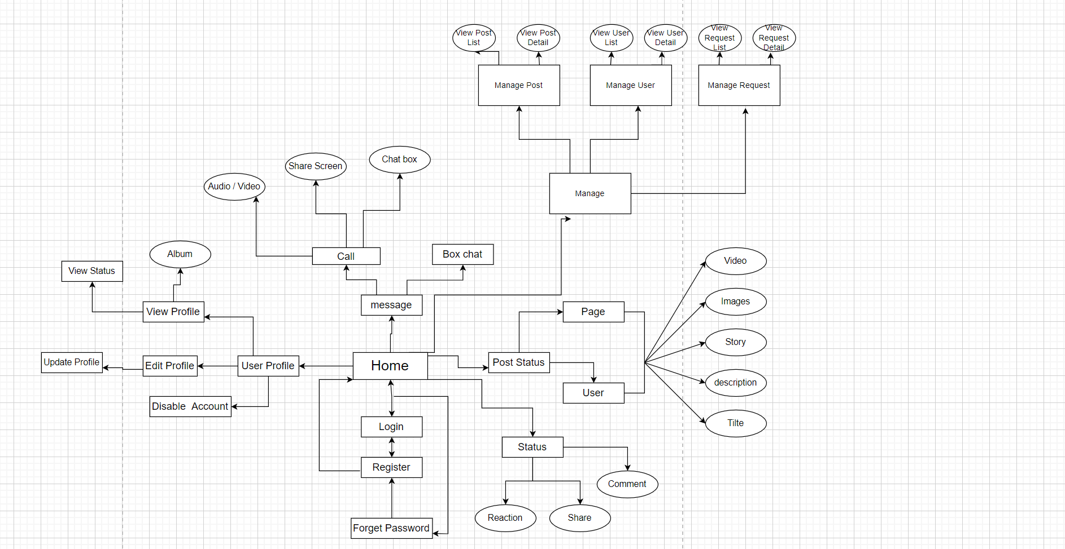

#### b. Screen Details

| **#** | **Feature** | **Screen** | **Description** |
| --- | --- | --- | --- |
| 1 | Home | Sign in | Screen for the user to sign in into the system. |
| 2 | Home | Register | Screen for guests to create an account. |
| 3 | Home | Forgot Password | Screen for the user to find the password. |
| 4 | UserProfile | Home | The screen that shows general information of the website: list online mentors, list requests, list skills, logo, slogan, etc. |
| 5 | UserProfile | View Profile | The screen for the user to view his/her profile |
| 6 | UserProfile | Disable Account | The screen shows lock the account can not be used anymore |
| 7 | UserProfile | Edit Profile | The screen where users edit their profiles |
| 8 | UserProfile | Update Profile | The update screen where users update profile |
| 9 | UserProfile | View Status | The screen for user to view his/her posts, articles |
| 10 | UserProfile | Album | The popup for users to view, post, create album, image |
| 11 | Message | Call Audio/Video | The screen for users to communicate via video or audio |
| 12 | Message | Box chat | The screen for users to chat with friends |
| 13 | Message | Share Screen | The screen if the session presenter screen sharing |
| 14 | Post Status | Status | The popup for the mentee to rate mentor after finishing the session |
| 15 | Post Status | Images | The popup for users to add images for the post |
| 16 | Post Status | Story | The popup for users to up stories for the post |
| 17 | Post Status | Description | The popup for users to add a hashtag or icon for the post |
| 18 | Post Status | Title | The popup for users to overview about story for the post |
| 19 | Status | Reaction | The popup for users to drop emotions into the article |
| 20 | Status | Share | The popup for users to share the post |
| 21 | Status | Comment | The popup for users to comment on post |
| 22 | Admin | Manage Users | The screen where the admin manages users |
| 23 | Admin | Manage Requests | The screen where the admin managers requests and inquiries on media sites |
| 24 | Admin | View Web Page | The screen for admins to monitor site analytics to see what types of content are responding to the most by followers |
| 25 | Admin | View List Created Request | The screen for manager view list created a request |
| 26 | Admin | Settings List | The screen shows the paginated list of settings |
| 27 | Admin | Setting Details | The screen shows detailed user information which allow the admin to add new, view or edit setting information |
| 28 | Admin | Admin Dashboard | The screen shows statistic of new users, posts, images, feedbacks |
| 29 | Manager | Posts List | The screen shows the paginated list of posts |
| 30 | Manager | Post Details | The screen shows detailed post information |
| 31 | Manager | Users List | The screen shows the list of users |
| 32 | Manager | User Details | The screen show detailed user/contact information, from that allow the manager to input, view or edit them |

#### c. Screen Authorization

| **Screen** | **Role 1** | **Role 2** | **Role 3** |
| --- | --- | --- | --- |
| Sign in | X | X | X |
| Register | X |  |  |
| Forgot Password | X | X | X |
| Home | X |  |  |
| View Profile | X | X | X |
| Disable Account | X | X | X |
| Edit Profile | X | X | X |
| Update Profile | X | X | X |
| View Status | X |  |  |
| Album | X |  |  |
| Call Audio/Video | X |  |  |
| Box chat | X |  |  |
| Share Screen | X |  |  |
| Status | X |  |  |
| Images | X |  |  |
| Story | X |  |  |
| Description | X |  |  |
| Title | X |  |  |
| Reaction | X |  |  |
| Share | X |  |  |
| Comment | X |  |  |
| Manage Users |  | X | X |
| Manage Requests |  | X | X |
| View Web Page |  |  | X |
| View List Created Request |  |  | X |
| Settings List |  |  | X |
| Setting Details |  |  | X |
| Admin Dashboard |  | X | X |
| Posts List |  | X | X |
| Post Details |  | X | X |
| Users List |  | X | X |

In which:

* Role1: User
* Role2: Manager
* Role3: Admin

#### d. Non-Screen Functions

| **#** | **Feature** | **System Function** | **Description** |
| --- | --- | --- | --- |
| 1 | Home | Sign out | Users sign out of the system. |

#### e. Entity Relationship Diagram

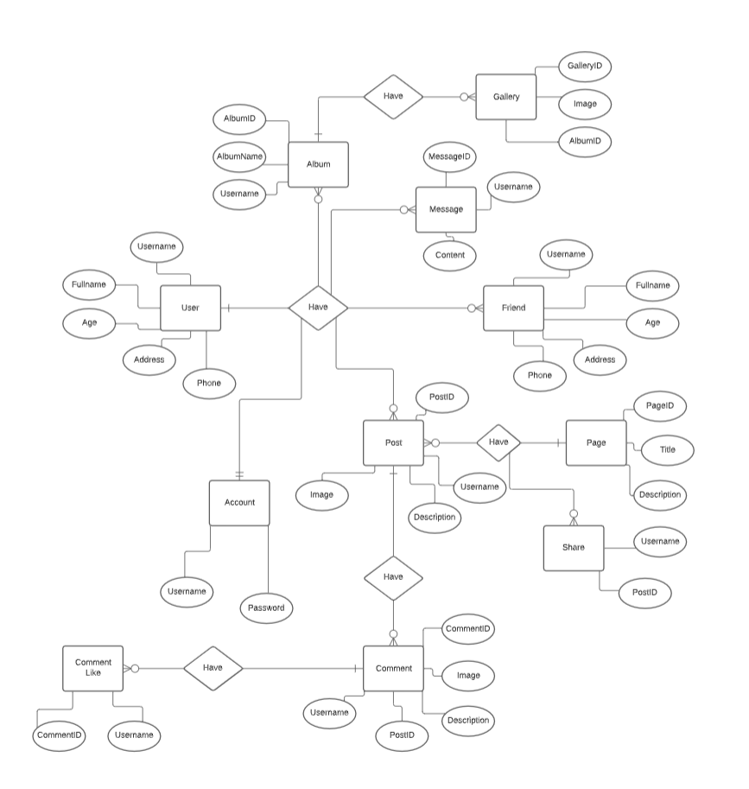

**Entities List**

| **#** | **Entity** | **Description** |
| --- | --- | --- |
| 1 | Notification | The notification of the user in the system. |
| 2 | Code IDE | Code on IDE in Session of mentee and mentor. |
| 3 | Profile | Detail of registered users. |
| 4 | Video Call/ Share Screen | Video Call/ Share Screen in Session of mentee and mentor. |
| 5 | Chax box | Chat box in Session of mentee and mentor. |
| 6 | Session | The Session of mentee and mentor |
| 7 | Matching | Mentor selects a question to match with the mentee. |
| 8 | LCM point | The point of LCM |
| 9 | Money Transaction | The money in transaction |
| 10 | Achievement | The achievement of the mentor. |
| 11 | BankCard | The bank card of the user |
| 12 | WithdrawalHistory | The withdrawal history. |
| 13 | Mentee | The mentee of the LCM system. |
| 14 | Mentor | The mentor of the LCM system. |
| 15 | PointExchangeHistory | The point exchange history |
| 16 | Skills | The tag skills. |
| 17 | Request | The request of mentee |
| 18 | Staff | The staff of the LCM system |
| 19 | Admin | The admin of the LCM system |

### 3.2 Login

#### a. Sign in

* *Function trigger: This function is triggered when the user clicks Sign in from Homepage*
* *Function description: User sign in into the system.*
* *Screen layout: mock-up prototype of the screen, sample below is for the Sign in screen.*

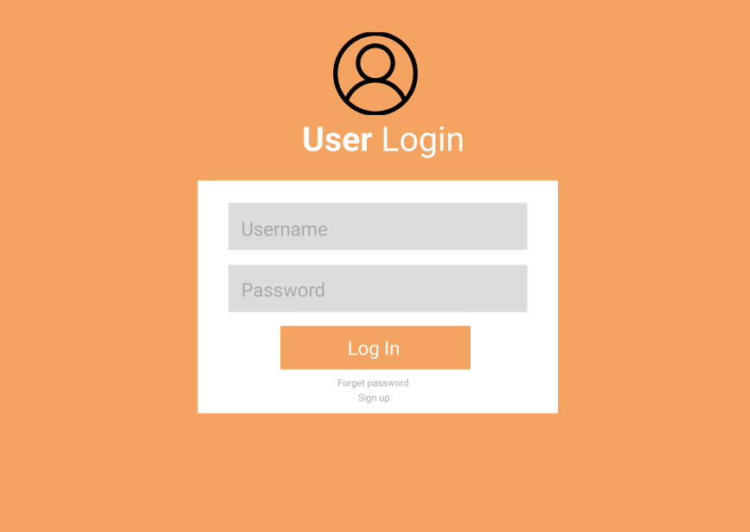

* *Function Details: When the user is in the state not logged in, at the home page there will be a Sign in button after sign in into the system, the Sign in button will become Sign out.*

#### b. Register

* *Function trigger: This function is triggered when the user clicks Sign in from Homepage*
* *Function description: The admin manages skills such as delete skills, update skills, ...*
* *Screen layout: mock-up prototype of the screen, sample below is for the Manage Skills.*
* *Function Details: After sign in, the admin selects Manage Skills, here the admin will add, edit, delete or update skills.*

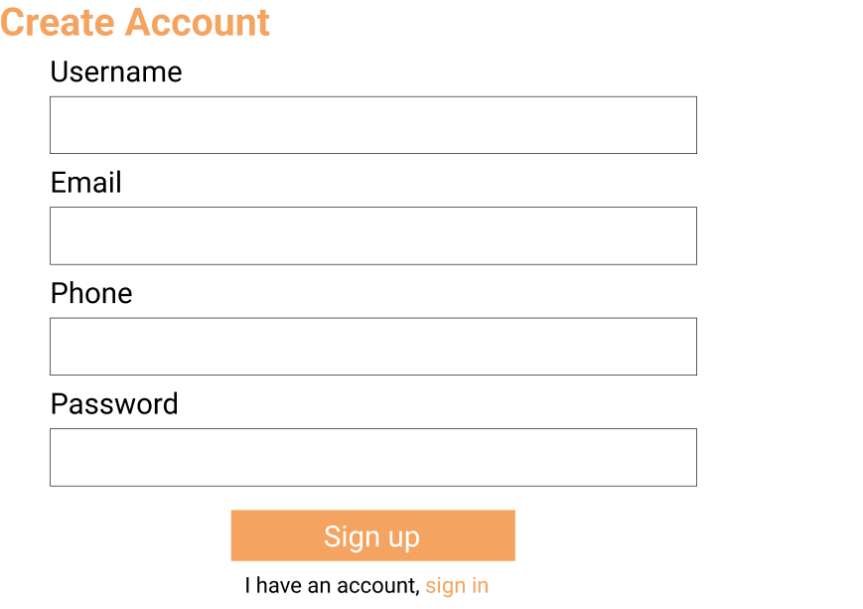

#### 3.3. Home

#### a. Home Page

* *Function trigger: This function is triggered when the mentee clicks Create Request from the Homepage.*
* *Function description: The mentee created a question to ask the mentor.*
* *Screen layout: mock up a prototype of the screen, the sample below is for the Create Request.*
* *Function Details: After sign in, the mentee selects Create Request, here the mentee will input into fields and chooses the programming language, ...*

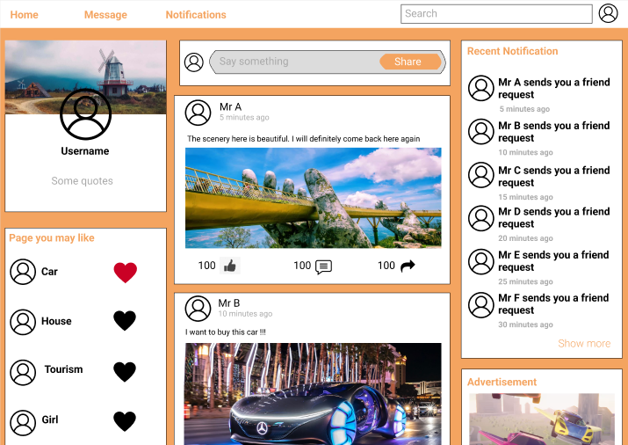

#### b. Message

* *Function trigger: This function is triggered when the Mentee requests to start the session with the mentor.*
* *Function description: The mentee and mentor start the session.*
* *Screen layout: mock-up prototype of the screen, sample below is for the Manage Skills.*
* *Function Details: After matching together, the mentee and mentor will create a session to resolve the problem of the mentee.*

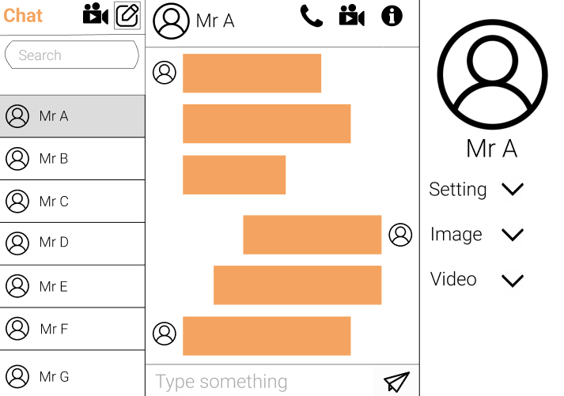

#### c. Personal Page

* *Function trigger: This function is triggered when the Mentor chooses the question of mentee.*
* *Function description: Mentor choose questions of mentee by skill.*
* *Screen layout: mock-up prototype of the screen, sample below is for the Manage Skills.*
* *Function Details: After matching with the mentor, the mentee can see the information of the mentor who just matched.*

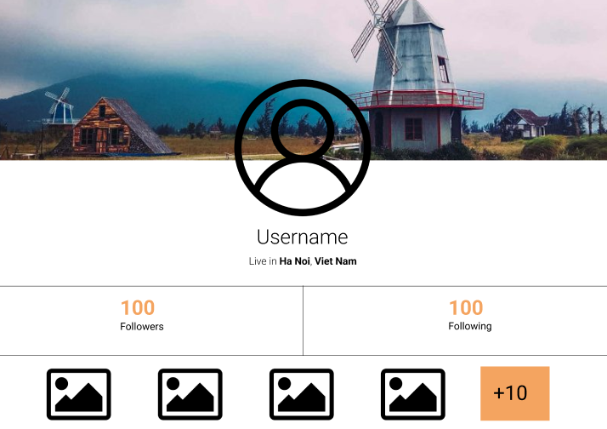

#### d. Notification

* *Function trigger: This function is triggered when the guest chooses View All Mentors on the Homepage*
* *Function description: The mentee views all mentors of LCM.*
* *Screen layout: mock-up prototype of the screen, sample below is for the View All Mentor.*
* *Function Details: After going to the homepage, guests can see a list of all mentors.*

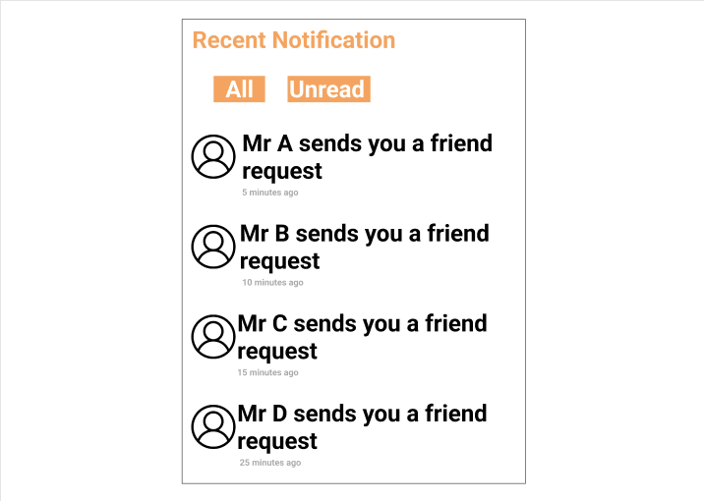

### 3.4 User Setting

#### a. Setting

* *Function trigger: This function is triggered when the guest goes to the Homepage*
* *Function description: The guest can see all categories*
* *Screen layout: mock-up prototype of the popup, sample below is for the View All Categories.*
* *Function Details: After going to the homepage, guests can see a list of all categories.*

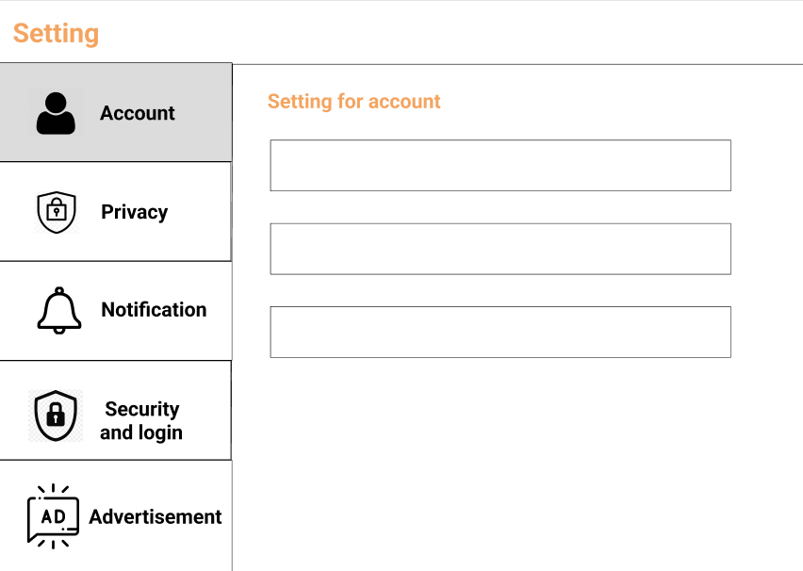

### 

#### b. User Profile

* *Function trigger: This function is triggered when the user chooses to see Profile*
* *Function description: The user can view their profile.*
* *Screen layout: mock-up prototype of the screen, sample below is for the User profile.*
* *Function Details: After login into the system, users can see their profile.*

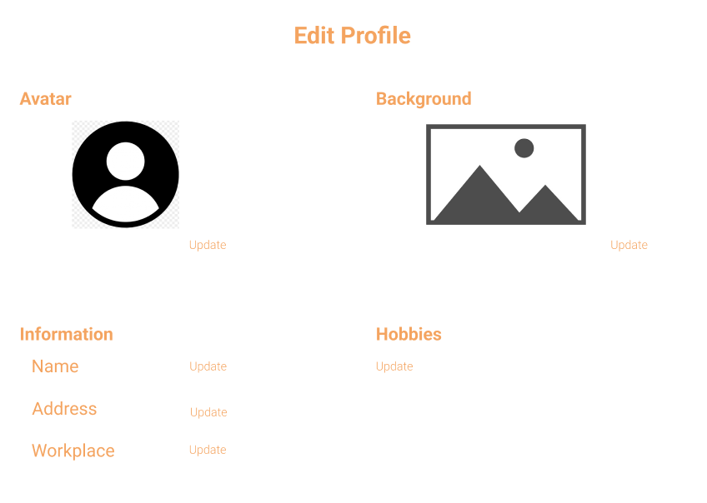

## 4. Non-Functional Requirements

### 4.1 External Interfaces

#### a. User Interfaces

UI-1: The websites will have a user-friendly interface and are easy to use.

UI-2: The layout of the screen is streamlined, easy to operate, and implement for the user.

UI-3: Buttons have distinctive features and colors but are in sync with the interface.

UI-4: When the user is on a screen or function, the position of that function displayed on the sidebar will be bright and synchronized with the interface.

UI-5: Notifications displayed on the screen have a friendly banner outlining the content for the user.

UI-6: The LCM screen displays shall conform to the Process Impact Internet Application User Interface Standard, Version 2.0 [3].

UI-7: The system will provide a website help link that is displayed explaining how to use that page to the user.

UI-8: Web pages will allow users to copy and paste using a mouse, in addition to using a mouse and keyboard combination.

#### b. Software Interfaces

SI-1: Login System

SI-1.1: The LCM will pass the username and password of the user to the sign-in system through a programming interface.

SI-1.2: The sign-in system will notify LCM that the user exists or not.

SI-1.3: When the sign-in system notifies LCM that the user exists or does not exist, LCM will take the user to the homepage or send a notification that the user does not exist.

SI-2: Manage System

The LCM shall communicate with the Manage System through a programmatic interface for the following operations:

SI-2.1: To allow an Admin to view all Users.

SI-2.2: To allow an Admin to view all Mentors.

SI-2.3: To allow an Admin to view all Requests.

SI-2.4: To allow an Admin to view all Skill.

SI-2.5: To inquire whether an Admin creates, updates, server or deletes skills.

SI-3: Payment System

SI-3.1: LCM will give the amount of one LCM point for user reference through the Payment System.

SI-3.2: The Payment system will allow users to top up their account then notify the LCM.

SI-3.3: After recharging an account via the Payment System, users can buy LCM points.

SI-3.4: After changing the LCM point to the Payment System, the LCM point number of the user will be updated by the LCM.

#### c. Hardware Interfaces

No hardware interfaces have been identified.

#### d. Communications Interfaces

CI-1: The LCM shall send an email or text message (based on user account settings) to the Patron to confirm acceptance of forgotten password.

CI-2: The LCM provides mentees and mentors with a chat box to communicate with each other.

### 4.2 Quality Attributes

#### a. Usability

* The languages are Vietnamese and English.
* The user interface of the solution should be elegant, easy to navigate, and user-friendly
* All the titles or names of functions should be easy to understand and reflect the purpose of the function.
* All error message should be clear for all users
* All related functions for each type of user should be grouped into categories and placed on a navigation bar for the efficiency of interactions.
* User should be able to learn to use the specified functions in no time
* Links, buttons are easily clickable.
* Links are easily recognizable, which looks clickable.
* Main functions are organized into tabs for easier access.
* Links, buttons, and checkboxes are easily clickable.
* The Front-end web application should support Chrome and Firefox browsers.

#### b. Reliability

* The system function is carefully observed and learned from the actual needs of users (mentee, mentor) and the LCM's demand.
* The average time it takes to repair the system if a module fails is about 4-8 hours.
* The system is only allowed to stop working for at most 8 hours since the problem occurred so that users can continue using the system.

#### c. Performance

* The Front-end system uses ReactJS which makes writing Javascript code easier because it uses a special syntax that is JSX syntax.
* The Back-end system uses NodeJS which is a platform that runs on the V8 JavaScript runtime - a very fast JavaScript interpreter that runs on the Chrome browser.

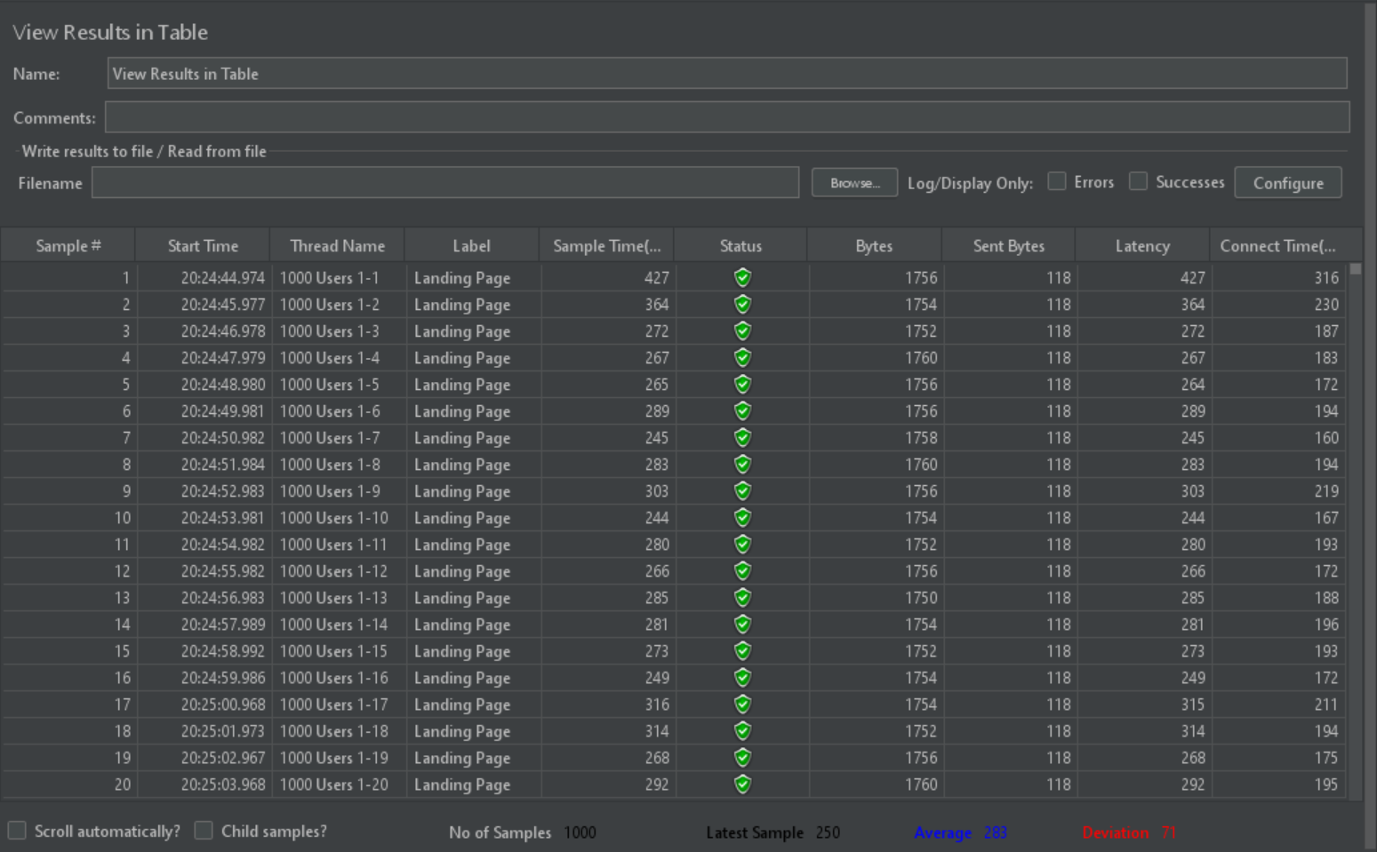

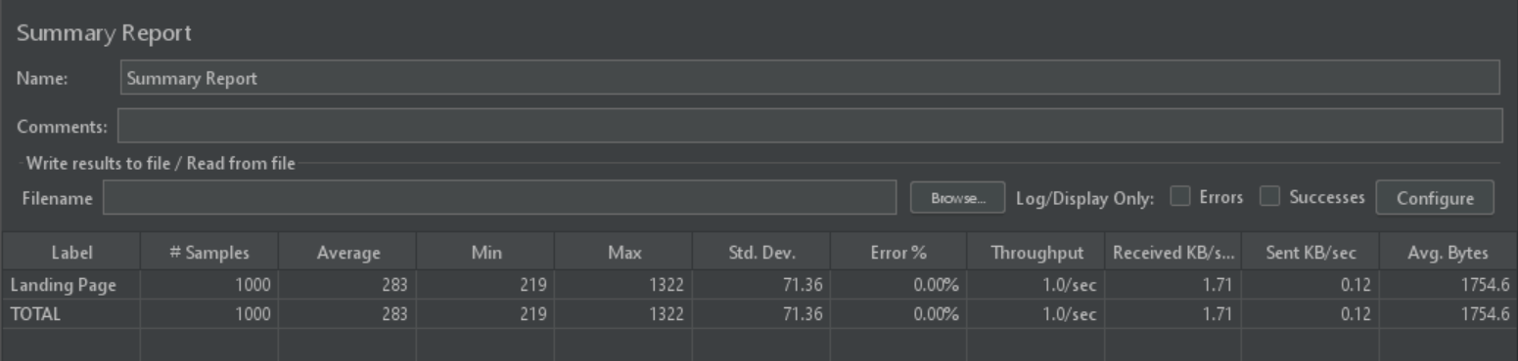

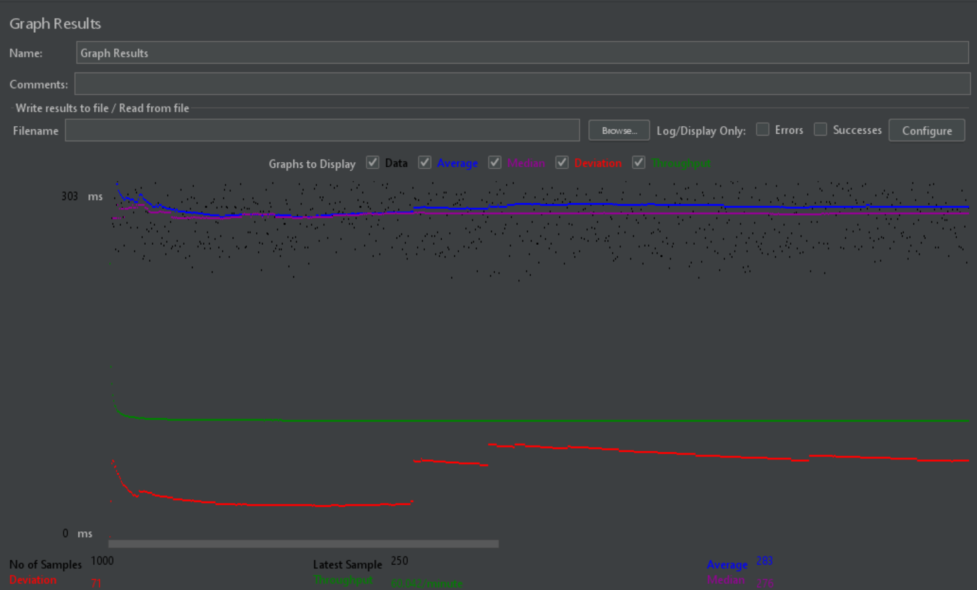

The results obtained when analyzing the results from the listeners with the Landing Page scenario:

* It can be seen that initially when the number of users is increasing, the response time of the server is quite fast, only about 1 second, and when the fixed number of users is 1000 people visit the homepage, children. this number falls to about 0.283s. The number of successful requests made increases slowly as the number of users increases and then very steadily (these lines are drawn next up on).
* The website's throughput after testing is 60,042 / minutes which means that the server processes 60,042 requests per minute
* The deviation of the website after the test is 72 it shows that the current deviation from the average is very low.
* The number of error transactions is only 0.00%, showing that the website works very well.
* The average response time value is 283ms

#### d. Dependability

##### d1. Security

* The system must use token-based authentication, in which the authentication server returns an access token after the user logged in with username/email and password. Then the client will include the access token in the subsequent requests to access protected resources. Using token-based authentication brings a lot of benefits to the system including:
* Allow cross-domain requests.
* Stateless, which improves the scalability of the system.
* Allow the separation between front-end and back-end sides. The front-end can be developed as standalone client applications (web, mobile, etc.), while the back-end provides APIs for client consumption.
* All passwords must be hashed using the BCrypt algorithm with at least 10 salt rounds.

##### d2. Safety

* This product is a web application running on the web browser so it will not affect any other application or user’s hardware, which may lead to data loss or system damage. The software is designed mainly for devices with an appropriate wide display so for maintaining the correctness of the user’s actions and data, the user should use this application on a device with a wide enough screen so the software can fit the screen.
* However, the solution is an e-commerce application so all transactions and behavior must follow the Law on Commerce of Vietnam No.36/2005/QH11 and Decree No.52/2013/NĐ-CP About eCommerce

#### e. Supportability

* The system will have maintenance periods to improve user security.
* The system will update content updates for users.
* The system has counselors to support mentees and mentors if they have any problems.

#### f. Design Constraints

- End-user’s Environment: Windows.

- Support languages: Vietnamese, English.

- Web application must be responsive and snappy.

- The user must have a stable connection to the internet.

#### g. Support Documents

- LCM User guides

## 5. Other Requirements

### 5.1 Appendix1 - Notification List

| **#** | **Notification code** | **Notification Type** | **Context** | **Content** |
| --- | --- | --- | --- | --- |
| 1 | NOT01 | Request | The user does not enter information in the fields | *Fields cannot be blank.* |
| 2 | NOT02 | Request | The user enters information in one field, leaving the remaining fields blank. | *Fields cannot be blank.* |
| 3 | NOT03 | Request | User input correct format of Username, Password, Re-password, Full name, Email | *Register Successfully.* |
| 4 | NOT04 | Request | Username already exists | *Show message "Username has already existed.* |
| 5 | NOT05 | Request | User input email does not contain the character "@". | *Email must contain one character @.* |
| 6 | NOT06 | Request | User input Re-password contains special characters such as:! @ # $ | *Passwords do not contain special characters such as: “! @ #$”.* |
| 7 | NOT07 | Request | Register successfully | *Register Successfully.* |
| 8 | NOT08 | Request | Input Password’s length between 8 to 24 characters | *Password’s length between 8 to 24 characters.* |