BÁO CÁO THỰC HÀNH HOMEWORK 1  
ITSS

# Calculator using Swing

## Write, compile :

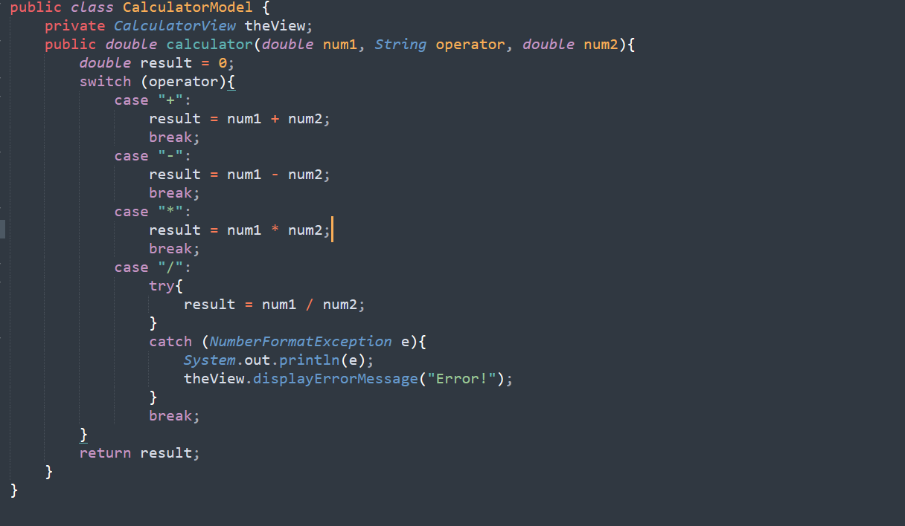

*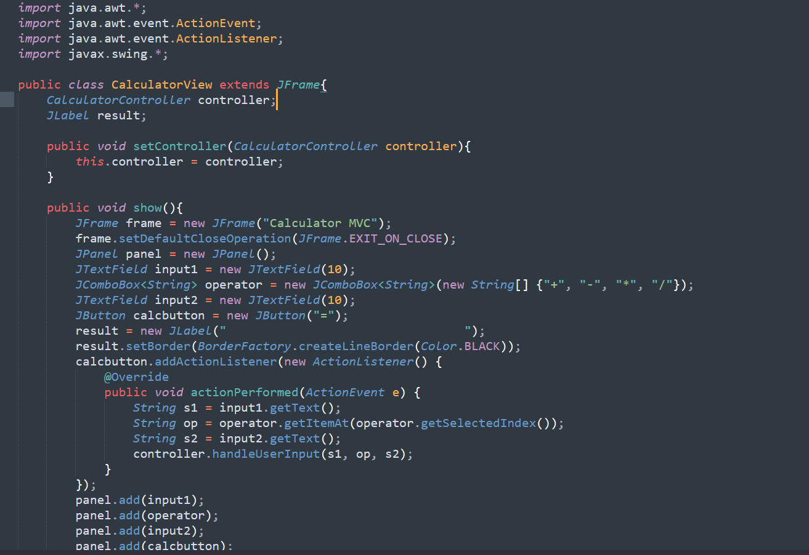  
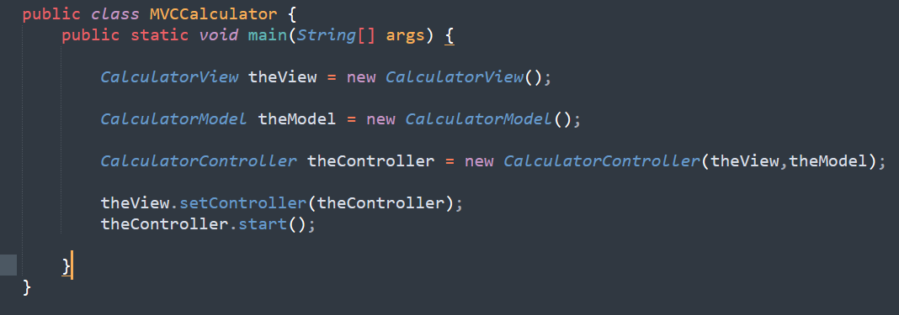  
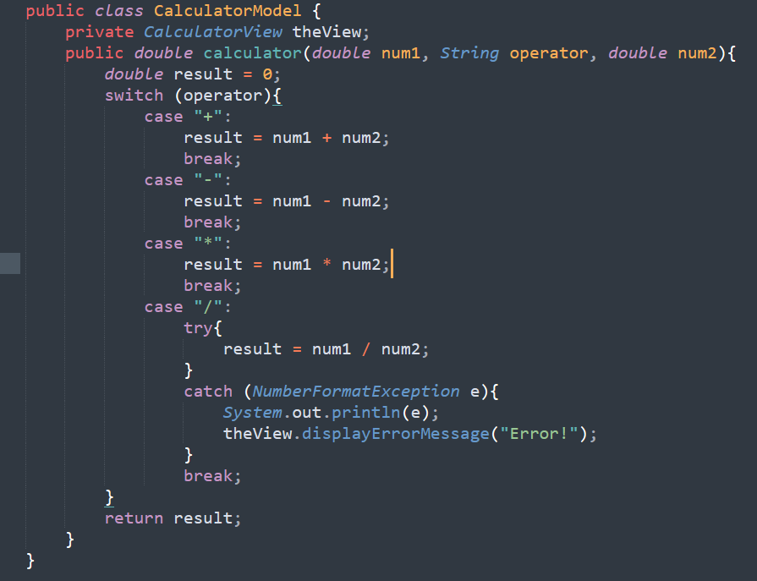*

*Kết quả*

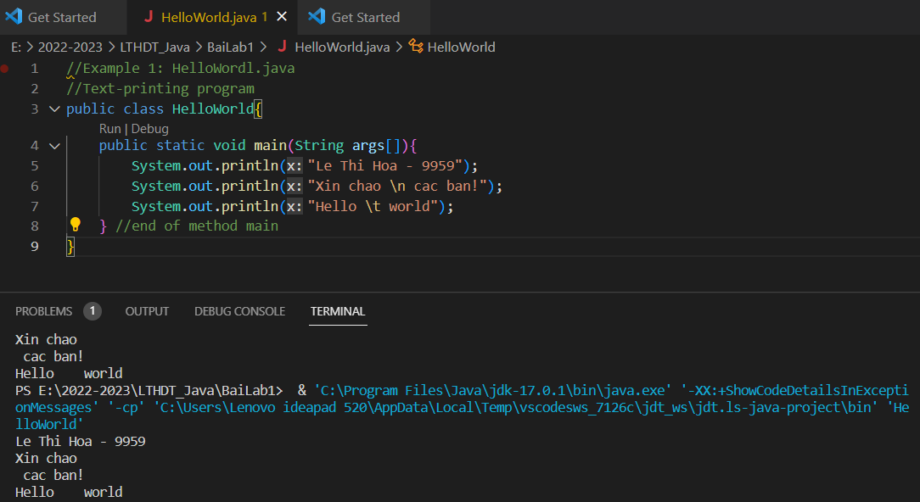

## 2.2.2 The obtained result

