STUDENT MANAGEMENT SYSTEM SPECIFICATION

1. FUNCTIONAL REQUIREMENTS

1.1. System Authentication / Login Function
All users (Admin, Lecturer, and Student) utilize a shared login interface to access the system. The system requires users to input authentication credentials. Upon validation, the system automatically checks user authorization roles and navigates the user to their corresponding subsystem dashboard.
All three subsystems (Admin, Lecturer, and Student) allow users to log out of their accounts by clicking the "Log out" button.

1.2. Admin Subsystem
Class Management:
- Admins can view the complete list of classes and perform operations including Search, Add, Edit, and Delete.
- Each class contains basic attributes: Class Name, Class ID, Faculty, and Total Students.
- Upon student enrollment, the Admin assigns each student to a fixed cohort class, forming a permanent student roster from admission until graduation.
Course Class Management:
- Admins can view the list of course classes and perform Search,Add, Edit, and Delete operations.
- Each course class includes attributes: Course Class ID, Subject Name, Semester, Class ID (Cohort), and Lecturer in Charge.
- When creating a new course class, the Admin enters the Class ID to assign all students of that cohort to the course class. The student roster will automatically populate on the assigned Lecturer's account for grade entry and appear on the respective Students' grade reports.
Student Management:
- Admins have permissions to view the comprehensive student directory, containing: Full Name, Student ID, Class ID, Phone Number, and Gender.
- Admins can execute Search, Add, Edit, and Delete operations on student profiles.
Grade Management / Grade Entry:
- Admins can manage and adjust student grades via Search, Edit, and Save functions.
- In the "Grade Entry" interface, the Admin searches by "Course Class ID" to load the roster of students enrolled in that course class.
- The displayed grade roster includes: No., Student ID, Full Name, Coursework Grades (Attendance, Midterm Exam), Final Exam Grade, and Total Grade. After modifying grades, the Admin clicks "Save" to commit the changes to the database.

1.3. Lecturer Subsystem
My Assigned Classes (Class Roster & Grade Management):
- Lecturers can only view the course classes assigned to them.
- Clicking "Details" displays the detailed roster for that course class: No., Student ID, Full Name, Coursework Grades, Final Exam Grade, and Total Grade.
- Lecturers can directly input and update individual grade components (attendance, midterm, final exam) within the editable table cells for each student.
Personal Profile Management:
- Lecturers can view and update their profile details.
- Profile attributes include: Full Name, Position (Lecturer), Email, and Phone Number. Lecturers click "Save Changes" to update their profile.

1.4. Student Subsystem
Academic Transcript / Grade Report (Read-Only):
- Students have read-only access to view academic results for enrolled/assigned courses.
- The Grade Report dashboard displays summary metrics: Total Courses Completed, Cumulative GPA, and Academic Standing / Classification.
- Detailed course grade entries include: No., Subject Name, Semester, Attendance Grade, Midterm Exam Grade, Final Exam Grade, and Total Grade.
Personal Profile Management:
- Students can view and update personal contact information.
- Editable fields include: Full Name, Phone Number, Email, and Contact Address. Students click "Update" to save changes.

2. NON-FUNCTIONAL REQUIREMENTS

2.1. Performance Requirements
- Response Time: The system must retrieve and render the student roster within < 2 seconds after an Admin or Lecturer initiates a search by "Course Class ID" under stable network conditions.
- Concurrency: The system must handle concurrent access by at least 500 students simultaneously querying the "Academic Transcript" module during peak end-of-semester periods without crashing .

2.2. Security Requirements
Password Security: 100% of user passwords stored in the database must be irreversibly
encrypted using the SHA-256 algorithm; plaintext storage is strictly prohibited.

2.3. Availability Requirements
System Availability: The system must maintain a monthly uptime of at least 99%. Scheduled maintenance and upgrades must occur strictly between 22:00 and 04:00 to minimize disruption to academic activities.
2.4. Tools Used
To develop this system, we utilized the following tools: Diagrams.net, Figma, Github, SQL Server, and VS Code.

3. Data Flow Diagram - DFD
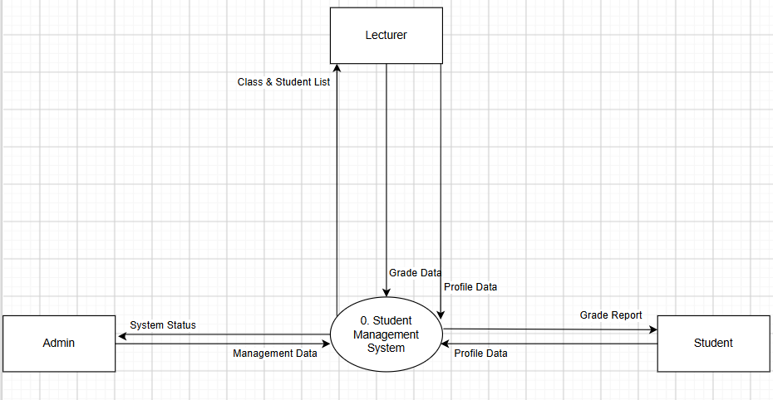

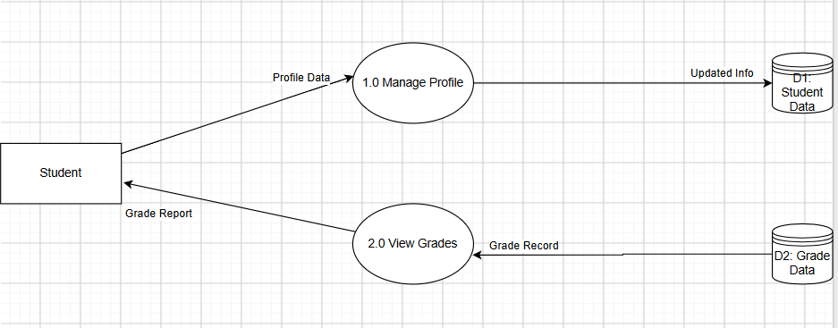

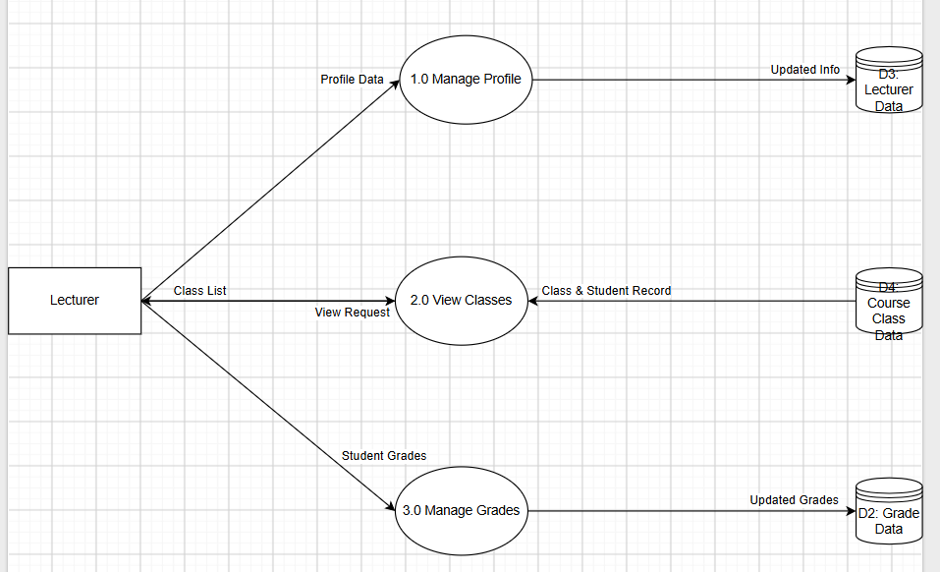

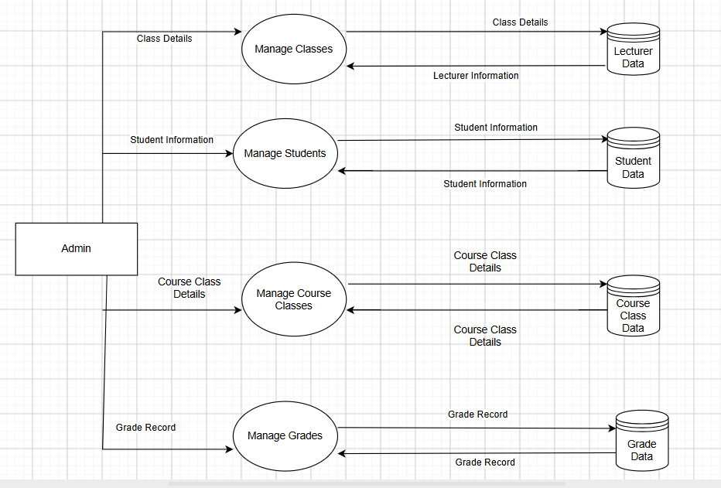

2.2. Security Requirements
- Password Security: 100% of user passwords stored in the database must be irreversibly encrypted using the SHA-256 algorithm; plaintext storage is strictly prohibited.

4.Use case Diagram
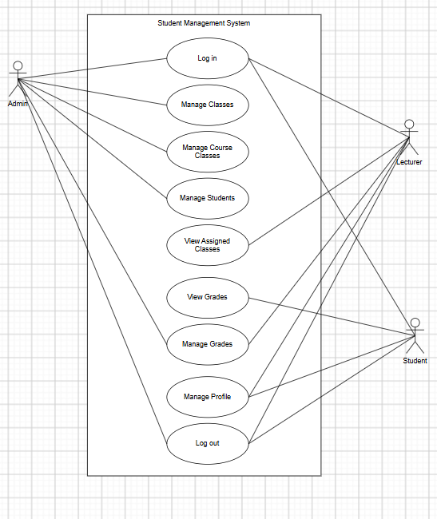

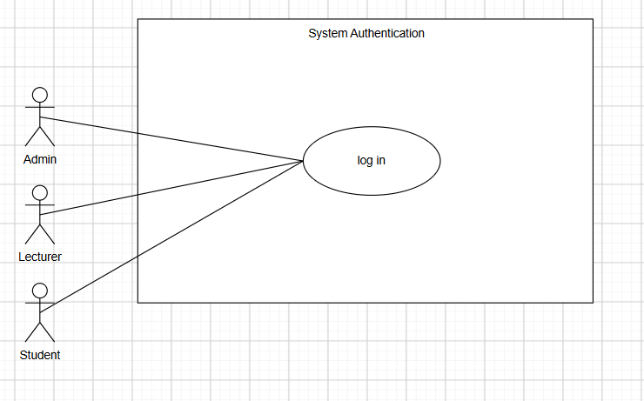

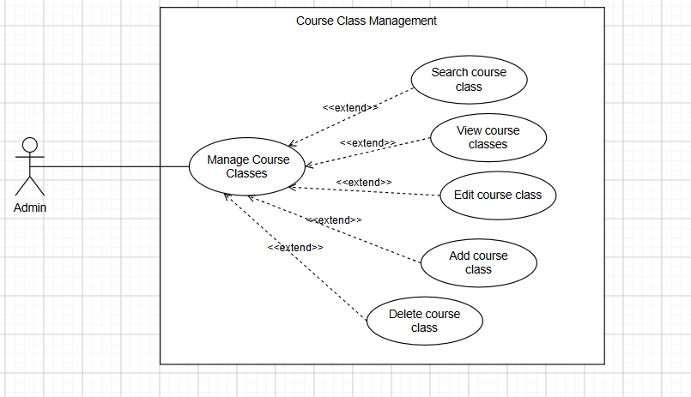
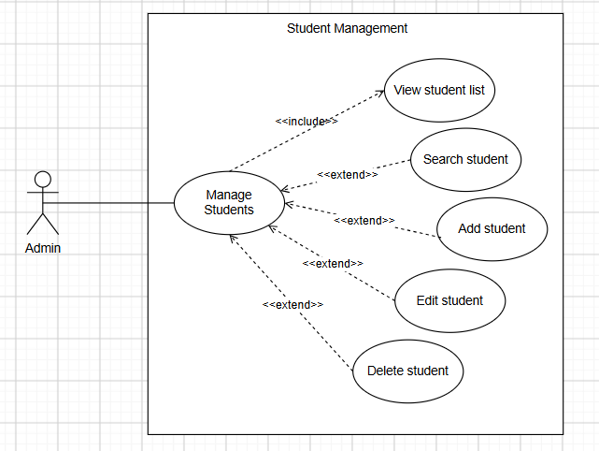

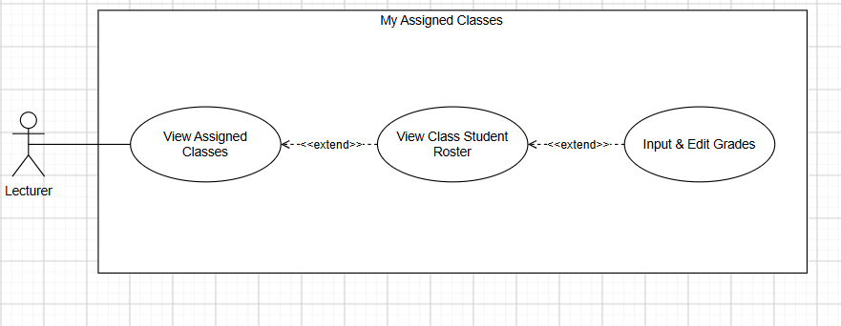
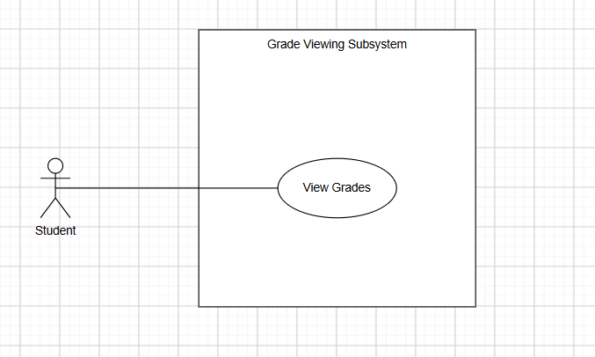

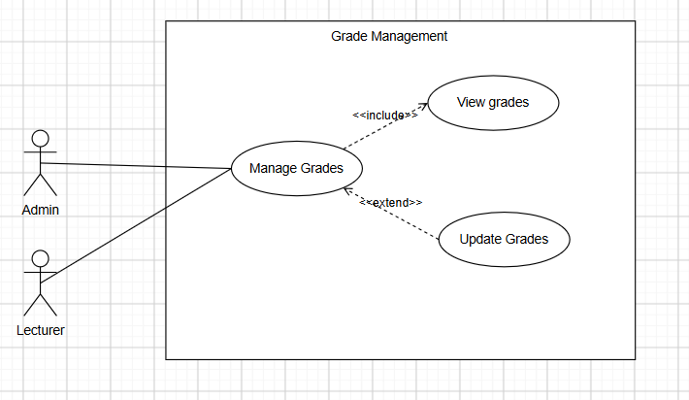
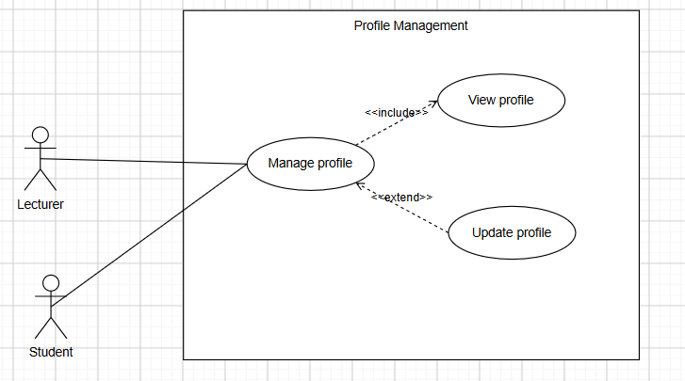

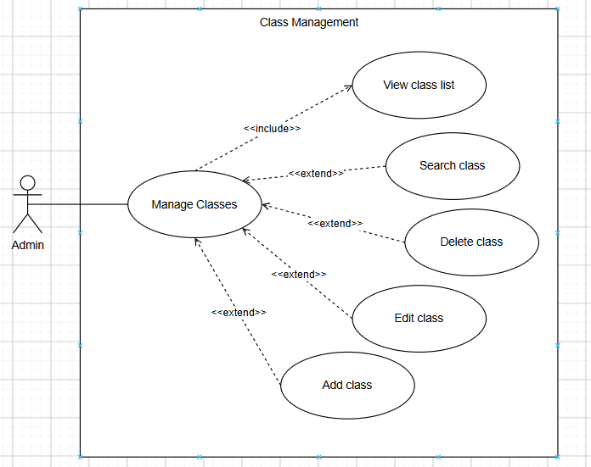

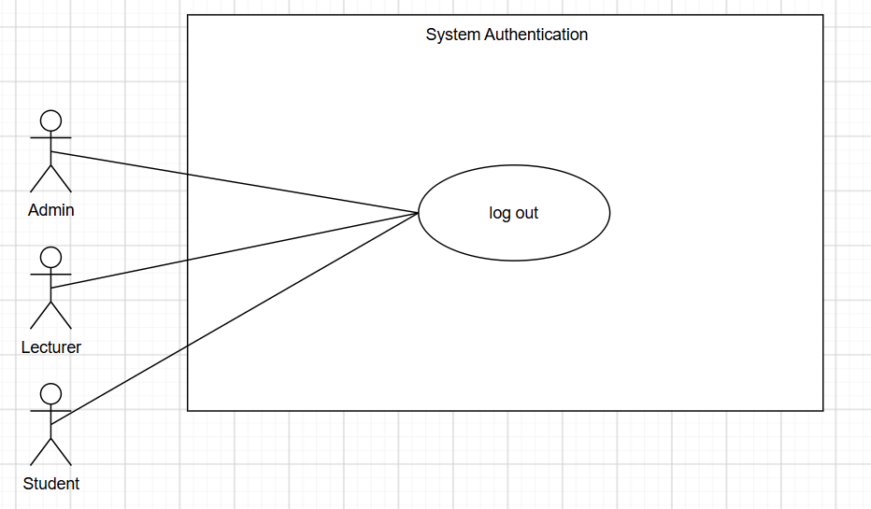

I. Use-Case: System Authentication / Log In

1. Use-Case: System Authentication / Log In
- 1.1. Summary: Enables users (Admin, Lecturer, and Student) to log in and access the system interface corresponding to their authorized roles.
- 1.2. Flow of Events:
  - 1.2.1. Basic Flow:
    - Step 1: The user navigates to the shared system login page.
    - Step 2: The system prompts for authentication credentials (Username and Password).
    - Step 3: The user submits credentials and requests authentication.
    - Step 4: The system verifies credentials, determines user role, and routes the user to the corresponding subsystem.
  - 1.2.2. Alternative Flows: If credentials are invalid, the system displays an error notification and prompts for re-entry.
- 1.3. Special Requirements:
  - Password Security: 100% of stored passwords must be irreversibly hashed using the SHA-256 algorithm.
  - Session Management: Automatic session termination (Auto-logout) triggers after 30 consecutive minutes of inactivity.
- 1.4. Pre-conditions: The user is not authenticated in the system.
- 1.5. Post-conditions: The user is successfully authenticated and redirected.

II. Use-Case: Manage Profile

2. Use-Case: Manage Profile
- 2.1. Summary: Allows Lecturers and Students to view and update their personal profiles.
- 2.2. Flow of Events:
  - 2.2.1. Basic Flow:
    - Step 1: The user accesses the Personal Profile Management feature.
    - Step 2: The system renders current profile details (Full Name, Phone Number, Email, Avatar, Address / Title).
    - Step 3: The user edits fields and clicks "Update" or "Save Changes".
    - Step 4: The system validates and persists the updated records into the database.
  - 2.2.2. Alternative Flows: If mandatory fields are empty, the system displays validation errors without persisting changes.
- 2.3. Special Requirements: None.
- 2.4. Pre-conditions: The user is logged in.
- 2.5. Post-conditions: Profile data is updated successfully.

III. Use-Case: Manage Classes

3. Use-Case: Manage Classes
- 3.1. Summary: Enables Admins to manage fixed cohort class records.
- 3.2. Flow of Events:
  - 3.2.1. Basic Flow:
    - Step 1: The Admin selects Class Management.
    - Step 2: The system displays the complete list of cohort classes.
    - Step 3: The Admin can Add, Edit, or Delete classes (Class Name, Class ID, Faculty, Total Students).
    - Step 4: The Admin assigns new students into a fixed cohort class.
    - Step 5: The system persists modifications and refreshes the directory.
  - 3.2.2. Alternative Flows: The system prompts for confirmation before permanently deleting a class record.
- 3.3. Special Requirements: None.
- 3.4. Pre-conditions: The Admin is logged in.
- 3.5. Post-conditions: Class records are successfully updated.

IV. Use-Case: Manage Course Classes

4. Use-Case: Manage Course Classes
- 4.1. Summary: Allows Admins to manage course classes and assign cohort student rosters to courses.
- 4.2. Flow of Events:
  - 4.2.1. Basic Flow:
    - Step 1: The Admin accesses Course Class Management.
    - Step 2: The system renders the course class list.
    - Step 3: The Admin performs Add, Edit, or Delete operations (Course Class ID, Subject Name, Semester, Cohort Class ID, Lecturer).
    - Step 4: The system automatically links the assigned cohort class roster to the course class via Class ID.
  - 4.2.2. Alternative Flows: None.
- 4.3. Special Requirements: None.
- 4.4. Pre-conditions: The Admin is logged in.
- 4.5. Post-conditions: Course classes are updated, and the student roster is accessible to the designated Lecturer.

V. Use-Case: Manage Students

5. Use-Case: Manage Students
- 5.1. Summary: Allows Admins to manage student master records.
- 5.2. Flow of Events:
  - 5.2.1. Basic Flow:
    - Step 1: The Admin navigates to Student Management.
    - Step 2: The system displays the full student roster.
    - Step 3: The Admin executes Add, Edit, or Delete operations on student records.
    - Step 4: The system persists data changes to the database.
  - 5.2.2. Alternative Flows: The system prompts for deletion confirmation before removing any student profile.
- 5.3. Special Requirements: None.
- 5.4. Pre-conditions: The Admin is logged in.
- 5.5. Post-conditions: Student directory records are updated.

VI. Use-Case: Manage Grades - Admin

6. Use-Case: Manage Grades - Admin
- 6.1. Summary: Enables Admins to query course classes and modify student grade sheets.
- 6.2. Flow of Events:
  - 6.2.1. Basic Flow:
    - Step 1: The Admin opens Grade Management and inputs a "Course Class ID" into the search bar.
    - Step 2: The system displays the enrolled student grade list for that course class.
    - Step 3: The Admin modifies coursework and final exam scores.
    - Step 4: The Admin clicks "Save", and the system updates the grade records.
  - 6.2.2. Alternative Flows: If the entered Course Class ID is invalid, the system displays a "No records found" notification.
- 6.3. Special Requirements: The response time to retrieve and display student lists must not exceed 2 seconds.
- 6.4. Pre-conditions: The Admin is logged in.
- 6.5. Post-conditions: Student grade records are updated.

VII. Use-Case: View Assigned Classes

7. Use-Case: View Assigned Classes
- 7.1. Summary: Allows Lecturers to view their assigned course classes and inspect enrolled students.
- 7.2. Flow of Events:
  - 7.2.1. Basic Flow:
    - Step 1: The Lecturer selects the "My Classes" feature.
    - Step 2: The system displays only course classes assigned to the logged-in Lecturer.
    - Step 3: The Lecturer clicks "Details" for a specific course class.
    - Step 4: The system displays the enrolled student roster: No., Student ID, Full Name, Coursework Grade, Final Exam Grade, and Total Grade.
  - 7.2.2. Alternative Flows: None.
- 7.3. Special Requirements: Transition and loading latency for class directories must not exceed 2 seconds.
- 7.4. Pre-conditions: The Lecturer is logged in.
- 7.5. Post-conditions: No database mutations occur.

VIII. Use-Case: View/Enter Grades

8. Use-Case: View/Enter Grades
- 8.1. Summary: Enables Lecturers to enter component scores for their classes, and allows Students to inspect academic transcripts.
- 8.2. Flow of Events:
  - 8.2.1. Basic Flow (For Lecturers):
    - Step 1: From the assigned class roster, the Lecturer enters or updates attendance, midterm, and final exam scores in the table cells.
    - Step 2: The Lecturer clicks "Save".
    - Step 3: The system automatically calculates total course grades for all students.
  - 8.2.2. Basic Flow (For Students):
    - Step 1: The Student selects "View Transcript".
    - Step 2: The system renders completed course count, cumulative GPA, and academic ranking.
    - Step 3: The system displays component scores (attendance, midterm, final) and overall grades per subject.
  - 8.2.3. Alternative Flows: The Student interface is strictly Read-Only.
- 8.3. Special Requirements: The transcript viewing module must support concurrency of at least 500 simultaneous student sessions without service failure.
- 8.4. Pre-conditions: The user is logged in.
- 8.5. Post-conditions: For Lecturer actions, grade data is persisted; for Student queries, system state remains unchanged.

5. Class Diagram
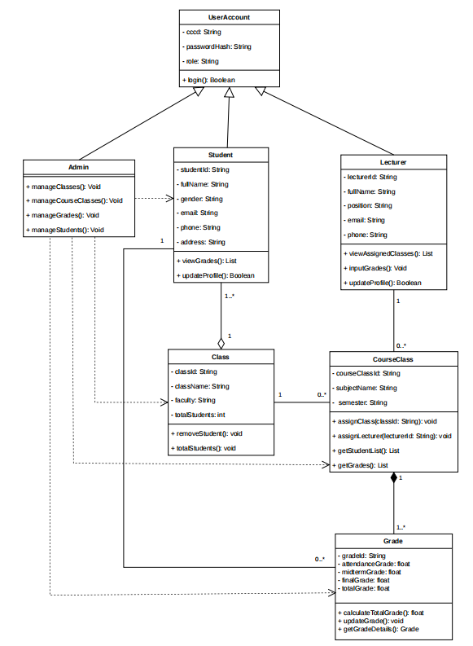

6.. Data Model

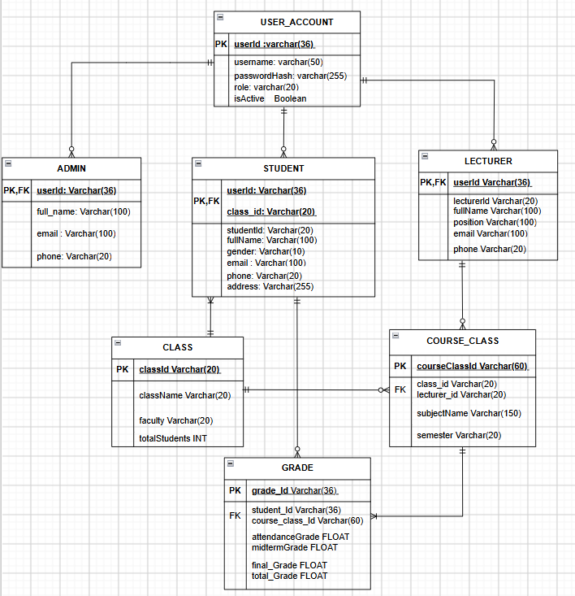

7. Interface Design
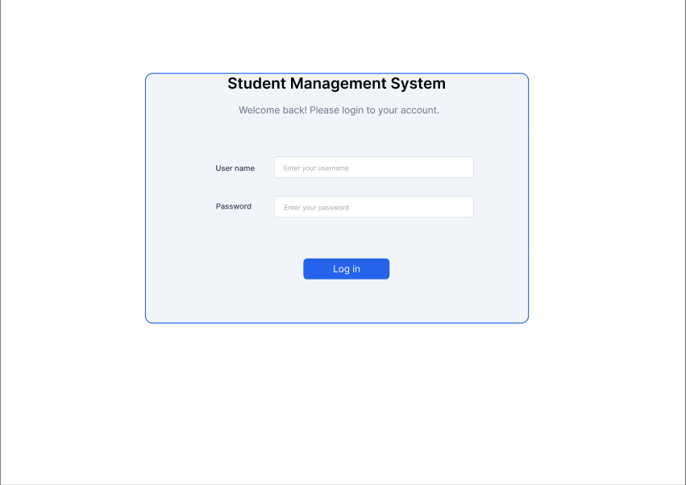

This interface serves as the centralized authentication gateway for all system user roles including Administrators, Lecturers, and Students, prompting users to input their authorized username and password credentials to securely access their designated portal dashboards.

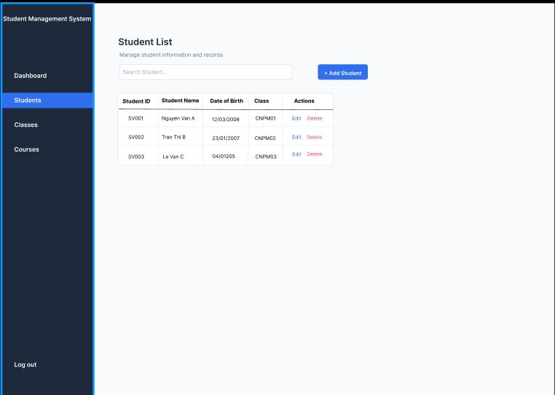
This interface enables the Administrator to oversee the comprehensive student directory, displaying structured demographic and academic records—such as Student ID, Full Name, Date of Birth, and Assigned Class—while providing administrative controls to search, add, edit, and delete student profiles.

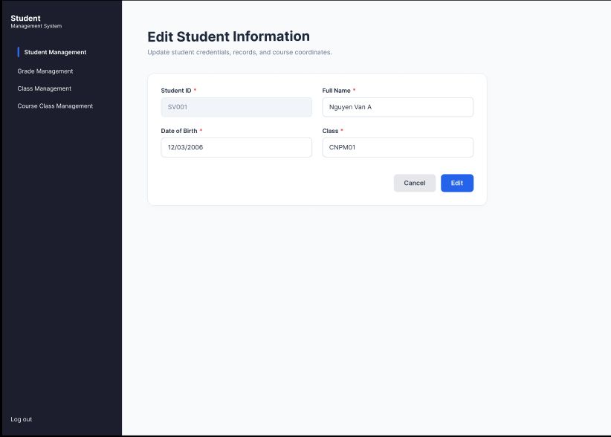

This modal dialog allows Administrators to either enroll a new student into the system or update an existing student's master profile by modifying personal data fields, including Full Name, Date of Birth, and Assigned Cohort Class.
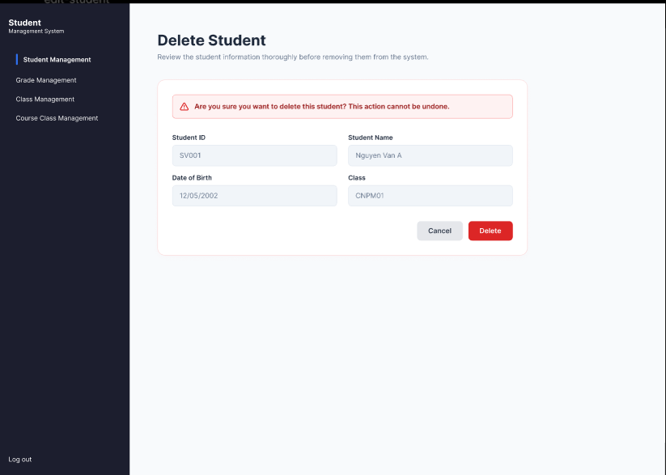

This safety confirmation prompt appears when an Administrator initiates a student deletion, requiring explicit verification before permanently removing the specified student record and all associated data from the system database.

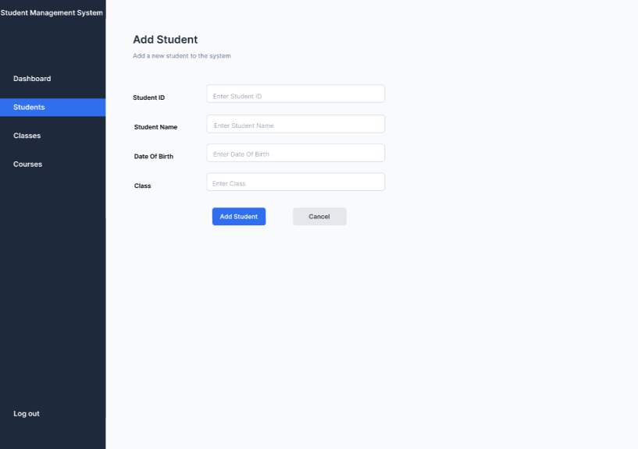
This form interface enables the Administrator to enroll and register a new student into the system by inputting essential demographic and academic information, including Student ID, Student Name, Date of Birth, and Assigned Cohort Class, with action buttons to submit the new profile directly to the database or cancel the operation.

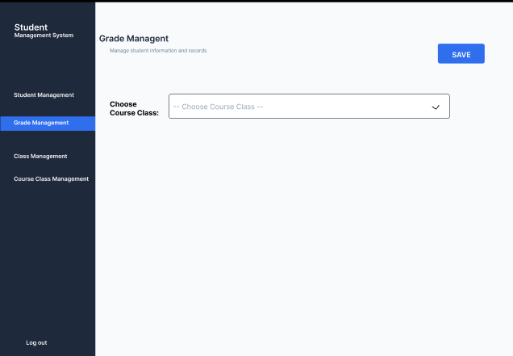

In the Grade Management interface, the Administrator selects or enters the "Course Class ID" into the search field, prompting the system to automatically retrieve and display the detailed student roster enrolled in that designated course class for grade management and evaluation purposes.
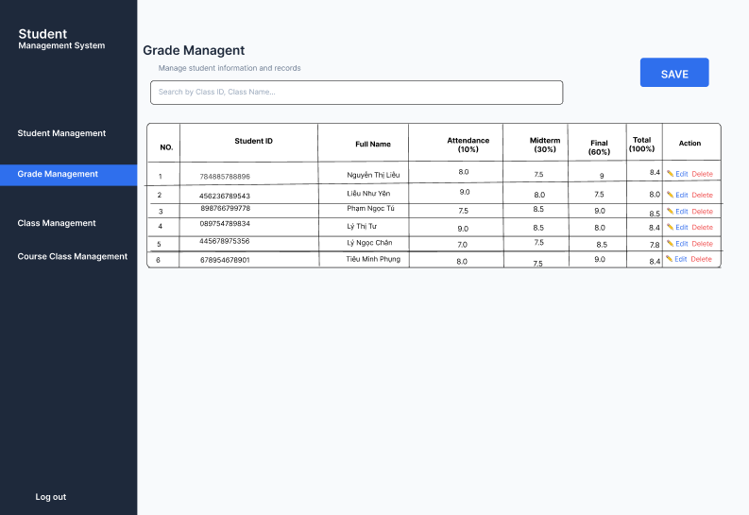

This interface provides Administrators with grade administration capabilities across course classes, allowing them to search for a specific class cohort, view all enrolled students alongside their respective attendance, midterm, and final exam scores, and execute real-time score modifications or batch saving .

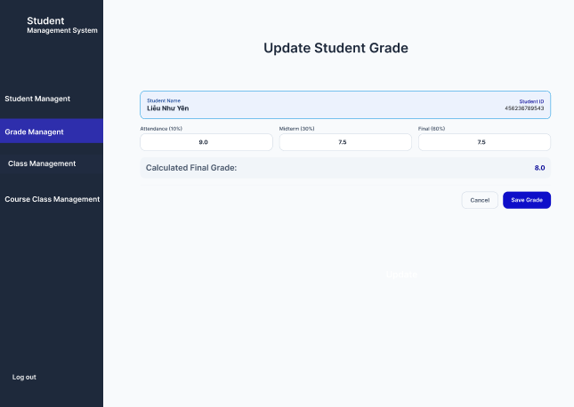

This modal pop-up allows the Administrator to adjust individual component scores—specifically attendance, midterm, and final exams—for a selected student, displaying the dynamically recalculated total grade prior to persisting the changes.
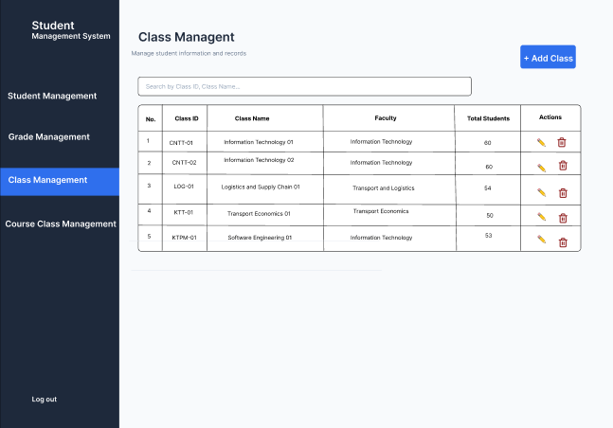
This interface displays the master list of all administrative cohort classes along with critical attributes like Class ID, Class Name, Faculty, and Total Student count, offering administrative tools to search, create, update, or remove cohort records.

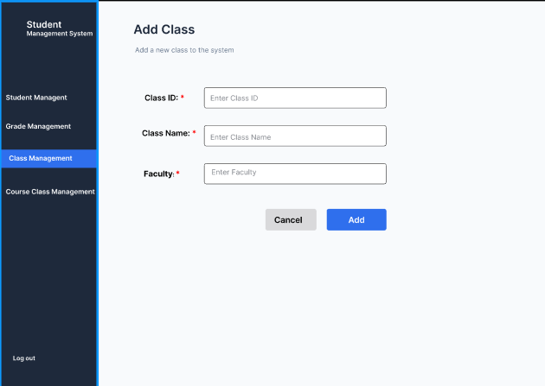
This dedicated form enables the Administrator to register a brand-new administrative cohort class into the institution by capturing mandatory attributes such as Class ID, Class Name, and the affiliated Faculty.

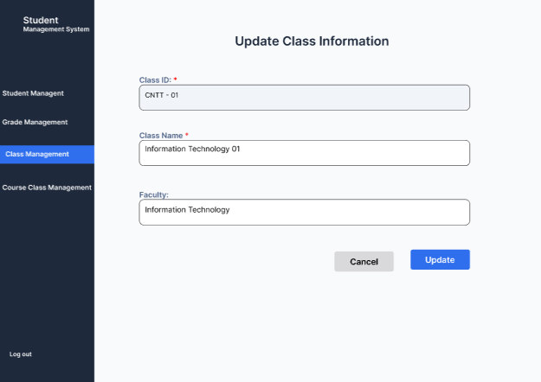
This form allows Administrators to edit the existing metadata of an administrative cohort class, including modifying its Class Name and associated Faculty designation while ensuring data consistency across the cohort
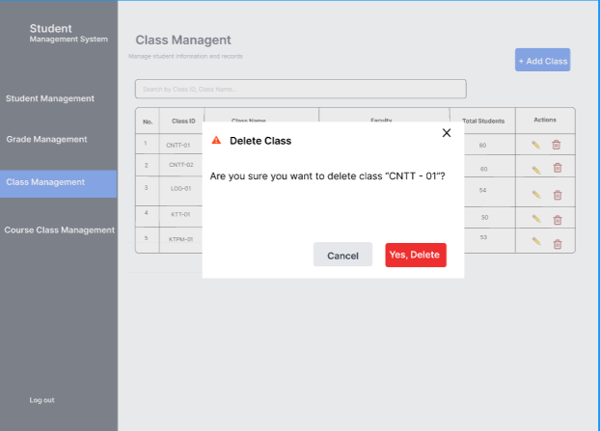
This alert modal intercepts class deletion requests, displaying a cautionary warning that prompts the Administrator to confirm the permanent removal of the selected cohort class and its associated historical records.
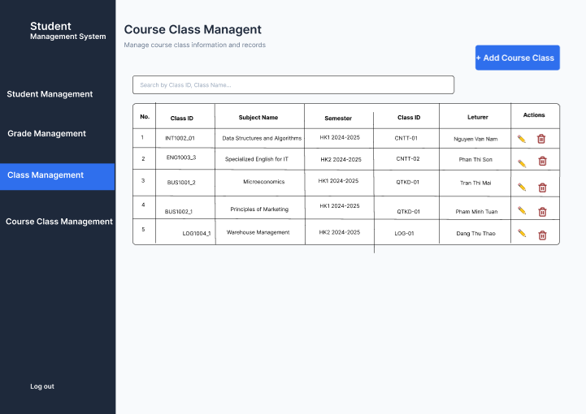
This interface provides an administrative overview of all scheduled course offerings across academic semesters, presenting key parameters such as Course Class ID, Subject Name, Semester, Assigned Cohort, and Lecturer in Charge alongside options to create, edit, or remove courses.
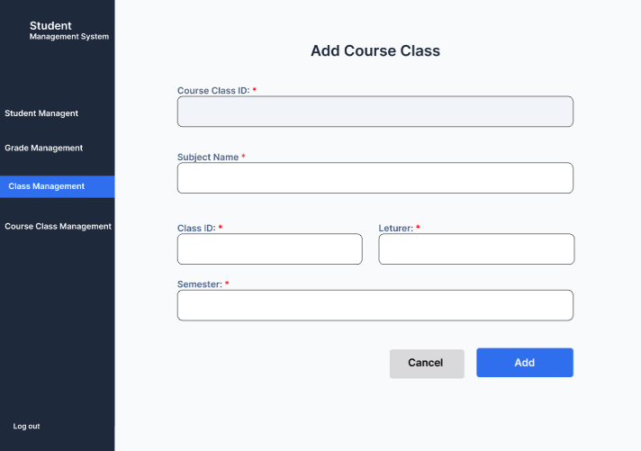
This form empowers Administrators to instantiate a new course class for a given semester by defining the Course Class ID, Subject Name, Semester, Assigned Cohort Class, and designating the responsible Lecturer.
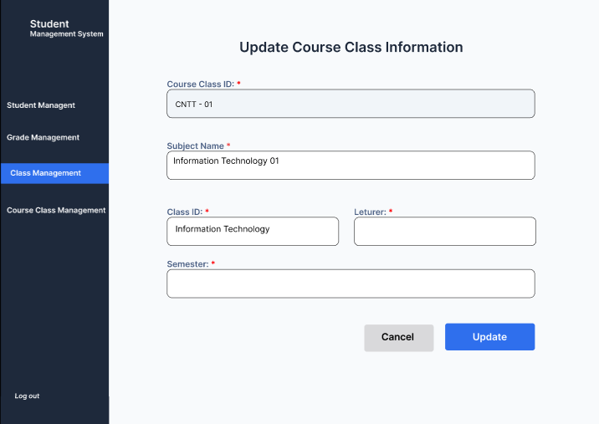
This editing screen enables the Administrator to revise operational course class parameters, allowing adjustments to the Subject Name, Semester scheduling, assigned cohort groups, or assigned teaching personnel.

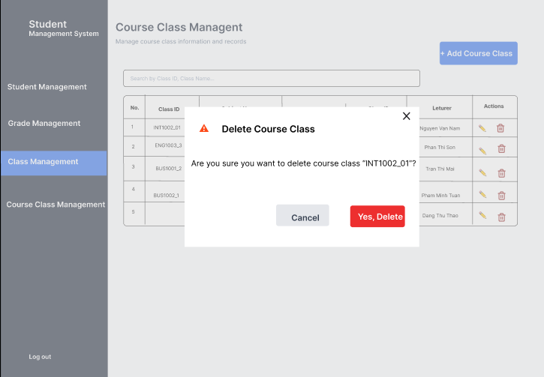
This verification dialog requires the Administrator to confirm the deletion of a specific course class instance before the system permanently purges the course offering and its associated grade sheets.

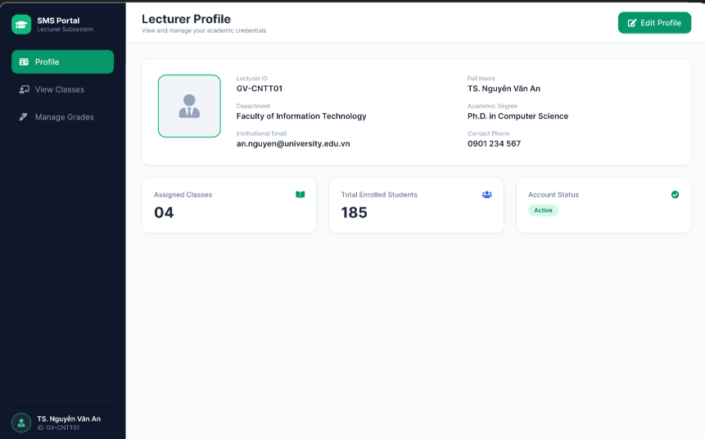
This dashboard interface displays the Lecturer's detailed academic profile and contact information—including Lecturer ID, Degree Title, Faculty, Email, Phone Number, and assigned class statistics—while providing an option to edit personal details.

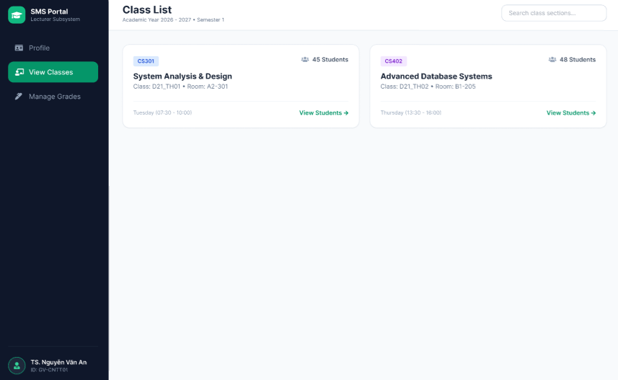
This interface allows logged-in Lecturers to view the specific course classes assigned to them for teaching, displaying key section details and student enrollment numbers alongside direct navigation to class rosters.

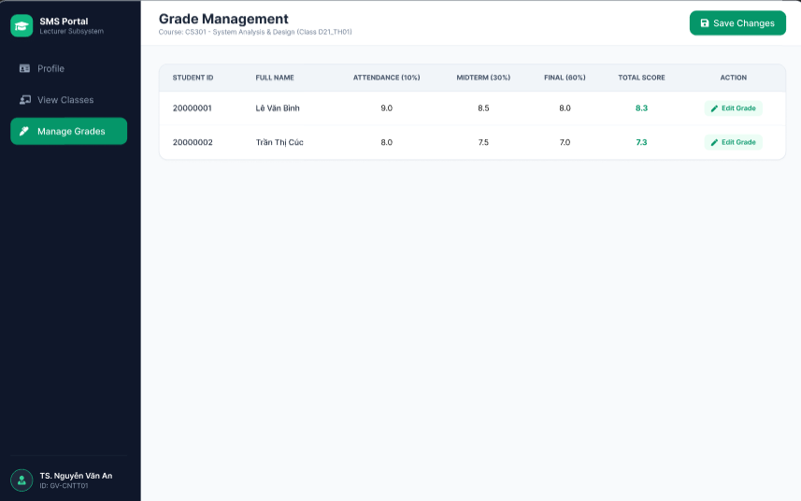
This interface enables Lecturers to inspect the enrolled student roster for their assigned course classes, calculate overall academic results, and directly input or update component marks for attendance, midterm exams, and final exams.

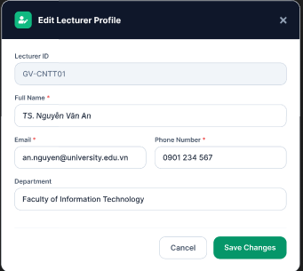

This modal interface allows Lecturers to update their personal contact information, specifically modifying their displayed Full Name, Email, and Phone Number while preserving system-locked identifiers like Lecturer ID and Faculty.

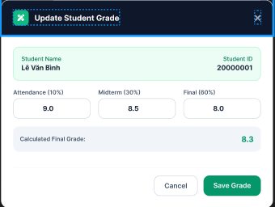

This modal dialog provides Lecturers with an interface to adjust an individual student's attendance, midterm, and final exam marks, automatically calculating and displaying the updated composite score before saving the record.

