BVLab Analyzer User Guide

Standard User Manual
Document Version: 3.0
Revision Date: 2026-08-26
Applicable Software Version: v2.0.0 and above
Target Audience: Laboratory Researchers, Image Analysis Engineers, Data Annotators
Document Number: SWI-UG-2026-008

Document Revision History
Version | Date | Revision Content | Reviser
1.0 | 2026-04-01 | Initial release | Technical Docs
2.0 | 2026-04-29 | Added Quick Start, Appendix, Copyright Notice; improved shortcut table and troubleshooting | Technical Docs
2.1 | 2026-04-29 | Added GUI screenshots | Technical Docs
3.0 | 2026-04-30 | Corrected workflow logic; added shortcut cheat sheet; supplemented parameter ranges and error handling; unified terminology | Technical Docs

Copyright and Disclaimer
Copyright © 2026 BVLab Inc.
Copying, distribution, or decompilation of this software and its documentation without written permission is prohibited.
This software is intended for research purposes only and is not for clinical diagnosis. The authors assume no responsibility for any data loss, hardware damage, or erroneous research conclusions resulting from the use of this software. Users should back up important data independently.

Table of Contents
1. Introduction and System Requirements 3
1.1 Software Overview 3
1.2 System and Environment Requirements 3
1.3 Data Format Specifications 3
2. Installation, Startup, and Interface Overview 4
2.1 Installation and Uninstallation 4
2.2 Starting the Software 4
2.3 Main Interface Overview 5
3. Core Workflow Overview (Important: Choose Path Based on Task) 5
4. Module 1: Dataset Creation 6
4.1 Function Description 6
4.2 Operation Steps 6
4.3 Precautions 8
5. Module 2: Model Training 8
5.1 Operation Steps 8
6. Module 3: Image Prediction 9
6.1 Operation Steps 9
6.2 Batch Prediction and Precautions 11
7. Module 4: Result Revision (Manual Annotation) 11
7.1 Quick Start 11
7.2 Shortcut Cheat Sheet 12
7.3 Operations in Browse Mode 13
7.4 Revision Mode Explained 16
7.5 Revision Suggestions 18
8. Module 5: Statistical Analysis (Vessel Only) 19
8.1 Operation Steps 19
8.2 Output Metrics Description 20
9. Glossary 20
10. Troubleshooting and Support 21
10.1 Common Issues 21
10.2 Logs and Support 21
11. Appendices 22
Appendix A: SWC Format Specification 22
Appendix B: Recommended Publications 22
Appendix C: Quick Start Example (Step-by-Step with Images) 22
Appendix D: Module Input/Output Quick Reference 25

1. Introduction and System Requirements

1.1 Software Overview
This software is designed for 3D biomedical images (TIF, BV, OME-Zarr formats) to provide a complete processing pipeline for cellular, neuronal, and vascular structures, including dataset preparation, deep learning model training and prediction, manual annotation correction, and morphological statistical analysis. Main application scenarios: neuronal morphology reconstruction, vascular network quantification, cell detection and counting.
Annotation Target Overview
This software supports three biological structure types, each with different annotation targets:
Cell: Annotate the center position of each cell (a single 3D coordinate point) for cell detection and counting. Output is a single-point SWC (containing only the soma point, with no line segments).
Neuron: Annotate the center skeleton line of neurites (continuous linear structures) for neuronal morphology reconstruction. Output is a tree-like SWC containing multiple points with parent-child relationships.
Vessel: Annotate the center skeleton line of the vascular network (connected network structure) for vascular network quantification. Output is a network SWC supporting multiple branch points.

1.2 System and Environment Requirements
To ensure stable software operation, your computer must meet the following minimum configuration requirements:
Component | Minimum Requirement | Recommended Configuration
OS | Windows 10 / 11 | Windows 11
CPU | 6 cores | 16 cores or more
GPU | NVIDIA GPU, CUDA capability 6.1+, ≥8GB VRAM | NVIDIA GPU, CUDA capability 8.9+, ≥24GB VRAM
RAM | 64GB | 128GB or higher
Storage | 100GB available space | 500GB+ SSD
Software Dependencies | Python 3.10, CUDA 12.6 (GPU only) | Python 3.10, CUDA 12.6
Note: If using GPU mode, please ensure the correct versions of NVIDIA drivers and CUDA Toolkit are installed.

1.3 Data Format Specifications
- Images: 3D TIF (recommended), BV format (config.cfg), OME-Zarr (*.ome.zarr).
- Labels: SWC format, must comply with standard SWC specifications (including point index, type, coordinates, radius, parent node index). See Appendix A for detailed format description.

2. Installation, Startup, and Interface Overview

2.1 Installation and Uninstallation
Installation:
- Run the installer BVLab-Analyzer-Setup.exe.
- Follow the on-screen prompts to choose the installation path (default C:\Program Files\BVLab-Analyzer).
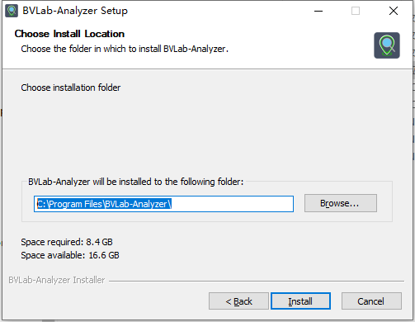 | 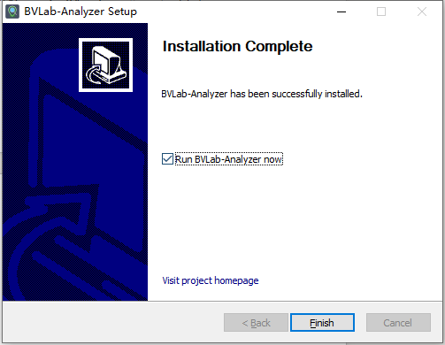
Uninstallation:
- Windows: Via “Control Panel” → “Programs and Features” → Select “BVLab-Analyzer” → Click “Uninstall”.
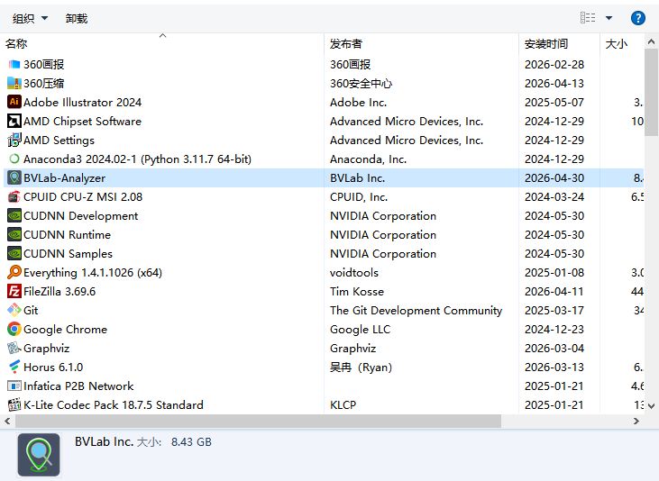 | 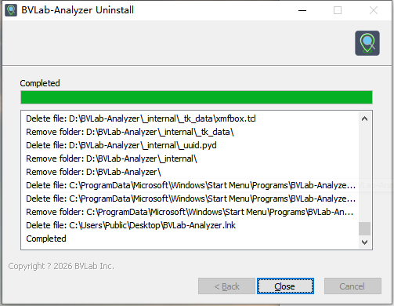

2.2 Starting the Software
After installation, you can start the software in any of the following ways: - Double-click the “BVLab-Analyzer” shortcut on the desktop or the BVLab-Analyzer.exe in the software directory. - Find “BVLab-Analyzer” in the Start menu and click it. - Command line startup (navigate to the software directory): enter BVLab-Analyzer –debug or BVLab-Analyzer.exe and press Enter.

2.3 Main Interface Overview
After startup, the main interface is divided into three core areas.
Figure 2-1 Software Main Interface Layout
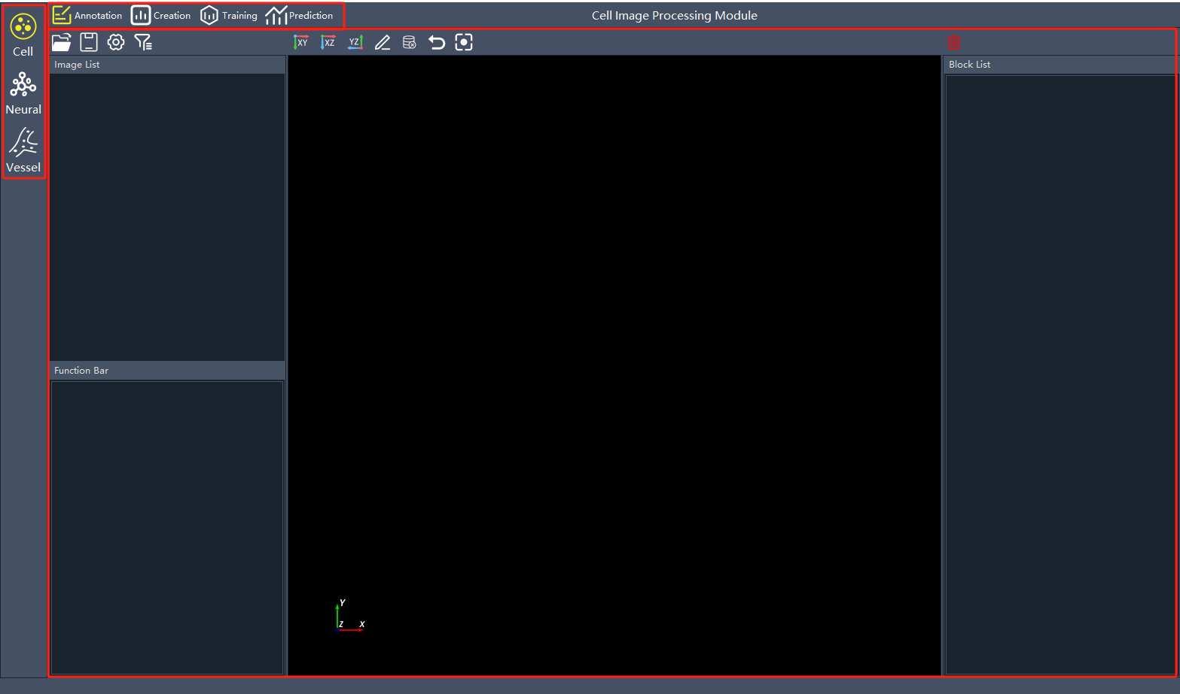
- Data Type Selection Toolbar: Select the corresponding module based on the type of image data (Cell, Neural, Vessel).
- Data Processing Selection Toolbar: Select the corresponding processing module based on the workflow (Creation, Training, Prediction, Annotation, Statistics).
- Interactive Operation Area: After selecting the data type and data processing method, refer to the operation steps for each processing module to process data.

3. Core Workflow Overview (Important: Choose Path Based on Task)
The standard usage workflow of this software is as follows. Please choose the path based on your goal:
Path A: Train a New Model (Using AI Pre-annotation + Manual Correction, Recommended) Applicable Scenario: You have a batch of unannotated images and want to train a dedicated model for your own data.
- Dataset Creation (convert raw images and a small number of manual labels into training format)
- Model Training (using a pre-trained model or training from scratch)
- Image Prediction (use the trained model to automatically annotate a large batch of unannotated images)
- Result Revision (manually correct errors in the prediction results to produce high-quality labels)
- (Optional) Dataset Creation Again (add the corrected high-quality labels to the training set)
- (Optional) Model Training Again (fine-tune the model for further accuracy improvement)
- Statistical Analysis (only required for vessel data)
Path B: Train a New Model (with Existing Labels)
Applicable Scenario: You already have a batch of manually annotated SWC point cloud files, ready for training.
- Dataset Creation (images + labels)
- Model Training
- Image Prediction
- Result Revision (can be skipped if prediction results are satisfactory)
- Statistical Analysis (vessel only)
Path C: Use Pre-trained Model Only for Annotation (No Training)
Applicable Scenario: Directly use the built-in general models (e.g., cell detection model) for annotation.
- Image Prediction (select the configuration file of the pre-trained model)
2. Result Revision
Path D: Manual Annotation Only (No AI)
Applicable Scenario: Completely manual annotation from scratch.
- Enter the Annotation Module
- Manually add annotation points (see Chapter 7)
- Save as SWC point cloud file

4. Module 1: Dataset Creation
Applicable Objects: Cell ✅ Neural ✅ Vessel ✅

4.1 Function Description
This module converts raw images and label data into the standard format required for model training (config.json and corresponding data blocks).

4.2 Operation Steps
- In the Data Type Selection Toolbar at the top of the main interface, select Cell / Neural / Vessel.
- Click Creation in the Data Processing Selection Toolbar.
- In the left parameter panel, select the corresponding label type based on whether you have label data:
  - Unlabeled dataset: Only images provided (for pre-training or self-supervised learning).
  - The labeled dataset: Images and corresponding SWC point cloud label files provided.
  - BV/OME-Zarr format data: Process proprietary format data.
- Set parameters (see table below):
Parameter Name | Default Value | Range/Unit | Configuration Suggestions
Filter Dataset Blocks | 100 | 20 ~ 1000 | Larger values better represent data distribution but take longer. 100 is recommended for initial attempts.
Parallel Processing Processes | 5 | 1 ~ (CPU cores - 2) | Each process uses about 2-3GB of memory. Calculation formula: suggested process count = (total RAM GB - 16) / 3.
Training Set Size (Cell) | (272,272,144) | Min (16,16,16), step 16 | Adjust based on GPU memory: 8GB VRAM is recommended not to exceed this default; 24GB VRAM can try (512,512,256).
Training Set Size (Neural/Vessel) | (192,192,192) | Min (64,64,32), step 16 | Same as above.
Train/Validation/Test Ratio | 7:2:1 | - | If data volume is less than 100, consider changing to 6:2:2 to increase validation and test sets.
BV ROI | All zeros | Min (512,512,512) | Set region of interest for dataset creation for BV format data.
- Set paths:
  - Image path: Click Open to select the folder containing 3D TIF files, BV format data folder (including config.cfg), or *.ome.zarr folder.
  - Label path (if labels exist): Select the folder containing SWC point cloud files.
  - Save path: Select an empty folder. The system will automatically create a MakeResults folder under this path and output config.json and data blocks.
- Click Start Making. Upon completion, the system will display a prompt window and show dataset statistics (number of images, etc.).
Figure 4-1 Dataset Creation Parameter Settings Panel
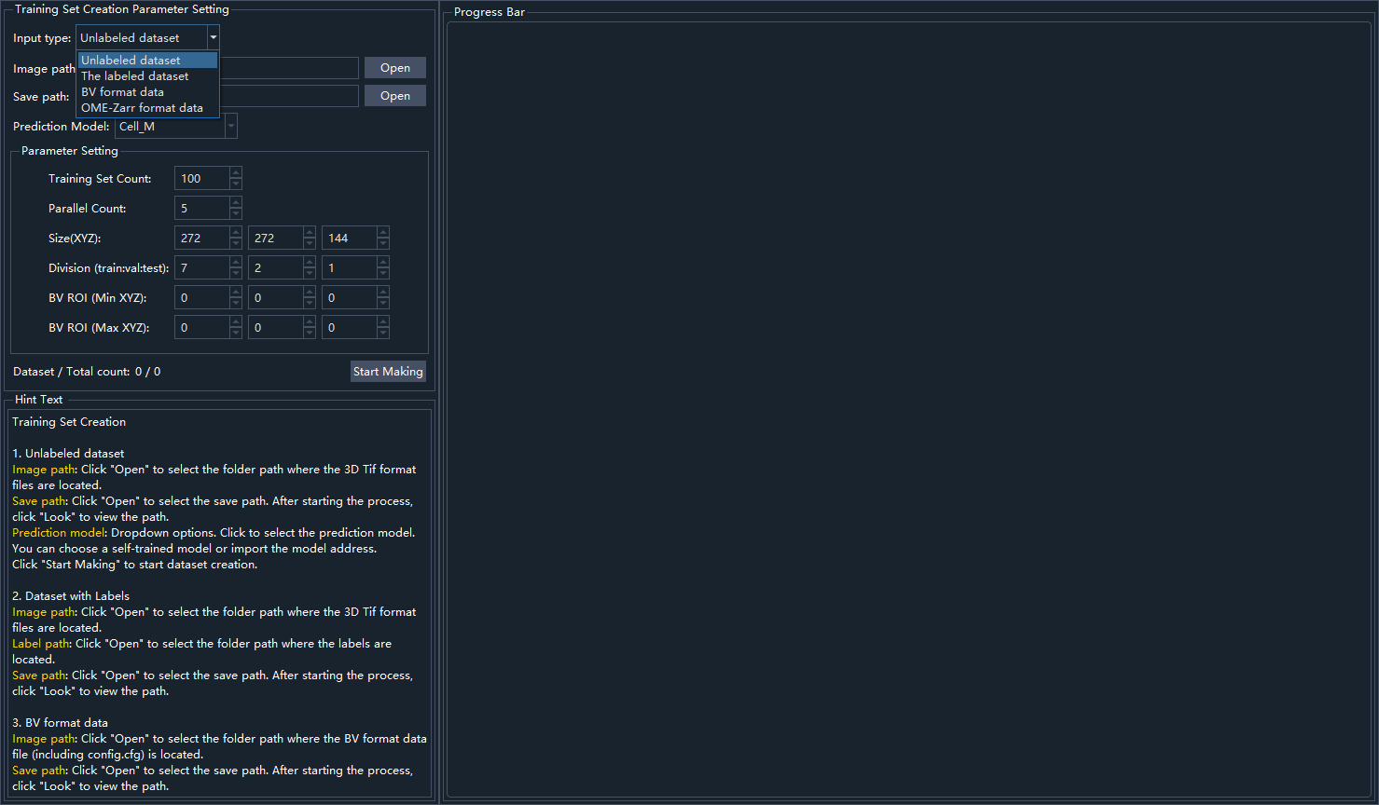

4.3 Precautions
- Image and label files must have matching filenames (e.g., sample1.tif corresponds to sample1.swc).
- Do not turn off power or force exit during the process, as this may corrupt intermediate files.
- If labels are manually modified and selectively filtered later in “Annotation”, the original config.json will no longer be suitable for training. You must regenerate a new configuration file via “The labeled dataset” (using the modified SWC point cloud folder as the label path).

5. Module 2: Model Training
Applicable Objects: Cell ✅ Neural ✅ Vessel ✅

5.1 Operation Steps
- In the Data Type Selection Toolbar at the top of the main interface, select Cell / Neural / Vessel.
- Click Training in the Data Processing Selection Toolbar.
- Set parameters:
  - Configuration file: Click Open to select the config.json generated in the previous step.
  - Save path: Select the folder to store training results. The system will automatically create a TrainResults folder.
    - Note: If a model file with the same name already exists at this path (e.g., cell_train.pth, neural_train.pth, vessel_train.pth), the system will prompt whether to overwrite.
  - Training Epochs: Default is 500.
    - Early Stopping: If validation accuracy does not improve for 100 consecutive epochs, training will automatically stop. Therefore, setting a large number of epochs will not lead to infinite training.
- Click Start Training.
  - Resume Training: If there is an interrupted training session (checkpoint.pth exists), the system will ask whether to resume training from the checkpoint.
- Monitor Training:
  - The interface will display the current epoch, loss values, and validation accuracy.
  - Every 10 validation epochs, a preview of the model’s current prediction results will be shown.
  - Click the “Training Visualization” button to view real-time charts including loss curves, evaluation curves, learning rate changes, etc.
- Click End Training to manually terminate; the system will automatically save the current checkpoint.
Figure 5-1 Training Module Panel
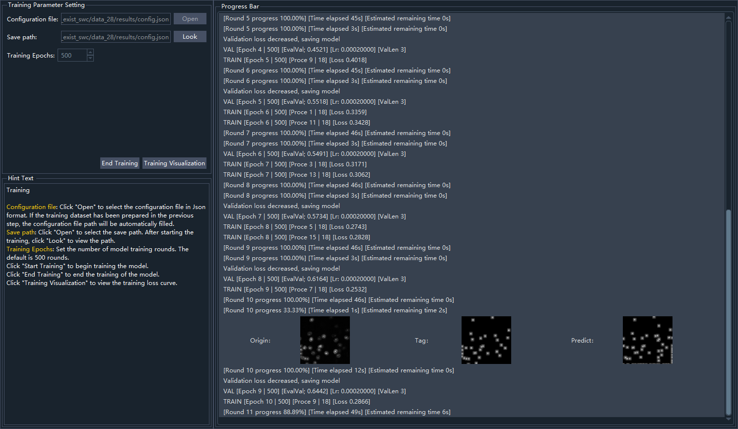

6. Module 3: Image Prediction
Applicable Objects: Cell ✅ Neural ✅ Vessel ✅

6.1 Operation Steps
- In the Data Type Selection Toolbar at the top of the main interface, select Cell / Neural / Vessel.
- Click Prediction in the Data Processing Selection Toolbar.
- Set parameters:
  - Configuration file: Select the config.json of the trained model or the model path.
  - Image path: Select the folder containing the 3D TIF, BV, or OME-Zarr format images to be predicted.
  - Save path: Select the folder to store prediction results. The system will create PredictResults (SWC point cloud results) and CutWorkFiles (intermediate blocks) folders.
  - BV ROI Region: If the image path is a BV format image folder, check this to select a region of interest for prediction.
  - Level (Downsampling level) (BV/OME-Zarr format only): Lower levels mean higher resolution (0 is original resolution). Range 0~5.
- Click Start Prediction. In the pop-up dialog, select:
  - Continue prediction: Only predict images that are not yet completed (useful after interruption).
  - Restart prediction: Ignore existing results and re-predict everything.
- After prediction is complete, the system will display a prompt and randomly show prediction previews for two blocks.
- Click Result Splicing. Enter the prediction-generated configuration file (large 3D TIF images: [filename].json; BV or OME-Zarr format images: [cut_infos.json]) and the save path to splice the prediction results (SWC point cloud) of large 3D TIF images and BV or OME-Zarr format images. Click “Start Splice”, and the system will automatically perform the splicing.
Prediction Results Preview after Completion as Shown in Figure 6-1
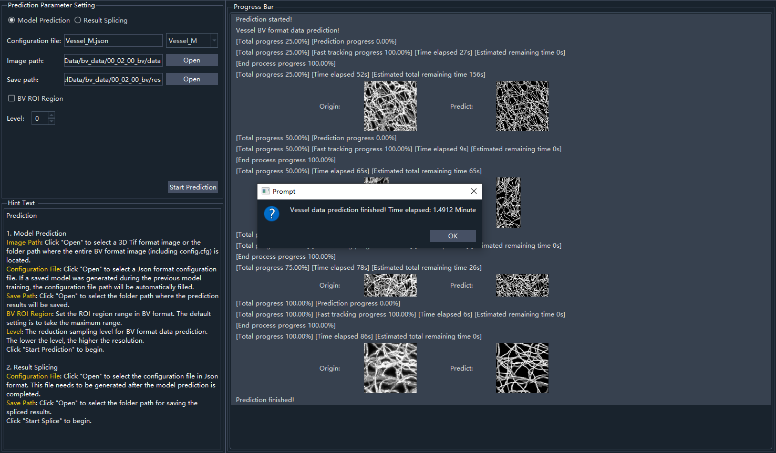

6.2 Batch Prediction and Precautions
- For large 3D TIF, BV, or OME-Zarr data prediction, the generated CutWorkFiles folder stores intermediate slicing results. Please do not modify it manually.
- If CUDA out of memory is reported during prediction: Reduce the “Training set size” in the Creation module, or switch to a GPU with more VRAM.

7. Module 4: Result Revision (Manual Annotation)
Applicable Objects: Cell ✅ Neural ✅ Vessel ✅
Important: This module has two operation modes——Browse Mode (default) and Revision Mode. Different data types have different shortcut keys. Please refer to the “Shortcut Cheat Sheet” below.
Annotation Method Difference Tips:
Cell: Only need to click to add a single point at the cell center; no line connection needed. Delete and move operations target individual points.
Neural / Vessel: Need to continuously add points along the centerline of the structure. The system automatically establishes connections (parent-child relationships) based on point order. Supports complex operations such as branching, connection, and branch deletion.
Data Type | Annotation Target | Minimum Operation Unit | Main Operation Method
Cell | Center point | Single point | Left-click to add / Right-click to delete
Neural / Vessel | Center skeleton line | Point + connection | Left-click two points for interpolation / Right-click for single point / Alt+Click to connect branches

7.1 Quick Start
- In the Data Type Selection Toolbar at the top of the main interface, select Cell / Neural / Vessel.
- Click Annotation in the Data Processing Selection Toolbar.
- Use the left list or shortcuts to switch images. Use the filter function (green icon, middle-click to mark / right-click to cancel / space to toggle) to select images that need focused revision.
- View the automatic annotation results in the visualization area.
- Press V to enter Revision Mode for fine-grained addition/deletion/movement of individual points.
- Press S (Neural/Vessel) or press V again (Cell) to exit Revision Mode.
- Use the save shortcut to export the final SWC point cloud labels.
Revision Mode Interface Layout as Shown in Figure 7-1
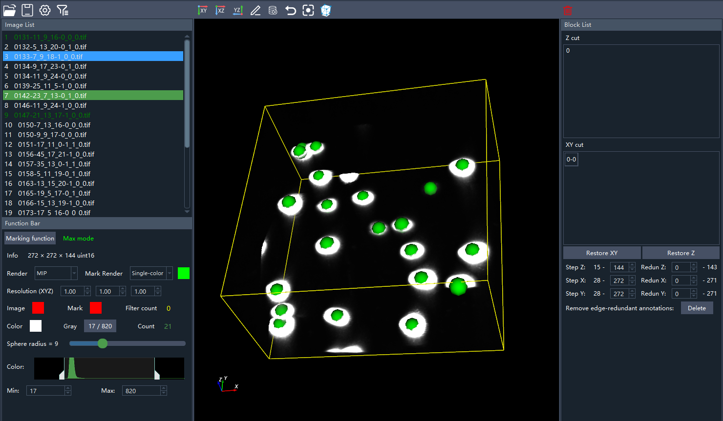

7.2 Shortcut Cheat Sheet
Be sure to use the corresponding shortcuts based on your currently selected data type. The current data type is displayed in the main interface top toolbar.
Function | Cell Module | Neural/Vessel Module | Description
Save File | Ctrl+S | Shift+S | In Neural/Vessel module, Ctrl+S has another purpose (see “Revision Mode” below).
Open File | Ctrl+Shift+Q | Ctrl+Shift+Q | Import TIF images and SWC labels.
Clear All Annotations | C | C | Irreversible; confirmation dialog will appear.
Filter Current Image | Middle-click/Space | Middle-click/Space | Green icon function: middle-click to mark / right-click to cancel / space to toggle.
Previous/Next Image | A / D | Ctrl+W / Ctrl+X
Show/Hide Image | Ctrl+Q | Q
Show/Hide Markers | Q | A
Undo | Ctrl+Z | Ctrl+Z | In Revision Mode, can undo single point operations.
Enter Revision Mode | V (toggle) | V | After entering, marker operations become “pending” status (Neural/Vessel only).
Exit Revision Mode | V (toggle) | S | In Neural/Vessel, pressing S will first confirm all pending markers, then exit.

7.3 Operations in Browse Mode
In Browse Mode, you can view annotation results but cannot modify individual points. Below are branch editing operations specific to Neural/Vessel modules:
Operation | Shortcut (Neural/Vessel) | Description
Connect Two Branches | Alt + Left-click on two endpoints | Connect two disconnected vessel/neuron segments.
Alternative Connection Method | Alt + Right-click on two endpoints | Same as above, but retains endpoint properties after connection.
Delete Branch Point (Disconnect) | Alt + Left-click on branch point | Delete the point, disconnecting the segments on both sides.
Disconnect but Keep Point | Alt + Right-click on branch point | Keep the point as an isolated point, but break the connection relationship.
Delete Selected Branch (Red) | D | Delete the entire currently selected branch.
Delete Small Branches (Shorter than Threshold) | Alt+D | Delete branches shorter than the set threshold (threshold adjustable in settings, default 10 marker points).
Branch Connection and Disconnection Operation Examples:
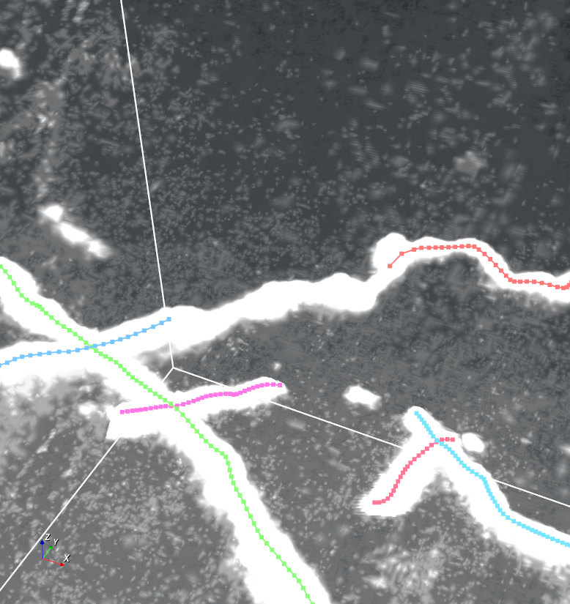 | 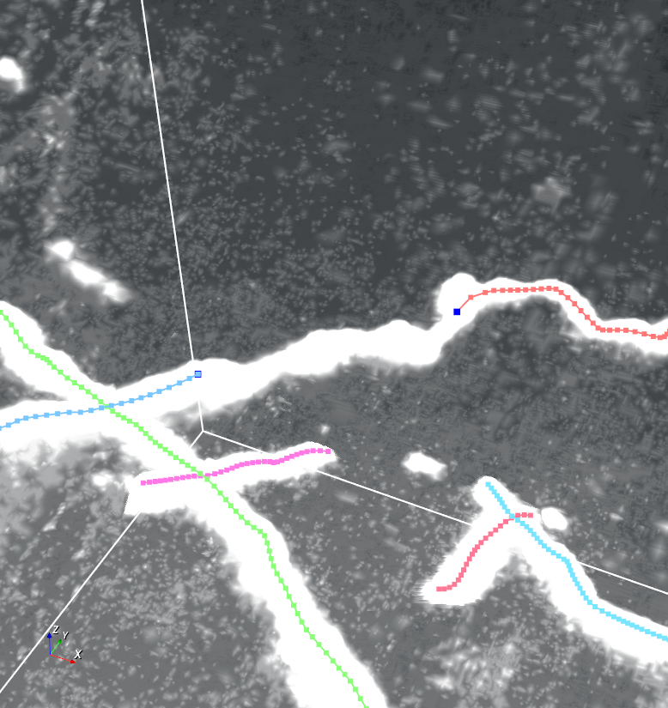 | 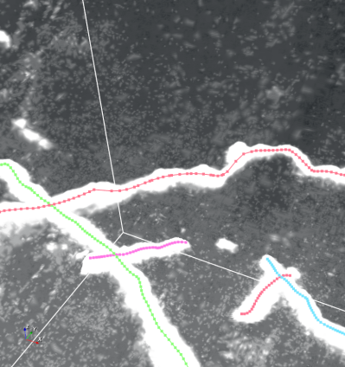
Hold Alt+Left mouse button click, click the two branch endpoints that need to be connected
 |  | 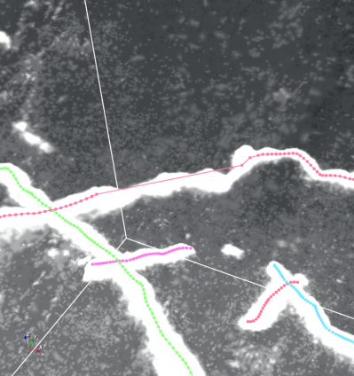
Hold Alt+Right mouse button click, click the two branch endpoints that need to be connected
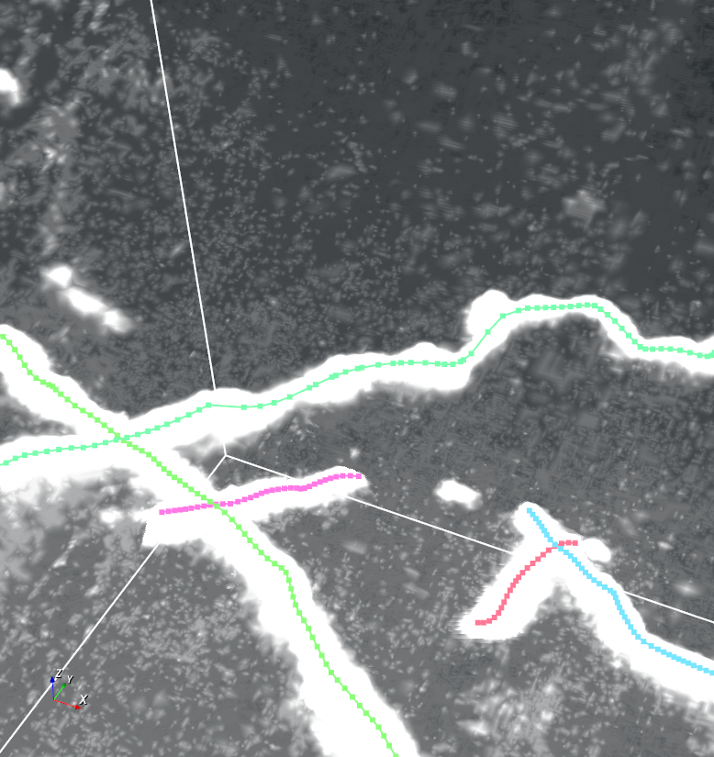 | 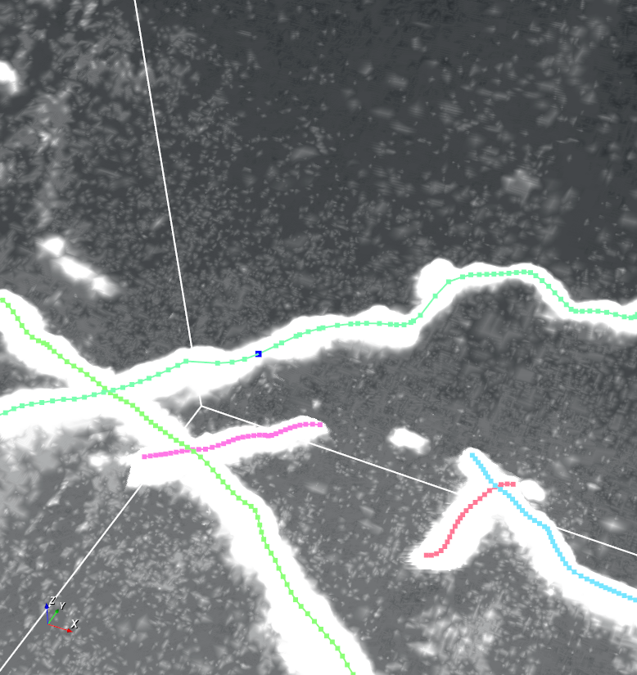 | 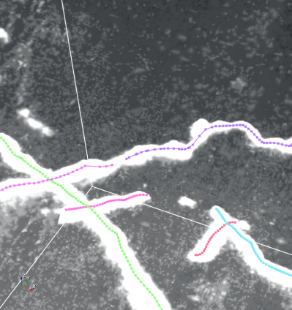
Hold Alt+Left mouse button click, click a branch point that needs to be disconnected, will delete the clicked branch point
 |  | 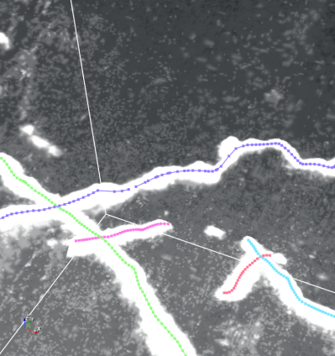
Hold Alt+Right mouse button click, click a branch point that needs to be disconnected, will keep the clicked branch point
Cell Module Operations in Browse Mode:
- Delete marker: Right-click
- Select marker: Left-click
- Focus on marker: F (focus on selected marker point)
Cross Mode Operation (Vessel Only) Workflow (Diameter adjustment popup can be opened to set resolution ratio, line segment length, truncation position, etc.):
- Press M until the mode icon changes to “Intersection mode”.
- Left-click on the image to generate the first line segment. After the segment is generated, drag endpoints to adjust length and position.
- Generate the second line segment (should intersect the first one), similarly adjustable in position and length.
- Click the “ok” button. After confirmation, the system will automatically generate a vessel intersection marker at the intersection of the two line segments.
Cross Mode Operation (Visualization):
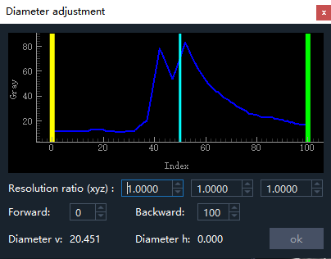 | 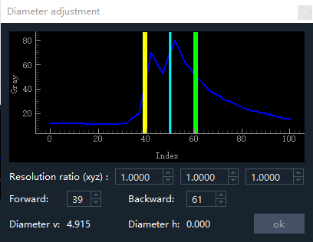
Diameter Adjustment Popup | Diameter Adjustment
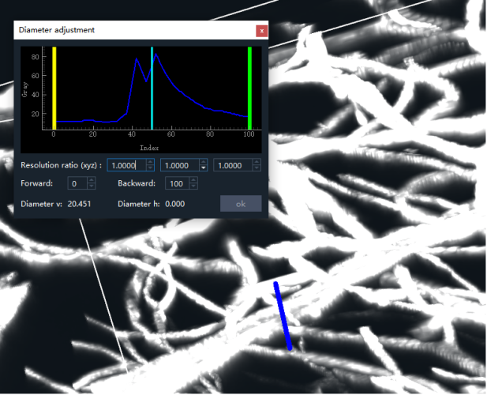 | 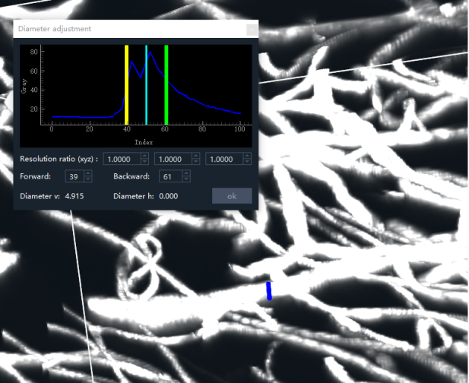
Generate First Line Segment | Adjust First Line Segment
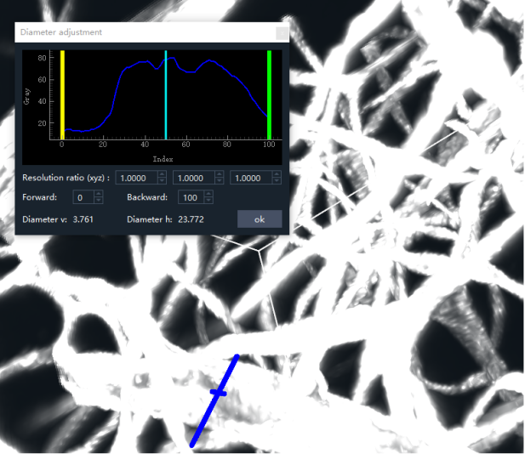 | 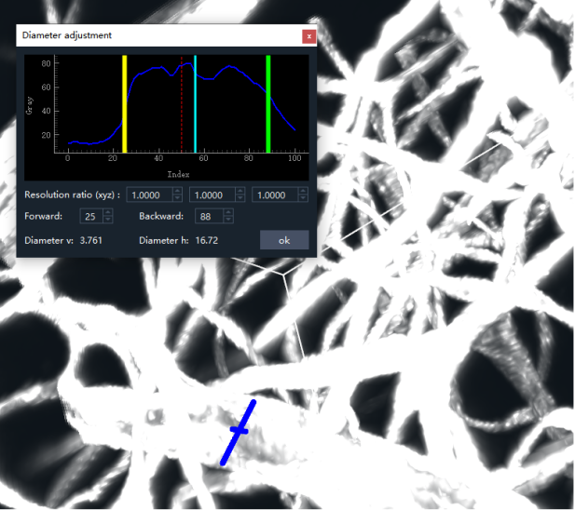
Generate Second Line Segment | Adjust Second Line Segment
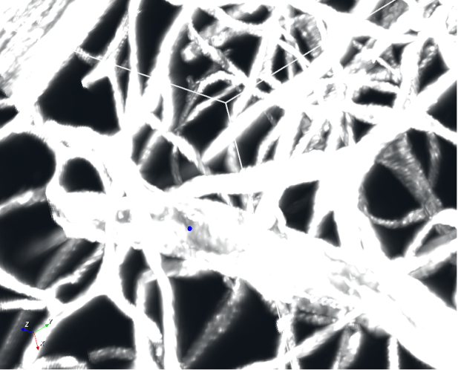 | 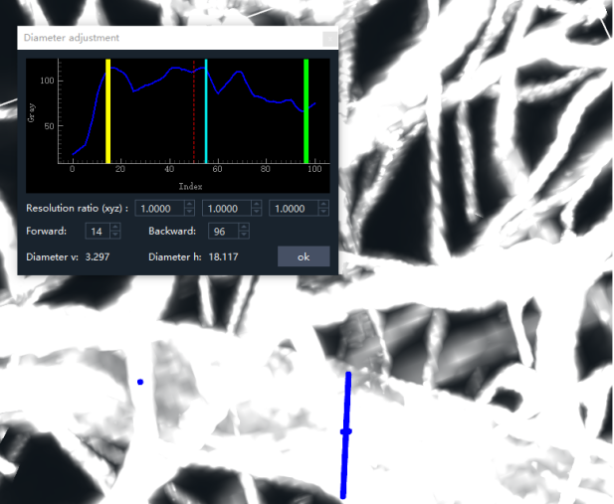
Click Ok | Same operation, generate second annotation
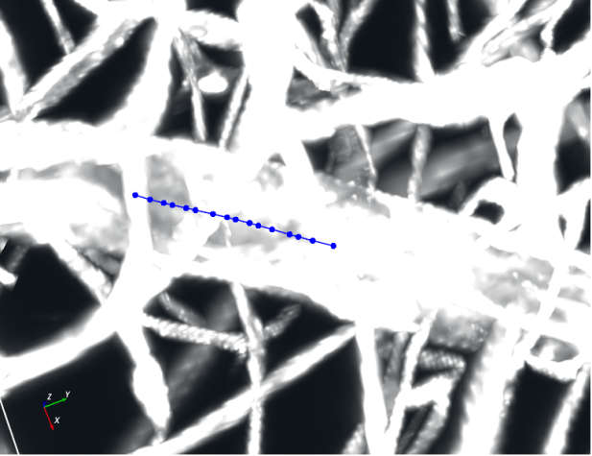 | 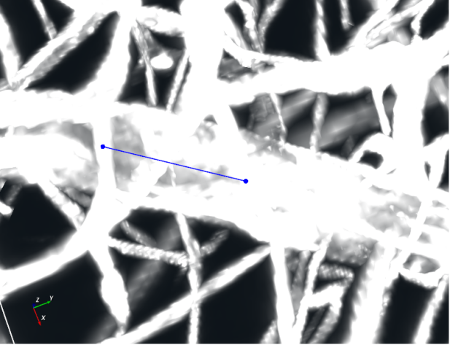
Left mouse button click, generate second annotation point | Right mouse button click, generate second annotation point

7.4 Revision Mode Explained
Revision Mode is used for point-by-point fine editing. After entering, all points added via mouse clicks are pending markers (displayed in blue) and must be explicitly confirmed before becoming permanent markers.

7.4.1 Revision Mode State Machine
Browse Mode —(Press V)— Revision Mode (pending list empty)
Revision Mode (pending list empty) —(Left/Right-click to add point)— Revision Mode (has pending markers)
Revision Mode (has pending markers) —(Ctrl+S)— Revision Mode (pending list empty) [Confirm all pending, but do not exit]
Revision Mode (has pending markers) —(S)— Browse Mode [Confirm all pending and exit]
Revision Mode (has pending markers) —(Z)— Revision Mode (pending list empty) [Discard all pending, do not exit]
Revision Mode (any state) —(Ctrl+Z)— Undo previous point operation (can be undone multiple times)

7.4.2 Point Addition Operations in Revision Mode
Operation | Mouse Button | Description
Interpolation Add (Neural/Vessel) | Left-click on two points | Automatically generates all intermediate points between the two points, forming a continuous line segment.
Non-interpolation Add (Neural/Vessel) | Right-click | Only adds a single point at the clicked position.
Direct Marker (Cell) | Left-click | Cell module has no pending markers; click takes effect immediately.
Generating Markers (Neural/Vessel) Operations:
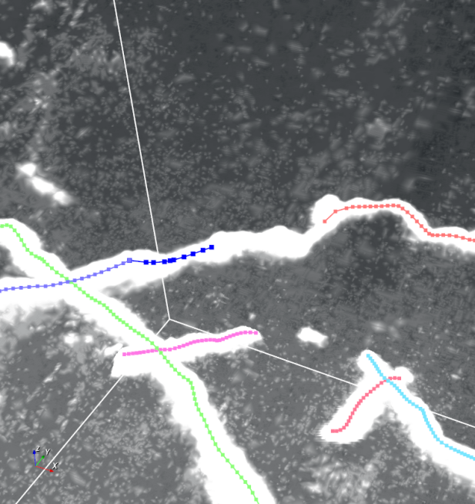 | 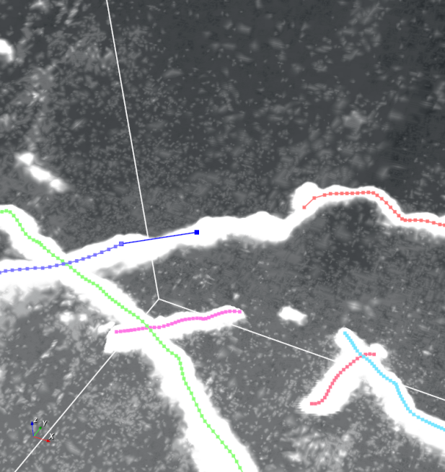
Left Mouse Button Click | Right Mouse Button Click
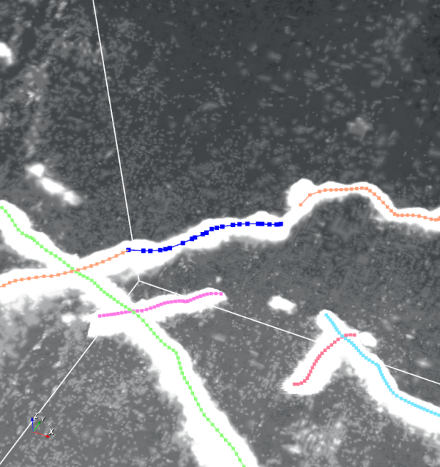 | 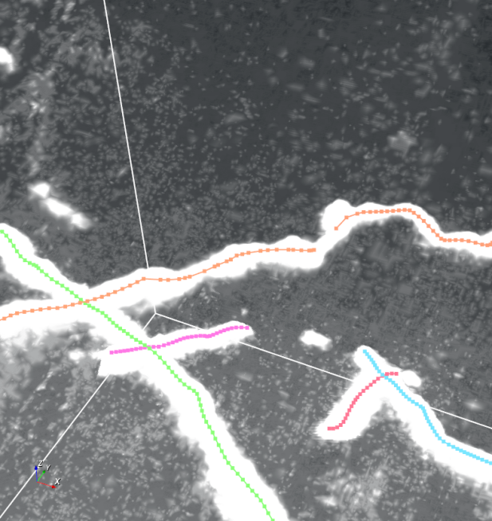
In revision mode, click to confirm pending annotations
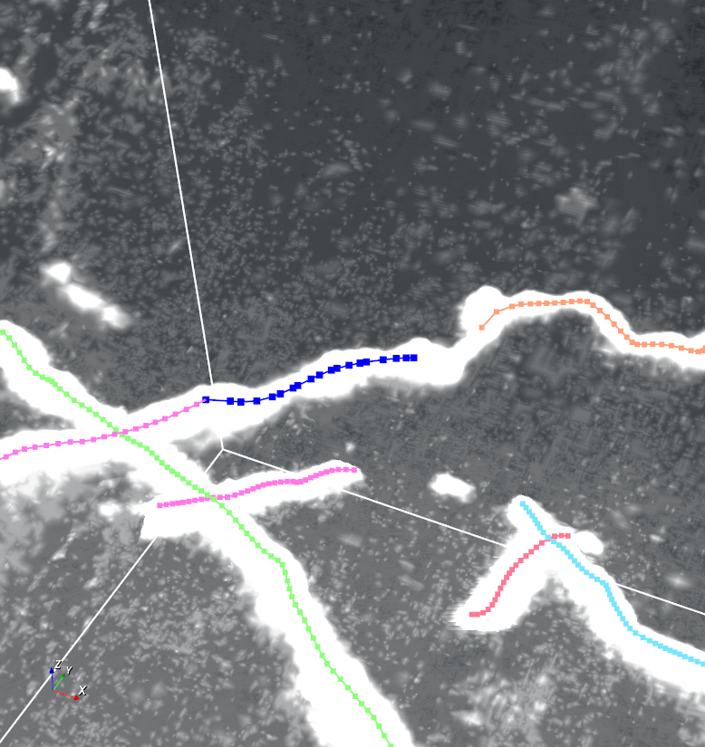 | 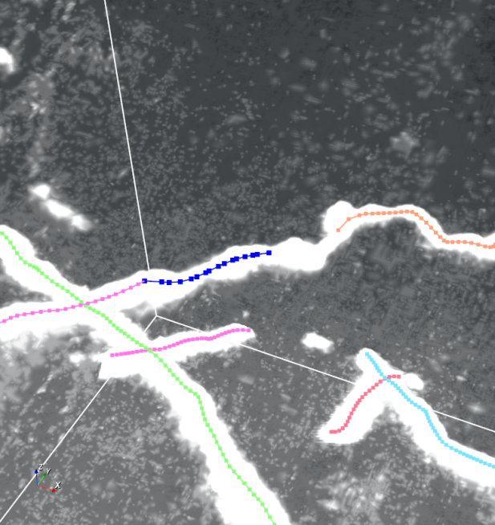
In revision mode, undo pending annotations
 | 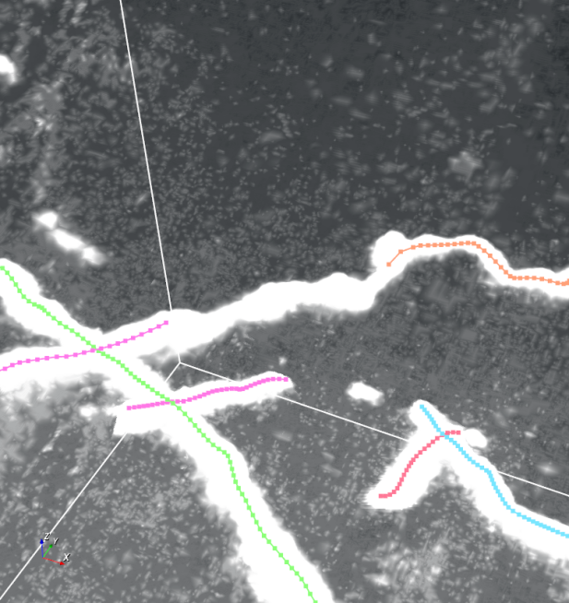
In revision mode, undo all pending annotations

7.5 Revision Suggestions
- Prefer using the “Connect Branch” function in Browse Mode to fix breakages (Alt+click) rather than adding points one by one.
- Press the save shortcut regularly (Cell: Ctrl+S, Neural/Vessel: Shift+S) to prevent accidental loss.
- Use the filter function to mark “difficult cases” and focus revision efforts.
- Use small block cropping for locally complex areas (Neural/Vessel press R to crop around selected point; press Q to restore full view).
- After annotation, check consistency using different view planes (XY/XZ/YZ).

8. Module 5: Statistical Analysis (Vessel Only)

8.1 Operation Steps
- In the Data Type Selection Toolbar at the top of the main interface, select Vessel.
- Click Statistics in the Data Processing Selection Toolbar.
- Set input files:
  - Image path: Select the folder containing the original 3D TIF images.
  - Label path: Select the folder containing the corresponding SWC point cloud label files.
  - Configuration file: Select the corresponding [filename].json or cut_infos.json (auto-filled if prediction has been performed).
- Set output and parameters:
  - Save path: Select the location to save results. The system will create an AnalyzeResults folder containing:
    - Single segment (single branch) statistics: CSV format, one row per branch segment.
    - Network global statistics: XLSX format, one row per image block.
  - Resolution: Enter the physical dimensions of the image in X, Y, Z directions (micrometers/pixel).
    - How to obtain: Check the “Physical Size X/Y/Z” field in image metadata, or ask the microscope operator.
    - Example: [0.5, 0.5, 1.0] means X and Y axes 0.5 µm/pixel, Z axis 1.0 µm/pixel.
  - Unit: Select the physical unit for results (µm, mm), default µm.
  - Branch Connection: When checked, the system will attempt to connect vessel segments that are broken in annotation but actually connected (based on angle and distance thresholds).
- Click Start.
- View Results:
  - Single image statistics: Click on an image in the left “File Bar” list; the right “Chart” will display its statistical data charts. Use the dropdown to switch chart types (Volume distribution histogram, Length vs Volume scatter plot, Tortuosity distribution histogram, Radius parameter box plot, Surface Area vs Volume scatter plot, Radius standard deviation distribution histogram). Support exporting the current statistical chart as PNG/PDF.
  - Global statistics: After completing statistics for all images, the system automatically enters the global statistics view. In the global view, you can select different variables (Volume, Length, Tortuosity, etc.), display by group, and switch between chart types like histogram/box plot.
Image Statistics Chart Example as Shown in Figure 8-1
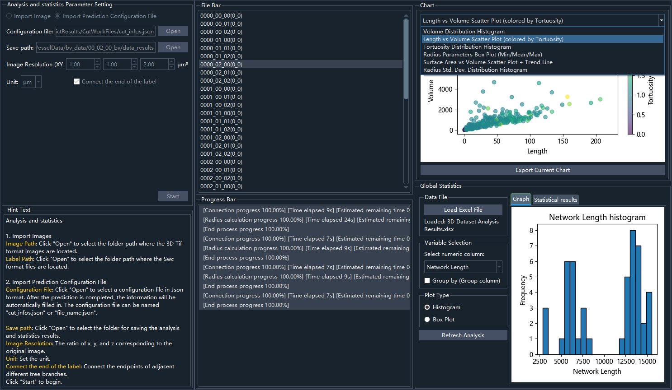

8.2 Output Metrics Description
Metric | Description
Total Length | Sum of spatial lengths of all vessel lines
Average Radius | Average radius of vessel segments
Branch Points | Number of bifurcation points in the vessel tree
Tortuosity | Actual length / straight-line end-to-end distance; closer to 1 means straighter
Surface Area | Total surface area of vessels (calculated based on radius)
Volume | Total volume occupied by vessels

9. Glossary
Term | Definition
SWC Point Cloud File | Standardized format for neuronal morphology representation, containing spatial coordinates, radius, and connection relationships for each point.
Patch/Block | Small data blocks cut from large 3D images to meet model input size requirements.
Configuration File (config.json) | Core file recording dataset paths, dimensions, model parameters, and all other settings.
Browse Mode | Default mode. Neural/Vessel: view, connect/disconnect branches, but cannot add individual points. Cell: can delete markers.
Revision Mode | Enter by pressing V. Neural/Vessel: can add individual points; has “pending markers” (Neural/Vessel only). Cell: can add/delete markers.
Pending Marker | Temporary annotation points (blue) not yet finalized in Revision Mode (Neural/Vessel).
Tortuosity | Statistical measure of curvature for vessels or neurons.
BV Format | Proprietary biomedical volume image format with config.cfg metadata.
OME-Zarr | Next-generation bio-image format based on Zarr, supporting multi-resolution pyramids.

10. Troubleshooting and Support

10.1 Common Issues
Issue | Solution
Q: CUDA out of memory during prediction | Reduce “Training set size” in the Creation module; or switch to a GPU with more VRAM. Also try reducing batch size (supported in future versions).
Q: Shortcut keys don’t work in Revision Mode? | Ensure the visualization area is active (click on the image area). Check if the current module’s shortcuts are correct (Cell vs Neural/Vessel).
Q: Statistical results are incorrect. | Check if the “Resolution” parameter matches the actual physical dimensions of the image. Check if SWC files are complete (no circular parent node indices).
Q: How to use “Intersection point mode” in Cell module? | Switch to “Intersection point mode” (press M until the mode icon changes to intersection), then generate two intersecting line segments sequentially; the intersection marker will be generated automatically.
Q: Disk space management recommendations | Regularly clean up error logs and training logs as needed (training logs occupy slightly more space).

10.2 Logs and Support
- Error Log Location:
  - Windows: software directory
- Training Log Location:
  - Windows: software directory
- User Support: If you encounter unsolvable issues, please send error logs and problem description to support@BVLab.com.
- Technical Forum: Visit https://forum.BVLab.com for community support.
- FAQ Knowledge Base: https://BVLab.com/faq

11. Appendices

Appendix A: SWC Format Specification
SWC files are plain text; each line represents a point in the following format:
index type X Y Z radius parent_index
Field Types and Value Ranges:
- Index: Positive integer, starting from 1, sequentially increasing.
- Type: Integer, 0=undefined, 1=soma, 2=axon, 3=dendrite, 4=branch point.
- X, Y, Z Coordinates: Floating-point numbers, units in voxels. Coordinate origin is the upper-left corner of the image, X-axis points right, Y-axis points down, Z-axis from top to bottom.
- Radius: Floating-point number, units in voxels.
- Parent Index: Integer, pointing to the parent node index of this node. -1 indicates root node (no parent). Parent index must be less than the current index (ensuring no cycles).
Example:
1 1 10.5 20.0 5.0 2.5 -1
2 3 12.0 21.0 6.0 2.0 1
3 3 14.0 22.0 7.0 2.0 2

Appendix B: Recommended Publications
For academic papers using this software, we recommend citing:
> BVLab-Analyzer: A Deep Learning Toolkit for 3D Biomedical Image Analysis. Journal of Neuroscience Methods, 2026.

Appendix C: Quick Start Example (Step-by-Step with Images)
Goal: To help new users complete a minimal end-to-end workflow within 5 minutes: use a pre-trained model to predict on a small set of images and manually correct a small portion (demonstration only).
Applicable Scenario: Verify correct software installation and understand basic operational logic.
Required Data (included in the software installation package as example data (software directory/neuron_example_tif/images)):
- Images: sample_neuron_0001.tif, sample_neuron_0002.tif,…

C.1 Step Overview
- Start the software → Select data type (Neural)
- Enter Prediction module → Run pre-trained model
- View prediction results
- Enter Revision module → Correct
- Save results

C.2 Detailed Operations (Image and Text Corresponding)

Step 1: Start and Select Data Type
Double-click the BVLab-Analyzer icon on the desktop. In the Data Type Selection Toolbar on the left side of the main interface, click Neural.
Select Data Type as “Neural”
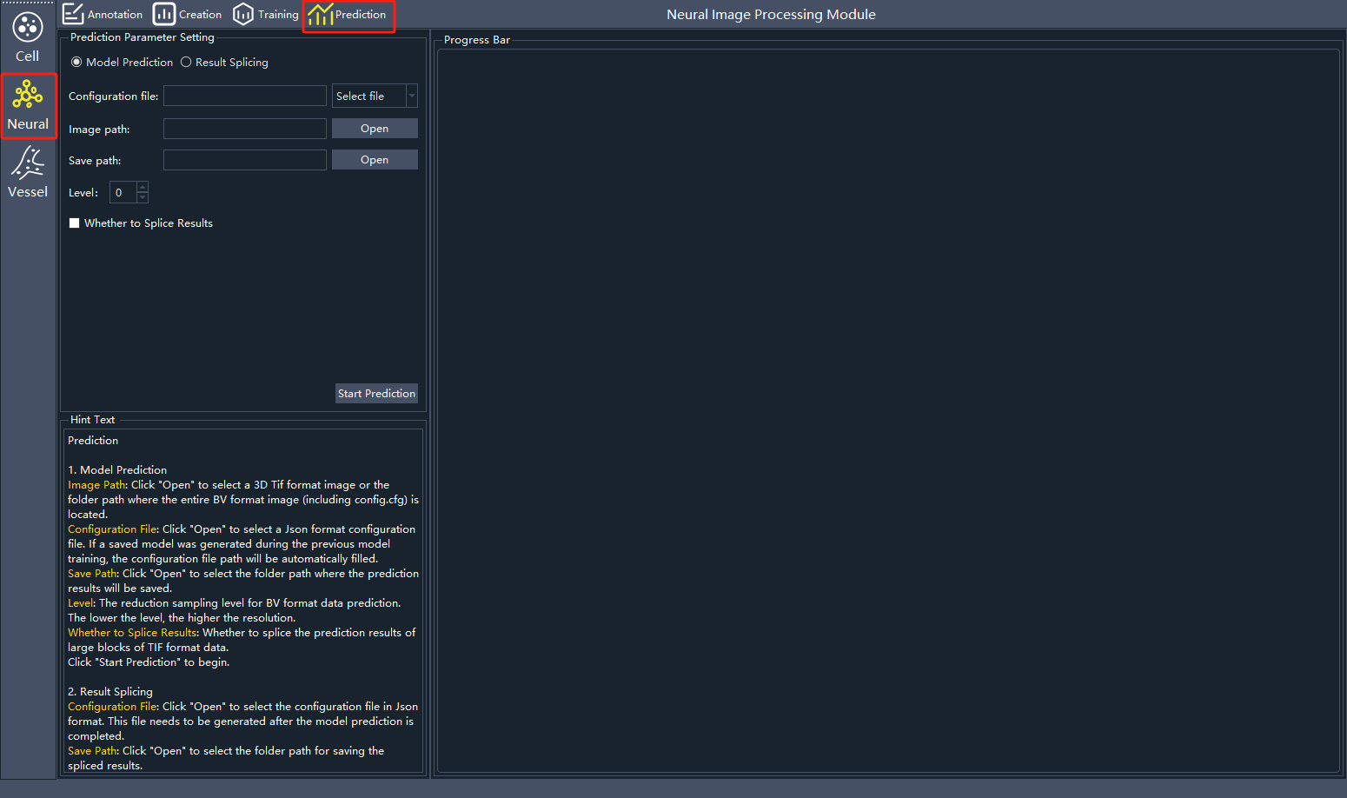

Step 2: Image Prediction (Using Pre-trained Model)
- In the top Data Processing Selection Toolbar, click Prediction.
- Set parameters:
  - Configuration file: Click Open, select Nerve_M (pre-trained model)
  - Image path: Select the example folder (containing sample_neuron_0001.tif)
  - Save path: Create a new folder, e.g., predict_res
- Click Start Prediction → Select Restart prediction.
- Wait for the prompt “Prediction finished” and see previews of two blocks.
Prediction Complete Preview
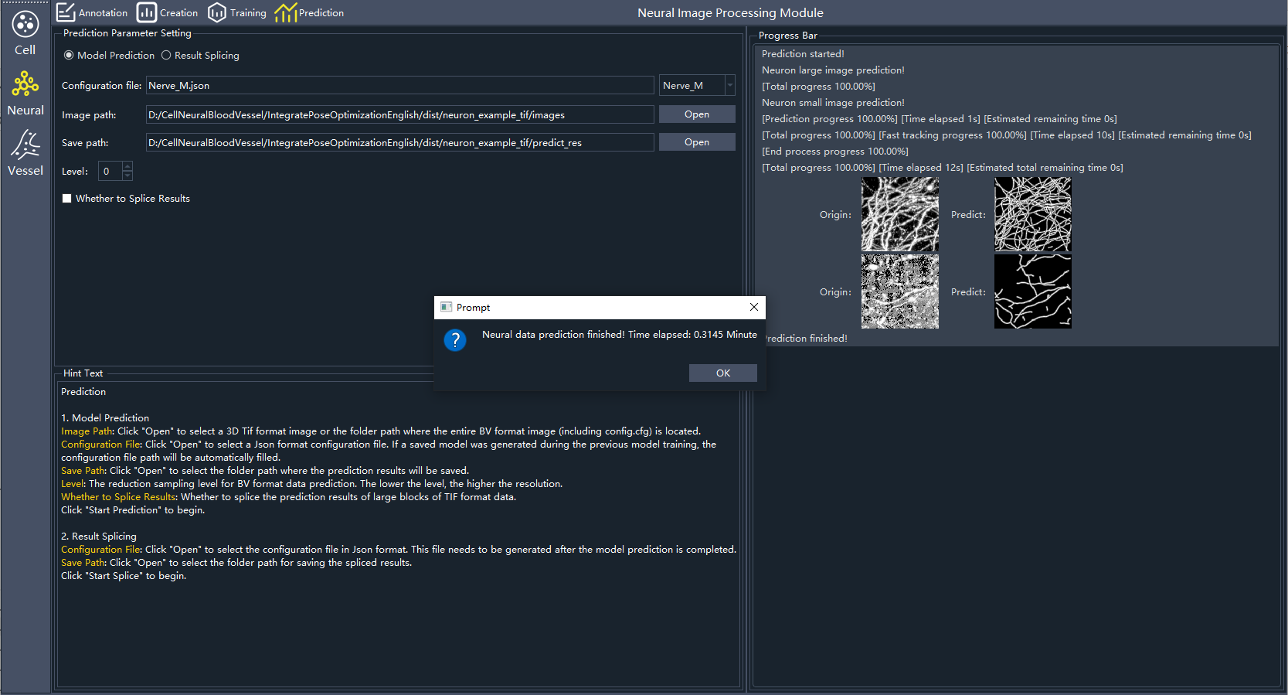

Step 3: View Prediction Results
- Open the PredictResults folder under the save path; you can see sample_neuron_0001.swc.
- This SWC point cloud is the AI-automatically annotated neuronal morphology.

Step 4: Enter Revision Mode and Correct
- Click “Annotation” at the top.
- Click Open File, in the popup select Import Image, click Open to select the example image folder path and the prediction result SWC point cloud folder path respectively.
- Follow [Chapter 7 steps] for revision.
Markers (blue) in Revision Mode
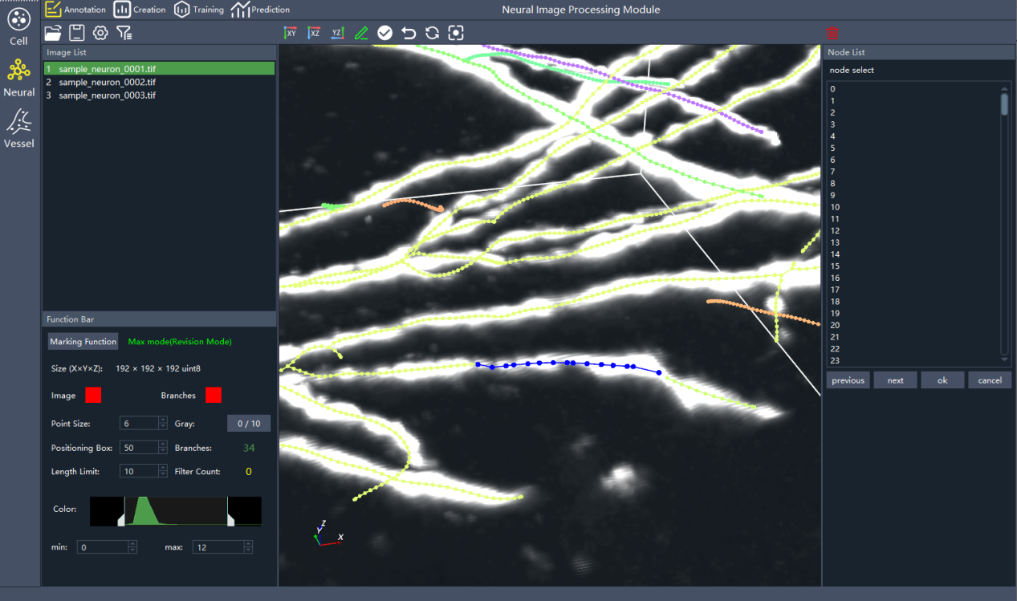

Step 5: Save Final Results
- Press Shift+S (Neural/Vessel module) to save the corrected SWC point cloud file.
- The system will overwrite the original file.

C.3 Verification of Success
- Reopen the Revision module, load the newly saved SWC; you should see the modifications have taken effect.
- If the entire workflow runs without errors and you can complete the above operations, the software is functioning normally.

Appendix D: Module Input/Output Quick Reference
Purpose: For engineers or advanced users to quickly understand the required inputs and key outputs of each module, facilitating integration, script invocation, and fault localization.

D.1 Quick Reference
Module Name | Input (Mandatory) | Input (Optional) | Main Output | Output Location Example (relative to save path) | Key Intermediate Files (Do not modify manually)
Dataset Creation | Image folder; save folder; label folder (SWC point clouds, if “The labeled dataset” mode) | None | config.json, data block files (DivideResults) | MakeResults/DivideResults/; config.json | MakeResults
Model Training | config.json (generated by Dataset Creation); save path | None | Model weight file (cell_train.pth / neural_train.pth / vessel_train.pth); training curve plots; checkpoint.pth (resume training) | TrainResults/ | TrainResults/
Image Prediction | Configuration file (config.json or model .pth); image folder to predict; save folder | None | SWC point cloud result files (one .swc per image); cut_infos.json (for large 3D TIF/BV/Zarr); PredictResults/ folder | PredictResults/ | CutWorkFiles/ (intermediate blocks)
Result Splicing | cut_infos.json (from Prediction module); save folder | None | Complete SWC point cloud file (single merged .swc) | SpliceResults/ | SpliceResults/
Result Revision | Image file; SWC point cloud file (from prediction or manual); config.json path (if making results revision); Filename.json path (if large 3D TIF/BV/Zarr, select the config file under CutWorkFiles folder) | None | Corrected SWC point cloud file (overwritten) | Original SWC point cloud folder | None
Statistical Analysis (Vessel only) | Image folder (TIF); label (SWC) folder; save folder; configuration file corresponding to the SWC point cloud folder (folder name.json/cut_infos.json) | Whether to connect branches | Single segment statistics (CSV); network global statistics (XLSX) | AnalyzeResults/ | AnalyzeResults/

D.2 Input/Output Examples (Real Filenames)
Scenario | Input Example | Output Example
“The labeled dataset” Creation | images/exp1.tif;labels/exp1.swc | config.json; MakeResults/
Training | config.json | TrainResults/neural_train.pth;TrainResults/CheckPoints/
Prediction (single 3D TIF block) | config.json;images/exp2.tif | PredictResults/Swc/exp2.swc
Splicing | CutWorkFiles/cut_infos.json | SpliceResults/splice.swc
Statistical Analysis | images/exp1.tif;labels/exp1.swc; config.json | AnalyzeResults/Segment_Results/exp1.csv;AnalyzeResults/3D Dataset Analysis Results.xlsx

D.3 Important Notes
- Filename matching rule: In “‘The labeled dataset’ Creation” and “Statistical Analysis”, the image filename (without extension) must exactly match the SWC point cloud filename.
- Prerequisite for Splicing: Before using “Result Splicing”, ensure the corresponding cut_infos.json was generated during prediction (for large 3D TIF or BV/Zarr format).
- Model file naming: The model file output from training is fixed as {data_type}_train.pth, where data_type is cell / neural / vessel.
- Resume from interruption: After training interruption, clicking “Start Training” again will automatically prompt whether to resume from checkpoint.pth.

