[解题报告] LeetCode 680. Valid Palindrome II

BY ZXI ON SEPTEMBER 17, 2017

**Problem:**

Given a non-empty string s, you may delete **at most** one character. Judge whether you can make it a palindrome.

**Example 1:**

|  |  |
| --- | --- |
| 1  2 | Input: "aba"  Output: True |

**Example 2:**

|  |  |
| --- | --- |
| 1  2  3 | Input: "abca"  Output: True  Explanation: You could delete the character 'c'. |

**Note:**

1. The string will only contain lowercase characters a-z. The maximum length of the string is 50000.

**Idea:**

Greedy, delete the first unmatched char

[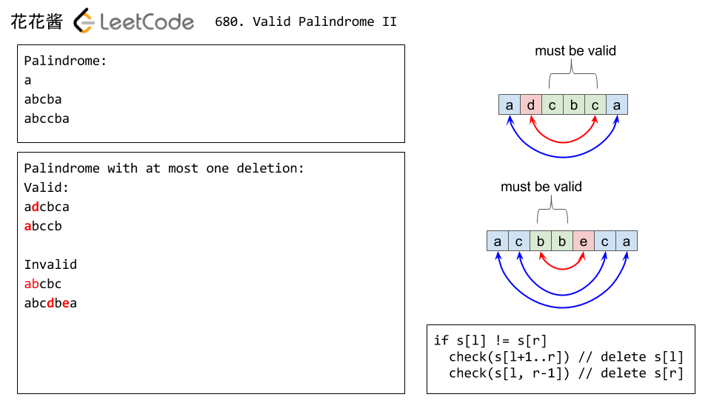](http://zxi.mytechroad.com/blog/wp-content/uploads/2017/09/680-ep60.png)

**Time complexity**

O(n)

**Solution:**

|  |  |
| --- | --- |
| 1  2  3  4  5  6  7  8  9  10  11  12  13  14  15  16  17  18  19  20 | // Author: Zhonghua Xi (huahua)  // Running time: 118 ms  class Solution {  public:      bool validPalindrome(const string& s) {          int l = -1;          int r = s.length();          while (++l < --r)              if (s[l] != s[r])                  return isPalindrome(s, l+1, r)                      || isPalindrome(s, l, r-1);          return true;      }  private:      bool isPalindrome(const string& s, int l, int r) {          while (l < r)              if (s[l++] != s[r--]) return false;          return true;      }  }; |