**推荐学习顺序**

学习机器学习得有个步骤, 下面大家就能按照自己所需, 来探索这个网站. 图中请找到 "Start", 然后依次沿着箭头, 看看有没有不了解/没学过的地方, 接着, 就能在底下的链接中找到对应的链接去往合适自己的地方.

[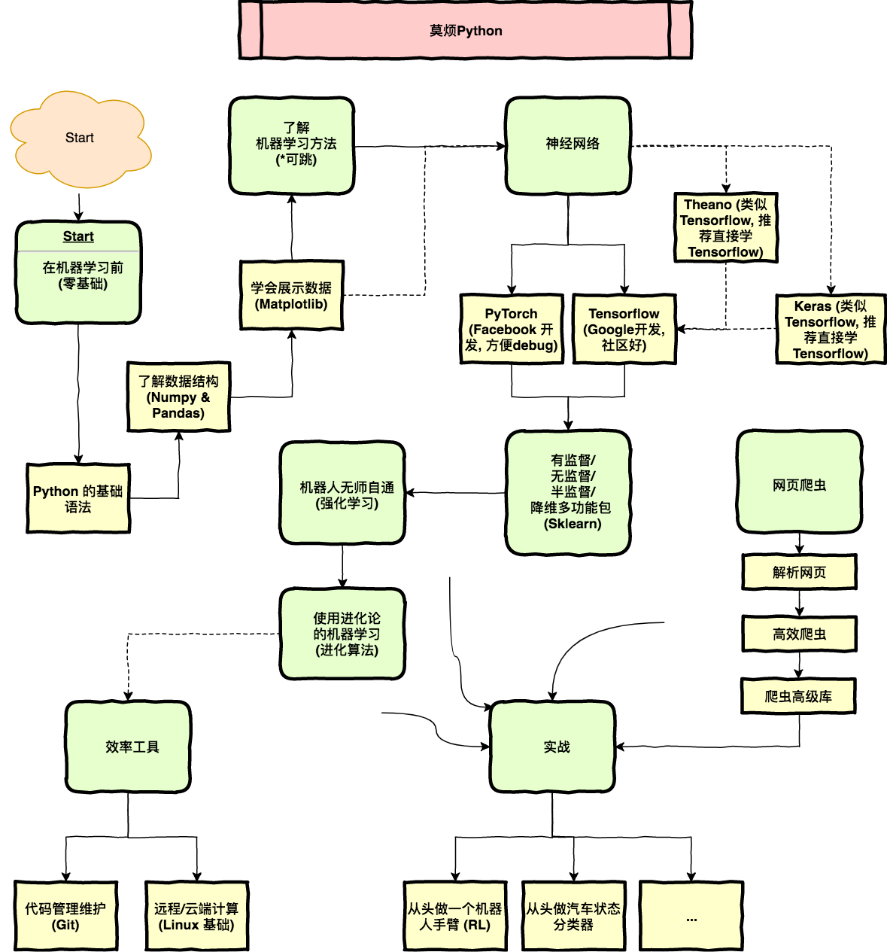](https://morvanzhou.github.io/static/img/description/learning_step_flowchart.png)

1. [在机器学习前 - (零基础)](https://morvanzhou.github.io/tutorials/python-basic/)
   1. [Python基础语法](https://morvanzhou.github.io/tutorials/python-basic/basic/)
   2. [了解数据结构 (Numpy & Pandas)](https://morvanzhou.github.io/tutorials/data-manipulation/np-pd/)
   3. [学会展示数据 (Matplotlib)](https://morvanzhou.github.io/tutorials/data-manipulation/plt/)
2. [了解机器学习方法 (*可跳)](https://morvanzhou.github.io/tutorials/machine-learning/ML-intro/)
3. [神经网络](https://morvanzhou.github.io/learning-steps/)
   1. [Tensorflow (Google开发, 社区大)](https://morvanzhou.github.io/tutorials/machine-learning/tensorflow/)
   2. [PyTorch (Facebook开发, 方便debug)](https://morvanzhou.github.io/tutorials/machine-learning/torch/)
   3. [Keras (类似Tensorflow, 推荐直接学Tensorflow)](https://morvanzhou.github.io/tutorials/machine-learning/keras/)
   4. [Theano (类似Tensorflow, 推荐直接学Tensorflow)](https://morvanzhou.github.io/tutorials/machine-learning/theano/)
4. [有监督/无监督/半监督/降维多功能包 (Sklearn)](https://morvanzhou.github.io/tutorials/machine-learning/sklearn/)
5. [机器人无师自通 (强化学习)](https://morvanzhou.github.io/tutorials/machine-learning/reinforcement-learning/)
6. [使用进化论的机器学习 (进化算法)](https://morvanzhou.github.io/tutorials/machine-learning/evolutionary-algorithm/)
7. [效率工具](https://morvanzhou.github.io/tutorials/others/)
   1. [代码管理维护 (Git)](https://morvanzhou.github.io/tutorials/others/git/)
   2. [远程/云端计算 (Linux基础)](https://morvanzhou.github.io/tutorials/others/linux-basic/)
8. [网页爬虫](https://morvanzhou.github.io/tutorials/data-manipulation/scraping/)
9. [实战](https://morvanzhou.github.io/tutorials/machine-learning/ML-practice/)
   1. [从头做一个机器人手臂](https://morvanzhou.github.io/tutorials/machine-learning/ML-practice/RL-build-arm-from-scratch1/)
   2. [从头做一个汽车状态分类器](https://morvanzhou.github.io/tutorials/machine-learning/ML-practice/build-car-classifier-from-scratch1/)