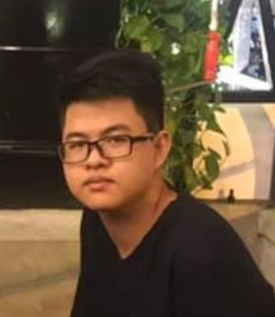

**Full name** Lý Gia Huy

**Date of birth** November 11, 1998

**Phone** 0393172020

**Email** lygiahuy11111998.hcmus@gmail.com

**Address** Ho Chi Minh City, Vietnam

**Linkedln** https://www.linkedin.com/in/huy-ly-82b053170/

|  |  |
| --- | --- |
| **Skills Summary**  Programming Languages  Programming Skills  **Education**  Oct 2016 – Aug 2020  **Experience**  July 2019 – Aug 2020  Sep 2020 – Oct 2020  Nov 2020 – Present | Dart, Swift.  OOP, Algorithm and Data Structure.  Ho Chi Minh city University of Science  Major: Software Engineering  GPA: 7.7/10    **VNG Corporation**  Mobile Developer Fresher (ios).  **Camelo HQ** Mobile Software Engineer  **ELCA Vietnam**  Mobile Software Engineer (flutter, ios) |

Aug 2021 – Present Software Developer Freelancer

**Projects**

**Github (**<https://github.com/huylg>)

**TIXnGO App (flutter app)**

TIXnGO is a ELCA’s product, a secure mobile ticketing application built on top of blockchain technology. Its’ aim is to upgrade security, reduce fraud, and digitalize your tickets purchase processes.

Develop automated test with flutter driver and cucumber.

Develop and design UI widget.  
Re-create admin tool version with flutter for web.

**vTeam App (ios app)**

vTeam App is the messaging app for your organization workspace for real-time collaboration and communication, meetings, file and app sharing, and even the occasional emoji! All in one place, all in the open, all accessible to everyone.

Using sockerIO to send and recive message real time, alamofire to send http request and fetch data from server.

Designed, implemented and optimized smooth function for send and recive message

included text, image, multiple image, video, audio, file,… Technique utilized: socketio, alamofire, MVC, uikit, swift.

**vCloudCam App (ios app)**  vCloudcam is a product of VNG Cloud, providing online monitoring and storage services on cloud computing technology platform, supporting using multi-platform services (Web, Mobile App, Desktop).

Using opencv for image processing include rotate, crop and resize image, convert image from yuv420 to rgb.

Designed and implemented function for change user’s password. Technique utilized: swift, opencv, objective-c, c++.

**vCS App (ios app)**

vCS (123CS) is an application of VNG Cloud, which is a user application of the call center system on mobile phones, supporting call reception and call transfer. Designed and implemented function for rating quality of call

Fixed some logic and UI bugs.

Technique utilized: objective-c, uikit.

**TryMe App (flutter app)**  
TryMe is an application that allows people to create a challenge for themselves or another people.  
Developed chatting feature.

Developed commenting feature.

Developed profile screen.  
Appstore: <https://apps.apple.com/vn/app/tryme-challenge-platform/id1544711559>

**Nexter App (flutter app)**

Nexter is a social network for English Learners

Upgrade the flutter version (from the very old version).

Refactor internal app flow.

Fix bugs (notification and deep link related).

Review code and mentor fresher.

Migrate from messy state management logic from well-known pattern.

Appstore: https://apps.apple.com/vn/app/nexter-speak-and-chat-english/id1591368404