Lab10

Bài 1: https://codepen.io/Huy-Lee-the-scripter/pen/zYLgNZz

<!DOCTYPE html>

<html lang="en">

<head>

<meta charset="UTF-8">

<meta http-equiv="X-UA-Compatible" content="IE=edge">

<meta name="viewport" content="width=device-width, initial-scale=1.0">

<title>Document</title>

<style>

\*{

margin: 0;

padding: 0;

box-sizing: border-box;

font-family: Arial, Helvetica, sans-serif;

}

.container{

max-width: 1200px;

margin: auto;

position: relative;

height: 100vh;

background-color: rgb(0, 128, 255);

}

form{

width: 450px;

top: 50%;

left: 50%;

transform: translate(-50%,-50%);

position: absolute;

padding: 8px;

}

.form-group{

margin: 10px 0;

}

.form-control{

width: 98%;

padding: 5px;

outline: none;

border: 1px solid gray;

border-radius: 3px;

}

.form-group label{

font-weight: bold;

font-variant: small-caps;

}

.form-control:focus{

background-color: gray;

box-shadow: 0 0 3px red;

border: 1px solid gray;

}

.form-buttom{

padding: 8px 30px;

outline: none;

border: none;

border-radius: 20px;

font-weight: bold;

background-color: white;

color: orangered;

box-shadow: inset 0 0 20px blue;

}

.form-buttom:hover{

color: blue;

box-shadow: inset 0 0 20px orangered;

}

.form-buttom:disabled{

color: darkgray;

box-shadow: inset 0 0 20px gray;

}

</style>

</head>

<body>

<div class="container">

<form action="">

<div class="form-group">

<label for="">Họ và tên:</label>

<input tabindex="1" class="form-control" type="text">

</div>

<div class="form-group">

<label for="">Quốc tịch:</label>

<input class="form-control" type="text" value="Việt nam" readonly>

</div>

<div class="form-group">

<label for="">Ghi chú:</label>

<textarea class="form-control" tabindex="2" name="" id="" cols="30" rows="10"></textarea> <br>

</div>

<hr>

<div class="form-group">

<button tabindex="3" class="form-buttom">Thêm</button>

<button tabindex="4" class="form-buttom">Sửa</button>

<button disabled class="form-buttom">Xóa</button>

</div>

</form>

</div>

</body>

</html>

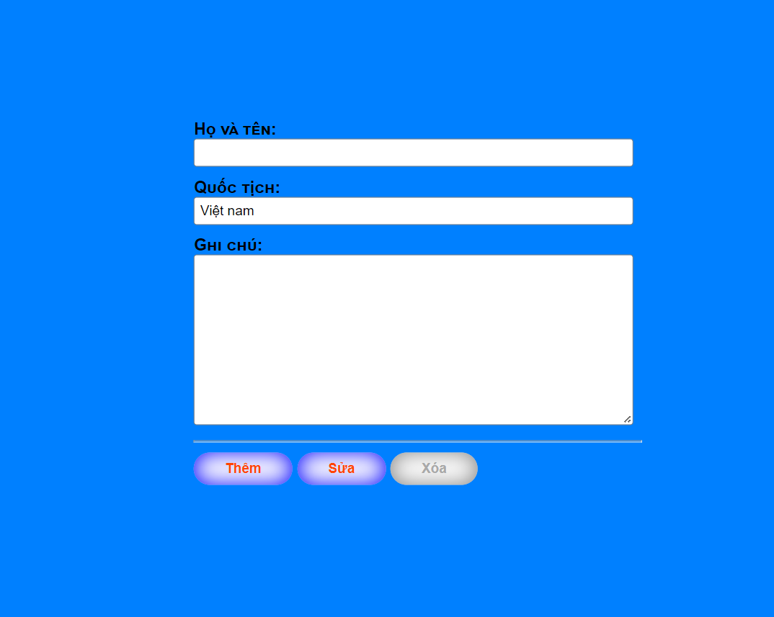

Bài 2: https://codepen.io/Huy-Lee-the-scripter/pen/vYaogmV

<!DOCTYPE html>

<html lang="en">

<head>

<meta charset="UTF-8">

<meta http-equiv="X-UA-Compatible" content="IE=edge">

<meta name="viewport" content="width=device-width, initial-scale=1.0">

<title>Document</title>

<style>

\* {

margin: 0;

padding: 0;

box-sizing: border-box;

font-family: Arial, Helvetica, sans-serif;

}

.container {

max-width: 1200px;

margin: auto;

position: relative;

height: 100vh;

background-color: rgb(0, 123, 255);

}

form {

width: 450px;

top: 50%;

left: 50%;

transform: translate(-50%, -50%);

position: absolute;

padding: 8px;

}

.form-group {

margin: 10px 0;

}

.form-control {

width: 98%;

padding: 2px;

outline: none;

border: 1px solid gray;

border-radius: 3px;

}

.form-group label {

font-weight: bold;

font-variant: small-caps;

}

.form-control:focus {

background-color: yellow;

box-shadow: 0 0 3px red;

border: 1px solid yellow;

}

.form-buttom {

width: 120px;

padding: 8px 30px;

outline: none;

border: none;

border-radius: 20px;

font-weight: bold;

background-color: white;

color: orangered;

box-shadow: inset 0 0 20px blue;

}

.form-buttom:hover {

color: blue;

box-shadow: inset 0 0 20px orangered;

}

.form-buttom:disabled {

color: darkgray;

box-shadow: inset 0 0 20px gray;

}

label {

display: block;

}

</style>

</head>

<body>

<div class="container">

<form action="">

<div class="form-group">

<label for="">Họ và tên:</label>

<input class="form-control" type="text">

</div>

<div class="form-group">

<fieldset>

<legend><label for="">Giới tính:</label></legend>

<input type="radio" name="gender" value="">Nam

<input type="radio" name="gender" value="">Nữ

</fieldset>

</div>

<div class="form-group">

<label for="">Ngày sinh:</label>

<input type="date">

</div>

<div class="form-group">

<label for="">Điểm:</label>

<input class="form-control" type="number" min="0" max="10" step="0.25">

</div>

<div class="form-group">

<label for="">Nghề nghiệp:</label>

<input class="form-control" type="list">

</div>

<div class="form-group">

<fieldset>

<legend><label for="">Sở thích:</label></legend>

<input type="radio" name="gender" value="">Thể thao

<input type="radio" name="gender" value="">Du lịch

<input type="radio" name="gender" value="">Âm nhạc

<input type="radio" name="gender" value="">Ẩm thực

</fieldset>

</div>

<div class="form-group">

<label for="">Ghi chú:</label>

<textarea class="form-control" name="" id="" cols="30" rows="10"></textarea>

</div>

<hr>

<div class="form-group">

<input class="form-buttom" type="buttom" value="Đăng kí">

<input class="form-buttom" type="reset" value="Nhập lại">

</div>

</form>

</div>

</body>

</html>

