Lab11

Bài 1: https://codepen.io/Huy-Lee-the-scripter/pen/ExpqZPm

<!DOCTYPE html>

<html lang="en">

<head>

<meta charset="UTF-8">

<meta http-equiv="X-UA-Compatible" content="IE=edge">

<meta name="viewport" content="width=device-width, initial-scale=1.0">

<title>Document</title>

</head>

<style>

\*{

padding: 0;

margin: 0;

box-sizing: border-box;

font-family: Arial, Helvetica, sans-serif;

}

.container{

width: 1200px;

margin:0 auto;

}

table, th ,td{

border: 1px solid black;

}

table{

border-collapse: collapse;

width: 80%;

margin: auto;

}

th {

height: 50px;

background-color: aquamarine;

color: white;

}

.tai{

background-color: orange;

text-align: center;

}

td{

text-align: center;

padding: 10px;

}

.vs{

width: 100px;

}

tr:hover{

background-color: aqua;

}

</style>

<body>

<div class="container">

<table border="1px">

<tr>

<th>Thời gian</th>

<th colspan="3">Trận đấu</th>

<th>Trực tiếp</th>

</tr>

<tr>

<td colspan="5" class="tai"> vòng chung kết u19 châu á 2016</td>

</tr>

<tr>

<td>17/10 <br> 20:30</td>

<td>U19 việt nam</td>

<td class="vs"></td>

<td>U19 UAE</td>

<td>Foxsports2</td>

</tr>

<tr>

<td>17/10 <br> 20:30</td>

<td>U19 iran</td>

<td class="vs"></td>

<td>U19 Nhật Bản</td>

<td></td>

</tr>

<tr>

<td>17/10 <br> 20:30</td>

<td>U19 Iranq</td>

<td class="vs"></td>

<td>U19 Triều Tiên</td>

<td></td>

</tr>

<tr>

<td>17/10 <br> 20:30</td>

<td>U19 Yemen</td>

<td class="vs"></td>

<td>U19 Qatar</td>

<td></td>

</tr>

</table>

</div>

</body>

</html>

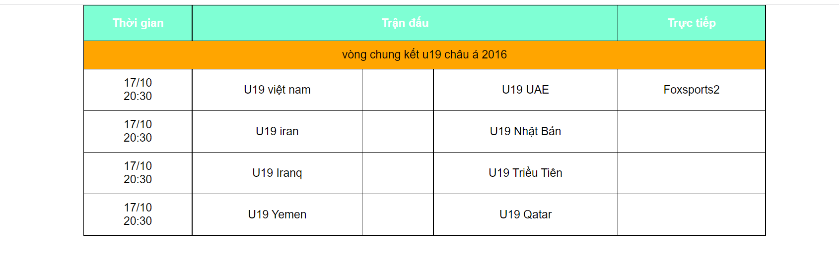

Bài2: https://codepen.io/Huy-Lee-the-scripter/pen/ZEjgLWO

<!DOCTYPE html>

<html lang="en">

<head>

<meta charset="UTF-8">

<meta http-equiv="X-UA-Compatible" content="IE=edge">

<meta name="viewport" content="width=device-width, initial-scale=1.0">

<title>Document</title>

</head>

<style>

\*{

margin: 0;

padding: 0;

box-sizing: border-box;

font-family: Arial, Helvetica, sans-serif;

}

.container{

width: 800px;

margin: auto;

}

table,th,td{

border: 1px solid black;

}

table{

border-collapse: collapse;

width: 80%;

margin: auto;

}

th{

height: 40px;

background-color: aqua;

color: white;

}

td{

text-align: center;

}

tr{

height: 40px;

}

tr:hover{

background-color: aquamarine;

}

tr:nth-child(even){

background-color: antiquewhite;

}

</style>

<body>

<div class="container">

<table >

<tr>

<th rowspan="2">Ngoại Tệ</th>

<th colspan="2">Tỷ giá mua</th>

<th rowspan="2">Tỷ giá bán</th>

</tr>

<tr>

<th>Tiền mặt</th>

<th>Chuyển khoản</th>

</tr>

<tr>

<td>USD(USD 50-100)</td>

<td>22,250</td>

<td>22,260</td>

<td>22,345</td>

</tr>

<tr>

<td>USD(USD 5-20)</td>

<td>22,240</td>

<td></td>

<td></td>

</tr>

<tr>

<td>USD(Dưới 5 USD)</td>

<td>22,230</td>

<td></td>

<td></td>

</tr>

<tr>

<td>EUR</td>

<td>24,041</td>

<td>24,284</td>

<td>24,649</td>

</tr>

<tr>

<td>GBR</td>

<td>26,621</td>

<td>26,890</td>

<td>27,339</td>

</tr>

<tr>

<td>JPY</td>

<td>208,00</td>

<td>212,70</td>

<td>216,11</td>

</tr>

<tr>

<td>HKD</td>

<td>2,756</td>

<td>2,841</td>

<td>2,907</td>

</tr>

<tr>

<td>CNY</td>

<td></td>

<td>3,266</td>

<td>3,350</td>

</tr>

<tr>

<td>USD</td>

<td>16,401</td>

<td>16,736</td>

<td>16,110</td>

</tr>

</table>

</div>

</body>

</html>

