**Lab2**

**Bài1.1:** https://codepen.io/Huy-Lee-the-scripter/pen/vYaxyRv

<!DOCTYPE html>

<html lang="en">

<head>

<meta charset="UTF-8">

<meta http-equiv="X-UA-Compatible" content="IE=edge">

<meta name="viewport" content="width=device-width, initial-scale=1.0">

<title>Document</title>

</head>

<body>

<h2>Bài thơ</h2>

<em>Màu <strong>tím</strong> hoa sim màu <strong>tím</strong> nhớ <br>

Màu <strong>tím</strong> lòng người <strong>tím</strong> mơ ước <br>

Ôi <strong>tím</strong> thủy chung màu đẹp quá <br>

Màu <strong>tím</strong> chiều tà <strong>tím</strong> ý thơ <br>

<br>

Màu <strong>tím</strong> hoa sim tin <strong>tím</strong> <mark>Huế</mark> <br>

Bầu trời tim <strong>tím tím </strong> tôi

</em>

</body>

</html>

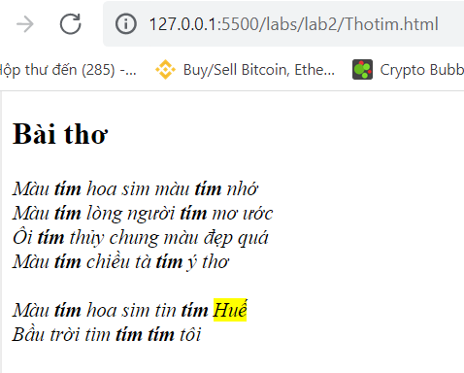

Bài1.2: https://codepen.io/Huy-Lee-the-scripter/pen/ZEjeBoe

<!DOCTYPE html>

<html lang="en">

<head>

<meta charset="UTF-8">

<meta http-equiv="X-UA-Compatible" content="IE=edge">

<meta name="viewport" content="width=device-width, initial-scale=1.0">

<title>Document</title>

</head>

<body>

<h2>Phương trình</h2>

<strong>a<sub>0</sub>x<sup>N</sup>+a<sub>1</sub>x<sup>N+1</sup>+...+a<sub>N</sub>X<sup>0</sup> = 0

</strong>

</body>

</html>

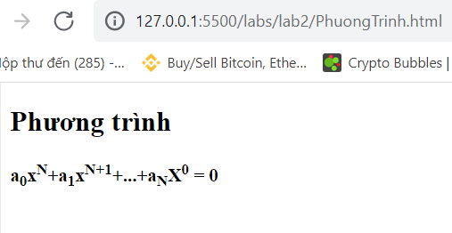

**Bài2:** https://codepen.io/Huy-Lee-the-scripter/pen/eYjvBKW

<!DOCTYPE html>

<html lang="en">

<head>

<meta charset="UTF-8">

<meta http-equiv="X-UA-Compatible" content="IE=edge">

<meta name="viewport" content="width=device-width, initial-scale=1.0">

<title>Document</title>

</head>

<body>

<img width="200" src="/img/logo-fpt-polytechnic-inkythuatso-09-13-08-21.jpg" alt="">

<hr>

<a href="2-1.html">Hello</a> <a href="Thotim.html">Bài thơ</a> <a href="PhuongTrinh.html">Phương trình</a>

</body>

</html>

