**Lab5**

Bài 1: <https://codepen.io/Huy-Lee-the-scripter/pen/GRBweKE>

<!DOCTYPE html>

<html lang="en">

<head>

<meta charset="UTF-8">

<meta http-equiv="X-UA-Compatible" content="IE=edge">

<meta name="viewport" content="width=device-width, initial-scale=1.0">

<title>Document</title>

</head>

<style>

p>img{

width: 20%;

height: 1000px;

border:2px solid gray ;

background-color: yellow;

border-radius: 10px;

padding: 20px;

margin: 60px;

box-shadow: 5px 5px blue;

}

p{

text-align: center;

}

p>img:hover{

box-shadow: 5px 5px red;

background-color: aqua;

}

</style>

<body>

<p>

<img src="/img/pngtree-cat-illustration-of-braised-fish-image_1381741.jpg" alt="hình 1">

<img src="/img/pngtree-cat-illustration-of-braised-fish-image_1381741.jpg" alt="hình 2">

<img src="/img/pngtree-cat-illustration-of-braised-fish-image_1381741.jpg" alt="hình 3">

<img src="/img/pngtree-cat-illustration-of-braised-fish-image_1381741.jpg" alt="hình 4">

<br>

<img src="/img/44b1aa2a5a9f579097e529e83c0bb2bd.jpg" alt="hình 5">

<img src="/img/44b1aa2a5a9f579097e529e83c0bb2bd.jpg" alt="hình 6">

<img src="/img/44b1aa2a5a9f579097e529e83c0bb2bd.jpg" alt="hình 7">

<img src="/img/44b1aa2a5a9f579097e529e83c0bb2bd.jpg" alt="hình 8">

</p>

</body>

</html>

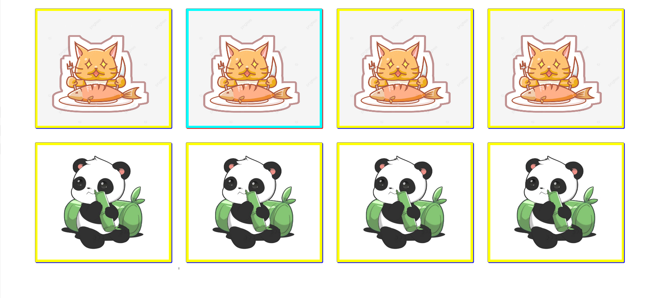

Bài 2: https://codepen.io/Huy-Lee-the-scripter/pen/GRBPgNz

<!DOCTYPE html>

<html lang="en">

<head>

<meta charset="UTF-8">

<meta http-equiv="X-UA-Compatible" content="IE=edge">

<meta name="viewport" content="width=device-width, initial-scale=1.0">

<title>Document</title>

</head>

<style>

.colum{

width: 1200px;

height: 1400px;

text-align: center;

float: left;

}

.sanpham{

border: 2px solid gray;

padding: 20px;

margin: 40px;

border-radius: 10%;

}

.sanpham>img{

width: 1000px;

height: 900x;

}

.sanpham>.name{

color: red;

font-size: 80px;

font-weight: bold;

}

.gia{

color: red;

font-size: 80px;

font-weight: bold;

font-weight: bolder;

text-align: center;

}

.gia>del{

color: aqua;

}

</style>

<body>

<div class="colum">

<div class="sanpham" >

<div class="name">Nokia2023</div>

<img src="/img/pngtree-cat-illustration-of-braised-fish-image_1381741.jpg" alt="hinh 1">

<div class="gia"> <del>250$</del> 200$</div>

</div>

</div>

<div class="colum">

<div class="sanpham" >

<div class="name">Nokia2023</div>

<img src="/img/pngtree-cat-illustration-of-braised-fish-image_1381741.jpg" alt="hinh 2">

<div class="gia"> <del>250$</del> 200$</div>

</div>

</div> <div class="colum">

<div class="sanpham" >

<div class="name">Nokia2023</div>

<img src="/img/pngtree-cat-illustration-of-braised-fish-image_1381741.jpg" alt="hinh 3">

<div class="gia"> <del>250$</del> 200$</div>

</div>

<br>

</div> <div class="colum">

<div class="sanpham" >

<div class="name">Nokia2023</div>

<img src="/img/pngtree-cat-illustration-of-braised-fish-image_1381741.jpg" alt="hinh 4">

<div class="gia"> <del>250$</del> 200$</div>

</div>

</div> <div class="colum">

<div class="sanpham" >

<div class="name">Nokia2023</div>

<img src="/img/pngtree-cat-illustration-of-braised-fish-image_1381741.jpg" alt="hinh 5">

<div class="gia"> <del>250$</del> 200$</div>

</div>

</div> <div class="colum">

<div class="sanpham" >

<div class="name">Nokia2023</div>

<img src="/img/pngtree-cat-illustration-of-braised-fish-image_1381741.jpg" alt="hinh 6">

<div class="gia"> <del>250$</del> 200$</div>

</div>

</div>

<div class="colum">

<div class="sanpham" >

<div class="name">Nokia2023</div>

<img src="/img/pngtree-cat-illustration-of-braised-fish-image_1381741.jpg" alt="hinh 7">

<div class="gia"> <del>250$</del> 200$</div>

</div>

</div>

<div class="colum">

<div class="sanpham" >

<div class="name">Nokia2023</div>

<img src="/img/pngtree-cat-illustration-of-braised-fish-image_1381741.jpg" alt="hinh 8">

<div class="gia"> <del>250$</del> 200$</div>

</div>

</div>

</body>

</html>

