**Lab6**

Bài1: https://codepen.io/Huy-Lee-the-scripter/pen/abjPOmQ

<!DOCTYPE html>

<html lang="en">

<head>

<meta charset="UTF-8">

<meta http-equiv="X-UA-Compatible" content="IE=edge">

<meta name="viewport" content="width=device-width, initial-scale=1.0">

<title>Document</title>

</head>

<style>

body{

padding: 0px;

margin: 0px;

}

.container{

max-width: 1000px;

margin: auto;

}

.container>header{

background-image: url(magin/bar.jpg);

background-size: 100%-100%;

height: 0px;

padding-bottom: 25%;

}

.container>nav{

line-height: 50px;

background-color: orangered;

color: white;

text-align: center;

font-variant: small-caps;

}

.container>article{

min-height: 400px;

width: 75%;

background-color: white;

float: left;

}

.container>aside{

min-height: 500px;

width: 25%;

background-color: lightgray;

float: right;

}

.container>footer{

border-top: 5px double orangered;

line-height: 50px;

background-color: lightcyan;

text-align: center;

font-variant: small-caps;

clear: both;

}

.container>nav>a{

color: white;

text-decoration: none;

margin: 0 10px;

}

.container>nav>a:hover{

color: yellow;

text-decoration: underline;

}

</style>

<body>

<div class="container">

<header></header>

<nav>

<a href="#">Trang chủ </a> |

<a href="#">Giới thiệu </a>|

<a href="#">Liên hệ </a>|

<a href="#">Góp ý </a>|

<a href="#">Hỏi đáp </a>|

</nav>

<article></article>

<aside>

<ul>

<li><a href="#">Máy tính sách tay</a></li>

<li><a href="#">Điệm thoại di động</a></li>

<li><a href="#">Máy quay phim</a></li>

<li><a href="#">Máy chụp ảnh</a></li>

</ul>

</aside>

<footer>

FPT Polytechic c 2023.All right reserved

</footer>

</div>

</body>

</html>

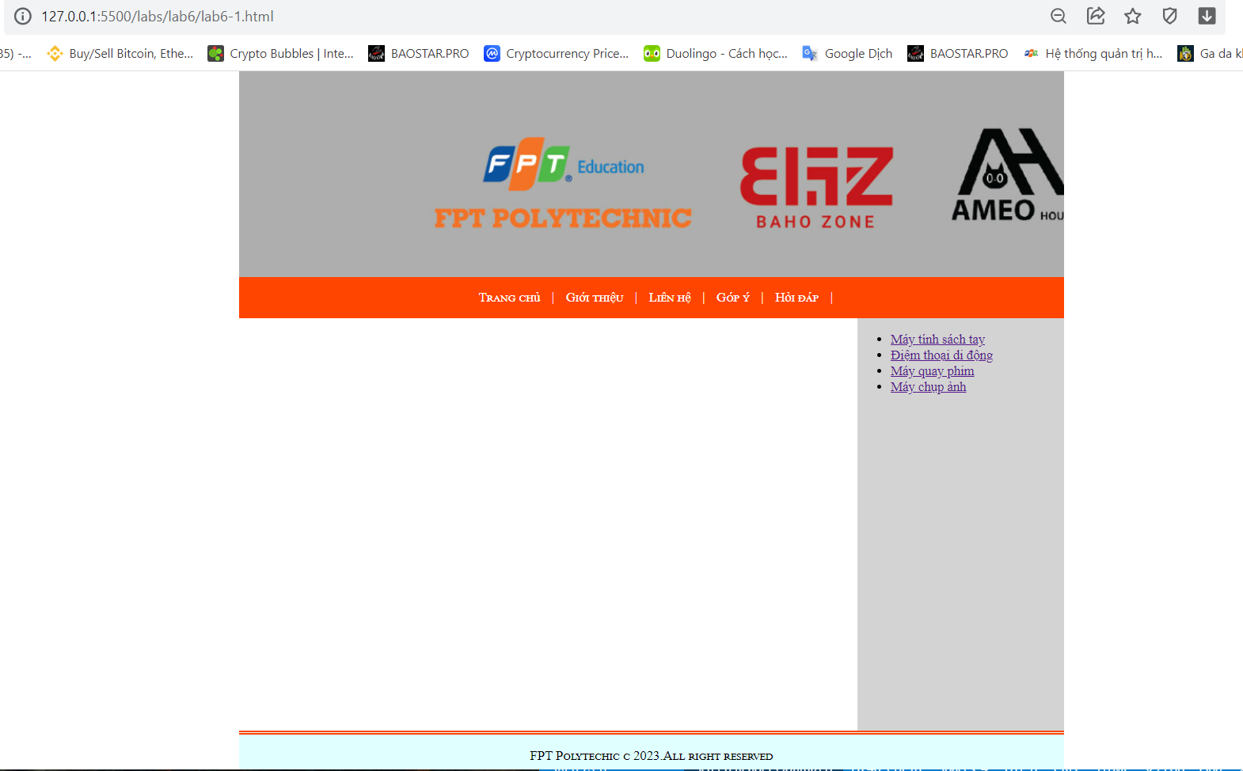

Bài2: https://codepen.io/Huy-Lee-the-scripter/pen/JjBwdbz

<!DOCTYPE html>

<html lang="en">

<head>

<meta charset="UTF-8">

<meta http-equiv="X-UA-Compatible" content="IE=edge">

<meta name="viewport" content="width=device-width, initial-scale=1.0">

<title>Document</title>

</head>

<style>

body{

padding: 0px;

margin: 0px;

}

.container{

max-width: 1000px;

margin: auto;

}

.container>header{

background-image: url(magin/bar.jpg);

background-size: 100%-100%;

height: 0px;

padding-bottom: 25%;

}

.container>nav{

line-height: 50px;

background-color: orangered;

color: white;

text-align: center;

font-variant: small-caps;

}

.container>article{

min-height: 400px;

width: 75%;

background-color: white;

float: left;

}

.container>aside{

min-height: 500px;

width: 25%;

background-color: lightgray;

float: right;

}

.container>footer{

border-top: 5px double orangered;

line-height: 50px;

background-color: lightcyan;

text-align: center;

font-variant: small-caps;

clear: both;

}

.container>nav>a{

color: white;

text-decoration: none;

margin: 0 10px;

}

.container>nav>a:hover{

color: yellow;

text-decoration: underline;

}

iframe[name=_page]{

width: 100%;

min-height: 500px;

}

</style>

<body>

<div class="container">

<header></header>

<nav>

<a href="home.html"target="_self">Trang chủ </a> |

<a href="about.html" target="_page">Giới thiệu </a>|

<a href="contract.html" target="_page">Liên hệ </a>|

<a href="feedback.html"target="_page">Góp ý </a>|

<a href="faq.html"target="_page">Hỏi đáp </a>|

</nav>

<article>

<iframe name="_page" src="home.html" frameborder="0"></iframe>

</article>

<aside>

<ul>

<li><a href="#">Máy tính sách tay</a></li>

<li><a href="#">Điệm thoại di động</a></li>

<li><a href="#">Máy quay phim</a></li>

<li><a href="#">Máy chụp ảnh</a></li>

</ul>

</aside>

<footer>

FPT Polytechic c 2023.All right reserved

</footer>

</div>

</body>

</html>

