**Lab8**

Bài 1: https://codepen.io/Huy-Lee-the-scripter/pen/bGjOeeM

<!DOCTYPE html>

<html lang="en">

<head>

<meta charset="UTF-8">

<meta http-equiv="X-UA-Compatible" content="IE=edge">

<meta name="viewport" content="width=device-width, initial-scale=1.0">

<title>Document</title>

</head>

<style>

.menu>ul>li{

display:inline-block

}

.menu>ul>li>a{

display: block;

}

.menu>ul{

padding:0px;

margin:0px;

list-style:none;

border-radius:5px;

background-color:orangered;

text-align:center;

}

.menu>ul>li>a{

text-decoration:none;

font-variant:small-caps;

font-size:larger;

color:white;

padding:0 10px;

line-height:40px;

}

.menu>ul>li>a:hover{

color: yellow;

}

</style>

<body>

<nav class="menu">

<ul>

<li><a href="#">Trang chủ</a></li>

<li><a href="#">Giới thiệu</a></li>

<li><a href="#">Liên hệ</a></li>

<li><a href="#">Góp ý</a></li>

<li><a href="#">Gỏi đáp</a></li>

</ul>

</nav>

</body>

</html>

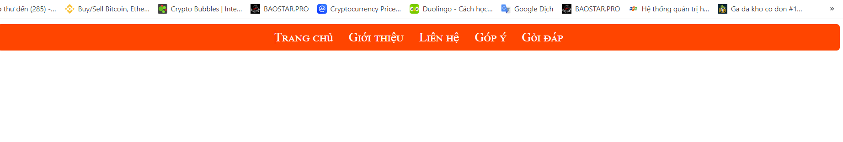

Bài 2: https://codepen.io/Huy-Lee-the-scripter/pen/KKBbMgb

<!DOCTYPE html>

<html lang="en">

<head>

<meta charset="UTF-8">

<meta http-equiv="X-UA-Compatible" content="IE=edge">

<meta name="viewport" content="width=device-width, initial-scale=1.0">

<title>Document</title>

</head>

<style>

.menu ul li{

display:inline-block;

position:relative;

}

.menu ul li a{

display: block;

}

.menu ul{

padding:0px;

margin:0px;

list-style:none;

border-radius:5px;

background-color:orangered;

text-align:center;

}

.menu ul li a{

text-decoration:none;

font-variant:small-caps;

font-size:larger;

color:white;

padding:0 10px;

line-height:40px;

}

.menu ul li a:hover{

color: yellow;

}

.menu ul ul{

position:absolute;

display:none;

padding:0px;

margin:0px;

list-style:none;

border-radius:3px;

width:200px;

background-color:white;

box-shadow:0 0 1px gray;

}

.menu ul ul a{

display: block;

line-height:30px;

color:white;

text-decoration:none;

font-variant:small-caps;

font-size:larger;

padding:0 10px;

}

.menu ul li:hover ul{

display: block;

background-color:orangered;

color: white;

}

</style>

<body>

<nav class="menu">

<ul>

<li><a href="#">Trang chủ</a></li>

<li><a href="#">Giới thiệu</a></li>

<li>

<a href="#">Liên hệ</a>

<ul>

<li><a href="#">Mobile</a></li>

<li><a href="#">Email</a></li>

</ul>

</li>

<li><a href="#">Góp ý</a></li>

<li><a href="#">Gỏi đáp</a></li>

</ul>

</nav>

</body>

</html>

