**Lab9**

Bài1: https://codepen.io/Huy-Lee-the-scripter/pen/mdjNREz

<!DOCTYPE html>

<html lang="en">

<head>

<meta charset="UTF-8">

<meta http-equiv="X-UA-Compatible" content="IE=edge">

<meta name="viewport" content="width=device-width, initial-scale=1.0">

<title>Document</title>

<style>

*{

margin: 0;

padding: 0;

box-sizing: border-box;

font-family: Arial, Helvetica, sans-serif;

}

.container{

max-width: 1200px;

margin: auto;

position: relative;

height: 100vh;

background-color: rgb(219, 127, 255);

}

form{

width: 450px;

top: 50%;

left: 50%;

transform: translate(-50%,-50%);

position: absolute;

padding: 8px;

}

label{

display: block;

margin-bottom: 10px;

}

input{

outline: none;

border: 1px solid #ccc;

font-size: 22px;

margin-bottom: 20px;

padding: 8px 16px;

}

.btn{

display: block;

width: 100px;

margin-top: 20px;

cursor: pointer;

background-color: rgb(136, 255, 0);

text-align: center;

}

</style>

</head>

<body>

<div class="container">

<form action="">

<label for="">User name:</label>

<input type="text">

<label for="">Password:</label>

<input type="password"><br>

<input type="radio" name="gender" value="">Remember me?<br>

<hr>

<input type="buttom" value="login" class="btn">

</form>

</div>

</body>

</html>

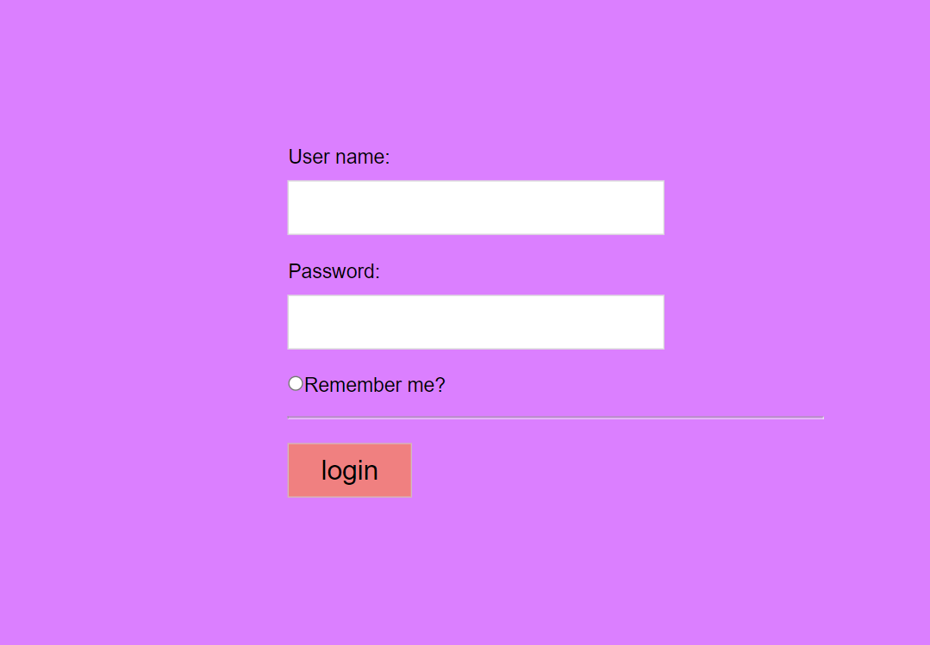

Bài 2: https://codepen.io/Huy-Lee-the-scripter/pen/oNMKBzq

<!DOCTYPE html>

<html lang="en">

<head>

<meta charset="UTF-8">

<meta http-equiv="X-UA-Compatible" content="IE=edge">

<meta name="viewport" content="width=device-width, initial-scale=1.0">

<title>Document</title>

<style>

*{

margin: 0;

padding: 0;

box-sizing: border-box;

font-family: Arial, Helvetica, sans-serif;

}

.container{

max-width: 1200px;

margin: auto;

position: relative;

height: 100vh;

background-color:rgb(0, 132, 255);

}

form{

width: 450px;

top: 50%;

left: 50%;

transform: translate(-50%,-50%);

position: absolute;

padding: 8px;

}

label{

margin-bottom: 10px;

font-size: larger;

}

input{

outline: none;

border: 1px solid #ccc;

font-size: 22px;

margin-bottom: 20px;

padding: 8px 16px;

}

.btn{

width: 120px;

margin-top: 20px;

cursor: pointer;

background-color: blue;

text-align: center;

}

textarea{

display: block;

width: 100%;

height: 100px;

}

select{

width: 100%;

}

.bl{

display: block;

}

</style>

</head>

<body>

<div class="container">

<form action="" method="post" enctype="multipart/form-data">

<label class="bl" for="">Họ và tên:</label>

<input type="text"> <br>

<label for="">Giới tính:</label>

<input type="radio" name="gender" value="">Nam

<input type="radio" name="gender" value="">Nữ

<label class="bl" for="">Hình ảnh:</label>

<input type="file">

<label class="bl" for="">Quốc tịch:</label>

<select name="" id="">

<option value="">USA</option>

<option value="">Việt Nam</option>

<option value="">Thái Lan</option>

<option value="">Lào</option>

</select>

<label class="bl" for="">Sở thích:</label>

<p>

<input type="radio" name="gender" value="">Thể thao

<input type="radio" name="gender" value="">Du lịch

<input type="radio" name="gender" value="">Âm nhạc

<input type="radio" name="gender" value="">Ẩm thực

</p>

<label class="bl" for="">Ghi chú:</label>

<textarea name="" id="" cols="30" rows="10"></textarea> <br>

<hr>

<input type="buttom" value="Đăng kí" class="btn">

<input type="reset" value="Nhập lại" class="btn">

</form>

</div>

</body>

</html>

