Counting people in real-time with object detection YOLO
Man Nguyen Huynh Huy^{[1]} , Binh Le Nguyen Thai^{[2]} , Binh Thanh Nguyen,
Tin Dang Thanh
Ho Chi Minh University of Technology, Ho Chi Minh 700000, Viet Nam dttin@hcmut.edu.vn
Abstract. Along with the development of humanity, artificial intelligence is increasingly diverse and can replace humans in many fields. Training so that computers can replace humans to handle manual or industrial tasks, military, dangerous places, ... in a continuous period of time without rest is becoming more and more popular. One of them is about security - computer vision. Computer vision is an area of ​​artificial intelligence (AI) that allows computers and systems to derive meaningful information from digital images, videos, and other visual inputs. From the recorded images, the image processing algorithm will recognize and distinguish different subjects. In this paper, we present the method of object recognition by You Only Look Once (YOLO), an artificial intelligence trained by computer hardware (deep learning) to be able to detect objects, specifically here is "human" in real time. YOLO is built using the Python programming language and the open source library OpenCV, which can use any type of camera with a pixel density large enough to be an "eye". This helps take advantage of today's modern computer hardware and saves build time. Thereby the computer will recognize and "count" the number of people it sees. Real-time counting of people from video recordings is becoming a major building block for many applications in smart cities. Popular and practical applications such as managing the number of people in an area, we can use YOLO to survey the number of employees attending a company meeting or the number of students present in a classroom. Moreover, for security purposes, it is able to manage the number of people entering and leaving a building.
Keywords: Artificial Intelligence, Computer Vision, Object Detection, YOLO.
- Introduction
In recent years, real-time object recognition has become an important and popular field of image processing and computer vision. The goal of real-time object detection is to detect, identify and classify objects, which can then be used in many fields and specialized applications such as face recognition, people control or self-driving cars (autopilot) ). The "brain" of a computer is not only the ability to view an image or video in the head, but also the ability to understand and infer from the image that has been seen. From there, the computer can remember what it "sees" and learning how to reproduce the vision in the computer is necessary to advance technology day by day [1]. Object detection solves this problem by predicting the location of objects through bounding boxes and classifying each object in a given image or video.
Besides, with the development of technology such as vehicle autopilot, detection systems need to ensure relative stability and accuracy. This means that algorithms need to be improved to achieve human-like recognition. Early systems had poor accuracy and took a long time to process. Other techniques that are computer-based only require large amounts of GPU power and even then are not always real-time, making them impractical for everyday applications. Previous methods such as Area-Based Neural Networks (R-CNN), Fast Area-Based Conforming Neural Networks (Fast R-CNN) have successfully achieved an efficient and accurate model with high average accuracy; however, their frames per second (FPS) on non-GPU computers are very slow and unwieldy, and even destroy the computer [1].
In this paper, YOLO is presented to solve this problem. Using the You Only Look Once (YOLO) algorithm as a starting point, it makes easier and more convenient to improve real-time person detection programs on standard computers (even those that are computer without GPU). You Only Look Once (YOLO) is a CNN model for object detection that has the outstanding advantage of being much faster than the older models. Can even run well on IOT devices like raspberry pi. The model input is an image, for the object detection problem, we not only have to classify the object on the image, but also have to locate the object's location. Object Detection has many applications, such as China's citizen tracking system, which can help authorities identify criminals hiding there, or self-driving car systems, which also have to identify determine where the pedestrians are and then make the next move. There are several approaches to solving the problem, and each run takes a lot of time. We will list them out as an idea to solve the whole problem of object detection: Divide the image into many boxes, each box will detect the object in that box, the position of the object is the degree of that box; or use an algorithm to select candidate regions, these candidate regions you can think of as interconnected regions on the RGB color channel, then for each of these candidate regions, we use the model to classify objects.
This paper includes 6 sections. A review of the previous models in the section 2. To the next section, we present the hardware implementation. In the section 4 and 5, we expose the program's algorithm and then the experimental setup and results . And the last section is conclusion.
- Related Work
YOLO is not the first real-time object detection.The Convolutional Neural Networks (CNNs) is the main architecture that is used for computer vision. Instead of having fully-connected layers, the CNN has a convolution layer where a filter is convolved with different parts of the input to create the output. The use of a convolution layer allows for relational patterns to be drawn from an input. In addition, a convolution layer tends to have less weights that need to be learned than a fully connected layer as filters do not need an assigned weight from every input to every output.
Unlike humans, identifying and classifying objects from an image or video to a computer is difficult to do. Over the years, humans have built AI platforms using complex neural networks (CNNs). In the field of object identification and classification, along with the development of computer hardware, neural networks have been used for more than a decade and are increasingly being improved to train these platforms. on big data warehouses. The researchers used deep learning to train the learning models to distinguish based on pixels from images. Recently, algorithms based on deep learning have eliminated the old methods, the construction method is more complex, but the efficiency of these is extremely significant. This methodology has been successfully demonstrated in Feature Pyramid Networks (FPNs) [2], Single-shot Detectors (SSDs) [3], and Single-shot Invalidation Detectors (DSSDs) [4]. Deep learning is a popular direction in the field of machine learning [5]. Researchers have shown that CNNs inherit the advantages of deep learning [6]. The researchers made a lot of improvements to use the stochastic gradient descent and backpropagation to train deep networks for object detection.
However, CNN has become obsolete due to support vector machines and other simple methods such as linear classifiers. CNNs have been used but are no longer fashionable due to support vector machines and other simple methods such as linear classifiers [7]. Therefore, some new methods have been developed alternatively to make larger-scale accuracy higher in large-scale image recognition ImageNet [8]. These methods have helped in training large networks and deeper, performance increases many times. Typical approaches for identifying and classifying other objects from images or videos are Deep Complex Neural Networks (DCNNs). For example, Regional-based convolutional neural networks (R-CNN) based on CNN gave much better performance. R-CNN consider region proposals for object detection in images. From each region proposal, a feature vector is extracted and fed into a convolutional neural network. For each class, the feature vectors are evaluated with Support Vector Machines (SVM). Although R-CNN results in high accuracy, the model is not able to achieve real-time speed even with Fast R-CNN and Faster R-CNN due to the expensive training process and the inefficiency of region proposition.
In the past few years, in order to use deep neural networks in real-time applications effectively on non-extreme hardware, many researchers have worked to solve this problem. In this paper, YOLO is an architecture was modified to detect objects in question, giving an optimal delivery and high accuracy in a short period of time.
- Hardware Implementation and Analysis of YOLO
  - Hardware Block Diagram
The camera is placed at a high angle or in a position where the entire monitoring area can be observed. In this case, the camera is placed to be able to observe all 300 people in the large hall, with adequate, stable and continuous lighting conditions. Then, the trained YOLO will recognize different objects such as people, tables, ceiling lights, etc. The number of recognized people will be counted and printed with a message on the monitor.

Set the threshold of detection
Set the camera’s height and angle

Detect people with re-training convolution neural network

Detect people and count based on appropriate boundary selection

Process the count information of previous step

Output real-time counting people

Fig. 1. The hardware block diagram structure of YOLO

The version of YOLO that we use is YOLO version 3 (YOLOv3). YOLO version 3 has a similar architecture to YOLO version 2 (YOLOv2). The author has added new improvements in recent studies to YOLOv2 to create YOLOv3. Those improvements include: Logistic regression for confidence score: YOLOv3 predict bounding box confidence (containing or not) using logistic regression; replacing softmax with Discrete Logistic Classifiers: YOLOv3 using logistic classifiers instead of softmax for object classification; new Backbone - Darknet-53: Backbone redesigned with the addition of residual blocks (architecture used in ResNet); multi-scale prediction: YOLOv3 uses Feature Pyramid Networks (FPN) architecture to make predictions from various scales of feature maps. This helps YOLOv3 take advantage of feature maps with different coarseness - fineness for prediction. Skip-layer concatenation: YOLOv3 also adds associations between prediction layers. Model upsample the prediction classes at the later layers and then concatenate with the prediction classes in the earlier layers. This method helps to increase accuracy when predicting small objects.
The processing goes from top to bottom sequentially from the input raw data and outputs to the screen the desired result: the number of people counted.
  - Analysis of the System
The custom camera system used is a camera with a relatively good resolution (720 megapixels or more) for good recording results. Based on that, the input data will not be too noisy due to lighting conditions and the high number of pixels will give high image quality, increasing the processing capacity of the algorithm. The more megapixels, the easier it is for the algorithm to divide objects into cells and increase the accuracy of subject recognition. Depending on economic conditions as well as commercial conditions (importing foreign goods), cameras can be used as webcams, kinect cameras or even DSLR cameras.
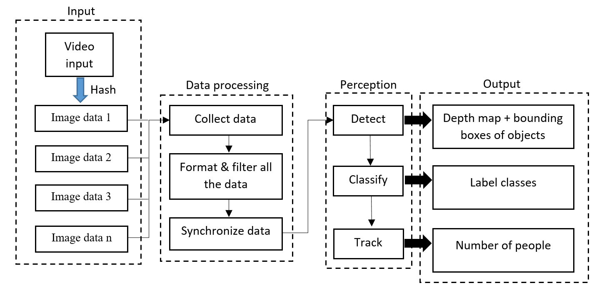
Fig. 2. Processing of YOLO

We've found that both hardware and software triggers work equally well as long as the code runs consistently and without glitches. When the program runs, the system will start the camera and it will start recording. Then from the recorded video, the algorithm will shred it into sequence of frames. This is important, as the specific applications of our system have shown us how important it is to use real-time data to ensure reliability. However, the system is limited by the hardware: if the camera is too good, the pixel density is too large, it will consume a lot of memory and reduce processing speed. Careful when choosing a camera [9].
In the perception module, there are three processing processes: detection, classification and tracking of observable objects. The order of the processing steps is determined according to each specific stage and it is required to process each step in order to have the data displayed on the screen.
The first step is to identify the specified objects from the input data by the algorithm. This algorithm will be presented in detail in part 4 - Algorithm. In the second step, the identified objects will be classified into classes. In case of multiple object types, there will be multiple classes. In this paper, we only train YOLO to recognize one object: human. The system will distinguish subjects into each class based on the training data it learned. During training, we labeled the subjects. Labels of objects in layers will be displayed on the screen, content such as people, dogs, vehicles, etc.
The final step is to track and predict the objects that will move in the next direction to simplify the processing of the algorithm. The results of the processed steps will be displayed on the screen in the most intuitive way for users to easily follow. Users looking at the screen will receive information including: Number of people counted, bounding boxes surrounding 1 person. The information will be displayed in real time. To achieve this, in the algorithm is programmed a mathematical function that calculates the probability to predict the next position of the object. This will also be covered in section 4.
In summary, from the raw data that the camera receives, the system will process it by an algorithm: hash the footage into frames and process it on a frame by frame basis. Because the algorithm has been improved and the computer's processing speed is very fast, the output results are considered real-time. The output results to the screen are applied in the management and security activities.
- Algorithmic Processing
To understand the YOLO algorithm, we first need to determine what is actually being recognized. The algorithm is built based on predicting a class of an object and the bounding box determines the position of the object. Each bounding box can be defined by four properties: Center of the bounding box (b_{x}, x), Width (b_{w}), Height (b_{h}), the value c corresponds to the class (human) of an object.
Based on that, we predict a real number calculated p_{c}, which is the probability to have an object in the bounding box.
When the data is input, YOLO's algorithm splits that data into frames, then it divides that frame into a grid of squares with a grid size of 19x19. Each cell assumes the role of predicting K bound cells [10]. To specify the size of the bounding box that surrounds the object, the cells containing the object will have the same color. The object to be recognized will be in specific cells, constrained by the condition that the center coordinate of the bounding box remains in that cell, while the width and height will be calculated relative to the entire image size. Because of this property, the center coordinate is always calculated relative to the cell while the height and width are calculated relative to the entire frame size.
After processing one image, it will move on to the next frame, the above process will be repeated. However, as the input is a video, the object moves and YOLO's algorithm establishes a way to calculate the probability that the subject is in the adjacent cells. That equation is:
(1)
Cells are selected based on the principle: Between the same attribute classes, the class with the greatest probability will be selected and assigned to that particular grid cell. The same process will take place for all cells in the frame.
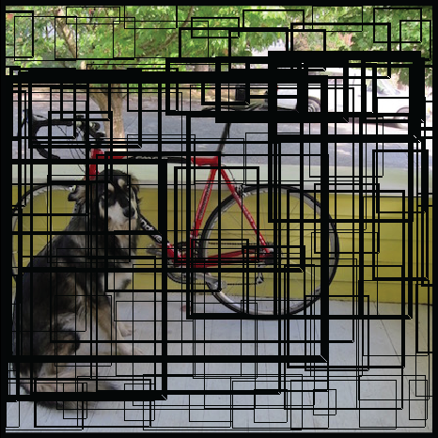
From the result of the calculated probability of the above class, the picture might look like this:
Fig. 3. Bounding Boxes around objects

This figure shows the processing of the algorithm before and after predicting the class probability for each grid cell. After predicting the probability of the class, the next step of the processing is to eliminate the Non-max, the meaning of this process is to remove the bounding boxes that have no meaning, as you can see in the figure. below, there are many anchor boxes calculated based on class probabilities. To solve this problem, the Non-max cancellation algorithm will remove the bounding boxes that are very close to each other by using the IoU (Intersection over Union) algorithm. Boxes that are close to each other will be removed and replaced with the box with the highest class probability among them.
After identifying the box with the highest probability, it discards the boxes with IoU values ​​greater than the threshold level. Considering two values ​​higher than the threshold, this means that there are two boxes containing the same object, but a box with a lower value means less objects and it will be discarded. It computes the value of IoU for all bounding boxes corresponding to the box with the highest probability of elimination, then it discards the bounding boxes whose IoU value is greater than a threshold. It denotes that those two bounding boxes are covering the same object but the other box has a low probability for the same object, so it is discarded. This process continues with the overlapping boxes with the next highest class probability until the frame contains only boxes containing different attributes.
Finally, bounding boxes will surround each person object and the resulting number of people will appear on the left corner of the screen. The result is as shown below:

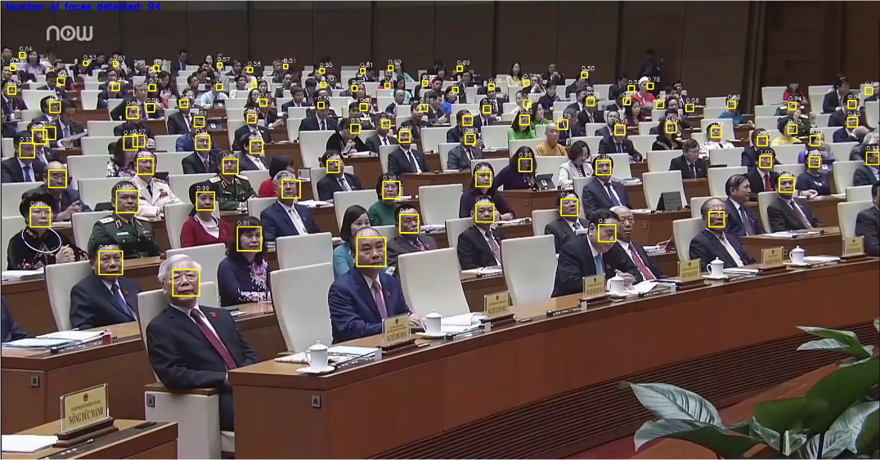
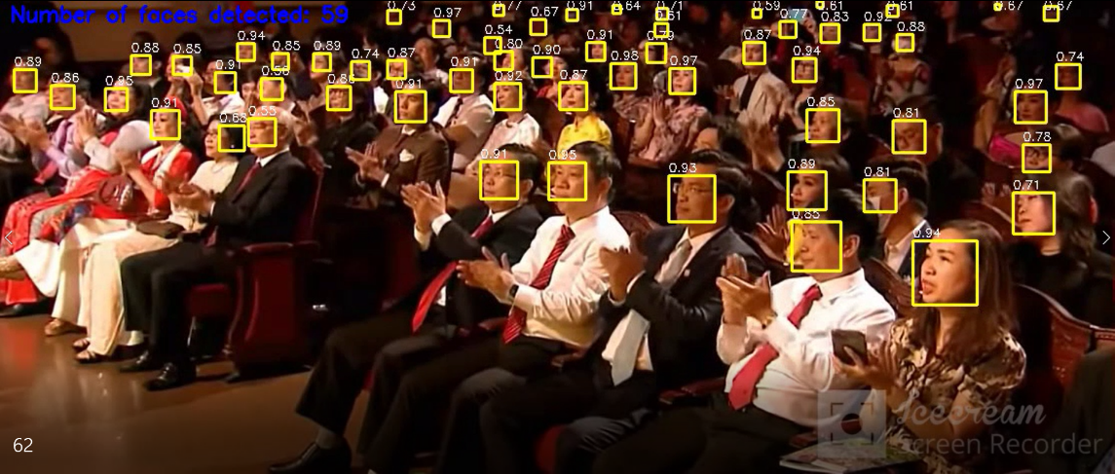
b
a)

Fig. 4. The result of YOLO algorithm. (a) 59 people counted and (b) 94 people counted

In this figure, each person's face is placed in a bounding box. We trained YOLO to only receive individual faces instead of the entire human body. The purpose of this is to reduce hardware processing and ensure that the results are clearly visible, rather than overlapping bounding boxes.
- Experimental Result
In order to evaluate the accuracy of our program, we computed the accuracy based on the output of the YOLO model and the number of faces that we manually count. We perform our evaluation on 11 videos with a different amount of attendance, the number of attendance in each video ranges from 50 to 250. The final result of our program is illustrated in the following table (Table 1).
Table 1. Human count for each pattern
Pattern | Yolo v3 | Manually | % accuracy
1 | 35 | 36 | 97.2
2 | 48 | 53 | 90.6
3 | 54 | 56 | 96.4
4 | 62 | 64 | 96.8
5 | 93 | 110 | 84.5
6 | 101 | 115 | 87.8
7 | 131 | 150 | 87.3
8 | 144 | 175 | 82.3
9 | 147 | 150 | 98
10 | 149 | 200 | 74.5
11 | 205 | 250 | 82
Overall, the Yolo-v3 model has achieved promising results with accuracy is greater than 74% in all 11 patterns. The performance of the counting face model is affected by several factors such as face size, occlusion, angle of the face towards the camera, etc. From pattern 1 to 11, the performance of our model tends to decline when the number of attendance of a pattern rises. With the high-quality videos in pattern 1,2,3,4 and 9, the accuracy of our program is remarkably high (90% to 98%). At the remaining pattern, the accuracy of the program is between 74.5% to 87.8%. However, the evaluation results have demonstrated that our model could be suitable for a real-life application. This program is suitable for counting in the medium hall which contains a maximum of 250 attendances.
- Conclusion
In this paper we have presented a program to count the number of people in the hall using YOLO v3. When we use this program to count halls which have a maximum capacity is 250 people, it gives high accurate results (over 74%). Given the program's countable scale, it can be used to survey the number of employees attending a company meeting or the number of students present in a classroom. The accuracy of the program depends heavily on the quality of the camera, it also requires that subject's face to be counted is not obscured too much. This program has many limitations when counting in an overcrowded hall such as government meetings, this counting may not be accurate. In the future, we can apply YOLO version 4, YOLO version 5 to improve the accuracy of this program and use many different datasets such as Egohand, headcut, ... to increase the ability to identify and count people. From there, this method will be applied in applications that manage the number of people in an area, in a hall, company, or manage the number of people entering and leaving a building.

Conflicts of Interest
The authors have no conflict of interest to declare.

References
- Tavir Ahmad, Yinglong Ma, Muhammad Yahya, Belal Ahmad, Shah Nazir, Amin ul Haq: Object Detection trough Modified YOLO Neutral Network, Scientific Programming, vol. 2020, pp. 1 – 10 (2020).
- T. Yi Lin, P. Dollar, R.B.Girsshick: Feature pyramid networks for object detction, IEEE CVPR, vol. 43, pp. 936 – 944 (2017).
- W. Liu, D. Anguelov, D. Erhan: SSD: Single shot multibox detector, Computer Vision-ECCV 2016, vol. 43, pp. 21–37 (2016).
- C.-Y. Fu, W. Liu, A. Ranga, A. Tyagi, C. Alexander, and C. Berg: DSSD: Deconvolutional Single Shot Detector, CoRR, vol. 45, (2017).
- J. Schmidhuber: Deep learning in neural networks: an overview, Neural Networks, vol. 61, pp. 85–117 (2015).
- M. Lin, Q. Chen, and S. Yan: Network in-network (2013).
- Mohana, HV Ravish Aradhya: Object Detection and Tracking using Deep Learning and Artificial Intelligence for Video Surveillance Applications, IJACSA) International Journal of Advanced Computer Science and Applications, Vol. 10, No. 12, (2019).
- Xin Feng, Youni Jiang, Xuejiao Yang, Ming Du, Xin Li: Computer vision algorithms and hardware implementations: A survey, pp. 309 – 320, Integration, Elsevier, Netherlands (2019).
- Dr. K. Seetharaman: An Efficient Real Time People Counting System Based on Identification and Tracking Using Surveillance Camera, isrjournals (2016).
- Toward data science, https://towardsdatascience.com/yolo-you-only-look-once, last accessed 2021/07/27.

