**Some problems:**

- DateAdded, DateRequested, DateGiven, DateJoined should be 'Date' data-type

- 'Title' of the 'Book' table should not be PK

- 'Summary' of the 'Book' table should be Text data-type

- 'Name' of the 'Member' table should not be PK

- The relationship between 'Book' and 'Member' should be refined 1 to many from Member to Book

- There should have a relationship between Member and Borrowed (1 to many)

- Phenomenon of data inconsistency: 'Member' field in Borowed and 'Name' field in Member

- Phenomenon of data redundancy: 'Book' table, 'Borrowed' table

- Lack of information about newsletter

- Lack of information about the monthly-payment

*Note: You should find out more problems for this scenario*

*You should design your own ERD, together with your own explaination*

*My proposal is one of the solutions which maybe not the best one.*

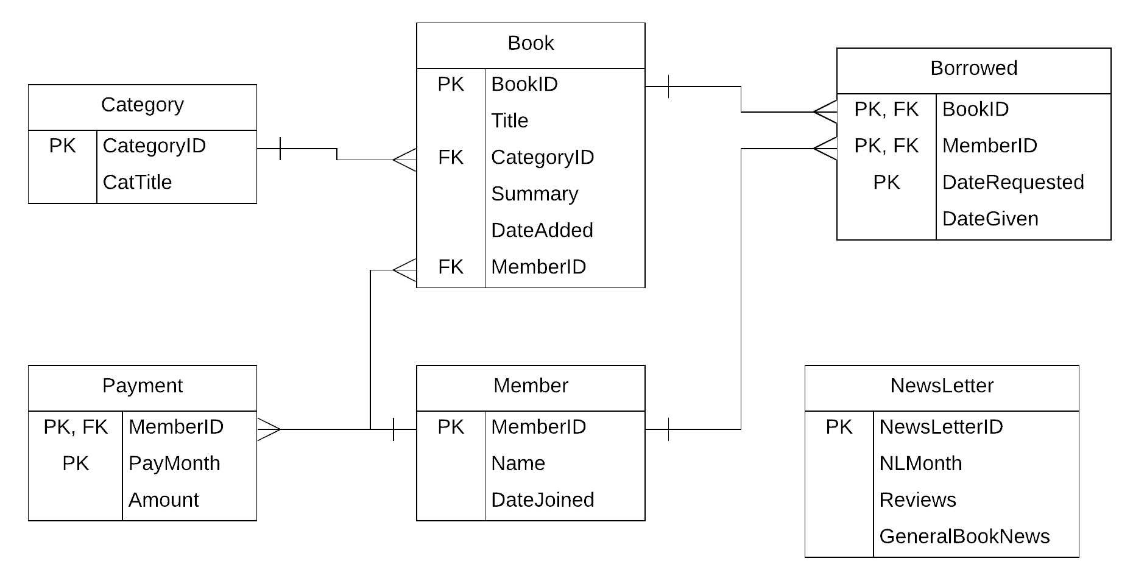

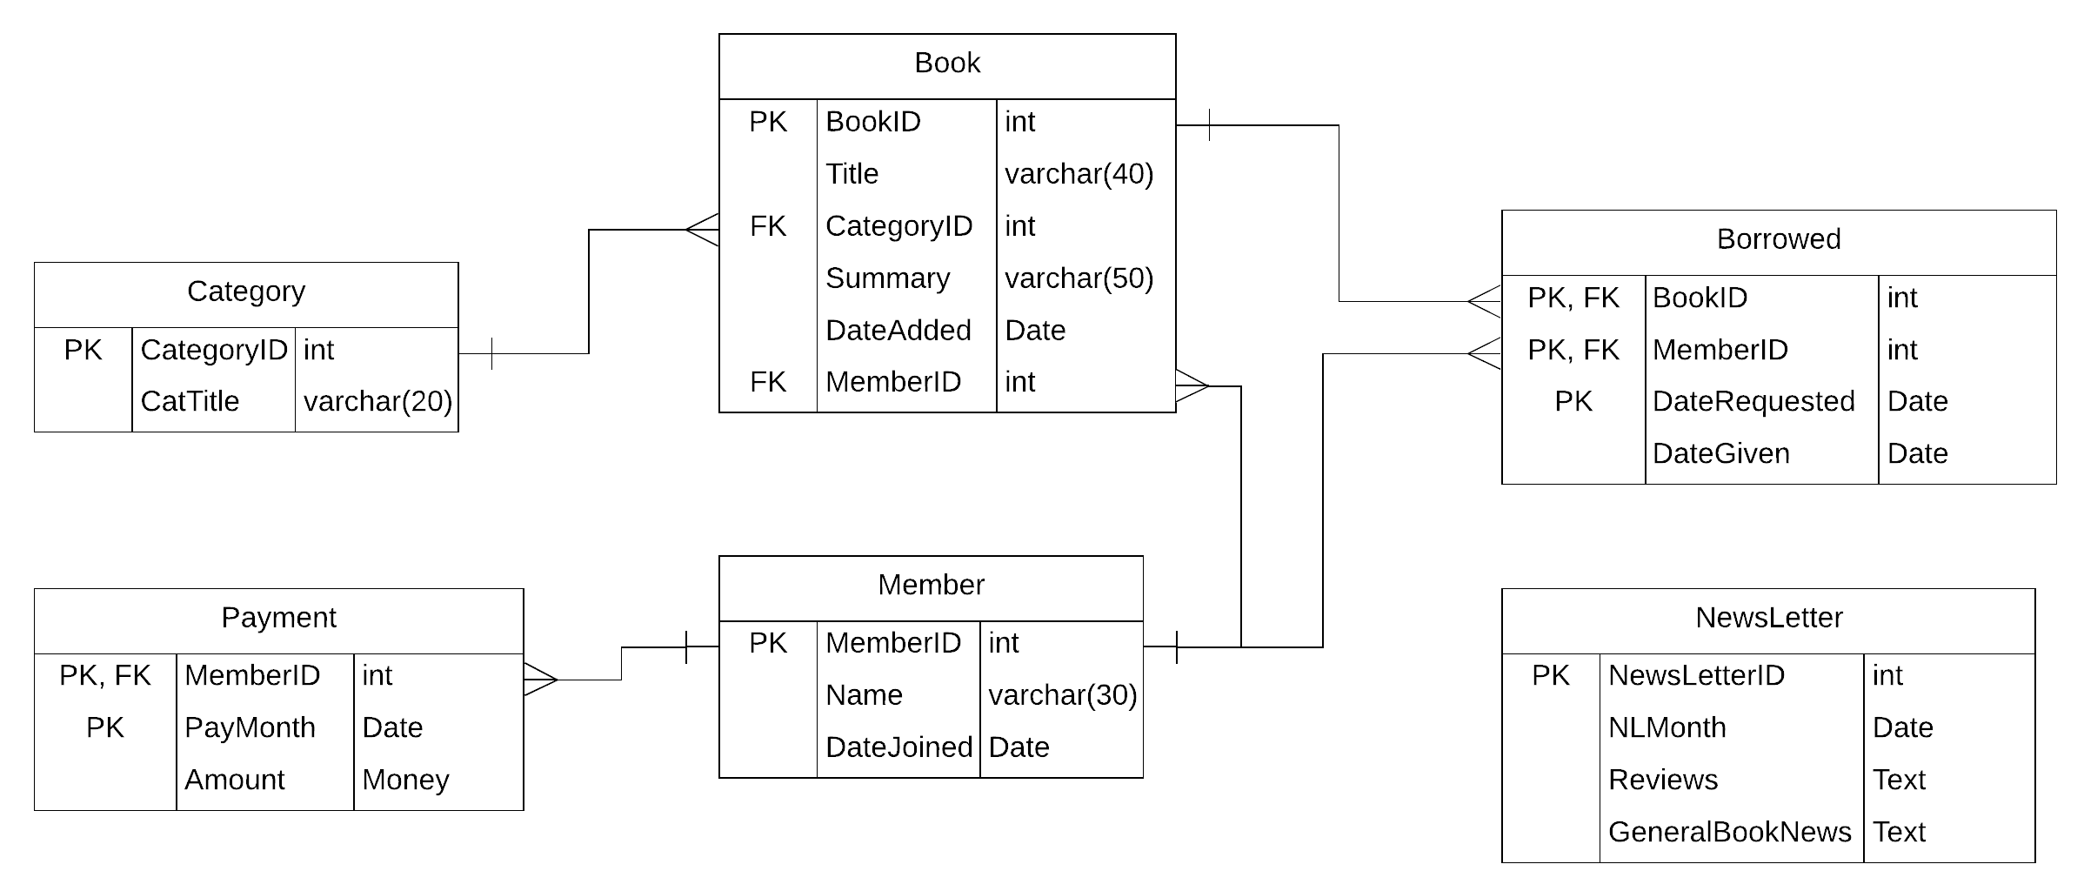

**Question 1: List member who have added some books this month:**

*Solution 1:*

SELECT * FROM Member

WHERE MemberID IN(

SELECT MemberID FROM Book

WHERE MONTH(DateAdded) = MONTH(GETDATE()) AND YEAR( DateAdded) = YEAR(GETDATE())

)

Member*(**П**MemberID(**Ϭ** MONTH(DateAdded) = MONTH(GETDATE()) Λ YEAR(DateAdded) = YEAR(GETDATE()) (Book))

*Solution 2:*

SELECT Member.* FROM Member INNER JOIN Book ON Member.MemberID = Book.MemberID

WHERE MONTH(DateAdded) = MONTH(GETDATE()) AND YEAR( DateAdded) = YEAR(GETDATE())

**П**Member.*(**Ϭ** MONTH(DateAdded) = MONTH(GETDATE()) Λ YEAR(DateAdded) = YEAR(GETDATE()) (Member*Book))

**Question 2: List members who have paid for newsletter this month:**

*Solution 1:*

SELECT * FROM Member

WHERE MemberID IN(

SELECT MemberID FROM Payment

WHERE MONTH(PayMonth) = MONTH(GETDATE()) AND YEAR( PayMonth) = YEAR(GETDATE())

)

Member*(**П**MemberID(**Ϭ** MONTH(PayMonth) = MONTH(GETDATE()) Λ YEAR(PayMonth) = YEAR(GETDATE()) (Payment))

*Solution 2:*

SELECT Member.* FROM Member INNER JOIN Payment ON Member.MemberID = Payment.MemberID

WHERE MONTH(PayMonth) = MONTH(GETDATE()) AND YEAR( PayMonth) = YEAR(GETDATE())

**П**Member.*(**Ϭ** MONTH(PayMonth) = MONTH(GETDATE()) Λ YEAR(PayMonth) = YEAR(GETDATE()) (Member*Payment))

**Question 3: List member who have added some books OR have paid for newsletter this month:**

*Solution 1:*

SELECT Member.* FROM Member INNER JOIN Payment ON Member.MemberID = Payment.MemberID

INNER JOIN Book ON Member.MemberID = Book.MemberID

WHERE (MONTH(PayMonth) = MONTH(GETDATE()) AND YEAR( PayMonth) = YEAR(GETDATE())) OR (MONTH(DateAdded) = MONTH(GETDATE()) AND YEAR( DateAdded) = YEAR(GETDATE()))

**П**Member.*(**Ϭ**(MONTH(PayMonth) = MONTH(GETDATE()) Λ YEAR(PayMonth) = YEAR(GETDATE())) ᴠ (MONTH(DateAdded) = MONTH(GETDATE()) AND YEAR( DateAdded) = YEAR(GETDATE()))  (Member*Payment*Book))

*Solution 2:*

SELECT * FROM Member

WHERE MemberID IN(

SELECT MemberID FROM Book

WHERE MONTH(DateAdded) = MONTH(GETDATE()) AND YEAR( DateAdded) = YEAR(GETDATE())

)

UNION

SELECT * FROM Member

WHERE MemberID IN(

SELECT MemberID FROM Payment

WHERE MONTH(PayMonth) = MONTH(GETDATE()) AND YEAR( PayMonth) = YEAR(GETDATE())

)

Member*(**П**MemberID(**Ϭ** MONTH(DateAdded) = MONTH(GETDATE()) Λ YEAR(DateAdded) = YEAR(GETDATE()) (Book)) U Member*(**П**MemberID(**Ϭ** MONTH(PayMonth) = MONTH(GETDATE()) Λ YEAR(PayMonth) = YEAR(GETDATE()) (Payment))

**Question 4: List members who have not added anybook this month:**

*Solution 1:*

SELECT * FROM Member

WHERE MemberID NOT IN(

SELECT MemberID FROM Book

WHERE DATEPART(MONTH, DateAdded) = DATEPART(MONTH, GETDATE())

AND DATEPART(YEAR, DateAdded) = DATEPART(YEAR, GETDATE())

)

Member*(**П**MemberID(Member) - **П**MemberID(**Ϭ** DATEPART(MONTH, DateAdded) = DATEPART(MONTH, GETDATE()) Λ DATEPART(YEAR, DateAdded) = DATEPART(YEAR, GETDATE())) (Book))

*Solution 2:*

SELECT * FROM Member

EXCEPT

SELECT Member.*

FROM Member INNER JOIN Book ON Member.MemberID = Book.MemberID

WHERE DATEPART(MONTH, DateAdded) = DATEPART(MONTH, GETDATE())

AND DATEPART(YEAR, DateAdded) = DATEPART(YEAR, GETDATE())

Member - **П**Member.*(Member * (**Ϭ** DATEPART(MONTH, DateAdded) = DATEPART(MONTH, GETDATE()) Λ DATEPART(YEAR, DateAdded) = DATEPART(YEAR, GETDATE())) (Book)))

--------------------------------------

Notice that you have 2 hours for your exam, so I think you must make use of time to do well your exam paper.

I think you should explain a little more about your decision, such as why you design so, why you choose your answer and so on.

If you give the answers only, duration of 30 minutes is enough for you to complete the exam. So it is not good!