UNIT 1 – INTRODUCE PEOPLE
Descriptive adjectives
- beautiful: xinh đẹp
- famous: nổi tiếng
- great: tuyệt vời
- fantastic: tuyệt vời, xuất sắc
- handsome: đep trai
- terrific: nổi tiếng
- wonderful: tuyệt vời, xuất sắc
Jobs
- interpreter: phiên dịch viên
- graphic designer: chuyên viên thiết kế đồ họa
- salesperson: nhân viên bán hang
- computer programmer: lập trình viên

Countries & Nationalities:
Countries | Nationalities
Japan | Japanese
China | Chinese
Canada | Canadian
Argentina | Argentinean
The UK | British
Turkey | Turkish
Vietnam | Vietnamese
Australia | Australian
Italy | Italian
GRAMMAR
THE VERB “TO BE”
S + be (am/ is/ are) +
+
S+ be not ( ‘m not/ isn’t/ arent’)+
__
Be ( am/ is/ are) + S?
?

E.g.
I’m sick.
She is a student.
Henry and David are 20 years old.
E.g.
You aren’t sick.
Tom isn’t my boyfriend.
They aren’t my classmates.
E.g.
Are you engineer?
Is Helen from Canada?
Are Matt, Tom and May Australian?

MODIFICATION WITH ADJECTIVES
Read the sentences and choose the correct answer:
She is beautiful.
They are famous.
- Adjectives go before/after to be.

Adam Levine is a famous singer.
Chris Pine is a handsome actor.
- Adjectives go before/after nouns.

------------------------------------------------------------------------------------------------------------

Unit 2 – FAMILY AND FRIENDS
PREVIEW
1. extended family (n): gia đình nhiều thế hệ cùng chung sống (đại gia đình)
2. in-laws: bên vợ/ bên chồng
3. mother-in-law (n): mẹ vợ/ mẹ chồng
4. father-in-law (n): ba vợ/ ba chồng
5. parents (n): bố mẹ
6. grandparents (n): ông bà
7. grandmother (n): bà ngoại/ bà nội
8. grandfather (n): ông ngoại/ ông nội
7. brother (n): anh trai
9. sister (n): chị gái
10. daughter (n): con gái
11. son (n): con trai
12. uncle (n): chú
13. aunt (n): dì
14. grandchildren (n): cháu (của ông bà)
15. cousin (n): anh (em) họ
16. nephew (n): cháu trai (con anh, con chị)
17. niece (n): cháu gái (con anh, con chị)
18. husband (n): chồng
19. wife (n): vợ
20. adopt (v): nhận làm con nuôi
21. only child (n): con một
22. twin (n): sinh đôi
LESSON 1 – REPORT NEWS ABOUT RELATIONSHIPS
1. single (adj): độc thân
2. engaged (adj): đính hôn
3. fiancé (n): hôn phu
4. fiancée (n): hôn thê
5. separated (adj): ly thân
6. divorced (adj): ly dị
7. ex-husband (n): chồng cũ
8. ex-wife (n): vợ cũ
9. widowed (adj): góa (chồng, vợ)
10. widow (n): góa phụ
LESSON 2 – DESCRIBE EXTENDED FAMILIES
1. stepfather (n): bố dượng
2. stepmother (n): mẹ kế
3. stepbrother (n): anh (em) con riêng của bố dượng (mẹ kế)
4. stepsister (n): chị (em) con riêng của bố dượng (mẹ kế)
5. stepson (n): con trai riêng
6. stepdaughter (n): con gái riêng
7. half-sister (n): chị (em) cùng cha khác mẹ
8. half-brother (n): anh (em) cùng cha khác mẹ
9. get up (v): thức dậy
10. have a shower (v): tắm rửa
11. get dressed (v): mặc quần áo
12. clean the teeth (v): đánh răng
13. leave the house (v): rời khỏi nhà
LESSON 3 – COMPARE PEOPLE
- look (v): trông
- alike (adj): giống nhau
- different (adj): khác nhau
- but (conj): nhưng
LESSON 4 – DISCUSS FAMILY CULTURAL TRADITIONS
1. college (n): trường cao đẳng
2. sell (v): bán
3. move back home (v): quay về nhà
4. expect (v): trông chờ, kì vọng
5. adult (n): trưởng thành, thành niên
6. high costs of housing (n): giá thuê nhà cao
7. problem (n): vấn đề
8. chores (n): việc vặt hàng ngày trong nhà
GRAMMAR
SIMPLE PRESENT TENSE
- TO BE (AM/IS/ARE)
Affirmative (+) | S + be | Ex1: I am happy.  Ex3: My mom is a teacher.  Ex4: Her sisters are students.
Negative (-) | S + be + not | Ex1: I am not happy.  Ex2: My mom is not a teacher. (is not = isn’t)  Ex3: Her sisters are not students. (are not = aren’t)
Yes / No Questions (?) | Be + S?  - Yes, S + be  - No, S + be + not | Ex1: Are you happy? → Yes, I am. / No, I am not.  Ex2: Is she sad? → Yes, she is. / No, she isn’t.  Ex3: Are her sisters students? → Yes, they are. / No, they aren’t.
Wh-questions (?) | Question word + be + S? | Ex1: Where are you? Ex4: How are you?  Ex2: Why is she sad? Ex5: Who is this?  Ex3: What time is it?

- VERBS
Affirmative (+) | S (I/you/we/they) + V.  S (He/she/it) + V-s/V-es. | Ex1: They do their homework every evening.  Ex3: My mom loves playing tennis.  Ex4: Jack often washes his car every weekend.
Negative (-) | S (I/you/we/they) + DO NOT (don’t) + V.  S (He/she/it) + DOES NOT (doesn’t) + V. | Ex1: They do not (don’t) their homework every evening.  Ex2: My mom does not (doesn’t) love playing tennis.  Ex3: Jack does not (doesn’t) wash his car every weekend.
Yes/No Questions (?) | DO + S (I/you/we/they) + V?  - Yes, S + do.  - No, S + don’t.  DOES + S (He/she/it) + V?  - Yes, S + Does.  - No, S + doesn’t. | Ex1: Do they do their homework every evening?  - Yes, they do.  - No, they don’t.  Ex2: Does your mom love playing tennis?  - Yes, she does.  - No, she doesn’t.
Wh-questions (?) | Question word + DO + S + V?  Question word + DOES + S + V? | Ex1: Where do you live?  - I live at 975 Nguyen Kiem Street.  Ex2: Where does Anna live?  - She lives at 975 Nguyen Kiem Street.

PRACTICE
1. Complete the paragraph. Use words from the box.
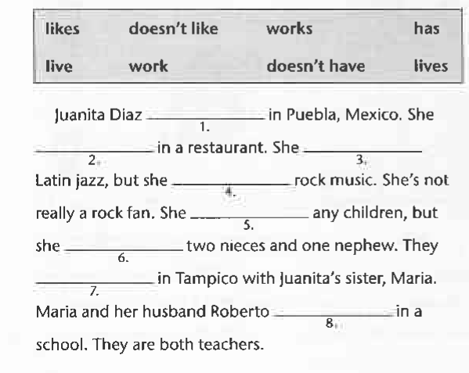
2. Look at the responses. Complete the questions.
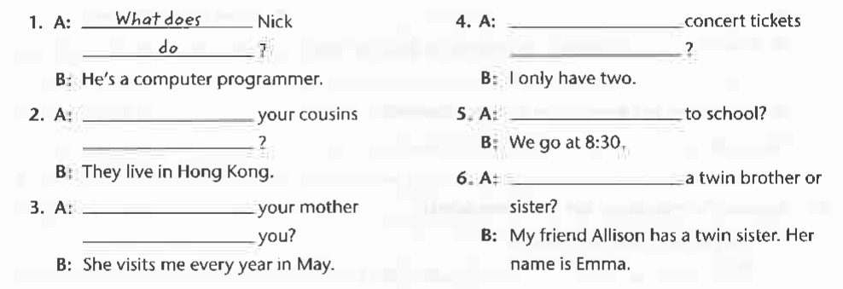

3. Look at the responses. Write information questions with the simple present tense.
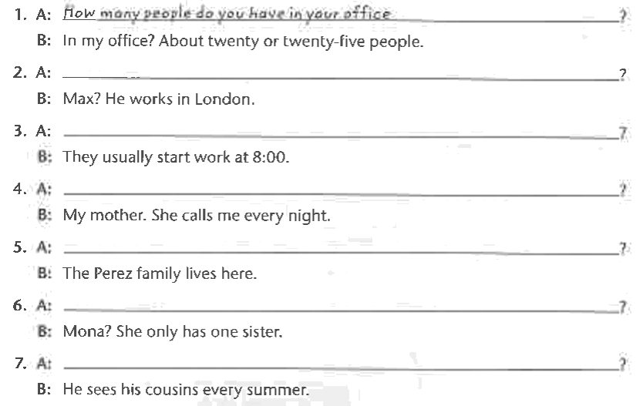

Further discussion questions for topic 1: DESCRIBE A FAMILY MEMBER OR A CLASSMATE
- Is he/she married?
- What is his/ her occupation?
- Where does he/she live now?
- What is his/her hometown?
- What’s his/her last name?
- What’s his/her first name?
- How do you spell his/her name?
- How old is he/she?
- Is he/she tall?
- Does he/she have any brother/sister?
- Does he/she have a big family?
- What does he/she look like?
- Where does he/she study?
- What’s your father’s/ mother’s occupation?
- What’s your mother’s/ father’s name?
- How old is your father/ mother/ sister/ brother?
- Is your brother/ sister married?
- Does your brother/sister have any children?
- Where does your father/mother work?
- What does your father/mother/brother/sister look like?
- What is your father’s/ mother’s birthday?
- What is your father’s/mother’s favorite clothes?
- How do you describe her?
- How do you describe her/his personality?
- What are his hobbies?
- Do you and your friend/ your father look alike?
- What do you and your friend/ your father usually do together?
- What do you love most about him/her?

Writing task:
Hello, teacher. My name is One. Today, I would like to talk about my sister. Her name is Ha Trang. Everyone calls her Mei Chan. She is 20 years old. She is a student at YonSei Unniversity.She is from Ha Noi Capital, VietNam. Now, she lives in Korea to learning. She is a talent and beautiful girl and she has a cute face with big eyes. Her personality are cheerful, humor and talent. Her friends really like her. In her free time, She likes editing video, watching vlog and styding English. I and my sister look different face but alike body. We often watch vlog, sleep and beauty together. What I love most about her is her personality. That’s all about my sister. Thanks for your listening. I hope you like my speech.

