Unit 7: LOCATIONS and DIRECTIONS
Locations
- on the right side /on ðə rait said/: phía bên tay phải
- across /əˈkros/: băng qua, ngang qua
- down the street /daun ðə striːt/: đi xuống con đường
- around the corner /əˈraund ðə ˈkoːnə/: quanh đây, gần đây
- between ………and ………….. /biˈtwiːn ənd/: ở giữa
Directions
- Turn left /təːn left/: rẽ trái
- Turn right /təːn rait/: rẽ phải
Road signs
- Traffic light /ˈtrӕfik lait/: đèn giao thông
- Pedestrian crossing /piˈdestriən ˈkrɔ.siɳ/: vạch qua đường
- Junction /ˈdʒaŋkʃən/: ngã 4
- Roundabout /ˈrɑʊn.də.ˌbɑʊt/: bùng binh
- Petrol station /ˈpetrəl steiʃən/: trạm xăng
- Car park / /kaː paːk/: bãi đậu xe
- Speed limit /spiːd ˈlimit/: Tốc độ giới hạn
- Speed camera /spiːd ˈkӕmərə/: Camera kiểm tra tốc độ
- Lane /lein/: Làn đường

GRAMMAR
PREPOSITIONS OF PLACE: USAGE RULES
Use ON with the names of streets and specific physical locations
on Main Street on Smith Avenue on the corner
Use IN with the names of cities, countries, continents, and other large locations.
in Korea in Africa in the ocean in the center
Use AT for buildings and addresses
at the theater at the supermarket at the bank at 10 NTMK Street
Use AT for general locations of activity
at home at work at school

PRACTICE
1. Complete the sentences with IN, ON, AT
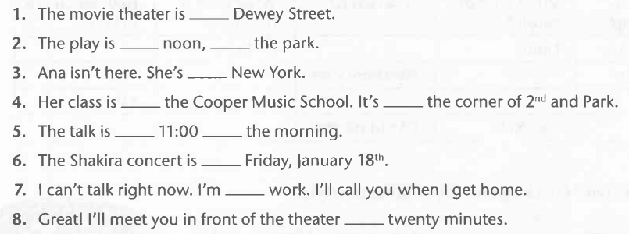
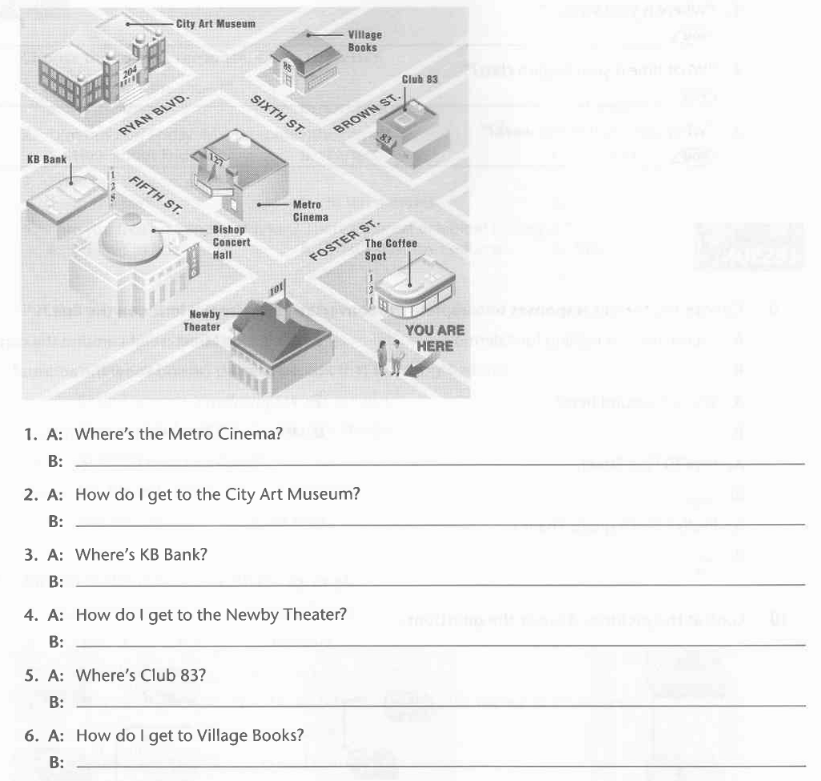
2. Look at the map. Answer the questions.

2. Choose the correct responses to complete the conversation. Write the letter on the line.
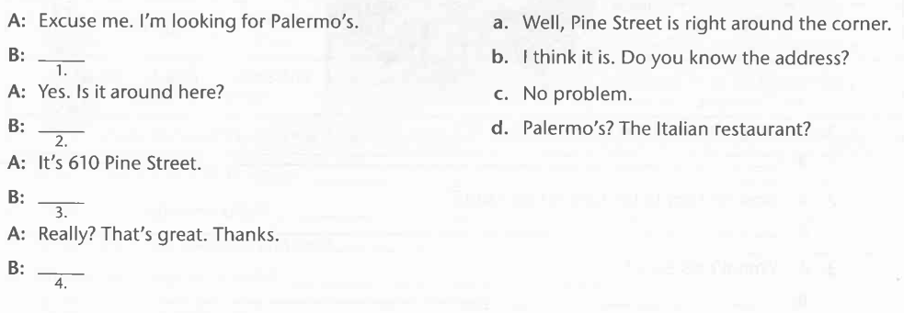

3. Write directions from your home to your school or a place in your community.
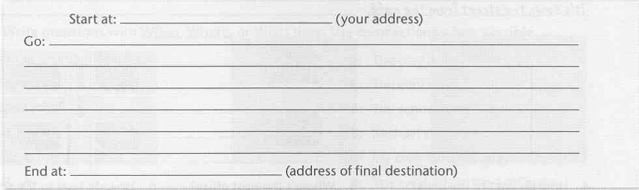

Further discussion questions for topic 2: Locations and Directions
- Where do you live?
- How long does it take you to get to school?
- How do you go to school?
- Where do you study?
- Where is your school?

