INKR Application
Test Plan
Version 1.0
05/13/2022

This document provides an overview of the project and the product test strategy, a list of testing deliverables and plan for development

Huy Nguyen
quochuy13se@gmail.com
VERSION HISTORY
Version  # | Implemented  By | Revision  Date | Approved  By | Approval  Date | Reason
1.0 | Huy Nguyen | 05/13/2022 | PM | 05/14/2022 | Test plan template

1 Introduction
2 TEST STRATEGY
2.1 Test Type 3
2.2 Scope of testing 3
2.2.1 Feature to be tested 3
2.2.2 Feature to be not tested 3
2.3 Risk and issue 3
2.4 Test logistics 3
2.4.1 Who will test? 3
2.4.2 When will test occur? 3
3 TEST OBJECTIVE
4 TEST CRITERIA
4.1 Suspension criteria 3
4.2 Exit criteria 3
5 RESOURCE PLANNING
5.1 System resource 3
5.2 Human resource 3
6 TEST ENVIRONMENT
7 SCHEDULE AND Estimation
7.1 All project task and estimation 3
7.2 Schedule to complete these tasks 3
8 TEST DELIVERABLES
8.1 Before testing phase 3
8.2 During testing 3
8.3 After the testing cycles is over 3

Introduction
The Test Plan is designed to prescribe the scope, approach, resources, and schedule of all testing activities of the project INKR. The plan identify the items to be tested, the features to be tested, the types of testing to be performed, the personnel responsible for testing, the resources and schedule required to complete testing, and the risks associated with the plan

TEST STRATEGY

Scope of testing

Feature to be tested
Module Name | Roles | Description
Account | - Audience  - Publisher | - An audience can sign up, sign in, change password, payments, add-delete reading list, become member, get notification,…  - Publisher can add, edit, manage, sell content on INKR platform
Home | - Audience | - An audience can look at and read all impressive comics, manga, manhua.. such as top highlighted title, trending today, new release, Hot updates, New, Must read for each type  - An audience can look and react to additional right menu (action, adventure, romance..) for exploring  Not only homepage, customer can view additional right menu in other page
INKR Extra | - Audience | - An audience extra can join INKR Extra to get many exclusive benefits
Recommended | - Audience | - An audience can add, edit reading list and receive recommended comics, manga… suitable
Browse | - Audience | - An audience can find exactly type which they want to read
Search | - Audience | - An audience can search and filter any title, author, genre, status, pricing...
Media | - Publisher  - Audience | - Publisher can upload, edit their content to INKR  - An audience can zoom in, zoom out, change background of chapter, share to social network...
Customer Service | - INKR admin | - INKR Admin can take care, support publisher, audience
Notification | - Publisher  - Audience | - Publisher and audience can receive important notification through email, notification board

Feature to be not tested
- Hardware interface
- Database Logical
- Website Security
- Performance

Test type
In INKR project, there are 3 type should be execute:
- API Testing: Test all API create for each module
- Integration Testing: Test modules are combined as a group
- System Testing: Test integrated system to evaluate system’s compliance with its specified requirements

Risk and issue
Risk | Reduce risk
Team members lack required skills | Plan training course to up skills
Project schedule is too tight, It’s hard to complete on time | Set priority for each testing activity
Test manager has poor management skill | Plan leadership training for manager
Wrong budget estimate and cost | Establish the scope before beginning work, pay a lot of attention to project planning and constantly track and measure the progress
Member out company | Plan to find alternate suitable member
A lack of cooperation of member | Encourage and inspire them to greater efforts.  Listening our member and share to help them overcome difficulties

Test logistics

Who will test?
How many out-source and in-source member will test?
Should use out-source to save cost for project
Estimate effort for members to ensure quality project

When will test occur?
- Software is available for testing
- Test Specification is create
- Test Environment is built
- Enough resource for testing

TEST OBJECTIVE
The test objectives are to verify the Functionality of website INKR, the project should focus on testing module such as Account Management, Home Page, INKR Extra, Recommended, Browse, Search, Media... can work normally in real business environment.

TEST CRITERIA

Suspension criteria
- If the team members report that there are 40% of test cases failed, suspend testing until the development team fixes all the failed cases
- If the blocker bug such as: Can’t login, issue from server, database issue happen, suspend testing until the development team fixes

Exit criteria
- Specifies the criteria that denote a successful completion of a test phase - Run rate is mandatory to be 100% unless a clear reason is given. - Pass rate is 80%, achieving the pass rate is mandatory.

RESOURCE PLANNING

System resource
No. | Resource | Description
1 | Server | Need a Database server which install MySQL server Web server which install Apache Serve
2 | Test tool | Develop a Test tool which can auto generate the test result to the predefined form and automated test execution
3 | Network | Setup a LAN Gigabit and 1 internet line with the speed at least 5 Mb/s
4 | Computer, Laptop, Mobile | At least 5 computer run Windows 10, Ram 16GB, CPU 3.4GHZ, 5 macbook, 5 iphone 13 pro max, 5 Samsung Galaxy Z Fold3

Human resource
No. | Member | Task
1 | Test lead | Manage the whole project Define project directions Acquire appropriate resources
2 | Test member | Identifying and describing appropriate test techniques/tools/automation architecture Verify and assess the Test Approach Execute the tests, Log results, Report the defects. Outsourced members

TEST ENVIRONMENT
The Test Environment should be setup as 3 environment: test, stage, production
Each environment should be have document such as: swagger for API, URL endpoint, steps to execute, database correspond, steps to connect DB..

SCHEDULE AND Estimation

All project task and estimation
Task | Members | Estimate Effort
Create the test specification | Test Lead | 170 man-hour
Perform Test Execution | Tester | 80 man-hour
Test report | Tester | 20 man-hour
Test delivery |  | 30 man-hour
Total |  | 300 man-hour

Schedule to complete these tasks
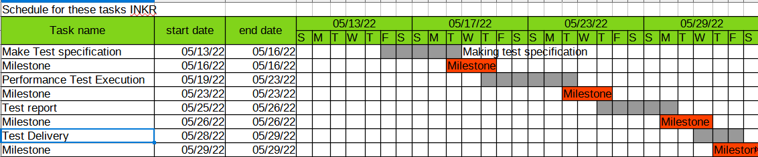

TEST DELIVERABLES

Before testing phase
- Test plans document.
- Test cases documents
- Test Design specifications.

During testing
- Test Tool
- Simulators.
- Test Data
- Test Trace-ability Matrix
- Error logs and execution logs

After the testing cycles is over
- Test Results/reports
- Defect Report
- Installation/ Test procedures guidelines
- Release note

