Overview
Discounts and markups

R-Keeper v.7 features a flexible discount/markup system. Discounts/markups can be either fixed amounts or percentages. The amount of a fixed discount/markup is determined as a fixed amount, which is then deducted from (added to) the amount to which the discount (markup) applies. The amount of a percentage discount/markup is calculated as a percentage of the amount to which the discount/markup applies.
At least one detail is created for each discount/surcharge. Details determine the value of the discount/surcharge as a percentage or the amount of the discount/surcharge (and/or the value and type of bonus) and the conditions required for the discount/surcharge to take effect. Details are arranged using priorities (see Priorities Ordered sequence of objects).
A surcharge is considered distributable if no tax group is selected for it. In this case, the surcharge amount is distributed in the order proportionally to the amounts of the dishes (as is the amount of any discount).
A surcharge is considered non-distributable if a tax group is selected for it. In accordance with this group, taxes will be calculated for the surcharge in the same way as for a dish with such a tax group.
The amount of the distributable surcharge is distributed among the costs of the dishes in the order. The amount of the non-distributable markup is entered as a separate item in the order. An example of a non-distributable markup is an entrance fee. Unlike discounts and distributable markups, a non-distributable markup may not have any details, as it can be designated as a "tip markup."
When calculating "by seat," the markup amount is distributed only to non-empty seats, proportionally to the amount per seat. Discounts/markups are calculated from the price list amount of the order (the amount that includes the cost of dishes, taking into account modifiers that change the price of the dish). Discounts/markups are not calculated from the amount of non-distributable markups.
When creating a discount/markup, select its scope of application on the Properties page: order, seat, or dish. If a discount (markup) with the scope of application "order" or "seat" is assigned in the "Visit calculation" mode (see Visit calculation), it will be applied to the entire visit.
It is possible to select several areas of application for one discount (surcharge). To be able to select discounts/surcharges with the area of application seat at the cash register, the parameter (see section Reference Guide Parameters) must have the value "True". Non-distributed surcharges are only available for orders and seats.
The most commonly used discounts/surcharges are for orders, while discounts for seats are used less frequently. Such discounts can be used when calculating by seat if they are assigned to a currency as a "payment" discount or if they are manually assigned by a cashier, who also specifies the company member for whom the discount is assigned ( ). Discounts on dishes are used if a particular dish has, for example, low liquidity or a short shelf life. The scope of application of a dish is an order line containing any number of portions of the dish. If the same dish is entered in the order with another line, when assigning discounts/markups, it will have an independent dish scope. The same discount/markup as the first one or another discount/markup (other discounts/markups) with the dish scope can be assigned to this dish.
Depending on the Combine with any Discount flag, discounts may or may not be freely combinable. Discounts that do not have the Combine with any Discount flag set on the Properties page are called non-freely combinable. Discounts that have this flag set are called freely combinable. Compositions are defined for non-freely combinable discounts. Freely combinable discounts have no restrictions on joint application.
Combination operations for various sets of non-freely combinable discounts are assigned in the Discount Combinations reference book. All markups are freely combinable. Discounts for a combination are selected from the list of non-freely combinable discounts. Any discount can also be selected as one of the discounts in the composition, allowing you to select no more than one discount when using the composition. One of the following composition operations is specified for the discount composition:
The maximum discount applies;
The discount amount applies;
The following are not valid. (The first non-zero discount applies).
The discount composition operation is only valid at the intersection of all discount application areas included in the composition.
For each dish (taking into account the place that is defined or can be defined for it), the composition is selected by the system separately. If the composition is not found, the discount does not apply. If at least one dish from the discount (markup) scope does not have the required composition, the set of discounts is not compositionally possible. In other words, a discount is compositionally possible if it is compositionally possible for all dishes in the scope of application, as well as for any places that can be assigned to a new dish or to which the places of previously added dishes can be changed. This topic is discussed in detail in the section Calculation of discount compositions.
Discounts depending on the flag A variable value, can be a fixed value or a value that can be entered/changed.
There are discounts/surcharges "on payment" that can be applied when paying in the currency for which they are assigned. A discount/surcharge "on payment" is created in the usual way in the Discounts/Surcharges directory. After that, in the Currencies directory, in the Discounts/Surcharges currency property, select this discount from the directory. When paying in a currency for which such a discount/surcharge is assigned (if this discount has not been added manually before), the payment amount with the discount/surcharge for this payment is calculated automatically.
Discounts/surcharges "on payment" can only be applied to an order or on the spot, depending on what the payment relates to. If the Not manually flag is set for a "per payment" discount/surcharge, such a discount/surcharge is automatically assigned when paying a check in the currency for which it is defined, and this discount/surcharge is not available for selection when assigning discounts/surcharges manually.
If the Not manually flag is not set for a "payment" discount/surcharge, it can be added like any other discount/surcharge to an order or to a location (when defining the corresponding scope of application). Since it is not possible to apply any discount/surcharge to the same scope of application, the "on payment" discount (surcharge) added when placing an order for the scope of application order or location manually will not be added when paying the invoice in the currency for which it is assigned.
The Discounts/Surcharges Reference Guide contains rules for applying discounts and surcharges with conditions for their application. There are 3 application rules:
Allow (default), Prohibit, Automatically. If no rule is assigned to a discount/surcharge, it is allowed to be assigned.
The Allow rule should be explicitly set to override the Automatically and Prohibit rules if necessary.
For each discount/markup, assign a rule (rules) for application and fill in the table of conditions for applying this rule.
For discounts (markups) with the scope of application "Per dish" and "Per seat", the Automatically usage rule cannot be assigned. If a discount/surcharge with the Changeable value flag set is assigned according to the Automatically usage rule, its value cannot be changed; it will be calculated based on the discount (surcharge) details used. If the same discount (surcharge) is not added automatically, its value can be changed.
Discounts/markups added automatically can be deleted by an employee with the "Delete automatic discounts" right.
When assigning percentage discounts/markups, a separate level of detail is selected for each dish (since dishes may differ in categories according to the discount classifier). For fixed-amount discounts/markups, a single level of detail is selected for the area of application.
In the Trade Groups reference book, trade groups determine the affiliation of discount types to trade groups. If there is no discount (markup) in the list of discounts available for selection, it is recommended to check that the following conditions are met:
The discount (markup) is active, the discount (markup) type is active;
The discount/markup can be added to the package, namely:
- The package date is within the interval limiting the discount: Start of sales... End of sales..., if specified;
- The discount (markup) is included in the sales group of the current package, or the discount (markup) type is included in the sales group used;
- The author's role has no access rights restrictions.
- The discount (markup) has been assigned to the appropriate scope of application: order, location, or dish;
There is at least one package for which the discount (markup) application rules are suitable, and the discount is included in the trade group of this package (Reference Guide: Using Discounts/Markups);
The discount is compositionally possible (see the Discount Compositions reference guide);
The same discount (markup) has not been given to a nested or external area of application (intersecting or the same area of application) (except for non- ly distributed markups from closed checks) (see Calculation of discount compositions).
The Not manually flag is not set.
When assigning a discount (markup) and calculating its value (this value can be zero), the following conditions are checked for each dish:
The dish belongs to a package in which the rules for using the discount allow its application, and the trading group of this package contains this discount/markup;
The dish belongs to a classification category (defined in the details) that allows the application of a discount/markup;
If the discount/markup is "on payment," the category restriction for the currency for which it is calculated is checked and the payment distribution is calculated;
If the discount is included in the composition for which the operation is defined, the following do not apply, its value may be empty;
Accounting for detail conditions Min. Quantity (if defined);
Taking into account the conditions for detailing Min. Payment (if defined);
If the dish is paid for with a closed check, the discount will not apply to it.
In order to enable the "Tip" operation when paying for an order in any currency, you need to create a special non-distributable markup to which the "Tip" amount will be assigned and assign it to this currency. The markup assigned to the currency for allocating the "Tip" amount can only be a fixed amount (it cannot be a percentage). The markup used for "Tips" can be assigned according to the rules of use like any other markup (allow, prohibit, automatically), but in the case of performing the "Tips" operation at the cash register, the details of this markup will not be considered.
If the Personal Discount System (PDS) application is used in conjunction with the R-Keeper v.7 application, the discount code in the R-Keeper v.7 editor is specified as the discount number in the PDS. The discount is assigned when the card is swiped through the magnetic card reader. If the discount area of application is defined as "Order," the discount is applied to the order. If the discount area of application is "Seat," after the employee determines the seat, the discount is applied to the seat.
The bonus type defined in the PDS for the guest card can be used in the discount details as one of the conditions for the described discount/surcharge to take effect. Along with the value of the discount/surcharge amount or percentage, the bonus percentage can be specified in the details. The bonus percentage is taken from the discount amount, i.e. if the discount applies to the order, the percentage is taken from the amount of dishes in the order; if the discount applied to the seat (even in the case of a general calculation), the percentage is taken from the amount of the seat to which the discount applied.
Two or more discount cards can be applied to one order. If the discount was not applied for any reason (no discount with this code was found, composition prohibited, this discount was previously given without using a card or with another card, etc.), then the card is considered inapplicable to this order. In this case, the check amount will not be included in the PDS as the purchase amount (for a cumulative discount, in the card operations window in the PDS, this is the "Paid" amount). If the PDS card is applicable to the order, but there should be no discount (there is no non-zero discount detail), a zero discount is used. If the discount applies to the order, all order receipts will be counted in the POS as the purchase amount. If the discount is given for a seat, the POS will count the receipts for that seat and the total receipts as the purchase amount.

Discount/Markup Type Properties
Discounts/Markups Reference Guide
Reference Guide for Using Discounts/Markups
Discount Composition Reference Guide
Bonus Types
Interaction between R-Keeper v.7 and PDS systems
Calculation of Discount Combinations

Basic reference guides and system concepts

R - Keeper v 7

Chapter 1
Properties of Discount/Markup Types

Depending on the object selected in the discount/markup tree, the Properties page may contain a description of the discount/markup type or a description of the discount/markup.
The Properties page for the discount/markup type (see Fig. below) contains the following groups:
Main - see Main;
Trade groups - see Trade groups;
Restrictions - see Restrictions;
Visualization - see section Visualization;
Selectors - a group that lists non-preset Check selectors: Main selector (if created by users). In these properties for the described discount/markup type, you can create a graphical model of the selector page (see Selectors Reference).
Properties page for discounts/markups - see section Properties of Discounts/Markups.
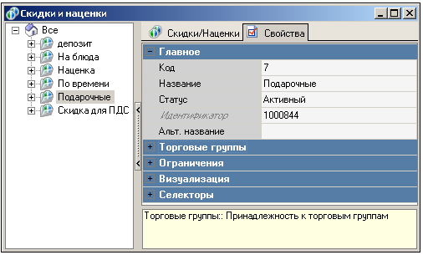

Discounts and markups

Basic reference guides and concepts of the system

R - Keeper v 7

Chapter 2

Overview
Reference Discounts / Markups

The reference tree contains discount (markup) types and the discounts/markups themselves. When you select a discount type in the discount tree, the Discounts/Surcharges are displayed in the Elements window area (see Fig. 1). When you select a discount/surcharge in the discount tree, the Discount/Surcharge Details are displayed in the Elements window area (see Fig. 2).

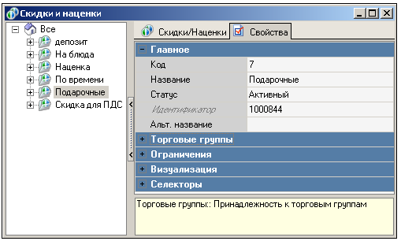
Fig. 1

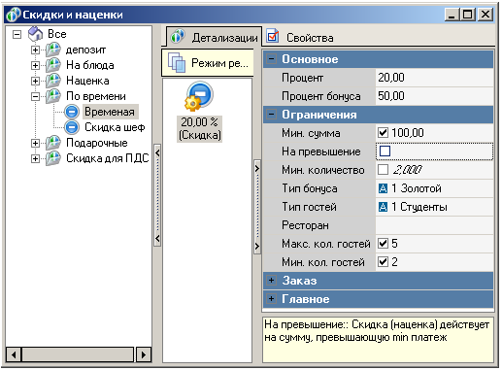
Fig. 2

Discount/Markup Properties
Discount/Markup Details Properties
Adding a discount/markup type, details

Discounts and markups

Basic reference books and system concepts

R - Keeper v 7

Section 1
Properties Discounts / Markups

If the discount type is selected in the tree, the Inspector window on this page displays the discount (markup) properties (see Fig. 1):

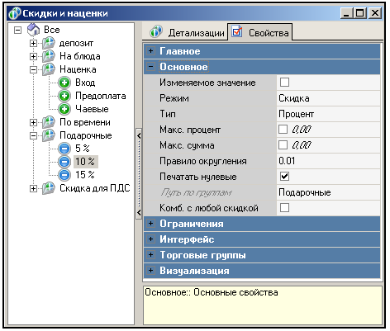
Fig. 1

v If your company uses PDS, discount codes must be no more than two digits (from 1 to 99).

Main points - see section Main points;
Main
Changeable value - if this field is checked, the discount value can be entered manually at the cash register. If the Auto rule is assigned to the discount/markup, its value cannot be changed;
Mode - select from the list in this field: "Discount" or "Markup" is created;
Type - type of discount/markup added: percentage or amount;
Max. Percentage - in this field, you can specify the maximum allowable percentage of the cost of dishes covered by the discount (discount coverage area);
Max. Amount - in this field, you can specify the maximum allowable amount that the discount/markup can reach;
Rounding rule - the order of rounding the discount (markup) amount;
Print zero values - if you check this box, this discount will be printed on the receipt even if its value is zero;
Path by groups - this field automatically displays the path through the tree to the discount/markup being created;
Combine with any discount - if you check this box, the discount will be freely combinable and cannot be included in ordered sets of discounts in the Discount Combinations reference book.
Only for non-distributed markups, see Fig. 2:

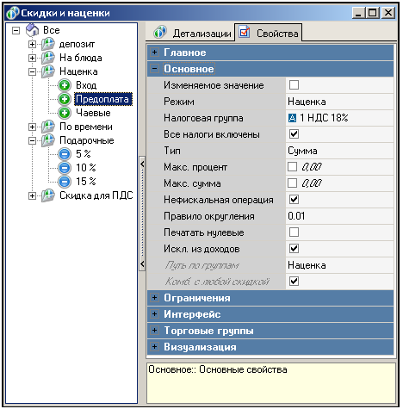
Fig. 2

v Changing non-distributability (selecting a tax group for a distributable markup or deselecting a tax group for a non-distributable markup) is only possible for markups with Draft status. This restriction is due to the fact that active or inactive markups can be transferred to the Store House, where they appear as dishes. Dishes cannot disappear without a trace, only their status can be changed to Deleted.
Tax Groups - in this field, select the markup tax group from the list. The distribution of the non-distributed markup amount among all guests is calculated in proportion to the amount of each guest's order.
All Taxes Included - only for non-distributed markups. If this flag is set, all taxes will be considered included, regardless of the Add to Price flag in the Taxes reference book. The flag is used for tips;
Non-fiscal transaction - when the Tax Groups flag is set, the surcharge is considered non-distributable, and the Non-fiscal Transaction flag appears in the inspector window. This option is intended for accounting for various types of tips and service charges. If the legislation of your country allows such amounts not to be accounted for through fiscal memory, you can set this flag - when set, the markup will not be accounted for by the fiscal registrar and will not be included in the fiscal receipt.
Example: The customer paid 100 rubles for a dish and 20 rubles as a "tip." If the Non-Fiscal Transaction flag is set for the "Tip" markup, "-20 rubles" will be automatically added to the receipt.
Excluded from Income - when the Non-Fiscal Transaction flag is set, this flag appears, which can be used in reports to separate different types of non-fiscal transactions, the proceeds from which do not go to the cash register.
Since non-fiscal markups are not printed on the fiscal receipt, there will be discrepancies between the cash in the cash register and the fiscal reports. These discrepancies can be corrected with additional fiscal documents on cash deposits. A receipt for tips will only be printed if the markup is flagged as a Non-fiscal transaction and the Tip accounting parameter is set to "True";
Restrictions - see Restrictions;
Classification - if necessary, select a classification from the list in this field. In the Details (Details) of this discount (markup), select the menu categories for the discount being created that relate to the selected classification.
Per Dish - set the flag in this field to define the scope of application of the added discount (markup) "Per Dish". The number of areas of application per dish in the order is equal to the number of order lines. This area of application is not available for discounts (markups) that have the Not Manually flag set;

v If the classification is specified and no category is selected in the details, this detail applies to dishes with no specified category in the corresponding classification (see the Dish Classification Reference Guide).

Per Order - set the flag in this field to define the scope of application of the added discount (markup) "Per Order". There is one scope of application per order;
On Site - check this box to specify the scope of application of the added discount (markup) "On Site". Discounts (markups) with this scope are available for assignment only if the Use Place parameter (see the Parameters Reference) is set to "True." The number of areas of application for the place in the order is equal to the number of guests in the company;
Not manually - if this flag is set, the discount (surcharge) is not available for manual assignment (it will not be displayed in the list of discounts for selection when assigning manually at the cash register). The flag can be used, for example, for discounts (surcharges) "on payment" or surcharges assigned for "tips". Discounts (markups) with this flag set cannot have the "Per dish" scope of application.
Access right - select the access right to the trade object that the cashier must have in order for the described currency to be available for selection.
Start of sales - if there is a start date for using the reference item being created, enter it in this field;
End of sales - if there is an end date for the use of the object, enter it in this field;
Multiple times - if the Amount discount type is selected, this flag appears, which means that the amount discount can be applied multiple times. In this case, percentage and amount restrictions on the discount cannot be used;
Manager confirmation - if this flag is set, the discount cannot be assigned manually by an employee who does not have the "Manager confirmation for discount" right;
Interface
Ignore end date - by setting this flag, you can cancel the expiration date of the discount card (not to be confused with PDS cards). This property is not available if the MCR algorithm property is not filled in.
MCR algorithm - if the company uses a magnetic card reader, to select a discount, specify the MCR algorithm for this discount in this field (see MCR Algorithms Reference Guide). When this property is filled in, the Magnetic Card Type and Ignore Expiration Date discount properties appear.
Interface - see Interface;
Magnetic card type - the number written on the magnetic card for this discount. This property only appears for discounts where the MCR algorithm property is filled in. Can be used in the MCR algorithm parameter to determine this discount. This property is not available if the MCR algorithm property is not filled in.
Only for non-distributed markups:
Transaction code - transaction code for replenishing the card balance.
Transaction values - The value (amount) of the FarCard transaction on the payment card (if the transaction code is not zero).
Merchant Groups - see Merchant Groups;
Visualization - see section Visualization;

Reference Guide Discounts / Markups

Discounts and markups

Basic reference guides and concepts of the system

R - Keeper v 7

Section 2
Properties of Discounts/Markups Details

For discounts/markups, create details specifying the conditions of application and determining the amount or percentage of the discount/markup and bonus.
For a fixed amount discount/markup and for a percentage discount/markup with an unspecified classification, one detail works for the entire area of application. For a percentage discount/markup with a specified classification, a separate detail is selected for each category.
The properties of the detail contain the following groups (see Fig. 1):

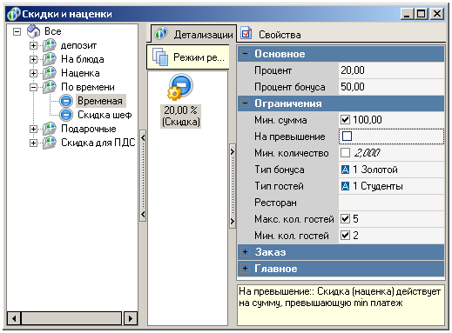
Fig. 1

Basic
Percentage (Amount) - enter the discount value in this field - a percentage of the dish price (if the discount is a percentage) or an amount (if the discount is an amount).
Example. Let's consider assigning a percentage and amount discount with the scope of application "Order" to the same order. The discount is defined for the "Meat content" classification. The order includes the following dishes: "Borscht" (category "Non-vegetarian menu") - 3 servings at 70 rubles each; "Vegetable stew" (category "Vegetarian menu") - 2 servings at 55 rubles each; "Fruit salad" ("Vegetarian menu") - 2 servings at 73 rubles each.
The "Special" discount (for the "Meat content" classification) has the following details:
1) 10 rubles, applicable to orders containing dishes from the "Non-vegetarian menu" category, with a minimum amount of 200 rubles (flag "For exceeding" is set);
2) 15 rubles, applicable to orders containing dishes from the "Vegetarian menu" category, with a minimum amount of 250 rubles (the "Exceed" flag is not set).
The priority of the 15 ruble discount is higher than that of the 10 ruble discount, so the 15 ruble discount will be considered first. Since the total amount of the "Fruit Salad" and "Vegetable Stew" dishes, which belong to the "Vegetarian Menu" category, is 256 rubles, which is more than 250 rubles (the minimum amount required to apply the discount), the 15-ruble discount will be applied to the order total. This completes the review of the order for the application of the total discount.
The "Special" percentage discount has the following breakdown:
1) 10%, applicable to orders containing dishes from the "Non-vegetarian menu" category, with a minimum payment of 200 rubles (the Exceed flag is set);
2) 15%, applicable to orders containing dishes from the "Vegetarian menu" category, with a minimum payment of 250 rubles (the "Not set" flag is set).
The priority of the 15% discount is higher than that of the 10% discount, so the 15% discount will be considered first. Since the total cost of the "Fruit Salad" and "Vegetable Stew" dishes in the "Vegetarian Menu" category is 256 rubles, which is more than 250 rubles (the minimum amount required for the discount to apply), a 15% discount will be applied to the total amount for all dishes in the "Vegetarian menu" category. Next, the 10% discount will be considered. The discount applies to the dish "Borscht," with a total amount of 210 rubles. (more than 200 rubles - the minimum amount at which the discount is applicable). Since the Exceed flag is set, a 10% discount will be applied to (210 - 200) rubles = 10 rubles - the amount exceeding the minimum amount for applying the discount.
Bonus Percentage - the percentage of the bonus to be accrued. It is calculated from the bonus value defined for the price type used (Price Types reference book, Bonuses page).
The bonus value for a price type can be calculated according to the calculation rule corresponding to the dish category (Bonuses page), or directly specified in the Menu reference book in the Bonus property (Prices group) - if the price type does not use calculation rules. If the Bonus - Percentage flag is set in the price type, the bonus percentage specified in the described property will be taken from the amount calculated as a bonus percentage in the price type used. This is done in the same way as calculating the consumption value and the amount of payment to the consumer, see section Scheme for calculating the consumption value and bonus, section Scheme for calculating the amount of payment to the consumer, the amount of bonus accrual. The Bonus Percentage specified in this property in the Calculation of the amount of payment to the consumer scheme is equivalent to the consumer's Percentage property.
Restrictions
Min. Amount - enter the minimum amount on the price list in this field, at which it becomes possible to apply this discount detail. If the discount (markup) has a restriction on the category of application, the Min. Amount is determined by this category. When the flag is set in this field, the Exceeding property is displayed for filling in (see below);
On Exceedance - if this flag is set, the discount is applied to dishes that are in the order after the amount specified in the Min. Amount field has been reached. In this case, the order of the dishes in the order is important for the discount amount. If the flag is not set, the discount will be applied to all dishes in the order if its price list amount exceeds the amount specified in the Min. Amount field.
Min. Quantity - in this field, you can enter the minimum number of portions of dishes in the area of application at which it becomes possible to apply this discount detail. This condition can only be set for percentage discounts/markups. The condition is checked for the total number of dishes in this classification group throughout the entire area of application. When the flag is set in this field, the Quantity Mode property is displayed.
Bonus Type - the bonus type applicable in this detail (from the Bonus Types reference book). To fulfill this detail condition, it must match the bonus type on the customer account card in the POS.
Guest Type - in this field, you can select the type of guests for whom the discount applies from the list;
Restaurant - select the restaurant in which the described detail will be applied in this property.
Max. No. of Guests - the maximum number of guests for which this discount detail applies.
Min. number of guests - the minimum number of guests for which this discount detail applies;
Order category - the order category where this detail applies.

After the Open Seat operation, these restrictions are checked. After the Close Seat operation, these restrictions are not checked, as this operation is equivalent to closing the check for the seat.

Reference Guide Discounts / Markups

Discounts and Surcharges

Basic reference guides and system concepts

R - Keeper v 7

Section 3
Adding discount/markup types, details

To create a discount/markup type:
? Select the discount/markup type to which the discount/markup type being created should belong (if the discount/markup type being created should be created at the root of the hierarchy tree, select the zero-level group All);
? In the hierarchy tree or from the Elements area, call up the pop-up menu, New Discount Type command;
? Fill in the discount/markup type properties (see Discount/Markup Type Properties);
? Save your changes.
To create a discount/markup, do the following:
? Select the discount/markup type to which the discount/markup being created should belong;
? In the hierarchy tree or from the Elements area, call up the pop-up menu, New Discount/Surcharge command;
? Fill in the discount/markup properties (see Discount/Markup Properties);

v Before activating a discount/markup (except for non-distributed markups), you must add at least one detail.

? Save your changes.
To create a discount/markup detail:
? Select the discount/markup to which the detail should apply in the hierarchy tree;
? Open the pop-up menu from the Details Page Elements area, New Detail command;
? Fill in the breakdown properties (see Discount/Markup Breakdown Properties).
? Save your changes;
? If necessary, prioritize the details.

Reference Guide Discounts / Markups

Discounts and Surcharges

Basic reference guides and concepts of the system

R - Keeper v 7

Chapter 3
Reference Guide Using Discounts/Markups

The Reference Guide for Using Discounts/Markups is shown in the figure below.

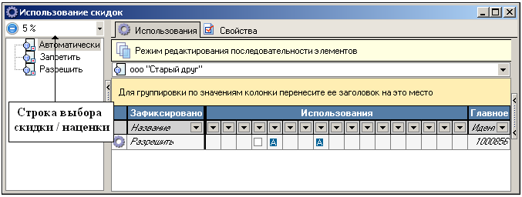

In the left pane of the window, you can see the application rules that can be assigned to the discount/markup selected in the selection bar. In the right pane of the window, there is a table with rules for using discounts/markups.
If no usage rules are assigned to the discount/markup, the Allow without conditions rule applies.
If the discount/markup has the Not manually flag set, it is not available for manual assignment at the cash register by any employees, regardless of the usage rules.
Objects assigned as conditions for use: Order Type, Employee, Period, Role, Trade Group, Order Category, Hall Plan, Table Type, Guest Type, Employee Group, Language.
In the figure above, the Allow rule will be considered first. It applies to the employee Kuzmin in the Evening Menu sales group. In all other cases, the Prohibit rule applies to this employee. In all cases not described by the usage rules, the "Temporary" discount can be applied (the Allow rule applies by default). During the "Discount" period, the "Temporary" discount is applied automatically.

v If, according to the terms of use, the Automatically rule should apply to two discounts that cannot be combined, the discount with the lower code will be applied.
v A discount assigned automatically is only valid in packages where the rules for automatic discount assignment apply, so the value of a manually assigned discount may not match the value of the same discount assigned automatically.

Discounts and markups

Basic reference guides and system concepts

R - Keeper v 7

Chapter 4
Discount Composition Reference Guide

The Discount Composition window is shown in Fig. 1.
The left pane of the window displays discount compositions, while the right pane displays the properties of the selected composition.

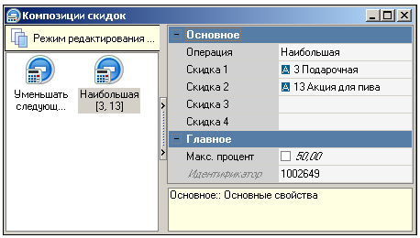
Fig. 1

v The discount composition priority will play a decisive role if "any discount" is used as one of the discounts in the composition.

Compositions in the reference book are arranged by priority.
"Any discount" is displayed in the composition with the code "-1".
To add a new discount composition, open the pop-up menu in the left pane of the window and select Create Discount Composition. Fill in the Inspector window for the discount composition you are creating.
Basic
Operation - select the operation to be assigned to the composition from the list in this field:
Largest;
First non-zero;
Summarize;
Decrease the following (see description in Calculation of discount composition actions).

v When calculating a composition with the Largest operation, the maximum discount amount will be distributed among the discounts applied to the dish in proportion to their values.

Discount 1 - the first discount in the composition;
Discount 2 - the second discount in the composition;
Discount 3 - the third discount of the composition;
Discount 4 - the fourth discount of the composition.

The First Non-Zero operation is useful when creating discount combinations, one of which has a Category restriction. To do this, select it as Discount 1 in the combination. In this case, when assigning discounts to an order, the possibility of applying this discount to dishes of the selected category will be considered first. To apply the second (and subsequent) discounts, dishes that do not belong to the category to which Discount 1 is assigned will be considered.

Max. Percentage - this field specifies the maximum percentage of the discount composition from the total amount of dishes in the area of application.
If the Max. percentage is specified in the composition and it turns out to be less than the calculated amount, the amount taken at this percentage is distributed among the discounts in proportion to the discount amounts calculated before combining.
When creating a composition of 3 or more discounts, it is necessary that there are paired compositions of all discounts included in it.
If the necessary compositions are not created, an error message is displayed listing the compositions that need to be created (see Fig. 2).

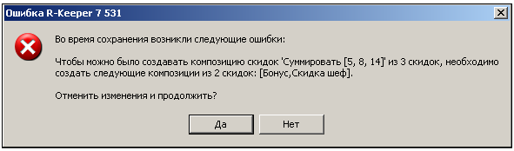
Fig. 2

Discounts and markups

Basic reference books and concepts of the system

R - Keeper v 7

Chapter 5
Bonus Types

This reference guide must be completed if the establishment plans to accrue bonuses on PDS cards.
The type of bonus is described by the properties of the group.
Main - see Main. (see Fig. 1).
Main
Discounted dish - if this flag is set, the amount of discounts (markups are ignored) for each dish will be checked. If the dish is discounted, no bonus will be accrued (see Calculation of the amount of payment to the customer, amount of bonus accrual).
Interface - see Interface.
Transaction code - transaction code for replenishing the card balance.

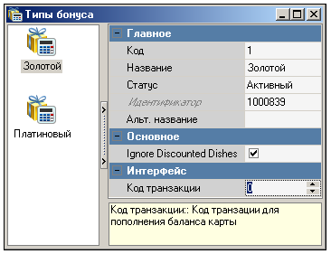
Fig. 1

The bonus type and bonus value are specified in the discount details (see Fig. 2).

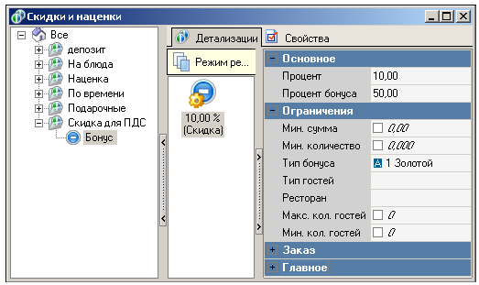
Fig. 2

The main criteria for crediting a bonus to a PDS card are:
the bonus percentage in the discount details must be different from "zero" (see Fig. 2);
the bonus type specified in the discount details must match the bonus type specified in the PDS card properties on the Parameters tab (see Fig. 3);

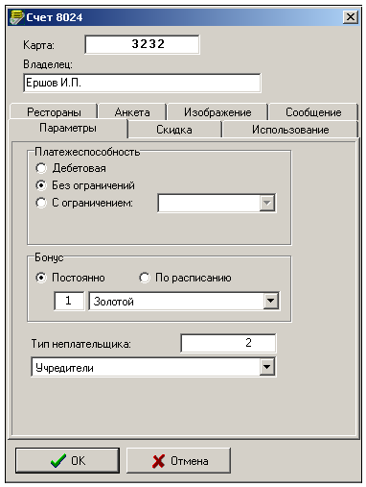
Fig. 3

The discount created in the R-keeper 7 program must be specified in the card's POS properties on the Discount tab (see Fig. 4).

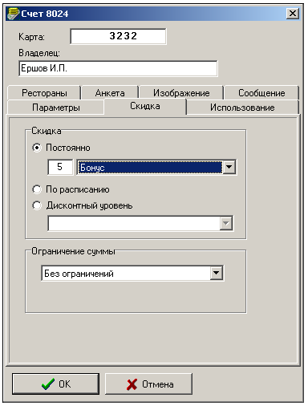
Fig. 4

The bonus percentage in the dish properties must be different from "zero" (see Fig. 5), since the calculation of the bonus amount accrued to the PDS card is based on the bonus amount of the dish (see Prices).

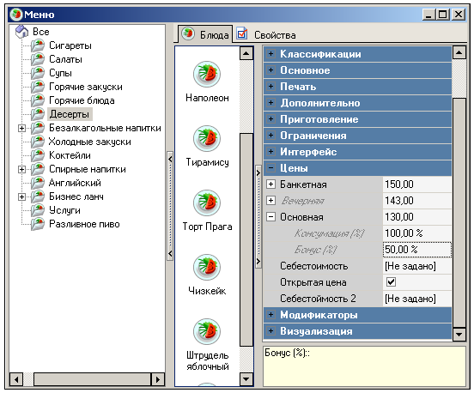
Fig. 5

- The bonus percentage in the currency properties must be different from "zero" (see Fig. 6).

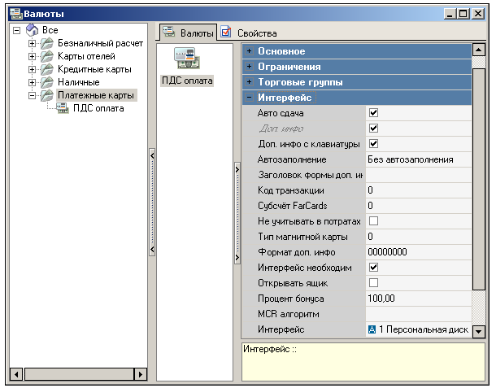
Fig. 6

Using R-keeper 7 and the PDS program, you can adjust the bonus accrual percentage on the PDS card, depending on the amount spent.
Let's consider the settings for a PDS card, which is only a bonus card and the bonus value depends on the amount spent:
The bonus accrual rules in this example will be as follows:

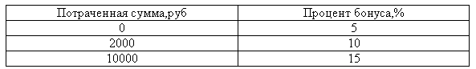
Fig. 7

1. In the R-keeper 7 program, in the Bonus Types reference book, create a bonus type, for example, "gold";
2. In the Discounts and Markups reference book, create three "zero" discounts with different bonus percentages. The discount percentage must be zero, as the card is only a bonus card (see Fig. 8, Fig. 9, Fig. 10);

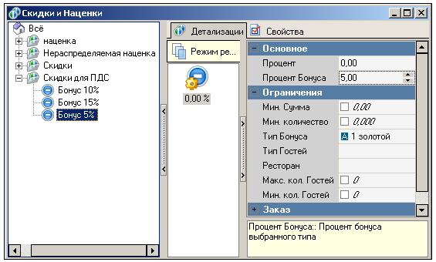
Fig. 8

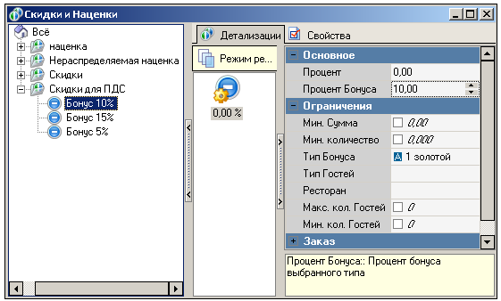
Fig. 9

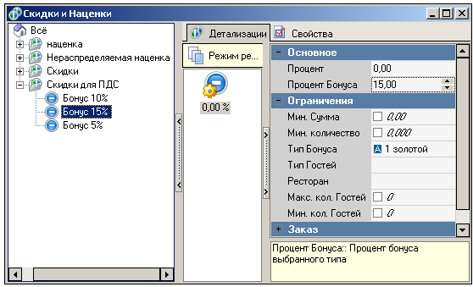
Fig. 10

3. In the PDS program, create a discount in the Composite Discounts reference book (see Fig. 11);

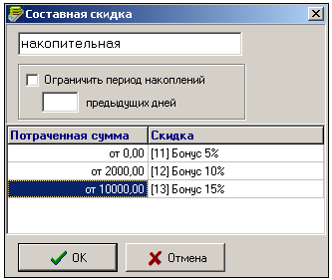
Fig. 11

4. Specify the following in the PDS card properties:
On the Parameters tab, specify the Bonus Type specified in the discount details;
On the Discounts tab, specify the composite discount that you created in the PDS program.

- Note: The Bonus (%) in the dish properties and the Bonus Percentage in the currency properties must be different from zero.

Discounts and markups

Basic reference guides and system concepts

R - Keeper v 7

Chapter 6

Overview
Interaction between R-Keeper v.7 and PDS systems

Using PDS cards in the R-Keeper v.7 system, you can perform the following actions:

Accrue a discount on a PDS card;
Accrue a bonus on a PDS card;
Accrue a discount and bonus on a PDS card;
Use a PDS card as currency when paying a bill with or without a discount and/or bonus.

v Assigning a bonus to a PDS card is only possible if the following are assigned to the card in the system:
1. Bonus type;
2. Discounts from the R-Keeper system. If a discount is not required, the details of this discount must have a zero value.
v The discount code intended for assignment using the PDS card must match the discount code in the PDS card.
v The discount percentage assigned by the PDS card is always calculated from the unpaid amount of the order. If, in addition to the "Order" definition area, the "Location" definition area is defined for the discount, place the cursor on this discount and use the Location operation.

Using a special interface (see Interfaces), the R-Keeper v.7 system interacts with the personal discount system (PDS).
The following settings are configured in the PDS personal card:
? Discount selection (from the R-Keeper v7 discount list) on the Discount page;
? Bonus selection (from the list of R-Keeper v7 bonus types) on the Parameters page;
? Selection of the type of non-payer (from the list of R-Keeper v7 non-payer types) by non-payer code on the Parameters page.
If the non-payer type is not selected (the value of the Non-payer type field on the PDS card Parameters page is "0"), then there are no restrictions on expense items. If the non-payer type is selected, the currencies allowed for this type of non-payer are available for paying the bill (see Non-payer Types).
The list of card transactions in the PDS contains data reflecting card actions in the R-Keeper v7 system:
Discount - the discount amount selected for this personal card on the Discount page;
Payment through the cash register - the amount paid in the currency - card expense item;
Spent - total check amount (may not match the amount paid at the cash register). This amount is displayed in PDS card transactions only if a discount was given on the card. From this condition it follows that:

v For a cumulative discount in the POS, the first threshold value must be set to 0.00. To prevent the discount from being applied, a zero discount should be assigned to this threshold value.

Discount deletion - in case of cancellation or deletion of a receipt - the amount of the deleted discount;
Cancellation of spending - in case of cancellation or deletion of a receipt - the amount of the deleted spending.
When swiping a magnetic card through the reader, the following sequence of actions is performed:
1. R-Keeper v.7 searches through MCR algorithms. If an MCR algorithm is found with the Area set to "Interface" and the Object set to "Personal Discount System," a request is sent to the PDS, where the card code is transferred.
2. The PDS returns information about the card and customer to the R-Keeper v.7 system, including the customer's full name, photo, discount and/or bonus type code, non-payer code, and balance. The data is displayed at the cash register in special screen forms.
3. The discount is added to the order if it can be added. The discount may have a zero value if none of the conditions are met, or a non-zero value (calculated based on the details used).

v If the Bonus Type detail flag is set, in order to accrue the bonus and calculate the discount amount for this detail, the bonus type code in the detail must match the bonus type code specified on the Personal Card Settings page.

The Bonus Percentage set in this detail property is calculated from the bonus price (bonus value) in the manager application (see Calculation of consumption, bonuses, Calculation scheme for consumption and bonus values). The bonus accrual amount is calculated on the workstation (see Calculation of consumption, bonuses, Calculation scheme for the amount of payment to the consumer, bonus accrual amount).

v The bonus is only assigned if a discount was assigned to the card (i.e., the discount was not selected manually). In this case, the discount value can be zero.

4. After the personal card is swiped through the reader, the currencies associated with this card are pre-personalized by determining the type of non-payer (see section Types of Non-payers). As a result, the currencies - expense items defined for this card are displayed (available only to employees with the right to pre-personalized currencies) in the "Payment Cards" currency group. The button with these currencies displays the cardholder's full name and the name of the expense items.
The R-Keeper v7 system allows you to set up employee meal accounting using the same cards that employees use to register in the system. To do this, you need to create employee cards in the PDS. The exception is temporary registration: separate from the PDS, manager cards must be created for temporary registration. If a discount or currency is associated with the card (via the MCR algorithm or authorization via the interface), temporary registration with this card will not be performed. If such a card exists in the PDS, the discount or currency will be added.
This restriction can be avoided by performing temporary registration of employees only using the "Temporary Registration" operation (rather than swiping the card through the reader). In the standard delivery, this operation is available in the TS station operations menu. On keyboard stations, this operation should be assigned to one of the buttons.

Configuring the R-Keeper v.7 system for interaction with the PDS

Discounts and markups

Basic reference guides and system concepts

R - Keeper v 7

Section 1
Configuring the R-Keeper v.7 system for interaction with the PDS

I. In the MCR reference book - algorithms (see MCR Reference Book Algorithms):
? Add MCR - algorithm "PDS", for which define:
1. Area - value "Interface";
2. Object - value "Personal discount system";
3. Device types: "Magnetic card" (if used, also "Proxy card" and "Barcode").
I. In the Bonus Types reference book (only applicable if bonuses need to be assigned to PDS cards).
? Create bonus type(s) (e.g., Gold);
II. In the Discounts and Markups reference book (only if discounts and/or bonuses need to be calculated for PDS cards).
Create a discount, the code of which should be specified for the card in the PDS system in the "Discount" field. Define the properties for the discount:
? Scope flag - To Order or On Site;
III. Create a discount detail in which:
? Specify the Bonus Type value (select from the list of R-Keeper bonus types (e.g., Gold)). Only applicable if a bonus must be accrued for the card;
? Specify the Bonus Percentage value (only if a bonus is to be accrued on the card);
? If a discount is required, specify the discount percentage (discount amount). If no discount should be accrued on the card (only a bonus is accrued), set the discount value to zero;
? If necessary, you can specify other conditions for detailing.
IV. In the Currencies reference book (only if you need to be able to pay bills with the card).
? Create a currency and set its interface to "PDS Interface."
? Remove the No bonuses flag (Main properties group) for currencies that can be used to accrue bonuses when paying.

Interaction between R-Keeper v.7 and PDS systems}

Discounts and markups

Basic reference books and system concepts

R - Keeper v 7

Chapter 7
Calculation of discount combinations

In this chapter, we will take a detailed look at how combinations affect the applicability of discounts.
Discount combinations can include discounts that apply to different areas: order, seat, dish.
The order scope includes the scope of all seats and the scope of all dishes. The scope of each seat is "independent" of the scope of other seats (does not include the scope of other seats). The area of application for a seat includes dishes that belong to that seat, as well as parts of dishes for which the seat is not specified (in the case of calculation by seat (see Calculation of order by seat), the cost of such dishes will be distributed among all seats in the order).
Discounts are considered when calculating the composition in the order of their location in the composition in the Main properties group.
The applicability of a discount is determined for each dish separately. Discount compositions for a dish are checked taking into account the place that is or is not assigned to the dish (in this case, the dish is "general").
A non-freely combinable discount that is not included in any composition can be assigned if no other non-freely combinable discounts have been previously assigned to this area of application. If other non-freely combinable discounts have been previously assigned to the scope of application of this discount, or if the scope of application of this discount falls within the scope of application of previously assigned non-freely combinable discounts, it can only be assigned if a composition is found that allows its application.

v If the order does not contain any non-freely combinable discounts and no discount composition is defined in the corresponding reference book, it is possible to assign non-freely combinable discounts with the following areas of application:

- "On order". One discount with this scope of application can be assigned, after which all non-freely combinable discounts will become unavailable for assignment.
- "On site." You can assign one discount with this scope of application to each seat, after which all non-freely combinable discounts will become unavailable for assignment. Another possible option. If a company of 3 guests is being served and a discount with the "Per seat" area of application is assigned to the 1st seat, you can assign discounts with the "Per dish" area of application to each dish for which 2 and/or 3 seats are specified. After that, all discounts that cannot be freely combined will become unavailable for assignment.

- "Per dish". One discount with the "Per dish" scope of application can be assigned to each dish. After assigning the first discount to a dish, all discounts with the "Per order" scope of application will become unavailable for assignment. If no seat is specified for this first "Per dish" discount, all "Per seat" discounts will also become unavailable for assignment. If a seat is specified for the dish, a discount with the "Per seat" scope cannot be assigned to that seat. After that, all discounts that cannot be freely combined will become unavailable for assignment. For example, a company of 3 guests is being served, and the "Per dish" discount is assigned to a dish for which the 1st place is specified. A discount with the "Per place" scope of application can be assigned to the 2nd and/or 3rd places, but not to the 1st place.
For a combination of 3 discounts, all paired combinations of discounts included in it must exist. For a combination of 4 discounts, all paired and tripled combinations of discounts included in it must exist.
The "Reduce the following" operation allows the second, third, and fourth discounts to be calculated from the amount of the scope of application (order, location, or dish) without taking into account the amounts of previous discounts.
For example, there is a composition of three discounts (see Fig. 1). (Compositions of pairs of discounts included in this composition have been created in advance: with the "Subtract the following" operation - for discounts "5%" and "10%"; "15%" and "10%"; with the "Sum" operation - for discounts "15%" and "5%").

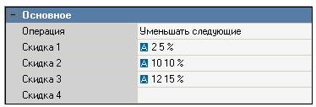
Fig. 1

All discounts with the scope of application - "On order". The order amount is 200 rubles. The amount of the first added discount "15%" is calculated from 200 rubles (see Fig. 2).

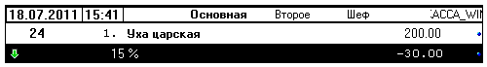
Fig. 2

The amount of the second added discount, "5%," is calculated from the order amount of 200 rubles using the "Sum" composition operation (see Fig. 3).

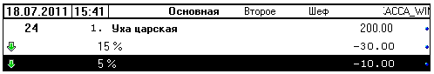
Fig. 3

When the third discount is added, the composition of three discounts takes effect and the discount amounts are recalculated: the "5%" discount is indicated in the composition as "Discount 1", so it is calculated from the order amount of 200 rubles. The amount of the "10%" discount is calculated from the order amount taking into account the first discount - 190 rubles. (200 - 10). The amount of the third discount of 15% is calculated from the order amount, taking into account the two discounts applied - 171 rubles. (200 - 10 -19) (see Fig. 4).

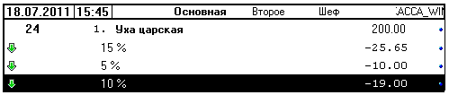
Fig. 4

Discounts and markups

Basic reference books and concepts of the system

R - Keeper v 7

