HO CHI MINH CITY UNIVERSITY OF TECHNOLOGY

FACULTY OF COMPUTER SCIENCE & ENGINEERING

Hình ảnh

**DISCRETE STRUCTURE FOR COMPUTING**

**(CO1007)**

Assignment Report – Group 10

**VIETNAMESE STOCK MARKET ANALYSIS**

**Lecturer: Mr. Trần Tuấn Anh, PhD**

|  |  |  |
| --- | --- | --- |
| **Student Name** | **Student ID.** | **Work Distribution** |
| Nguyễn Đức Bảo Huy | 2152089 | 25% |
| Nguyễn Vũ Khánh | 2153444 | 25% |
| Đặng Hoàng Gia | 2153312 | 25% |
| Hoàng Tiến Đức | 2152520 | 25% |

HO CHI MINH CITY, DECEMBER, 2022

**Contents**

**I.** **Introduction** 3

**II.** **Problem Solving** 3

**1.** **Collecting Data** 3

**2.** **Analyzing movement** 5

**2.1.** **Data Selection** 5

**2.2.** **Data Import** 5

**2.3.** **Data Preprocessing** 6

**2.4.** **Build Predictive Model** 10

**3.** **Predictive Model** 14

**3.1.** **Three stocks in three different sectors (HNX-INDEX): tourism, finance, F&B** 14

**3.2.** **Three stocks with the strongest drop rate on HNINDEX in the period from January to July 2022** 18

**3.3.** **Three stocks with the strongest growth rate on HNINDEX in the period from January to July 2022** 23

**4.** 27

**4.1.** **Stock Market Sectors** 27

**4.2.** **Impact Factors** 34

# **Introduction**

Vietnam finished 2021 with a 2.58% GDP growth rate, despite witnessing one of the harshest COVID lockdowns in the world during the second half of 2021. Yet, Viet Nam is also one of the rare economies to post two consecutive years of growth since the start of COVID-19 globally. However, 2022 is a difficult time for economic growth. Recently, we can follow the news in the press and see that the financial situation of Vietnam, particularly, and the world in general, has become chaotic and complex. We can see that the economic crisis is approaching, and state banks continuously increase interest rates. This leads to a significant impact on the stock market. These are tough times for all businesses, but it's also an opportunity for those who can. Who will be the millionaire? Is this the game for us?

In this assignment, we conducted several research on stock market indexes during the past 1 year, which was negatively affected by the Covid-19 Pandemic. Applying some Statistics and Discrete Mathematics learning, we implemented several calculations based on the data imported, and used R code to visualize and compute the result more precisely.

# **Problem Solving**

## **Collecting Data**

Our task is to analyze the stock indexes in group B, which is HNX (Hanoi Stock Exchange) during the past 1 year (from July 2021 to July 2022). Therefore, it is necessary to collect the data of HNX and other related stock prices in the equivalent indexes.

The task has to be conducted by choosing the trading market to clone the stock prices. In this project, we collect the data from investing.com and vietstock.vn so as to provide sufficient and in-depth information with our data storage.

From vietstock.vn, we collect the data of the HNX index, and 341 stock tickers in that index.

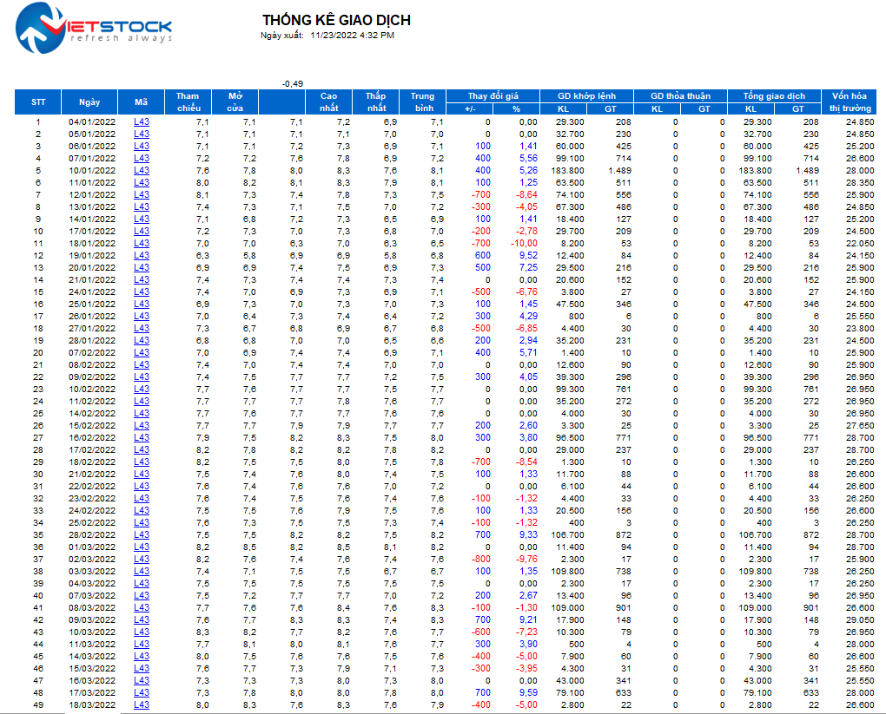

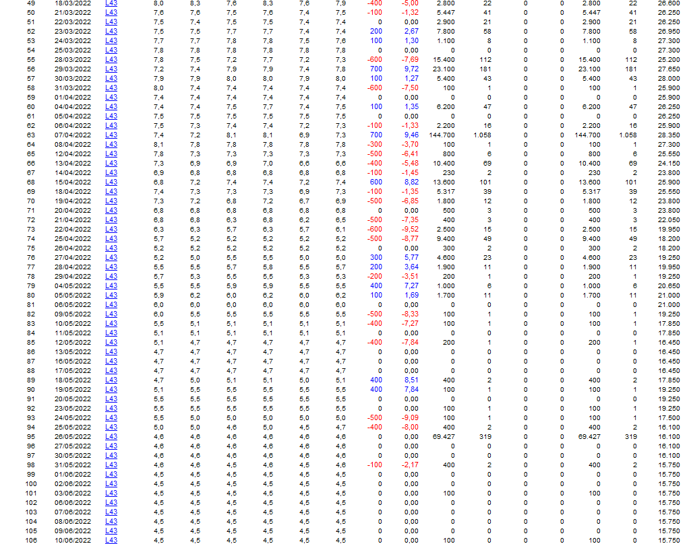

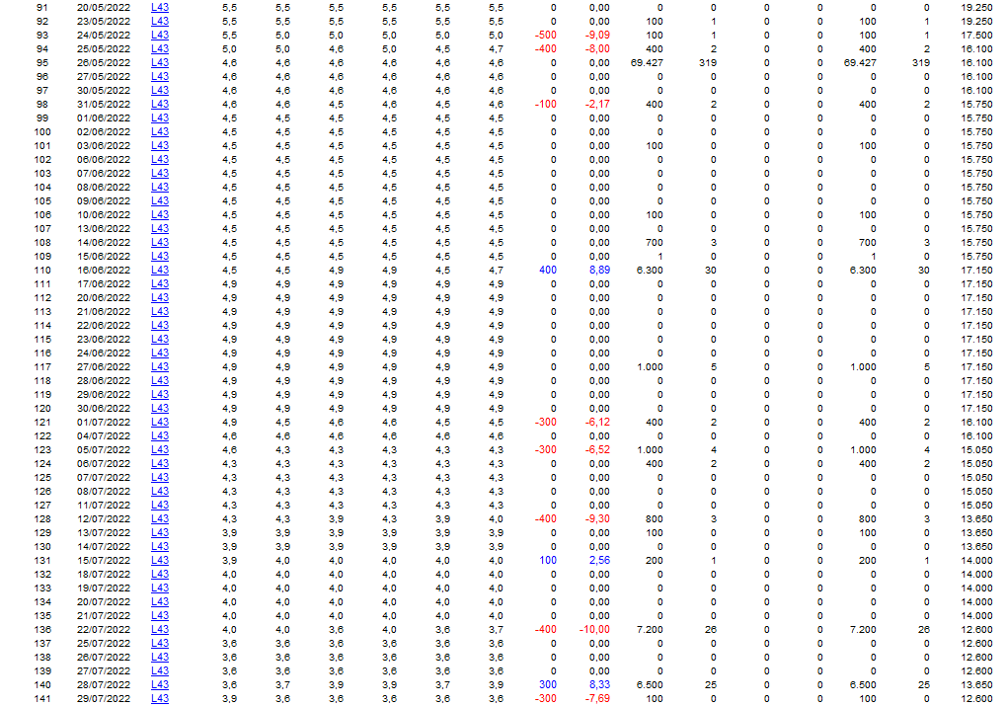

***Figure 1.*** *The data of L43 is collected from vietstock.vn*

The file downloaded is in .xlsx form, which means it could be opened via excel or imported by reading the excel file from Rstudio.



## **Analyzing movement**

* 1. **Data Selection**

The purpose is to analyze the HNX index distribution over the period of 1 year and build a predictive model, which is a linear regression model in the next section, we need to have our factors to be unrelated to each other. Therefore, in our analysis, we will analyze **closing prices** according to the following variables: the opening prices, the highest price, the lowest price, and the volume of the stock index.

In detail, these dependent variables can be defined:

* Opening price: The price from the first transaction of a business day.
* Highest price: The highest closing price of a [stock](https://www.nasdaq.com/glossary/s/stock) over the past 52 weeks, adjusted for any [stock splits](https://www.nasdaq.com/glossary/s/split-stock), or the highest [intraday](https://www.nasdaq.com/glossary/i/intraday) price of a stock in the most recent (or current) trading session. (according to NASDAQ)..
* Lowest price: the lowest price at which [the securities](https://www.lawinsider.com/clause/the-securities) were [traded](https://www.lawinsider.com/dictionary/traded) on [the exchange](https://www.lawinsider.com/clause/the-exchange) on which the securities are [listed](https://www.lawinsider.com/clause/listed).
* Volume: the number of shares traded in a particular stock, index, or other investment over a specific period of time.
  1. **Data Import**

First, we have to import the data using R. We choose the data of HNX_Index.xls which was already collected via the previous step. We only select the specific column in the data set, according to those aforementioned dependent and independent variables.

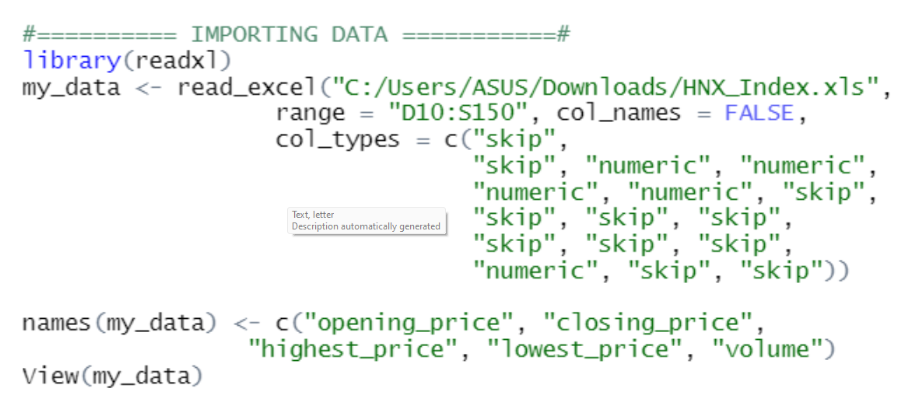

***Figure 2.*** *Import and view the data.*

We should check out the data and also make sure it is imported properly.

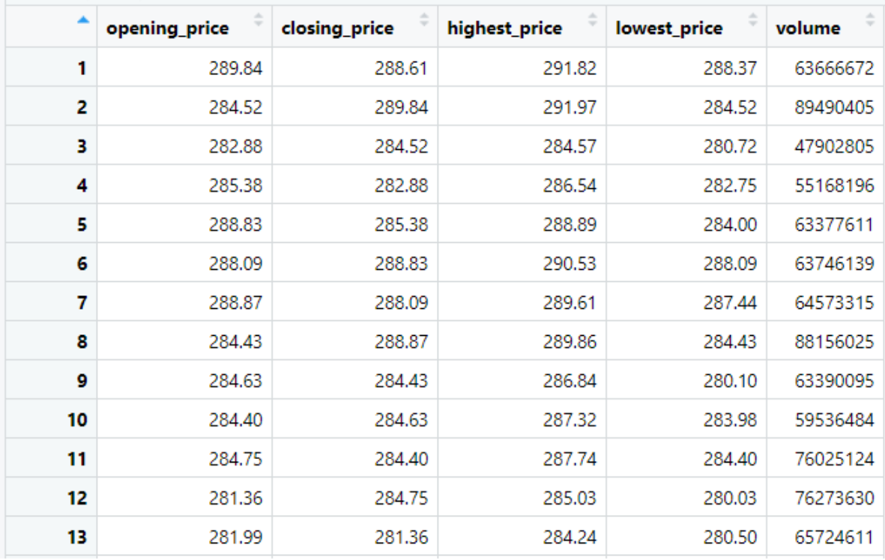

***Figure 3.*** *View the table of data.*

* 1. **Data Preprocessing**
     1. **Data Cleaning**
  2. **Eliminating NA values**

Since the data set is not large, we do not have to remove the Not Available (NA) data. However, it is necessary to replace all NA values with the means of all the values in the equivalent column.

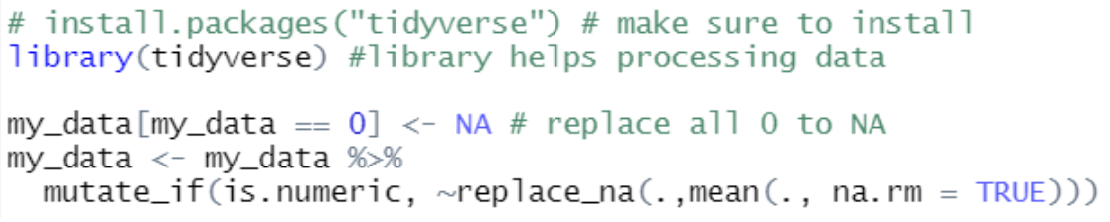

***Figure 4.*** *Data Cleaning – Remove NA values.*

* 1. **Excluding outliers**

Similar to NA values, they will lead to some fallacies; hence, outliers need to be removed. In terms of methods that help eliminate outliers, we will apply *interquartile range calculation* [1].

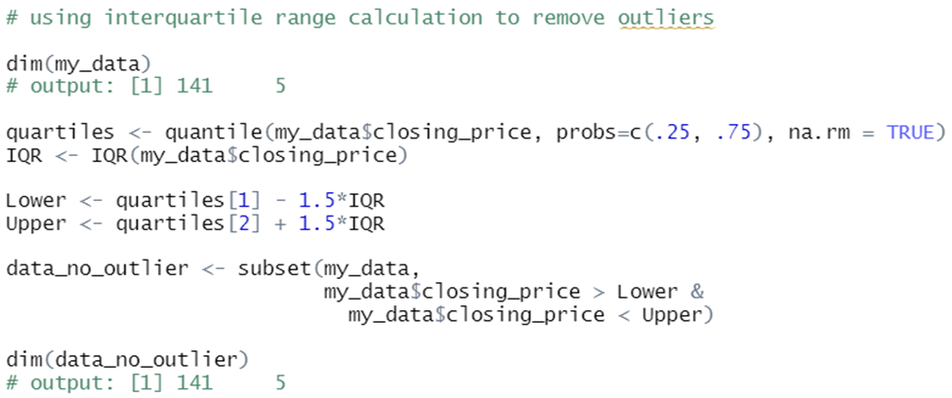

***Figure 5.*** *Exclude outliers.*

We can see from the output, reasoning that outliers do not exist (the output gives the same results).

It is clearly depicted that, the non-processed data does not have outliers.

* + 1. **Data scaling (Feature scaling)**

On examining, we can clearly see those data variables are not on the same scale. As a result, we will apply *feature scaling* [2]in order to boost the accuracy of the regression model. The following image shows how we scale the data according to the formula:



***Figure 6.*** *Feature scaling.*

* + 1. **Data visualization**
       - 1. **Data Distribution**

Using plot() function to examine the distribution of runtime. Below are the codes:

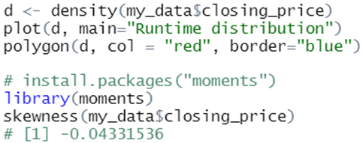

***Figure 6.*** *Use plot( ) to illustrate the distribution of runtime.*

After running these lines of codes, we have the following images:

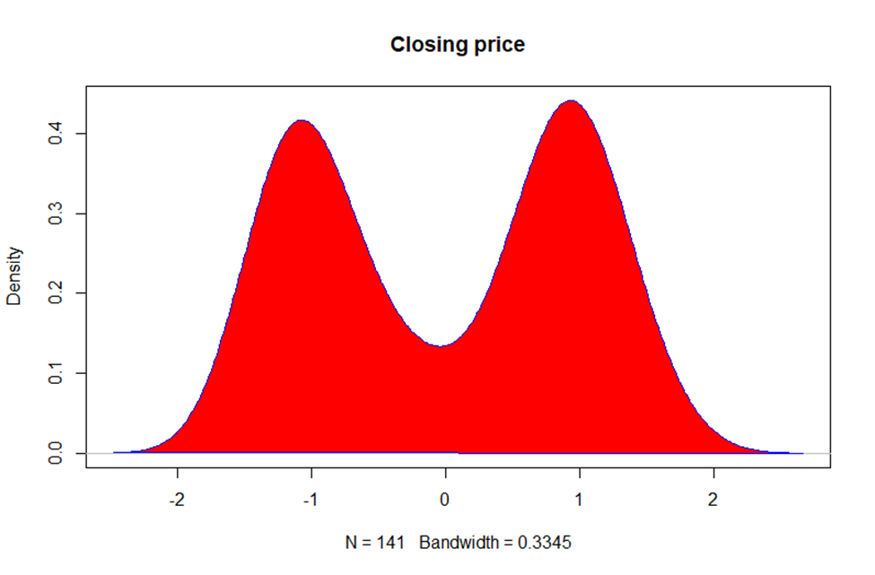

***Figure 7.*** *The distribution of* ***closing_price****.*

The closing price apparently do **not** follow any distribution.

To further check how normal the distribution is, we will go through the qqnorm and qqline functions.

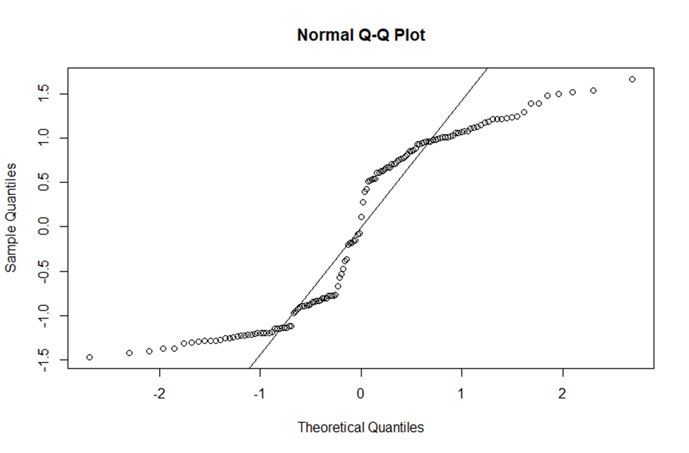

***Figure 8.*** *Qqplot of* ***closing_price.***

This graph ensures the **abnormality** of the closing price.

* 1. **Correlation Plot**

We will use corrplot to see how each of the variables depends on the other with the following R implementation.

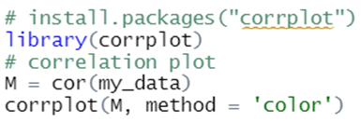

***Figure 9.*** *Install package to plot the correlation.*

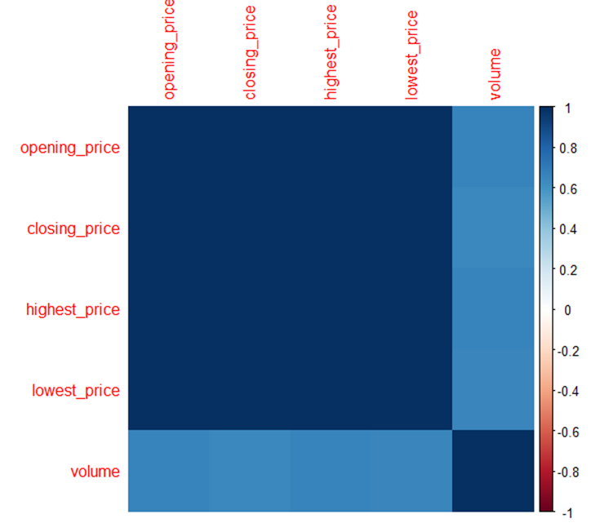

***Figure 10.*** *Correlation plot.*

As we can see, there are strong connections between every two variables.



### **Build Predictive Model**

* + 1. **Formula**

In this part, we will use multiple linear regression models to examine the runtime.

* Dependent variable: closing_price
* Independent variable: opening_price, highest_price, lowest_price, volume

The model is performed by the following formula:

closing price = α + β1* opening_price + β2* highest_price + β3* lowest price + β4* volume + ***ε*** where ***ε*** ~ N(0, σ2)

Implement the following R code:

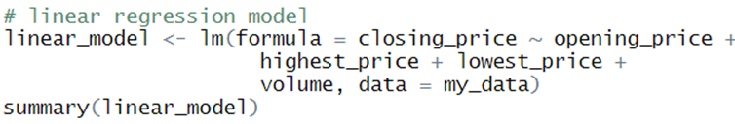

***Figure 11.*** *Fitting the linear regression model.*

After we call the summary of the model, we have the following results:

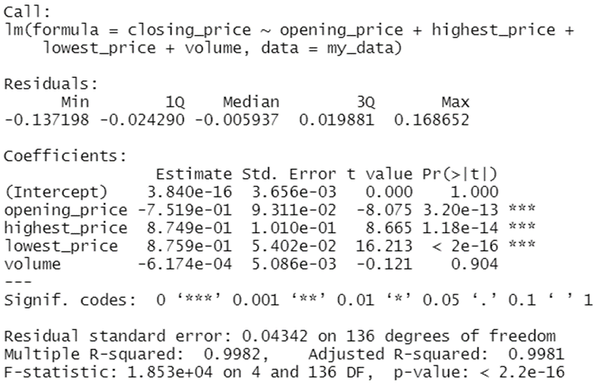

***Figure 12.*** *The output of* ***summary(linear_model)****.*

From the above results, the specific formula is:

closing_price= 3.840e–12 – 0.752* opening_price + 0.875* highest_price + 0.876* lowest_price – 0.00062* volume

* + 1. **Result Explanation**

We will explain some significant points in the results:

The above equation follows the explanation that if **closing price** increases by 1, **opening price** will decrease by 0.752 (supposed that other values are fixed). This can be reasoned that if the opening **price** increases by 1, **the closing price** decreases by 1.33. Consequently, variables with *large coefficients* will have a more significant impact on dependent values.

In terms of Residuals, the average of the residuals is theoretically **zero**. The median in the results is -0.006 (not far from 0). Additionally, the 25% (1Q) and 75% (3Q) quantiles are also fairly well balanced between the median, which shows that the residual of this equation is *relatively balanced*.

The last three columns are standard error, t tests and p-values. Let’s consider the hypothesis test for regression coefficient:

* H0: Regression coefficient is not statistically significant (βi = 0)
* H1: Regression coefficient is statistically significant (βi ≠ 0)
* As the p-values of all factors < 0.05 reject H0 All regression coefficients of these variables are *statistically significant* except **Volume**.
* This indicates that Volume has no impact on closing price.

Another thing that should be mentioned is the R-squared. This value indicates that the more it is near to 1, the tighter the connection between closing price and other variables. As the results have shown, the value is approximately 0.9982 (= 99.82%), which is an extremely high percentage.

* + 1. **Validity**

Next, to test the **validity** of the equation, we will go through the following assumptions:

* + - 1. ***All independent variables have fixed value (fixed means these variables are supposed not to have any errors in measurement).***

This is true because our independent variables are either ordinal or binary, which indicates that those are fixed parameters and not deduced from any pre-calculation.

1. ***Error ε is normally distributed.***
2. ***ε has its mean equal to 0.***
3. ***ε has fixed variance.***
4. ***The error terms εi are mutually independent (which means εi and εj has no relation)***

To testify the last 3 assumptions, I will plot 4 different related graphs by calling plot (linear_model) in the R program.

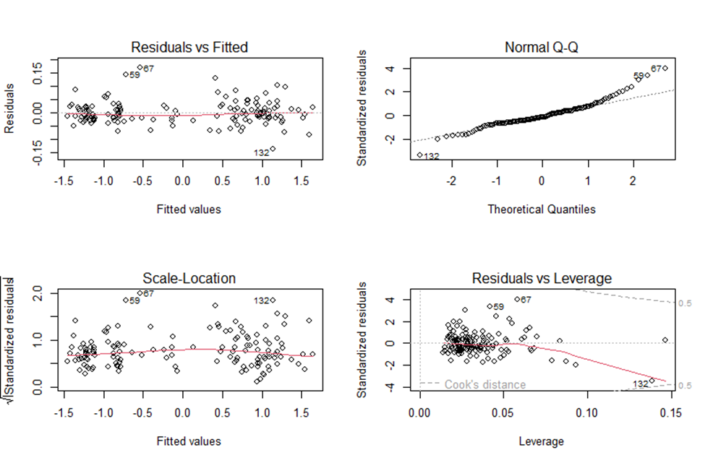

***Figure 13.*** *4 related graphs of* ***linear_model.***

- The top left graph shows that residuals are clustered around the y = 0, so error ε has a mean value around 0 ((3) is acceptable).

- The graph at top right corner plots the residual and expected values ​​based on normal distribution. We can see that the residuals are concentrated relatively close to the values ​​on the standard curve, and therefore, assumption (2) can also be met.

- About the bottom left one, it is illustrated that there is not much difference between square root of standardized residuals and fitted values. This means (4) might be satisfied

In general, after analyzing the model, we can conclude that the model has demonstrated the connection between closing price and independent variables fairly well.

* + 1. **Prediction**

Before we predict the stock index, let’s have a look on how the fitted values plotted against the actual values.

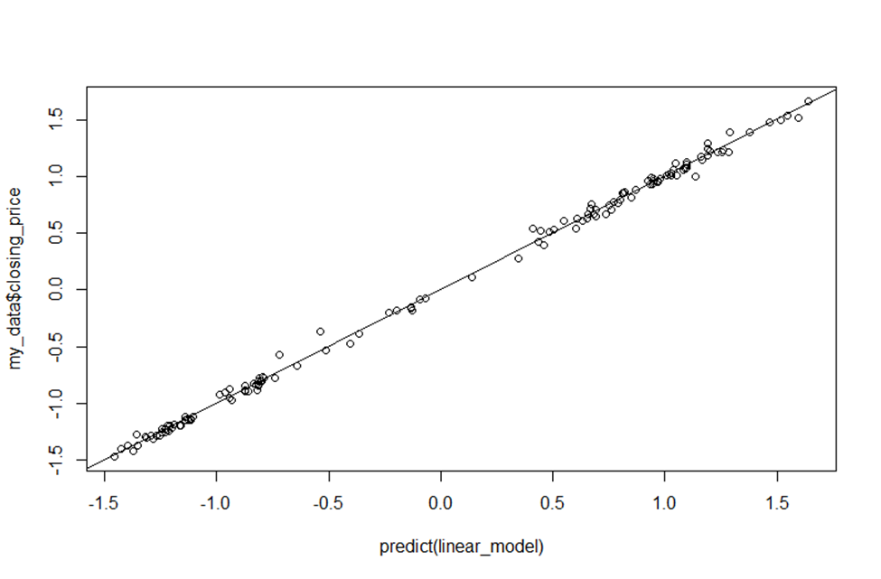

***Figure 14.*** *Predict graph.*

It can be seen that it is relatively fit, which partly explains that the model is good.

Now let’s predict the stock in the next 3 months to see if the model is actually good or not.

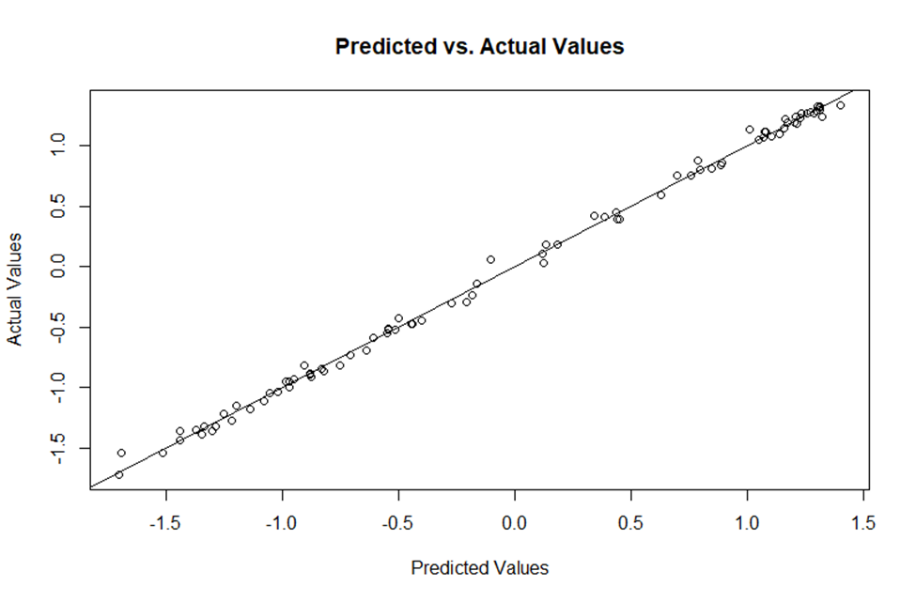

***Figure 15.*** *Predict graph of the stock in the next 3 months.*

We can see that there is not much difference between the predicted values and the actual values in the next 3 months of the HNX index.

1. **Model Analysis, Influencing Factors and Cross-model Usability**
   1. **Three stocks in three different sectors (HNX-INDEX): tourism, finance, F&B**
      1. **Sources**

We have chosen 3 stocks corresponding to 3 sectors:

* Tourism: OCH (One Capital Hospitality Joint Stock Company)

<https://finance.vietstock.vn/ket-qua-giao-dich?tab=thong-ke-gia&exchange=2&code=632>

* Financial: EVS (Everest Securities Joint Stock Company)

<https://finance.vietstock.vn/ket-qua-giao-dich?tab=thong-ke-gia&exchange=2&code=13290>

* F&B: SLS (Son La Sugar JSC)

<https://finance.vietstock.vn/ket-qua-giao-dich?tab=thong-ke-gia&exchange=2&code=921>

* + 1. **Data Visualization**
* Tourism (OCH):

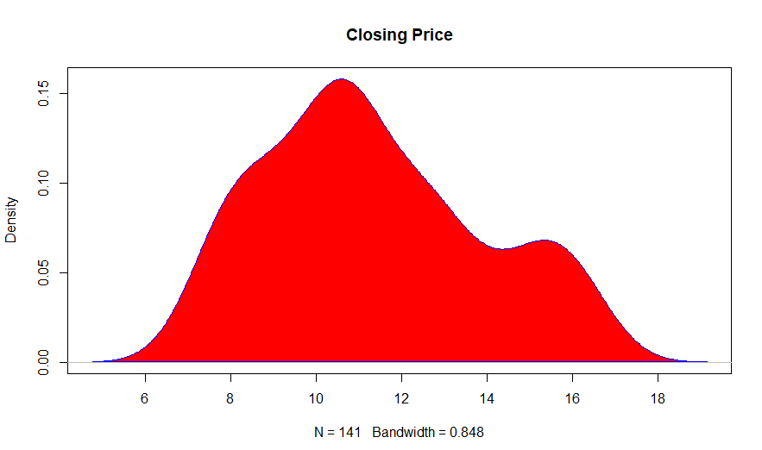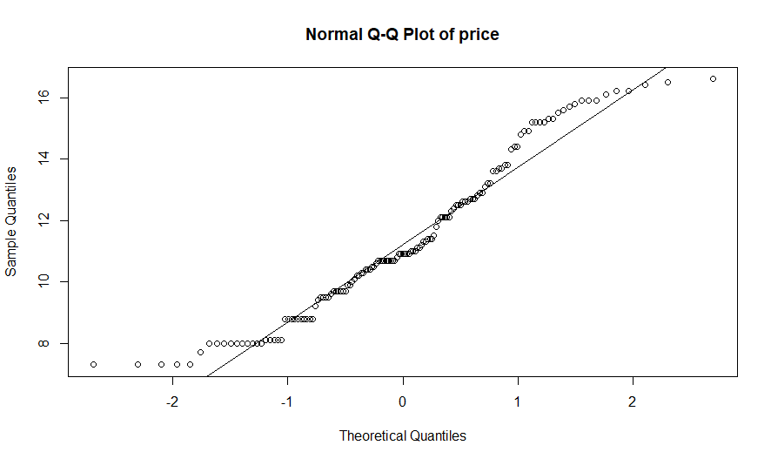

***Figure 16.*** *The distribution of OCH.*

* Finance (EVS):

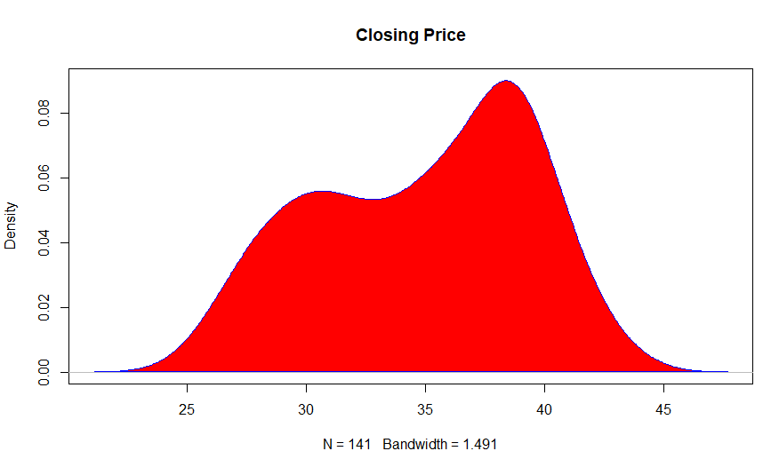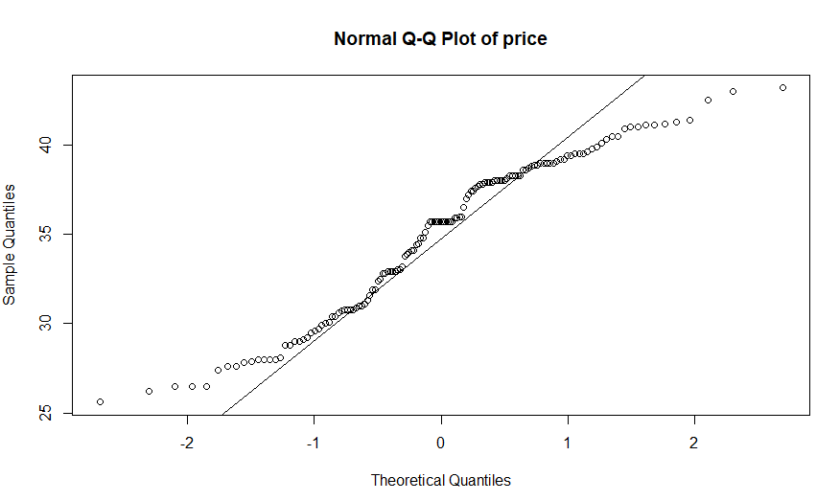

***Figure 17.*** *The distribution of EVS.*

* F&B (SLS):

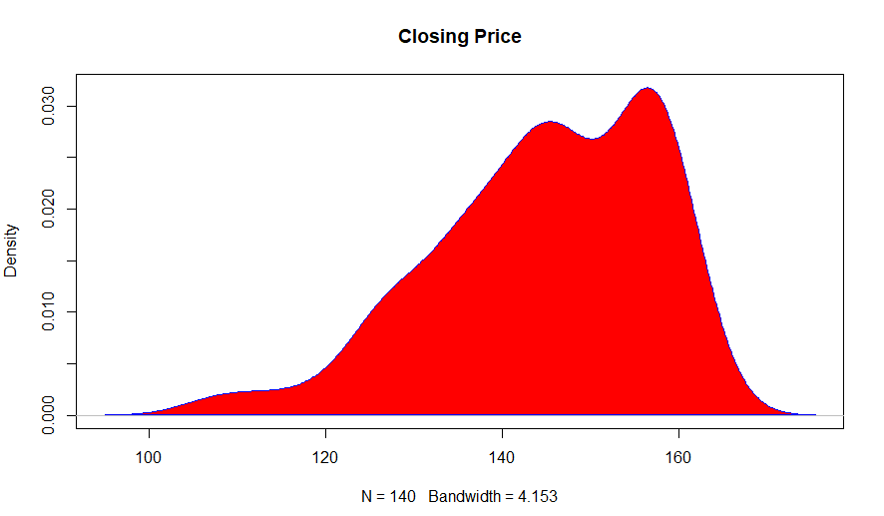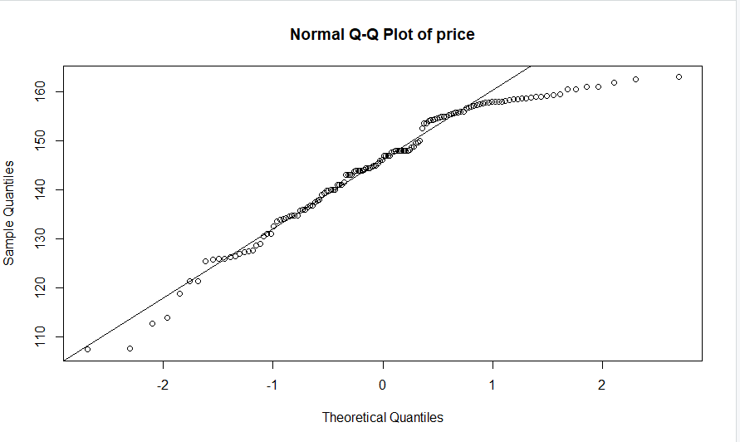

***Figure 18.*** *The distribution of SLS.*

* + 1. **Correlation Plot**

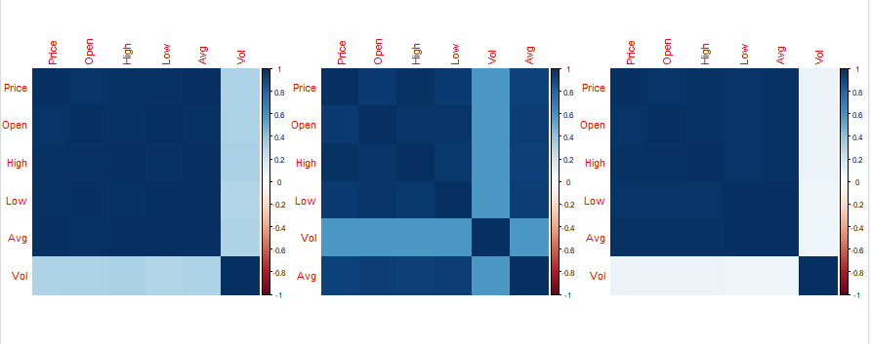

***Figure 19.*** *Correlation plots of 3 stocks OCH, EVS, SLS respectively.*

* + 1. **Regression Model**

Overall formula:

closing_price = α + β1* opening_price + β2* highest_price + β3* lowest_price + β4* volume + β5* avg + ***ε*** , where ***ε*** ~ N(0, σ2)

* Toursim (OCH):

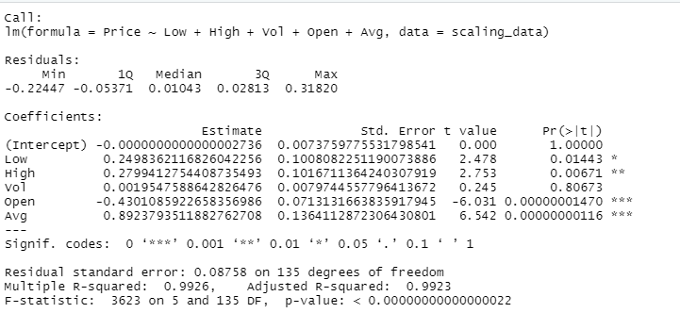

***Figure 20.*** *Linear regression model of OCH.*

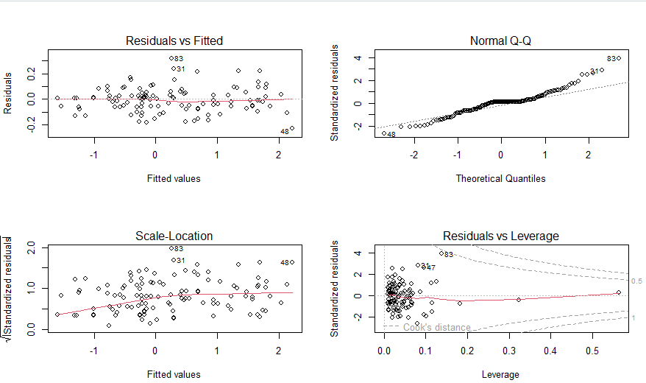

***Figure 21.*** *4 related graphs.*

* Finance (EVS):

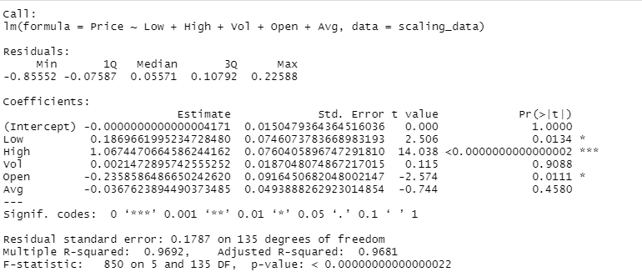

***Figure 22.*** *Linear regression model of EVS.*

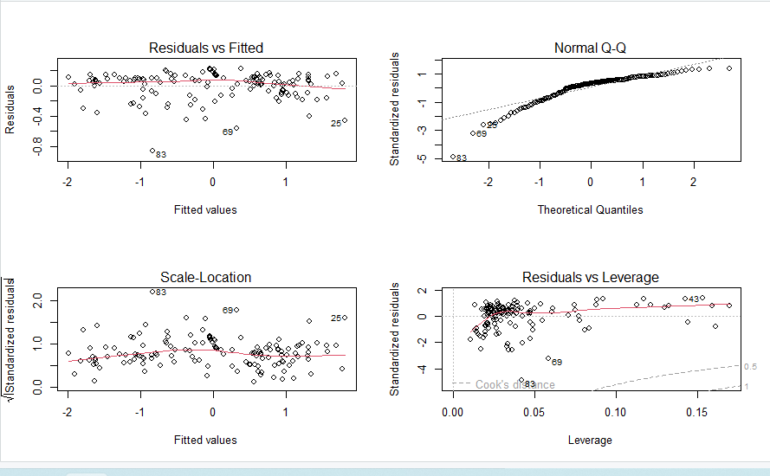

***Figure 23.*** *4 related graphs.*

* F&B (SLS):

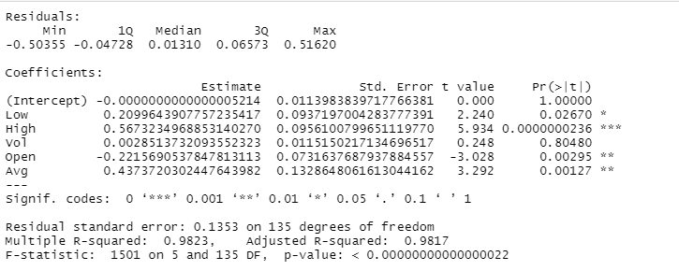

***Figure 24.*** *Linear regression model of OCH.*

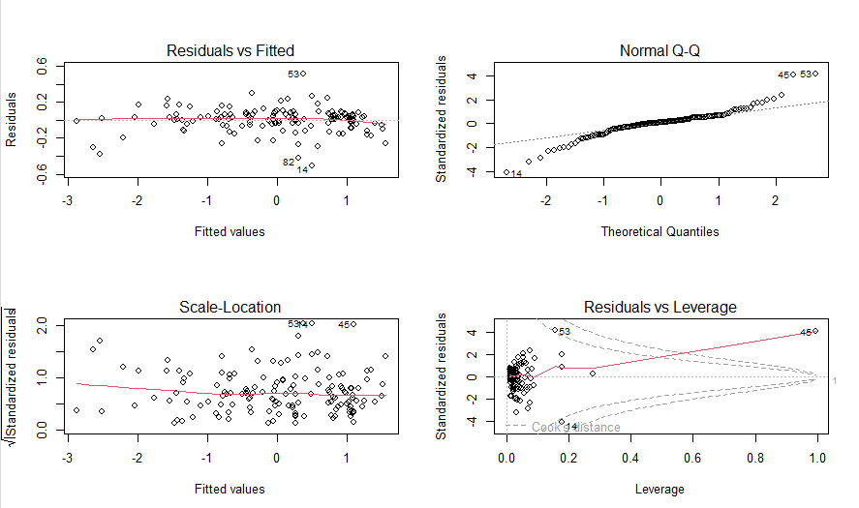

***Figure 25.*** *4 related graphs.*

* + 1. **Cross-model Usability**

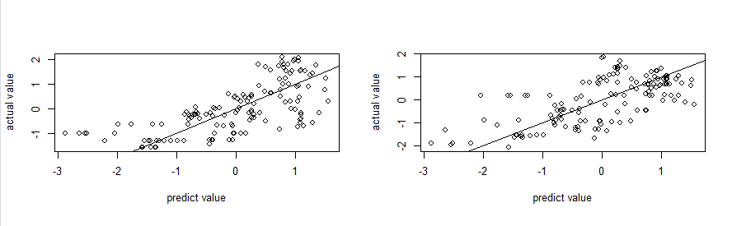

***Figure 26.*** *Apply model of SLS to the others.*

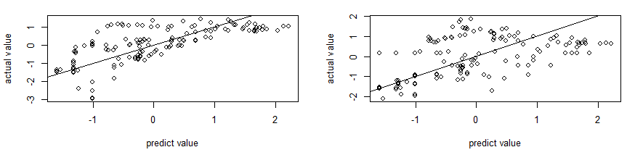

***Figure 27.*** *Apply model of OCH to the others.*

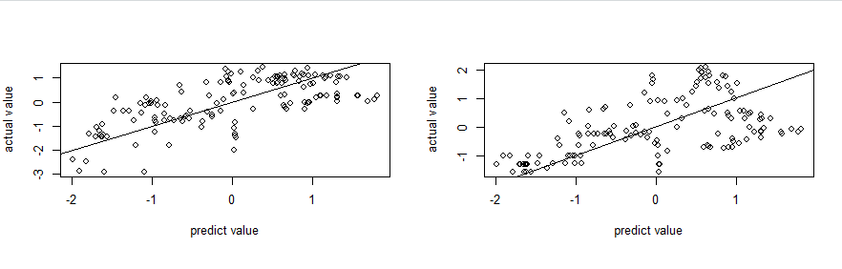

***Figure 28.*** *Apply model of EVS to the others.*

It is obvious that we can apply model of OCH to SLS and EVS although it has some errors.

* + 1. **Conclusion**

In conclusion, the influential factors include Low, High and Open.

* 1. **Three stocks with the strongest drop rate on HNINDEX in the period from January to July 2022**
     1. **Source**

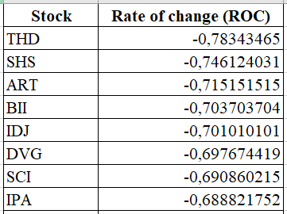

***Figure 28.*** *The Rate of change with ascendsing order.*

* THD: Thaiholdings Joint Stock Company

<https://finance.vietstock.vn/ket-qua-giao-dich?tab=thong-ke-gia&exchange=2&code=13728>

* SHS: Saigon – Hanoi Securities JSC

<https://finance.vietstock.vn/ket-qua-giao-dich?tab=thong-ke-gia&exchange=2&code=13728>

* ART: Bos Securities Corporation

<https://finance.vietstock.vn/ket-qua-giao-dich?tab=thong-ke-gia&exchange=2&code=12979>

* + 1. **Data Visualization**
* THD:

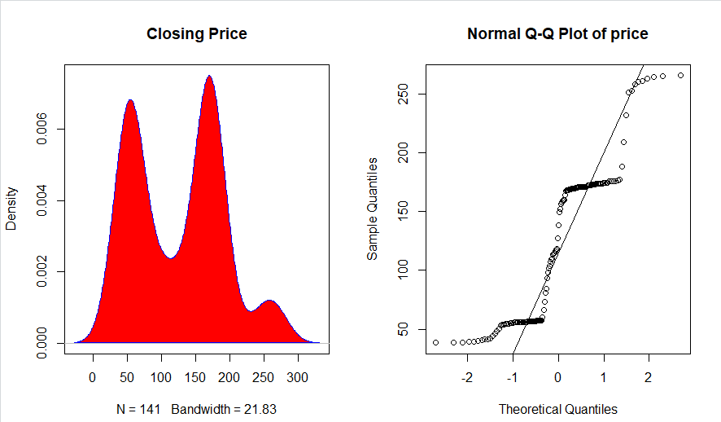

***Figure 29.*** *The distribution of THD.*

* SHS:

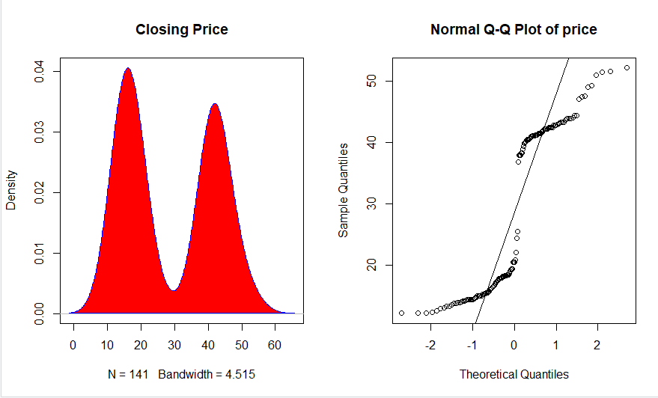

***Figure 30.*** *The distribution of SHS.*

* ART:

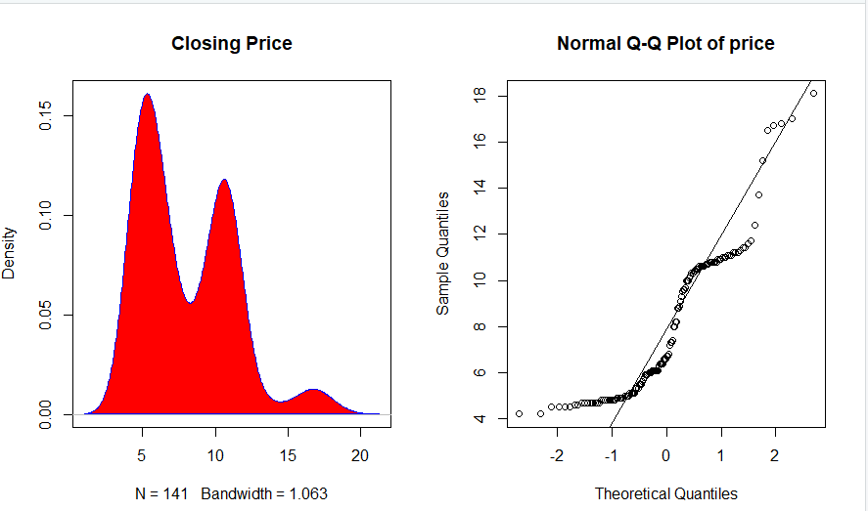

***Figure 31.*** *The distribution of ART.*

* + 1. **Correlation Plot**

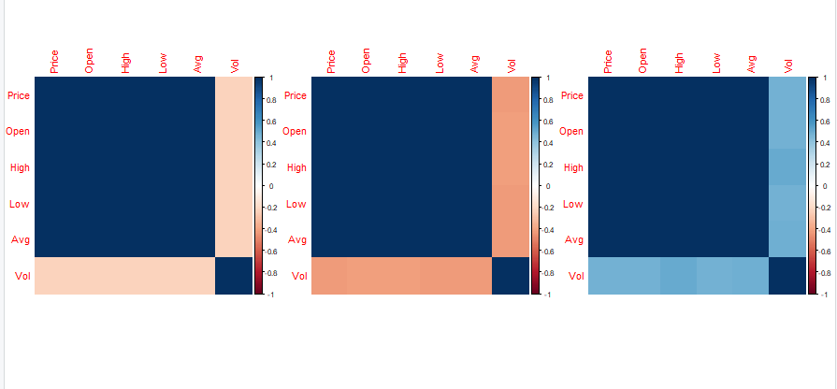  
***Figure 32.*** *Correlation plots of THD, SHS ,ART ,repectively.*

* + 1. **Regressive Model**

Overall formula:

closing_price = α + β1* opening_price + β2* highest_price + β3* lowest_price + β4* volume + β5* avg + ***ε*** , where ***ε*** ~ N(0, σ2)

* THD:

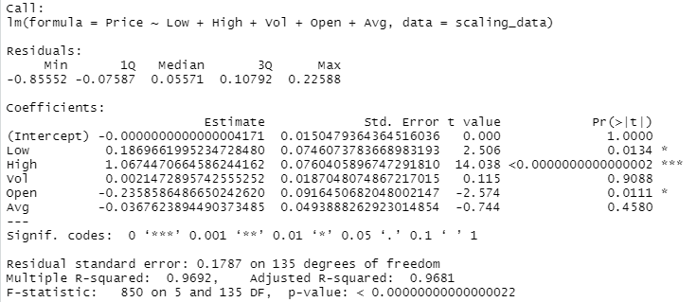

***Figure 33.*** *Linear regression model of THD.*

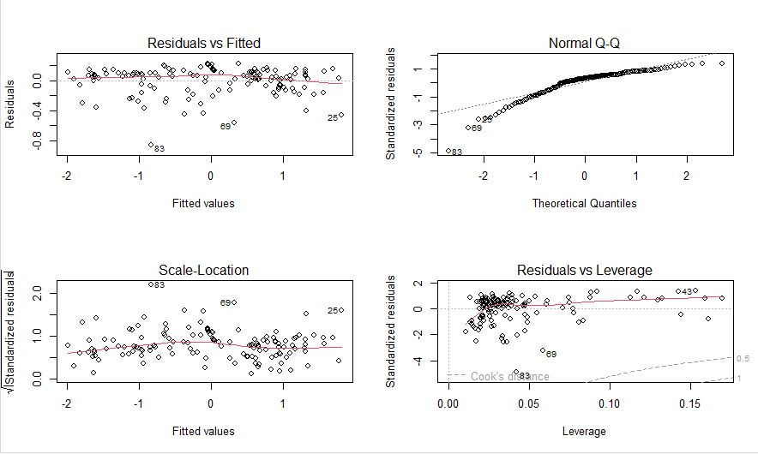

***Figure 34.*** *4 related graphs.*

* SHS:

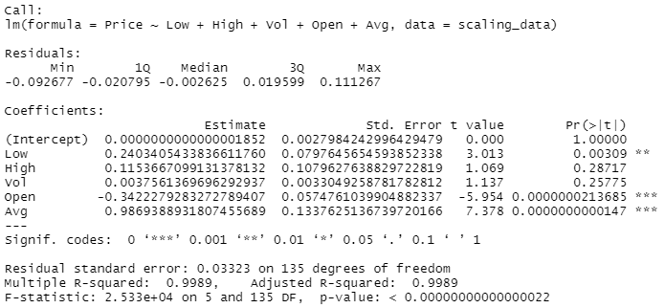

***Figure 35.*** *Linear regression model of SHS.*

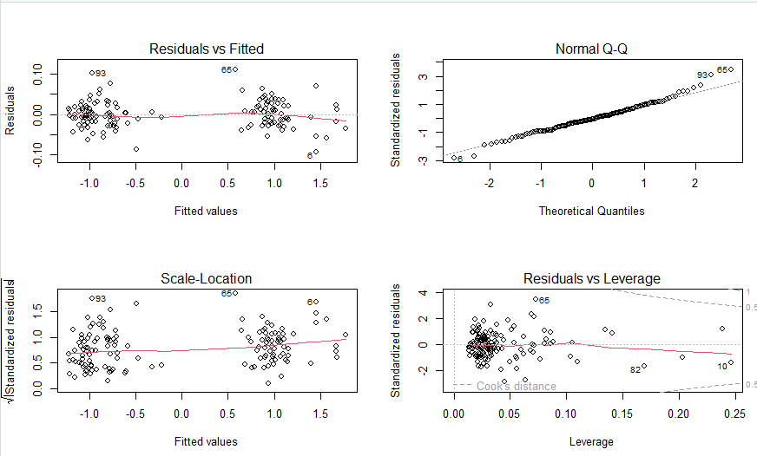

***Figure 36.*** *4 related graphs.*

* ART:

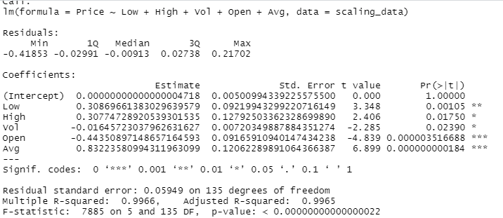

***Figure 37.*** *Linear regression model of ART.*

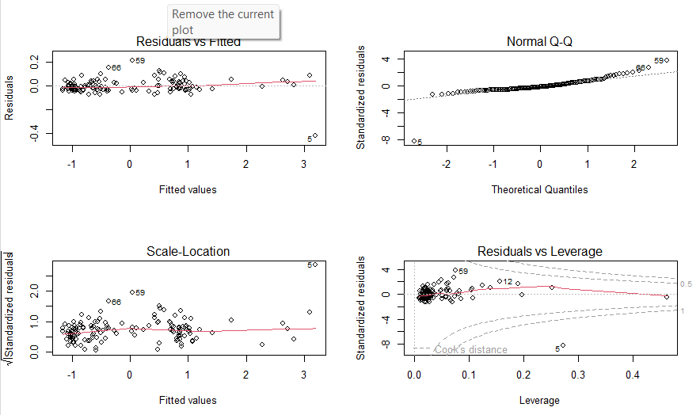

***Figure 38.*** *4 related graphs.*

* + 1. **Cross-model Usability**

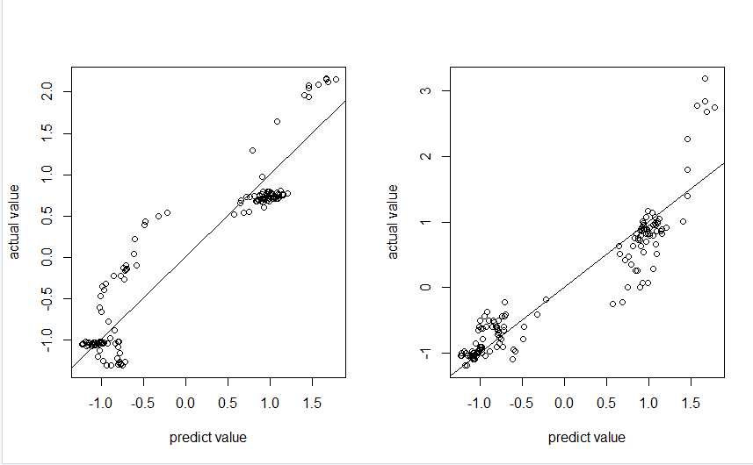

***Figure 39.*** *Apply SHS model to the others.*

We can apply SHS model to THD and ART although it has some errors.

* + 1. **Conclusion**

In conclusion, the influential factors include Low and Open.

* 1. **Three stocks with the strongest growth rate on HNINDEX in the period from January to July 2022**
     1. **Source**

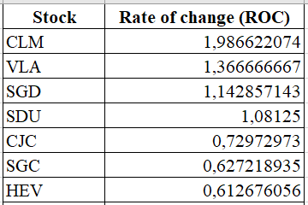

***Figure 28.*** *The Rate of change with descendsing order.*

* CLM: Vinacomin – Coal Import Export Joint Stock Company

<https://finance.vietstock.vn/ket-qua-giao-dich?tab=thong-ke-gia&exchange=2&code=12400>

* VLA: Van Lang Technology Development & Investment JSC

<https://finance.vietstock.vn/ket-qua-giao-dich?tab=thong-ke-gia&exchange=2&code=320>

* SGD: Educational Book JSC In Ho Chi Minh City

<https://finance.vietstock.vn/ket-qua-giao-dich?tab=thong-ke-gia&exchange=2&code=62>

* + 1. **Data Visualization**
* CLM:

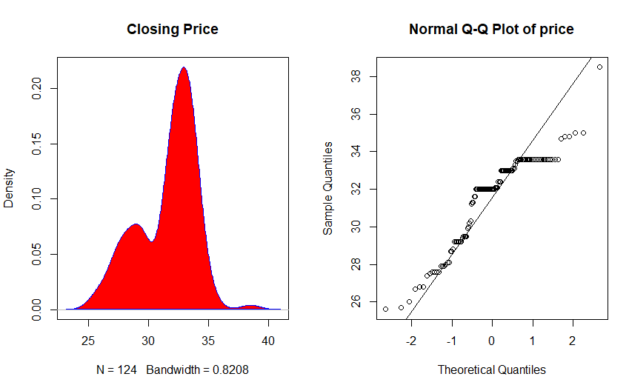

***Figure 40.*** *The distribution of CLM.*

* VLA:

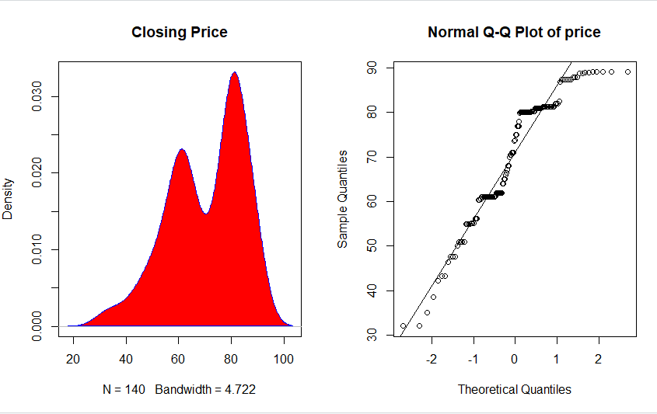

***Figure 41.*** *The distribution of VLA.*

* SGD:

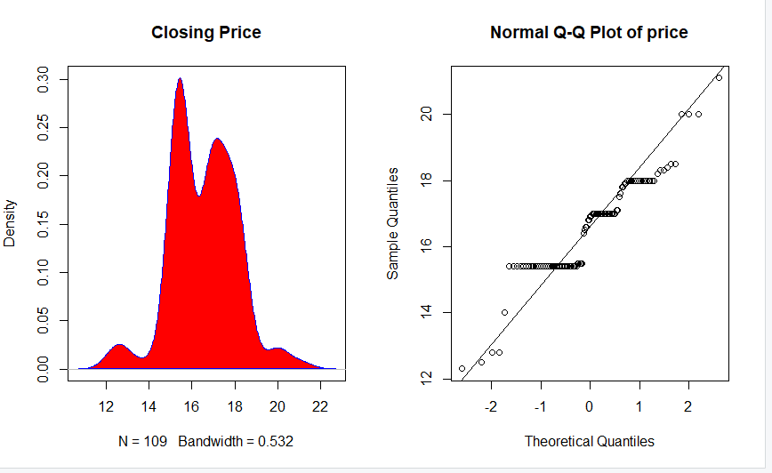

***Figure 42.*** *The distribution of SGD.*

* + 1. **Correlation Plot**

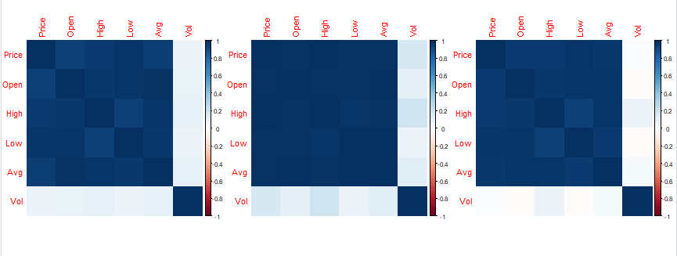

***Figure 43.*** *Correlation plots of CLM, VLA ,SGD repectively.*

* + 1. **Regressive Model**

Overall formula:

closing_price = α + β1* opening_price + β2* highest_price + β3* lowest_price + β4* volume + β5* avg + ***ε*** , where ***ε*** ~ N(0, σ2)

* CLM:

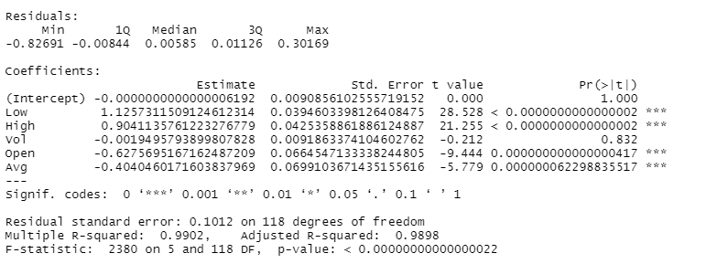

***Figure 44.*** *Linear regression model of CLM.*

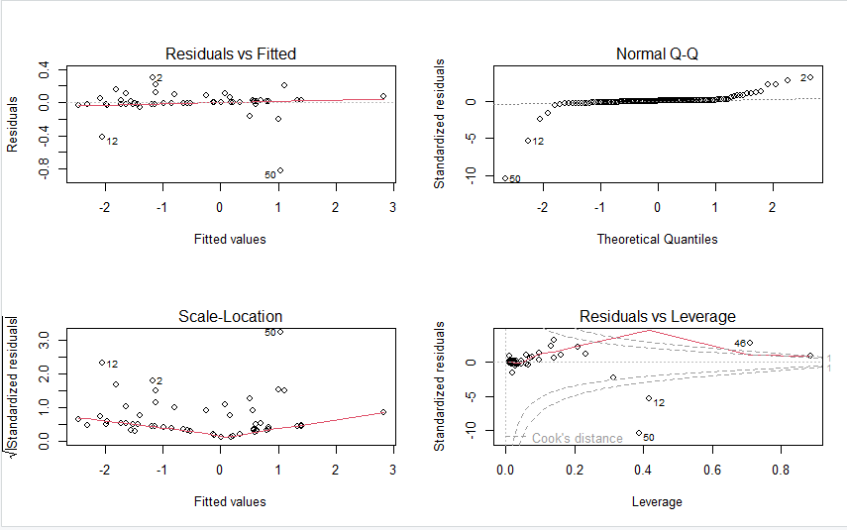

***Figure 45.*** *4 related graphs.*

* VLA:

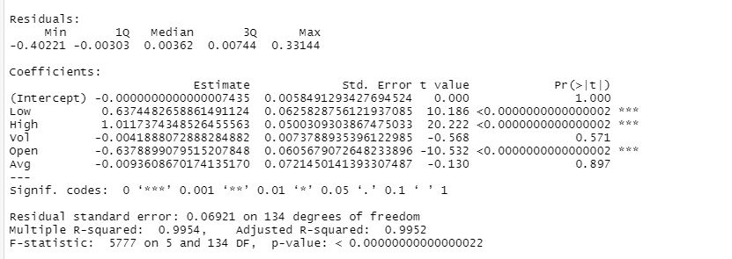

***Figure 46.*** *Linear regression model of VLA.*

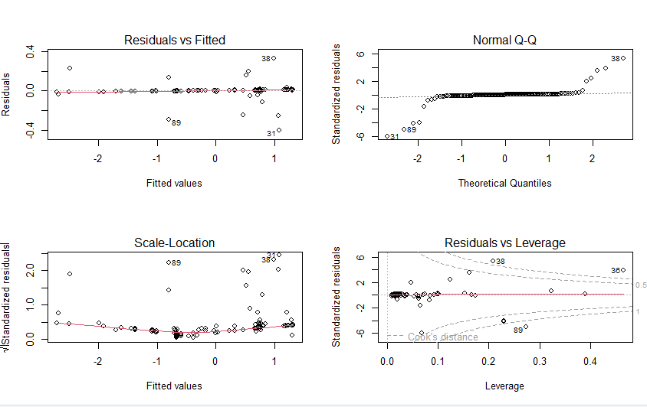

***Figure 47.*** *4 related graphs.*

* SGD:

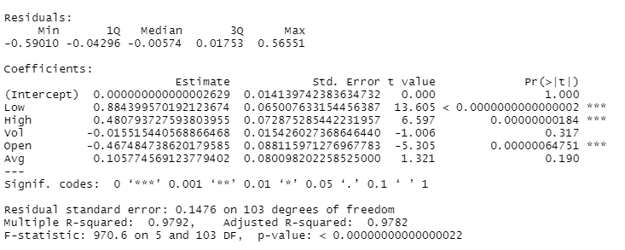

***Figure 48.*** *Linear regression model of SGD.*

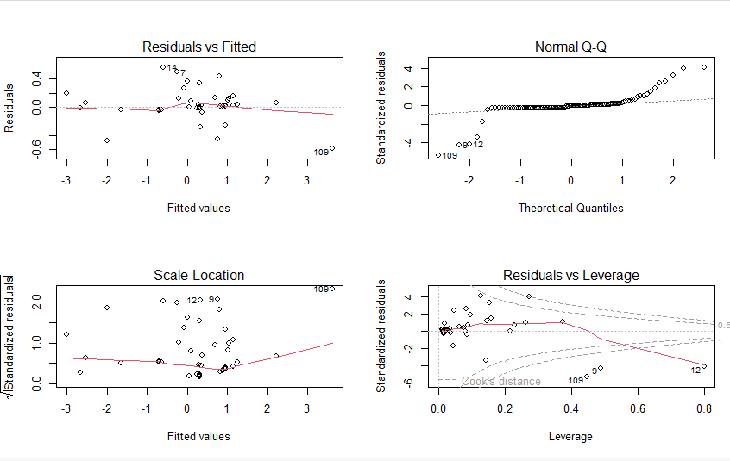

***Figure 49.*** *4 related graphs.*

* + 1. **Cross-model Usability**

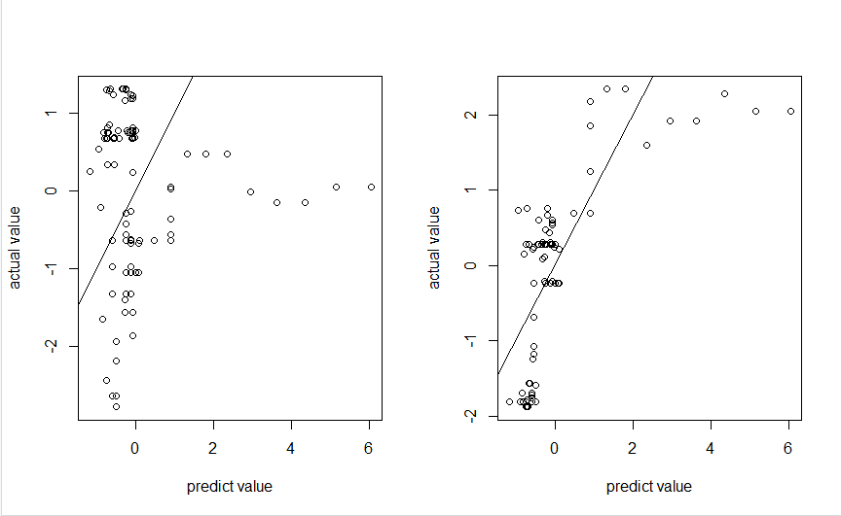

***Figure 50.*** *Apply CLM model to the others.*

If we ignore some outliers, we can apply model of CLM to VLA and SGD. However, if we want to have an accuarate result, this method does not work well.

* + 1. **Conclusion**

In conclusion, the influential factors include Low, High and Open.

1. **The effect of the Economic Crisis on stock index sector**
   1. **Stock Market Sectors**

In this part, we will analyze 11 GICS (stands for Global Industry Classification Standard) stock market sectors, including:

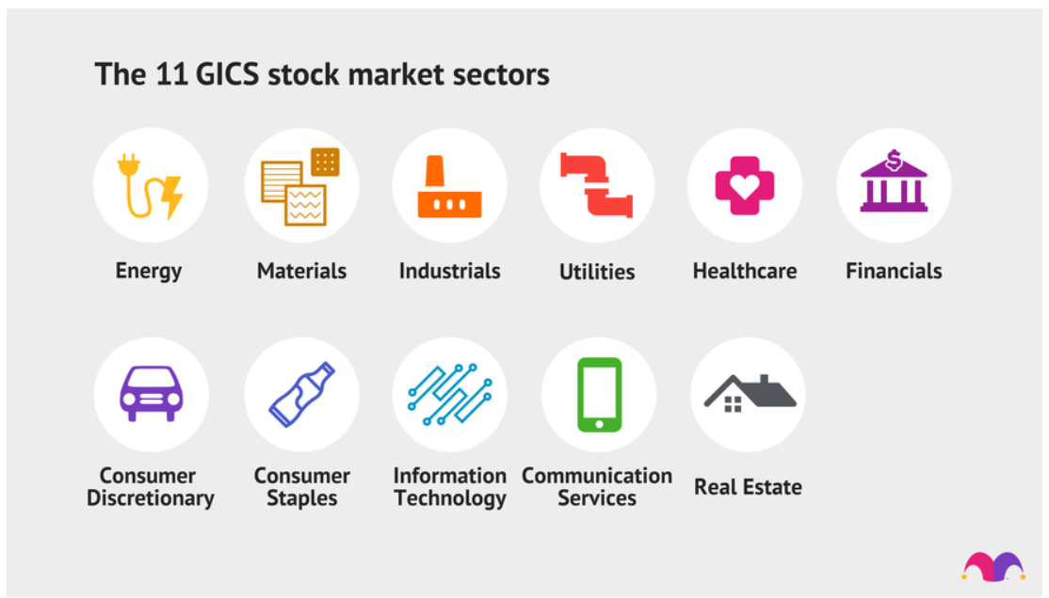

***Figure 51.*** *11 GICS stock market sectors.*

For more information, you can access this website: <https://www.fool.com/investing/stock-market/market-sectors/>

The table below indicates more details about each stock market sector:

|  |  |
| --- | --- |
| Energy | covers companies that do business in the **oil, natural gas and consumable fuels** industry. |
| Materials | includes companies that provide various **goods** for use **in manufacturing** and other applications. |
| Industrials | encompasses a wide range of different businesses like **airlines, railroads, and logistics** companies. |
| Utilities | encompasses every different type of utility activities such as **making** **electrical power** available **to residential** and commercial customers, as well as things like **natural gas transmission and distribution** or **water delivery**. |
| Healthcare | Includes all companies **related to health**; for example, pharmacies, hospitals, etc. |
| Financials | includes businesses that are primarily related to **handling money**. |
| Consumer Discretionary | covers **goods** and **services** for which consumer demand **depends upon** consumer **financial status**. |
| Consumer  Staples | provides **necessities** for consumers, **regardless of** their **financial situation**. Things like food and clothing are the examples. |
| Information Technology | includes businesses engaged in several fields of **technological innovation**. |
| Communication Services | contains companies that **provide communications services** primarily **through** a **fixed-line, cellular, wireless**, high bandwidth and/or fiber optic cable network. |
| Real Estate | includes different types of investments related to **real estate**. |

* + 1. **Energy**

- BKC: CTCP Khoáng Sản Bắc Kạn

<https://vn.investing.com/equities/bamcorp.-historical-data>

- HGM: CTCP Than Núi Béo - Vinacomin

<https://vn.investing.com/equities/vnbc-historical-data>

- HLC: CTCP Than Hà Lầm – Vinacomin

<https://vn.investing.com/equities/vhlc-historical-data>

***Figure 52.*** *The distribution of Energy.*

* + 1. **Materials**

- BCC: CTCP Xi măng Bỉm Sơn

<https://vn.investing.com/equities/bim-son-cement-jsc-historical-data>

- BTS: CTCP Xi măng VICEM Bút Sơn

<https://vn.investing.com/equities/but-son-cement-jsc-historical-data>

- GKM: CTCP Khang Minh Group

<https://vn.investing.com/equities/khang-minh-brick-historical-data>

***Figure 53.*** *The distribution of Materials.*

* + 1. **Industrials**

- CCR: CTCP Cảng Cam Ranh

<https://vn.investing.com/equities/camranh-port-jsc-historical-data>

- GMD: CTCP Gemadept

<https://vn.investing.com/equities/gemadept-corp-historical-data>

- CDN: CTCP Cảng Đà Nẵng

<https://vn.investing.com/equities/danang-port-jsc-historical-data>

***Figure 54.*** *The distribution of Industrials.*

* + 1. **Utlities**

- GAS: Tổng Công ty Khí Việt Nam

<https://vn.investing.com/equities/petrovietnam-gas-jscrp-historical-data>

- DDG: CTCP Đầu tư Công nghiệp Xuất nhập khẩu Đông Dương

<https://vn.investing.com/equities/indochine-import-export-historical-data>

- BWE: CTCP Nước - Môi trường Bình Dương

<https://vn.investing.com/equities/binh-duong-water-historical-data>

***Figure 55.*** *The distribution of Utilities.*

* + 1. **Healthcare**

- IMP: CTCP Dược phẩm IMEXPHARM

<https://vn.investing.com/equities/imexpharm-corp-historical-data>

- DHT: CTCP Dược phẩm Hà Tây

<https://vn.investing.com/equities/hataphar-historical-data>

- DHG: CTCP Dược Hậu Giang

<https://vn.investing.com/equities/dhg-pharmaceutical-jsc-historical-data>

***Figure 56.*** *The distribution of Healthcare.*

* + 1. **Financials**

- ACB: Ngân hàng TMCP Á Châu

<https://vn.investing.com/equities/asia-commercial-bank-historical-data>

- SHB: Ngân hàng TMCP Sài Gòn - Hà Nội

<https://vn.investing.com/equities/shb-historical-data>

- TVC: CTCP Tập đoàn Quản lý Tài sản Trí Việt

<https://vn.investing.com/equities/tri-viet-management-investment-corp-historical-data>

***Figure 57.*** *The distribution of Financials.*

* + 1. **Consumer Discretionary**

- DAH: CTCP Tập đoàn Khách sạn Đông Á

<https://vn.investing.com/equities/dong-a-hotel-group-jsc-historical-data>

- FRT: CTCP Bán lẻ Kỹ thuật số FPT

<https://vn.investing.com/equities/fpt-digital-historical-data>

- CVN: CTCP Vinam

<https://vn.investing.com/equities/vinam.,jsc-historical-data>

***Figure 58.*** *The distribution of Consumer Discretionary.*

* + 1. **Consumer Staples**

- DBC: CTCP Tập đoàn Dabaco Việt Nam

<https://vn.investing.com/equities/dabaco-historical-data>

- TFC: CTCP Trang

<https://vn.investing.com/equities/trangcorp-corporation-jsc-historical-data>

- TDT: CTCP Đầu tư và Phát triển TDT

<https://vn.investing.com/equities/tdt-invest-historical-data>

***Figure 59.*** *The distribution of Consumer Staples.*

* + 1. **Information Technology**

- KST: CTCP KASATI

<https://vn.investing.com/equities/kasati-historical-data>

- FPT: CTCP FPT

<https://vn.investing.com/equities/fpt-corp-historical-data>

- CMG: CTCP Đầu Tư CMC

<https://vn.investing.com/equities/cmc-corp-historical-data>

***Figure 60.*** *The distribution of Information Technology.*

* + 1. **Communication Services**

- SDA: CTCP Simco Sông Đà

<https://vn.investing.com/equities/song-da-manpower-supply-trading-jsc-historical-data>

- TV4: CTCP Tư vấn Xây dựng Điện 4

<https://vn.investing.com/equities/pecc4-historical-data>

- IBC: CTCP Đầu tư Apax Holdings

<https://vn.investing.com/equities/apax-historical-data>

***Figure 61.*** *The distribution of Communication Services.*

* + 1. **Real Estate**

- API: CTCP Đầu tư Châu Á - Thái Bình Dương

<https://vn.investing.com/equities/apec-investmen-historical-data>

- BII: CTCP Louis Land

<https://vn.investing.com/equities/bao-thu-industrial-develop-invest-historical-data>

- HUT: CTCP Tasco

<https://vn.investing.com/equities/hud---tasco-historical-data>

***Figure 62.*** *The distribution of Real Estate.*

* 1. **Impact Factors**

Then, we choose 5 factors that impose big impact on the economy, including: Stock Market, Inflation Rate, Balance of Trade, Manufacturing PMI, Currency. We will explain why we make this selection with the following rationales:

- **Stock market** refers to several exchanges in which shares of publicly held companies are bought and sold. This means that it allows buyers and sellers of securities to meet, interact, and transact. Therefore, the competitions between market participants serve as a barometer for the overall economy.

- **Inflation** can be simply interpreted as a rise in prices. Therefore, high and variable rates of inflation can impose major costs on an economy, which make this one of important factors to the economy.

- **Balance of Trade** (BOT) is the difference between the value of a country's exports and the value of a country's imports for a given period. This index is also one of the key factors that ensure economic stability.

- **Purchasing Managers' Index** (PMI) is an index of the prevailing direction of economic trends in the manufacturing and service sectors. Therefore, paying attention to the value and movements in the PMI can yield profitable foresight into developing trends in the overall economy.

- **Currency** fluctuations are a natural outcome of floating exchange rates (determined by supply and demand on the open market), which is the norm for most major economies.

|  |  |
| --- | --- |
| Energy |  |
| Materials |  |
| Industrials |  |
| Utilities |  |
| Healthcare |  |
| Financials |  |
| Consumer Discretionary |  |
| Consumer  Staples |  |
| Information Technology |  |
| Communication Services |  |
| Real Estate |  |

After getting the results, we can summarize those in the following table:

|  |  |  |  |  |  |
| --- | --- | --- | --- | --- | --- |
| **Level of statistical importance** | **Stock Market** | **Inflation Rate** | **Balance of Trade** | **PMI** | **Currency** |
|  | All of stock sectors | Consumer Staples | - Consumer Staples  - Energy | Financials | - Utilities  - Healthcare |
|  |  | Energy | - Materials  - Real Estate  - Communication Services |  | Consumer Discretionary |
|  |  | - Utilities  - Real Estate | - Information Technology  - Healthcare | - Industrials  - Utilities | - Consumer Staples  - Industrials  - Information Technology |

From the table, we can have some significant points:

* All of the stock sectors are **strongly** affected by the stock market.
* Consumer Staples, sector that provide basic necessities such as food and clothing, **largely** depends on Inflation Rate and Balance of Trade. This is true because if an economic crisis occurs, which results in the increase of Inflation Rate and the imbalance between Export and Import, daily needs will be more expensive and lack in quantity. Therefore, it will badly damage this sector. Also, Consumer Staples somehow relates to the currency. Foreign capital tends to flow into countries that have strong governments, dynamic economies, and **stable** currencies. A nation needs a relatively stable currency to attract capital from foreign investors. Otherwise, the prospect of exchange-rate losses inflicted by currency depreciation may deter overseas investors. As a result, we can conclude that economic crisis has the most detrimental effect on Consumer Staples.
* Other sectors, that would be negatively impacted by economic recession, are Energy, Financials, Utilities and Healthcare.