1. Admin’s Home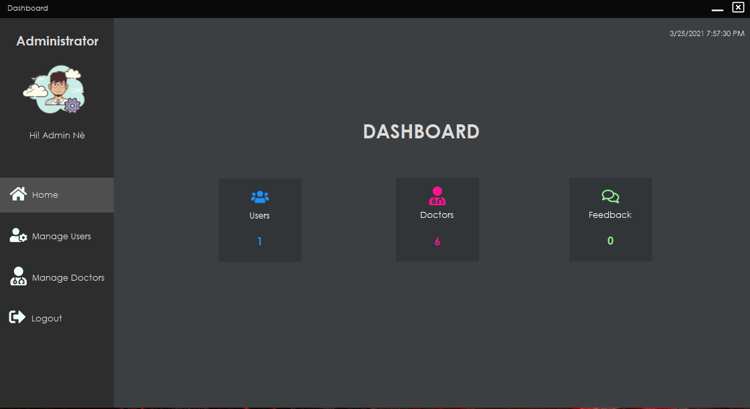

|  |  |  |  |  |  |
| --- | --- | --- | --- | --- | --- |
| **Name** | **Type** | **Event** | **Validation** | **Description** | **Status** |
| Home | Button |  | Click | Main frame of Admin |  |
| Manage Users | Button |  | Click | To view how many customer that program has and information of customer |  |
| Manage Doctors | Button |  | Stick | To view how many Doctor that program has and information of Doctor |  |
| Logout | Button |  | Click | Logout account |  |
| User | iconButton |  |  | View number of User is online |  |
| Doctors | iconButton |  |  | View number of Doctor is online |  |
| Feedbacks | iconButton |  |  | View number of Feedbacks is online |  |

1. Manage Users

|  |  |  |  |  |  |
| --- | --- | --- | --- | --- | --- |
| **Name** | **Type** | **Event** | **Validation** | **Description** | **Status** |
| List of Users | Data Grid View |  |  | View information of Users |  |
| Delete Users | Button |  | Click | To delete User |  |

1. Manage Doctors

|  |  |  |  |  |  |
| --- | --- | --- | --- | --- | --- |
| **Name** | **Type** | **Event** | **Validation** | **Description** | **Status** |
| List of Doctors | Data Grid View |  |  | View information of Doctors |  |
| Create Doctor | Button |  | click | To create new Doctor |  |
| Delete Doctor | Button |  | Click | To delete User |  |

1. Create Doctors

|  |  |  |  |  |  |
| --- | --- | --- | --- | --- | --- |
| **Name** | **Type** | **Event** | **Validation** | **Description** | **Status** |
| UserName | TextBox | Onchange | String, not null | Input UserName Doctor |  |
| Password | TextBox |  | String, not null, | Input Doctor’s New password |  |
| Confirm Password | TextBox |  | String,not null | Input Doctor’s Confirm Password |  |
| Full Name | TextBox |  | String, not null | Input Full Name Doctor |  |
| Gender | Check Box |  | Stick | Input Male,Female |  |
| Email | TextBox |  | String ,not null, have Validation | Input Email Customer |  |
| Phone Number | TextBox |  | Number,not null | Input Phone Number Doctor |  |
| Certificate | TextBox |  | String, not null | Input certificate of Doctor |  |
| Submit | Button |  | Click | Register Customer |  |