

Healthy Care

* **Faculty: Ho Hoan Kiem**
* **Batch:**
* **Team Member:**
  + - * **Huỳnh Gia Bảo**
      * **Huỳnh Minh nghiệp**
      * **Nguyễn Quốc Trường Huy**
      * **Hồ Quốc Đạt**
      * **Nguyễn Tiến Hưng**

**Ho Chi Minh City**

Table of Contents

1. Review 1

* **Problem Definition..…………………………………………………………………………………01**
* **Customer Request Specification……………………………………………………………… 02**

1. Review 2

* ***Use Case Diagram* 04**
* ***Class Diagram* 15**
* ***Sequence Diagram* 16**
* ***ERD* 18**
* ***Entity Description* 19**
* ***Table Relationship Diagram* 26**

1. Review 3

* Interface Design………………………………………………………………………………..... 27
* Site Map……………………………………………………………………………………………… 51
* Report ………………………………………………………………………………………………..53
* Tasksheet……………………………………………………………………………………………. 56

REVIEW 1

Problem Definition

1. **The Object Of The Project**

This project will aim at creation of a high quality reputation booking doctor system. This will be accessible to all customers who have a valid User Id and Password . This system provides the following facilities:

* Booking reputable doctor
* doctors come to the place

1. **Functional Requirements(**Customer Request**)**

Following is a list of functionalities of the system. More functionalities that you find appropriate can be added to this list.

• Customer must have a valid User Id and password to login to the system

• If a wrong password is given, that account will be received a mesages .

• After the valid user logs in he is shown the list of reputable doctor .

• On selecting the doctor he is taken to a page which shows the present detail of that doctor.

• User can see details of the last doctor he has booked.

• User can upload their sysmptom to find a suitable doctor near them.

• User can Book doctor from his account to make him go to that phace to check out the patient. If that docor acept a notification should appear to the customer, in case it is unsuccessful, a proper message should be given to the customer as to why it failed.

• User can request for change of address/ payment / times

• User can view feedback rating of that doctor

• Proper help to be provided as and when requested by the user.

# Hardware/ Software Requirements

By adding new technologies such as ASP.NET 3.5, AJAX, Web Service and 3-layer architecture, the web site becomes more interactive with users, security and easily updated.

1. **System Requirement**

* **For Users**
  + **Hardware**
    - CPU: Pentium IV 2.0 GHz or higher
    - RAM: 512 MB or higher
  + **Software**
    - OS: Windows >8/XP Professional/Server 2003…
    - Browser: Internet Explorer 8.0 or higher
* **For Software Developers**
  + **Hardware**
    - CPU: Pentium IV 2.0 GHz or higher
    - RAM: 512 MB or higher
  + **Software**
    - OS: Windows XP Professional/Server 2003…
    - Environment: Microsoft .NET Framework 3.5
    - Database Management System: Microsoft SQL Server 2014 - 2019
    - IDE: Microsoft Visual Studio 2019
    - Winform

REVIEW 2

* + - **USE CASE DIAGRAM**

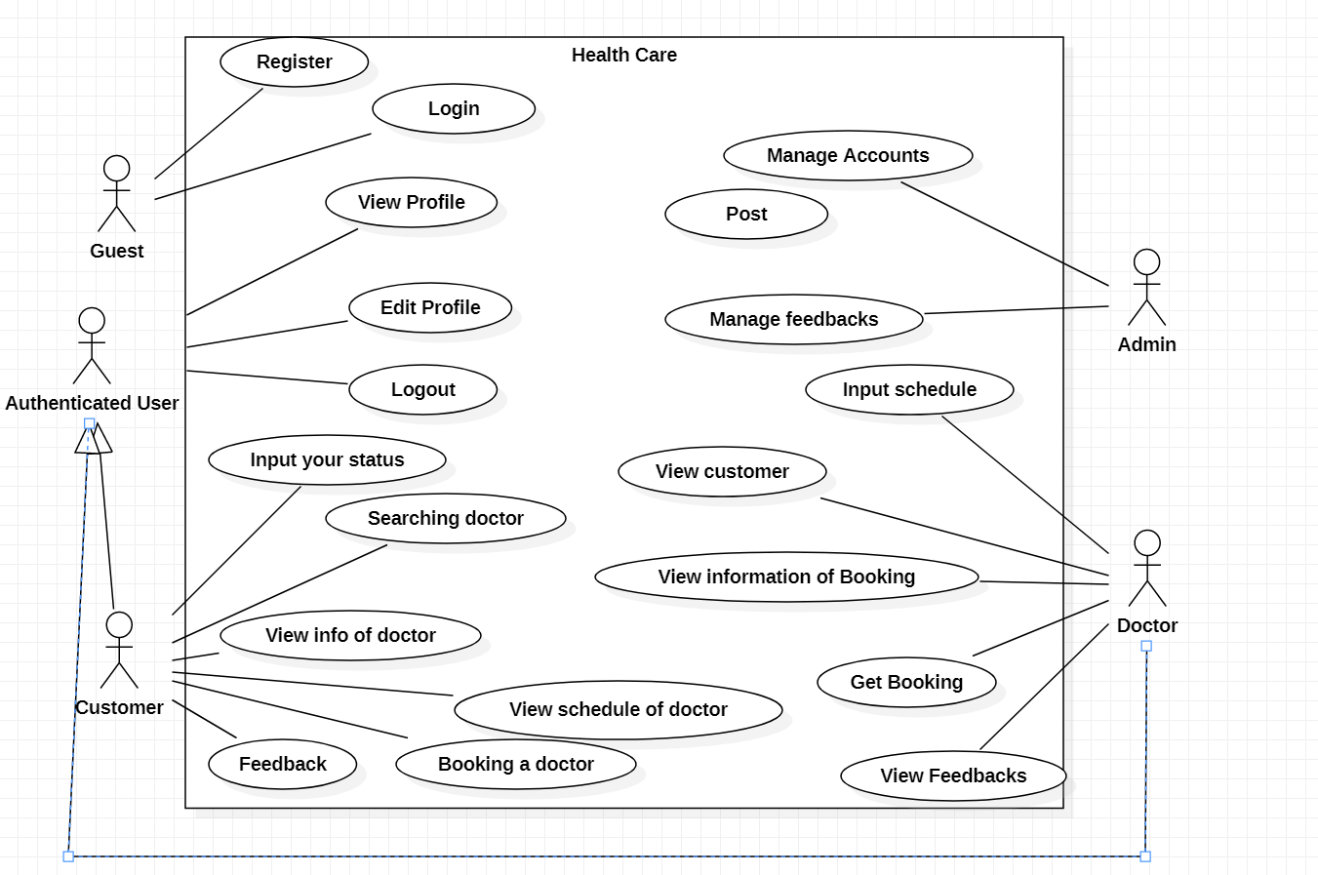

**USE CASE DESCRIPTION**

1. **Actor:**

* **Customers :** include all visitors that use this App. They are customer. When visitors uses this app and register to become a customer
* **Doctor:** include all visitors that use this App. They are doctor. When visitors uses this app and register with ADMIN to become a doctor
* **administrators :** The person(s) that manage and maintain this app.

1. **Usecase:**

|  |  |
| --- | --- |
| **Usecase** | Register |
| **Short Description** | Register account to become a member of the app. |
| **Pre-Conditions** |  |
| **Post-Conditions** |  |
| **Main flow** | _Guest must provide mandatory information :   * LoginID. * Password. * Confirm Password. * Email. * Address   _Guest provides supplementary information : FirstName, LastName, PhoneNumber, Address  _Guest clicks on Register button.  _System checks the information which guest provided  _System create new account for guest that registers to this App.  _Guest becomes a Customer of this app. |
| **Alternative flow(s)** | _If guest clicks on the Reset button, all the field will be reset.  _If the mandatory information that guest provided, is missed or not exactly, system notifys the error. All cases are :   * LoginID has existed in Database. * Password is less than 6 characters or more than 30 characters. * Confirm Password and Password are not the same. * Email is invalid or has existed in database. * Any fields are blank.   _System must be insert the date that guest register to become member.  _If server notifys any error when it’s processing, system must be write report into Log file. |

|  |  |
| --- | --- |
| **Use case** | Search Doctor |
| **Short Description** | Search doctor on app |
| **Pre-Conditions** |  |
| **Post-Conditions** |  |
| **Main flow** | _Customer access the news page.  _Customer drag the mouse over the link of search, read the list of search.  _If customer want to see the details of docotr, he(she) clicks on the link of this doctor. All content of new will be shown. |
| **Alternative flow(s)** | _If server notifies any error when it’s processing, system must be write report into Log file. |

|  |  |
| --- | --- |
| **Usecase** | Login |
| **Short Description** | Log in website to use any function of member. |
| **Pre-Conditions** |  |
| **Post-Conditions** |  |
| **Main flow** | _Guest inputs the login information :   * Login ID. * Password.   _Guest clicks on the Login button.  _System check the Login ID and Password.  _If Login ID and Password are valid, system will move customer to Homepage.  _ If a wrong password is given, that account will be received a mesages . |
| **Alternative flow(s)** | _If guest clicks on “Reset” button, the Login ID field and Password field are blank.  _If Login ID field or Password field is invalid form or blank when guest clicks on the “Login” button, system will notify the error.  _If server notifies any error when it’s processing, system must be write report into Log file. |

|  |  |
| --- | --- |
| **Usecase** | Edit Account |
| **Short Description** | Edit customer or Doctor information. |
| **Pre-Conditions** |  |
| **Post-Conditions** |  |
| **Main flow** | _Guest login to this website.  _ customer or Doctor clicks on the link to edit his(her) information, and access the private information page.  _ customer or Doctor edits information and save this action.  _System check this information and save it on the server.  _System notify report to member. |
| **Alternative flow(s)** | _If any information edit are invalid, system will notify the error.  _If server notifies any error when it’s processing, system must be write report into Log file. |

|  |  |
| --- | --- |
| **Usecase** | Manage Customers |
| **Short Description** | Manage all information about customer. |
| **Pre-Conditions** |  |
| **Post-Conditions** |  |
| **Main flow** | _Manage all information of customer. |
| **Alternative flow(s)** | _If server notifies any error when it’s processing, system must be write report into Log file. |

|  |  |
| --- | --- |
| **Usecase** | FeedBack |
| **Short Description** | Feedback,rating doctor |
| **Pre-Conditions** |  |
| **Post-Conditions** |  |
| **Main flow** | _customer chooses the doctor whose has been booked.  _customer write coment and rate  _customer clicks on the “feedback” button. |
| **Alternative flow(s)** | _If server notifies any error when it’s processing, system must be write report into Log file. |

|  |  |
| --- | --- |
| **Usecase** | View Doctor or Customer Information |
| **Short Description** | Administrator view customer or doctor information. |
| **Pre-Conditions** |  |
| **Post-Conditions** |  |
| **Main flow** | _Administrator choose the customer or doctor that administrator wants to see information.  _Administrator clicks on the “View Information” button.  _System shows the customer’s information to the administrator. |
| **Alternative flow(s)** | _If server notifies any error when it’s processing, system must be write report into Log file. |

|  |  |
| --- | --- |
| **Usecase** | Administrator Edit Account |
| **Short Description** | Edit customer or doctor information. |
| **Pre-Conditions** |  |
| **Post-Conditions** |  |
| **Main flow** | _Admin can edit credit card customer request to suspend use of credit card  _System check this information and save it on the server.  _System notify report to member. |
| **Alternative flow(s)** | _If any information edit are invalid, system’ll notify the error.  _If server notifies any error when it’s processing, system must be write report into Log file. |

|  |  |
| --- | --- |
| **Usecase** | Manage FeedBack |
| **Short Description** | Admin nanage news of app |
| **Pre-Conditions** |  |
| **Post-Conditions** |  |
| **Main flow** | _Administrator can view, insert, update, delete news.  _Administrator chooses the correlative function.  _System passes administrator to the page that administrator can interact with system. |
| **Alternative flow(s)** | _If server notifys any error when it’s processing, system must be write report into Log file. |

|  |  |
| --- | --- |
| **Usecase** | Edit Feedback |
| **Short Description** | Update, Delete all information about this app. |
| **Pre-Conditions** |  |
| **Post-Conditions** |  |
| **Main flow** | _Administrator can update ,delete , news, drivers…of this app.  _Administrator chooses the correlative function.  _System passes administrator to the page that administrator can interact with system. |
| **Alternative flow(s)** | _If server notifies any error when it’s processing, system must be write report into Log file. |

|  |  |
| --- | --- |
| **Usecase** | Booking |
| **Short Description** | Customer book doctor |
| **Pre-Conditions** |  |
| **Post-Conditions** |  |
| **Main flow** | _customer upload their sysmptom  _ customer can book doctor base on their sysmptom  _customer chose time location and click on button “Book”  _wait for the doctor reply |
| **Alternative flow(s)** | _If server notifies any error when it’s processing, system must be write report into Log file. |

|  |  |
| --- | --- |
| **Usecase** | Acept Booking |
| **Short Description** | Doctor Acpet book or not |
| **Pre-Conditions** |  |
| **Post-Conditions** |  |
| **Main flow** | _Doctor see the information of the order  _doctor acpet or not |
| **Alternative flow(s)** | _If server notifies any error when it’s processing, system must be write report into Log file. |

|  |  |
| --- | --- |
| **Usecase** | Search |
| **Short Description** | Search all information about this site. |
| **Pre-Conditions** |  |
| **Post-Conditions** |  |
| **Main flow** | _Administrator inputs the information that wants to see in the search field.  _Administrator clicks on the “Search” button Or onKeydown  _System shows the result to the administrator. |
| **Alternative flow(s)** | _If server notifies any error when it’s processing, system must be write report into Log file. |

**CLASS DIAGRAM**

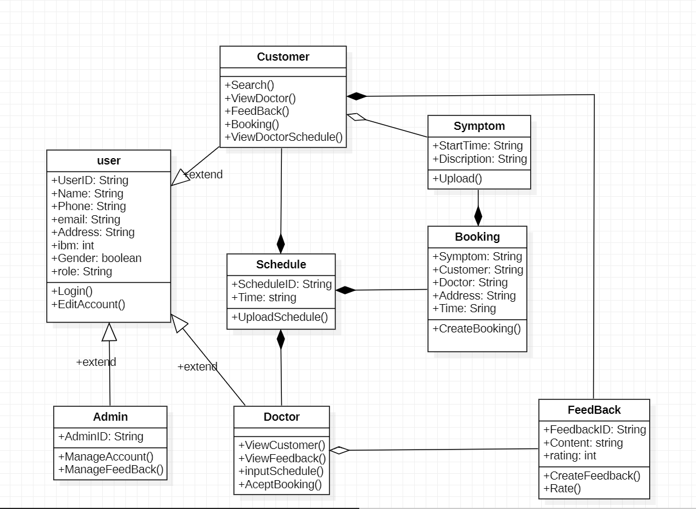

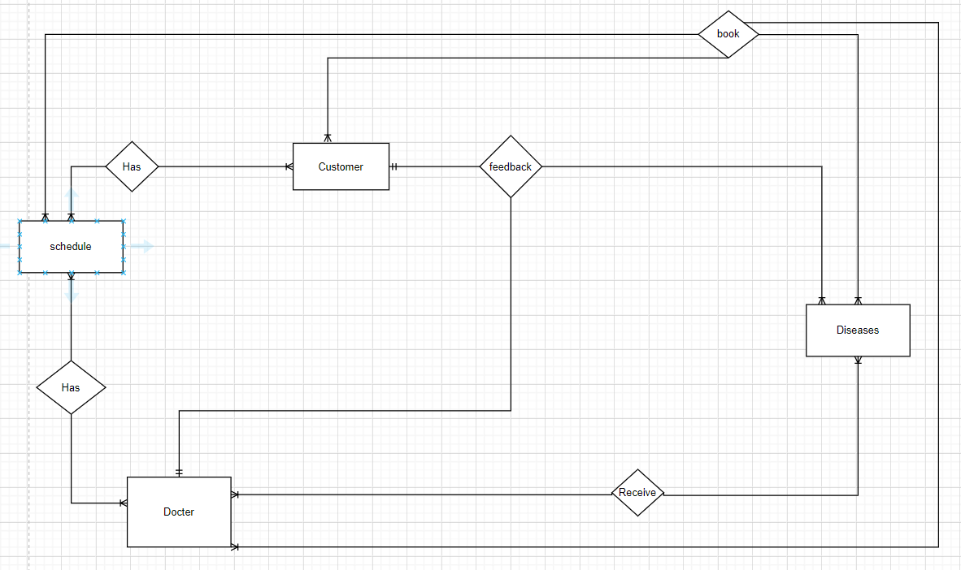**ENTITY RELATIONSHIP DIAGRAM (ERD)**  
 **Note:  
  
  
ENTITY DESCRIPTION**

Entity

Entity Relationship

One to  
 many relationship

**1.Role:**

Certificate

Roles

**2. Certificate :  
3. User :**

User

**4. Major :**

Major

**5. Booking :**

Booking

**6. Feedback:**

Feedback

**TABLE DESIGN**

**1.User:**

|  |  |  |  |  |  |
| --- | --- | --- | --- | --- | --- |
| **No** | **Column Name** | **Data Type** | **Size** | **Check** | **Description** |
| 1 | **🗝idUser** | Int | 10 | Not Null | ID |
| 2 | phone | Varchar | 9 | Null | Phone User |
| 3 | Name | Varchar | 30 | Null | Name User |
| 4 | address | Date | 100 | Null | Address User |
| 5 | Email | Varchar | 50 | Null | Email User |
| 6 | Gender | Varchar | 100 | Null | Gender User |
| 7 | password | Varchar | 15 | Null | password User |
| 8 | idRole | Int | 10 | NOT Null | idRole |
| 9 | idCertificate | Int | 15 | NOT Null | idCertificate |
| 10 | Status | bit |  | NOT Null | Status |
| 11 | majorID | int | 10 | NOT Null | Major id |

**2.Role:**

|  |  |  |  |  |  |
| --- | --- | --- | --- | --- | --- |
| **No** | **Column Name** | **Data Type** | **Size** | **Check** | **Description** |
| 1 | **idRole** | Int | 10 | Not Null | ID |
| 2 | name | Varchar | 9 | Null | name User |

**3.Certificate:**

|  |  |  |  |  |  |
| --- | --- | --- | --- | --- | --- |
| **No** | **Column Name** | **Data Type** | **Size** | **Check** | **Description** |
| 1 | **idCertificate** | Int | 10 | Not Null | ID |
| 2 | name | Varchar | 9 | Null | Name certificate |

**4.Major :**

|  |  |  |  |  |  |
| --- | --- | --- | --- | --- | --- |
| **No** | **Column Name** | **Data Type** | **Size** | **Check** | **Description** |
| 1 | **MajorId** | Int | 10 | Not Null | ID |
| 2 | name | Varchar | 9 | Null | Name major |

**5.Booking :**

|  |  |  |  |  |  |
| --- | --- | --- | --- | --- | --- |
| **No** | **Column Name** | **Data Type** | **Size** | **Check** | **Description** |
| 1 | **idBooking** | Int | 10 | Not Null | ID |
| 2 | IDUser | Int | 10 | Not Null | ID |
| 3 | idDoctor | Int | 10 | Not null | ID |
| 4 | bookingDay | Date |  | Null | day |
| 5 | status | bit |  | Null | Status |

**6.Feedback:**

|  |  |  |  |  |  |
| --- | --- | --- | --- | --- | --- |
| **No** | **Column Name** | **Data Type** | **Size** | **Check** | **Description** |
| 1 | **idFeedback** | Int | 10 | Not Null | ID |
| 2 | idUser | Int | 10 | Not Null | ID |
| 3 | idBooking | Int |  | Not Null | ID |
| 4 | Comment | Varchar | Max | Null | comment |
| 5 | point | int | 10 | Not Null | point |

**Note**

**🗝** Primary key

✓ Unique constraint

**TABLE RELATIONSHIP DIAGRAM**

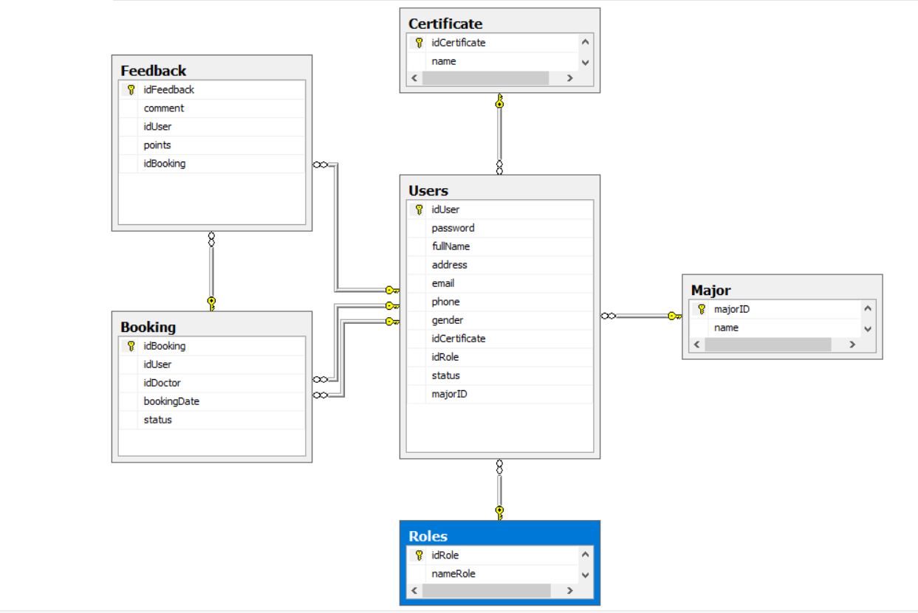

REVIEW 3

**INTERFACE DESIGN**

1. **Edit Password**

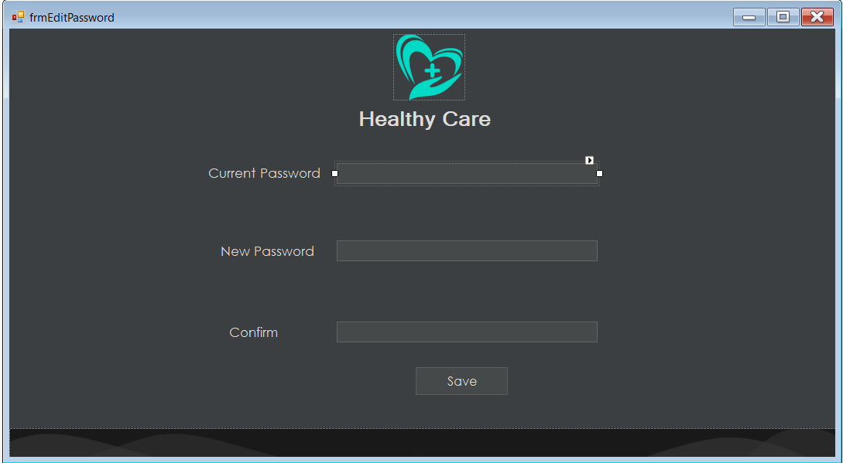

|  |  |  |  |  |  |
| --- | --- | --- | --- | --- | --- |
| **Name** | **Type** | **Event** | **Validation** | **Description** | **Status** |
| Current password | TextBox |  | String, not null | Input User’s current password |  |
| New password | TextBox |  | String, not null, | Input User’s new password |  |
| Confirm | TextBox |  | String, not null, | Input User’s new password again |  |
| Save | Button |  | Click | Choose Save |  |

1. **Edit profile:**

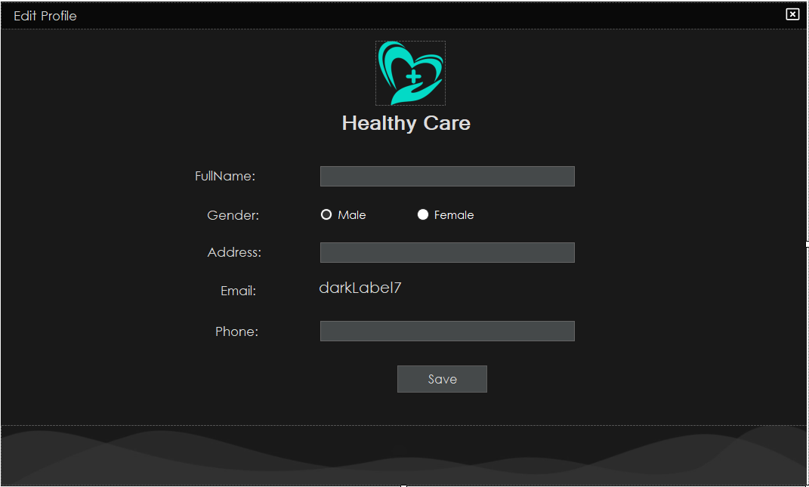

|  |  |  |  |  |  |
| --- | --- | --- | --- | --- | --- |
| **Name** | **Type** | **Event** | **Validation** | **Description** | **Status** |
| Full Name | TextBox |  | String, not null | Input User’s fullname |  |
| Address | TextBox |  | String, not null, | Input User’s Address |  |
| Gender | Check Box |  | Stick | Choose gender |  |
| Email | Label |  |  | Email of user |  |
| Phone | TextBox |  | int, not null | Input User’s phone |  |
| Save | Button |  | Click | Choose Save |  |

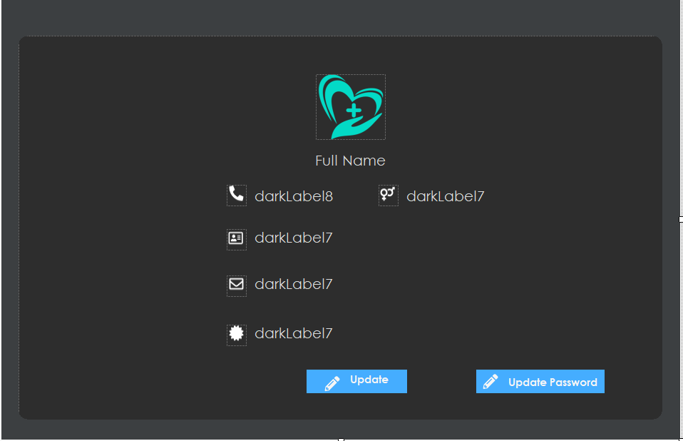  
**3.Profile user:**

|  |  |  |  |  |  |
| --- | --- | --- | --- | --- | --- |
| **Name** | **Type** | **Event** | **Validation** | **Description** | **Status** |
| Phone | Label |  | String, not null | Phone of user |  |
| Full name | Label |  | String, not null, | Full name of user |  |
| Gender | Label |  | String,not null | Gender of user |  |
| Email | Label |  | String, not null | Email of user |  |
| Address | Lebel |  | String,not null | Address of User |  |
| Update | Button |  | Click | Update profile |  |
| Update password | Button |  | Click | Go to update password page |  |

**4.Sign Up:**

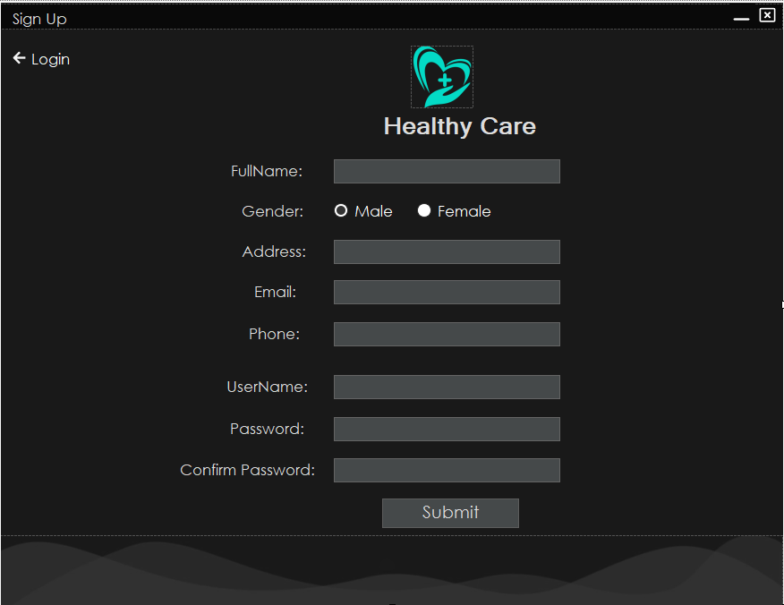

|  |  |  |  |  |  |
| --- | --- | --- | --- | --- | --- |
| **Name** | **Type** | **Event** | **Validation** | **Description** | **Status** |
| FullName | TextBox |  | String,not null | Input FullName |  |
| Gender | Check Box |  | Click | Click gender |  |
| Address | TextBox |  | String ,not null | Input Address |  |
| Email | TextBox |  | String ,not null | Input Email |  |
| Phone | TextBox |  | String ,not null | Input Phone |  |
| UserName | TextBox |  | String ,not null | Input Username |  |
| Password | TextBox |  | String ,not null | Input password |  |
| ConfirmPassword | TextBox |  | String ,not null | Input confirm password |  |

**5.Login:**

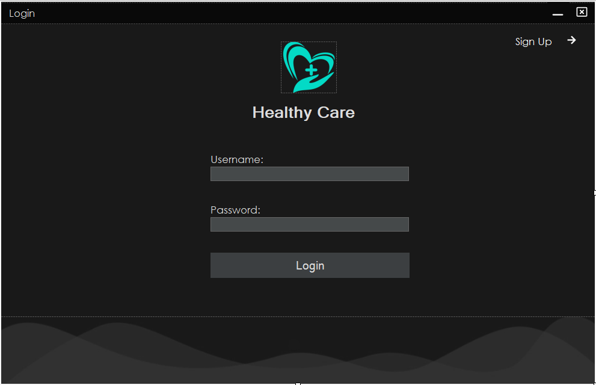

|  |  |  |  |  |  |
| --- | --- | --- | --- | --- | --- |
| **Name** | **Type** | **Event** | **Validation** | **Description** | **Status** |
| UserName | TextBox |  | String, not null | Input username |  |
| Password | TextBox |  | String, not null, | Input password |  |
| Login | Button |  |  | To login frm |  |

**6.Change CodePin:**

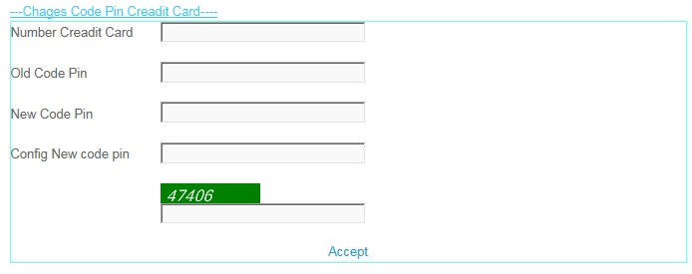

|  |  |  |  |  |  |
| --- | --- | --- | --- | --- | --- |
| **Name** | **Type** | **Event** | **Validation** | **Description** | **Status** |
| Number Credit Card | TextBox |  | int, not null | Input Customer’s Number Credit Card |  |
| Old Code Pin | TextBox |  | int, not null, | Input Customer’s Old Code Pin |  |
| New Code Pin | TextBox |  | int,not null | Input Customer’s New Code Pin |  |
| Config New Code Pin | TextBox |  | int, not null | Input Customer’s Config New Code Pin |  |
| CapChar | TextBox |  | int ,not null | Input number follow Image at above Text Box |  |
| Accept | LinkButton |  | Click | Accept Change code Pin . |  |

**7.Create Information:**

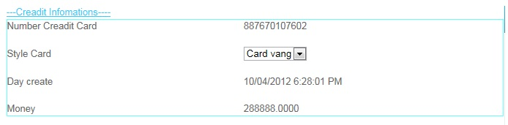

|  |  |  |  |  |  |
| --- | --- | --- | --- | --- | --- |
| **Name** | **Type** | **Event** | **Validation** | **Description** | **Status** |
| Number Credit Card | Label |  | Read Only | View Number Credit Card |  |
| Style Card | Drop Down List |  | Select | View and select Card |  |
| Day Create | Label |  | Read Only | View Day Create |  |
| Money | Label |  | Read Only | View Money |  |

**8.Edit Account User:**

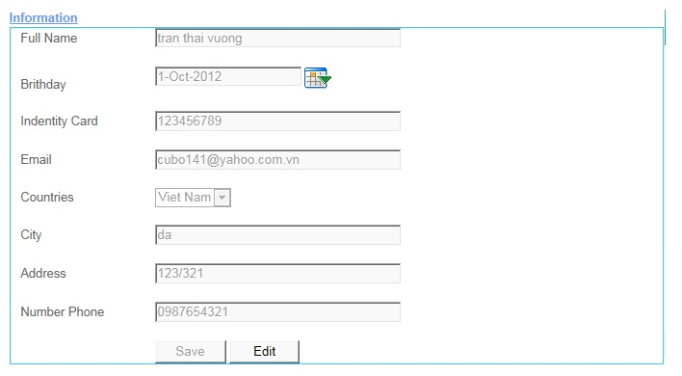

|  |  |  |  |  |  |
| --- | --- | --- | --- | --- | --- |
| **Name** | **Type** | **Event** | **Validation** | **Description** | **Status** |
| Full Name | TextBox |  | String, not null | Input Full Name |  |
| Birthday | TextBox |  | DatetTime | Input DateTime |  |
| Calendar Tool | Calendar |  | Select | Select Date on Calendar |  |
| Identity Card | TextBox |  | Int , not null | Input identity Card |  |
| Email | TextBox |  | String ,not null, have Validation | Input Customer’s Email |  |
| Country | DropDownList |  | Select | Select country |  |
| Address | TextBox |  | Int, not null | Input Customer’s Address |  |
| Number Phone | TextBox |  | Int, not null | Input Customer’s Number Phone |  |
| Save | Button |  | Click | click save edit enable |  |
| Edit | Button |  | Click | click edit Save unenable |  |

**9.Transaction:**

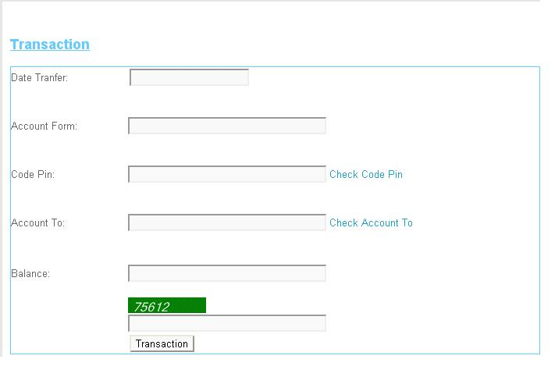

|  |  |  |  |  |  |
| --- | --- | --- | --- | --- | --- |
| **Name** | **Type** | **Event** | **Validation** | **Description** | **Status** |
| Date Tranfer | TextBox |  | DateTime, not null | Input Date Tranfer |  |
| Account From | TextBox |  | DatetTime | Input Account From |  |
| Code Pin | TextBox |  | Int, not null and Valiadaton | Input Code Pin |  |
| Account To | TextBox |  | DateTime, not null and Validation | Input Account To |  |
| Balance | TextBox |  | String ,not null, have Validation | Input Customer’s Balance |  |
| Transaction | Button |  | Click | Transaction |  |
| Check CodePin | LinkButton |  | Click | Check Codepin inval or not inval.. |  |
| Check Account To | LinkButton |  | Click | Check Account Inval or Not inval |  |
| CapChar | TextBox |  | int ,not null | Input number follow Image at above Text Box |  |

**10.Transaction Admin:**

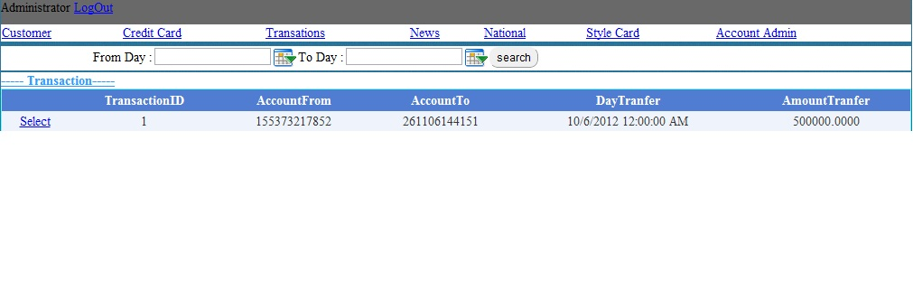

|  |  |  |  |  |  |
| --- | --- | --- | --- | --- | --- |
| **Name** | **Type** | **Event** | **Validation** | **Description** | **Status** |
| Log Out | LoginStatus |  | Click | Click Log Out |  |
| From Day | BasicdatePicker |  | Date time | Input From Date tranfer |  |
| To Day | BasicDatePicker |  | Date Time | Input To Date Tranfer |  |
| Transaction | Drop Down List |  | Select inform | Select Transaction |  |
| List Transaction | Grid view |  | Read Only | View inform Transaction |  |
| Select | LinkButton |  | Select | Select then view Detail |  |

**11.View Transaction:**

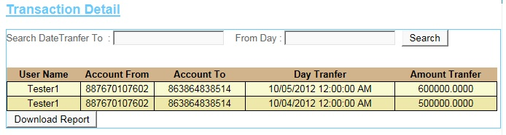

|  |  |  |  |  |  |
| --- | --- | --- | --- | --- | --- |
| **Name** | **Type** | **Event** | **Validation** | **Description** | **Status** |
| Search Date Transfer To | TextBox |  | DateTime , not null | Input DateTime |  |
| From Day | TextBox |  | DateTime , not null | Input DateTime |  |
| Search | Button |  | Click | Search |  |
| Transaction Detail | GridView |  | Read Only | View Inform of Detail’s Transaction |  |
| DownLoad Report | Button |  | Click | DownLoad Report |  |

**12.News:**

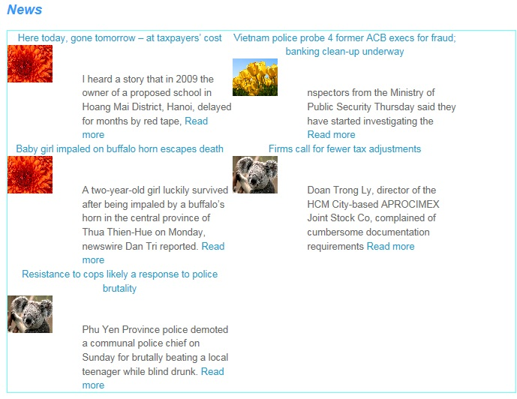

**13.AdminLogin:**

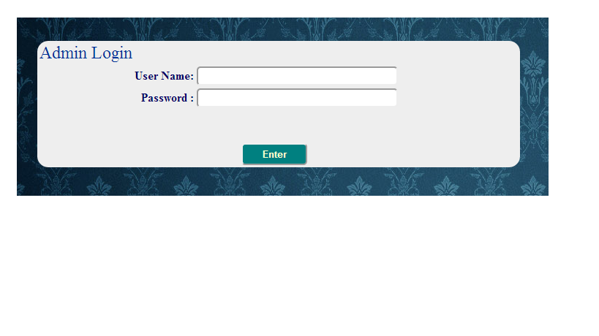

|  |  |  |  |  |  |
| --- | --- | --- | --- | --- | --- |
| **Name** | **Type** | **Event** | **Validation** | **Description** | **Status** |
| User Name | TextBox |  | String, not null | Input Admin’s user name |  |
| Password | TextBox |  | String, not null, | Input Admin’s password |  |
| Enter | Button |  | Click |  |  |

**14.AccountAdmin:**

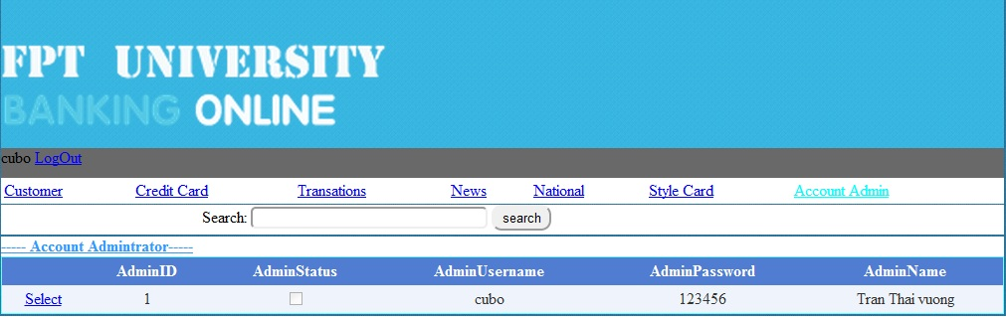

|  |  |  |  |  |  |
| --- | --- | --- | --- | --- | --- |
| **Name** | **Type** | **Event** | **Validation** | **Description** | **Status** |
| Search | TextBox | Onkeydown | String, | Search Admin’s Usernmae |  |
| Select Object | Hyperlink |  |  |  |  |
| DetailView1 | DetailsView |  |  | Select Account Admin |  |
| Select | Linbutton |  |  | Select Details Account Admin |  |

**15.AccountCustomer:**

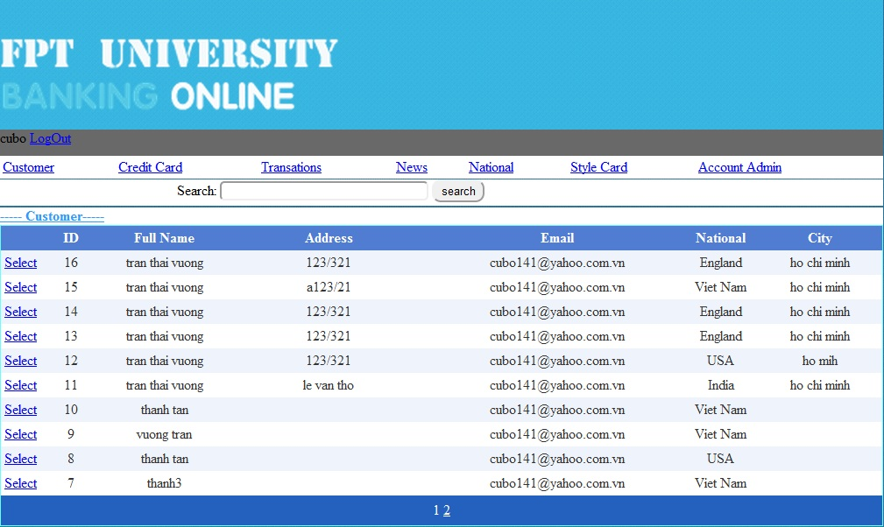

|  |  |  |  |  |  |
| --- | --- | --- | --- | --- | --- |
| **Name** | **Type** | **Event** | **Validation** | **Description** | **Status** |
| Search | TextBox |  | String | Search Customer’s Username |  |
| Select Object | Hyperlink |  |  |  |  |
| GridviewAccountCustomer | Gridview |  |  | Select Account Customer |  |
| Select | Linbutton |  |  | Select Details Account Customer |  |

**16.CreditCard:**

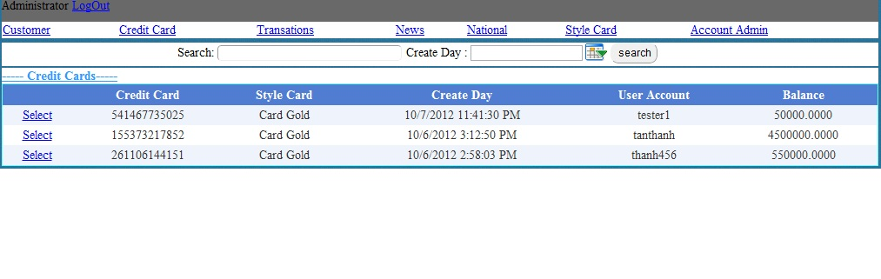

|  |  |  |  |  |  |
| --- | --- | --- | --- | --- | --- |
| **Name** | **Type** | **Event** | **Validation** | **Description** | **Status** |
| Search | TextBox | OnKeyDown | String | Search UserName |  |
| Select Object | Hyperlink |  |  |  |  |
| GvCreditCard | Gridview |  |  | Select ListCreditCard |  |
| Select | Linbutton |  |  | Select Details CreditCard |  |

**17.StyleCard:**

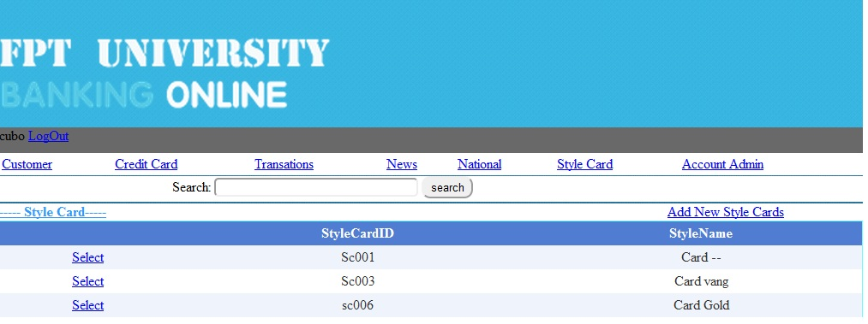

|  |  |  |  |  |  |
| --- | --- | --- | --- | --- | --- |
| **Name** | **Type** | **Event** | **Validation** | **Description** | **Status** |
| Search | TextBox | OnkeyDown | String | Search Style CardName |  |
| Select Object | Hyperlink |  |  |  |  |
| GvStyleCard | Gridview |  |  | Select Style Card |  |
| Select | Linbutton |  |  | Select Details Style Card |  |

**18.News:**

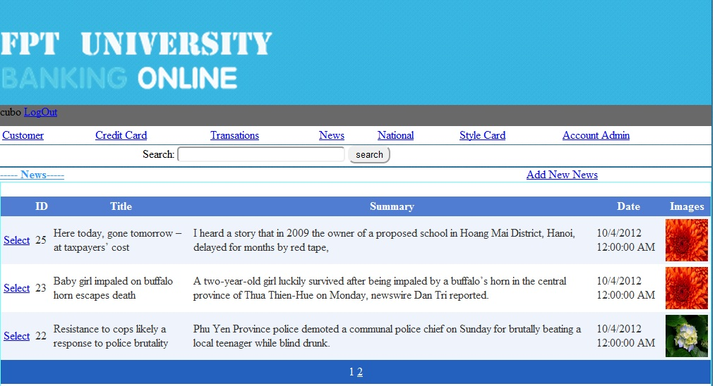

|  |  |  |  |  |  |
| --- | --- | --- | --- | --- | --- |
| **Name** | **Type** | **Event** | **Validation** | **Description** | **Status** |
| Search | TextBox | Onkeydown | String | Search Title News |  |
| Select Object | Hyperlink |  |  | Go Add new News |  |
| GvNews | Gridview |  |  | Select News |  |
| Select | Linbutton |  |  | Select Details News |  |

**19.National:**

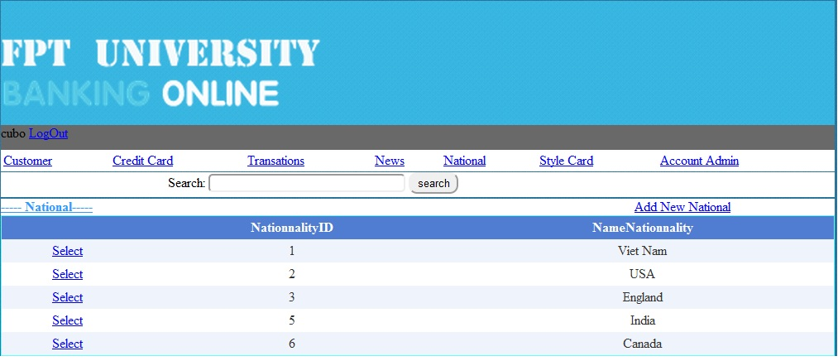

|  |  |  |  |  |  |
| --- | --- | --- | --- | --- | --- |
| **Name** | **Type** | **Event** | **Validation** | **Description** | **Status** |
| Search | TextBox | onKeydown | String | Search Name Nationality |  |
| Select Object | Hyperlink |  |  |  |  |
| Gv Nationality | Gridview |  |  | Select Nationality |  |
| Select | Linbutton |  |  | Select Details Nationality |  |

**20.Details Account Admin:**

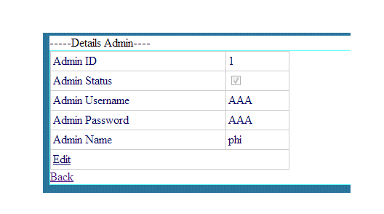

|  |  |  |  |  |  |
| --- | --- | --- | --- | --- | --- |
| **Name** | **Type** | **Event** | **Validation** | **Description** | **Status** |
| Edit | LinkButton |  |  | Edit Account Admin |  |
| Back | LinkButon |  |  | Back to MainAdmin.aspx |  |
| DetailsView1 | DetailsView |  |  | Select Details Admin |  |

**21.Details Account Customer:**

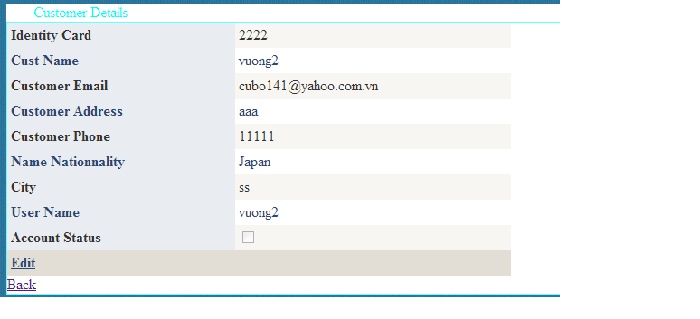

|  |  |  |  |  |  |
| --- | --- | --- | --- | --- | --- |
| **Name** | **Type** | **Event** | **Validation** | **Description** | **Status** |
| Edit | LinkButton |  |  | Edit Account Customer |  |
| Back | LinkButon |  |  | Back to MainAdmin.aspx |  |
| DetailsView1 | DetailsView |  |  | Select Customer Information |  |

**22.Details Credit Card:**

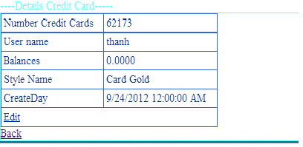

|  |  |  |  |  |  |
| --- | --- | --- | --- | --- | --- |
| **Name** | **Type** | **Event** | **Validation** | **Description** | **Status** |
| Edit | LinkButton |  |  | Edit Balance of Customer |  |
| Back | LinkButon |  |  | Back to MainAdmin.aspx |  |
| DetailsView1 | DetailsView |  |  | Select Details Credit Card of |  |

**23.Details Style Card:**

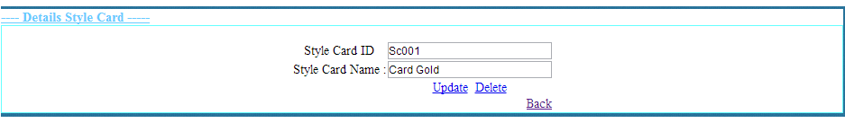

|  |  |  |  |  |  |
| --- | --- | --- | --- | --- | --- |
| **Name** | **Type** | **Event** | **Validation** | **Description** | **Status** |
| txtStyleCardID | TextBox |  | String,Not null | Input Style CardID |  |
| txtStyleCardName | TextBox |  | String,Not null | Input Style Card Name |  |
| Update | LinkButton |  |  | Update Style Card |  |
| Delete | LinkButton |  |  | Delete Style Card |  |
| Back | LinkButtom |  |  | Back to MainAdmin.aspx |  |

**24.News:**

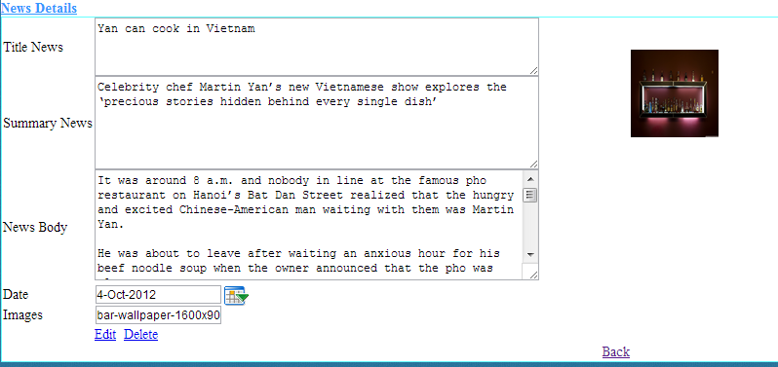

|  |  |  |  |  |  |
| --- | --- | --- | --- | --- | --- |
| **Name** | **Type** | **Event** | **Validation** | **Description** | **Status** |
| txtTitle News | TextBox |  | String,Not null | Input Title News |  |
| txtSummary News | TextBox |  | String,Not null | Input Summary News |  |
| txtNews Body | TextBox |  | String,Not null | Input News Body |  |
| txtDay | BasicDatePicker |  | Datetime,Not null | Input Datetime |  |
| txtImages | TextBox |  | String ,Not null | Input Images |  |
| Edit | LinkButton |  |  | Update Style Card |  |
| Delete | LinkButton |  |  | Delete Style Card |  |
| Back | LinkButtom |  |  | Back to MainAdmin.aspx |  |

**24.Details Nationality:**

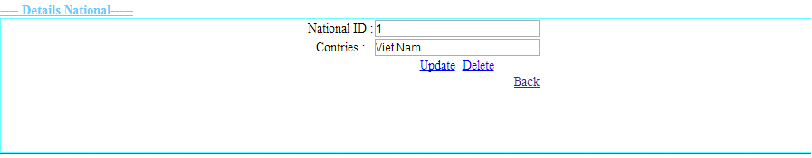

|  |  |  |  |  |  |
| --- | --- | --- | --- | --- | --- |
| **Name** | **Type** | **Event** | **Validation** | **Description** | **Status** |
| txtID | TextBox |  | String,Not null | Input CardID |  |
| txtNationalityName | TextBox |  | String,Not null | Input Nationality |  |
| Update | LinkButton |  |  | Update Nationality |  |
| Delete | LinkButton |  |  | Delete Nationality |  |
| Back | LinkButtom |  |  | Back to MainAdmin.aspx |  |

**Support:**

**+ Connected**

* **Gold :**

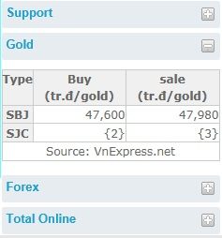

* **Forex :**

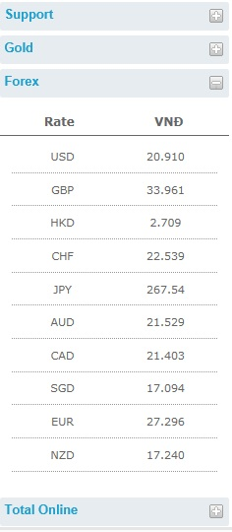

**+Disconnection**

* **Gold :**

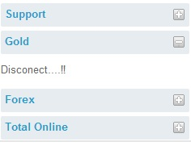

* **Forex :**

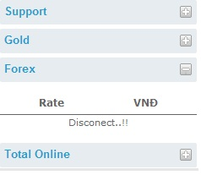

**+Total Online**

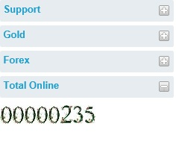

**TASK SHEET**

|  |  |  |  |  |  |  |
| --- | --- | --- | --- | --- | --- | --- |
| **Project Group FFG** | | **Project Title**  **Laptop Shop Online** | | **Date of Preparation** | | **Activity Plan Prepared by**  **Le Hoang Hai** |
| **No** | **Task Title** | | **Planned Start Date** | **Planned Completed Date** | **Team Mate Names** | **Status** |
| 1 | Login Customer | | Sep 10, 2012 | Oct 10, 2012 |  |  |
| 2 | Search admin evevnt onkeydown | |  |
| 3 | Change CodePin Credit Card | |  |
| 4 | Load News Masterpage Customer | |  |
| 5 | Design Masterpage Customer | |  |
| 6 | Register Customer | |  |  |
| 7 | Change Password | |  |
| 8 | Forget Password | |  |
| 9 | Credit card Infomation | |  |
| 10 | Your`s Profile | |  |
| 11 | Login Admin | |  |  |
| 12 | Edit Credit Card | |  |
| 13 | Edit Style Card | |  |
| 14 | Edit National | |  |
| 15 | Masterpage Admin | |  |
| 16 | Edit Status Customer | |  |  |
|  |
| 17 | Show Transaction | |  |
| 18 | Edit Balance | |  |
| 19 | Add, Edit, Delete news | |  |
| 20 | Customer Transaction | |  |  |
| 21 | Detail Transaction | |  |
| 22 | Download Report Transaction | |  |
| 23 | Create Report | |  |
| 25 | Contact | |  |
| 26 | Search Report | |  |
| 27 | Design Masterpage Customer | |  |

|  |  |  |
| --- | --- | --- |
| **Date: Oct 10, 2012** | **Prepared by Project Group 4**  **Team Leader:** | **Approved by**  **Mr. Ho Hoan Kiem** |
| **Signature** |  |  |

Following is a list of functionalities of the system. More functionalities that you find appropriate can be added to this list.

• Customer must have a valid User Id and password to login to the system

• If a wrong password is given, that account will be received a mesages .

• After the valid user logs in he is shown the list of reputable doctor .

• On selecting the doctor he is taken to a page which shows the present detail of that doctor.

• User can see details of the last doctor he has booked.

• User can upload their sysmptom to find a suitable doctor near them.

• User can Book doctor from his account to make him go to that phace to check out the patient. If that docor acept a notification should appear to the customer, in case it is unsuccessful, a proper message should be given to the customer as to why it failed.

• User can request for change of address/ payment / times

• User can view feedback rating of that doctor

• Proper help to be provided as and when requested by the user.