**LAB3**

Họ tên: Huỳnh bảo Trân

Lớp: 11_TMĐT

MSSV: 1150070045

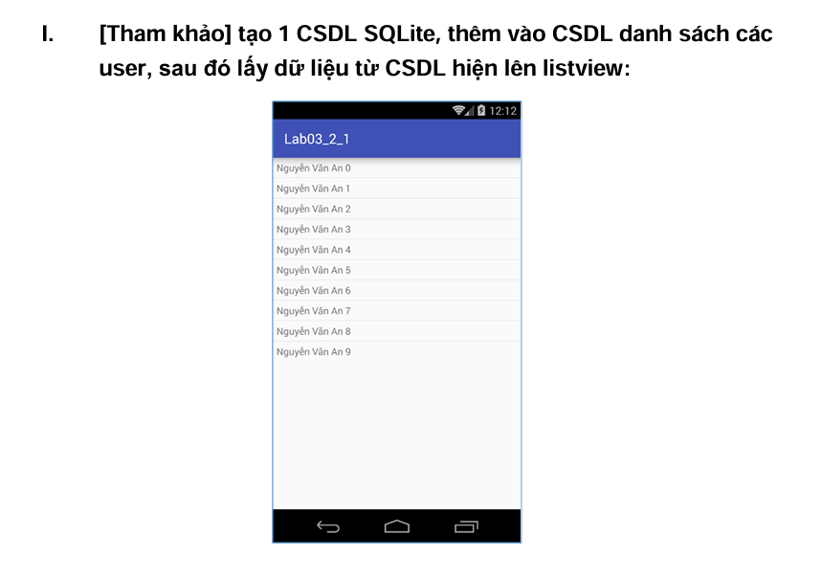

* Nội dung file activity_main
* <?xml version="1.0" encoding="utf-8"?>  
  <LinearLayout xmlns:android="http://schemas.android.com/apk/res/android"  
   android:layout_width="match_parent"  
   android:layout_height="match_parent"  
   android:orientation="vertical">  
    
   <ListView  
   android:id="@+id/lv_user"  
   android:layout_width="wrap_content"  
   android:layout_height="wrap_content" />  
  </LinearLayout>
* Tạo file item_user.xml
* Nội dung file
* <?xml version="1.0" encoding="utf-8"?>  
  <TextView xmlns:android="http://schemas.android.com/apk/res/android"  
   android:id="@+id/tv_user"  
   android:layout_width="wrap_content"  
   android:layout_height="wrap_content"  
   android:padding="@dimen/margin_base"/>
* Tạo class DatabaseHelper
* Nội dung package com.example.tran;  
    
  import android.content.Context;  
  import android.database.sqlite.SQLiteDatabase;  
  import android.database.sqlite.SQLiteOpenHelper;  
    
  public class DatabaseHelper extends SQLiteOpenHelper {  
    
   private static final String *DATABASE_CREATE* =  
   "CREATE TABLE users (" +  
   "_id INTEGER PRIMARY KEY AUTOINCREMENT, " +  
   "name TEXT NOT NULL);";  
    
    
    
   public DatabaseHelper(Context context, String name,  
   SQLiteDatabase.CursorFactory factory, int version) {  
   super(context, name, factory, version);  
   // *TODO Auto-generated constructor stub* }  
    
   @Override  
   public void onCreate(SQLiteDatabase db) {  
   // *TODO Auto-generated method stub* db.execSQL(*DATABASE_CREATE*);  
   }  
    
   @Override  
   public void onUpgrade(SQLiteDatabase db, int oldVersion, int newVersion)  
   {  
   // *TODO Auto-generated method stub* db.execSQL("DROP TABLE IF EXISTS users");  
   onCreate(db);  
   }  
  }
* Tạo tiếp class DBAdapter
* Nội dung
* package com.example.tran;  
    
  import android.content.ContentValues;  
  import android.content.Context;  
  import android.database.Cursor;  
  import android.database.sqlite.SQLiteDatabase;  
    
  import com.example.tran.DatabaseHelper;  
    
  public class DbAdapter {  
   public static final String *KEY_ID* = "_id";  
   public static final String *KEY_NAME* = "name";  
    
   private DatabaseHelper dbHelper;  
   private SQLiteDatabase sqLiteDatabase;  
   private static final String *DATABASE_NAME* = "Database_Demo";  
   private static final String *DATABASE_TABLE* = "users";  
   private static final int *DATABASE_VERSION* = 2;  
   private final Context context;  
    
   public DbAdapter(Context ctx) {  
   this.context = ctx;  
   }  
    
   public DbAdapter open() {  
   dbHelper = new DatabaseHelper(context, *DATABASE_NAME*, null,  
   *DATABASE_VERSION*);  
   sqLiteDatabase = dbHelper.getWritableDatabase();  
   return this;  
   }  
    
   public void close() {  
   dbHelper.close();  
   }  
    
   public long createUser(String name) {  
   ContentValues inititalValues = new ContentValues();  
   inititalValues.put(*KEY_NAME*, name);  
   return sqLiteDatabase.insert(*DATABASE_TABLE*, null, inititalValues);  
   }  
    
   public boolean deleteUser(long rowId) {  
   return sqLiteDatabase.delete(*DATABASE_TABLE*, *KEY_ID* + "=" + rowId,  
   null) > 0;  
   }  
    
   public boolean deleteAllUsers() {  
   return sqLiteDatabase.delete(*DATABASE_TABLE*, null, null) > 0;  
   }  
    
   public Cursor getAllUsers() {  
   return sqLiteDatabase.query(*DATABASE_TABLE*, new String[]{*KEY_ID*,  
   *KEY_NAME*}, null, null, null, null, null);  
   }  
  }
* Tạo file Dimens.xml
* Nội dung

<resources>  
 <dimen name="margin_base">16dp</dimen>  
</resources>

* Kết quả