**CÔNG NGHỆ LẬP TRÌNH ĐA NỀN TẢNG CHO ỨNG DỤNG DI ĐỘNG**

Họ tên: Huỳnh bảo Trân

Lớp: 11_TMĐT

MSSV: 1150070045

**LAB3**

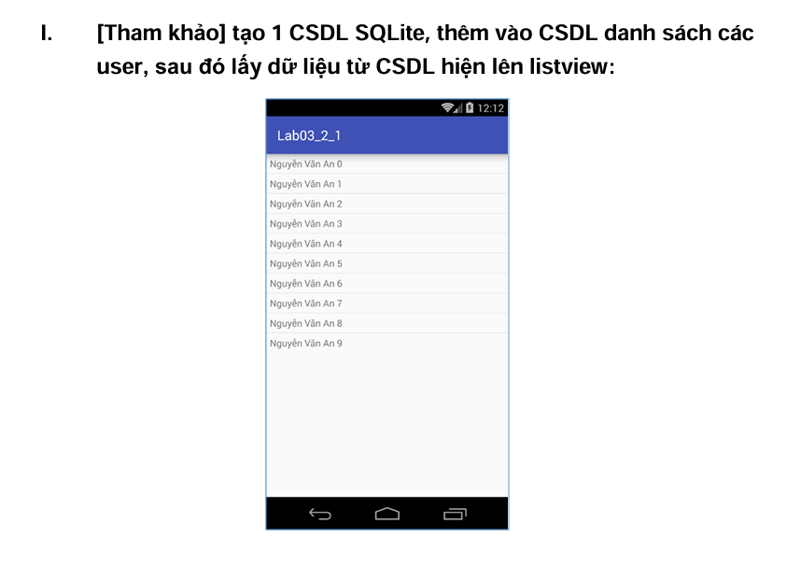

* **Nội dung file activity_main**
* <?xml version="1.0" encoding="utf-8"?>  
  <LinearLayout xmlns:android="http://schemas.android.com/apk/res/android"  
   android:layout_width="match_parent"  
   android:layout_height="match_parent"  
   android:orientation="vertical">  
    
   <ListView  
   android:id="@+id/lv_user"  
   android:layout_width="wrap_content"  
   android:layout_height="wrap_content" />  
  </LinearLayout>
* **Tạo file item_user.xml**
* **Nội dung file**
* <?xml version="1.0" encoding="utf-8"?>  
  <TextView xmlns:android="http://schemas.android.com/apk/res/android"  
   android:id="@+id/tv_user"  
   android:layout_width="wrap_content"  
   android:layout_height="wrap_content"  
   android:padding="@dimen/margin_base"/>
* **Tạo class DatabaseHelper**
* **Nội dung**

package com.example.tran;  
  
import android.content.Context;  
import android.database.sqlite.SQLiteDatabase;  
import android.database.sqlite.SQLiteOpenHelper;  
  
public class DatabaseHelper extends SQLiteOpenHelper {  
  
 private static final String *DATABASE_CREATE* =  
 "CREATE TABLE users (" +  
 "_id INTEGER PRIMARY KEY AUTOINCREMENT, " +  
 "name TEXT NOT NULL);";  
  
  
  
 public DatabaseHelper(Context context, String name,  
 SQLiteDatabase.CursorFactory factory, int version) {  
 super(context, name, factory, version);  
 // *TODO Auto-generated constructor stub* }  
  
 @Override  
 public void onCreate(SQLiteDatabase db) {  
 // *TODO Auto-generated method stub* db.execSQL(*DATABASE_CREATE*);  
 }  
  
 @Override  
 public void onUpgrade(SQLiteDatabase db, int oldVersion, int newVersion)  
 {  
 // *TODO Auto-generated method stub* db.execSQL("DROP TABLE IF EXISTS users");  
 onCreate(db);  
 }  
}

* **Tạo tiếp class DBAdapter**
* **Nội dung**
* package com.example.tran;  
    
  import android.content.ContentValues;  
  import android.content.Context;  
  import android.database.Cursor;  
  import android.database.sqlite.SQLiteDatabase;  
    
  import com.example.tran.DatabaseHelper;  
    
  public class DbAdapter {  
   public static final String *KEY_ID* = "_id";  
   public static final String *KEY_NAME* = "name";  
    
   private DatabaseHelper dbHelper;  
   private SQLiteDatabase sqLiteDatabase;  
   private static final String *DATABASE_NAME* = "Database_Demo";  
   private static final String *DATABASE_TABLE* = "users";  
   private static final int *DATABASE_VERSION* = 2;  
   private final Context context;  
    
   public DbAdapter(Context ctx) {  
   this.context = ctx;  
   }  
    
   public DbAdapter open() {  
   dbHelper = new DatabaseHelper(context, *DATABASE_NAME*, null,  
   *DATABASE_VERSION*);  
   sqLiteDatabase = dbHelper.getWritableDatabase();  
   return this;  
   }  
    
   public void close() {  
   dbHelper.close();  
   }  
    
   public long createUser(String name) {  
   ContentValues inititalValues = new ContentValues();  
   inititalValues.put(*KEY_NAME*, name);  
   return sqLiteDatabase.insert(*DATABASE_TABLE*, null, inititalValues);  
   }  
    
   public boolean deleteUser(long rowId) {  
   return sqLiteDatabase.delete(*DATABASE_TABLE*, *KEY_ID* + "=" + rowId,  
   null) > 0;  
   }  
    
   public boolean deleteAllUsers() {  
   return sqLiteDatabase.delete(*DATABASE_TABLE*, null, null) > 0;  
   }  
    
   public Cursor getAllUsers() {  
   return sqLiteDatabase.query(*DATABASE_TABLE*, new String[]{*KEY_ID*,  
   *KEY_NAME*}, null, null, null, null, null);  
   }  
  }
* **Tạo file Dimens.xml**
* **Nội dung**

<resources>  
 <dimen name="margin_base">16dp</dimen>  
</resources>

* **Kết quả**

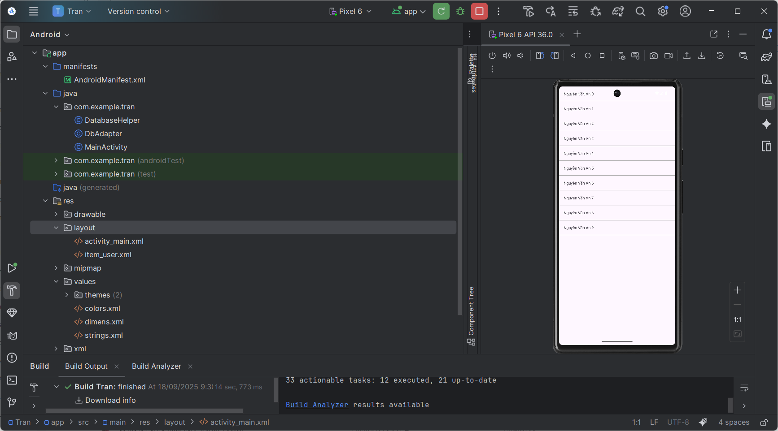

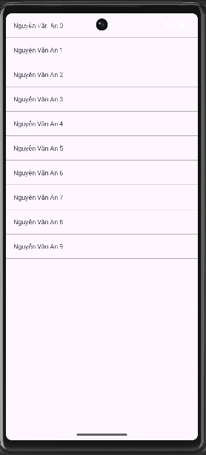

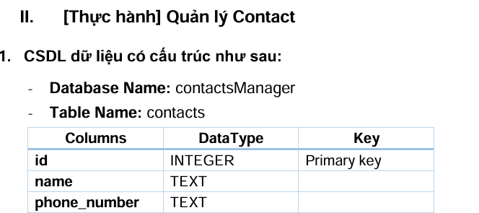

* **Tạo lớp Contact**
* **Nội dung**

**package com.example.tran;**

**public class Contact {**

**int id;**

**String name;**

**String phoneNumber;**

**public Contact() {}**

**public Contact(int id, String name, String phoneNumber) {**

**this.id = id;**

**this.name = name;**

**this.phoneNumber = phoneNumber;**

**}**

**public Contact(String name, String phoneNumber) {**

**this.name = name;**

**this.phoneNumber = phoneNumber;**

**}**

**public int getID() {**

**return this.id;**

**}**

**public void setID(int id) {**

**this.id = id;**

**}**

**public String getName() {**

**return this.name;**

**}**

**public void setName(String name) {**

**this.name = name;**

**}**

**public String getPhoneNumber() {**

**return this.phoneNumber;**

**}**

**public void setPhoneNumber(String phone_number) {**

**this.phoneNumber = phone_number;**

**}**

**@Override**

**public String toString() {**

**return name + " - " + phoneNumber;**

**}**

**}**

* **Tạo 1 lớp DatabaseHandler kế thừa từ SQLiteOpenHelper**
* **Nội dung**

**package com.example.tran;**

**import java.util.ArrayList;**

**import java.util.List;**

**import android.content.ContentValues;**

**import android.content.Context;**

**import android.database.Cursor;**

**import android.database.sqlite.SQLiteDatabase;**

**import android.database.sqlite.SQLiteOpenHelper;**

**public class DatabaseHandler extends SQLiteOpenHelper {**

**private static final int DATABASE_VERSION = 1;**

**private static final String DATABASE_NAME = "contactsManager";**

**private static final String TABLE_CONTACTS = "contacts";**

**private static final String KEY_ID = "id";**

**private static final String KEY_NAME = "name";**

**private static final String KEY_PH_NO = "phone_number";**

**public DatabaseHandler(Context context) {**

**super(context, DATABASE_NAME, null, DATABASE_VERSION);**

**}**

**@Override**

**public void onCreate(SQLiteDatabase db) {**

**String CREATE_CONTACTS_TABLE = "CREATE TABLE " + TABLE_CONTACTS + "("**

**+ KEY_ID + " INTEGER PRIMARY KEY AUTOINCREMENT,"**

**+ KEY_NAME + " TEXT,"**

**+ KEY_PH_NO + " TEXT" + ")";**

**db.execSQL(CREATE_CONTACTS_TABLE);**

**}**

**@Override**

**public void onUpgrade(SQLiteDatabase db, int oldVersion, int newVersion) {**

**db.execSQL("DROP TABLE IF EXISTS " + TABLE_CONTACTS);**

**onCreate(db);**

**}**

**// Thêm contact**

**public void addContact(Contact contact) {**

**SQLiteDatabase db = this.getWritableDatabase();**

**ContentValues values = new ContentValues();**

**values.put(KEY_NAME, contact.getName());**

**values.put(KEY_PH_NO, contact.getPhoneNumber());**

**db.insert(TABLE_CONTACTS, null, values);**

**db.close();**

**}**

**// Lấy tất cả contact**

**public List<Contact> getAllContacts() {**

**List<Contact> contactList = new ArrayList<>();**

**String selectQuery = "SELECT * FROM " + TABLE_CONTACTS;**

**SQLiteDatabase db = this.getReadableDatabase();**

**Cursor cursor = db.rawQuery(selectQuery, null);**

**if (cursor.moveToFirst()) {**

**do {**

**Contact contact = new Contact();**

**contact.setID(cursor.getInt(0));**

**contact.setName(cursor.getString(1));**

**contact.setPhoneNumber(cursor.getString(2));**

**contactList.add(contact);**

**} while (cursor.moveToNext());**

**}**

**cursor.close();**

**return contactList;**

**}**

**// Xóa contact**

**public void deleteContact(Contact contact) {**

**SQLiteDatabase db = this.getWritableDatabase();**

**db.delete(TABLE_CONTACTS, KEY_ID + " = ?", new String[]{String.valueOf(contact.getID())});**

**db.close();**

**}**

**}**

* **Nội dung MainActivity**

package com.example.tran;

import android.os.Bundle;

import android.view.View;

import android.widget.AdapterView;

import android.widget.ArrayAdapter;

import android.widget.ListView;

import android.widget.Toast;

import androidx.appcompat.app.AppCompatActivity;

import java.util.List;

public class MainActivity extends AppCompatActivity {

DatabaseHandler db;

List<Contact> contactList;

ArrayAdapter<Contact> adapter;

ListView lvContacts;

@Override

protected void onCreate(Bundle savedInstanceState) {

super.onCreate(savedInstanceState);

setContentView(R.layout.activity_main);

lvContacts = findViewById(R.id.lv_user);

db = new DatabaseHandler(this);

// Thêm dữ liệu mẫu

db.addContact(new Contact("Nguyễn Văn An", "0901234567"));

db.addContact(new Contact("Trần Thị B", "0912345678"));

db.addContact(new Contact("Lê Văn C", "0987654321"));

// Load danh sách

loadContacts();

// Sự kiện long click -> xóa contact

lvContacts.setOnItemLongClickListener(new AdapterView.OnItemLongClickListener() {

@Override

public boolean onItemLongClick(AdapterView<?> parent, View view, int position, long id) {

Contact contact = contactList.get(position);

db.deleteContact(contact);

Toast.makeText(MainActivity.this, "Đã xóa: " + contact.getName(), Toast.LENGTH_SHORT).show();

loadContacts(); // reload lại danh sách

return true;

}

});

}

private void loadContacts() {

contactList = db.getAllContacts();

adapter = new ArrayAdapter<>(this, android.R.layout.simple_list_item_1, contactList);

lvContacts.setAdapter(adapter);

}

}

* **Kết quả**

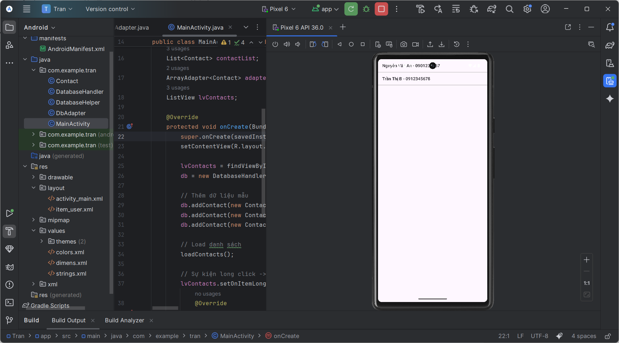

* **Nhấn giữ sẽ xóa dữ liệu**