CALIFORNIA STATE UNIVERSITY, LONG BEACH

**IS 445/545 – Internet Application Development**

## Spring 2022 Term – Section 01 (#6176/7039) – Individual Assignment #5

## Due: February 24, 2022

**Notes:**

* You will create a web site using tutorial 4 lab 2 as a template
* **Submission requirements (two files)**

1. Zipped file containing the following
   1. The directory containing all your code   
      (these are the same files you push to GitHub)

Name the file as follows: yourLastNmae_hw4.zip (e.g. asher_hw4.zip)

1. Solution to questions following the programming exercises

* **Dropbox Requirement**
  + In the comments section, include the links to your GitHub Repository and Netlify application. For example:  
    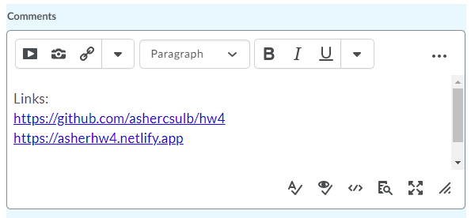

**Programming Assignment**

The programming assignment requires you to create solutions to several exercises below. Use tutorial 4 lab 2 as a template, that is

* Create the directory structure as in tutorial 4 lab 2 (html, js, and css)
* Create an index.html file
  + 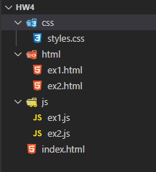It will have links to the solution for each exercise
* For each exercise, create two files   
  (replace # with the exercise number)
  + ex#.js (placed in js directory)
    - Contains JavaScript code
  + ex#.html (placed in html directory)
    - Runs the JavaScript code
    - Contains link back to index.html
* styles.css (optional)
  + Optional style sheet

1. Square Class

Create a square class defined by the following

* Property
  + side
* Methods
  + perimeter (side times 4)
  + area (side squared)
  + diagonal (square root of 2 * side squared, $\sqrt{2*s^{2}}$)
  + describe – shows the squares information as follows (assume side is 2):

Square with side 2 has perimeter of 8, area of 4, and diagonal of 2.828

Your program is to create three squares and use the describe method to show each squares information.

1. Starting with an array containing the numbers 1 through 10, use filter, map and reduce to produce the following. Use console.log to display the results.
   1. An array of odd numbers
   2. An array of numbers divisible by 2 or 5
   3. An array of numbers divisible by 3 squared (square the numbers that are divisible by 3)
   4. The sum of the following: square the numbers divisible by 5
2. Complete the code to produce the output shown.

Input: An array of student objects

Processing:

Use functional programming. Use filter, map, reduce, and pure functions.

Hint: See tutorial, "Student Results"

Output: An array of student objects with the shown properties. Shows students whose last name begins with "C": First and Last name; Min, Max, and Average Score.

//Declare studentList Array

const studentList = [

    {

        firstName: "Allan",

        lastName: "Able",

        scores: [95, 85, 92, 98]

    },

    {

        firstName: "Amy",

        lastName: "Alexander",

        scores: [80, 88, 100]

    },

    {

        firstName: "Betty",

        lastName: "Barns",

        scores: [70, 80, 90, 100]

    },

    {

        firstName: "Bob",

        lastName: "Bones",

        scores: [75, 85, 95, 85]

    },

    {

        firstName: "Cindy",

        lastName: "Chase",

        scores: [95, 90, 92, 98]

    },

    {

        firstName: "Charles",

        lastName: "Chips",

        scores: [88, 99, 90]

    },

];

// TO DO - Write higher order functions / There are many solutions

//Declare cLastNameResults.  Use functions and map a new array of objects

//Output

console.log(cLastNameResults);

Console Output



**Answer the following**

1. What are the links to your web site (see notes on first page)?
   1. GitHub URL: https://github.com/huynhderek/HW5.git
   2. Netlify URL: https://derekhuynhhw5.netlify.app/index.html
2. Start with an array containing the numbers 1 through 10. Assume the name is "anArray"
   1. What is the output of the following?

console.log(anArray.filter(value => value % 2 === 0).map(x => x * 2));

**Array [4, 8, 12, 16, 20]**

* 1. Let's reorder the filter and map methods. What is the output of the following?

console.log(anArray.map(x => x * 2).filter(value => value % 2 === 0));

**Array [2,4,6,8,10,12,14,16,18,20]**

* 1. Are the outputs the same? Why?

**No, they add onto the array with the map function in addition to the filter but the numbers 1-10 are gone**