Z
Ztech Dental Lab
Product Features Overview
May 2025

1. Secure Login
Access the system with your email and password. Each team member gets their own secure account to log in.
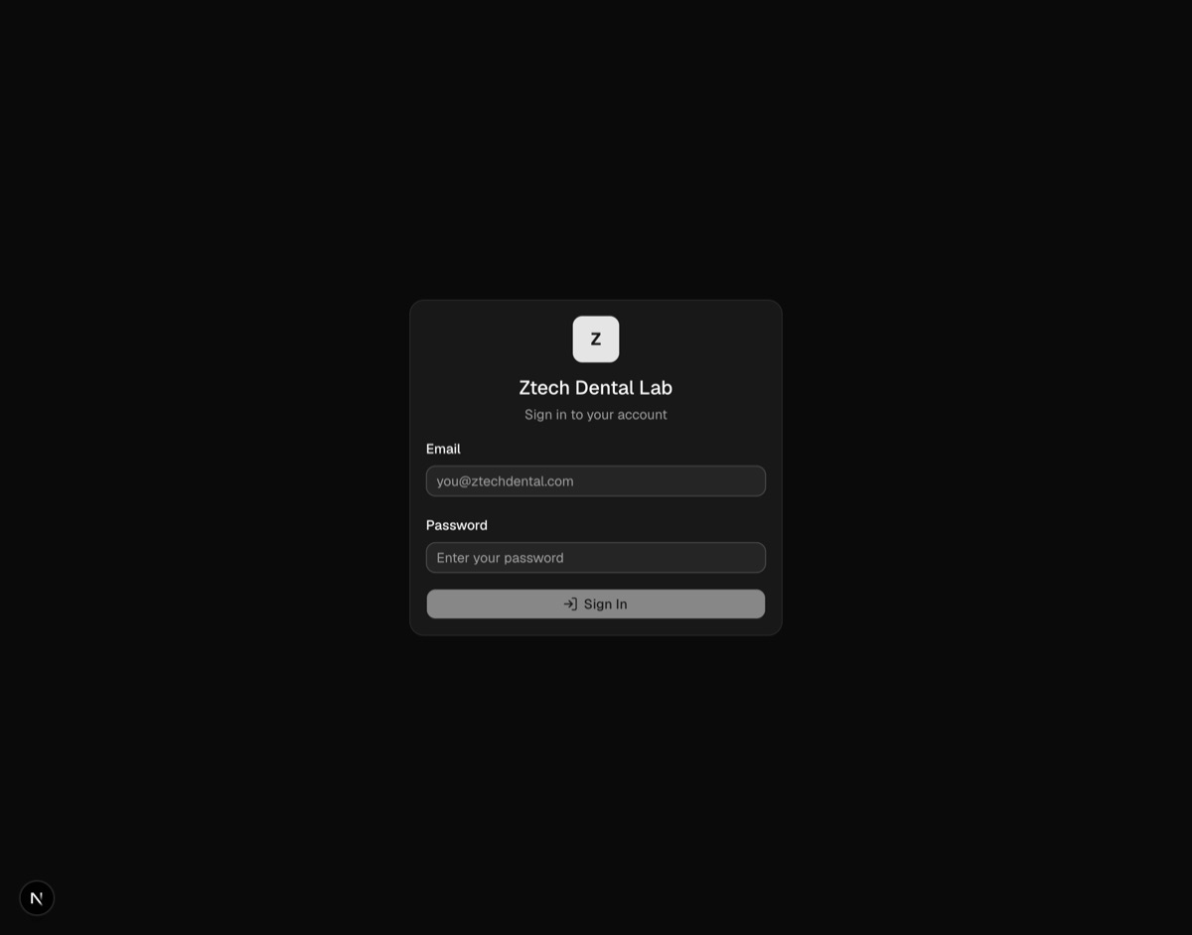

2. Dashboard — Operations Overview
See all key numbers at a glance: revenue, total cases, labs, doctors, and case statuses. Includes revenue trends, customer trends, volume charts, top labs/doctors, and a client activity heatmap.
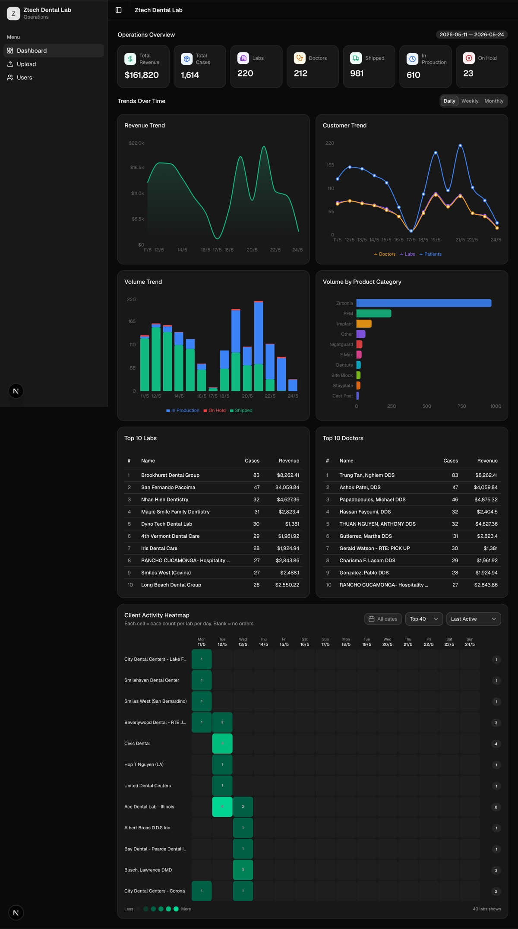

3. Data Upload — File History
View all uploaded Excel files with their status (Completed, Processing, or Failed), upload date, and who uploaded them. Supports pagination for large file lists.
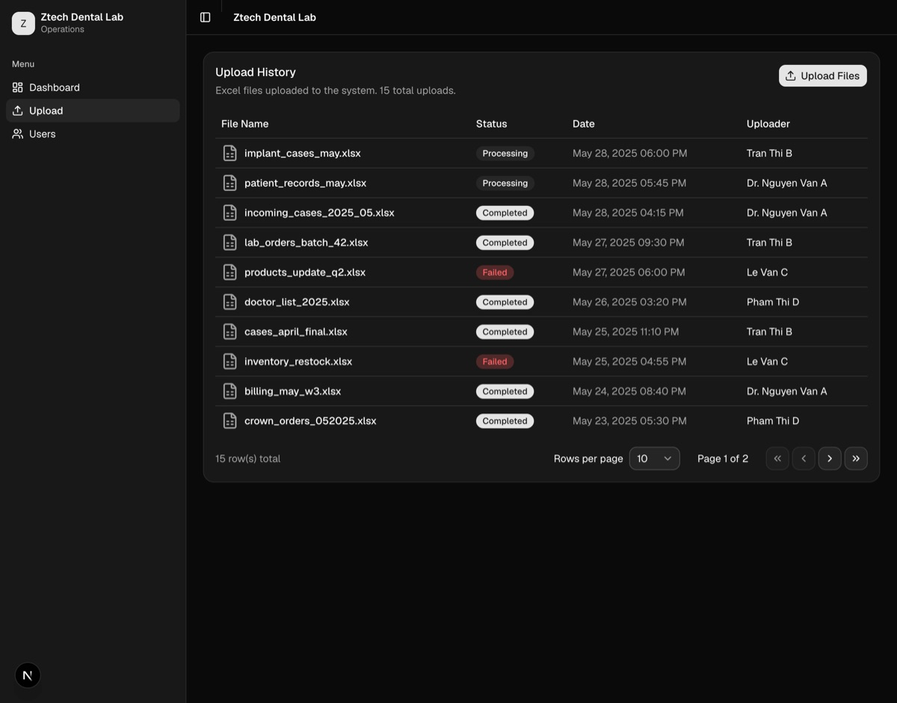

4. Data Upload — Upload Files
Drag and drop or click to browse and upload Excel files (.xlsx, .xls, .csv). You can upload multiple files at once.
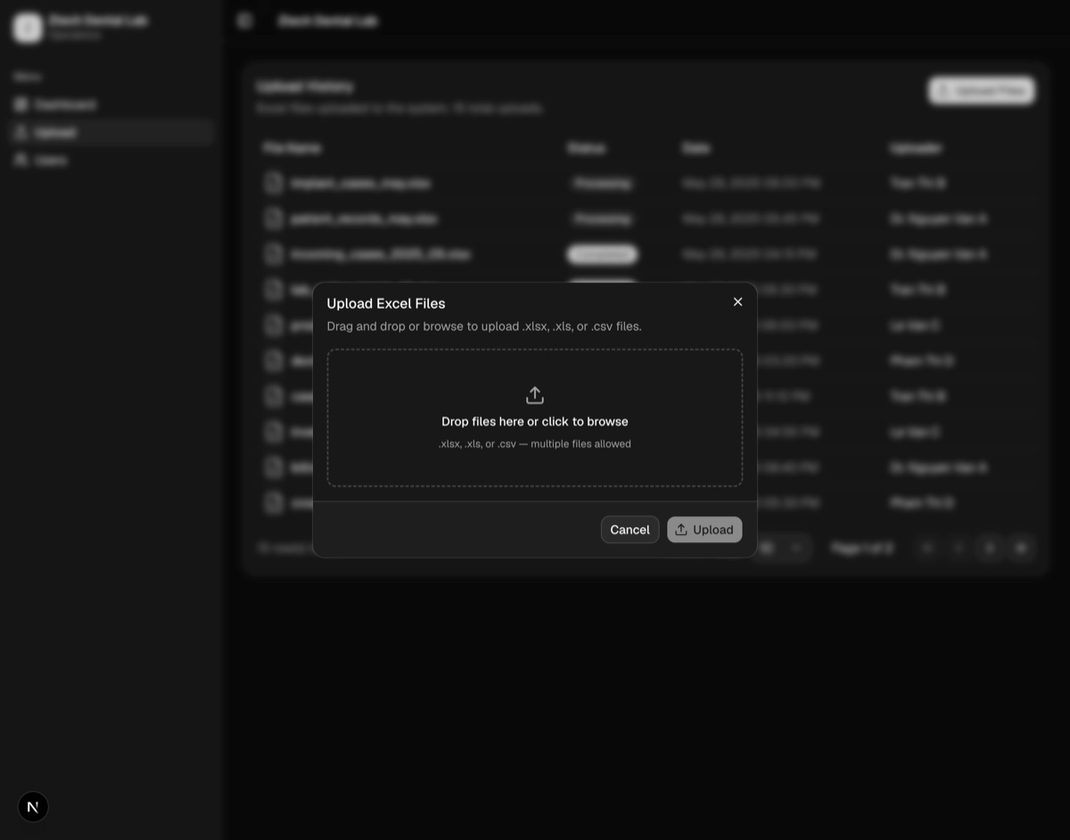

5. User Management — Team Members
View and manage all team members. See their name, email, and when their account was created. Use the action menu on each row for quick edits.
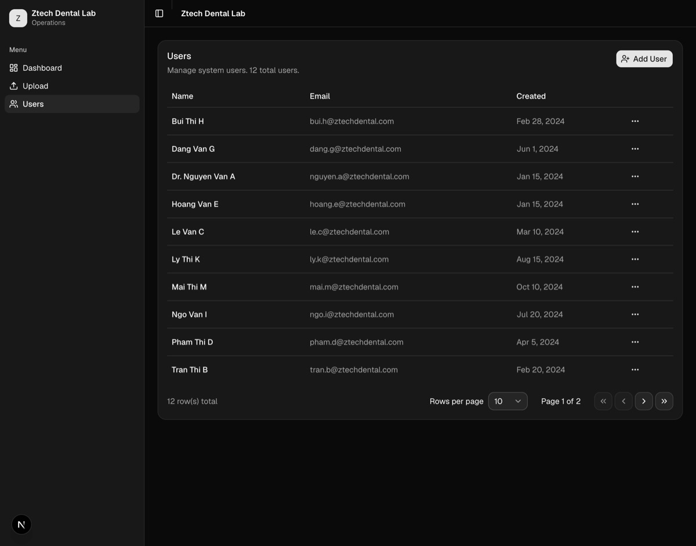

6. User Management — Add New User
Add new team members by entering their email and setting a password. New users can log in immediately after being created.
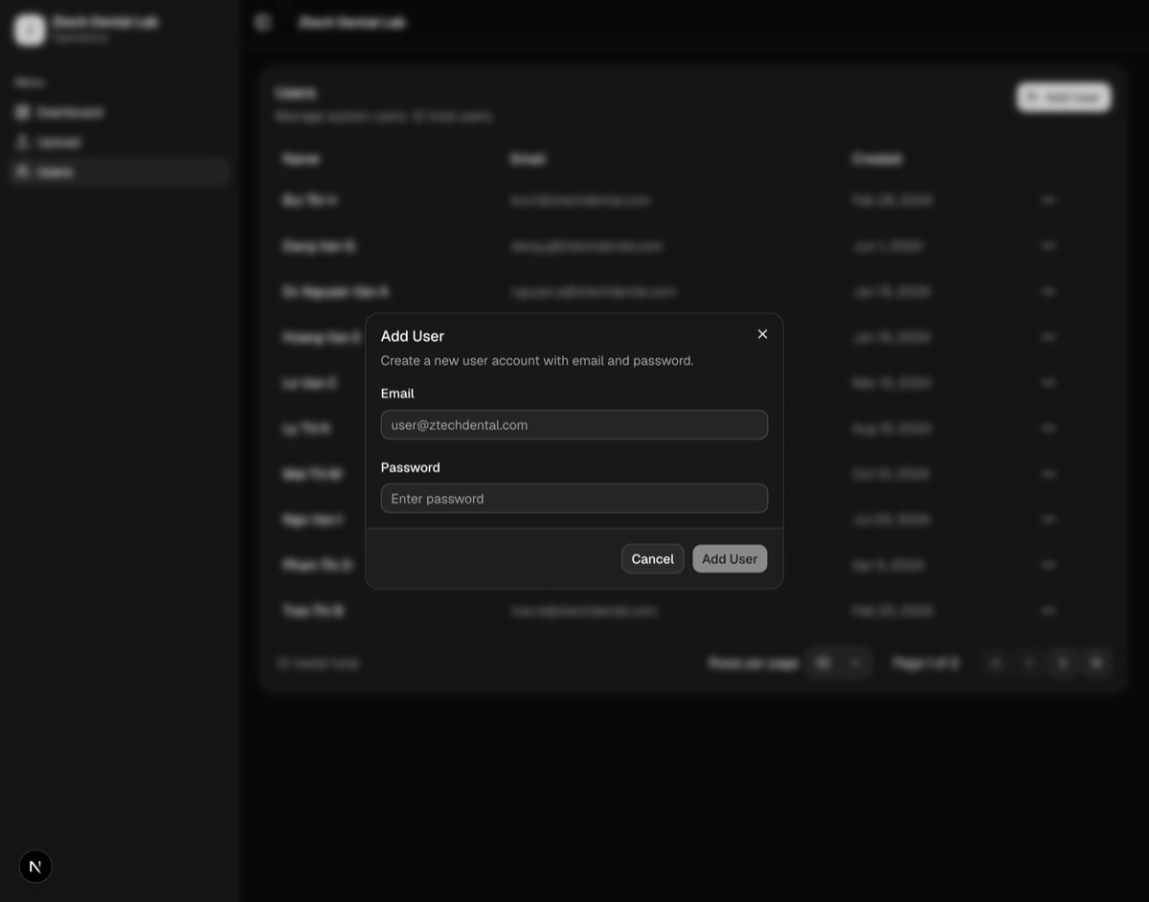

7. User Management — Edit User
Update a team member's email or reset their password. Leave the password field blank to keep the current password unchanged.
