Table of content:
1. Instruction to install
2. Instruction to edit ~/.bashrc
3. Instruction to run full simulation
4. Simple instruction to config each package
5. All information about packages

--------------------------------------------------------------------------

1. Instruction to install a full UAV navigation simulation system
Include:
- PX4
- Flightmare
- VIO utilities
- VINS-Fusion
- Ewok optimization
- PD velocity controller

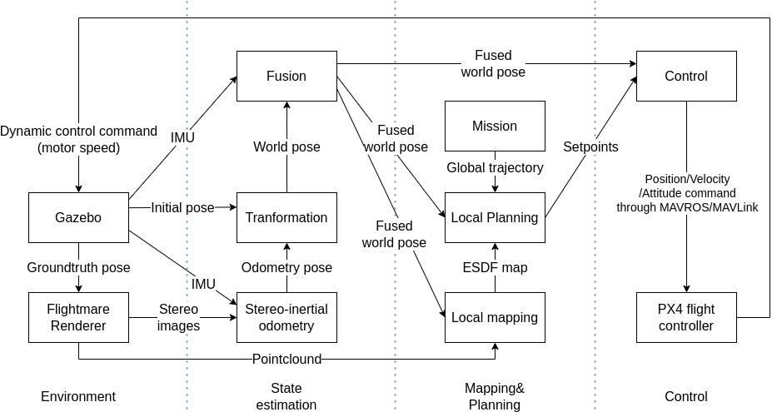
Ubuntu 20.04

ROS: Noetic
http://wiki.ros.org/noetic/Installation/Ubuntu

Every package can be installed in the same workspace except PX4, sample file management below
sample_folder/flightmare_ws/src/
sample_folder/PX4-Autopilot/

PX4
Install PX4
https://docs.px4.io/main/en/dev_setup/building_px4.html
remember to use make px4_sitl gazebo

Script for setup all dependencies (use with precaution as it is meant to be used for ROS Melodic)(fix dependencies by hand would be better, contact Minh to help and please document if possible, tks)
https://docs.px4.io/main/en/dev_setup/dev_env_linux_ubuntu.html
bash ./PX4-Autopilot/Tools/setup/ubuntu.sh --no-nuttx --no-sim-tools

QGroundControl
start PX4 (roslaunch px4 mavros_posix_sitl.launch)
open QGroundControl.AppImage (if cannot run open properties/Permissions/Allow executing file as program)
Click on Q symbol on top left corner
Choose Vehicle setup
Choose Parameters
Find COM_RCL_EXCEPT and set to 4 (offboard mode)

Flightmare
Follow the instruction to install Flightmare
https://flightmare.readthedocs.io/en/latest/getting_started/quick_start.html#quick-start

protoc 3.6.1 is fine on Ubuntu 20.04, no need for version 3.0.0 like the instruction said

After finish installing Flightmare, replace the contents in the flightros folder with the contents in the repo (this folder have added camera, connect with PX4+Gazebo, some other small thing ...)
https://github.com/huynhducmink/flightros_for_PX4-Gazebo.git

VINS-Fusion
Ceres-solver dont need to be install to ros workspace, it will be installed to root

ceres-solver 2.1.0 (http://ceres-solver.org/installation.html)

As ceres-solver 2.1.0 require fully C++17 compliant compiler, any ROS package that report ceres related error can be fix by changing all C++ standard in the CMakeList.txt of that package to C++17

VINS-Fusion
git clone https://github.com/huynhducmink/VINS-Fusion

Ewok optimization
sudo apt install ros-noetic-sophus
sudo apt-get install git python python3-matplotlib python3-numpy libeigen3-dev libgoogle-glog-dev libatlas-base-dev libsuitesparse-dev protobuf-compiler libnlopt-dev libnlopt-cxx-dev ros-noetic-octomap ros-noetic-octomap-ros ros-noetic-octomap-msgs ros-noetic-tf-conversions ros-noetic-eigen-conversions
git clone https://github.com/huynhducmink/ewok_optimization_DN.git

PD controller
catkin config --cmake-args -DCMAKE_BUILD_TYPE=Release
git clone https://github.com/ethz-asl/eigen_checks.git
git clone https://github.com/ethz-asl/nlopt.git
git clone https://github.com/ethz-asl/glog_catkin.git
git clone https://github.com/ethz-asl/yaml_cpp_catkin.git
git clone https://github.com/ethz-asl/mav_trajectory_generation.git
git clone https://github.com/huynhducmink/offboard

VIO utilities
https://github.com/huynhducmink/Visual_odometry_utilities

MSF
https://github.com/huynhducmink/ethzasl_msf

-------------------------------------------------------------------------
catkin build
(Errors may occur):
1. Fatal error: nlopt.hpp: no such file or directory
=> Fix: sudo apt install libnlopt-cxx-dev
2. Could not find a package configuration file provided by "eigen_checks", "nlopt", "glog_catkin"
=> Fix:
+ cd catkin_ws/src
+ wstool init
+ wstool set eigen_checks https://github.com/ethz-asl/eigen_checks --git
+ wstool update eigen_checks
(do the same with the others, you don't need to wstool init many times)

2. Edit ~/.bashrc
after catkin build successfully, add the following lines to ~/.bashrc (order is important), then fix all to correct path

source /opt/ros/noetic/setup.bash
export FLIGHTMARE_WS_PATH=(ADD PATH TO THE ROS WORKSPACE FOR FLIGHTMARE)
source $FLIGHTMARE_WS_PATH/devel/setup.bash
export FLIGHTMARE_PATH=$FLIGHTMARE_WS_PATH/src/flightmare

export PX4_INSTALL_PATH=(ADD PATH TO THE PX4 INSTALL LOCATION)
source $PX4_INSTALL_PATH/Tools/setup_gazebo.bash $PX4_INSTALL_PATH $PX4_INSTALL_PATH/build/px4_sitl_default
export ROS_PACKAGE_PATH=$ROS_PACKAGE_PATH:$PX4_INSTALL_PATH
export ROS_PACKAGE_PATH=$ROS_PACKAGE_PATH:$PX4_INSTALL_PATH/Tools/sitl_gazebo
export GAZEBO_PLUGIN_PATH=$GAZEBO_PLUGIN_PATH:/usr/lib/x86_64-linux-gnu/gazebo-11/plugins

-------------------------------------------------------------------------

3. Instruction to run full simulation

roslaunch px4 mavros_posix_sitl.launch

rosrun read_topic vio_transform
choose option 1 (to choose /mavros/local_position/odom to be groundtruth)

roslaunch flightros rotors_gazebo.launch

rosrun vins vins_node $FLIGHTMARE_WS_PATH/src/VINS-Fusion/config/euroc/euroc_stereo_imu_config.yaml

roslaunch msf_updates viconpos_sensor.launch

roslaunch ewok_optimization optimization_point.launch

roslaunch offboard planner.launch simulation:=true
choose 2 then 3 to enter planner flight mode

------------------------------------------------------------------------

4. Simple instruction to config each package

# msf
file launch in ethzasl_msf/msf_updates/launch/viconpos_sensor.launch show the remap for the pose input and imu input of the multi sensor fusion package
/vio_odo_posestamped is output of odometry package change to posestamped format by VIO_utilities package

# ewok optimization
file ewok_optimization/launch/optimization_point.launch have preset trajectory
if change trajectory also need to change number_of_target

file ewok_optimization/example/spline_optimization_example3.cpp
- fx,fy,cx,cy depend on output image from Flightmare
- custom transform from /map to /base_link is created here
transform from /world to /map is in launch file
transform from /base_link to /camera_link is set in flightmare (as it output image)
to create a full tf tree from world to map to base_link to /camera_link to transform esdf map from /camera_link back to /world
- depth_image_sub_ sub to /depth topic from flightmare
- current_pose_sub sub to current pose to check for position of the drone to start output planning point. currently set to /msf_core/pose_after_update, set to /vio_odo_posestamped if you dont run msf
- to run without odometry
set current_pose_sub to /mavros/local_position/pose
comment custom transform from /map to base_link
change /opt/ros/noetic/share/mavros/launch/px4_config.yaml line 71 from false to true to publish transform from /map to /base_link using px4

# Flightmare
file flightros/src/pilot/flight_pilot.cpp
- B_r_BC and B_r_BC2 set position of stereo camera (cam 1 double as depth camera)
- set POV, Width and Height of output image
- sub_state_est_ sub to /mavros/local_position/pose and each received pose render 2 RGB and 1 Depth image
- depth image have frame_id as /camera_link to use with ewok

# Offboard

planner.launch
have start and endpoint of trajectory set in planner, start and endpoint must be different otherwise the controller will detect start point is same is endpoint and land imediately
change PID_kp to change accelleration to max speed (set in offboard_lib.cpp)

offboard_lib.cpp
odom_sub_ to current pose, currently sub to /msf_core/odometry (output of msf), change to /mavros/local_position/odom to fly using groundtruth or /vio_odo to fly using output of odometry
important function is the cal_vel function that calculate velocity from input setpoint and current position

# VINS-FUSION
file config/euroc/euroc_stereo_imu_config.yaml is used when running the package
config parameter have explaination comment from author
file euroc_stereo_imu_config.yaml, cam0_pinhole.yaml and cam1_pinhole.yaml need to match the image resolution

# VIO_utilities
take groundtruth and publish different ros message formats
transform output of visual odometry from /vio_frame to /world frame and publish in diffrent formats

5. All information about packages

