CS203 Project Report Template

Homework #3
Ethan Huynh, ethuynh

Introduction
Explain the purpose of the project (1 Paragraph)
The purpose of this project is to read the CSV data analysis for employees. With the file, the project would be able to organize the employees by departments. There will be functions that can calculate basic statistics. The project will be made using encapsulation and arraylists to store each employee and department. This will ultimately help any users get the calculated data they need from the csv file.

Code Explanation
Briefly explain your code (how many classes you created, what OOP methods you implemented…)
After looking at the csv file, I start with the Employee class. The attributes contains everything in the file header; so full name, department, salary, years, and lead. Then I made the constructor and getters and setters due to the attributes being private.
The next class I made was the Department class. This contains everything related to the employees’ departments. I made an arraylist named “depEmployees”. I made an “addEmployee”, “getLowestPaidEmplyee” “getAverageSalary”, “getLeadCount”, and then basic getters and setters. The methods are very similar to one another. It would run through the “depEmployees” arraylist and do what it is told to do. For example, “getLowestPaidEmplyee” keeps the lowest salary using “getSalary” and as it runs through the list, if it finds one that is lower, replaces the one it was just holding. Average gets all employee salary and divide it by total employees, while leadcount count ++ if true.
The class named “DataProcessor” is intended to read the csv file and do the following: “readData”, Add it to an arraylist, “getEmployeeLessThanFourYears” and, “getLongestTenuredEmployee”. First I made a private attribute “employees” as an arraylist, and a private map “departments” as a hashmap. For the readData method, I decided to use BufferedReader. I made a new br obj, made it read the csv file. Since there was a header in the file I skiped “First Name” with continue. After that I split the lines and parse it accordingly and add it to the employees list. Then I use the department attribute, and for every new department, it will create a new list and add that employee to the list. Then close br. <4 years employee will do as told and add employee into the “result” list. LongestEmployee is also done similarly. one employee placeholder, for any employee with years higher than the placeholer, it will replace it.
The Main class is the final class, it is where everything runs. There is only one main method, and it will call all the methods in the other classes in the same package. First I make a DataProcessor obj named dp. It will help me call its methods. Then I wrap the readData method in a try and catch. When I tried it, there was an error. So I changed the catch to e.printStackTrace(). This helped me find where the problem was. It turns out that there was a problem where it was trying to parse the word “salary” into an int. that is not possible. So after some research, it seems like there was an invisible character in the header line. Therefore, it was not able to “continue” pass the first line. So I went back to the DataProcessor class and handled the error. I did this by finding the Byte Order Mark (BOM) and removing it. After that, reading the data finally worked. I started doing println and the methods, and organizing the outputs. To help with the formatting of the double “salary”, I used String.format(“%.0f”, .getSalary). this is to help for the numbers that don’t need any decimal points ex.($55000) and I used %.2f for those that did need it such as the average calculations.

Result
Put as many screenshots as you can (try to display the functionality of your code; display list, add/remove record…etc)
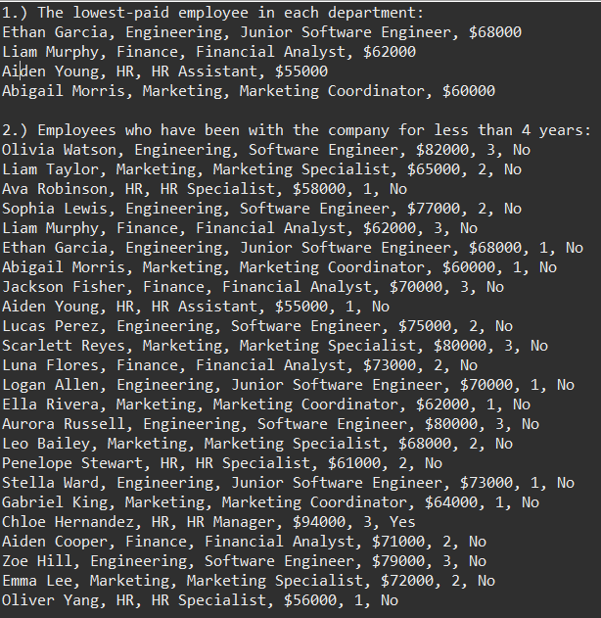
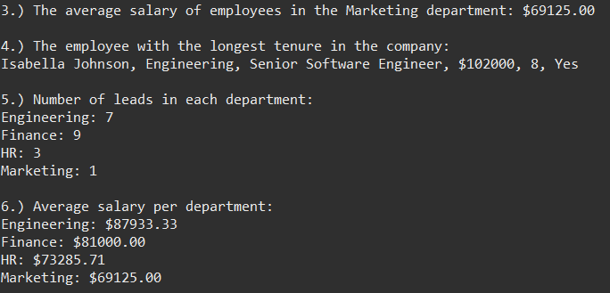

References
List all of the resources you have use
Lecture Notes on Aggregation, Error Handling, packages, string format
I used the Book/Booktester example codes to look back at class, constructor, accessors/mutators.
I used the BankAccount lab for objects and scanners.
I used textbook JJJ OOP to look at the usage of maps for hashmapping.
I used the calculator lab to reference back on inheritance.
I used the student array/file lab

