**TF-IDF Vectorizer scikit-learn**

1. **Introduction**

Natural Language Processing (NLP) is a sub-field of artificial intelligence that deals understanding and processing human language. Many organizations have begun applying natural language processing for translation, chatbots and candidate filtering.

1. **Problems**

Machine learning algorithms cannot work with raw text directly. Rather, the text must be converted into vectors of numbers. In natural language processing, a common technique for extracting features from text is to place all of the words that occur in the text in a bucket. This approach is called a **bag of words (BoW)**.

1. **Bag of words**

* By casting the bag of words to a set, duplicate words will be automatically removed.
* A dictionary of words and their occurrence for each document in the corpus (collection of documents) will be created.

1. **Stop words**

Useless words are referred to as stop words, the python natural language toolkit library provides a list of English stop words

from nltk.corpus import stopwords

stopwords.words(‘english’)

* When building a model with the goal of understanding text, all stop words will be removed.
* Another strategy is to score the relative importance of words using **TF-IDF**.

1. **What is it?**

*TF-IDF is an abbreviation for Term Frequency Inverse Document Frequency.*

***General****: Transform text into a meaningful representation of numbers which is used to fit machine algorithm for prediction.*

This metric calculates the number of times a word appears in a text (term frequency) and compares it with the inverse document frequency (how rare or common that word is in the entire data set).

**The higher the score is, the more relevant the word is to the document.**

In many of these cases, the words that appear more frequently in a group of documents are not necessarily the most relevant. Likewise, a word that appears in a single text but doesn’t appear in the remaining documents may be very important to understand the content of that text.

**Background:**

It was introduced in 1972 by Karen Spärck Jones with title “term specificity”. Instead of representing a term in a document by its raw frequency (number of occurrences) or its relative frequency, each term is weighted by dividing the term frequency by the number of documents in the corpus containing the word.

**Why**: to avoid common problem when conducting text analysis:

* The most frequently used words in a document are often the most frequently used words in all of the documents.
* In contrast, terms with the highest **tf-idf** scores are the terms in a document that are distinctively frequent in a document, when that document is compared to other documents.

1. **How to transform?**

$$TF-IDF(t)=TF\left(t,d\right)×IDF (t)$$

$$TF\left(t,d\right):number of times term t appears in a doc d$$

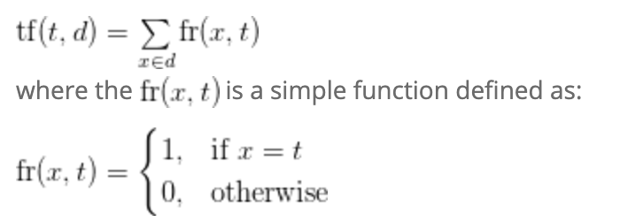

$$IDF \left(t\right)=log\frac{1+n}{1+df(d,t)}$$

Where:

n: number of documents

$df\left(d,t\right)= \left|\{d:t ∈d\}\right|$: document frequency of the term t/ the number of documents where the term t appears.

1. **Example**

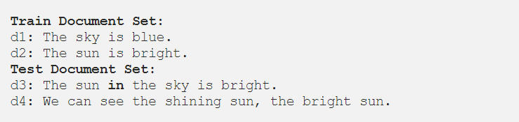

tf(“sun”,d4) could be 2

* 1. **Create a dictionary**

Now, we are creating index vocabulary (dictionary) of the words of the train documents set, using the documents d1 and d2 from document set.

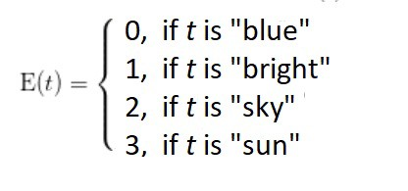

* 1. **Convert to vector (**CountVectorizer python’s library)

When we represent d3 and d4 of test document set as vectors:

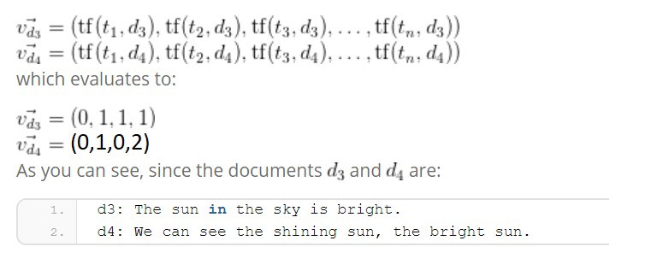

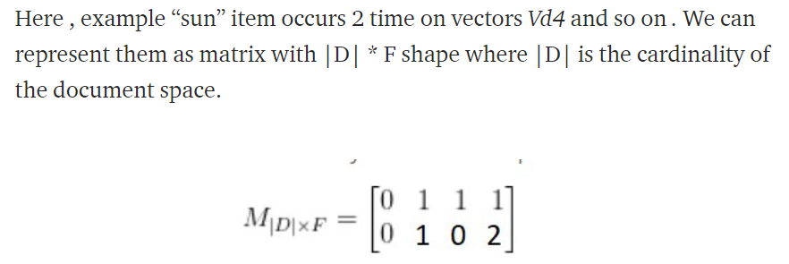

* 1. **Tf-idf weight**

Now let’s come to idf(inverse document frequency) topic that how it is calculate and multiplication with tf (term frequency) . The idf is defined.

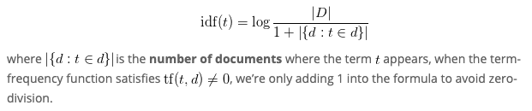

* 1. Keyword Extraction

It is a text analysis technique that automatically extracts the most used and most important words and expressions from a text. It helps summarize the content of texts and recognize the main topics discussed.

Example: Imagine you want to analyze thousands of online reviews about your product. Keyword extraction helps you sift through the whole set of data and obtain the words that best describe each review in just seconds. That way, you can easily and automatically see what your customers are mentioning most often, saving your teams hours upon hours of manual processing.

* 1. **Why is Keyword Extraction Important?**

With keyword extraction you can find the most important words and phrases in massive datasets in just seconds. And these words and phrases can provide valuable insights into topics your customers are talking about.

Example:

What percentage of customer reviews are saying something related to Price? How many of them are talking about UX? These insights can help you shape a data-driven business strategy by identifying what customers consider important, the aspects of your product that need to be improved, and what customers are saying about your competition, among others.

* Help you something:
* Automatically index data
* Summarize a text
* Generate tag clouds with the most representative keywords
  1. How does keyword extraction work?

There are different approaches to keyword extraction:

There are different types of statistical approaches: word frequency, word collocations and co-occurrences, TF-IDF, and RAKE (Rapid Automatic Keyword Extraction).

**References**

1. <https://towardsdatascience.com/tf-idf-explained-and-python-sklearn-implementation-b020c5e83275>
2. <https://medium.com/@cmukesh8688/tf-idf-vectorizer-scikit-learn-dbc0244a911a>
3. <https://bktranquangchung.wordpress.com/2018/09/10/tf-idf/>
4. <https://programminghistorian.org/en/lessons/analyzing-documents-with-tfidf#tf-idf-definition-and-background>
5. <https://monkeylearn.com/keyword-extraction/>