- Cài đặt PostgreSQL – PostGIS

Installer walkthrough
The PostgreSQL installer is based on Windows Installer, so it should be familiar to most Windows users. Following is a quick walkthrough of the installer steps.
- Language selection
Select the language you want to use for the installer. This only sets the language used in the install wizard - the actual installed PostgreSQL can be installed with or without language support and has it's own language choice independent from the installer.
You can also select if you want the installer to create a detailed logfile of the installation process. Note that this logfile will contain both the service user and database superuser password if created.
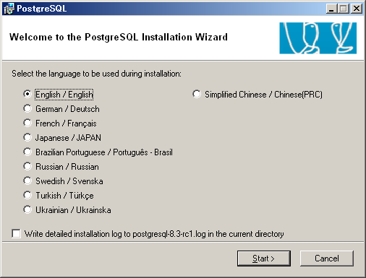
- Introduction screen
Introduction message. Just click Next to get started.
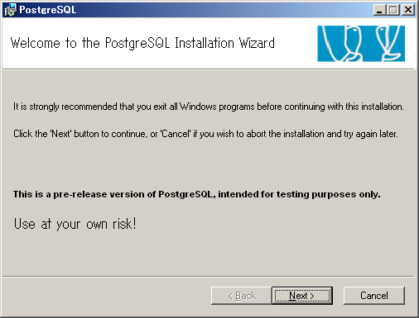
- Welcome message and instructions
As always, please read the complete instructions before you continue.
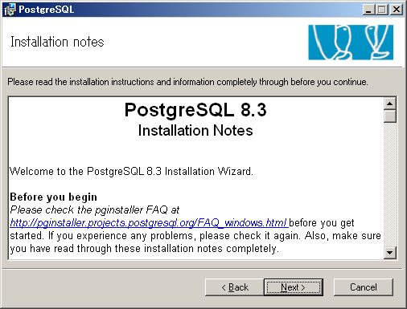
- Feature selection
Select what you want to install. The server part will only be available on NT based platforms. Note that the 'Data Directory' option may only be installed on an NTFS partition. If you wish to install the data directory on any other partition type, you will need to run initdb.exe manually after installation.
You can change the directory of the entire installation by selecting the feature PostgreSQL and click Browse to pick the new directory. You can also change the directory of an individual feature (such as the server, or pgAdmin) by selecting that feature and clicking Browse.
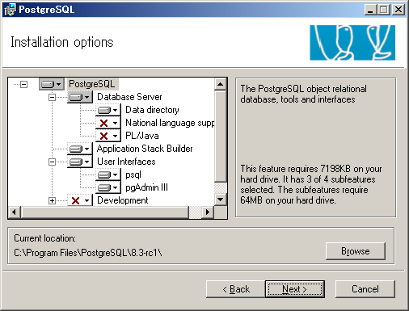
- Service installation
Choose whether you want PostgreSQL installed as a service, and if so specify which account should be used. This account will be created and granted the Logon On as a Service right if required.
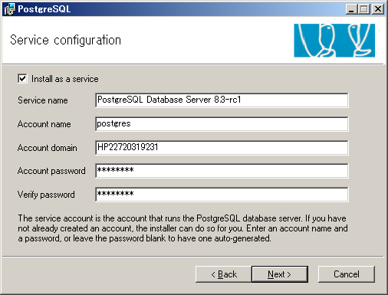
- Initdb
Chose whether you want a database cluster to be initialized in the database. If so, choose character set and encoding for your database, and specify login details for the database superuser. You may also specify a non-default port number to run the server on, and opt to listen for connections on all IP addresses on the system rather than just localhost. Note that you will still have to enable access in the host based authentication configuration (pg_hba.conf) to allow remote users to connecto the server.
This dialog is only available if you chose to install PostgreSQL as a service.
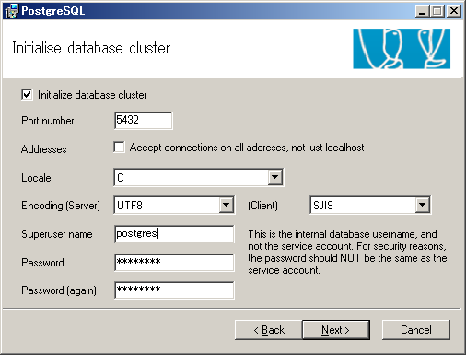
- Procedural languages
Chose the procedural languages you want activated in template1. All PL files are always installed, this step just activates them by default in all your databases.
This dialog is only available if you chose to install PostgreSQL as a service, and chose to have a database cluster initialized.
Only the languages where the corresponding runtimes were found installed on the system are available for selection.
PL/perl requires ActiveState Perl 5.8 to be installed (5.10 for PostgreSQL 8.4 and above).
PL/python requires Python 2.4 to be installed (2.6 for PostgreSQL 8.4 and above).
PL/tcl requires ActiveState Tcl 8.4 to be installed (8.5 for PostgreSQL 8.4 and above).
PL/java requires a valid Sun Java Runtime Environment to be installed.
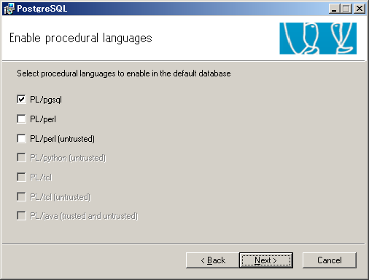
- Contrib modules
Select the contrib modules to activate in template1. All contrib files are always installed, this step just activates them by default in all your databases.
This dialog is only available if you chose to install PostgreSQL as a service, and chose to have a database cluster initialized.
Note: The Adminpack module is installed by default because pgAdmin will use it to provide enhanced functionality. It may be removed if you do not want it to be installed in all databases; pgAdmin will simply not offer the enhanced functionality it allows.
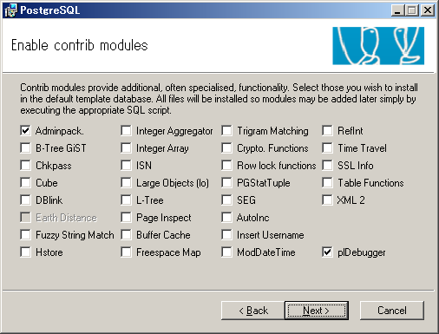
- Ready to install
Just click Next to start the actual installation.
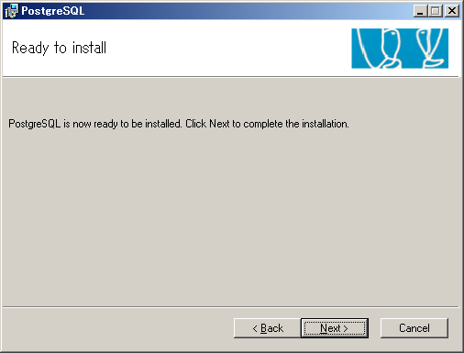
- Installing
A progress bar is shown during the installation.
On some versions of Windows (notably Windows XP before Service Pack 2 and Windows 2003 before Service Pack 1 - see Microsoft Knowledge Base article Q818858) a Command Prompt window will appear during the "Initializing database cluster" step. Don't close this window - it will automatically close once the operation is complete.
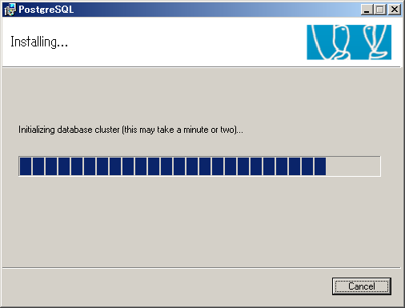
- Finished
Installation is complete. You can now go ahead and test your installation and subscribe to the pgsql-announce mailing list to keep up to date.
If you need to add or remove a feature from PostgreSQL, use the Add/remove programs feature in the Control Panel.
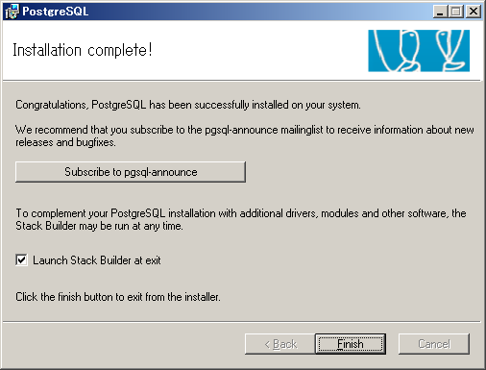
- Stack Builder
Stack Builder may be run at the end of the installation, or from the Start Menu. It may be used to download and install additional components, drivers and applications to complement any of your PostgreSQL installations on the local machine, or on a remote server. The packages offered will be targetted to the version of the server you select here, unless you select <Remote Server>, in which case all packages will be offered.
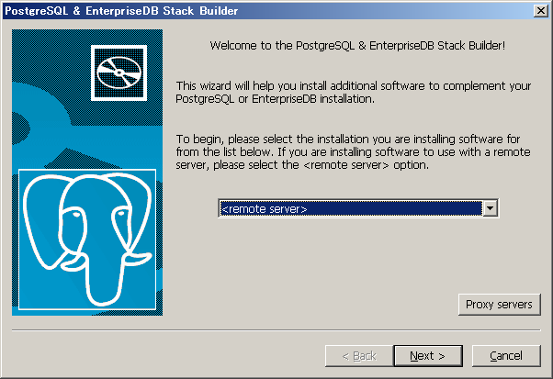
- Software selection
Select the packages you wish to install. If a package is dependent on another package, it will automatically be selected as well.
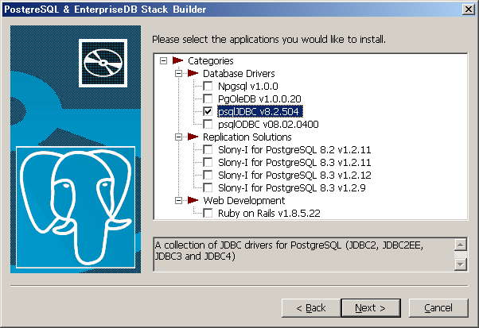
- Mirrer site selection
Please select a mirrer site to download from.
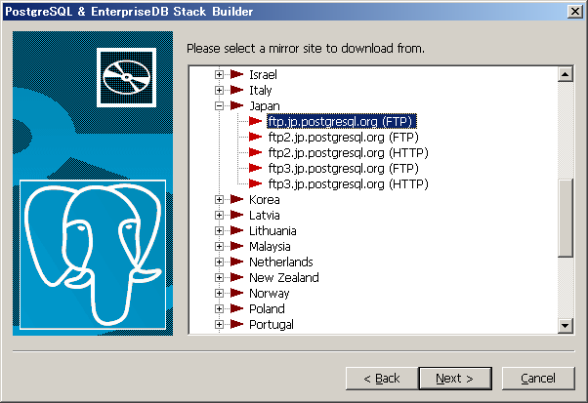
- Review the download selection
The software to be installed is shown for review. If you need to make any changes, use the back button.
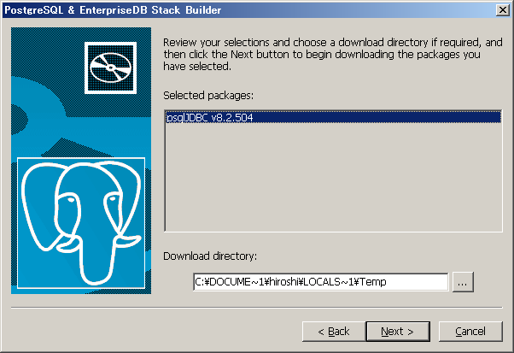
- Download and installation
Stack Builder will download each of the packages you have chosen and install them in the order required to satisfy any inter-dependencies.
Downloading...
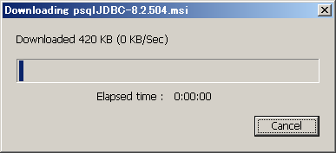
Confirmation ...
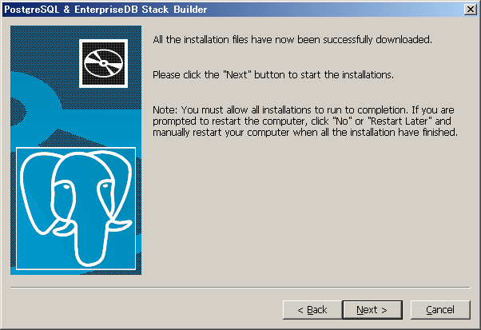
Installation start...
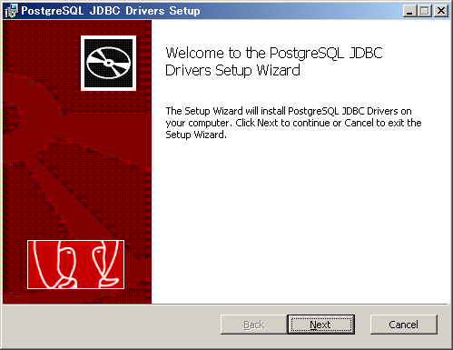
- Installation complete
Once the download and installation process has completed, Stack Builder will show a summary, indicating any problems encountered.
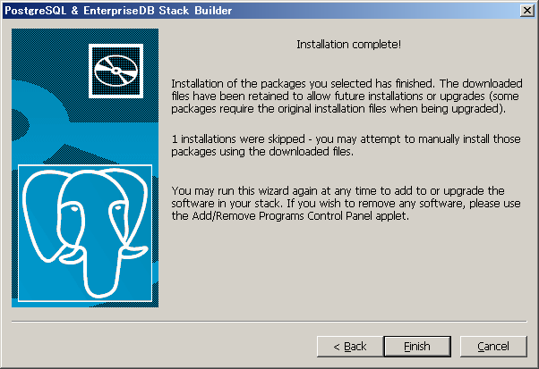

- Chuyển đổi dữ liệu Shapefile sang PostgreSQL và ngược lại
Hệ quản trị cơ sở dữ liệu PostgreSQL có hỗ trợ PostGIS, nó có khả năng lưu trữ được các đối tượng địa lý.
- PostgreSQL cũng hỗ trợ 2 công cụ cơ bản để chuyển đổi dữ liệu từ PostgreSQL sang Shapefile và ngược lại là shp2pgsql và pgsql2shp.
  - Chuyển từ shapefile sang Postgres:
Shp2pgsql <Options> <shapefile> <schema> | psql <database> <user>
Options : -I –D
-I: tạo chỉ số không gian
-D: Load using dump format (faster)‏
Shapefile: Đường dẫn và tên shapefile muốn đưa vào postgresql
Schema: tên bảng trong CSDL.
database : tên cơ sở dữ liệu.
user: Tên người dùng
Thí dụ: Ta có file streets.shp lưu trong D:\Data và ta muốn chuyển vào CSDL QHSDD trong Postgres ta thực hiện như sau:
Vào menu Start > Programs > PostgreSQL > Command Promt và gõ vào dòng chữ như hình minh họa dưới đây:
Shp2pgsql –I –D D:\DATA\streets.shp streets | psql QHSDD postgres
  - Chuyển từ postgreSQL sang shapefile:
pqsql2shp [<option>] <database> [schema.]<table>
hoặc:
pqsql2shp [<option>] <database> <query>
Options:
-f <filename>: tên tập tin shapefile
-h <host>: tên máy chủ (localhost)
-p <port>: cổng
-P <password>: mật khẩu
-u <user>: tên đăng nhập CSDL
Thí dụ: Giả sử ta có cơ sở dữ liệu là QHSDD và ta muốn chuyển bảng ranhgioi sang shapefile và lữu trữ trong ổ đĩa D:\Data với tên là ranhgioi.shp, ta thực hiện câu lệnh như sau:
Vào menu Start > Programs > PostgreSQL > Command Promt và gõ vào dòng chữ
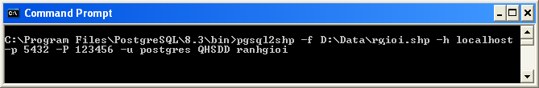
- LIÊN KẾT DỮ LIỆU VỚI POSTGRESQL
gvGIS hỗ trợ nhiều định dạng dữ liệu khác nhau như: shapefile, PostgreSQL, MySQL, Oracle Spatial (SDO geometry). Do đó người dùng có thể dễ dàng khai thác và lưu trữ theo nhiều định dạng. Để có thể liên kết với PostgreSQL, người dùng cần phải thực hiện cấu hình liên kết cơ sở dữ liệu như sau:
Bước 1: Bấm chọn add layer trên thanh Toolbar.
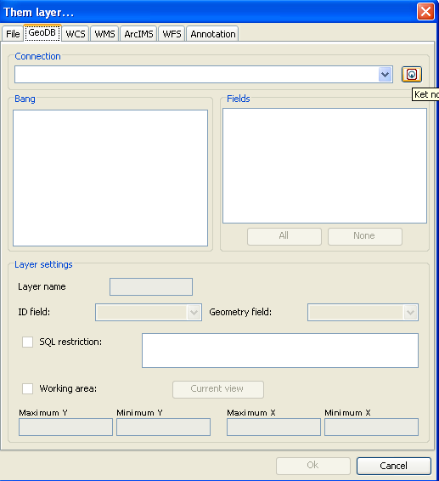
Bước 2: Bấm chọn để thực hiện kết nối, khi đó hộp thoại Kết nối CSDL xuất hiện:
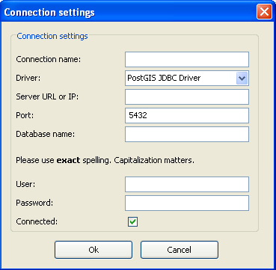
* Connection name: Nhập tên liên kết CSDL
* Server URL or IP: tên máy chủ (localhost)
* Port: 5432
* Database name: Tên cơ sở dữ liệu
* User: tên đăng nhập
* Password: Mật khẩu

