Johnson Huynh

INFO 343 C

October 7, 2013

For this assignment, I decided to check <http://www.yahoo.com/> with the Wave accessibility evaluation tool. The errors and alerts that I am discussing below were the ones that I felt were needed to be resolved in order to improve comprehensibility and usability of screen readers for those who are visually or cognitively impaired.

**Missing Alt Text**

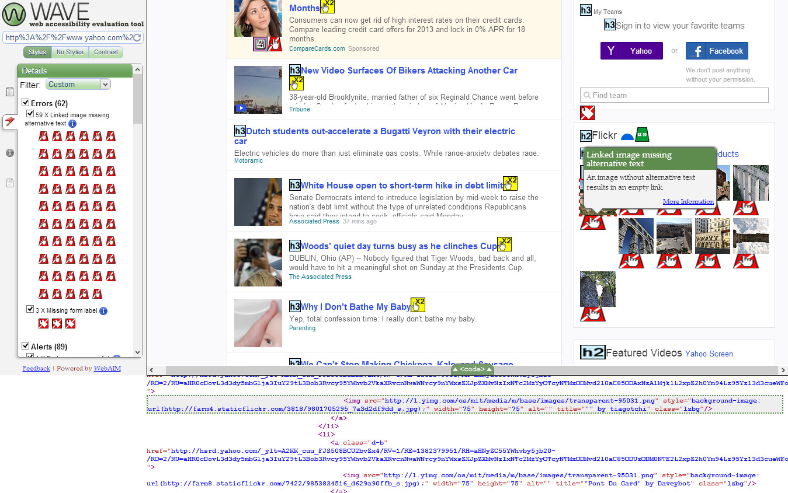

There were total of 59 errors at the time I evaluated Yahoo’s homepage. I found that 56 of the errors were due to the linked images missing alternative text. In terms of web accessibility, this could pose as a potential problem because screen readers are not able to inform individuals with visual or cognitive disabilities on what image they are viewing. If I were in charge of this website, I would resolve this issue by adding alternative texts for the 59 images that are missing them.

|  |  |
| --- | --- |
| **Before** | **After** |
| <img src="<http://l.yimg.com/os/mit/media/m/base/images/transparent-95031.png>" style="background-image:url('http://farm8.staticflickr.com/7369/9753430964_e1c86cab43_s.jpg');" width="75" height="75" alt="" title="&quot;Aqueduct Next To Apartments&quot; by Corey O" class="lzbg"> | <img src="<http://l.yimg.com/os/mit/media/m/base/images/transparent-95031.png>" style="background-image:url('http://farm8.staticflickr.com/7369/9753430964_e1c86cab43_s.jpg');" width="75" height="75" alt="Aqueduct Next To Apartments by Corey O" title="&quot;Aqueduct Next To Apartments&quot; by Corey O" class="lzbg"> |

**Missing Label**

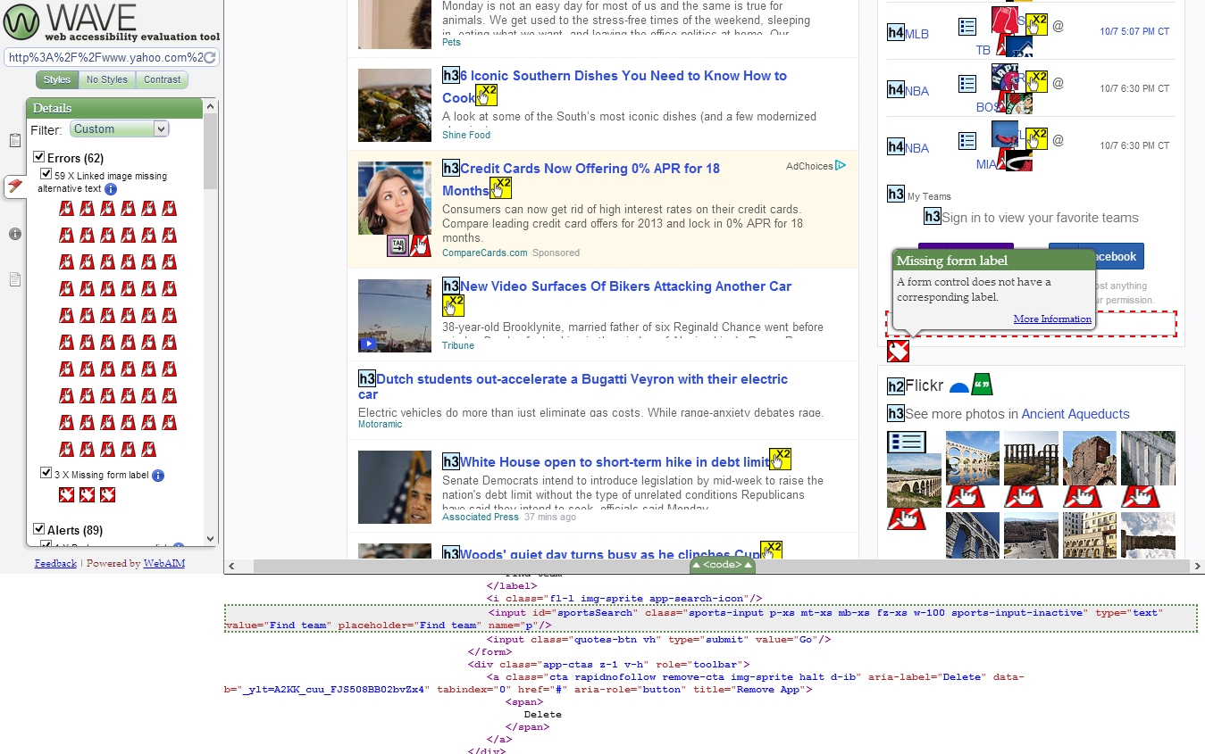

I also found that the last three errors had missing form labels. This is another issue that prevents screen readers from giving users who are visually impaired a clear understanding of what input tag they are viewing. Labels provide meaning to form elements by giving the fields a purpose. As a way to resolve this issue, I added the “for” property in the label tag so that the screen reader can understand that the label is associated with the input tag.

|  |  |
| --- | --- |
| **Before** | **After** |
| <label class="vh">Find team</label>  <input id="sportsSearch" class="sports-input p-xs mt-xs mb-xs fz-xs w-100 sports-input-inactive" type="text" value="Find team" placeholder="Find team" name="p" /> | <label class="vh" for="Find team" >Find team</label>  <input id="sportsSearch" class="sports-input p-xs mt-xs mb-xs fz-xs w-100 sports-input-inactive" type="text" value="Find team" placeholder="Find team" name="p" /> |

**Broken same-page link**

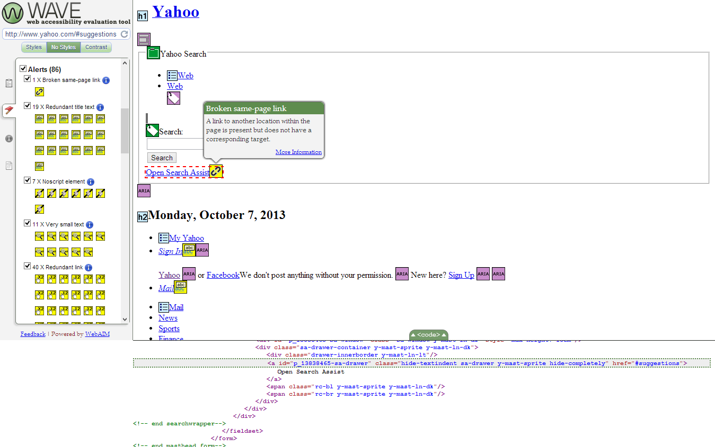

Along with the errors, there were also several alerts that needed to be fixed. One of the alerts was a broken same-page link notification. This problem means that there is a link to another location of the page, but it does not have a corresponding target. I inspected the elements, hid the styles, and found that the href attribute for Yahoo’s Open Search Assist was targeting the link ‘#suggestions’. This appeared to be a problem because the link is invalid, and if the user had clicked on this link, he or she would not have gone to another location of the page. In order to resolve this issue, I decided to replace the ‘#suggestions’ to ‘<http://search.yahoo.com/>’ since this was the actual link to the destination.

|  |  |
| --- | --- |
| **Before** | **After** |
| <a id="p_13838465-sa-drawer" class="hide-textindent sa-drawer y-mast-sprite hide-completely" href="[#suggestions](http://www.yahoo.com/#suggestions)">Open Search Assist</a> | <a id="p_13838465-sa-drawer" class="hide-textindent sa-drawer y-mast-sprite hide-completely" href="<http://search.yahoo.com/>">Open Search Assist</a> |

**Redundant title text**

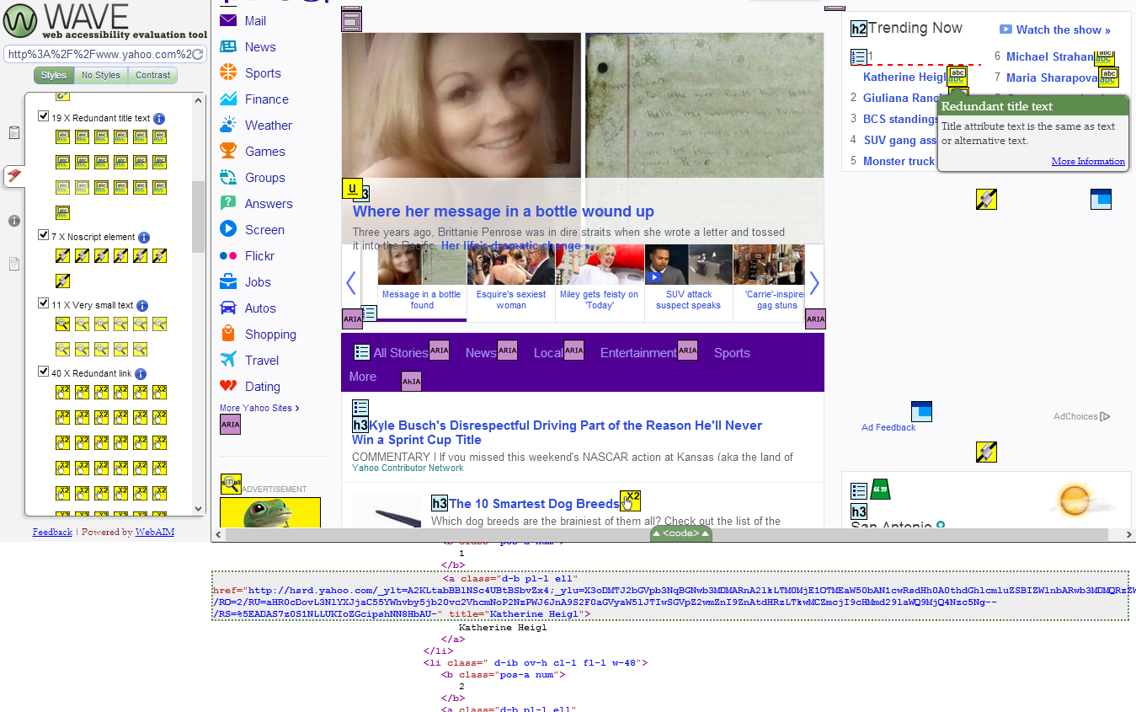

Another alert problem that I thought needed to be fixed was the redundant title text. The title attribute was just a plain duplication of the link text. This was a problem because the duplicated text does not really explain in more detail on what the link directs to, and is just as redundant and irrelevant to users viewing the webpage. Most users would need to have understood what a hypertext link is and what it does before clicking on the next link. As a result, I decided to be more descriptive in the title text by replacing “Katerhine Heigl” to “Katherine Heigl: Former Co-Star Talks About “Grey’s” Exit”. By solving the issue this way, the user would be able to hover over the link to get a more detailed description of what content there will be on the next page. This can be more helpful to user in case they still do not understand the link text.

|  |  |
| --- | --- |
| **Before** | **After** |
| <a class="d-b pl-l ell" href="[http://hsrd.yahoo.com/_ylt=ArseEBa4J5xNM0tWcKC0lLGbvZx4;_ylu=X3oDMTJ2cXRoMjkwBGNwb3MDMARnA2lkLTM0MjE1OTMEaW50bAN1cwRsdHh0A0thdGhlcmluZSBIZWlnbARwb3MDNwRzZWMDdGMtdHMEc2xrA3RpdGxlBHRlc3QDOTAwBHdvZQMyNDkwMzgz/RV=1/RE=1382380611/RH=aHNyZC55YWhvby5jb20-/RO=2/RU=aHR0cDovL3NlYXJjaC55YWhvby5jb20vc2VhcmNoP2NzPWJ6JnA9S2F0aGVyaW5lJTIwSGVpZ2wmZnI9ZnAtdHRzLTkwMCZmcjI9cHMmd29laWQ9MjQ5MDM4Mw--/RS=^ADAeyGiKulF0g_uP7sYbKZ_Wbt42Uk-](http://hsrd.yahoo.com/_ylt=ArseEBa4J5xNM0tWcKC0lLGbvZx4;_ylu=X3oDMTJ2cXRoMjkwBGNwb3MDMARnA2lkLTM0MjE1OTMEaW50bAN1cwRsdHh0A0thdGhlcmluZSBIZWlnbARwb3MDNwRzZWMDdGMtdHMEc2xrA3RpdGxlBHRlc3QDOTAwBHdvZQMyNDkwMzgz/RV=1/RE=1382380611/RH=aHNyZC55YWhvby5jb20-/RO=2/RU=aHR0cDovL3NlYXJjaC55YWhvby5jb20vc2VhcmNoP2NzPWJ6JnA9S2F0aGVyaW5lJTIwSGVpZ2wmZnI9ZnAtdHRzLTkwMCZmcjI9cHMmd29laWQ9MjQ5MDM4Mw--/RS=%5EADAeyGiKulF0g_uP7sYbKZ_Wbt42Uk-)" title="Katherine Heigl”>Katherine Heigl</a> | <a class="d-b pl-l ell" href="[http://hsrd.yahoo.com/_ylt=ArseEBa4J5xNM0tWcKC0lLGbvZx4;_ylu=X3oDMTJ2cXRoMjkwBGNwb3MDMARnA2lkLTM0MjE1OTMEaW50bAN1cwRsdHh0A0thdGhlcmluZSBIZWlnbARwb3MDNwRzZWMDdGMtdHMEc2xrA3RpdGxlBHRlc3QDOTAwBHdvZQMyNDkwMzgz/RV=1/RE=1382380611/RH=aHNyZC55YWhvby5jb20-/RO=2/RU=aHR0cDovL3NlYXJjaC55YWhvby5jb20vc2VhcmNoP2NzPWJ6JnA9S2F0aGVyaW5lJTIwSGVpZ2wmZnI9ZnAtdHRzLTkwMCZmcjI9cHMmd29laWQ9MjQ5MDM4Mw--/RS=^ADAeyGiKulF0g_uP7sYbKZ_Wbt42Uk-](http://hsrd.yahoo.com/_ylt=ArseEBa4J5xNM0tWcKC0lLGbvZx4;_ylu=X3oDMTJ2cXRoMjkwBGNwb3MDMARnA2lkLTM0MjE1OTMEaW50bAN1cwRsdHh0A0thdGhlcmluZSBIZWlnbARwb3MDNwRzZWMDdGMtdHMEc2xrA3RpdGxlBHRlc3QDOTAwBHdvZQMyNDkwMzgz/RV=1/RE=1382380611/RH=aHNyZC55YWhvby5jb20-/RO=2/RU=aHR0cDovL3NlYXJjaC55YWhvby5jb20vc2VhcmNoP2NzPWJ6JnA9S2F0aGVyaW5lJTIwSGVpZ2wmZnI9ZnAtdHRzLTkwMCZmcjI9cHMmd29laWQ9MjQ5MDM4Mw--/RS=%5EADAeyGiKulF0g_uP7sYbKZ_Wbt42Uk-)" title=" Katherine Heigl: Former Co-Star Talks About “Grey’s” Exit">Katherine Heigl</a> |

By resolving these errors and alerts, the web accessibility of the Yahoo homepage will be improved and become more usable for all users to view.