

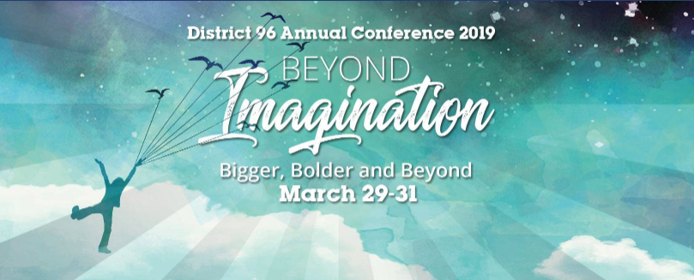

**Call for Education Session Presenters**

Are you a dynamic presenter known to dazzle large audiences? Can you speak eloquently and expertly on a topic that offers personal and professional growth and enrichment?

District 96 Toastmasters is inviting qualified presenters to submit an application to present an Education Session at our upcoming Annual Conference. We are looking for three to six speakers who can present a 45-minute session on Saturday morning, March 30, 2019 at the Pinnacle Hotel at the Pier in North Vancouver, B. C.

Non-Toastmasters may also apply. Many speakers consider it an honor and a privilege to be invited to present at a Toastmasters Conference. After all, Toastmasters International is the world leader in Communication and Leadership development.

The Selection Committee will evaluate applications based on the following criteria:

* Applicant’s Qualifications and Experience
* Content: Completeness, Clarity, and Audience Appeal
* Level of Audience Engagement and Interactive Participation
* Relevance to the Conference theme “*Beyond Imagination*”
* Take-Away Benefits for the Audience
* Relevance to one of the **i**dentified Education Tracks (Communication, Leadership, or Personal Development)

To submit your proposal, fill out the form below or visit <https://tinyurl.com/y9nt4dd6>

The deadline to apply is midnight PST **January 31, 2019**.

**Please note:**

1. You are responsible for preparing and producing your own handout materials and unless otherwise agreed, meeting your own audio/visual requirements.

1. No hard selling, pitching or promoting yourself or your products or services is allowed during or after your presentation, and no financial compensation or reimbursement of any expenses will be given. Instead, we will post the profiles of or otherwise reference the selected presenters on our Conference website, District 96’s Facebook and other Social Media channels, at promotional events and in our printed Conference Program (received by approximately 200 Conference attendees). Presenters will also be featured in at least one email sent to our entire D96 membership (2,500+).

1. Selected applicants who are Toastmasters are required to purchase the full Conference Registration. Selected applicants who are non-Toastmasters are not required to purchase the Conference Registration. They may only attend for the duration of their presentation. If they wish to attend any other part of the Conference, they are welcome to do so by purchasing either the entire registration or a part of it, on an à la carte basis. Pricing right now is $229 for full registration with à la carte pricing to be released in due course. Here is a link to registration: <https://tinyurl.com/ydzas6xm>

1. Contestants at the District 96 Evaluation and International Speech contests that will take place at the Conference are ineligible to be Educational Session presenters. Thus, you should not apply if you are planning to compete in either contest.

If you have any questions, please contact Percy Billimoria [billimoria.percy@gmail.com](mailto:billimoria.percy@gmail.com), Education Sessions Chair for the District 96 Annual Conference 2019.

|  |  |
| --- | --- |
| **District 96 Toastmasters Annual Conference 2019**  **Education Session Proposal Submission Form**  **Submission Deadline: January 31, 20196** | |
| **Personal Information** | |
| **Name:**  **Address:** | **Tel:**  **Email:** |
| |  | | --- | | **Toastmasters Information**  **Are you currently a member of Toastmasters?**  **How long have you been a Toastmaster?**  **Club Name(s)**  **Toastmasters Designation (CC, CL etc.)**  **Leadership Positions Held**  **Other Educational Qualifications** |   **Proposed Education Session Description**  **Provide a time-referenced Outline of your presentation** (200 words maximum)  **What is your presentation’s working title?**  **Share At Least 3 Learning Objectives** (50 words maximum)  1.  2.  3.  **Describe Interactive Activities and Audience Participation:** (100 words max.)  **What makes you a credible expert on this topic?** (50 words max.)  **Will you be providing a workbook/handout to the attendees?**  **Will you be using any slides, videos or props? If so, please identify them.**  **Why do you want to deliver this presentation?**  **In which Education Track does your presentation belong?** (Select one):  Communication  Leadership  Personal Development | |
| **Speaking Experience:** Describe your previous training and education experience such as venues, audiences, dates, topics, and purpose such as continuing education, etc.   |  |  |  |  |  | | --- | --- | --- | --- | --- | | **Title/Topic** | **Length of Presentation** | **Event/Venue/Purpose** | **Date** | **Audience Size (approx.)** | |  |  |  |  |  | |  |  |  |  |  | |  |  |  |  |  | |  |  |  |  |  | |  |  |  |  |  |   **Please share any other relevant information on your training and presentation experience in Toastmasters or elsewhere.**  **Provide at least 3 testimonials from past attendees at your speaking event(s):**  1.  2.  3. | |
| **Your Bio**  Share 150 words about you, and attach a recent head shot. If you are selected, these may be used in publications and promotions for the Conference and your session. You may also be asked to submit a professional head shot obtained at your expense. | |
| **Your Website**  **Your Social Media Channels**  **Your YouTube or Video Links to your presentations** | |
| **Equipment Requirement**s: Presenters are responsible for preparing and producing their own visual aids including handouts. The Conference team will provide a moderator to introduce you. Please indicate if you need any of the following:  _____ Projector  _____ Screen  _____ Table  _____ Flipchart  _____ Other | |
| **Provide References (Name, Email and Tel. #) who will vouch for you and your expertise:**  1.  2.  3. | |
| **Will You Be Selling Products or making any form of promotion during or after your presentation? If Yes, please describe:** | |
| **Anything else that you would like to add?** | |
| **Rules & Procedures** | |
| 1. By submitting this application, you confirm having read the Call for Education Session Presenters. 2. The Deadline for Submission is Midnight PST January 31, 2019. 3. Submit your proposal, including any attachments such as your head shot, using the online submission form. As an alternative, you can submit your proposal, with attachments, directly to the Education Sessions Chair, Percy Billimoria <billimoria.percy@gmail.com> in Microsoft Word. 4. If no acknowledgement is received within 5 days of your submission, please contact the Education Sessions Chair. 5. The final selection of Education Session Presenters will be made by the Education Sessions Selection Committee. 6. The Selection Committee will endeavour to announce the final selections by February 20, 2019. All applicants will be notified regardless of outcome. 7. Contestants at the District 96 Finals of the Evaluation and International Speech Contests are not eligible to present Education sessions during the D96 Conference. Do not apply if you are competing. 8. Education Session Presenters are not compensated financially or otherwise, and Conference fees are not waived. 9. Full Conference registration is mandatory for applicants who are Toastmasters. 10. Applicants may submit multiple proposals, however successful applicants will be allowed to present only one Education Session. 11. Proposals from previous Conference presenters are welcome. 12. Upon selection, speakers will be required to provide a short promotional video of about 1 minute in duration. 13. Once selected, speakers will not be allowed to substantially change the topic or time referenced outline without prior approval of the Education Sessions Chair. 14. Selected speakers must ensure they do not use any copyrighted materials in any part of their presentations and represent that the Education session is their own original work, does not infringe upon intellectual property rights of any third party and agree to indemnify and hold harmless Toastmasters International, its officers, employees and agents for any breach of this representation. 15. Selected presenters will be required to grant Toastmasters International a non-exclusive, royalty-free license in the Education session presented, including but not limited to the spoken/printed words and any accompanying audio-visual or electronic presentations, and any handout materials. Speakers will not receive any royalty or other monetary compensation from Toastmasters or its designees for the license granted. | |
| **The Conference Committee will:**   * Regularly communicate with you and keep you posted of relevant details * Answer any questions that you might have. * Promote your workshop to Toastmasters in District 96. * Provide you with a suitable room, and - if required and available - a projector, screen, flipchart etc. * Provide a room supervisor to introduce you and assist you. * Provide an audience of enthusiastic Toastmasters to participate in your presentation * Request written evaluations of your session from attendees and share the submissions with you. | |

**THANK YOU FOR SUBMITTING YOUR APPLICATION!**