Demo guideline

@author: Huỳnh Lê Hoài Bắc

@email: [huynhlehoaibac@gmail.com](mailto:huynhlehoaibac@gmail.com)

@tel: 0896624589

Contents

1 Demo application 3

1.1 Technologies 3

1.1.1 Frontend 3

1.1.2 Backend 3

1.1.3 Git 3

1.2 Setup DEV environment 3

1.2.1 Backend 4

1.2.2 Frontend 6

# Demo application

## Technologies

### Frontend

* Node.js 12.10.0
* Angular 9 / Angular CLI 9.0.5

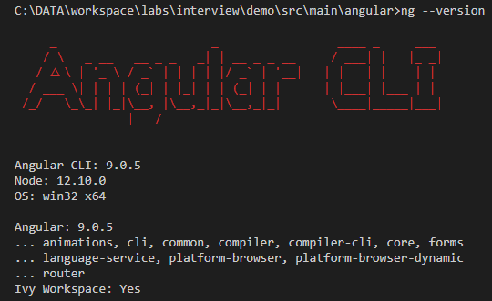

* PrimeNg 9.0.0

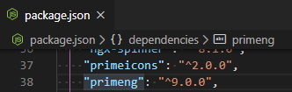

* VS code 1.14.1

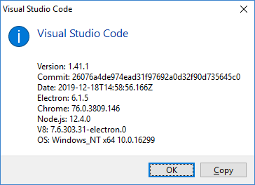

### Backend

* Java 8
* Spring boot 2.2.5.RELEASE
* H2-DB
* Eclipse 2019-12 (4.14.0)

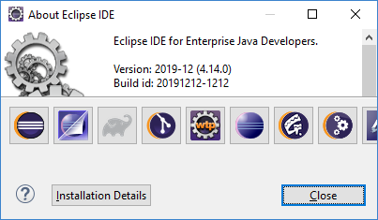

### Git

* <https://github.com/huynhlehoaibac/demoAppForZalo.git>

## Setup DEV environment

Download source code from Git repository.

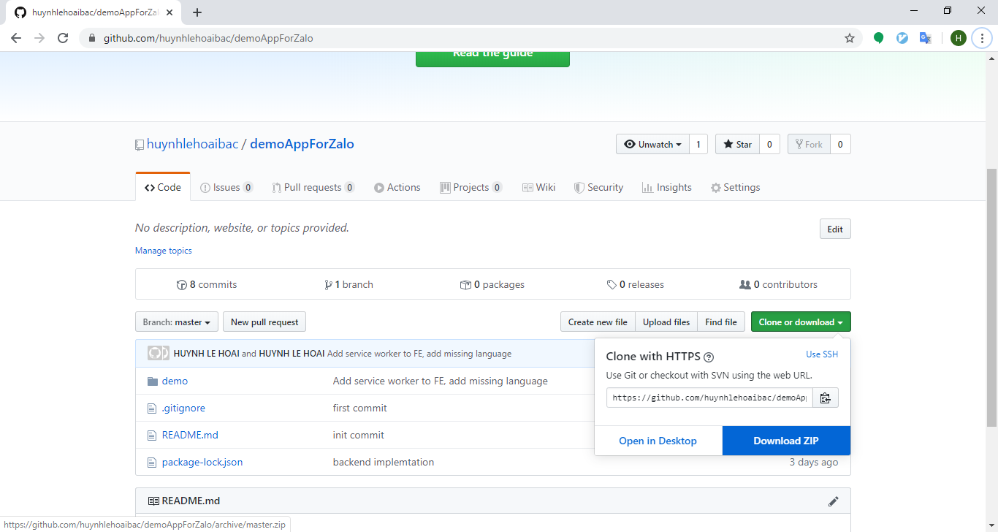

Extract the zip file to specific folder like C:\DATA\dev-workspace

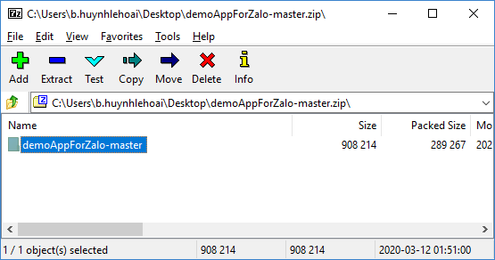

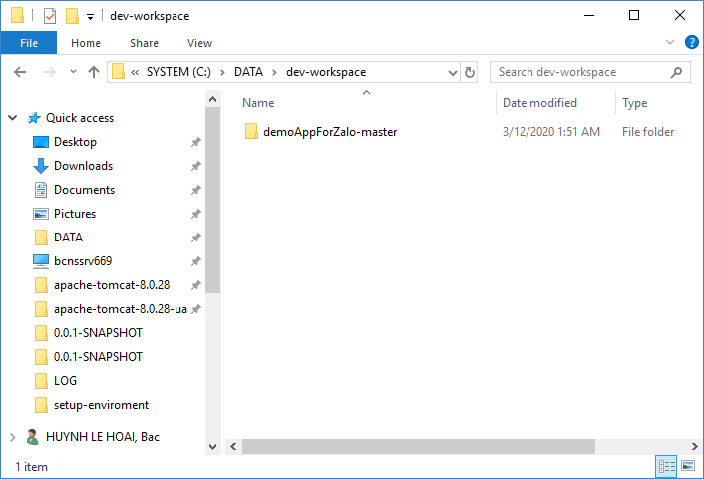

### Backend

Open Eclipse

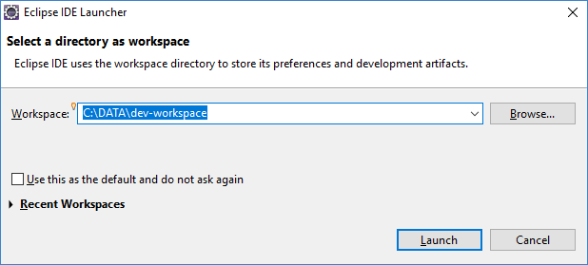

Import maven project

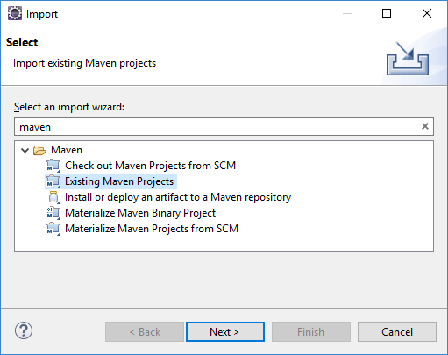

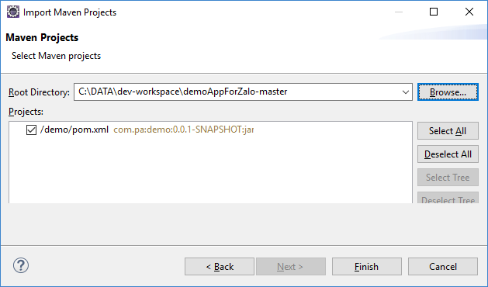

Wait for maven install all dependencies.

After all dependencies are installed successfully, try to run backend by right click at DemoApplication.java

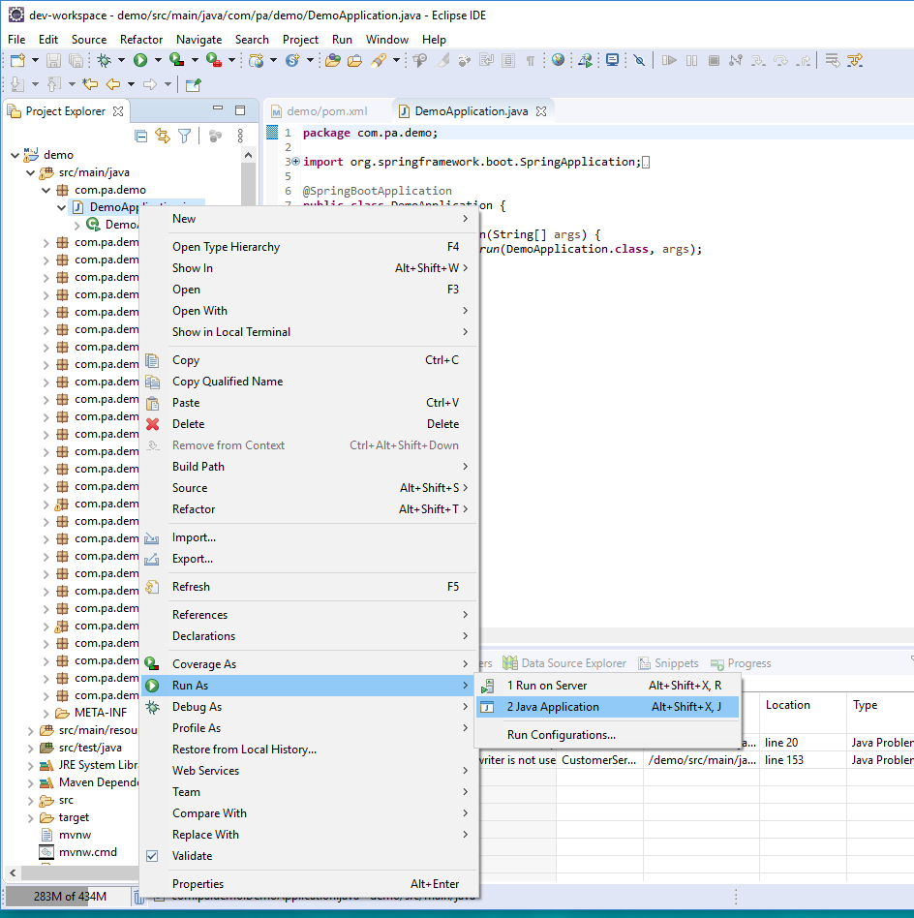

The tomcat server start successfully on 8080 (https)

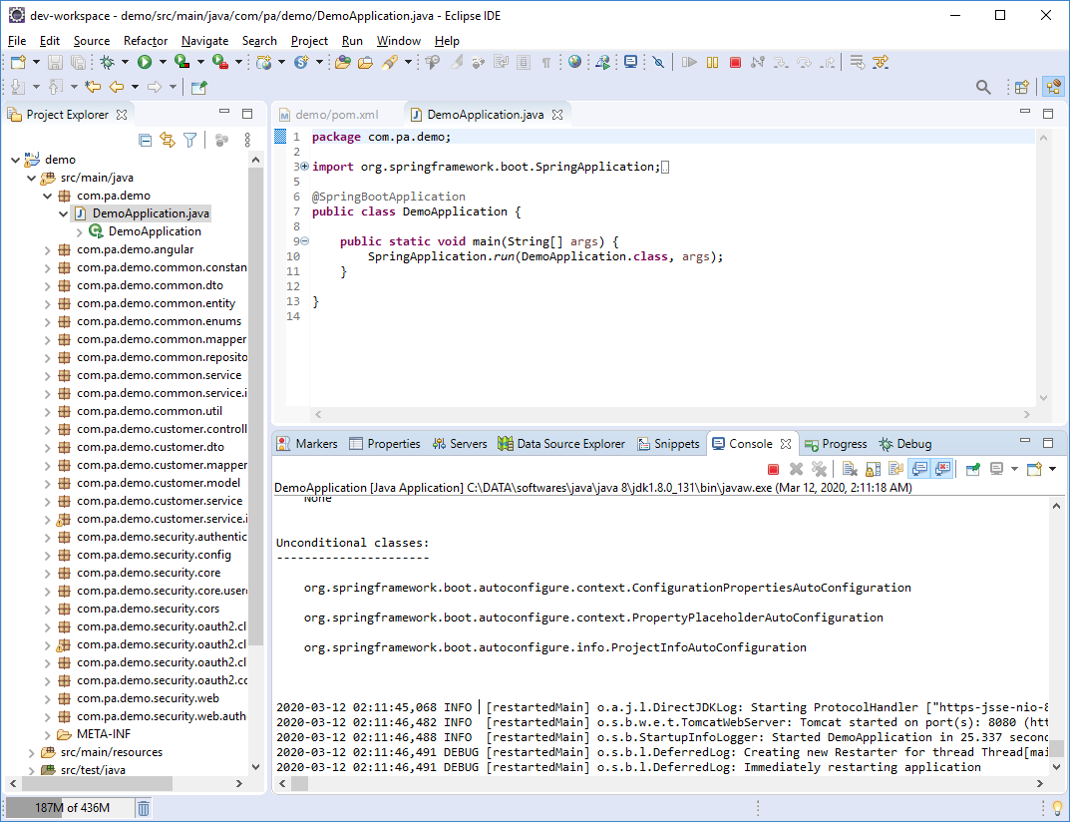

### Frontend

* Follow the guide at (<https://angular.io/guide/setup-local#prerequisites>, <https://angular.io/guide/setup-local#step-1-install-the-angular-cli>) to set up environment for Angular development.
* Using VS code to open Angular project located in demo\src\main\angular

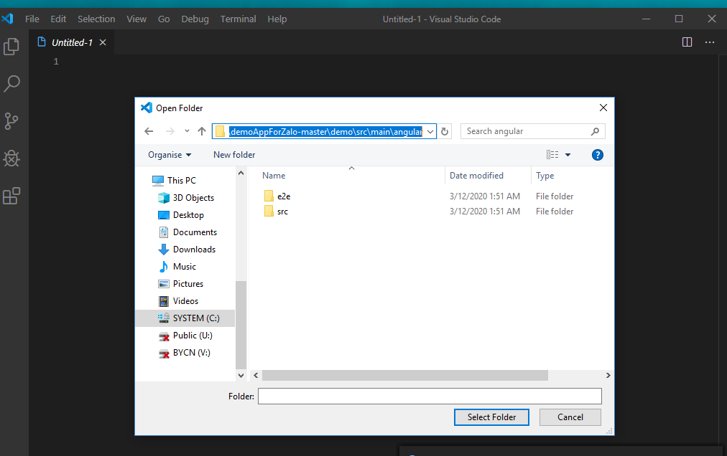

* Open terminal (Ctrl + ~ or Terminal / New Terminal in VS code toolbar), run npm install command to a package and any packages that it depends on. (It take me 20 minutes)

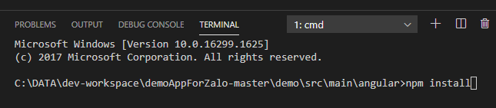

* Serves demo app, rebuilding on file changes by run ng serve --ssl command

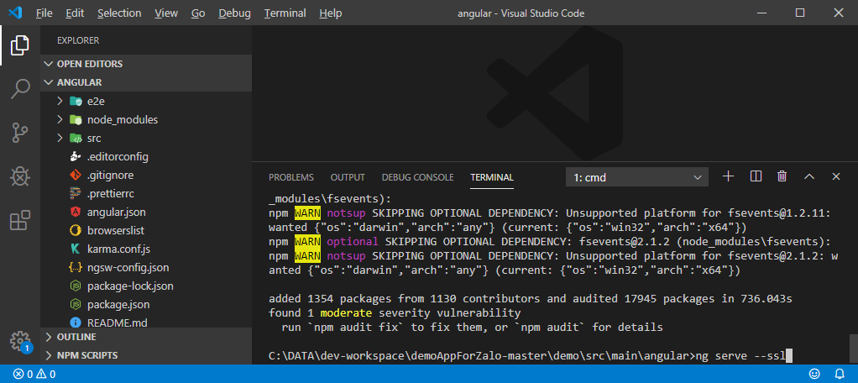

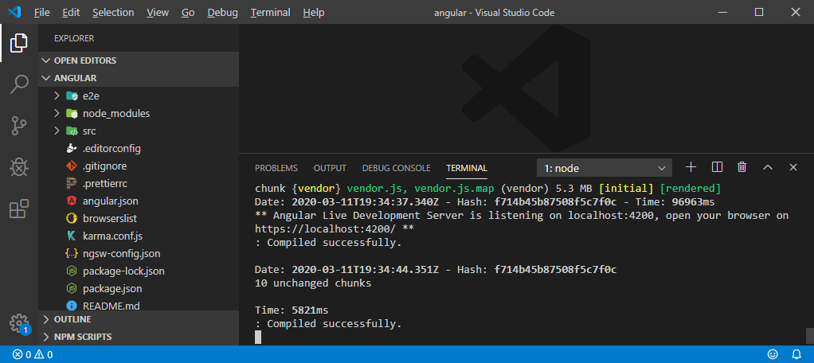

* Open a Google chrome at [http**s**://localhost:4200/](https://localhost:4200/)

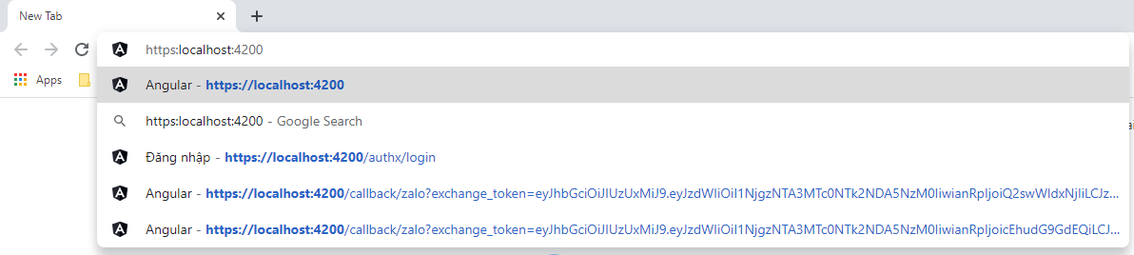

* Zalo requires https for redirect_url, so we need https in local and it’s not authorized.

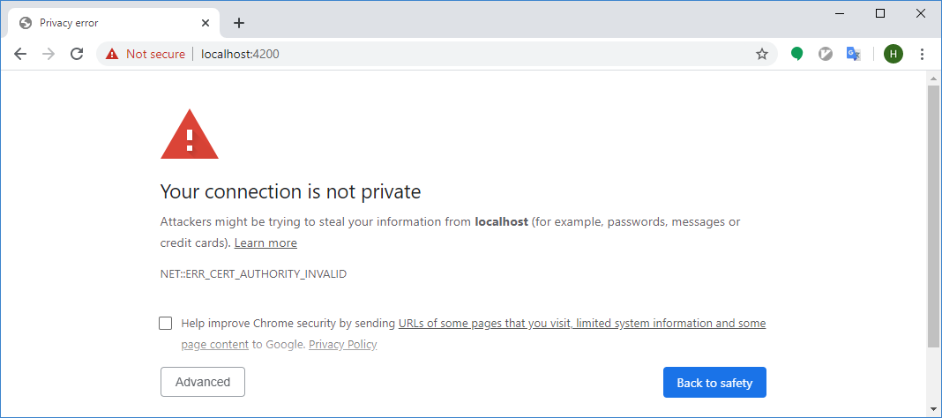

* Select Advaned -> Proceed to localhost (unsafe)

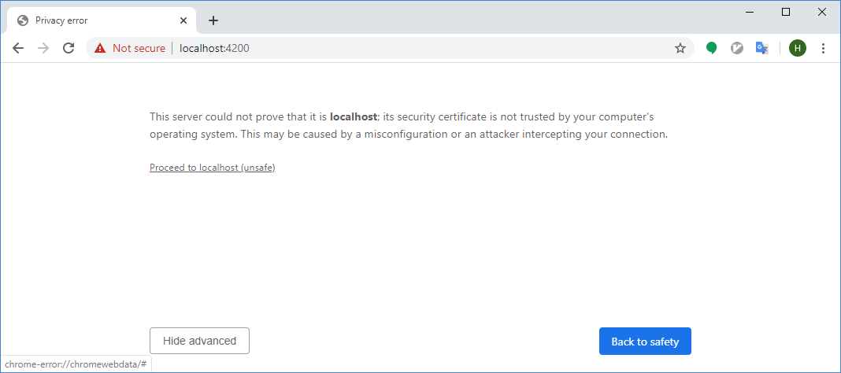

* Login via Zalo

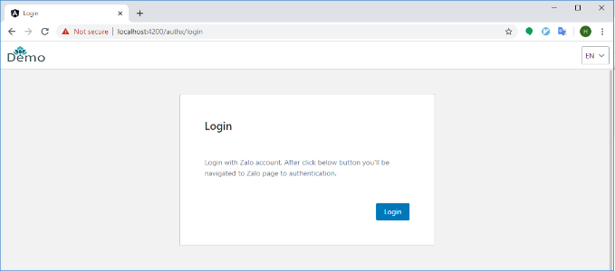

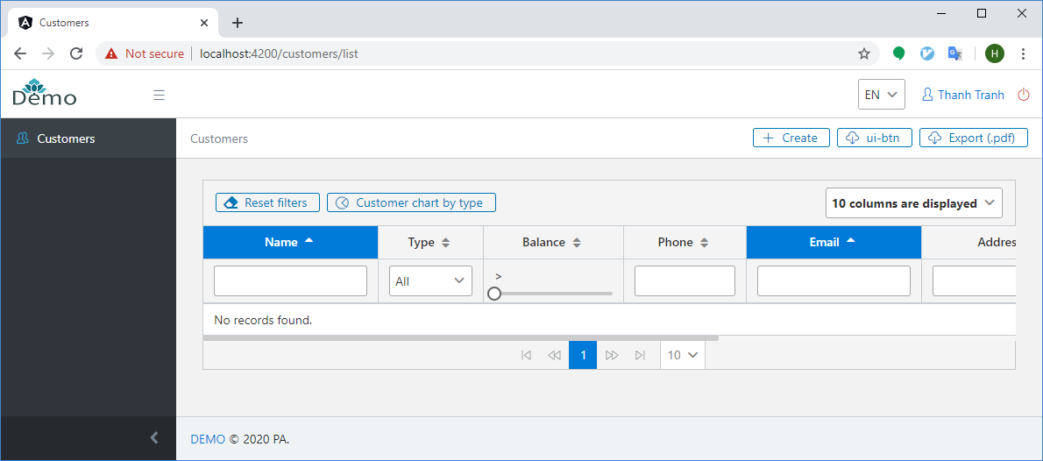

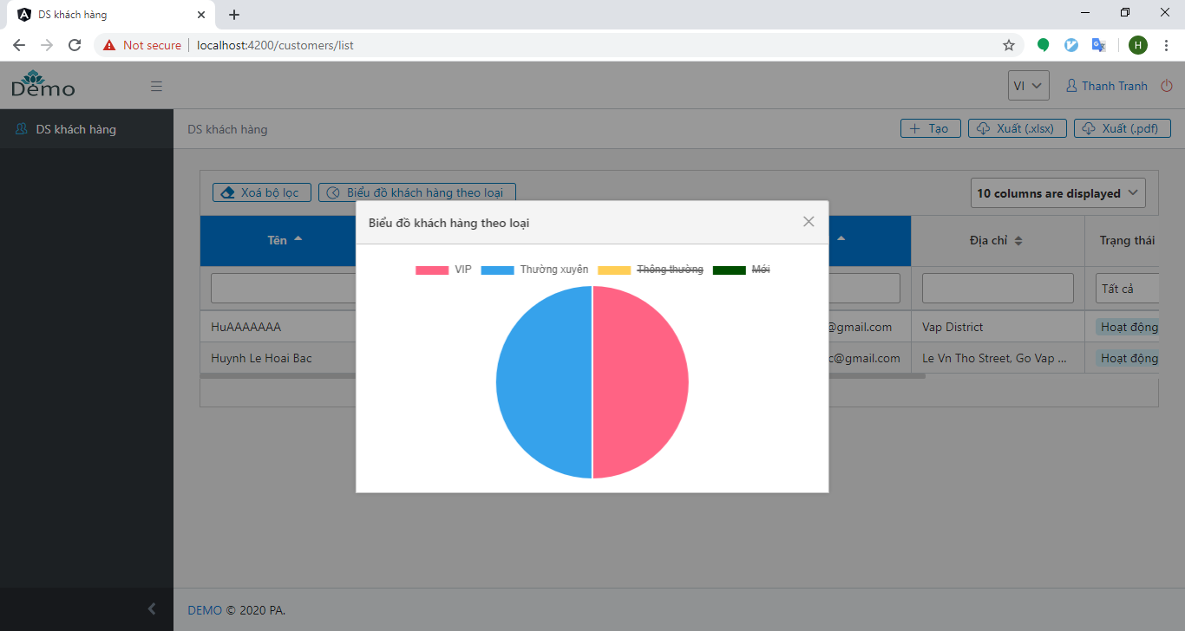

DONE!