|  |  |
| --- | --- |
|  | **FPT ACADEMY INTERNATIONAL**  **FPT – APTECH COMPUTER EDUCATION** |

**Centre Name: FAT2-HCM**

**Address: 590 Cach Mang Thang 8, District 3, Ho Chi Minh City, Viet Nam.**

🙢★🙠

**Auto Ancillaries Limited**

|  |  |  |
| --- | --- | --- |
| **Supervisor:** | Mr. Hoang Duc Quang | |
| **Semester:** | 3 | |
| **Batch No:** | T1.2109.M1 | |
| **Group No:** | 6 | |
| **Team member:** | **Full name** | **Roll No.** |
| 1. | Tran Cong Thinh | Student1331708 |
| 2. | Tong Nguyen Thai An | Student1331707 |
| 3. | Huynh Ngoc Thai | Student1317113 |

**Month**: Dec **Year**: 2022

Contents

I. ACKNOWLEDGEMENT 0

II. problem definition 0

**1.** **Introduction:** 0

**2.** **Existing System :** 0

III. Requirement Specification 1

**1.** **Customer’s Requirement Specifications:** 1

**1.1** **Auto Ancilaries Limited:** 1

**1.2** **Admin** 1

**1.3** **Users** 2

1.4 Payment module of online gallery art system: 2

**1.5** **About us** 2

**1.6** **Contact us** 2

**2.** **Functional Requirement Specifications :** 2

**2.1** **Function of Admin :** 2

**2.2** **Function of Users:** 3

**3.** **Non-Functional Requirement Specifications:** 4

**4.** **System Requirement Specifications:** 4

**4.1. Server requirements:** 4

4.2 Client requirements: 5

**5.** **Development Software** 5

**6.** **Technology** 5

TASK SHEET REVIEW 1 6

I. ARCHITECTURE AND DESIGN OF THE PROJECT: 8

II. USECASE DIAGRAM 8

III. SEQUENCE DIAGRAM 10

**1.** **Login (Admin or User):** 10

**2.** **Create Product (Admin)** 10

**3.** **Update Product (Admin)** 11

**4.** **Delete Product (Admin)** 12

**5.** **Order (Admin)** 13

**6. Create Product In Stock (Admin)** 13

**7. Update Product In Stock (Admin)** 14

**8. Delete Product In Stock (Admin)** 14

**9. Create Account User (Admin)** 15

**10. Update Account User (Admin)** 15

**11. Delete Account User (Admin)** 16

**12. Buy Product (User)** 16

**13. Payment (User)** 17

**14. Search (User)** 17

**15. Feedback (User)** 18

IV. CLASS DIAGRAM 18

19

V. Entity Relationship Diagram (ERD) 20

VI. Entities & Attributes 20

**1.** **Category** 20

**2.** **Products** 21

**3.** **User** 21

**4.** **Wishlist** 22

**5.** **Comment** 23

**6.** **Coupon** 23

**7.** **Order** 24

**8.** **Order_Details** 25

**9.** **Staff** 26

**10.** **Stock** 26

TASK SHEET REVIEW 2 27

REVIEW 3 28

I. GUI Design 29

**1.** **Home Page** 29

29

**2.** **Login Page** 29

**3.** **Product Page** 30

**4.** **Wishlist Page** 30

**5.** **About Page** 31

**6.** **Contact Page** 31

**7.** **Cart Page** 32

**8.** **Checkout Page** 32

**9.** **Detail Page** 33

TASK SHEET REVIEW 3 34

**REVIEW 1**

# ACKNOWLEDGEMENT

We would want to express our gratitude to everyone who has supported and assisted us, especially our instructor Hoang Duc Quang, who has provided us with helpful resources and several consultations that have helped us develop a successful project plan. Numerous people, particularly our classmates and team members, provided insightful comments and recommendations that motivated us to enhance our effort.

We express our gratitude to everyone who contributed directly and indirectly to the success of our initiative.

# problem definition

1. **Introduction:**

Manufacturing vital ancillaries for the two-wheeler and four-wheeler auto industries is what Auto Ancillaries Limited (AAL) does. They have been having issues with their present system for the last few months.

They have felt that a change in their system is necessary as a result of the issues. They have asked you to create items for them in order to do this. They want you to research the issue at hand and develop a plan for resolving the present issues. Additionally, they want you to recommend strategies that the business might use to get a competitive edge in this fiercely competitive industry.

1. **Existing System :**

AAL has a $15 million yearly revenue. There are 4 factories and 4 warehouses for the firm. the Original Equipment Manufacturers are AAL's clientele (OEM). Through dealers, the firm connects with its customers. Orders are delivered by the Ware Houses directly to OEMs and other clients. Regular dealers and Exclusive dealers are the two different categories of dealers.

Regular dealers are the general distributors of both AAL's products and those of other businesses. Exclusive dealers exclusively sell products from the AAL. Thus, the business must have a complex system in place to ensure that all clients receive material promptly and that dealers are informed of its stock levels.

# Requirement Specification

1. **Customer’s Requirement Specifications:**
   1. **Auto Ancilaries Limited:**

* Auto Ancilaries Limited (AAL) is a story application that serves the auxiliary manufacturing industry for two- and four-wheelers. The application specializes in providing and trading auto accessories for online .
* Auto Ancilaries Limited (AAL) is a very useful application platform for the automotive industry in general and car lovers in particular.
* This application will provide customers with a variety of rich and diverse choices. Only with simple operations, along with extremely fast and free registration steps.
* It provides free home delivery to buyers. It allows users to create their own portfolio.
* The main menu will contain six parts which are as follow: CUSTOMER LOGIN , ADMIN LOGIN , PRODUCT IN SALE, NEW PRODUCT, PAYMENT MODE, ABOUT US, CONTACT US.
  1. **Admin**
* The administrator will run the product with the tasks of adding, editing, deleting and searching products. Will allow the product to display where and how.
* The administrator will manage the user's accounts, view the details of the accounts, and have the right to block users with violations, unauthorized purchases and comments real.
* Admin accepts orders from customers, tracks and monitors orders. Invoices can be printed and sent to customers.
* The administrator is also responsible for checking and calculating the number of products in stock.
  1. **Users**
* After the user has successfully logged in, the user begins to explore the products and choose to buy the products through suggestions such as pictures, reviews,...
* Users can upload personal information such as name, gender, address, phone number, etc. These are extremely important steps to link between users and the system.
* Users can add to the cart their favorite products, rate the product according to the customer's feelings after experiencing the system's products and services.

### 1.4 Payment module of online gallery art system:

* This modules helps the buyers to make the financial transactions easily.
* The buyers can make a deposit or make the payment with different payment methods such as :debit card, credit card or through net banking(ex: PayPal).
* The buyers will get the notification to complete the payment prior two to three days so that buyers don’t get any late charges.
  1. **About us**
* The admin can change or update easily the design and the content of the About us page .
  1. **Contact us**
* The admin can change or update easily the design and the content of the Contact us page .

1. **Functional Requirement Specifications :**
   1. **Function of Admin :**

* REQ-01: Login, Logout.
* REQ-02: Manage user.
* REQ-02.01 : Can activate or deactivate any member.
* REQ-02.02 : Can create new member or delete any member.
* REQ-02.03 : User profiles should be updated with profile images,...
* REQ-03: Manage order
* REQ-03.01: Customers locate and purchase things; if the item is genuine, the administrator will approve the order.
* REQ-03.02 : Processes including product acceptance, product packing, and product shipping will be handled by the administrator.
* REQ-03.03: The system will inform the client of the order's success status after it has been dispatched, enabling the consumer to track the order's progress.
* REQ-03.04: The buyer can get in touch with the system to report an issue if the order has any mistakes or does not reflect the true value.
* REQ-04: Manage product
* REQ-04.01: The administrator will manage items by adding new products, updating existing products, eliminating outdated products, and finding products.
* REQ-04.02 : The administrator will also control how items are shown based on criteria like the newest products, the most popular products, and the most popular things sold.
* REQ-05: Manage warehouse
* REQ-05.01: The administrator also rigorously controls inventory, which enables her to match client demands with product evaluation.
  1. **Function of Users:**
* REQ-07 : Register.
* REQ-08 : Login, Logout.
* REQ-09 : Create personal information
* REQ-10 : Receive the notification and verification by email.
* REQ-11 : After buying a product, give it a rating or remark.
* REQ-12 : Search the art work by categories and price.
* REQ-13 : Place your order and follow it.
* REQ-14 : View the product's specifications and prior reviews.
* REQ-15: Consider looking up further details about the goods, such as the brand.
* REQ-16 : Contact the admin.

1. **Non-Functional Requirement Specifications:**

* Login by Facebook, Gmail.
* Report.
* Realtime of auction.

1. **System Requirement Specifications:**

**4.1. Server requirements:**

* **Hardware**

|  |  |
| --- | --- |
| Component | Requirement |
| CPU | Processor type:  Pentium IV-compatible processor or faster  Processor speed:  Recommended: 2.0 GHz or faster |
| OS | Microsoft Windows XP or higher with IIS |
| Memory (RAM) | RAM:  Minimum: 512 MB  Recommended: 2 GB or more |
| Hard Drive | Free space:  Minimum: 200 MB  Recommended: 50 GB or more  Maximum: Operating system maximum |

* **Software :**

|  |  |
| --- | --- |
| Component | Requirement |
| Microsoft .NET Core | Version 3.1 |
| RDBMS | MySQL Server 10.4.11 - MariaDB |

### 4.2 Client requirements:

* **Hardware**

|  |  |
| --- | --- |
| Component | Requirement |
| CPU | Processor type:  Pentium III-compatible processor or faster  Processor speed:  Recommended: 1.0 GHz or faster |
| OS | All OS(Window ,Linux ,Android ,Mac OS …) |
| Memory (RAM) | RAM:  Minimum: 512 MB  Recommended: 1 GB or more  Maximum: Operating system maximum |
| Hard Drive | Free space:  Minimum: 10 MB |

* **Software**

|  |  |
| --- | --- |
| Component | Requirement |
| Web Browser | IE 4.0 , Firefox 3.0,Chrome or Higher….. |

1. **Development Software**

* MySQL Server 10.4.11 - MariaDB
* Microsoft Visual Studio 2022.

1. **Technology**

* ASP.Net MVC 5
* .Net CORE 3.1

# TASK SHEET REVIEW 1

|  |  |  |  |  |  |  |  |
| --- | --- | --- | --- | --- | --- | --- | --- |
| **Project Ref. No.:**  **eP/Advertisement** **Portal Management** **System/01** | | **Project Title:** | **Activity Plan** **Prepared** **By:** | **Date of Preparation of Activity Plan:** | | | |
| **Sr.No.** | **Task** | **Actual Start** **Date** | **Actual** **Days** | **Team** **Mate** **Names** | **Status** |
| 1 | Acknowledgement | ***Auto Ancillaries Limited*** | Huỳnh Ngọc Thái | 01/01/2023 | 2 | All member | Completed |
| 2 | Problem Definition | 01/01/2023 | 2 | All member | Completed |
| 3 | Requirement Specification | 01/01/2023 | 2 | All member | Completed |
| 4 | Task sheet review | 01/01/2023 | 2 | All member | Completed |

|  |
| --- |
|  |

|  |  |
| --- | --- |
| **Date: 02/01/2023** | |
| Signature of Instructor:  **Mr. Hoàng Đức Quang** | Signature of Team Leader:  **Trần Công Thịnh** |

**REVIEW 2**

# ARCHITECTURE AND DESIGN OF THE PROJECT:

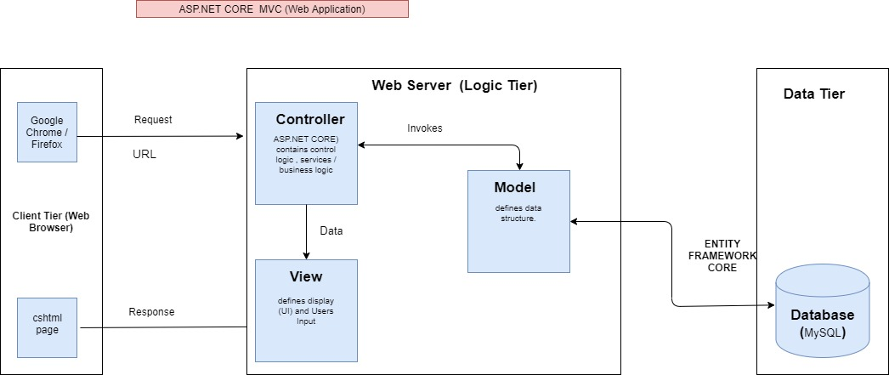

Figure 1: Architecture and Design of the Project

1. **USECASE DIAGRAM**

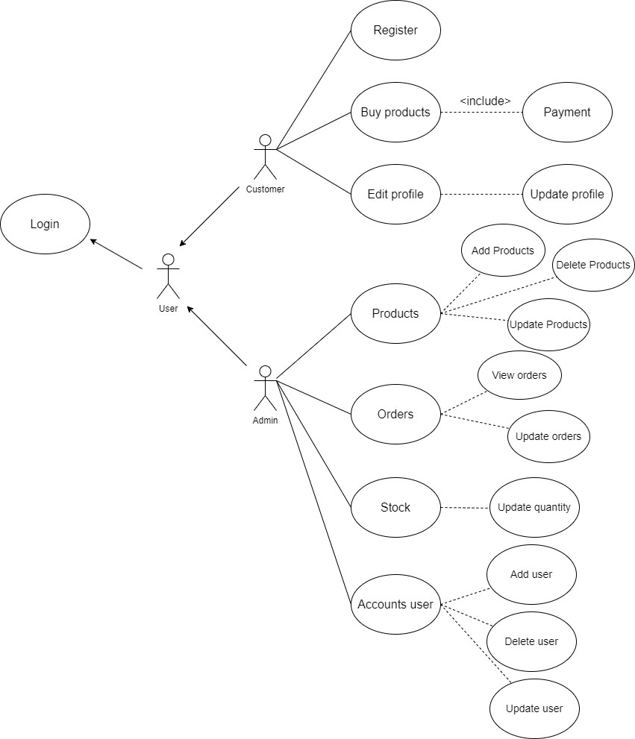

Figure 2: UseCase

1. **SEQUENCE DIAGRAM**
2. **Login (Admin or User):**

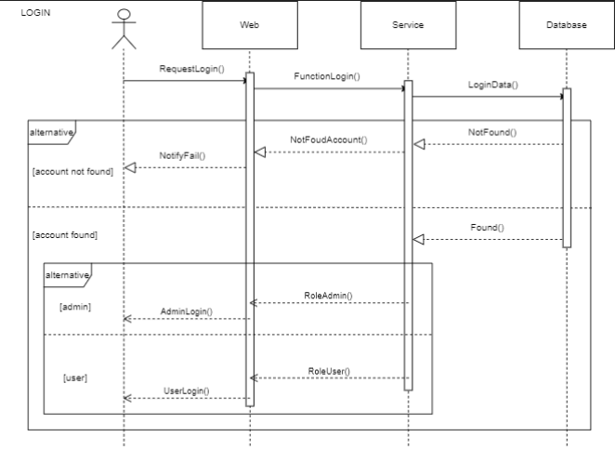

Figure 3: Login

1. **Create Product (Admin)**

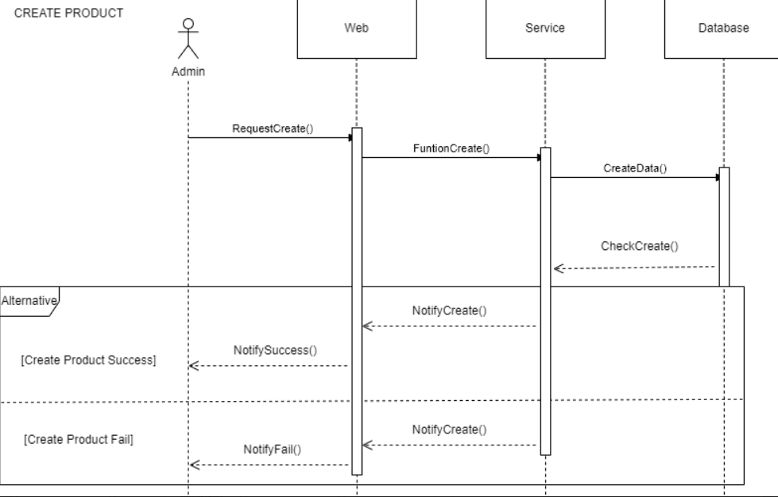

Figure 4: Create Product

1. **Update Product (Admin)**

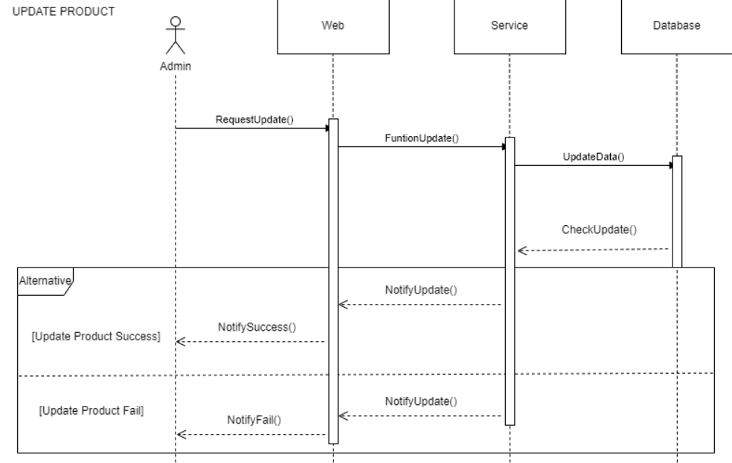

Figure 5: Update Product

1. **Delete Product (Admin)**

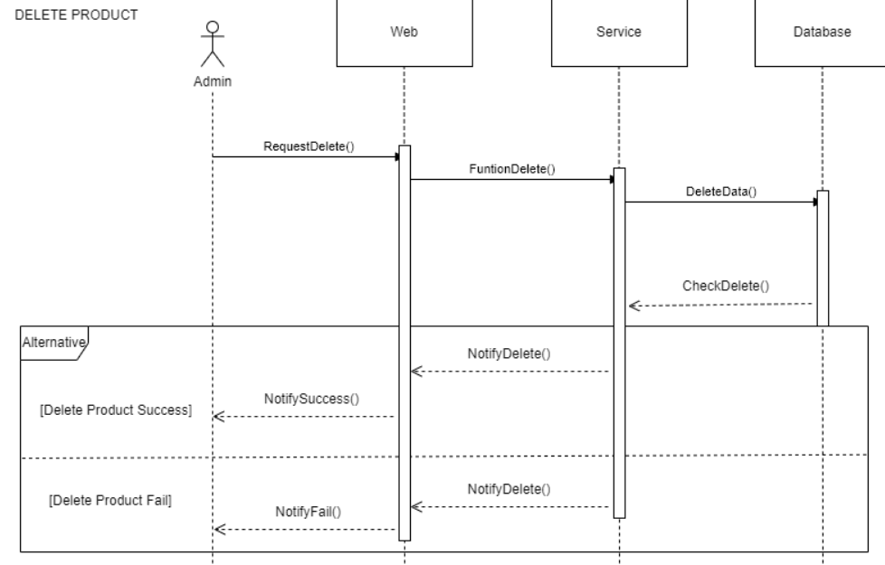

Figure 6:Delete Product.

1. **Order (Admin)**

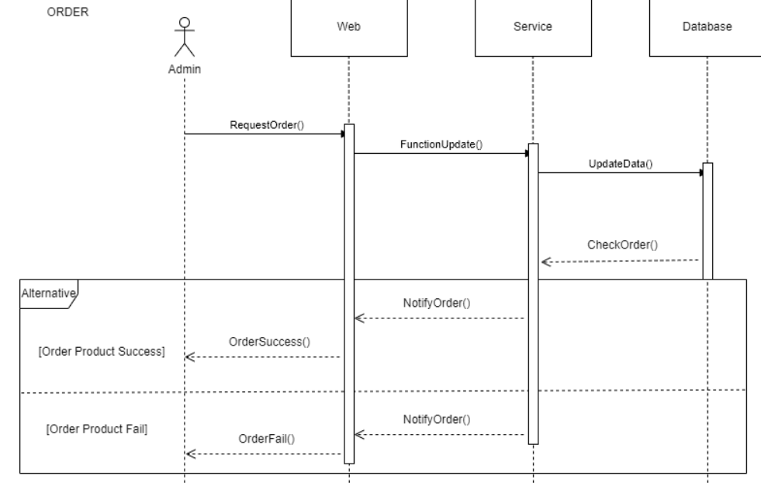

Figure 7: Order

**6. Create Product In Stock (Admin)**

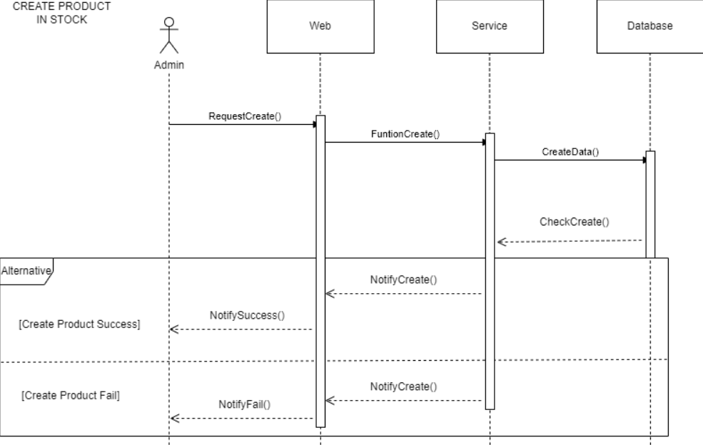

Figure 8: Create Product in Stock

**7. Update Product In Stock (Admin)**

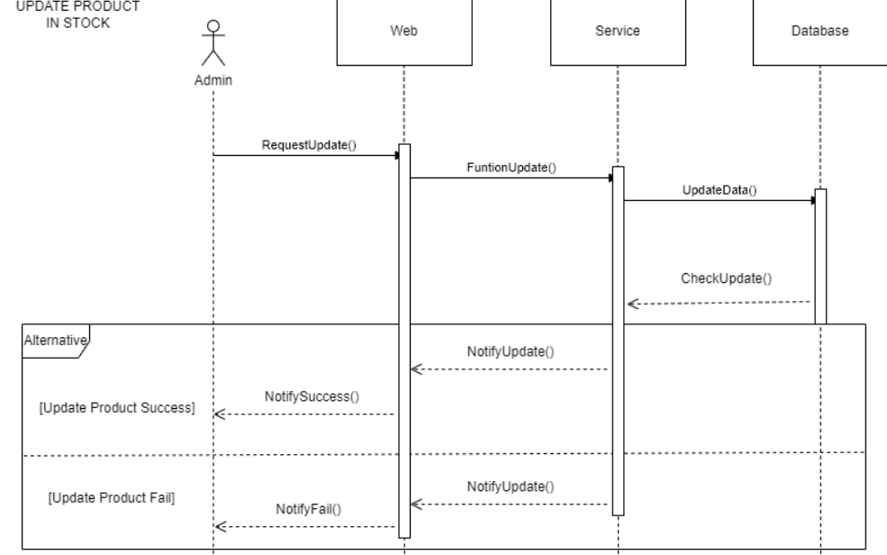

Figure 9: Update Product in Stock

**8. Delete Product In Stock (Admin)**

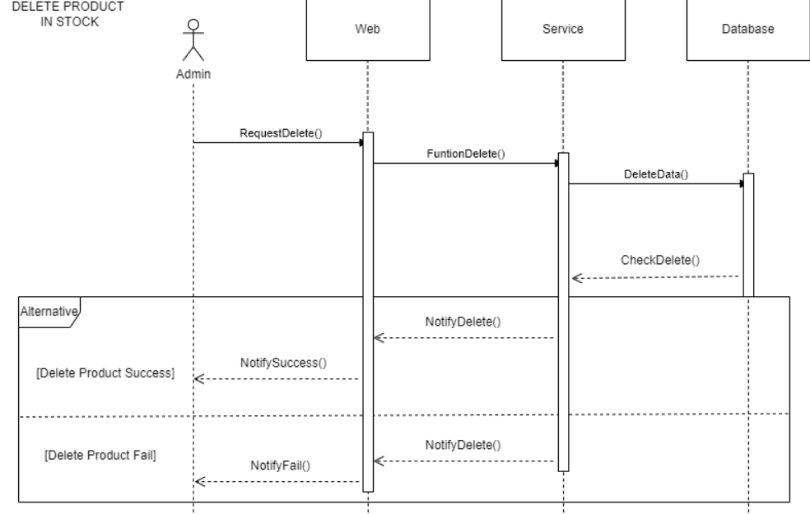

Figure 10: Delete Product in Stock

**9. Create Account User (Admin)**

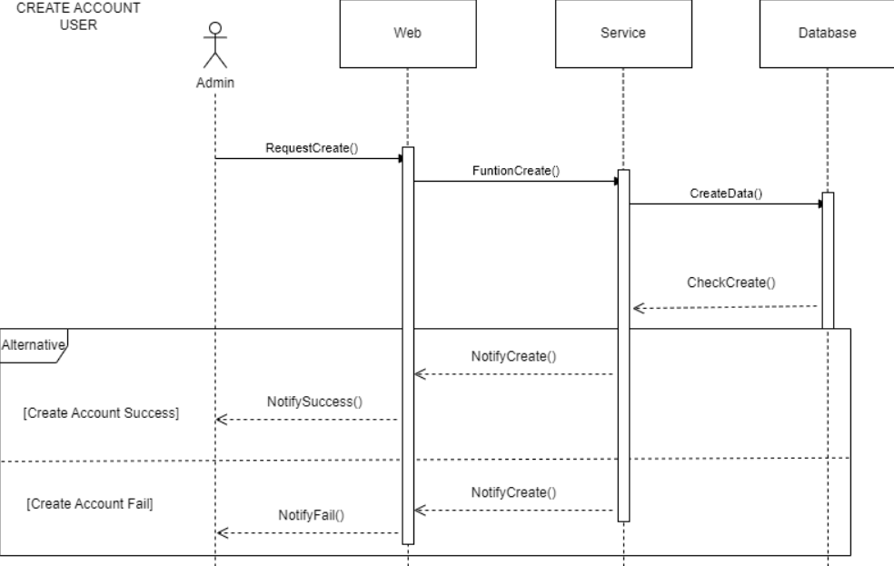

Figure 11: Create Account User

**10. Update Account User (Admin)**

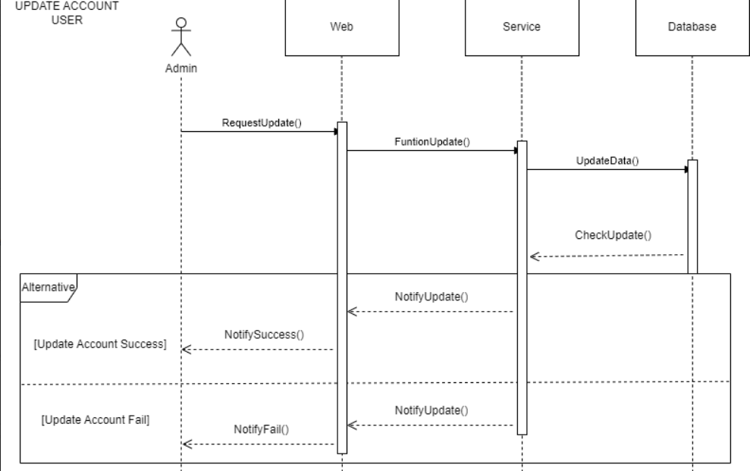

Figure 12: Update Account User

**11. Delete Account User (Admin)**

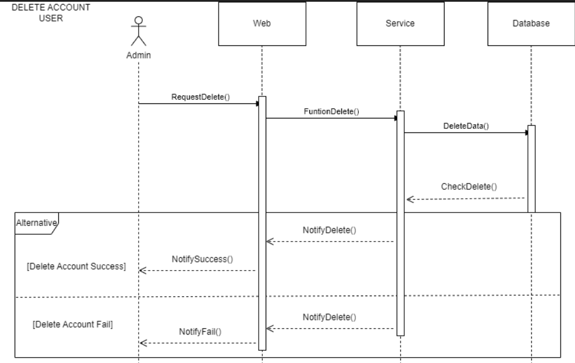

Figure 13: Delete Account User

**12. Buy Product (User)**

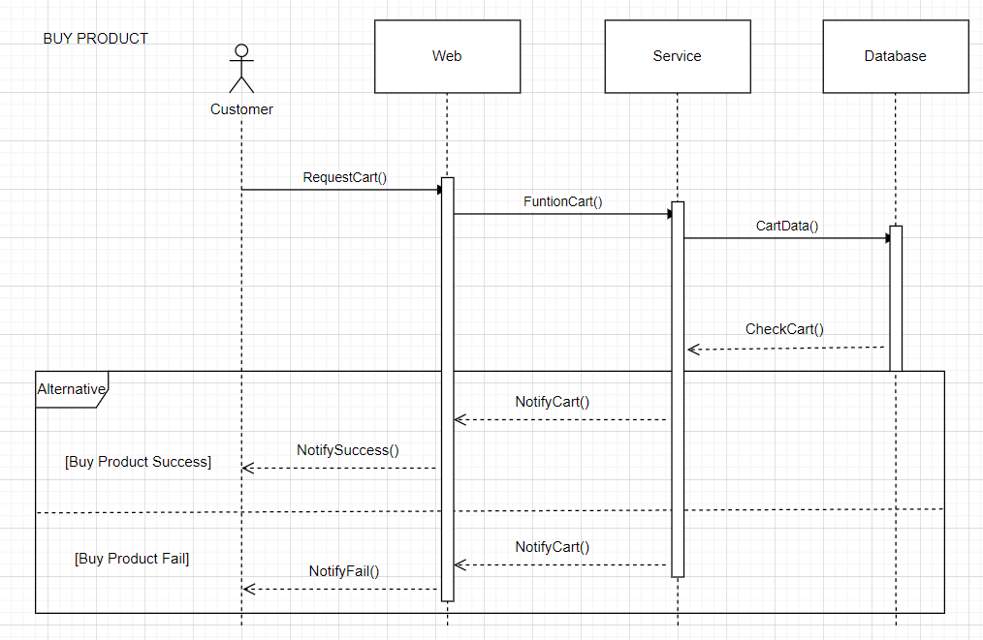

Figure 14: Buy Product

**13. Payment (User)**

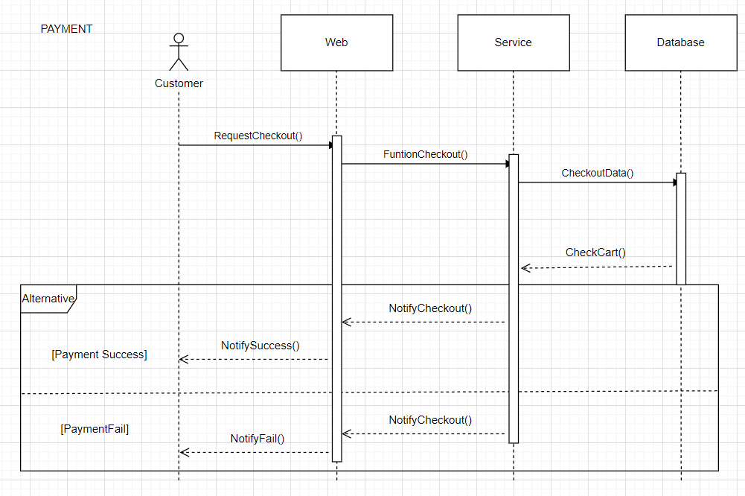

Figure 15: Payment

**14. Search (User)**

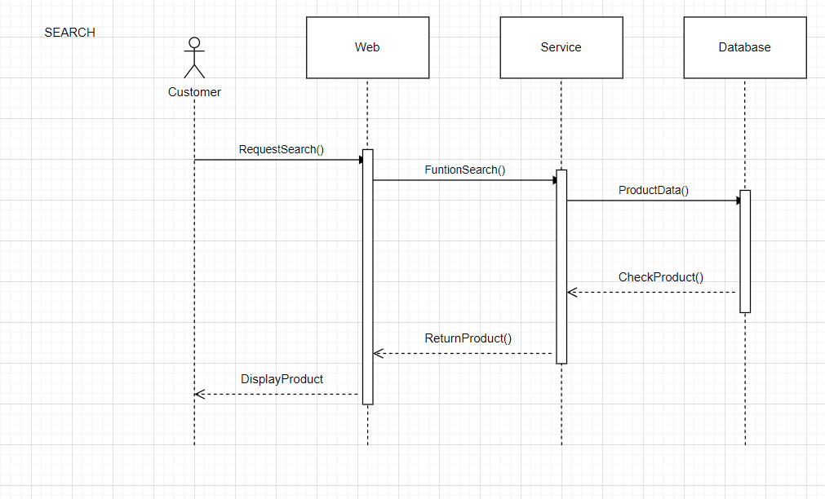

Figure 16: Search

**15. Feedback (User)**

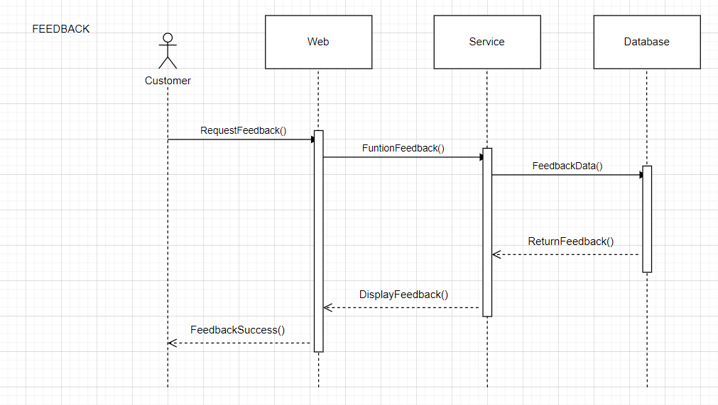

Figure 17: Feedback

1. **CLASS DIAGRAM**

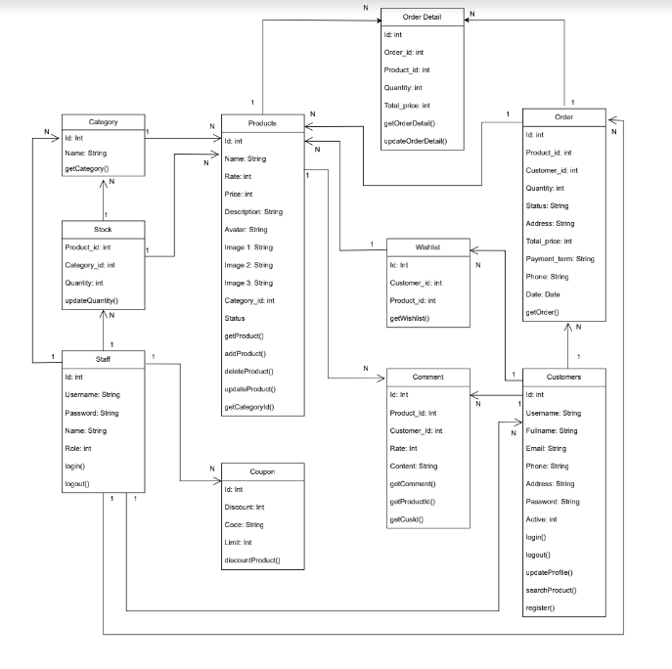

1. **Entity Relationship Diagram (ERD)**

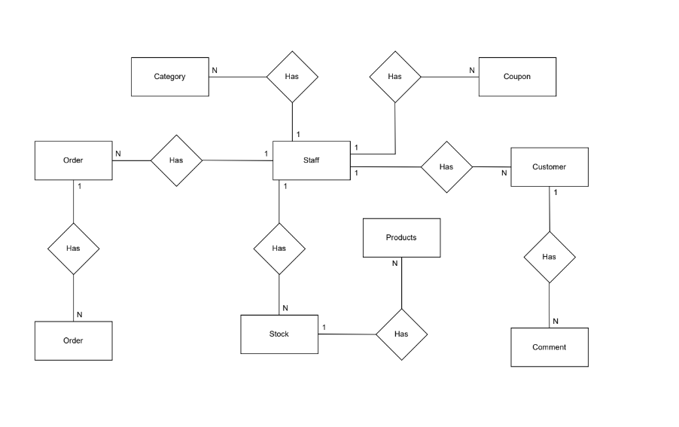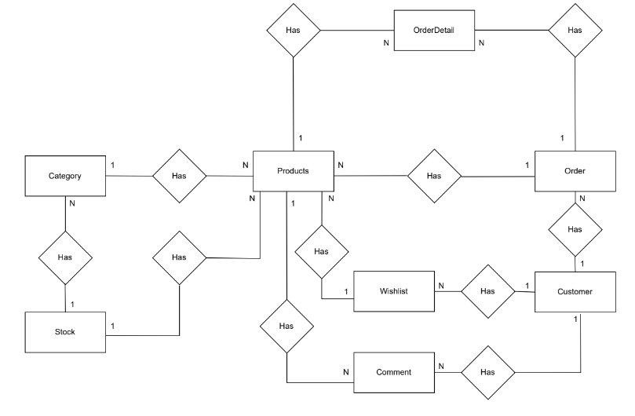

1. **Entities & Attributes**
2. **Category**

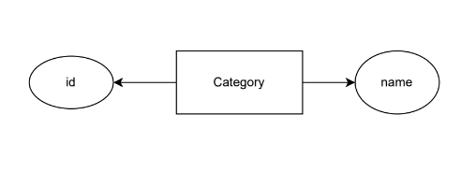

1. **Products**

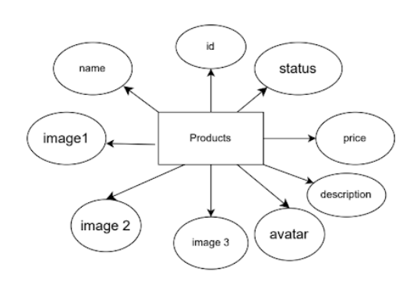

1. **User**

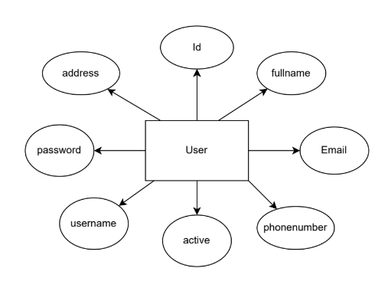

1. **Wishlist**

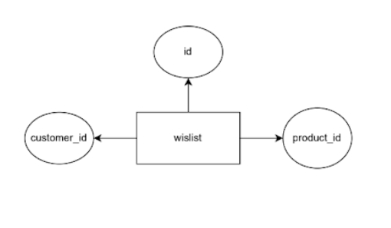

1. **Comment** 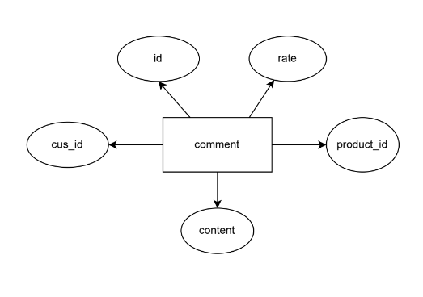
2. **Coupon** 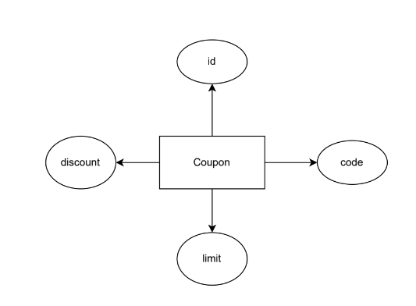
3. **Order** 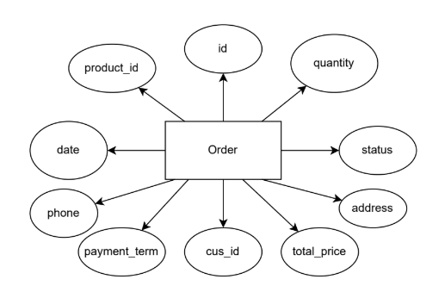
4. **Order_Details** 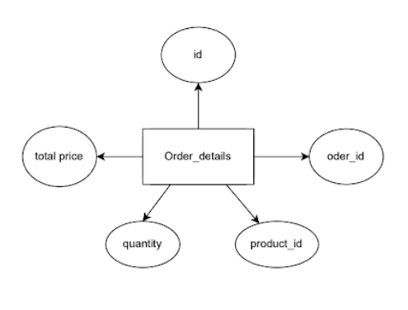
5. **Staff** 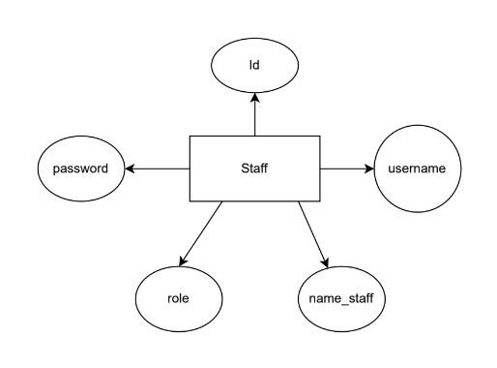
6. **Stock** 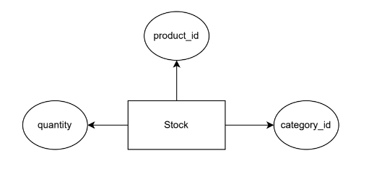

# TASK SHEET REVIEW 2

|  |  |  |  |  |  |  |  |
| --- | --- | --- | --- | --- | --- | --- | --- |
| **Project Ref. No.:**  **eP/Advertisement** **Portal Management** **System/01** | | **Project Title:** | **Activity Plan** **Prepared** **By:** | **Date of Preparation of Activity Plan:** | | | |
| **Sr.No.** | **Task** | **Actual Start** **Date** | **Actual** **Days** | **Team** **Mate** **Names** | **Status** |
| 1 | Architecture & Design of Project | ***Auto Ancillaries Limited*** | Thịnh | 03/01/2023 | 1 | All Member | Completed |
| 2 | Usecase Diagram | 04/01/2023 | 1 | Thịnh | Completed |
| 3 | Sequence Diagram | 04/01/2023 | 2 | Thái | Completed |
| 4 | Class Diagram | 05/01/2023 | 2 | Thịnh | Completed |
| 5 | Entities & Attributes | 04/01/2023 | 1 | Ân | Completed |
| 6 | ERD Concept | 06/01/2023 | 1 | Thái | Completed |
| 7 | Task Review |  |  | 06/01/2023 | 1 | All Member | Completed |

# REVIEW 3

1. **GUI Design**
2. **Home Page**

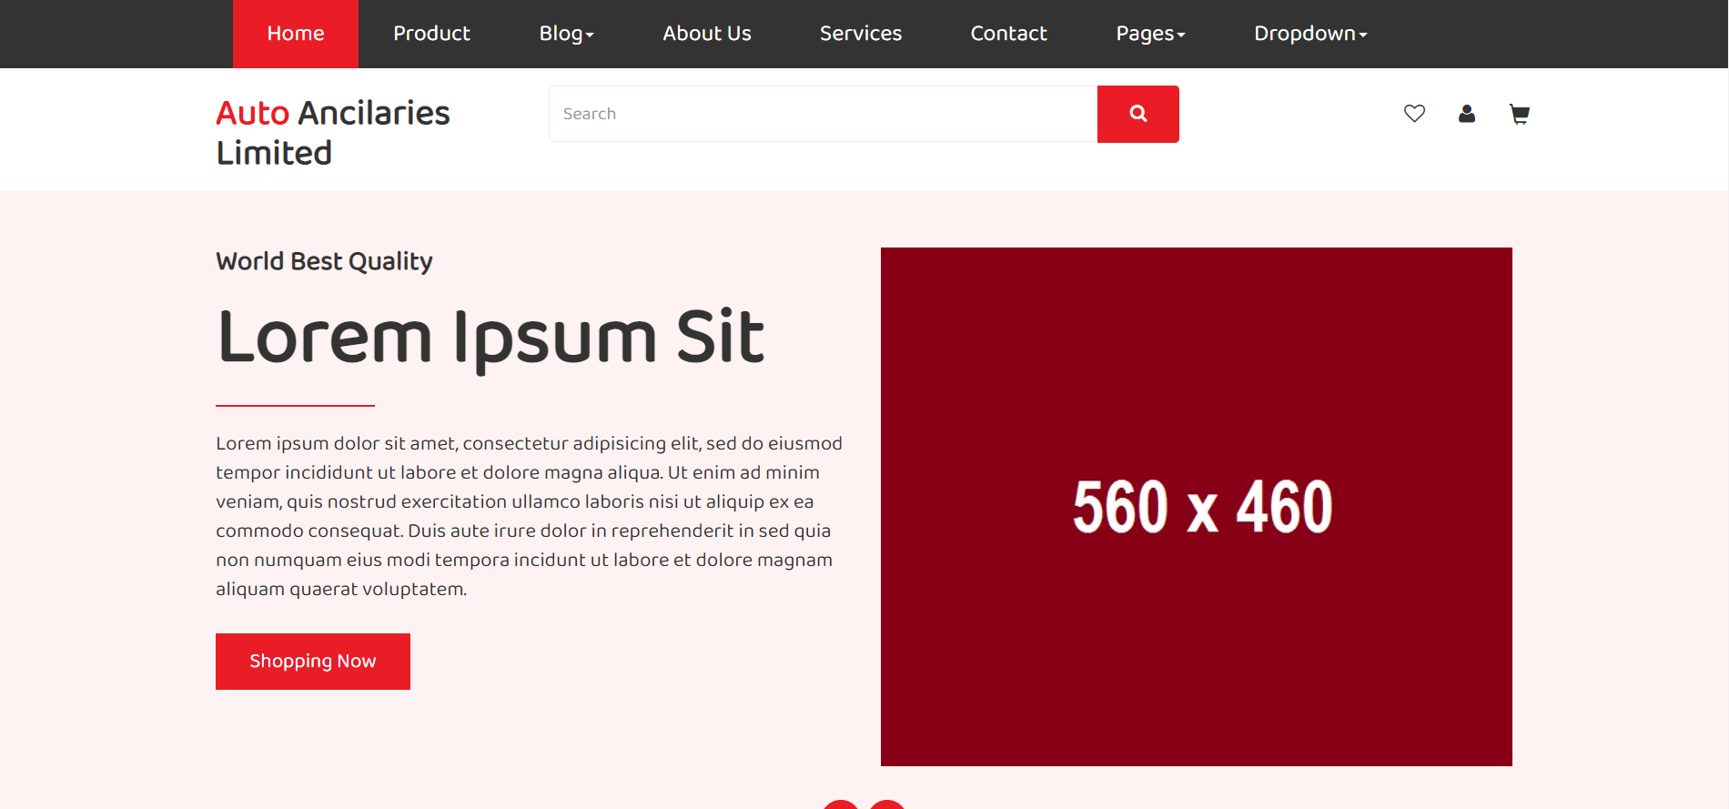

1. 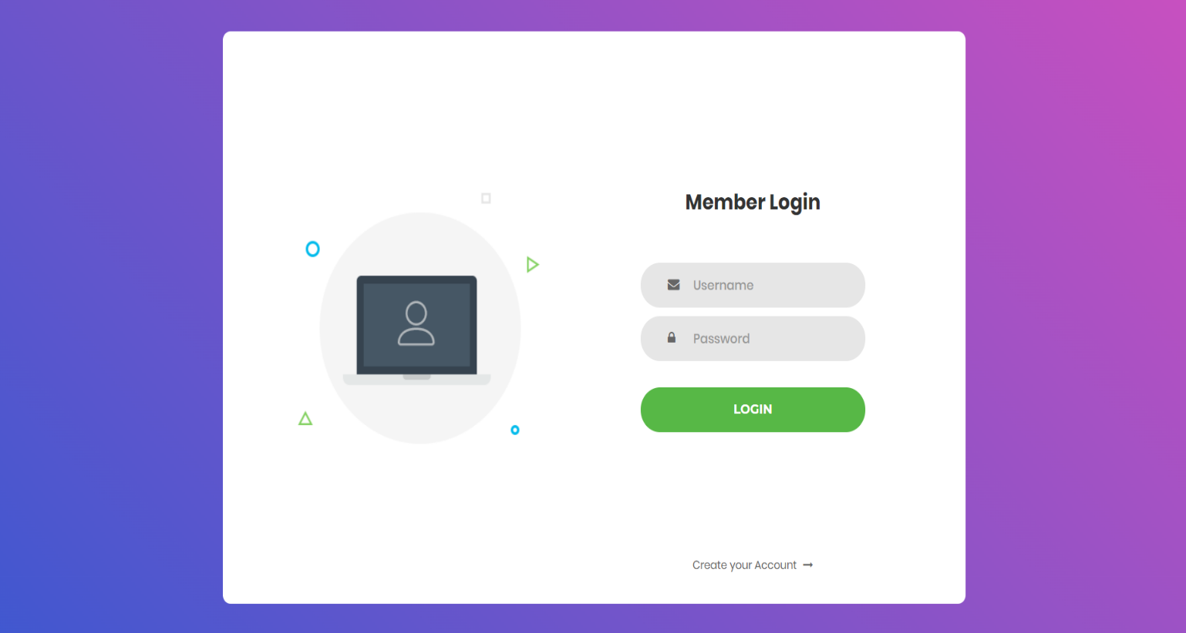**Login Page**
2. 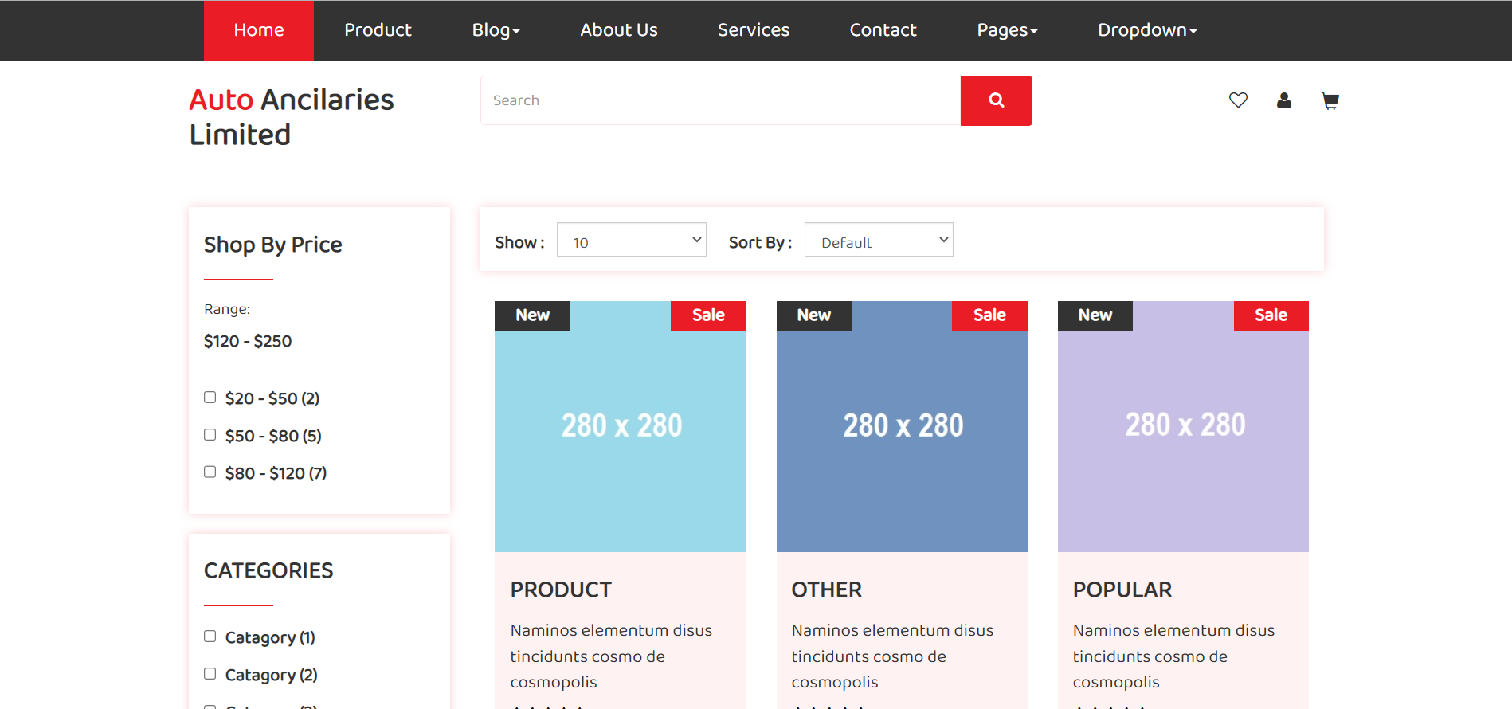**Product Page**
3. 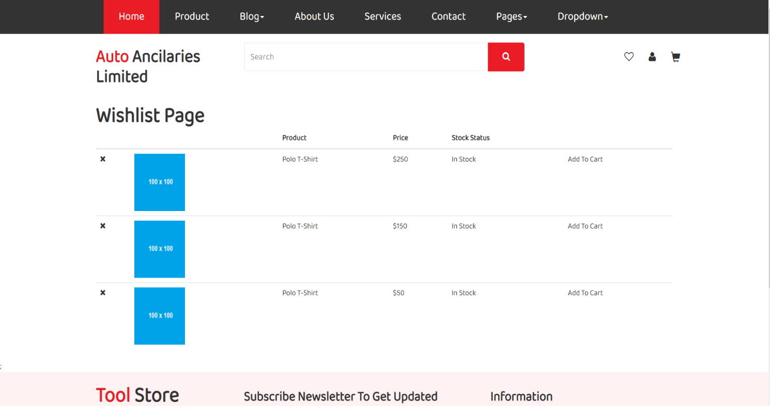**Wishlist Page**
4. 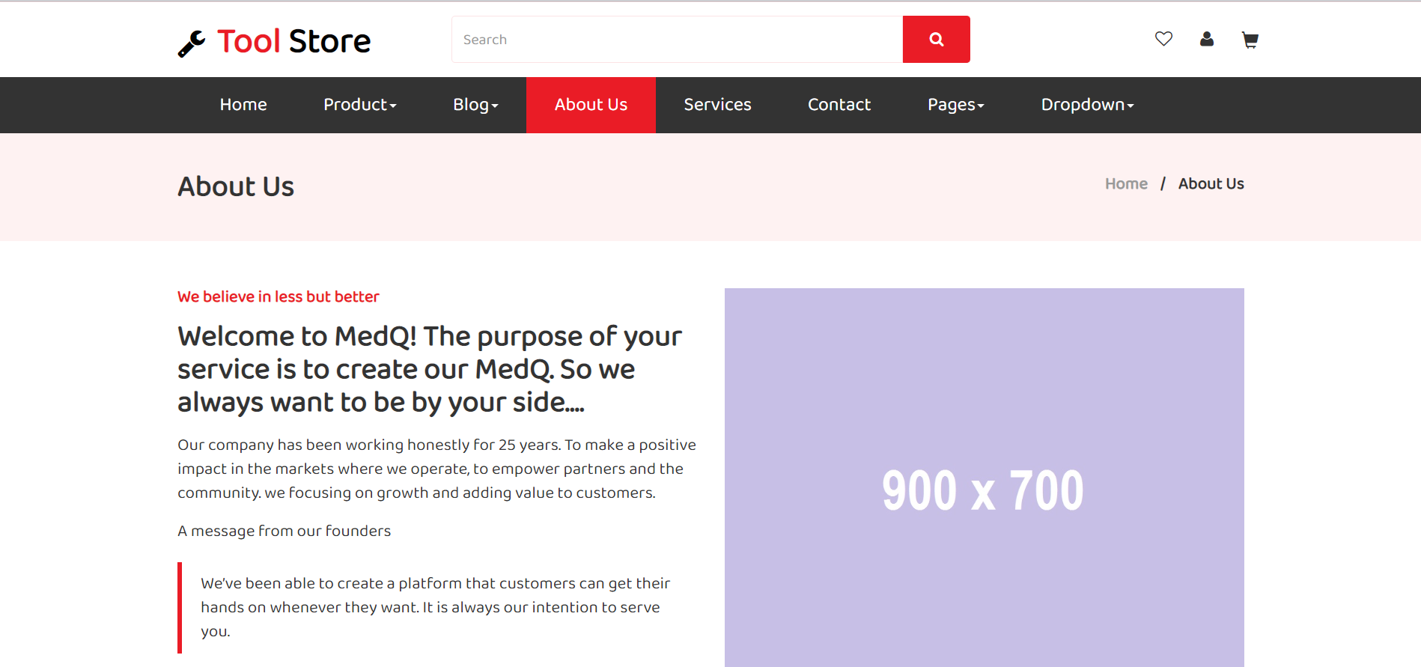**About Page**
5. 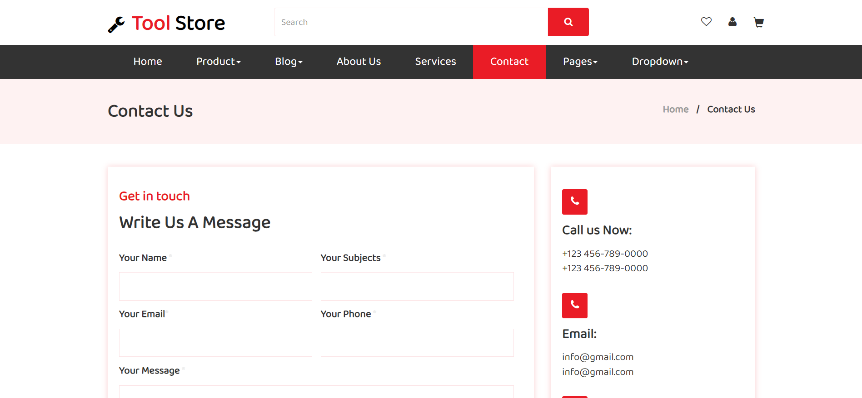**Contact Page**
6. 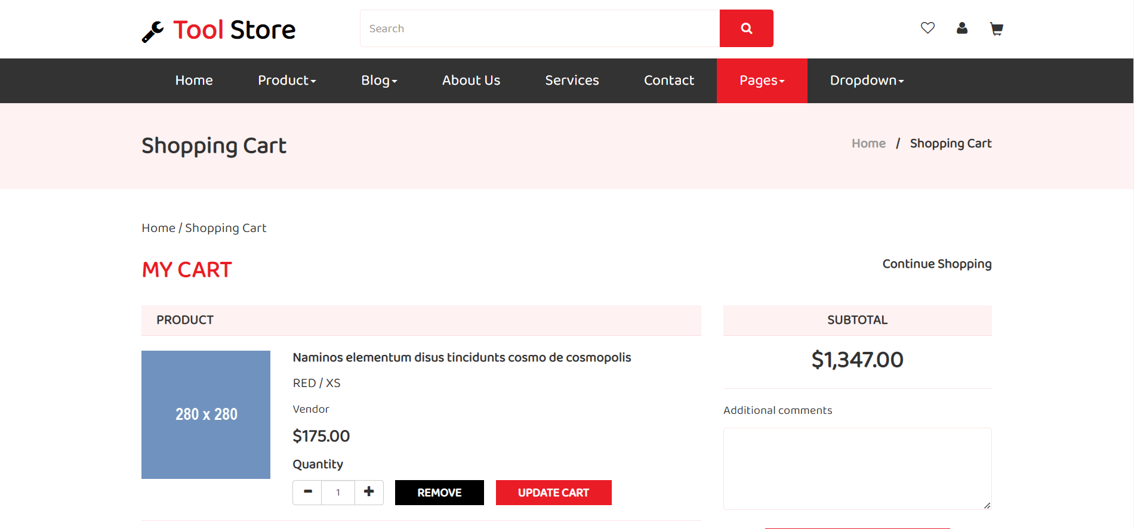**Cart Page**
7. **Checkout Page**

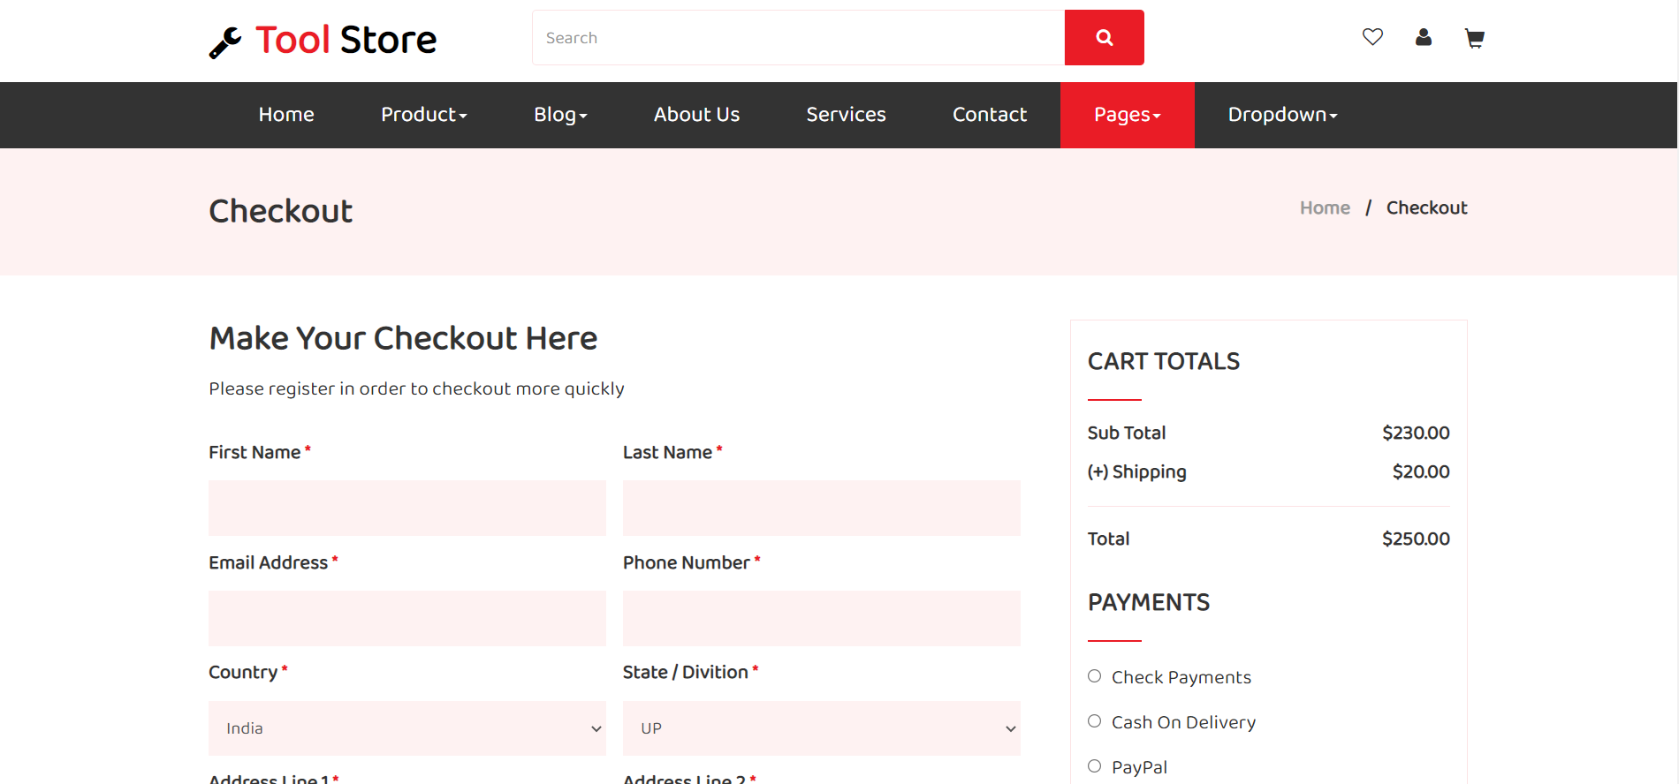

1. **Detail Page**

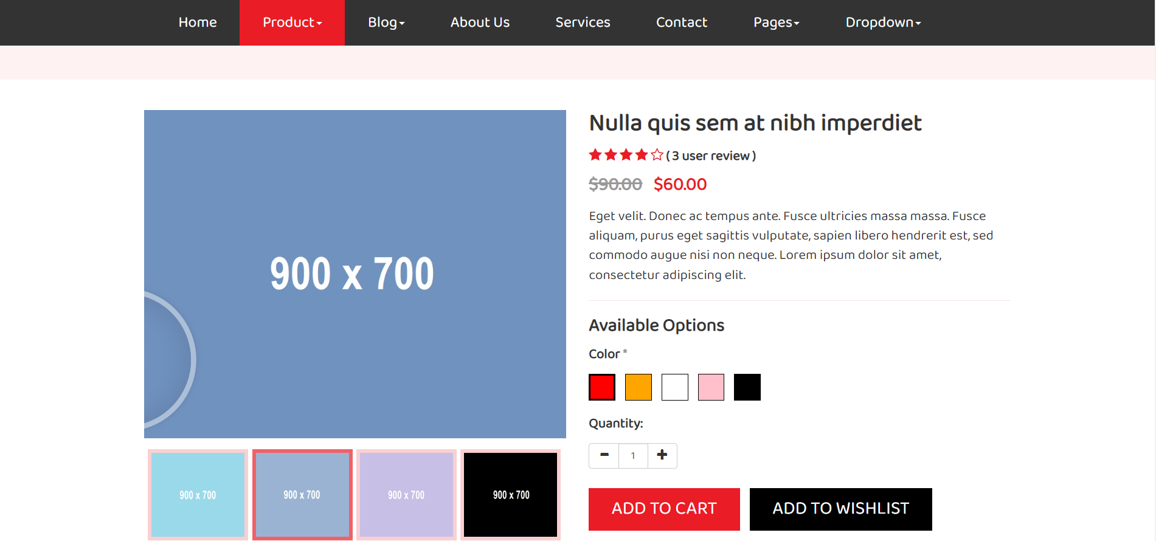

|  |  |  |  |  |  |  |  |
| --- | --- | --- | --- | --- | --- | --- | --- |
| **Project Ref. No.:**  **eP/Advertisement** **Portal Management** **System/01** | | **Project Title:** | **Activity Plan** **Prepared** **By:** | **Date of Preparation of Activity Plan:** | | | |
| **Sr.No.** | **Task** | **Actual Start** **Date** | **Actual** **Days** | **Team** **Mate** **Names** | **Status** |
| 1 | Home Page | Auto Ancilaries Limited | Thịnh | 05/01/2023 | 1 | Thái | Completed |
| 2 | Product Page | 05/01/2023 | 2 | Thái | Completed |
| 3 | Detail Page | 06/01/2023 | 2 | Thái | Completed |
| 4 | Comment Page | 06/01/2023 | 1 | Thái | Completed |
| 5 | Cart Page | 05/01/2023 | 2 | Thịnh | Completed |
| 6 | Checkout Page | 05/01/2023 | 2 | Thịnh | Completed |
| 7 | Login Page | 06/01/2023 | 3 | Thịnh | Completed |
| 8 | About Page | 06/01/2023 | 2 | Ân | Completed |
| 9 | Contact Page | 06/01/2023 | 2 | Ân | Completed |

# TASK SHEET REVIEW 3