Part 1- Overall Information
Proposal Form for Advantech AIoT InnoWorks
University Name | Thai Nguyen University of Information and Communication Technology (ICTU) | Department/Institute | Faculty of Information Technology
Professor Name  (Applicant/Host) | Dao Thi Hang
Email | Team contact: huynhpham13790@gmail.com · (+84) 359 260 290 — Pham Van Huynh, team lead
Overall Information and Resource Requirement for AIoT InnoWorks Program
Duration of AIoT InnoWorks  Please specify the timeline of skills developments, application development and final demo. The suggested overall duration is 4-6 months. | l Skills development: 2026/08/15 to 2026/09/10 (WISE-IoT Academy certificate, MQTT / WISE-PaaS protocol, TinyML)  l Application development: 2026/09/01 to 2026/11/20 (hardware, Edge AI, cloud integration, field validation)  l Semi-final: 2026/09/26 · Final Demo Day: 2026/11/27
How many number of students participate?  Please include:  1. Number of teams  2. Number of team members in each teams | 1. Number of teams: 01 (Team Hu Tieu)  2. Number of team members: 05 students
How many slots on WISE-IoT’s training websites are needed for participants? | 05 slots (one per team member)
The duration of WISE-IoT space open for application developments and final demo?  For example: 2026 Jun 1~2026 Dec 30 | 2026/09/01 ~ 2026/12/31

Part 2- Project Information (at least 05 projects)
Please fill in project information for each team. The form can be copied for use.
Advantech AIoT InnoWorks - Project Information: Team
Team Name | Hu Tieu | No. of Team Members | 05
Project Topic | Edge-AI Thermal Safety Monitor for Electric-Vehicle Battery Packs — per-cell anomaly detection on-device + remaining-useful-life prediction in the cloud | Adviser | Dao Thi Hang
Member background (department) | All five members: Faculty of Information Technology, ICTU.  Pham Van Huynh — team lead: planning, business model, presentation  Pham Minh Tu — AI/ML: Layer 1 anomaly model, training and evaluation  Dam Duc Don — AI/ML: Layer 2 battery-health model, datasets  Hoang Van Huy — embedded: ESP32-S3 firmware, sensors, local alarm  Nguyen Hoang Anh Tuan — cloud: MQTT/WISE-PaaS integration, dashboard, demo video
Project introduction  For example:  The target audience of the project, the issue want to be resolved and the expected benefits of the project | Target audience  Primary (B2B): electric two-wheeler fleet operators and battery-swap networks — delivery fleets, ride-hailing fleets, rental operators. In a swap model the operator owns the packs, so the party that loses money on a dead or burnt pack is the same party that can buy the device. Secondary: EV service garages and used-vehicle appraisers (handheld battery health report). Individual riders are the emotional story, not the business model.  The problem  A lithium battery pack does not fail all at once: one weak cell heats up first. Every BMS already has a hard 60 °C cut-off, but by the time any absolute limit is crossed, thermal runaway is self-sustaining and cannot be stopped. About 31 % of EV fires start while the vehicle is parked and about 25 % happen in underground car parks — exactly when a system that only wakes up while riding or charging would be asleep. Replacing an e-motorbike pack in Vietnam costs 1.5–12 million VND, and a fire in a fleet warehouse can destroy the whole warehouse.  What the project does  A low-cost module measures every cell individually (6 × DS18B20 probes + an INA228 current/voltage sensor on a 6-cell 18650 test pack) and runs an autoencoder directly on an ESP32-S3, once per second. The model does not look at absolute temperature; it looks at the relation between one cell and the rest of the pack — how far it deviates, its rank inside the pack, and whether it is heating faster than its neighbours. A fixed threshold can never see "cell #3 is 4 °C hotter than the others at only 35 °C"; this model can. A separate hard 60 °C rule runs in parallel, outside the AI, so that a wrong model can never silence the last line of defence.  Expected benefits  · Safety: the cell that is behaving differently is identified early, and the local alarm still works when the network is completely down.  · Maintenance: reporting battery health after each charge turns pack replacement from an emergency into a scheduled maintenance item, which also extends the useful life of the fleet.  · Low running cost: the device is built from inexpensive, widely available components, and in a swap model the packs return to a station every day, so the station Wi-Fi can serve as the uplink instead of a mobile data plan.  What we have tested so far  We have not tested on an electric-vehicle pack in service. Our work is research on a laboratory pack built from cells of the same type, together with public datasets recorded on real packs. So far we have verified that:  · the sensing chain and the data path work end to end on the bench — readings reach the dashboard live and are buffered while the device is offline;  · the four-level alarm logic behaves correctly in a full bench test, including when the AI output is disabled entirely;  · on public datasets, an injected single-cell fault is detected reliably, while normal operation produces essentially no false alarms over long runs;  · on an independent real pack that the model had never seen, the faulty runs separate clearly from the healthy ones.  Warming a cell on our own pack, and then measuring a pack on a vehicle in daily use, are the next two steps. We also state a known limit openly: because Layer 1 compares cells with each other, a pack that heats up uniformly produces no deviation — that case is handled by the hard 60 °C threshold, which we have not yet been able to test on hardware.
Please provide the functional/system diagram of the project and briefly describe how Edge AI / Edge Computing will be utilized in the project? | System / functional diagram — see the three figures below.  How Edge AI / Edge Computing is used  Layer 1 — Edge AI, on the device. A small autoencoder runs on the ESP32-S3 itself, once per second, and is small enough to sit in a fraction of the microcontroller's flash. Its inputs are purely relative: how far each cell sits from the rest of the pack, its rank among the cells, whether it is heating faster than its neighbours, and whether the deviation is a slow drift or a sudden jump. It raises an alarm only when the signal persists, so sensor noise alone cannot trigger it. A fixed 60 °C threshold runs in parallel, outside the AI, as an independent last line of defence.  Why the edge and not the cloud: sensing, inference, the local buzzer/LED alarm and logging all work with no network at all. The network is needed to tell someone far away — not to stay safe. While offline the module buffers its data in flash and back-fills the cloud, with timestamps generated by the device, as soon as a link returns.  Layer 2 — cloud. Battery health and remaining life are computed once per charge cycle from the shape of the charge curve, which changes measurably as cells age. The device sends only a short summary per charge and the cloud does the prediction, so the model can be improved without reflashing any vehicle.  An Edge AI design result worth highlighting  Our first model mixed absolute context inputs (ambient temperature, current, charge level) with the relative ones. On an independent real pack it alarmed on a healthy run almost all of the time — worse than on the faulty run. The cause turned out to be that those absolute inputs had shifted far outside the range the model was trained on and, because they are identical for every cell, they raised the error of all cells at once. Removing them and keeping only cell-to-cell relations reduced false alarms, improved detection, and made the model transfer to packs it had never seen. That is also what would make manufacturing practical: one identical model in every unit, instead of one calibration per pack.  WISE-PaaS integration status  The firmware already publishes the native WISE-PaaS SCADA format — topic /wisepaas/scada/{nodeId}/data with payload {"d":{…},"ts":…} — verified byte-for-byte against Advantech's own Edge SDK. While waiting for a WISE-IoT account we host the same underlying components ourselves (Mosquitto + Node-RED + InfluxDB + Grafana), so moving onto WISE-PaaS IoT Hub, Dashboard and AFS is a change of broker host and credentials, not a rewrite. Figures 2 and 3 show both states.
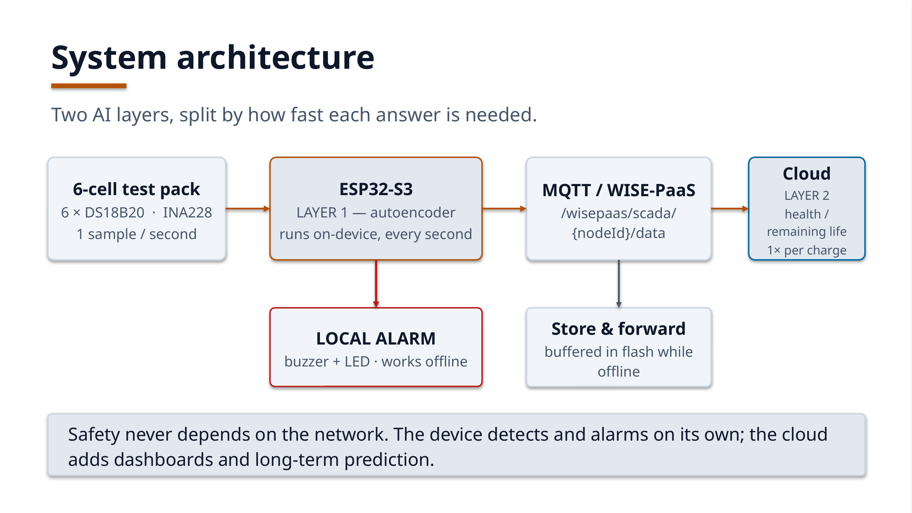
Figure 1 — Functional / system diagram: sensing → Edge AI on ESP32-S3 → MQTT (WISE-PaaS format) → cloud health prediction.
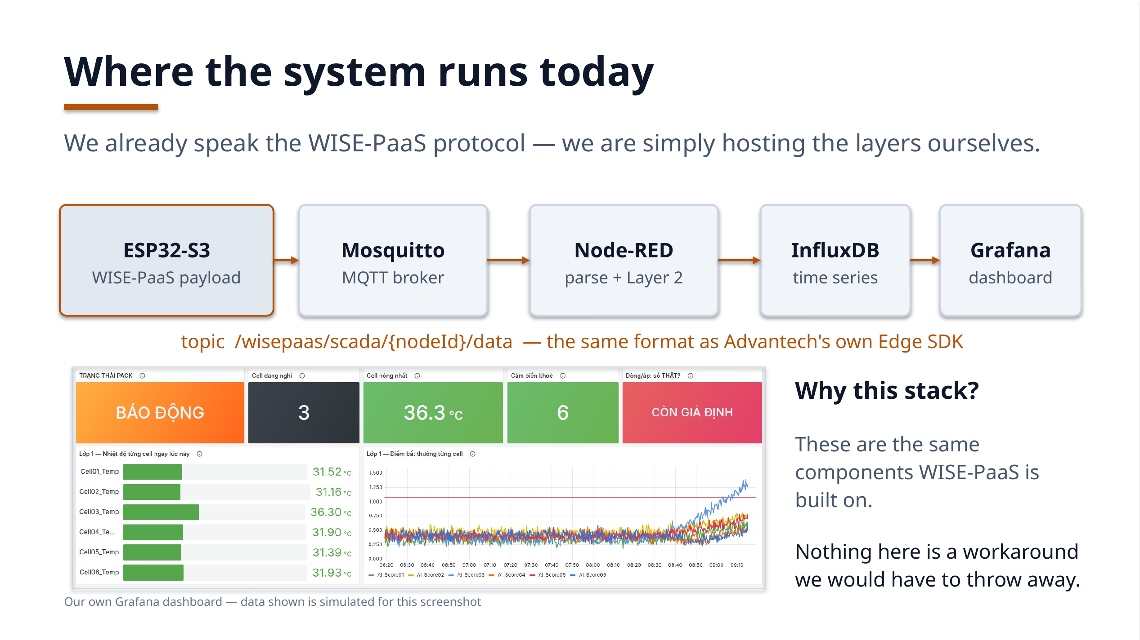
Figure 2 — Current deployment: the same WISE-PaaS payload into a self-hosted broker / time-series store / dashboard stack.
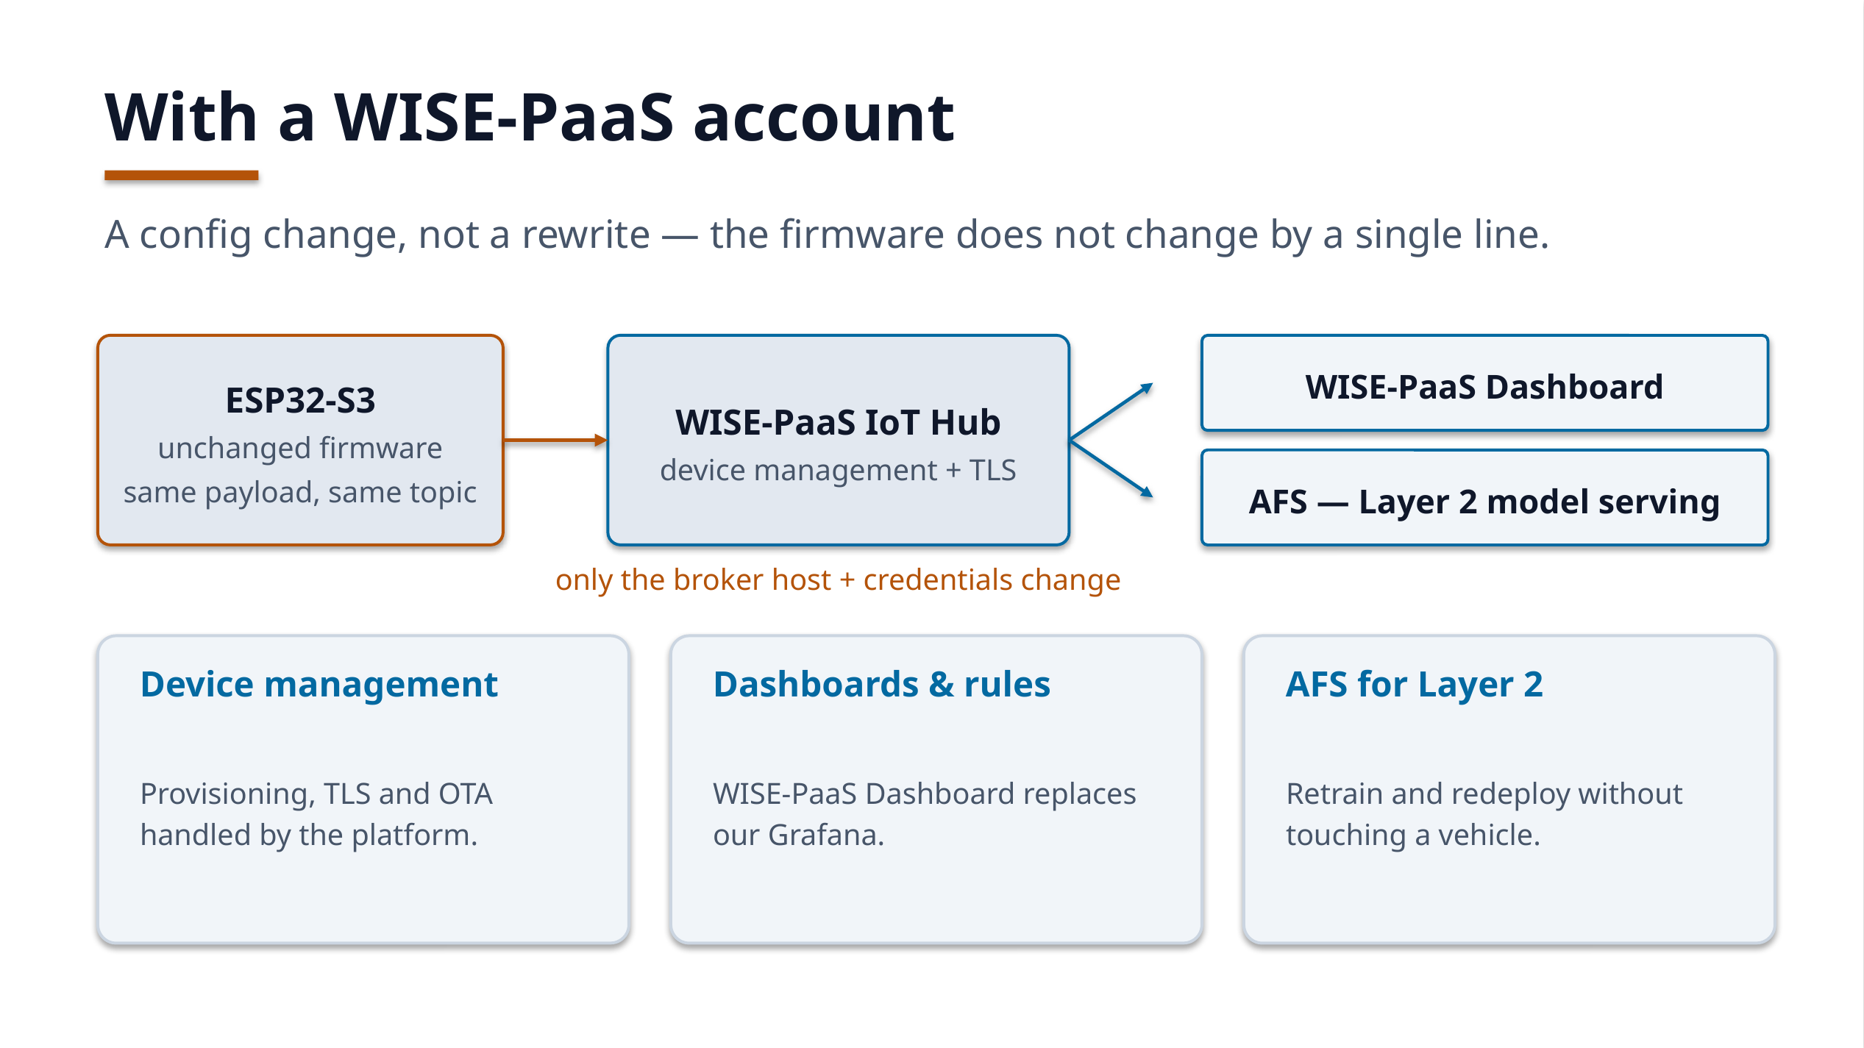
Figure 3 — Target deployment with a WISE-PaaS account: unchanged firmware, IoT Hub + Dashboard + AFS.
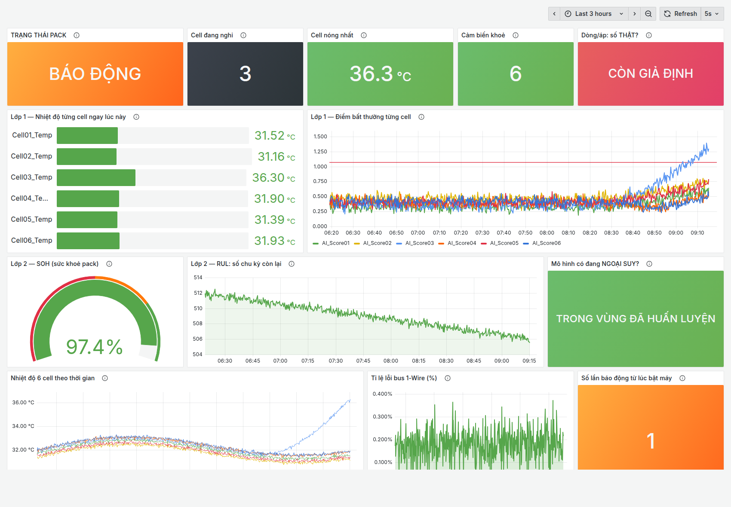
Figure 4 — Our monitoring dashboard: pack state, the suspect cell, per-cell temperatures and the Layer 1 anomaly score. The data in this screenshot is simulated to show the scenario of one cell heating up.

