**Table of Contents**

1. Overview 5

2. ADSP Base 9

2.1 Structure 10

2.1.1 xf_callback_func structure 10

2.1.2 xf_adsp_base_cmd structure 10

2.1.3 xf_handle structure 11

2.1.4 xf_adsp_base structure 11

2.1.5 xf_adsp_renderer_params structure 11

2.1.6 xf_adsp_renderer structure 12

2.1.7 xf_adsp_capture_params structure 12

2.1.8 xf_adsp_capture structure 12

2.1.9 xf_equalizer_parametric_coef structure 12

2.1.10 xf_equalizer_graphic_coef structure 13

2.1.11 xf_adsp_equalizer_params structure 13

2.1.12 xf_adsp_equalizer structure 13

2.1.13 xf_adsp_tdm_renderer_params structure 13

2.1.14 xf_adsp_tdm_renderer structure 14

2.1.15 xf_adsp_tdm_capture_params structure 14

2.1.16 xf_adsp_tdm_capture structure 14

2.2 Interface APIs 15

2.2.1 xf_adsp_base_create 15

2.2.2 xf_adsp_base_destroy 15

2.2.3 xf_adsp_empty_this_buffer 15

2.2.4 xf_adsp_fill_this_buffer 16

2.2.5 xf_adsp_allocate_mem_pool 16

2.2.6 xf_adsp_free_mem_pool 16

2.2.7 xf_adsp_get_data_from_pool 17

2.2.8 xf_adsp_set_param 17

2.2.9 xf_adsp_get_param 17

2.2.10 xf_adsp_route 18

2.2.11 xf_adsp_renderer_create 18

2.2.12 xf_adsp_renderer_destroy 19

2.2.13 xf_adsp_renderer_set_params 19

2.2.14 xf_adsp_renderer_get_params 19

2.2.15 xf_adsp_capture_create 20

2.2.16 xf_adsp_capture_destroy 20

2.2.17 xf_adsp_capture_set_params 21

2.2.18 xf_adsp_capture_get_params 21

2.2.19 xf_adsp_equalizer_create 22

2.2.20 xf_adsp_equalizer_destroy 22

2.2.21 xf_adsp_equalizer_set_params 23

2.2.22 xf_adsp_equalizer_get_params 23

2.2.23 xf_adsp_tdm_renderer_create 24

2.2.24 xf_adsp_tdm_renderer_destroy 24

2.2.25 xf_adsp_tdm_renderer_set_params 25

2.2.26 xf_adsp_tdm_renderer_get_params 25

2.2.27 xf_adsp_tdm_capture_create 26

2.2.28 xf_adsp_tdm_capture_destroy 26

2.2.29 xf_adsp_tdm_capture_set_params 27

2.2.30 xf_adsp_tdm_capture_get_params 27

3. Proxy Driver Interface - Extension APIs for ADSP Base 28

3.1 xf_adsp_base_client_register 28

3.2 xf_adsp_base_client_unregister 28

3.3 xf_adsp_base_send 28

3.4 xf_adsp_base_recv 29

3.5 xf_adsp_base_poll 29

4. Processing Flow 30

4.1 ADSP Base Flow 30

4.1.1 ADSP Base Creation 30

4.1.2 ADSP Base Destruction 31

4.2 Renderer Flow 32

4.2.1 Renderer Creation 32

4.2.2 Renderer Execution 33

4.2.3 Renderer Destruction 34

4.3 Capture Flow 35

4.3.1 Capture Creation 35

4.3.2 Capture Execution 36

4.3.3 Capture Destruction 37

4.4 Equalizer Flow 38

4.4.1 Equalizer Creation 38

4.4.2 Equalizer Execution 39

4.4.3 Equalizer Destruction 40

4.5 TDM Renderer Flow 41

4.5.1 TDM Renderer Creation 41

4.5.2 TDM Renderer Execution 42

4.5.3 TDM Renderer Destruction 43

4.6 TDM Capture Flow 44

4.6.1 TDM Capture Creation 44

4.6.2 TDM Capture Execution 45

4.6.3 TDM Capture Destruction 46

5. Appendix 47

5.1 Error Code 47

5.2 Structures 47

**List of Tables**

Table 1‑1 Development environment 5

Table 1‑2 Build environment 5

Table 2‑1 List of structure in ADSP base 9

Table 2‑2 List of APIs in ADSP base 10

Table 3‑1 List of extension APIs for proxy driver 27

Table 5‑1 Generic error code definition 46

Table 5‑2 External structure definition 46

**List of Figures**

Figure 1‑1 Overview configuration of ADSP driver 6

Figure 4‑1 ADSP base creation flow chart 29

Figure 4‑2 ADSP base destruction flow chart 30

Figure 4‑3 Renderer creation flow chart 31

Figure 4‑4 Renderer execution flow chart 32

Figure 4‑5 Renderer destruction flow chart 33

Figure 4‑6 Capture creation flow chart 34

Figure 4‑7 Capture execution flow chart 35

Figure 4‑8 Capture destruction flow chart 36

Figure 4‑9 Equalizer creation flow chart 37

Figure 4‑10 Equalizer execution flow chart 38

Figure 4‑11 Equalizer destruction flow chart 39

Figure 4‑12 TDM Renderer creation flow chart 40

Figure 4‑13 TDM Renderer execution flow chart 41

Figure 4‑14 TDM Renderer destruction flow chart 42

Figure 4‑15 TDM Capture creation flow chart 43

Figure 4‑16 TDM Capture execution flow chart 44

Figure 4‑17 TDM Capture destruction flow chart 45

# Overview

The below figure shows the basic configuration of ADSP driver and the connection with the ALSA framework when performs playback and record to ADSP device.

ALSA SoC core

Shared memory area

ADSP

Audio applications

*User side*

*Kernel side*

*Hardware* side

ALSA Lib

Renderer/Capture/ Equalizer/TDM Renderer/TDM Capture plugin

*PCM parameters*

*Extension parameters (volume, SRC, Equalizer)*

PCM interface

Control interface

*Kernel* side

ALSA framework supported by Linux

ALSA SoC core

Shared memory, ADSP hardware, codec

ADSP Driver Extension

PCM data

Communication

Platform driver, Machine driver, Codec driver

Audio application layer

***Legend:***

Plugins (Capture, Renderer, Equalizer, TDM Capture, TDM Renderer)

The target of this document is in side of red square.

ALSA Middleware Layer

Platform driver (rcar_adsp_sound)

ADSP ALSA

ADSP Driver Extension

CPU DAI

Codec driver

Codec DAI

Codec DAI

Codec DAI

ADSP ALSA

CPU DAI and Codec DAI

PCM Interface, Control Interface

Proxy Extension Interface

Proxy Extension Interface

ADSP Driver

Codec

ADSP Driver

Codec

Codec

CPU DAI

CPU DAI

Machine driver

Machine driver

Machine driver

Figure 1‑1 Overview configuration of ADSP driver

* **Audio applications (aplay, arecord, amixer, etc)**:

The user applications that support to play or record sound by using ALSA library.

* **ALSA Lib**:

The ALSA library APIs are the interface to the ALSA drivers.

* **ALSA Middle Layer**:

It is a set of libraries which APIs gives applications access to the sound card drivers. And it can be broken down into the major interfaces such as control interface, PCM interface, raw MIDI interface, timer interface, sequencer interface and mixer interface.

* **ALSA SoC core:**

It is part of ALSA Framework and does processing of PCM data

* **ADSP ALSA**:

It is an ALSA device driver, implements to register a sound card for ADSP device. It provides callback functions for the native supports from ALSA framework to perform both playback and record. For playback/TDM playback, it receives PCM data from user app and transfers to ADSP Renderer plugin/ADSP TDM Renderer plugin. For record, it receives PCM data from ADSP Capture plugin/ADSP TDM Capture plugin and transfers to user app. The equalization function can be integrated into playback and record by routing between Equalizer and Renderer plugin, and between Equalizer and Capture plugins.

* **CPU DAI**:

DAI stands for Digital Audio Interface. CPU DAI is the interface for the platform driver to communicate with other drivers.

* **Platform driver**:

This is used to register ADSP sound card into ASoC framework. It holds ADSP ALSA driver, ADSP Driver Extension and ADSP sound card.

* **Codec driver**:

It represents interface for codecs.

* **Codec DAI**:

The DAI for codecs to communicate with other drivers

* **Machine driver**:

The ASoC machine (or board) driver is the code that glues together the platform driver and codec driver.

* **Proxy Extension Interface**:

APIs of methods through which ADSP Driver Extension communicates with shared memory area in Hardware side.

* **Shared memory area**:

Shared memory is a memory area which can be read and written by both CPU and ADSP.

* **ADSP**:

It is an audio DSP hardware unit. It provides ADSP framework which has the capability to control and execute multiple plugins (Renderer/Capture/Equalizer/TDM Renderer/TDM Capture) for playback, record, TDM and equalization. The communication between ADSP side and CPU side is performed by the interrupt, and the shared memory area.

# ADSP Base

The below table shows list of structures in the ADSP base.

|  |  |  |
| --- | --- | --- |
| No. | Structures | Descriptions |
| 1 | struct xf_callback_func | The callback functions for ADSP ALSA driver |
| 2 | struct xf_callback_base_cmd | The callback functions for ADSP base |
| 3 | struct xf_handle | The registered handle’s data |
| 4 | struct xf_adsp_base | ADSP base’s processing data |
| 5 | struct xf_adsp_renderer_params | Renderer plugin’s parameters |
| 6 | struct xf_adsp_renderer | Renderer component’s data |
| 7 | struct xf_adsp_capture_params | Capture plugin’s parameters |
| 8 | struct xf_adsp_capture | Capture component’s data |
| 9 | struct xf_equalizer_parametric_coef | Parametric coefficients of Equalizer plugin |
| 10 | struct xf_equalizer_graphic_coef | Graphic coefficients of Equalizer plugin |
| 11 | struct xf_adsp_equalizer_params | Equalizer plugin’s parameters |
| 12 | struct xf_adsp_equalizer | Equalizer component’s data |
| 13 | struct xf_adsp_tdm_renderer_params | TDM Renderer plugin’s parameters |
| 14 | struct xf_adsp_tdm_renderer | TDM Renderer component’s data |
| 15 | struct xf_adsp_tdm_capture_params | TDM Capture plugin’s parameters |
| 16 | struct xf_adsp_tdm_capture | TDM Capture component’s data |

Table 2‑1 List of structure in ADSP base

The below table shows list of APIs in the ADSP base.

|  |  |  |
| --- | --- | --- |
| No. | APIs | Descriptions |
| 1 | xf_adsp_base_create | Create ADSP base control |
| 2 | xf_adsp_base_destroy | Destroy ADSP base control |
| 3 | xf_adsp_empty_this_buffer | Send data to ADSP plugin |
| 4 | xf_adsp_fill_this_buffer | Get data from ADSP plugin |
| 5 | xf_adsp_allocate_mem_pool | Allocate memory pool from ADSP |
| 6 | xf_adsp_free_mem_pool | Free memory pool to ADSP |
| 7 | xf_adsp_get_data_from_pool | Get data buffer from the given pool |
| 8 | xf_adsp_set_param | Set a single parameter to a registered plugin |
| 9 | xf_adsp_get_param | Get a single parameter to a registered plugin |
| 10 | xf_adsp_route | Route two registered plugins together |
| 11 | xf_adsp_renderer_create | Register Renderer component |
| 12 | xf_adsp_renderer_destroy | Unregister Renderer component |
| 13 | xf_adsp_renderer_set_params | Set parameters to Renderer plugin |
| 14 | xf_adsp_renderer_get_params | Get parameters from Renderer plugin |
| 15 | xf_adsp_capture_create | Register Capture component |
| 16 | xf_adsp_capture_destroy | Unregister Capture component |
| 17 | xf_adsp_capture_set_params | Set parameters to Capture plugin |
| 18 | xf_adsp_capture_get_params | Get parameters from Capture plugin |
| 19 | xf_adsp_equalizer_create | Register Equalizer component |
| 20 | xf_adsp_equalizer_destroy | Unregister Equalizer component |
| 21 | xf_adsp_equalizer_set_params | Set parameters to Equalizer plugin |
| 22 | xf_adsp_equalizer_get_params | Get parameters from Equalizer plugin |
| 23 | xf_adsp_tdm_renderer_create | Register TDM Renderer component |
| 24 | xf_adsp_tdm_renderer_destroy | Unregister TDM Renderer component |
| 25 | xf_adsp_tdm_renderer_set_params | Set parameters to TDM Renderer plugin |
| 26 | xf_adsp_tdm_renderer_get_params | Get parameters to TDM Renderer plugin |
| 27 | xf_adsp_tdm_capture_create | Register TDM Capture component |
| 28 | xf_adsp_tdm_capture_destroy | Unregister TDM Capture component |
| 29 | xf_adsp_tdm_capture_set_params | Set parameters to TDM Capture plugin |
| 30 | xf_adsp_tdm_capture_get_params | Get parameters to TDM Capture plugin |

Table 2‑2 List of APIs in ADSP base

## Structure

### xf_callback_func structure

|  |  |
| --- | --- |
| struct xf_callback_func | |
| int (*empty_buf_done)(void *data, int opcode, int length, char *buffer) | Callback function for response message of XF_EMPTY_THIS_BUFFER command |
| int (*fill_buf_done)(void *data, int opcode, int length, char *buffer) | Callback function for response message of XF_FILL_THIS_BUFFER command |
| int (*event_handler)(void *data) | Callback for event handler |

### xf_adsp_base_cmd structure

|  |  |
| --- | --- |
| struct xf_adsp_base_cmd | |
| int (*client_register)(void **private_data) | Callback function for registering a new client from proxy driver for ADSP base control |
| int (*client_unregister)(void *private_data) | Callback function for freeing the registered client to proxy driver |
| int (*recv)(void *private_data, void *buf) | Callback function for getting the message from client message queue |
| int (*send)(void *private_data, void *buf) | Callback function for sending command to from ADSP base for ADSP transfer process to proxy driver |
| int (*poll)(void *private_data, int *condition) | Callback function to sleep and wait until there is a response message available from the client message queue or the condition flag becomes true. |

### xf_handle structure

|  |  |
| --- | --- |
| struct xf_handle | |
| int comp_id | Component ID of handler that registered in ADSP |
| struct xf_callback_func *cb | Callback functions to ADSP ALSA driver |
| void *private_data | A data in ADSP ALSA driver that is used as a parameter in the callback functions |

### xf_adsp_base structure

|  |  |
| --- | --- |
| struct xf_adsp_base | |
| struct xf_adsp_base_cmd cmd | Struct of extension APIs for ADSP base |
| void *client | Client data which registered on proxy driver |
| struct xf_pool *aux_pool | Auxiliary pool data which registered to ADSP [*] |
| struct xf_handle *handle[256] | Handle data which registered by ADSP ALSA driver |
| struct task_struct *rsp_thread | Response thread of ADSP base [*] |
| wait_queue_head_t base_wait | Wait queue for the response messages [*] |
| struct xf_message base_msg | The message for stored the response message [*] |
| int base_flag | The flag for ADSP base waiting |
| int err_flag | The flag to indicate an error from plugins |
| int wait_flag | The flag for ADSP base polling waiting |
| spinlock_t lock | Spinlock data |

### xf_adsp_renderer_params structure

|  |  |
| --- | --- |
| struct xf_adsp_renderer_params | |
| int channel | PCM channels |
| int pcm_width | PCM width |
| int frame_size | Size of a frame in sample |
| int in_rate | Input sampling rate |
| int out_rate | Output sampling rate |
| int vol_rate | Volume rate |
| int dev1 | Index of first output device |
| int dev2 | Index of second output device |
| int dma1 | Index of first DMA channel |
| int dma2 | Index of second DMA channel |
| int out_channel | Output PCM channels |
| int mix_ctrl | Mix control flag |
| int state | Operation state control |

### xf_adsp_renderer structure

|  |  |
| --- | --- |
| struct xf_adsp_renderer | |
| struct xf_adsp_renderer_params params | Store the parameters of Renderer plugin |
| struct xf_pool *buf_pool | Buffer pool data that used for PCM transfer |
| int handle_id | Handle ID that Renderer has registered in ADSP base |

### xf_adsp_capture_params structure

|  |  |
| --- | --- |
| struct xf_adsp_capture_params | |
| int channel | PCM channels |
| int pcm_width | PCM width |
| int frame_size | Size of a frame in sample |
| int in_rate | Input sampling rate |
| int out_rate | Output sampling rate |
| int vol_rate | Volume rate |
| int dev1 | Index of first input device |
| int dev2 | Index of second input device |
| int dma1 | Index of first DMA channel |
| int dma2 | Index of second DMA channel |
| int state | Operation state control |

### xf_adsp_capture structure

|  |  |
| --- | --- |
| struct xf_adsp_capture | |
| struct xf_adsp_capture_params params | Store the parameters of Capture plugin |
| struct xf_pool *buf_pool | Buffer pool data that used for PCM transfer |
| int handle_id | Handle ID that Capture has registered in ADSP base |

### xf_equalizer_parametric_coef structure

|  |  |
| --- | --- |
| struct xf_equalizer_parametric_coef | |
| int type[9] | Parametric filter type |
| int fc[9] | Parametric filter center frequency |
| int gain[9] | Parametric filter gain |
| int band_width[9] | Parametric filter band width |
| int gain_base[9] | Parametric filter gain base |

### xf_equalizer_graphic_coef structure

|  |  |
| --- | --- |
| struct xf_equalizer_graphic_coef | |
| int gain_g[5] | Graphic filter gain |

* Note:

There are 9 filters for parametric equalizer type and 5 filters for graphic equalizer type.

### xf_adsp_equalizer_params structure

|  |  |
| --- | --- |
| struct xf_adsp_equalizer_params | |
| int channel | PCM channel |
| int pcm_width | PCM width |
| int rate | Sampling rate |
| int eqz_type | Equalizer type |
| struct xf_equalizer_parametric_coef p_coef | Parametric coefficients |
| struct xf_equalizer_graphic g_coef | Graphic coefficient |

### xf_adsp_equalizer structure

|  |  |
| --- | --- |
| struct xf_adsp_equalizer | |
| struct xf_adsp_equalizer_params params | Store the parameters of Equalizer plugin |
| struct xf_pool *buf_pool | Buffer pool data that used for PCM transfer |
| int handle_id | Handle ID that Equalizer has registered |

### xf_adsp_tdm_renderer_params structure

|  |  |
| --- | --- |
| struct xf_adsp_tdm_renderer_params | |
| int ch_mode | Channel mode |
| int pcm_width | PCM width |
| int frame_size | Size of a frame in sample |
| int in_rate | Input sampling rate |
| int out_rate | Output sampling rate |
| int vol_rate | Volume rate |
| int dev1 | Index of first output device |
| int dev2 | Index of second output device |
| int dma1 | Index of first DMA channel |
| int dma2 | Index of second DMA channel |

### xf_adsp_tdm_renderer structure

|  |  |
| --- | --- |
| struct xf_adsp_tdm_renderer | |
| struct xf_adsp_tdm_renderer_params params | Store the parameters of TDM Renderer plugin |
| struct xf_pool *buf_pool | Buffer pool data that used for PCM transfer |
| int handle_id | Handle ID that TDM Renderer has registered in ADSP base |

### xf_adsp_tdm_capture_params structure

|  |  |
| --- | --- |
| struct xf_adsp_tdm_capture_params | |
| int ch_mode | Channel mode |
| int pcm_width | PCM width |
| int frame_size | Size of a frame in sample |
| int in_rate | Input sampling rate |
| int out_rate | Output sampling rate |
| int vol_rate | Volume rate |
| int dev1 | Index of first input device |
| int dev2 | Index of second input device |
| int dma1 | Index of first DMA channel |
| int dma2 | Index of second DMA channel |

### xf_adsp_tdm_capture structure

|  |  |
| --- | --- |
| struct xf_adsp_tdm_capture | |
| struct xf_adsp_tdm_capture_params params | Store the parameters of TDM Capture plugin |
| struct xf_pool *buf_pool | Buffer pool data that used for PCM transfer |
| int handle_id | Handle ID that TDM Capture has registered in ADSP base |

## Interface APIs

### xf_adsp_base_create

FD_DRV_CMN_001

|  |  |  |
| --- | --- | --- |
| xf_adsp_base_create | | |
| Synopsis | This API creates and initializes ADSP base data that ADSP ALSA driver can use to control ADSP plugins (Renderer/Capture/Equalizer/TDM Capture/TDM Renderer). | |
| Syntax | int xf_adsp_base_create(struct xf_adsp_base_cmd *cmd) | |
| Parameter | struct xf_adsp_base_cmd *cmd | Pointer to struct of commands for extension interface |
| Return value | 0 | ADSP base registers successful. |
| -EINVAL | ADSP base has been alive.  Parameter cmd is invalid. |
| -ENOMEM | Cannot allocate memory for ADSP base usage. |
| -EBUSY | ADSP base cannot register to proxy driver due to number of client has been exceeded. |

[Covers: RD_002, RD_003, RD_004, RD_005]

### xf_adsp_base_destroy

FD_DRV_CMN_002

|  |  |  |
| --- | --- | --- |
| xf_adsp_base_destroy | | |
| Synopsis | This API frees all resources that ADSP base has registered. | |
| Syntax | int xf_adsp_base_destroy (void) | |
| Parameter | - | - |
| Return value | 0 | ADSP base destroy successful. |
| -EINVAL | ADSP base has not been registered yet. |

[Covers: RD_002, RD_003, RD_004, RD_005]

### xf_adsp_empty_this_buffer

FD_DRV_CMN_003

|  |  |  |
| --- | --- | --- |
| xf_adsp_empty_this_buffer | | |
| Synopsis | This API sends a XF_EMPTY_THIS_BUFFER command to ADSP framework. | |
| Syntax | int xf_adsp_empty_this_buffer(int handle_id, char *buffer, int length) | |
| Parameter | int handle_id | Handle ID that registered in ADSP base |
| char *buffer | Pointer to PCM buffer |
| int length | Size of buffer in byte |
| Return value | 0 | Success |
| -EINVAL | ADSP base has not registered yet, or the handle ID has not registered to ADSP base yet. |

[Covers: RD_002, RD_003, RD_004, RD_005]

### xf_adsp_fill_this_buffer

FD_DRV_CMN_004

|  |  |  |
| --- | --- | --- |
| xf_adsp_fill_this_buffer | | |
| Synopsis | This API sends a XF_FILL_THIS_BUFFER command to ADSP framework. | |
| Syntax | int xf_adsp_fill_this_buffer(int handle_id, char *buffer, int length) | |
| Parameter | int handle_id | Handle ID that registered in ADSP base |
| char *buffer | Pointer to PCM buffer |
| int length | Size of buffer in byte |
| Return value | 0 | Success |
| -EINVAL | ADSP base has not registered yet, or the handle ID has not registered to ADSP base yet. |

[Covers: RD_002, RD_003, RD_004, RD_005]

### xf_adsp_allocate_mem_pool

FD_DRV_CMN_005

|  |  |  |
| --- | --- | --- |
| xf_adsp_allocate_mem_pool | | |
| Synopsis | This API sends a XF_ALLOC to ADSP to request a memory pool with desired pool size and buffer length. | |
| Syntax | struct xf_pool *xf_adsp_allocate_mem_pool(int pool_size, int buf_length) | |
| Parameter | int pool_size | Number of buffer need to allocate from ADSP |
| int buf_length | Size of buffer need to allocate from ADSP |
| Return value | Pointer | Pointer to registered memory pool |
| -EINVAL | ADSP base has not registered yet. |
| -ENOMEM | Cannot allocate memory for pool |

[Covers: RD_002, RD_003, RD_004, RD_005]

### xf_adsp_free_mem_pool

FD_DRV_CMN_006

|  |  |  |
| --- | --- | --- |
| xf_adsp_free_mem_pool | | |
| Synopsis | This API frees memory pool and sends a XF_FREE to ADSP to return the previous registered buffers. | |
| Syntax | int xf_adsp_free_mem_pool(struct xf_pool *pool) | |
| Parameter | struct xf_pool *pool | Pointer to allocated memory pool |
| Return value | 0 | Pool has been free successfully. |
| -EINVAL | ADSP base has not registered yet, or memory pool is invalid. |

[Covers: RD_002, RD_003, RD_004, RD_005]

### xf_adsp_get_data_from_pool

FD_DRV_CMN_007

|  |  |  |
| --- | --- | --- |
| xf_adsp_get_data_from_pool | | |
| Synopsis | This API gets a data buffer from pool, which registered before. | |
| Syntax | char *xf_adsp_get_data_from_pool(struct xf_pool *pool, int index) | |
| Parameter | struct xf_pool *pool | Pointer to allocated memory pool |
| int index | The index of buffer in pool |
| Return value | Pointer | Buffer address of pool |
| -EINVAL | Memory pool is invalid or, the index is over than number of buffer in pool. |

[Covers: RD_002, RD_003, RD_004, RD_005]

### xf_adsp_set_param

FD_DRV_CMN_008

|  |  |  |
| --- | --- | --- |
| xf_adsp_set_param | | |
| Synopsis | This API sets a single parameter to a registered plugin. | |
| Syntax | int xf_adsp_set_param(int handle_id, int index, int value) | |
| Parameter | int handle_id | Handle ID that registered in ADSP base |
| int index | The sub-command index of the setting value |
| int value | The setting value |
| Return value | 0 | Success |
| -EINVAL | ADSP base has not registered yet, or the handle ID has not registered to ADSP base yet, or the setting command makes a fatal error from ADSP plugin. |

[Covers: RD_002, RD_003, RD_004, RD_005]

### xf_adsp_get_param

FD_DRV_CMN_009

|  |  |  |
| --- | --- | --- |
| xf_adsp_get_param | | |
| Synopsis | This API gets a single parameter to a registered plugin. | |
| Syntax | int xf_adsp_get_param(int handle_id, int index, int *value) | |
| Parameter | int handle_id | Handle ID that registered in ADSP base |
| int index | The sub-command index of the getting value |
| int *value | Pointer of the stored getting value |
| Return value | 0 | Success |
| -EINVAL | ADSP base has not registered yet, or the handle ID has not registered to ADSP base yet, or the pointer of value is invalid, or the getting command makes a fatal error from ADSP plugin. |

[Covers: RD_002, RD_003, RD_004, RD_005]

### xf_adsp_route

FD_DRV_CMN_010

|  |  |  |
| --- | --- | --- |
| xf_adsp_route | | |
| Synopsis | This API sends a XF_ROUTE command to ADSP framework to register a tunnel for transfer data between two ADSP plugins. | |
| Syntax | int xf_adsp_route(int src_handle_id, int dst_handle_id, int buf_cnt, int buf_size) | |
| Parameter | int src_handle_id | Handle ID of source component |
| int dst_handle_id | Handle ID of destination component |
| int buf_cnt | Number of buffer that used for tunnel |
| int buf_size | Size of a buffer that used for tunnel |
| Return value | 0 | Success |
| -EINVAL | ADSP base has not registered yet, or the src/dst handle ID have not registered to ADSP base yet, or the tunnel request cannot complete from ADSP. |

[Covers: RD_002, RD_003, RD_004, RD_005]

### xf_adsp_renderer_create

FD_DRV_CMN_011

|  |  |  |
| --- | --- | --- |
| xf_adsp_renderer_create | | |
| Synopsis | This API initializes a Renderer instance, registers ADSP Renderer plugin. After Renderer has registered successful, the API registers a handler to ADSP base, and get a handle ID which represents for a new handler which has been registered completely. Finally, it initializes all parameters as default values with default values of ADSP Renderer plugin. | |
| Syntax | int xf_adsp_renderer_create(  struct xf_adsp_renderer **renderer, struct xf_callback_func *cb,  void *private_data) | |
| Parameter | struct xf_adsp_renderer **renderer | The pointer to store the created Renderer instance |
| struct xf_callback_func *cb | Pointer to the callback functions |
| void *private_data | Pointer to a private data that used as a parameter in callback functions |
| Return value | 0 | Success |
| -EINVAL | ADSP base has not registered yet, or cannot register new handler to ADSP base, or cannot register Renderer plugin to ADSP, or cannot get default value from ADSP Renderer plugin. |
| -ENOMEM | Cannot allocate Renderer instance |

[Covers: RD_002]

### xf_adsp_renderer_destroy

FD_DRV_CMN_012

|  |  |  |
| --- | --- | --- |
| xf_adsp_renderer_destroy | | |
| Synopsis | This API unregisters ADSP Renderer plugin, frees registered handler and instance. | |
| Syntax | int xf_adsp_renderer_destroy(struct xf_adsp_renderer *renderer) | |
| Parameter | struct xf_adsp_renderer *renderer | Pointer to Renderer instance |
| Return value | 0 | Success |
| -EINVAL | ADSP base has not registered yet, or Renderer instance is invalid. |

[Covers: RD_002]

### xf_adsp_renderer_set_params

FD_DRV_CMN_013

|  |  |  |
| --- | --- | --- |
| xf_adsp_renderer_set_params | | |
| Synopsis | This API sets all parameters for ADSP Renderer plugin based on the values in params structure of Renderer instance. | |
| Syntax | int xf_adsp_renderer_set_params(struct xf_adsp_renderer *renderer) | |
| Parameter | struct xf_adsp_renderer *renderer | Pointer to Renderer instance |
| Return value | 0 | Success |
| -EINVAL | ADSP base has not registered yet, or Renderer instance is invalid, or Renderer instance has not register to ADSP base yet, or the setting command make a fatal error from ADSP Renderer plugin. |

[Covers: RD_002]

### xf_adsp_renderer_get_params

FD_DRV_CMN_014

|  |  |  |
| --- | --- | --- |
| xf_adsp_renderer_get_params | | |
| Synopsis | This API gets all ADSP Renderer’s parameters and stores the returned values in params structure of Renderer instance. | |
| Syntax | int xf_adsp_renderer_get_params(struct xf_adsp_renderer *renderer) | |
| Parameter | struct xf_adsp_renderer *renderer | Pointer to Renderer instance |
| Return value | 0 | Success |
| -EINVAL | ADSP base has not registered yet, or Renderer instance is invalid, or Renderer instance has not register to ADSP base yet, or the getting command make a fatal error from ADSP Renderer plugin. |

[Covers: RD_002]

### xf_adsp_capture_create

FD_DRV_CMN_015

|  |  |  |
| --- | --- | --- |
| xf_adsp_capture_create | | |
| Synopsis | This API initializes a Capture instance, registers ADSP Capture plugin. After Capture has registered successful, the API registers a handler to ADSP base, and get a handle ID which represents for a new handler which has been registered completely. Finally, it initializes all parameters as default values with default values of ADSP Capture plugin. | |
| Syntax | int xf_adsp_capture_create(  struct xf_adsp_capture **capture, struct xf_callback_func *cb,  void *private_data) | |
| Parameter | struct xf_adsp_capture **capture | The pointer to store the created Capture instance |
| struct xf_callback_func *cb | Pointer to the callback functions |
| void *private_data | Pointer to a private data that used as a parameter in callback functions |
| Return value | 0 | Success |
| -EINVAL | ADSP base has not registered yet or cannot register new handler to ADSP base, or cannot register Capture plugin to ADSP, or cannot get default values from ADSP Capture plugin. |
| -ENOMEM | Cannot allocate Capture instance |

[Covers: RD_003]

### xf_adsp_capture_destroy

FD_DRV_CMN_016

|  |  |  |
| --- | --- | --- |
| xf_adsp_capture_destroy | | |
| Synopsis | This API unregisters ADSP Capture plugin, frees registered handler and instance. | |
| Syntax | int xf_adsp_capture_destroy(struct xf_adsp_capture *capture) | |
| Parameter | struct xf_adsp_capture *capture | Pointer to Capture instance |
| Return value | 0 | Success |
| -EINVAL | ADSP base has not registered yet, or Capture instance is invalid. |

[Covers: RD_003]

### xf_adsp_capture_set_params

FD_DRV_CMN_017

|  |  |  |
| --- | --- | --- |
| xf_adsp_capture_set_params | | |
| Synopsis | This API sets all parameters for ADSP Capture plugin based on the values in params structure of Capture instance. | |
| Syntax | int xf_adsp_capture_set_params(struct xf_adsp_capture *capture) | |
| Parameter | struct xf_adsp_capture *capture | Pointer to Capture instance |
| Return value | 0 | Success |
| -EINVAL | ADSP base has not registered yet, or Capture instance is invalid, or Capture instance has not register to ADSP base yet, or the setting command make a fatal error from ADSP Capture plugin. |

[Covers: RD_003]

### xf_adsp_capture_get_params

FD_DRV_CMN_018

|  |  |  |
| --- | --- | --- |
| xf_adsp_capture_get_params | | |
| Synopsis | This API gets all ADSP Capture’s parameters and stores the returned values in params structure of Capture instance. | |
| Syntax | int xf_adsp_capture_get_params(struct xf_adsp_capture *capture) | |
| Parameter | struct xf_adsp_capture *capture | Pointer to Capture instance |
| Return value | 0 | Success |
| -EINVAL | ADSP base has not registered yet, or Capture instance is invalid, or Capture instance has not register to ADSP base yet, or the getting command make a fatal error from ADSP Capture plugin. |

[Covers: RD_003]

### xf_adsp_equalizer_create

FD_DRV_CMN_019

|  |  |  |
| --- | --- | --- |
| xf_adsp_equalizer_create | | |
| Synopsis | This API initializes an Equalizer instance, registers ADSP Equalizer plugin. After Equalizer has registered successful, the API registers a handler to ADSP base, and get a handle ID which represents for a new handler which has been registered completely. Finally, it initializes all parameters as default values with defaul values of ADSP Equalizer plugin. | |
| Syntax | int xf_adsp_equalizer_create(  struct xf_adsp_equalizer **equalizer, struct xf_callback_func *cb,  void *private_data) | |
| Parameter | struct xf_adsp_equalizer **equalizer | The pointer to store the created Equalizer instance |
| struct xf_callback_func *cb | Pointer to the callback functions |
| void *private_data | Pointer to a private data that used as a parameter in callback functions |
| Return value | 0 | Success |
| -EINVAL | ADSP base has not registered yet or cannot register new handler to ADSP base, or cannot register Equalizer plugin to ADSP, or cannot get default values from ADSP Equalizer plugin. |
| -ENOMEM | Cannot allocate Equalizer instance |

[Covers: RD_005]

### xf_adsp_equalizer_destroy

FD_DRV_CMN_020

|  |  |  |
| --- | --- | --- |
| xf_adsp_equalizer_destroy | | |
| Synopsis | This API unregisters ADSP Equalizer plugin, frees registered handler and instance. | |
| Syntax | int xf_adsp_equalizer_destroy(struct xf_adsp_equalizer *equalizer) | |
| Parameter | struct xf_adsp_equalizer *equalizer | Pointer to Equalizer instance |
| Return value | 0 | Success |
| -EINVAL | ADSP base has not registered yet, or Equalizer instance is invalid. |

[Covers: RD_005]

### xf_adsp_equalizer_set_params

FD_DRV_CMN_021

|  |  |  |
| --- | --- | --- |
| xf_adsp_equalizer_set_params | | |
| Synopsis | This API sets all parameters for ADSP Equalizer plugin based on the values in params structure of Equalizer instance. | |
| Syntax | int xf_adsp_equalizer_set_params(struct xf_adsp_equalizer *equalizer) | |
| Parameter | struct xf_adsp_equalizer *equalizer | Pointer to Equalizer instance |
| Return value | 0 | Success |
| -EINVAL | ADSP base has not registered yet, or Equalizer instance is invalid, or Equalizer instance has not register to ADSP base yet, or the setting command makes a fatal error from ADSP Equalizer plugin. |

[Covers: RD_005]

### xf_adsp_equalizer_get_params

FD_DRV_CMN_022

|  |  |  |
| --- | --- | --- |
| xf_adsp_equalizer_get_params | | |
| Synopsis | This API gets all ADSP Equalizer’s parameters and stores the returned values in params structure of Equalizer instance. | |
| Syntax | int xf_adsp_equalizer_get_params(struct xf_adsp_equalizer *equalizer) | |
| Parameter | struct xf_adsp_equalizer *equalizer | Pointer to Equalizer instance |
| Return value | 0 | Success |
| -EINVAL | ADSP base has not registered yet, or Equalizer instance is invalid, or Equalizer instance has not register to ADSP base yet, or the getting command makes a fatal error from ADSP Equalizer plugin. |

[Covers: RD_005]

### xf_adsp_tdm_renderer_create

FD_DRV_CMN_023

|  |  |  |
| --- | --- | --- |
| xf_adsp_tdm_renderer_create | | |
| Synopsis | This API initializes a TDM Renderer instance, registers ADSP TDM Renderer plugin. After TDM Renderer has been registered successfully, the API registers a handler to ADSP base, and gets a handle ID which represents for a new handler which has been registered completely. Finally, it initializes all parameters as default values with default values of TDM Renderer plugin. | |
| Syntax | int xf_adsp_tdm_renderer_create(  struct xf_adsp_tdm_renderer **tdm_renderer, struct xf_callback_func *cb,  void *private_data) | |
| Parameter | struct xf_adsp_tdm_renderer **tdm_renderer | The pointer to store the created TDM Renderer instance |
| struct xf_callback_func *cb | Pointer to the callback functions |
| void *private_data | Pointer to a private data that used as a parameter in callback functions |
| Return value | 0 | Success |
| -EINVAL | ADSP base has not registered yet, or cannot register new handler to ADSP base, or cannot register TDM Renderer plugin to ADSP, or cannot get default values from ADSP TDM Renderer plugin. |
| -ENOMEM | Cannot allocate TDM Renderer instance |

[Covers: RD_004]

### xf_adsp_tdm_renderer_destroy

FD_DRV_CMN_024

|  |  |  |
| --- | --- | --- |
| xf_adsp_tdm_renderer_destroy | | |
| Synopsis | This API unregisters ADSP TDM Renderer plugin, frees registered handler and instance. | |
| Syntax | int xf_adsp_tdm_renderer_destroy(  struct xf_adsp_tdm_renderer *tdm_renderer) | |
| Parameter | struct xf_adsp_tdm_renderer *tdm_renderer | Pointer to TDM Renderer instance |
| Return value | 0 | Success |
| -EINVAL | ADSP base has not registered yet, or TDM Renderer instance is invalid. |

[Covers: RD_004]

### xf_adsp_tdm_renderer_set_params

FD_DRV_CMN_025

|  |  |  |
| --- | --- | --- |
| xf_adsp_tdm_renderer_set_params | | |
| Synopsis | This API sets all parameters for ADSP TDM Renderer plugin based on the values in params structure of TDM Renderer instance. | |
| Syntax | int xf_adsp_tdm_renderer_set_params(struct xf_adsp_tdm_renderer *tdm_renderer) | |
| Parameter | struct xf_adsp_tdm_renderer *tdm_renderer | Pointer to TDM Renderer instance |
| Return value | 0 | Success |
| -EINVAL | ADSP base has not registered yet, or TDM Renderer instance is invalid, or TDM Renderer instance has not register to ADSP base yet, or the setting command make a fatal error from ADSP TDM Renderer plugin. |

[Covers: RD_004]

### xf_adsp_tdm_renderer_get_params

FD_DRV_CMN_026

|  |  |  |
| --- | --- | --- |
| xf_adsp_tdm_renderer_get_params | | |
| Synopsis | This API gets all ADSP TDM Renderer’s parameters and stores the returned values in params structure of TDM Renderer instance. | |
| Syntax | int xf_adsp_tdm_renderer_get_params(struct xf_adsp_tdm_renderer *tdm_renderer) | |
| Parameter | struct xf_adsp_tdm_renderer *tdm_renderer | Pointer to TDM Renderer instance |
| Return value | 0 | Success |
| -EINVAL | ADSP base has not registered yet, or TDM Renderer instance is invalid, or TDM Renderer instance has not register to ADSP base yet, or the getting command make a fatal error from ADSP TDM Renderer plugin. |

[Covers: RD_004]

### xf_adsp_tdm_capture_create

FD_DRV_CMN_027

|  |  |  |
| --- | --- | --- |
| xf_adsp_tdm_capture_create | | |
| Synopsis | This API initializes a TDM Capture instance, registers ADSP TDM Capture plugin. After TDM Capture has been registered successfully, the API registers a handler to ADSP base, and get a handle ID which represents for a new handler has been registered completely. Finally, it initializes all parameters as default values with default values of the plugin. | |
| Syntax | int xf_adsp_tdm_capture_create(  struct xf_adsp_tdm_capture **tdm_capture, struct xf_callback_func *cb,  void *private_data) | |
| Parameter | struct xf_adsp_tdm_capture **tdm_capture | The pointer to store the created TDM Capture instance |
| struct xf_callback_func *cb | Pointer to the callback functions |
| void *private_data | Pointer to a private data that used as a parameter in callback functions |
| Return value | 0 | Success |
| -EINVAL | ADSP base has not registered yet or cannot register new handler to ADSP base, or cannot register TDM Capture plugin to ADSP, or cannot get default values from ADSP TDM Capture plugin. |
| -ENOMEM | Cannot allocate TDM Capture instance |

[Covers: RD_004]

### xf_adsp_tdm_capture_destroy

FD_DRV_CMN_028

|  |  |  |
| --- | --- | --- |
| xf_adsp_tdm_capture_destroy | | |
| Synopsis | This API unregisters ADSP TDM Capture plugin, frees registered handler and instance. | |
| Syntax | int xf_adsp_tdm_capture_destroy(struct xf_adsp_tdm_capture *tdm_capture) | |
| Parameter | struct xf_adsp_tdm_capture *tdm_capture | Pointer to TDM Capture instance |
| Return value | 0 | Success |
| -EINVAL | ADSP base has not registered yet, or TDM Capture instance is invalid. |

[Covers: RD_004]

### xf_adsp_tdm_capture_set_params

FD_DRV_CMN_029

|  |  |  |
| --- | --- | --- |
| xf_adsp_tdm_capture_set_params | | |
| Synopsis | This API sets all parameters for ADSP TDM Capture plugin based on the values in params structure of TDM Capture instance. | |
| Syntax | int xf_adsp_tdm_capture_set_params(struct xf_adsp_tdm_capture *tdm_capture) | |
| Parameter | struct xf_adsp_tdm_capture *tdm_capture | Pointer to TDM Capture instance |
| Return value | 0 | Success |
| -EINVAL | ADSP base has not registered yet, or TDM Capture instance is invalid, or TDM Capture instance has not register to ADSP base yet, or the setting command make a fatal error from ADSP TDM Capture plugin. |

[Covers: RD_004]

### xf_adsp_tdm_capture_get_params

FD_DRV_CMN_030

|  |  |  |
| --- | --- | --- |
| xf_adsp_tdm_capture_get_params | | |
| Synopsis | This API gets all ADSP TDM Capture’s parameters and stores the returned values in params structure of TDM Capture instance. | |
| Syntax | int xf_adsp_tdm_capture_get_params(struct xf_adsp_tdm_capture *tdm_capture) | |
| Parameter | struct xf_adsp_tdm_capture *tdm_capture | Pointer to TDM Capture instance |
| Return value | 0 | Success |
| -EINVAL | ADSP base has not registered yet, or TDM Capture instance is invalid, or TDM Capture instance has not register to ADSP base yet, or the getting command make a fatal error from ADSP TDM Capture plugin. |

[Covers: RD_004]

# Proxy Driver Interface - Extension APIs for ADSP Base

The below table shows list of extension APIs for proxy driver.

|  |  |  |
| --- | --- | --- |
| No. | APIs | Descriptions |
| 1 | xf_adsp_base_client_register | Register a proxy client for ADSP base |
| 2 | xf_adsp_base_client_unregister | Unregister the given client of ADSP base |
| 3 | xf_adsp_base_send | Send a command message to proxy driver |
| 4 | xf_adsp_base_recv | Receive a response message from proxy driver |
| 5 | xf_adsp_base_poll | Wait for the response message from proxy driver |

Table 3‑1 List of extension APIs for proxy driver

## xf_adsp_base_client_register

FD_DRV_CMN_031

|  |  |  |
| --- | --- | --- |
| xf_adsp_base_client_register | | |
| Synopsis | This API registers a new client from proxy driver for ADSP base control. | |
| Syntax | int xf_adsp_base_client_register(void **private_data) | |
| Parameter | void **private_data | The pointer to store the registered proxy client. |
| Return value | 0 | Success |
| -ENOMEM | Cannot allocate memory for client |
| -EBUSY | Number of client in proxy has exceeded. |

[Covers: RD_002, RD_003, RD_004, RD_005]

## xf_adsp_base_client_unregister

FD_DRV_CMN_032

|  |  |  |
| --- | --- | --- |
| xf_adsp_base_client_unregister | | |
| Synopsis | This API frees the registered client to proxy driver. | |
| Syntax | int xf_adsp_base_client_unregister(void *private_data) | |
| Parameter | void *private_data | Pointer to registered client of ADSP base |
| Return value | 0 | Success |
| -EINVAL | Client data is invalid. |

[Covers: RD_002, RD_003, RD_004, RD_005]

## xf_adsp_base_send

FD_DRV_CMN_033

|  |  |  |
| --- | --- | --- |
| xf_adsp_base_send | | |
| Synopsis | This API sends a command message from ADSP base for ADSP transfer process to proxy driver. | |
| Syntax | int xf_adsp_base_send(void *private_data, void *buf) | |
| Parameter | void *private_data | Pointer to registered client of ADSP base |
| void *buf | Pointer to command message data |
| Return value | 0 | Success |
| -EINVAL | Client data is invalid, or it has not registered to proxy driver yet, or cannot send message to proxy |

[Covers: RD_002, RD_003, RD_004, RD_005]

## xf_adsp_base_recv

FD_DRV_CMN_034

|  |  |  |
| --- | --- | --- |
| xf_adsp_base_recv | | |
| Synopsis | This API gets the message from client message queue | |
| Syntax | int xf_adsp_base_recv (void *private_data, void *buf) | |
| Parameter | void *private_data | Pointer to registered client of ADSP base |
| void *buf | Pointer to the stored message data |
| Return value | 0 | Success |
| -EINVAL | Client data is invalid, or it has not registered to proxy driver yet, or the response message is invalid. |

[Covers: RD_002, RD_003, RD_004, RD_005]

## xf_adsp_base_poll

FD_DRV_CMN_035

|  |  |  |
| --- | --- | --- |
| xf_adsp_base_poll | | |
| Synopsis | This API sleeps and waits until there are a response message is available from client message queue or the condition flag becomes true. | |
| Syntax | int xf_adsp_base_poll (void *private_data, int *condition) | |
| Parameter | void *private_data | Pointer to registered client of ADSP base |
| int *condition | Pointer to a waiting condition flag  Valid value:  0: wait for the valid response message from client queue  1: cancel the waiting |
| Return value | 0 | Responded message is available. |
| 1 | Responded message is not available. |
| -EINVAL | Client or condition data is invalid, or the value of condition is not supported, or the waiting of event is interrupted. |

[Covers: RD_002, RD_003, RD_004, RD_005]

# Processing Flow

This part shows the processing flow of ADSP base, Renderer, Capture, and Equalizer component.

## ADSP Base Flow

### ADSP Base Creation

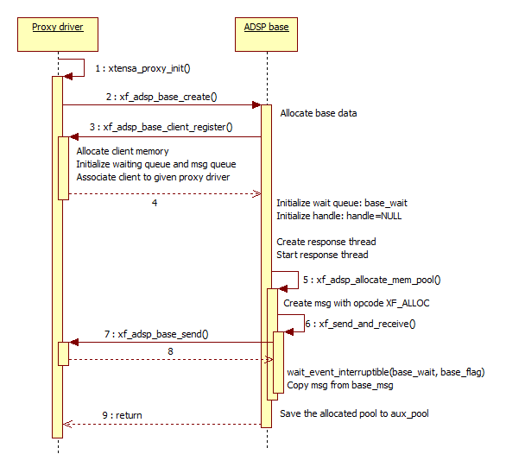

Figure 4‑1 ADSP base creation flow chart

### ADSP Base Destruction

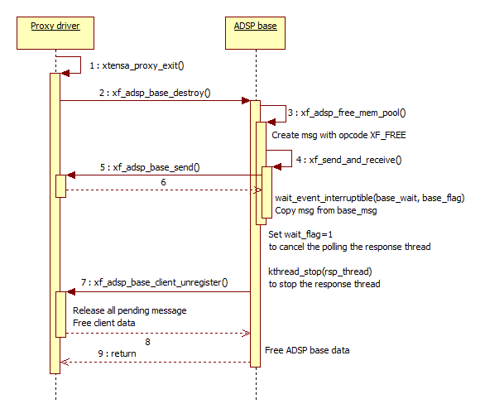

Figure 4‑2 ADSP base destruction flow chart

## Renderer Flow

### Renderer Creation

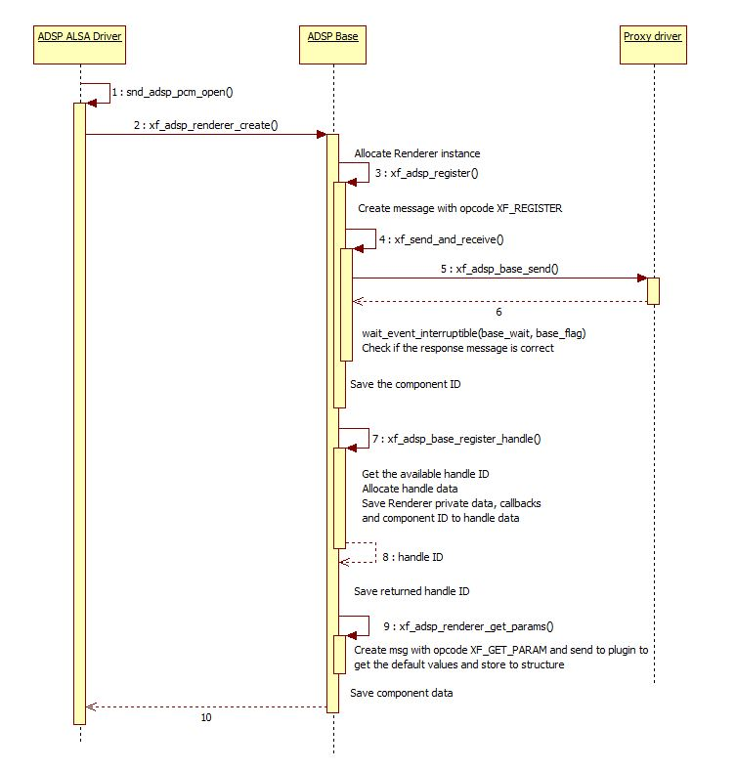

Figure 4‑3 Renderer creation flow chart

### Renderer Execution

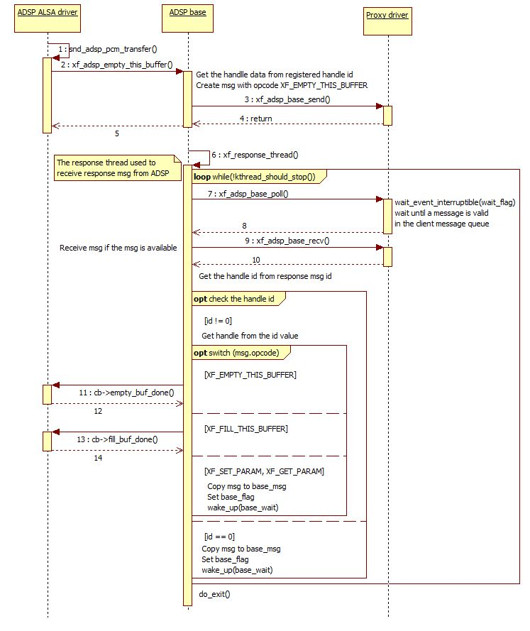

Figure 4‑4 Renderer execution flow chart

### Renderer Destruction

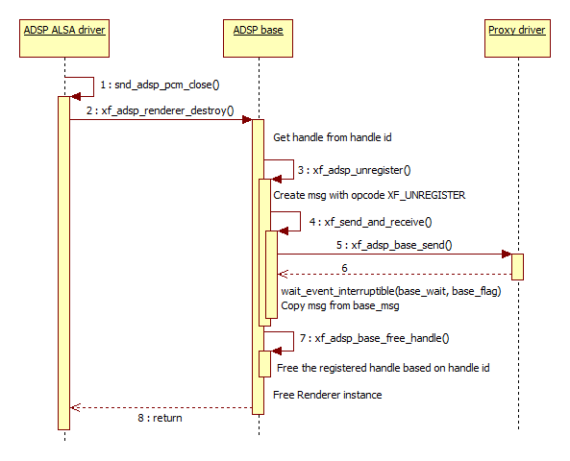

Figure 4‑5 Renderer destruction flow chart

## Capture Flow

### Capture Creation

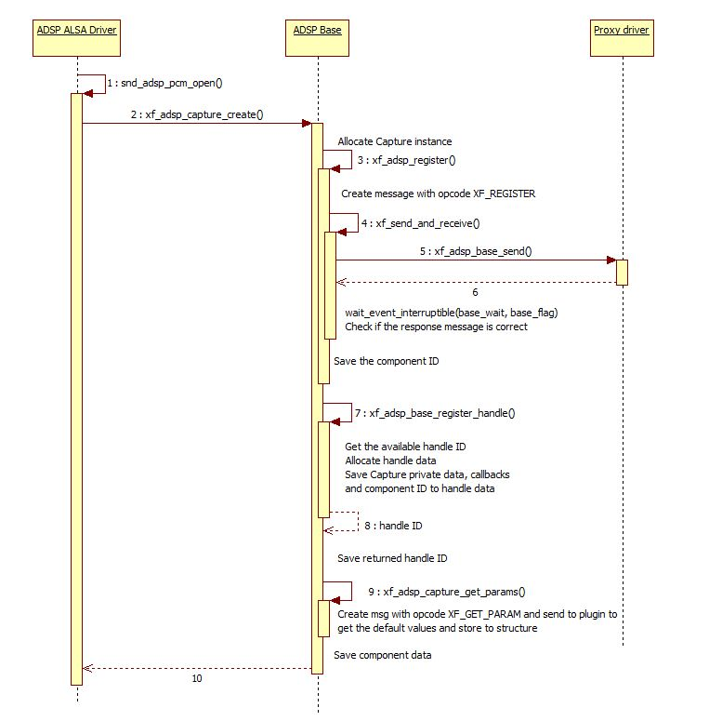

Figure 4‑6 Capture creation flow chart

### Capture Execution

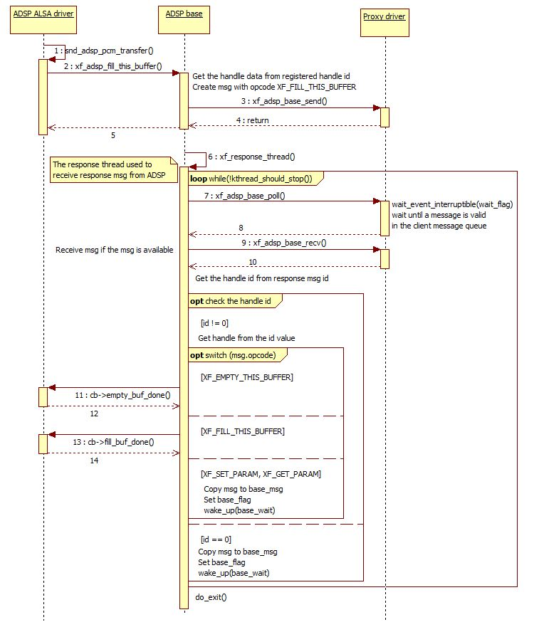

Figure 4‑7 Capture execution flow chart

### Capture Destruction

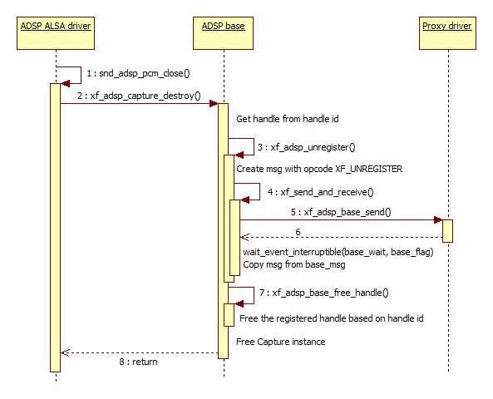

Figure 4‑8 Capture destruction flow chart

## Equalizer Flow

### Equalizer Creation

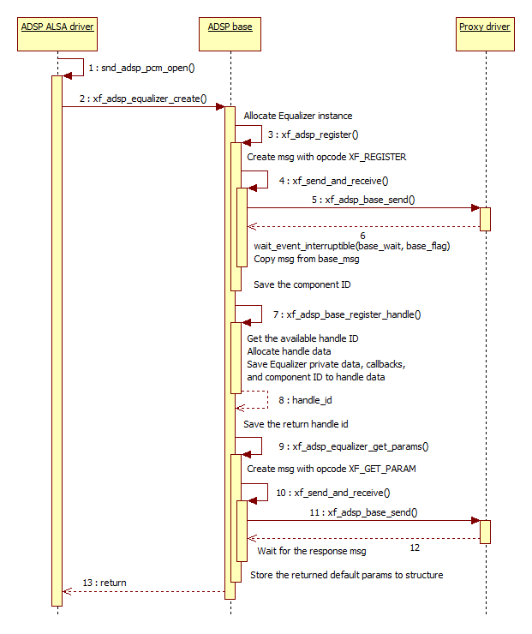

Figure 4‑9 Equalizer creation flow chart

### Equalizer Execution

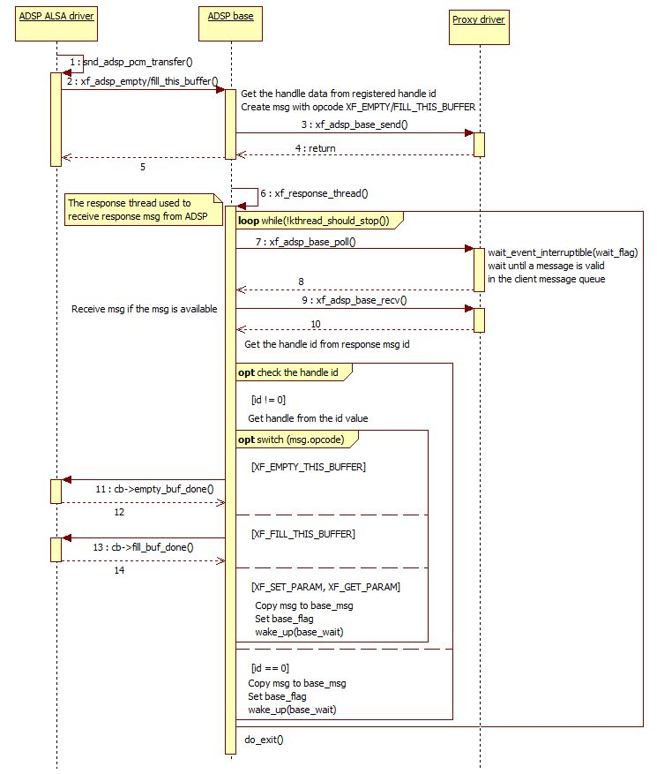

Figure 4‑10 Equalizer execution flow chart

### Equalizer Destruction

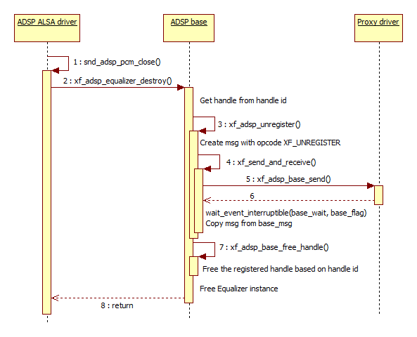

Figure 4‑11 Equalizer destruction flow chart

## TDM Renderer Flow

### TDM Renderer Creation

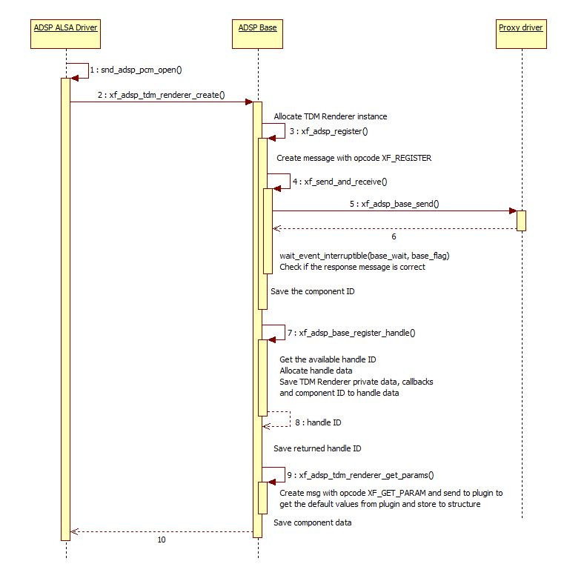

Figure 4‑12 TDM Renderer creation flow chart

### TDM Renderer Execution



Figure 4‑13 TDM Renderer execution flow chart

### TDM Renderer Destruction

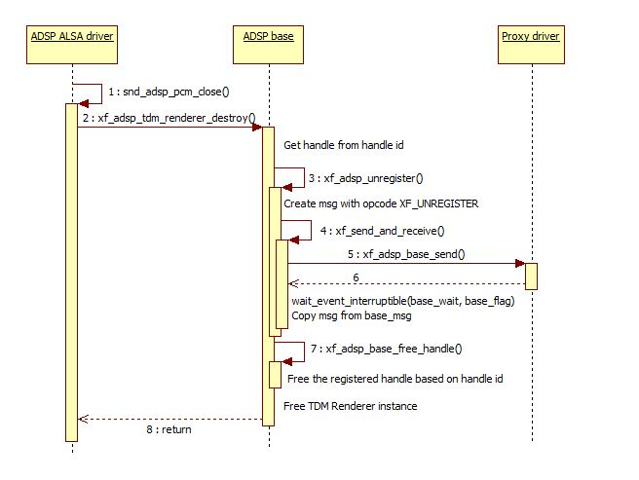

Figure 4‑14 TDM Renderer destruction flow chart

## TDM Capture Flow

### TDM Capture Creation

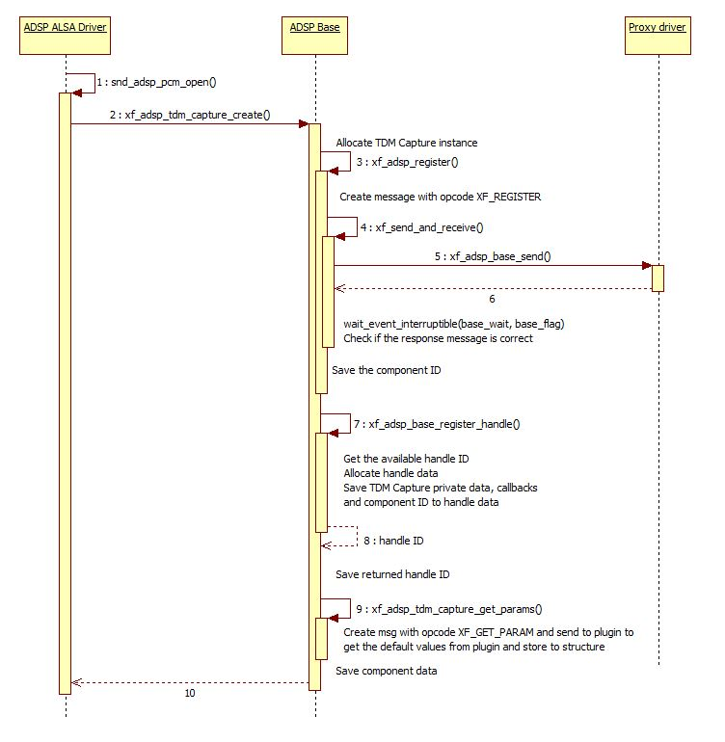

Figure 4‑15 TDM Capture creation flow chart

### TDM Capture Execution



Figure 4‑16 TDM Capture execution flow chart

### TDM Capture Destruction

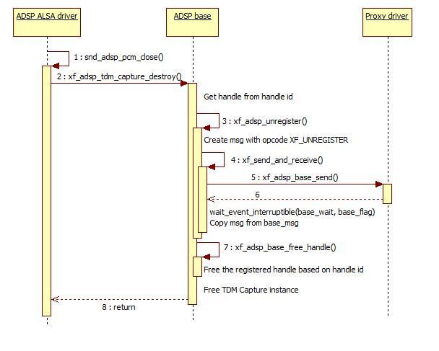

Figure 4‑17 TDM Capture destruction flow chart

# Appendix

## Error Code

|  |  |  |
| --- | --- | --- |
| **Error code** | **Description** | **Reference** |
| ENOMEM | Out of memory | https://elixir.free-electrons.com/linux/v4.0/source/include/uapi/asm-generic/errno-base.h |
| EINVAL | Invalid argument |
| ENODEV | No such device |
| EBUSY | Device or resource busy |

Table 5‑1 Generic error code definition

## Structures

|  |  |  |
| --- | --- | --- |
| **Structure** | **Description** | **Reference** |
| struct xf_pool | Data pool type | Defined in the ADSP Interface for Linux document |
| struct xf_message | Message type | Defined in the ADSP framework document |
| struct task_struct | Task process structure | http://elixir.free-electrons.com/linux/latest/source/include/linux/sched.h |
| wait_queue_head_t | Waiting queue structure | https://elixir.free-electrons.com/linux/latest/source/include/linux/wait.h |

Table 5‑2 External structure definition