ADSP Framework

RCG3AHFWN0201ZDP

Rev.1.00

Jan 29, 2018

Startup Manual

Overview

This document explain how to setup the ADSP Framework.

Target Device

R-Car Series, 3rd Generation

Requirements

Xtensa Xplorer 7.0.4(RG-2016.4)

Contents

1. Introduction 3

1.1 Overview 3

1.2 Folder Structure 3

1.3 Related documents 3

2. Setup the environments 4

2.1 Install the Redistribution Package to Xtensa Xplorer 4

2.2 Import the Xtensa Project Workspace to Xtensa Xplorer 4

3. Using the ADSP Framework 5

3.1 About Build Target 5

3.2 Create the ADSP Firmware 5

3.3 Using the ADSP Firmware 5

4. How to add the Plugins 6

4.1 Import the Xtensa Project Workspace of Plugins to Xtensa Xplorer 6

4.2 Change the ADSP Framework Project for using the imported Plugins 7

4.3 Add the Library Dependencies for using the imported Plugins 8

4.4 Re-Create the ADSP Firmware and using the firmware 8

5. How to change the Memory Map 9

5.1 Device tree change point 9

5.2 ADSP Driver change point 10

5.3 ADSP Framework change point 11

5.3.1 ADSP Framework Source Code 11

5.3.2 ADSP Framework Memory Map 12

5.3.3 ADSP Framework Create Firmware scripts 13

# Introduction

## Overview

This document explain how to setup the ADSP Framework.

## Folder Structure

Table 1 The list of files

|  |  |  |
| --- | --- | --- |
| Folder name | File name | Description |
|  | Contents.txt | Contents Summary |
| Document | StartupManual.pdf | Startup Manual(This document) |
| ReleaseNote.txt | Release note(English) |
| RCG3AHFWN0201ZDPE.pdf | User’s Manual(English) |
| Reference | adsp_framework.xws | ADSP Framework project workspace |
| hifi2_rcar_rg20164c_linux_redist.tgz | Redistribution package for Linux |
| hifi2_rcar_rg20164c_win32_redist.tgz | Redistribution package for Windows |
| Software | .tar.gz | Pre-built firmware |

## Related documents

Table 2 shows related documents and references.

Table 2 Ralated documents

|  |  |  |
| --- | --- | --- |
| No. | Name | Published by |
| [1] | Xtensa Software Development Toolkit User’s Guide | Cadence Design Systems, Inc. |
| [2] | ADSP Framework User’s Manual | Renesas Electronics Corporation |

# Setup the environments

## Install the Redistribution Package to Xtensa Xplorer

Please see the Section 2.2 of “Xtensa Software Development Toolkit User’s Guide” (sw_dev_toolkit_ug.pdf).

## Import the Xtensa Project Workspace to Xtensa Xplorer

(1) "File"->"Import".

(2) Select

Select "Xtensa Xplorer"->"Import Xtensa Xplorer Workspace".

(3) Select Workspace File (.xws)

Select "adsp_framework.xws"

(4) Select Projects to be Imported

"Select All"

(5) Select memory Maps and Custom LSPs to be Imported

"Select All"

# Using the ADSP Framework

## About Build Target

Table 3 The list of files

|  |  |
| --- | --- |
| Target | Description |
| Debug | This Build target is for ISS Debug.  This target link the “adsp_command” project. |
| Release | This Build target is for create the ADSP Firmware.  This target NOT link the “adsp_command” project. |

## Create the ADSP Firmware

(1) Select Build Target to “Release”.

(2) Build

(3) After successfully build, “xf-rcar.fw” is appeared at “adsp_framework” project root.  
 (If you cannot see the file, press “F5” key to refresh)

## Using the ADSP Firmware

(1) Copy the “xf-rcar.fw” to the target board file system.  
 The firmware file must be located on “/lib/firmware/xf-rcar.fw”.

(2) Boot-up target board.

　　Load the firmware automatically in boot-up sequence.

(3) Login as root.

(4) Run the applications.

ADSP Interface Reference programs can help you for testing ADSP Framework.

# How to add the Plugins

## Import the Xtensa Project Workspace of Plugins to Xtensa Xplorer

(1) "File"->"Import".

(2) Select

Select "Xtensa Xplorer"->"Import Xtensa Xplorer Workspace".

(3) Select Workspace File (.xws) of Plugins

Select "adsp_renderer.xws" (e.g.)

(4) Select Projects to be Imported

"Select All"

(5) Select memory Maps and Custom LSPs to be Imported

"Select All"

(6) Similarly repeat the above steps (1 to 5) for adsp_equalizer.xws and adsp_tdm.xws to import Equalizer and TDM workspaces.

## Change the ADSP Framework Project for using the imported Plugins

Change the build properties for adsp_framework (Target: CommonTarget).

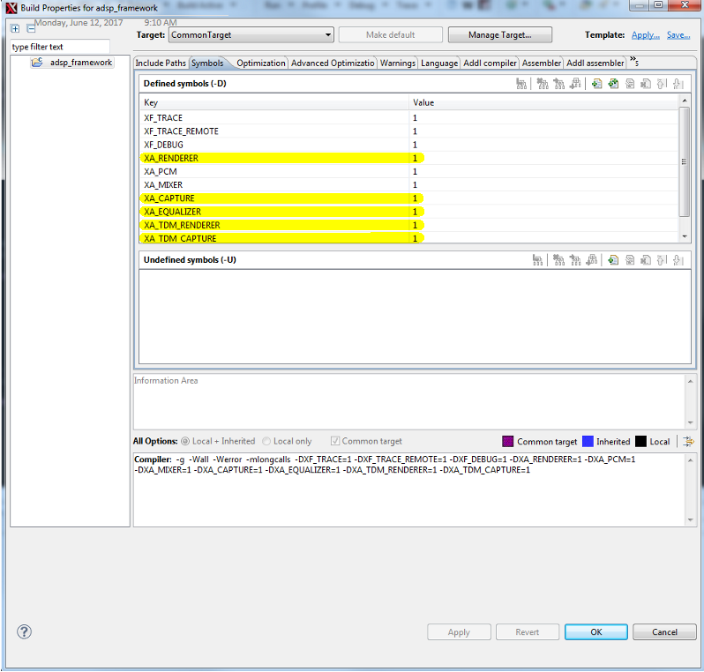

e.g.)

Yellow marked: the value is set “1”, use the plugins.

## Add the Library Dependencies for using the imported Plugins

Change the Library Dependencies for adsp_framework.

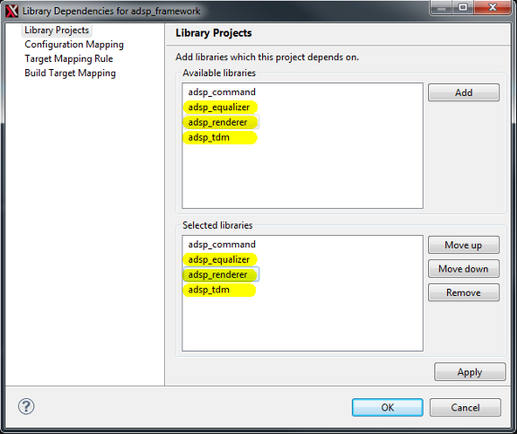

e.g.)

Yellow marked: set the dependencies of plugins to ADSP Framework.

## Re-Create the ADSP Firmware and using the firmware

See the section 3.2 and 3.3.

# How to change the Memory Map

## Device tree change point

The device tree files is located in as following: for example

${KernelSources}/arch/arm64/boot/dts/renesas/r8a7795-salvator-x.dts (for R-Car H3)

${KernelSources}/arch/arm64/boot/dts/renesas/r8a7796-salvator-x.dts (for R-Car M3)

${KernelSources}/arch/arm64/boot/dts/renesas/r8a77965-salvator-x.dts (for R-Car M3N)

${KernelSources}/arch/arm64/boot/dts/renesas/r8a77990-ebisu.dts (for R-Car E3)

The memory map is defined as following:

/* For Audio DSP */

adsp_reserved: linux,adsp {

compatible = "shared-dma-pool";

reusable;

reg = <0x00000000 0x57000000 0x0 0x01000000>;

};

Yellow marked: top address of ADSP memory.

Blue marked: size of ADSP memory.

See the section "1.4. Memory specification" of ADSP Framework User's Manual for more detail

## ADSP Driver change point

The define file is located in as following:

${ADSPDriverSource}/include/sys/xt-shmem/xf-config.h

The memory map is defined as following:

#define XF_CFG_MESSAGE_POOL_SIZE 256

#define XF_CFG_REMOTE_IPC_POOL_SIZE (256 << 10)

#define XF_PROXY_DATA_ADDRESS(core) (0x57400000)

#define XF_PROXY_DATA_SIZE(core) (0x00C00000)

Purple marked: the number of communication control area

Green marked: valid size of shared memory

Yellow marked: top address of shared memory

Blue marked: all size of shared memory

See the section "1.4. Memory specification" and "2.2. Memory structure" of ADSP Framework User's Manual for more detail

## ADSP Framework change point

There are three change points. The one is sources, the second one is memory map editor, and the third one is create firmware scripts.

### ADSP Framework Source Code

The define file is located in as following:

${ADSPFrameworkSource}/include/sys/xt-shmem/board-rcar/xf-memory.h

The memory map is defined as following:

#define XF_CFG_SHMEM_ADDRESS(core) ((void *)0x57400000)

#define XF_CFG_TRACE_START(core) ((void *)0x57000000)

#define XF_CFG_TRACE_END(core) ((void *)0x57100000)

Yellow marked: top address of ADSP shared area

Blue marked: top address of ADSP debug area

Purple marked: end address of ADSP debug area

See the section "1.4. Memory specification" of ADSP Framework User's Manual for more detail

The define file is located in as following:

${ADSPFrameworkSource}/include/sys/xt-shmem/xf-config.h

The memory map is defined as following:

#define XF_CFG_MESSAGE_POOL_SIZE 256

#define XF_CFG_REMOTE_IPC_POOL_SIZE (256 << 10)

Purple marked: the number of communication control area

Green marked: valid size of shared memory

See the section "2.2. Memory structure" of ADSP Framework User's Manual for more detail

### ADSP Framework Memory Map

Please see the section "Memory Map Editor" of Xtensa Xplorer Help files.

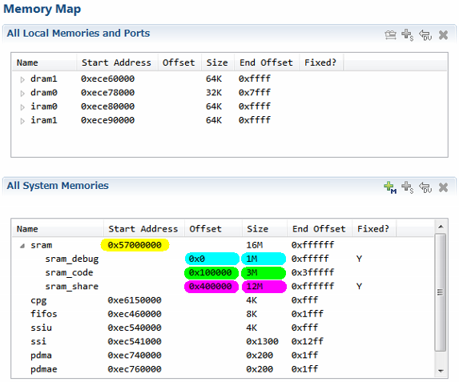

*

*

*dram0/iram1 can not be used with R-Car E3.

Yellow marked: top address of ADSP total memory area

Blue marked: offset and size of ADSP debug area

Green marked: offset and size of ADSP code area

Purple marked: offset and size of ADSP shared area

See the section "1.4. Memory specification" of ADSP Framework User's Manual for more detail

### ADSP Framework Create Firmware scripts

The define file is located in as following:

${ADSPFrameworkSource}/sections.py

The memory map is defined as following:

# ...main memory

('-j .sram.rodata ' +

'-j .rodata ' +

'-j .sram.literal ' +

'-j .literal ' +

'-j .sram.text ' +

'-j .text ' +

'-j .sram.data ' +

'-j .data ' +

'-j .sram.bss ' +

'-j .bss',

0x57100000),

Yellow marked: top address of ADSP code area

See the section "1.4. Memory specification" of ADSP Framework User's Manual for more detail