**Document Type: Detail Design**

**Document Name:**

**ADSP OMX RDR**

Renesas Design Vietnam Co. Ltd

R-Car Software Solution 2 Group

Middleware 1 Team

Renesas Electronics Corporation

Table of Contents

1. Overview 3

2. Function list 4

3. Detail information 5

3.1 Data type and Macro definition 5

3.2 Function definition 6

3.2.1 OMX Capture 6

3.2.1.1 CAPTURE_SetConfig_Send 6

3.2.1.2 CAPTURE_SetConfigIndex 7

3.2.1.3 CAPTURE_Setup 8

3.2.1.4 CAPTURE_RuntimeInit 9

3.2.1.5 CAPTURE_GetParam 10

3.2.1.6 CAPTURE_TimeStamp 11

3.2.1.7 CAPTURE_GetParameter 12

3.2.1.8 CAPTURE_SetParameter 13

3.2.1.9 CAPTURE_ComponentInit 14

3.2.1.10 CAPTURE_ComponentDeInit 15

3.2.1.11 CAPTURE_ComponentCreate 16

3.2.2 OMX RENDERER 18

3.2.2.1 RENDERER_SetConfig_Send 18

3.2.2.2 RENDERER_SetConfigIndex 19

3.2.2.3 RENDERER_Setup 20

3.2.2.4 RENDERER_RuntimeInit 21

3.2.2.5 RENDERER_GetParam 22

3.2.2.6 RENDERER_TimeStamp 23

3.2.2.7 RENDERER_GetParameter 24

3.2.2.8 RENDERER_SetParameter 25

3.2.2.9 RENDERER_ComponentInit 26

3.2.2.10 RENDERER_ComponentDeInit 27

3.2.2.11 RENDERER_ComponentCreate 28

3.2.3 OMX Codec Base 30

3.2.3.1 xaomx_create_buffer 30

3.2.3.2 xaomx_response_process 32

4. Revision history 33

List of Figures

Figure 1‑1 The software architecture 3

Figure 3‑1 CAPTURE_SetConfig_Send flowchart 6

Figure 3‑2 CAPTURE_SetConfigIndex flowchart 7

Figure 3‑3 CAPTURE_Setup flowchart 8

Figure 3‑4 CAPTURE_RuntimeInit flowchart 9

Figure 3‑5 CAPTURE_GetParam flowchart 10

Figure 3‑6 CAPTURE_TimeStamp flowchart 11

Figure 3‑7 CAPTURE_GetParameter flowchart 12

Figure 3‑8 CAPTURE_SetParameter flowchart 13

Figure 3‑9 CAPTURE_ComponentInit flowchart 14

Figure 3‑10 CAPTURE_ComponentDeInit flowchart 15

Figure 3‑11 CAPTURE_ComponentCreate flowchart 17

Figure 3‑12 RENDERER_SetConfig_Send flowchart 18

Figure 3‑13 RENDERER_SetConfigIndex flowchart 19

Figure 3‑14 RENDERER_Setup flowchart 20

Figure 3‑15 RENDERER_GetParam flowchart 22

Figure 3‑16 RENDERER_TimeStamp flowchart 23

Figure 3‑17 RENDERER_GetParameter flowchart 24

Figure 3‑18 RENDERER_SetParameter flowchart 25

Figure 3‑19 RENDERER_ComponentInit flowchart 26

Figure 3‑20 RENDERER_ComponentDeInit flowchart 27

Figure 3‑21 RENDERER_ComponentCreate flowchart 29

Figure 3‑22 xaomx_create_buffer flowchart 31

Figure 3‑23 xaomx_response_process flowchart 32

List of Table

Table 2‑1 Function list of OMX Capture 4

Table 2‑2 Function list of OMX Renderer 4

Table 2‑3 Function list of OMX Codec base 4

Table 3‑1 XAOMXCapture type structure information 5

Table 3‑2 XAOMXRenderer type structure information 5

Table 3‑3 Macro definitions of OMX Capture 5

Table 3‑4 Macro definitions of OMX Renderer 5

Table 2‑1 Function list of OMX Capture 4

Table 2‑2 Function list of OMX Renderer 4

Table 2‑3 Function list of OMX Codec base 4

Table 3‑1 XAOMXCapture type structure information 5

Table 3‑2 XAOMXRenderer type structure information 5

Table 3‑3 Macro definitions of OMX Capture 5

Table 3‑4 Macro definitions of OMX Renderer 5

# Overview

In this chapter, overview of OMX Capture/Renderer interface is explained.

User Application

OMX TDM

OMX Renderer/Capture

OMX Equalizer

User Space

ADSP Interface for Linux (base)

Kernel Space

ARM

ADSP Driver for Linux

Audio HW

ADSP

NC/EC

ADSP Framework

Renderer/Capture Plugin

TDM Plugin

Equalizer Plugin

Codec

This document’s target is in side of red square.

DAC/ADC

SRC/CTU/MIX/ DVC/ SSI/

ADMA

Figure 1‑1 ****The software architecture****

# Function list

The following is list of functions:

Table 2‑1 Function list of OMX Capture

|  |  |  |
| --- | --- | --- |
| **No.** | **Function Name** | **Outline** |
| 1 | CAPTURE_SetConfig_Send | Prepare message contain volume value want to set parameters for XF_SET_PARAM command to send to plug-in. |
| 2 | CAPTURE_SetConfigIndex | Check the index of parameter structure is correct. |
| 3 | CAPTURE_Setup | Capture prepare codec setup parameters. |
| 4 | CAPTURE_RuntimeInit | Gets the command index of 1st and 2nd DMA devices |
| 5 | CAPTURE_GetParam | Get DMA channel 1, 2 value from response structure. |
| 6 | CAPTURE_TimeStamp | Calculate timestamp for current output buffer and next buffer. |
| 7 | CAPTURE_GetParameter | Get Capture parameter. |
| 8 | CAPTURE_SetParameter | Set Capture parameter. |
| 9 | CAPTURE_ComponentDeInit | Destroy Capture component and private data. |
| 10 | CAPTURE_ComponentInit | Initialize base codec interface, parameters, PCM and Capture format. |
| 11 | CAPTURE_ComponentCreate | Create base component and initialize the Capture component. |

Table 2‑2 Function list of OMX Renderer

|  |  |  |
| --- | --- | --- |
| **No.** | **Function Name** | **Outline** |
| 1 | RENDERER_SetConfig_Send | Prepare message contain volume value want to set parameters for XF_SET_PARAM command to send to Renderer plug-in. |
| 2 | RENDERER_SetConfigIndex | Check the index of parameter structure is correct. |
| 3 | RENDERER_Setup | Renderer prepare codec setup parameters. |
| 4 | RENDERER_RuntimeInit | This is a dummy function, not use in Renderer runtime initialization. |
| 5 | RENDERER_GetParam | This is a dummy function. |
| 6 | RENDERER_TimeStamp | Calculate timestamp for current input buffer and next buffer. |
| 7 | RENDERER_GetParameter | Get Renderer parameter. |
| 8 | RENDERER_SetParameter | Set Renderer parameter. |
| 9 | RENDERER_ComponentDeInit | Destroy Renderer component and private data. |
| 10 | RENDERER_ComponentInit | Initialize base codec interface, parameters, PCM and Renderer format. |
| 11 | RENDERER_ComponentCreate | Create base component and initialize the Renderer component. |

Table 2‑3 Function list of OMX Codec base

|  |  |  |
| --- | --- | --- |
| **No.** | **Function Name** | **Outline** |
| 1 | xaomx_create_buffer | Allocate buffer header for OMX, set buffer pointer and request ADSP to map this buffer to optimize latency. |
| 2 | xaomx_response_process | Handle response received massage from proxy. To reduce audio Latency on Android this function add an opcode XF_MMAP_THIS_BUFFER. |

# Detail information

This section describes detail information of data types, macro definitions.

## Data type and Macro definition

Table 3‑1 XAOMXCapture type structure information

|  |  |
| --- | --- |
| Member name | Outline |
| XAOMXCodecBase base | Generic codec structure. |
| OMX_AUDIO_PARAM_PCMMODETYPE sPCM | PCM-specific parameters (output port). |
| XAOMX_AUDIO_PARAM_CAPTURE sCAPTURE | Capture parameters. |

Note:

Structure XAOMXCodecBase is a base codec structure of OMX in omx-codec-base.h

Structure OMX_AUDIO_PARAM_PCMMODETYPE is a PCM format description in OMX_Audio.h

Structure XAOMX_AUDIO_PARAM_CAPTURE is a parametric Capture settings structure.

Table 3‑2 XAOMXRenderer type structure information

|  |  |
| --- | --- |
| Member name | Outline |
| XAOMXCodecBase base | Generic codec structure. |
| OMX_AUDIO_PARAM_PCMMODETYPE sPCM | PCM-specific parameters (input port). |
| XAOMX_AUDIO_PARAM_RENDERER sRENDERER | Renderer parameters. |

Note:

Structure XAOMX_AUDIO_PARAM_RENDERER is a parametric Renderer settings structure.

Table 3‑3 Macro definitions of OMX Capture

|  |  |  |
| --- | --- | --- |
| Macro | Value | Outline |
| NUM_OUTPUT_BUFFERS | 4 | Total amount of output buffers. |
| OUTPUT_BUFFER_LENGTH | 4096 | Default output buffer length. |
| BUFFER_ALIGNMENT | 32 | Required data alignment of Capture. |

Table 3‑4 Macro definitions of OMX Renderer

|  |  |  |
| --- | --- | --- |
| Macro | Value | Outline |
| NUM_INPUT_BUFFERS | 4 | Total amount of input buffers. |
| INPUT_BUFFER_LENGTH | 4096 | Default input buffer length. |
| BUFFER_ALIGNMENT | 32 | Required data alignment of Renderer. |

## Function definition

### OMX Capture

#### CAPTURE_SetConfig_Send

DD_API_RDR_01_001

|  |  |  |  |  |
| --- | --- | --- | --- | --- |
| **Syntax** | static s32 CAPTURE_SetConfig_Send(XAOMXCodecBase *pBase,  xf_set_param_msg_t *msg,  OMX_PTR pParam) | | | |
| **Function** | Prepare message contain volume value want to set parameters for XF_SET_PARAM command to send to plug-in. | | | |
| **Arguments** | Type | Name | I/O | Description |
| XAOMXCodecBase * | pBase | I | Pointer to base codec structure of Capture component. |
| xf_set_param_msg_t* | msg | O | Message send to Capture plugin. |
| OMX_PTR | pParam | I | Parameter want to send to plug-in. |
| **Return value** | length | | Number of parameters want to set for Capture plugin. | |
| 0 | | Do not set volume to plug-in. | |
| **Description** | * CAPTURE_SetConfig_Send processing:   - Prepare volume rate value into command message. | | | |

[Covers: FD_API_RDR_006]

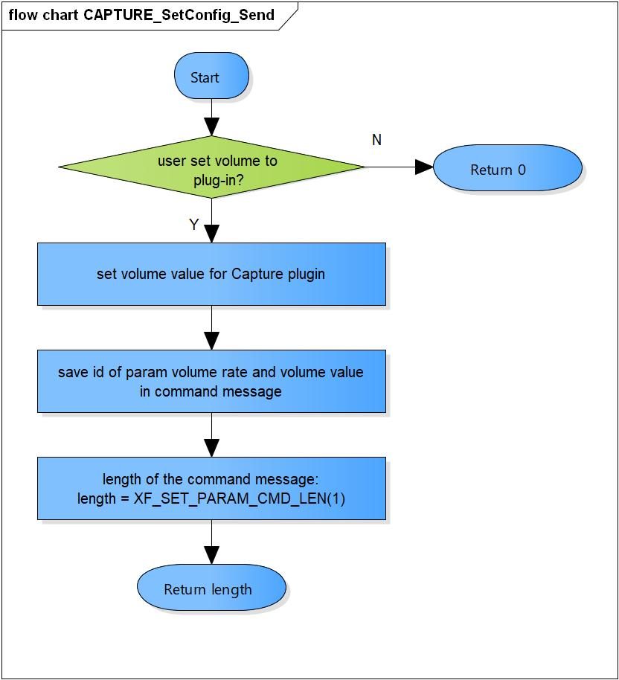

Figure 3‑1 CAPTURE_SetConfig_Send flowchart

#### CAPTURE_SetConfigIndex

DD_API_RDR_01_002

|  |  |  |  |  |
| --- | --- | --- | --- | --- |
| **Syntax** | static OMX_ERRORTYPE CAPTURE_SetConfigIndex(OMX_INDEXTYPE nIndex) | | | |
| **Function** | Check the index of parameter structure is correct. | | | |
| **Arguments** | Type | Name | I/O | Description |
| OMX_INDEXTYPE | nIndex | I | Index of parameter structure.  Valid range: XAOMX_IndexParamAudioCapture |
| **Return value** | XA_NO_ERROR | | Normal return. | |
| OMX_ErrorUnsupportedIndex | | Wrong Index of structure. | |
| **Description** | * CAPTURE_SetConfig_Send processing:   - Check the index of parameter structure is correct. | | | |

[Covers: FD_API_RDR_006]

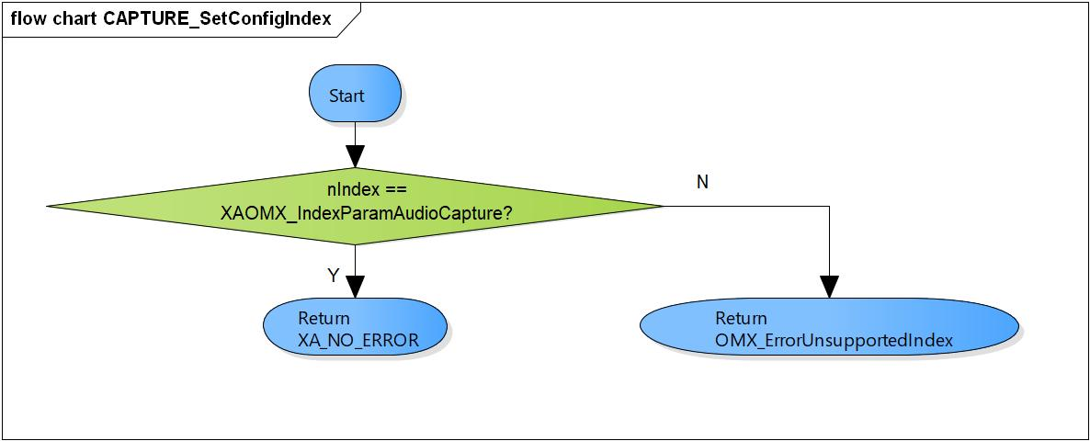

Figure 3‑2 CAPTURE_SetConfigIndex flowchart

#### CAPTURE_Setup

DD_API_RDR_01_003

|  |  |  |  |  |
| --- | --- | --- | --- | --- |
| **Syntax** | static s32 CAPTURE_Setup(XAOMXCodecBase *pBase, xf_set_param_msg_t *msg) | | | |
| **Function** | Capture prepare codec setup parameters. | | | |
| **Arguments** | Type | Name | I/O | Description |
| XAOMXCodecBase * | pBase | I | Pointer to base codec structure of Capture component. |
| xf_set_param_msg_t* | msg | O | Message send to Capture plugin. |
| **Return value** | length | | Number of parameters want to set for Capture plugin. | |
| **Description** | * CAPTURE_Setup processing:   - Prepare PCM width, channels, sample rate, input1, 2; DMA channel 1, 2; out sample rate, volume rate and ring-buffer number values into command message. | | | |

[Covers: FD_API_RDR_003]

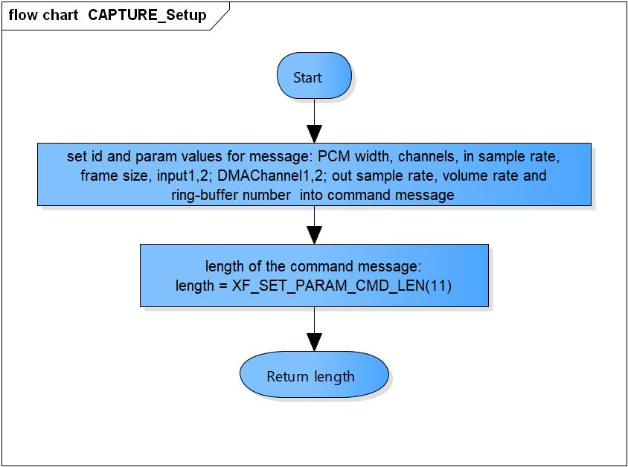

Figure 3‑3 CAPTURE_Setup flowchart

#### CAPTURE_RuntimeInit

DD_API_RDR_01_004

|  |  |  |  |  |
| --- | --- | --- | --- | --- |
| **Syntax** | static s32 CAPTURE_RuntimeInit(XAOMXCodecBase *pBase, xf_start_msg_t *msg) | | | |
| **Function** | This function gets the command index of 1st and 2nd DMA devices | | | |
| **Arguments** | Type | Name | I/O | Description |
| XAOMXCodecBase * | pBase | I | Pointer to base codec structure of Capture component. |
| xf_start_msg_t* | msg | O | Message send to Capture plugin. |
| **Return value** | length | | Number of parameters want to set for Capture plugin. | |
| **Description** | * CAPTURE_RuntimeInit processing:   - Save DMA channel 1, 2 into command structure. | | | |

[Covers: FD_API_RDR_003]

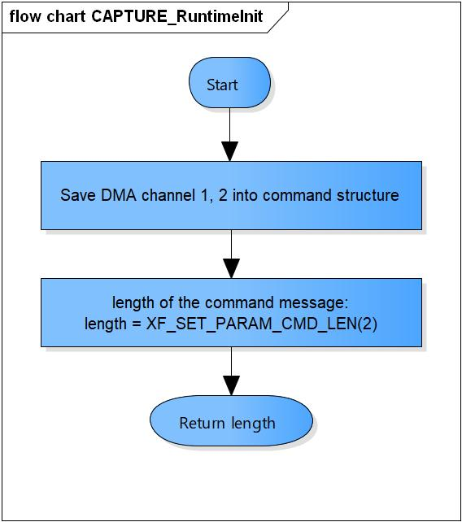

Figure 3‑4 CAPTURE_RuntimeInit flowchart

#### CAPTURE_GetParam

DD_API_RDR_01_005

|  |  |  |  |  |
| --- | --- | --- | --- | --- |
| **Syntax** | static s32 CAPTURE_GetParam(XAOMXCodecBase *pBase,  xf_get_param_msg_t *msg,  u32 length) | | | |
| **Function** | Get DMA channel 1, 2 value from response structure. | | | |
| **Arguments** | Type | Name | I/O | Description |
| XAOMXCodecBase * | pBase | I/O | Pointer to base codec structure of Capture component. |
| xf_get_param_msg_t * | msg | I | Message receive from Capture plugin. |
| u32 | lenghth | I | Length of message. |
| **Return value** | 0 | | Normal return. | |
| -EBADF | | The message length is invalid. | |
| **Description** | * CAPTURE_GetParam processing:   - Get DMA channel 1, 2 values from response structure. | | | |

[Covers: FD_API_RDR_003]

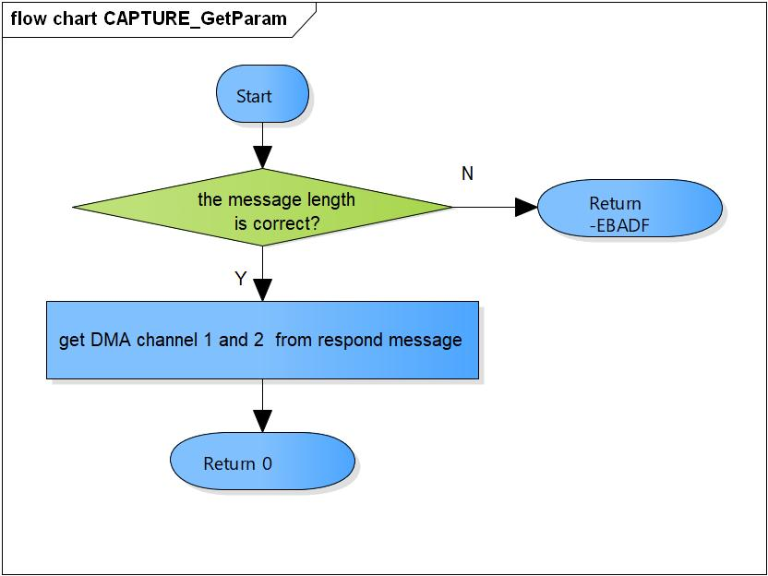

Figure 3‑5 CAPTURE_GetParam flowchart

#### CAPTURE_TimeStamp

DD_API_RDR_01_006

|  |  |  |  |  |
| --- | --- | --- | --- | --- |
| **Syntax** | static void CAPTURE_TimeStamp(XAOMXCodecBase *pBase,  OMX_BUFFERHEADERTYPE *pBufHdr) | | | |
| **Function** | Calculate timestamp for current output buffer and next buffer. | | | |
| **Arguments** | Type | Name | I/O | Description |
| XAOMXCodecBase * | pBase | I/O | Pointer to base codec structure of Capture component. |
| OMX_BUFFERHEADERTYPE* | msg | O | Output buffer. |
| **Return value** | None. | | | |
| **Description** | * CAPTURE_TimeStamp processing:   - Add current timestamp to the output buffer.  - Calculate timestamp for the next buffer. | | | |

[Covers: FD_API_RDR_003]

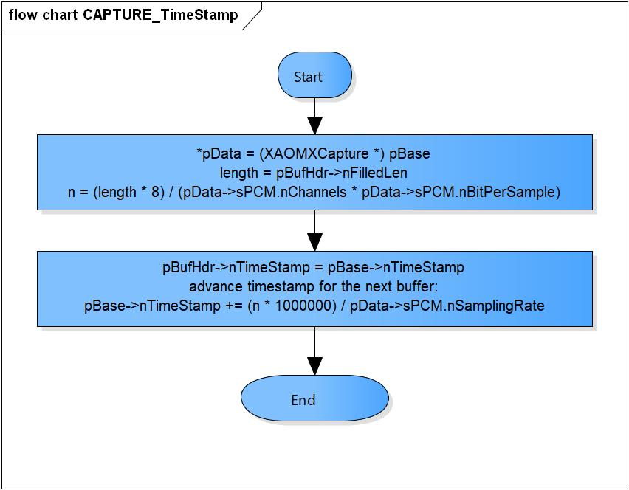

Figure 3‑6 CAPTURE_TimeStamp flowchart

#### CAPTURE_GetParameter

DD_API_RDR_01_007

|  |  |  |  |  |
| --- | --- | --- | --- | --- |
| **Syntax** | static OMX_ERRORTYPE CAPTURE_GetParameter(XAOMXCodecBase *pBase,  OMX_INDEXTYPE nIndex,  OMX_PTR pParam) | | | |
| **Function** | Get parameter and save to pParam. | | | |
| **Arguments** | Type | Name | I/O | Description |
| XAOMXCodecBase * | pBase | I/O | Pointer to base codec structure of Capture component. |
| OMX_INDEXTYPE | nIndex | I | Index of parameter structure.  Supported index:  OMX_IndexParamAudioPcm  XAOMX_IndexParamAudioCapture  OMX_IndexParamCompBufferSupplier |
| OMX_PTR | pParam | O | Pointer to parameter structure want to save. |
| **Return value** | OMX_ErrorNone | | Normal return. | |
| OMX_ErrorUnsupportedIndex | | Wrong Index of structure. | |
| **Description** | * CAPTURE_GetParameter processing:   - Get parameters of OMX_AUDIO_PARAM_PCMMODETYPE, XAOMX_AUDIO_PARAM_CAPTURE, OMX_PARAM_BUFFERSUPPLIERTYPE structure base on nIndex. | | | |

[Covers: FD_API_RDR_004]

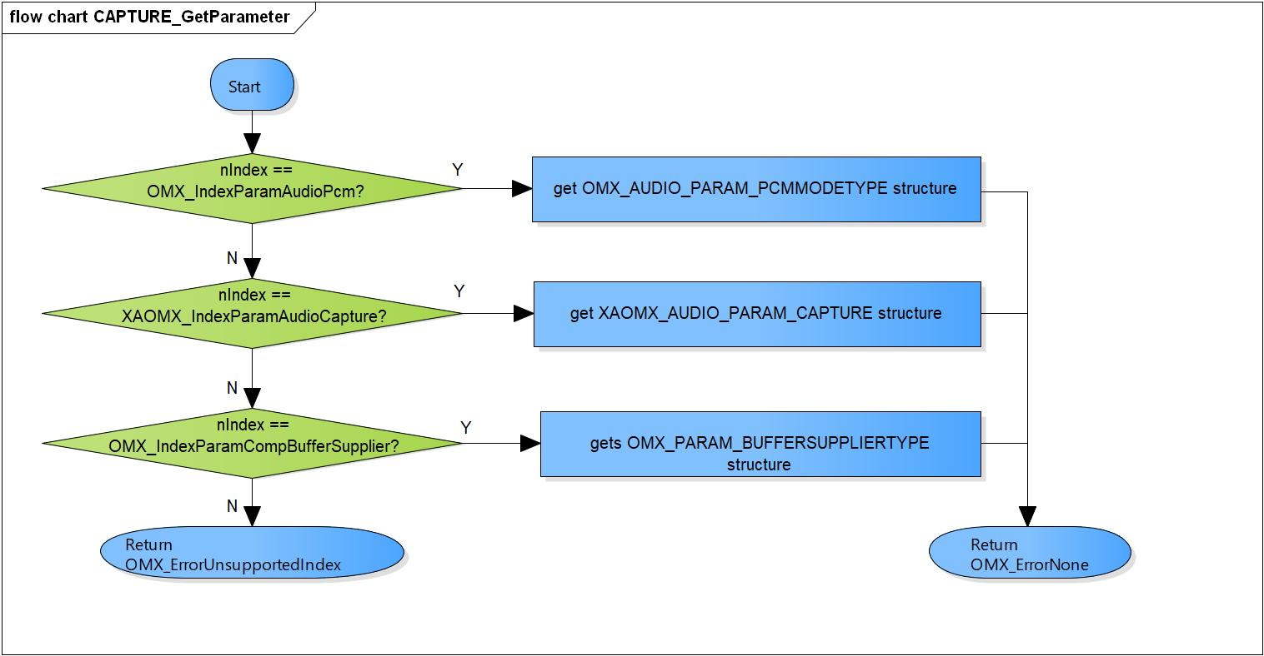

Figure 3‑7 CAPTURE_GetParameter flowchart

#### CAPTURE_SetParameter

DD_API_RDR_01_008

|  |  |  |  |  |
| --- | --- | --- | --- | --- |
| **Syntax** | static OMX_ERRORTYPE CAPTURE_SetParameter(XAOMXCodecBase *pBase,  OMX_INDEXTYPE nIndex,  OMX_PTR pParam) | | | |
| **Function** | Set parameter from pParam and save to parameter structure. | | | |
| **Arguments** | Type | Name | I/O | Description |
| XAOMXCodecBase * | pBase | I/O | Pointer to base codec structure of Capture component. |
| OMX_INDEXTYPE | nIndex | I | Index of parameter structure.  Supported index:  OMX_IndexParamAudioPcm  XAOMX_IndexParamAudioCapture  OMX_IndexParamCompBufferSupplier |
| OMX_PTR | pParam | I | Pointer to parameter structure want to set. |
| **Return value** | OMX_ErrorNone | | Normal return. | |
| OMX_ErrorUnsupportedIndex | | Wrong Index of structure. | |
| OMX_ErrorBadPortIndex | | Port index is invalid. | |
| **Description** | * CAPTURE_SetParameter processing:   - Set parameters of OMX_AUDIO_PARAM_PCMMODETYPE, XAOMX_AUDIO_PARAM_CAPTURE, OMX_PARAM_BUFFERSUPPLIERTYPE structure base on nIndex. | | | |

[Covers: FD_API_RDR_005]

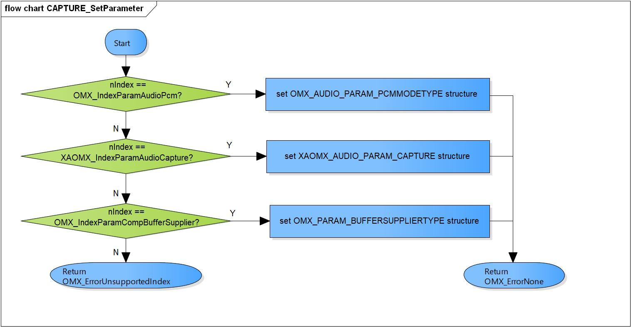

Figure 3‑8 CAPTURE_SetParameter flowchart

#### CAPTURE_ComponentInit

DD_API_RDR_01_009

|  |  |  |  |  |
| --- | --- | --- | --- | --- |
| **Syntax** | static OMX_ERRORTYPE CAPTURE_ComponentInit(xf_proxy_t *proxy,  OMX_HANDLETYPE hComponent,  OMX_PTR pAppData,  OMX_CALLBACKTYPE *pCallbacks) | | | |
| **Function** | Initialize base codec interface, parameters, PCM and Capture format. | | | |
| **Arguments** | Type | Name | I/O | Description |
| xf_proxy_t * | proxy | O | OpenMAX interface proxy. |
| OMX_HANDLETYPE | hComponent | O | Pointer to Capture component handle. |
| OMX_PTR | pAppData | I | Pointer to pAppData of Capture component. |
| OMX_CALLBACKTYPE | pCallbacks | I | Pointer to Callbacks of Capture component. |
| **Return value** | OMX_ErrorNone | | Normal return. | |
| OMX_ErrorInsufficientResources | | Initialize base codec interface is fail. | |
| **Description** | * CAPTURE_ComponentInit processing:   - Initialize base codec interface, parameters, PCM and Capture format. | | | |

[Covers: FD_API_RDR_001]

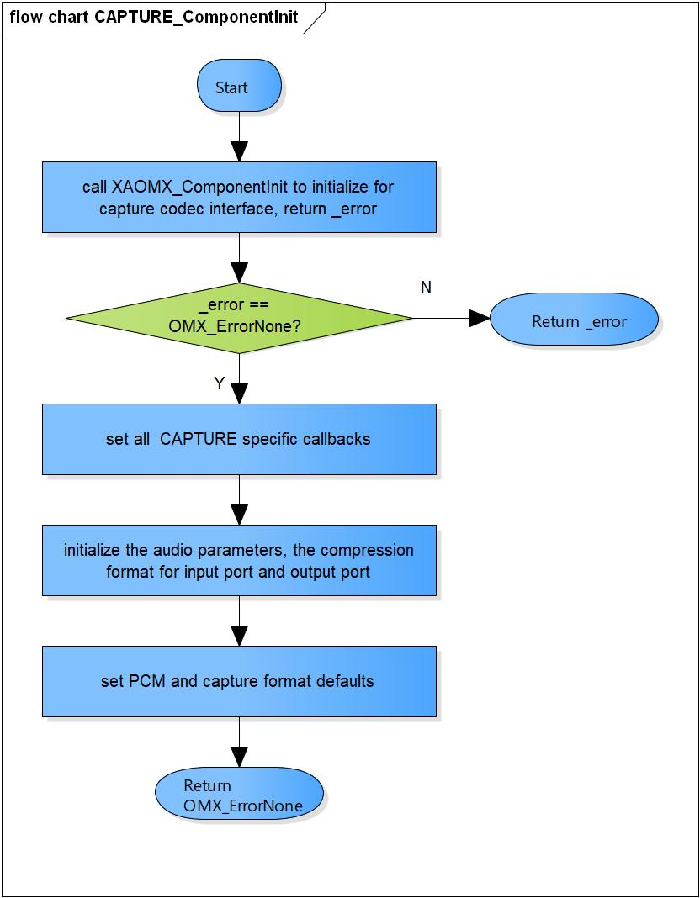

Figure 3‑9 CAPTURE_ComponentInit flowchart

#### CAPTURE_ComponentDeInit

DD_API_RDR_01_010

|  |  |  |  |  |
| --- | --- | --- | --- | --- |
| **Syntax** | static OMX_ERRORTYPE CAPTURE_ComponentDeInit(OMX_HANDLETYPE hComponent) | | | |
| **Function** | Destroy Capture component and private data. | | | |
| **Arguments** | Type | Name | I/O | Description |
| OMX_HANDLETYPE | hComponent | O | Pointer to Capture component handle. |
| **Return value** | OMX_ErrorNone | | Normal return. | |
| OMX_ErrorBadParameter | | Private data is NULL. | |
| **Description** | * CAPTURE_ComponentDeInit processing:   - Destroy Capture component and private data. | | | |

[Covers: FD_API_RDR_002]

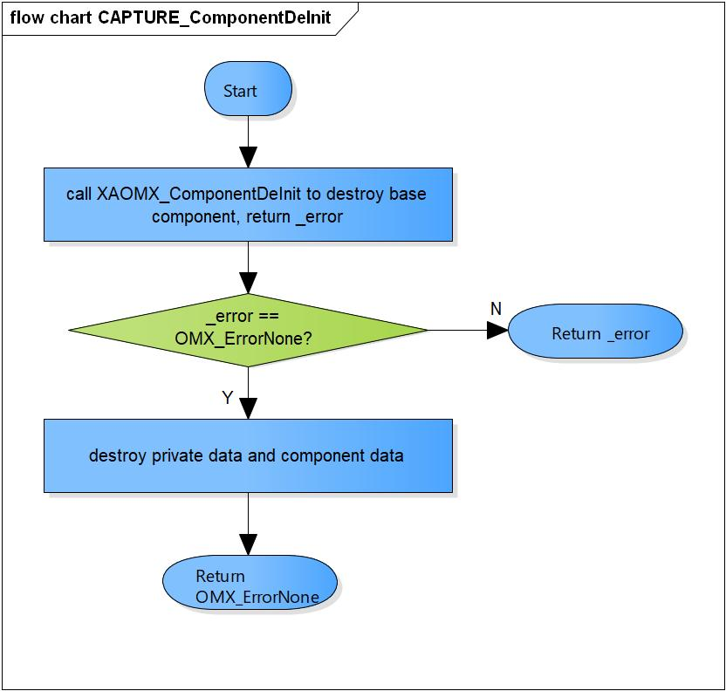

Figure 3‑10 CAPTURE_ComponentDeInit flowchart

#### CAPTURE_ComponentCreate

DD_API_RDR_01_011

|  |  |  |  |  |
| --- | --- | --- | --- | --- |
| **Syntax** | OMX_ERRORTYPE CAPTURE_ComponentCreate(xf_proxy_t *proxy, OMX_HANDLETYPE *hComponent, OMX_PTR pAppData, OMX_CALLBACKTYPE *pCallbacks) | | | |
| **Function** | Create base component and initialize the Capture component. | | | |
| **Arguments** | Type | Name | I/O | Description |
| xf_proxy_t* | proxy | O | OpenMAX interface proxy. |
| OMX_HANDLETYPE* | hComponent | O | Pointer to Capture component handle. |
| OMX_PTR | pAppData | I | Pointer to pAppData of Capture component. |
| OMX_CALLBACKTYPE * | pCallbacks | I | Pointer to Callbacks of Capture component. |
| **Return value** | OMX_ErrorNone | | Normal return. | |
| OMX_ErrorInsufficientResources | | Cannot create the base component.  Cannot allocate private memory.  Initialize the Capture component is fail. | |
| **Description** | * CAPTURE_ComponentCreate processing:   - Create the base component.  - Allocate the private memory.  - Initialize the Capture component. | | | |

[Covers: FD_API_RDR_001]

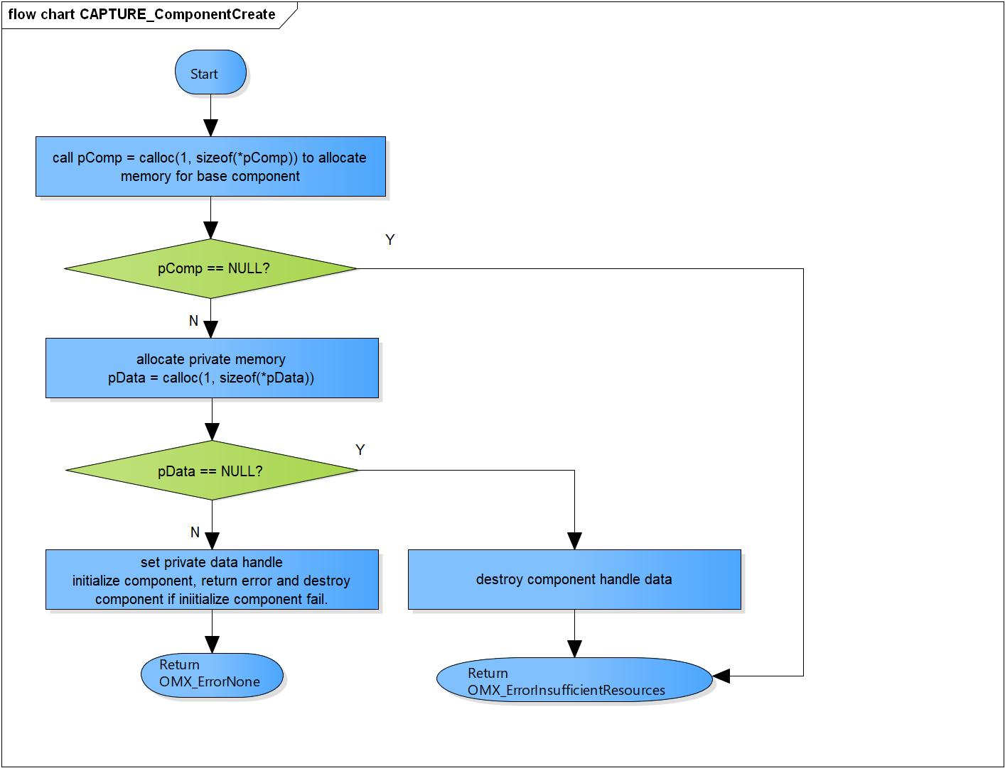

Figure 3‑11 CAPTURE_ComponentCreate flowchart

### OMX RENDERER

#### RENDERER_SetConfig_Send

DD_API_RDR_01_012

|  |  |  |  |  |
| --- | --- | --- | --- | --- |
| **Syntax** | static s32 RENDERER_SetConfig_Send(XAOMXCodecBase *pBase,  xf_set_param_msg_t *msg,  OMX_PTR pParam) | | | |
| **Function** | Prepare message contain volume value want to set parameters for XF_SET_PARAM command to send to Renderer plug-in. | | | |
| **Arguments** | Type | Name | I/O | Description |
| XAOMXCodecBase * | pBase | I | Pointer to base codec structure of Renderer component. |
| xf_set_param_msg_t* | msg | O | Message send to Renderer plugin. |
| OMX_PTR | pParam | I | Parameter want to send to plug-in. |
| **Return value** | length | | Number of parameters want to set for Renderer plugin. | |
| 0 | | Do not set volume to plug-in. | |
| **Description** | * RENDERER_SetConfig_Send processing:   - Prepare volume rate value into command message. | | | |

[Covers: FD_API_RDR_006]

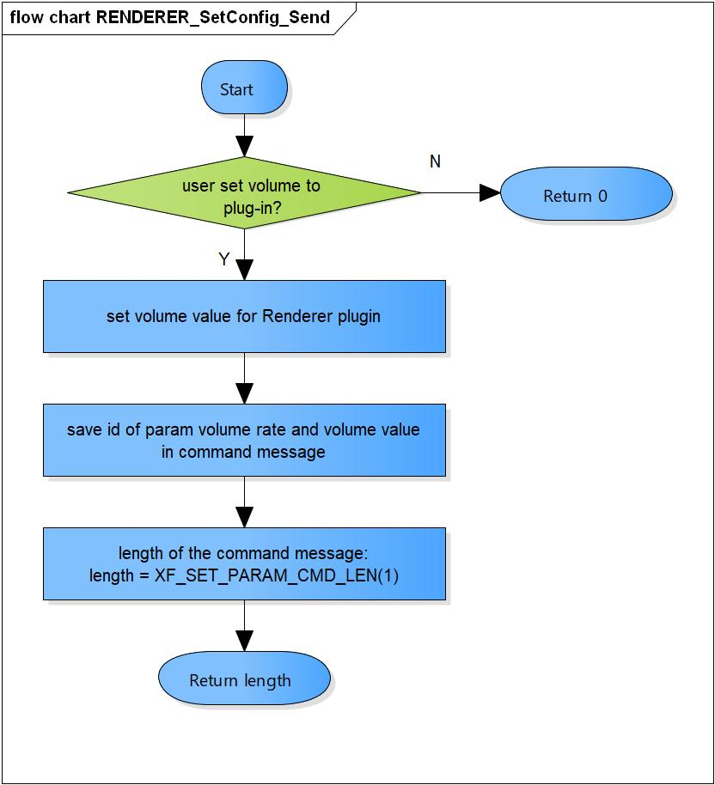

Figure 3‑12 RENDERER_SetConfig_Send flowchart

#### RENDERER_SetConfigIndex

DD_API_RDR_01_013

|  |  |  |  |  |
| --- | --- | --- | --- | --- |
| **Syntax** | static OMX_ERRORTYPE RENDERER_SetConfigIndex(OMX_INDEXTYPE nIndex) | | | |
| **Function** | Check the index of parameter structure is correct. | | | |
| **Arguments** | Type | Name | I/O | Description |
| OMX_INDEXTYPE | nIndex | I | Index of parameter structure.  Supported value:  XAOMX_IndexParamAudioRenderer |
| **Return value** | OMX_ErrorNone | | Normal return. | |
| OMX_ErrorUnsupportedIndex | | Wrong Index of structure. | |
| **Description** | * RENDERER_SetConfig_Send processing:   - Check the index of parameter structure is correct. | | | |

[Covers: FD_API_RDR_006]

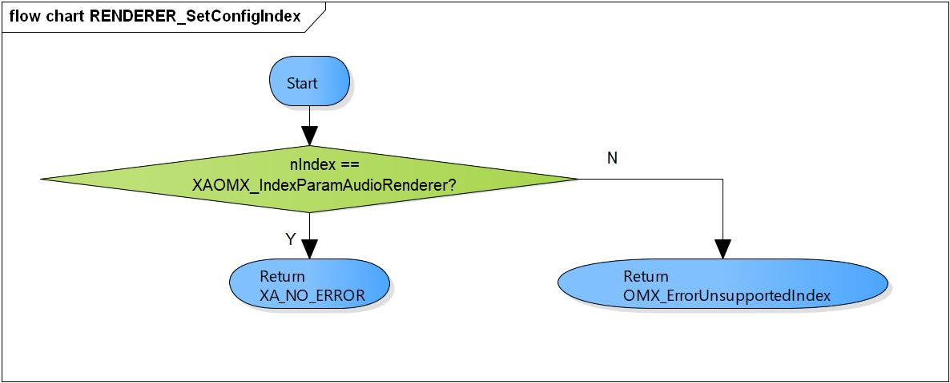

Figure 3‑13 RENDERER_SetConfigIndex flowchart

#### RENDERER_Setup

DD_API_RDR_01_014

|  |  |  |  |  |
| --- | --- | --- | --- | --- |
| **Syntax** | static s32 RENDERER_Setup(XAOMXCodecBase *pBase, xf_set_param_msg_t *msg) | | | |
| **Function** | Renderer prepare codec setup parameters. | | | |
| **Arguments** | Type | Name | I/O | Description |
| XAOMXCodecBase * | pBase | I | Pointer to base codec structure of Renderer component. |
| xf_set_param_msg_t* | msg | O | Message send to Renderer plugin. |
| **Return value** | length | | Number of parameters want to set for Renderer plugin. | |
| **Description** | * Renderer_Setup processing:   - Prepare PCM width, channels, sample rate, output1, 2; DMA channel 1, 2; out sample rate, volume rate, out channel and mix control values and ring-buffer number into command message. | | | |

[Covers: FD_API_RDR_003]

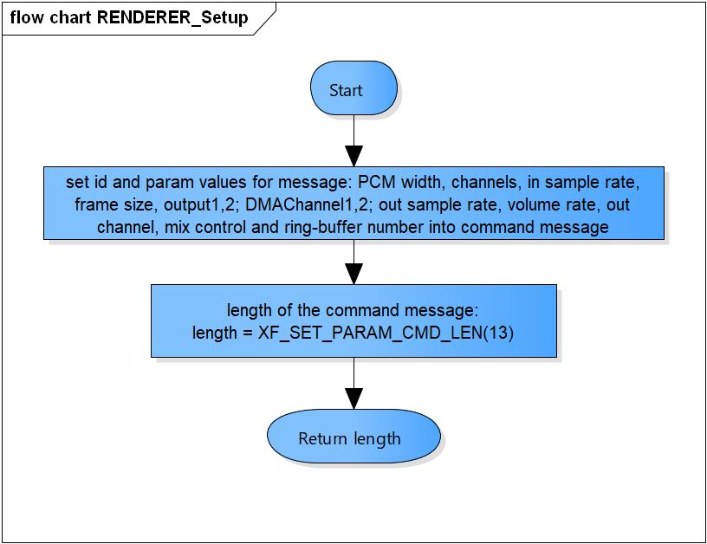

Figure 3‑14 RENDERER_Setup flowchart

#### RENDERER_RuntimeInit

DD_API_RDR_01_015

|  |  |  |  |  |
| --- | --- | --- | --- | --- |
| **Syntax** | static s32 RENDERER_RuntimeInit(XAOMXCodecBase *pBase, xf_start_msg_t *msg) | | | |
| **Function** | This is a dummy function, not use in Renderer runtime initialization. | | | |
| **Arguments** | Type | Name | I/O | Description |
| XAOMXCodecBase * | pBase | I | Pointer to base codec structure of Renderer component. |
| xf_start_msg_t* | msg | O | Message send to Renderer plugin. |
| **Return value** | 0 | | No parameter need to set to plugin. | |
| **Description** | * RENDERER_RuntimeInit processing:   - Return 0. | | | |

[Covers: FD_API_RDR_003]

#### RENDERER_GetParam

DD_API_RDR_01_016

|  |  |  |  |  |
| --- | --- | --- | --- | --- |
| **Syntax** | static s32 RENDERER_GetParam(XAOMXCodecBase *pBase,  xf_get_param_msg_t *msg,  u32 length) | | | |
| **Function** | This is a dummy function. | | | |
| **Arguments** | Type | Name | I/O | Description |
| XAOMXCodecBase * | pBase | I/O | Pointer to base codec structure of RENDERER component. |
| xf_get_param_msg_t * | msg | I | Message receive from RENDERER plugin. |
| u32 | lenghth | I | Length of message. |
| **Return value** | 0 | | Normal return. | |
| -EBADF | | The message length is invalid. | |
| **Description** | * RENDERER_GetParam processing:   - Check the message length is correct and return 0. | | | |

[Covers: FD_API_RDR_003]

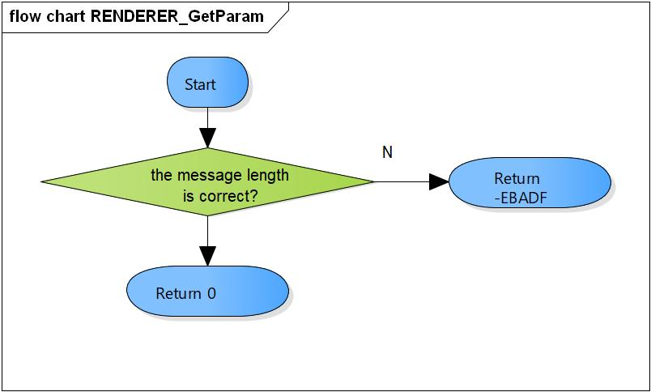

Figure 3‑15 RENDERER_GetParam flowchart

#### RENDERER_TimeStamp

DD_API_RDR_01_017

|  |  |  |  |  |
| --- | --- | --- | --- | --- |
| **Syntax** | static void RENDERER_TimeStamp(XAOMXCodecBase *pBase,  OMX_BUFFERHEADERTYPE *pBufHdr) | | | |
| **Function** | Calculate timestamp for current input buffer and next buffer. | | | |
| **Arguments** | Type | Name | I/O | Description |
| XAOMXCodecBase * | pBase | I | Pointer to base codec structure of RENDERER component. |
| OMX_BUFFERHEADERTYPE* | msg | O | Input buffer. |
| **Return value** | None. | | | |
| **Description** | * RENDERER_TimeStamp processing:   - Add current timestamp to the Input buffer.  - Calculate timestamp for the next buffer. | | | |

[Covers: FD_API_RDR_003]

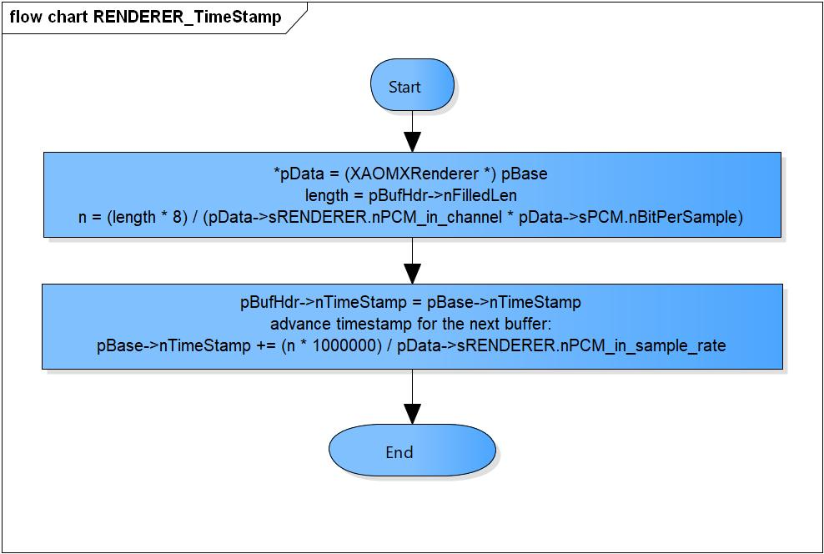

Figure 3‑16 RENDERER_TimeStamp flowchart

#### RENDERER_GetParameter

DD_API_RDR_01_018

|  |  |  |  |  |
| --- | --- | --- | --- | --- |
| **Syntax** | static OMX_ERRORTYPE RENDERER_GetParameter(XAOMXCodecBase *pBase,  OMX_INDEXTYPE nIndex,  OMX_PTR pParam) | | | |
| **Function** | Get parameter and save to pParam. | | | |
| **Arguments** | Type | Name | I/O | Description |
| XAOMXCodecBase * | pBase | I | Pointer to base codec structure of Renderer component. |
| OMX_INDEXTYPE | nIndex | I | Index of parameter structure.  Supported value:  OMX_IndexParamAudioPcm  XAOMX_IndexParamAudioRenderer  OMX_IndexParamCompBufferSupplier |
| OMX_PTR | pParam | O | Pointer to parameter structure want to save. |
| **Return value** | OMX_ErrorNone | | Normal return. | |
| OMX_ErrorUnsupportedIndex | | Wrong Index of structure. | |
| **Description** | * RENDERER_GetParameter processing:   - Get parameters of OMX_AUDIO_PARAM_PCMMODETYPE, XAOMX_AUDIO_PARAM_RENDERER, OMX_PARAM_BUFFERSUPPLIERTYPE structure base on nIndex. | | | |

[Covers: FD_API_RDR_004]

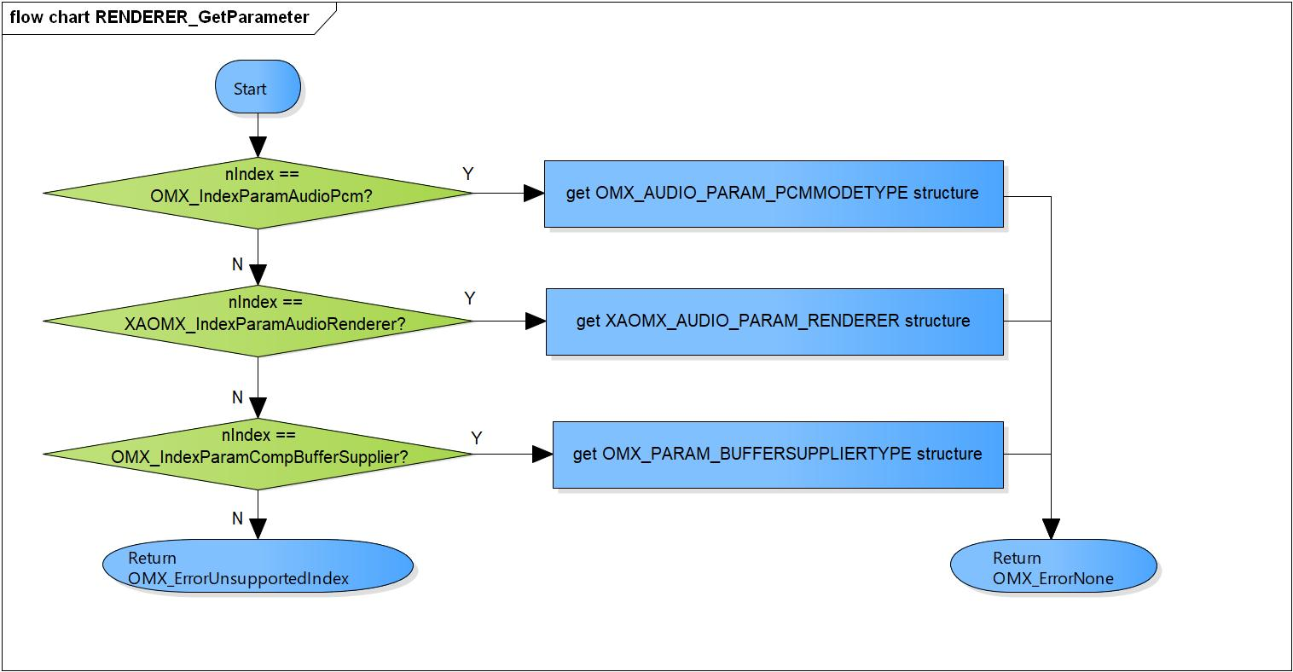

Figure 3‑17 RENDERER_GetParameter flowchart

#### RENDERER_SetParameter

DD_API_RDR_01_019

|  |  |  |  |  |
| --- | --- | --- | --- | --- |
| **Syntax** | static OMX_ERRORTYPE RENDERER_SetParameter(XAOMXCodecBase *pBase,  OMX_INDEXTYPE nIndex,  OMX_PTR pParam) | | | |
| **Function** | Set parameter from pParam and save to parameter structure. | | | |
| **Arguments** | Type | Name | I/O | Description |
| XAOMXCodecBase * | pBase | I/O | Pointer to base codec structure of Renderer component. |
| OMX_INDEXTYPE | nIndex | I | Index of parameter structure.  Supported range:  OMX_IndexParamAudioPcm  XAOMX_IndexParamAudioRenderer  OMX_IndexParamCompBufferSupplier |
| OMX_PTR | pParam | I | Pointer to parameter structure want to set. |
| **Return value** | OMX_ErrorNone | | Normal return. | |
| OMX_ErrorUnsupportedIndex | | Wrong Index of structure | |
| OMX_ErrorBadPortIndex | | Port index is invalid. | |
| **Description** | * RENDERER_SetParameter processing:   - Set parameters of OMX_AUDIO_PARAM_PCMMODETYPE, XAOMX_AUDIO_PARAM_RENDERER, OMX_PARAM_BUFFERSUPPLIERTYPE structure base on nIndex. | | | |

[Covers: FD_API_RDR_005]

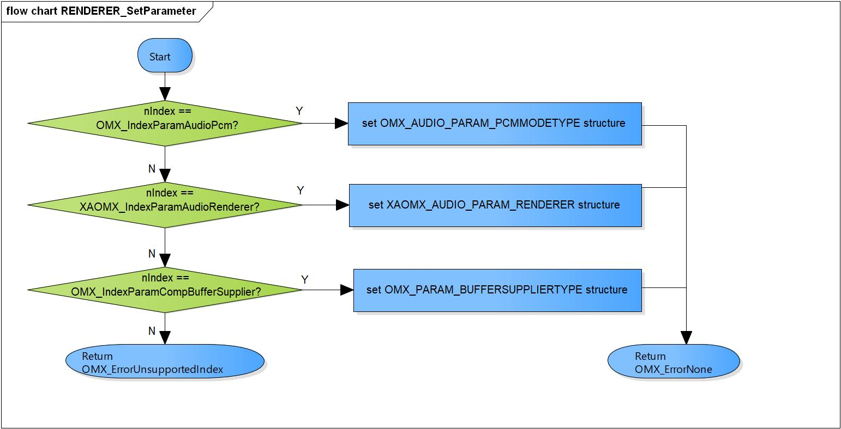

Figure 3‑18 RENDERER_SetParameter flowchart

#### RENDERER_ComponentInit

DD_API_RDR_01_020

|  |  |  |  |  |
| --- | --- | --- | --- | --- |
| **Syntax** | static OMX_ERRORTYPE RENDERER_ComponentInit(xf_proxy_t *proxy,  OMX_HANDLETYPE hComponent,  OMX_PTR pAppData,  OMX_CALLBACKTYPE *pCallbacks) | | | |
| **Function** | Initialize base codec interface, parameters, PCM and Renderer format. | | | |
| **Arguments** | Type | Name | I/O | Description |
| xf_proxy_t * | proxy | O | OpenMAX interface proxy. |
| OMX_HANDLETYPE | hComponent | O | Pointer to Renderer component handle. |
| OMX_PTR | pAppData | I | Pointer to pAppData of Renderer component. |
| OMX_CALLBACKTYPE | pCallbacks | I | Pointer to Callbacks of Renderer component. |
| **Return value** | OMX_ErrorNone | | Normal return. | |
| OMX_ErrorInsufficientResources | | Initialize base codec interface is fail. | |
| **Description** | * RENDERER_ComponentInit processing:   - Initialize base codec interface, parameters, PCM and Renderer format. | | | |

[Covers: FD_API_RDR_001]

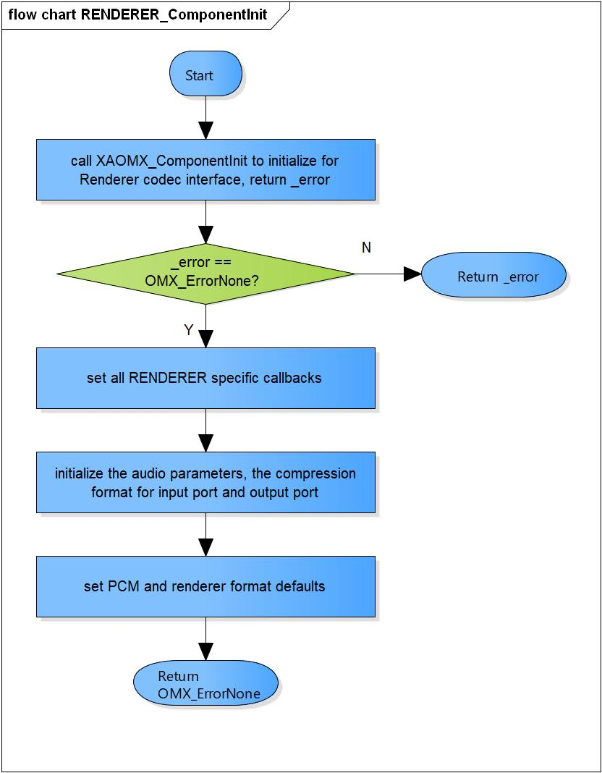

Figure 3‑19 RENDERER_ComponentInit flowchart

#### RENDERER_ComponentDeInit

DD_API_RDR_01_021

|  |  |  |  |  |
| --- | --- | --- | --- | --- |
| **Syntax** | static OMX_ERRORTYPE RENDERER_ComponentDeInit(OMX_HANDLETYPE hComponent) | | | |
| **Function** | Destroy Renderer component and private data. | | | |
| **Arguments** | Type | Name | I/O | Description |
| OMX_HANDLETYPE | hComponent | I | Pointer to Renderer component handle. |
| **Return value** | OMX_ErrorNone | | Normal return. | |
| OMX_ErrorBadParameter | | Private data is NULL | |
| **Description** | * RENDERER_ComponentDeInit processing:   - Destroy Renderer component and private data. | | | |

[Covers: FD_API_RDR_002]

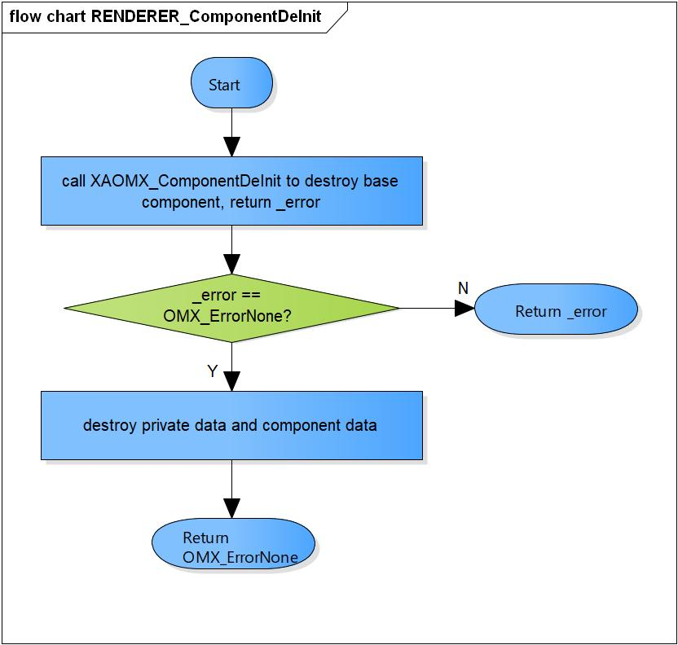

Figure 3‑20 RENDERER_ComponentDeInit flowchart

#### RENDERER_ComponentCreate

DD_API_RDR_01_022

|  |  |  |  |  |
| --- | --- | --- | --- | --- |
| **Syntax** | OMX_ERRORTYPE RENDERER_ComponentCreate(xf_proxy_t *proxy, OMX_HANDLETYPE *hComponent, OMX_PTR pAppData, OMX_CALLBACKTYPE *pCallbacks) | | | |
| **Function** | Create base component and initialize the Renderer component. | | | |
| **Arguments** | Type | Name | I/O | Description |
| xf_proxy_t* | proxy | O | OpenMAX interface proxy. |
| OMX_HANDLETYPE* | hComponent | O | Pointer to Renderer component handle. |
| OMX_PTR | pAppData | I | Pointer to pAppData of Renderer component. |
| OMX_CALLBACKTYPE * | pCallbacks | I | Pointer to Callbacks of Renderer component. |
| **Return value** | OMX_ErrorNone | | Normal return. | |
| OMX_ErrorInsufficientResources | | Cannot create the base component.  Cannot allocate private memory.  Initialize the Renderer component is fail. | |
| **Description** | * RENDERER_ComponentCreate processing:   - Create the base component.  - Allocate the private memory.  - Initialize the Renderer component. | | | |

[Covers: FD_API_RDR_001]

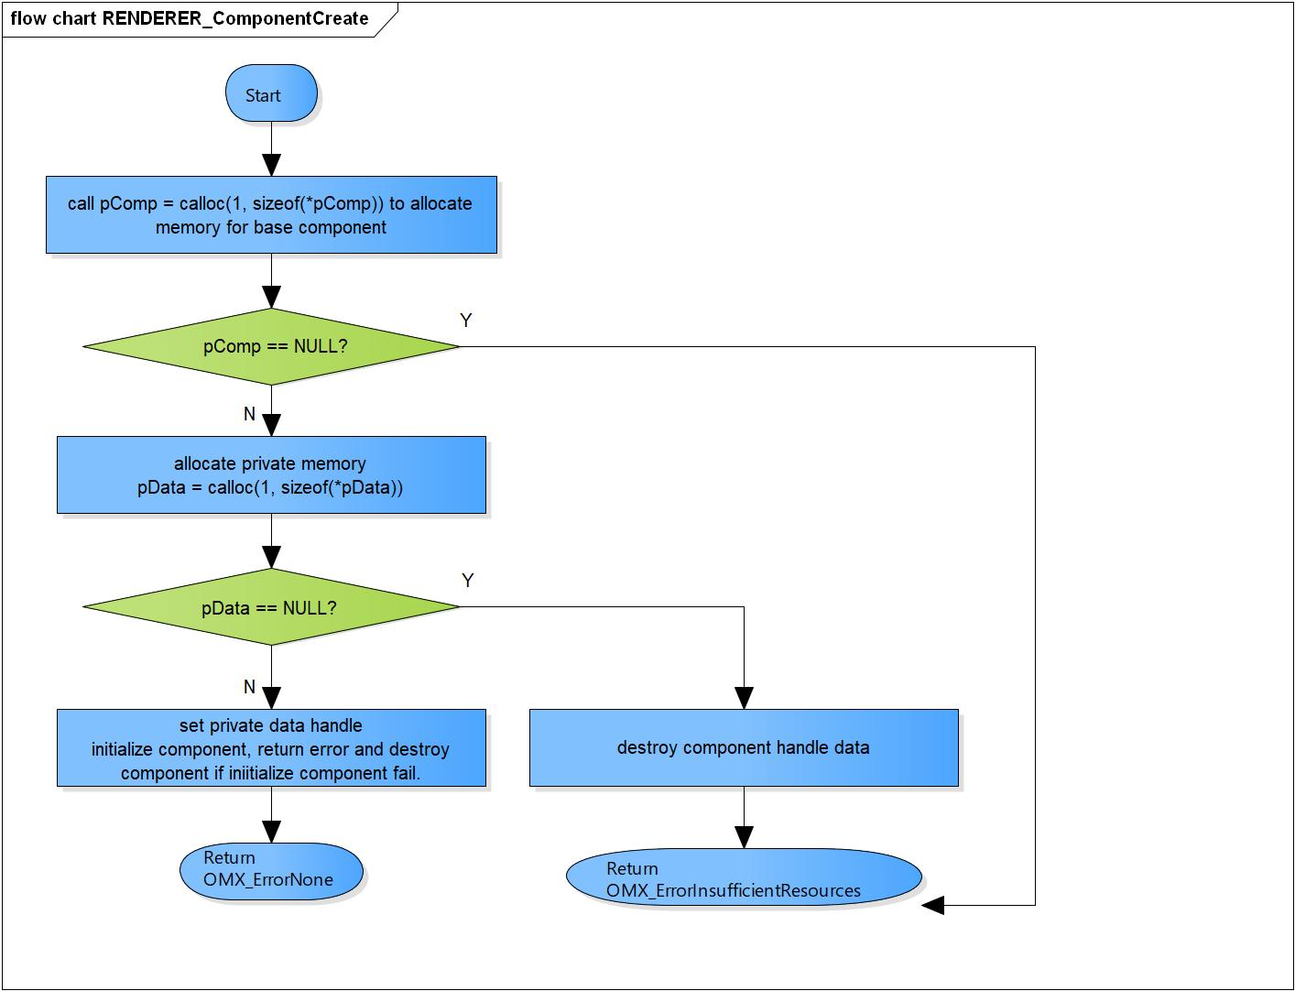

Figure 3‑21 RENDERER_ComponentCreate flowchart

# Revision history

|  |  |  |  |  |  |
| --- | --- | --- | --- | --- | --- |
| **Version** | **Date** | **Page** | **Content** | **Approved** | **Changed** |
| 1.0.0 | Nov 14 2018 | - | First Edition issued | Vu Phan | Vu Phan |
| 1.1.0 | Dec 10 2018 | - | Add traceability ID | Vu Phan | Ngu Pham |
| 1.2.0 | Jan 03, 2019 | - | Add range for input parameters | Vu Phan | Tien Tran |
| 1.3.0 | Apr 16, 2019 | 8, 20 | Update for Android |  |  |