**Document Type: Detail Design**

**Document Name:**

**ADSP OMX RDR**

Renesas Design Vietnam Co. Ltd

R-Car Software Solution 2 Group

Middleware 1 Team

Renesas Electronics Corporation

Table of Contents

1. Overview 3

2. Function list 4

3. Detail information 5

3.1 Data type and Macro definition 5

3.2 Function definition 6

3.2.1 EQUALIZER_Setup 6

3.2.2 EQUALIZER_RuntimeInit 7

3.2.3 EQUALIZER_GetParam 8

3.2.4 EQUALIZER_TimeStamp 9

3.2.5 EQUALIZER_GetParameter 10

3.2.6 EQUALIZER_SetParameter 11

3.2.7 EQUALIZER_ComponentInit 12

3.2.8 EQUALIZER_ComponentDeInit 13

3.2.9 EQUALIZER_ComponentCreate 14

4. Revision history 16

List of Figures

Figure 1‑1 The software architecture 3

Figure 3‑1 EQUALIZER_Setup flowchart 6

Figure 3‑2 EQUALIZER_RuntimeInit flowchart 7

Figure 3‑3 EQUALIZER_GetParam flowchart 8

Figure 3‑4 EQUALIZER_TimeStamp flowchart 9

Figure 3‑5 EQUALIZER_GetParameter flowchart 10

Figure 3‑6 EQUALIZER_SetParameter flowchart 11

Figure 3‑7 EQUALIZER_ComponentInit flowchart 12

Figure 3‑8 EQUALIZER_ComponentDeInit flowchart 13

Figure 3‑9 EQUALIZER_ComponentCreate flowchart 15

List of Table

Table 2‑1 Function list of OMX Equalizer 4

Table 3‑1 XAOMXEqualizer type structure information 5

Table 3‑2 Macro definitions of OMX Equalizer 5

# Overview

In this chapter, overview of OMX Equalizer interface is explained.

User Application

OMX TDM

OMX Renderer/Capture

OMX Equalizer

User Space

ADSP Interface for Linux (base)

Kernel Space

ARM

ADSP Driver for Linux

Audio HW

ADSP

NC/EC

ADSP Framework

Renderer/Capture Plugin

TDM Plugin

Equalizer Plugin

Codec

This document’s target is in side of red square.

DAC/ADC

SRC/CTU/MIX/ DVC/ SSI/

ADMA

Figure 1‑1 ****The software architecture****

# Function list

The following is list of functions:

Table 2‑1 Function list of OMX Equalizer

|  |  |  |
| --- | --- | --- |
| **No.** | **Function Name** | **Outline** |
| 1 | EQUALIZER_Setup | Equalizer prepare codec setup parameters. |
| 2 | EQUALIZER_RuntimeInit | Return no parameter is set in runtime. |
| 3 | EQUALIZER_GetParam | Check the message length is 0. |
| 4 | EQUALIZER_TimeStamp | Calculate timestamp for current output buffer and next buffer. |
| 5 | EQUALIZER_GetParameter | Get Equalizer parameter. |
| 6 | EQUALIZER_SetParameter | Set Equalizer parameter. |
| 7 | EQUALIZER_ComponentDeInit | Destroy Equalizer component and private data. |
| 8 | EQUALIZER_ComponentInit | Initialize base codec interface, parameters, PCM and Equalizer format. |
| 9 | EQUALIZER_ComponentCreate | Create base component and initialize the Equalizer component. |

# Detail information

This section describes detail information of data types, macro definitions.

## Data type and Macro definition

Table 3‑1 XAOMXEqualizer type structure information

|  |  |
| --- | --- |
| Member name | Outline |
| XAOMXCodecBase base | Generic codec structure. |
| OMX_AUDIO_PARAM_PCMMODETYPE sPCM_in | PCM-specific parameters (input port). |
| OMX_AUDIO_PARAM_PCMMODETYPE sPCM_out | PCM-specific parameters (output port). |
| XAOMX_AUDIO_PARAM_EQUALIZER sEQU | Equalizer parameters. |

Note:

Struct XAOMXCodecBase is a base codec structure of OMX in omx-codec-base.h

Struct OMX_AUDIO_PARAM_PCMMODETYPE is a PCM format description in OMX_Audio.h

Struct XAOMX_AUDIO_PARAM_EQUALIZER is a parametric Equalizer settings structure.

Table 3‑2 Macro definitions of OMX Equalizer

|  |  |  |
| --- | --- | --- |
| Macro | Value | Outline |
| NUM_INPUT_BUFFERS | 4 | Total amount of input buffers. |
| INPUT_BUFFER_LENGTH | 4096 | Default input buffer length. |
| NUM_OUTPUT_BUFFERS | 4 | Total amount of output buffers. |
| OUTPUT_BUFFER_LENGTH | 4096 | Default output buffer length. |
| BUFFER_ALIGNMENT | 32 | Required data alignment of Equalizer. |

## Function definition

### EQUALIZER_Setup

DD_API_EQZ_01_001

|  |  |  |  |  |
| --- | --- | --- | --- | --- |
| **Syntax** | static s32 EQUALIZER_Setup(XAOMXCodecBase*pBase, xf_set_param_msg_t *msg) | | | |
| **Function** | Equalizer prepare codec setup parameters. | | | |
| **Arguments** | Type | Name | I/O | Description |
| XAOMXCodecBase* | pBase | I | Pointer to base codec structure of Equalizer component. |
| xf_set_param_msg_t* | msg | O | Message send to Equalizer plugin. |
| **Return value** | length | | Number of parameters want to set for Equalizer plugin. | |
| **Description** | * EQUALIZER_Setup processing:   - Prepare PCM width, sample rate, Equalizer type, center frequencies, filter type, filter bandwidth, filter gain, and filter gain base values into command message. | | | |

[Covers: FD_API_EQZ_003]

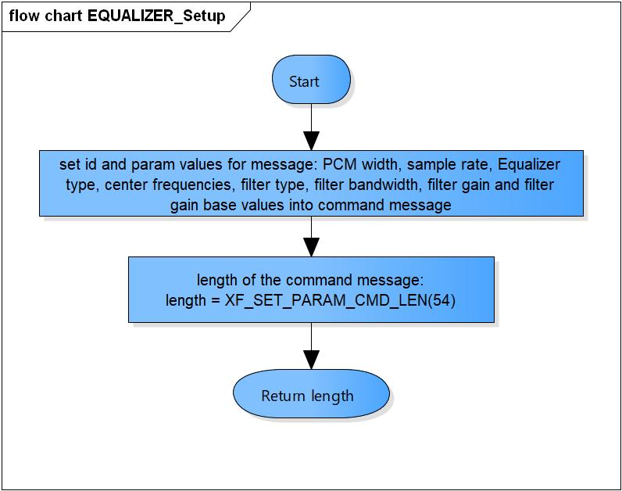

Figure 3‑1 EQUALIZER_Setup flowchart

### EQUALIZER_RuntimeInit

DD_API_EQZ_01_002

|  |  |  |  |  |
| --- | --- | --- | --- | --- |
| **Syntax** | static s32 EQUALIZER_RuntimeInit(XAOMXCodecBase*pBase, xf_start_msg_t *msg) | | | |
| **Function** | Return no parameter is set in runtime. | | | |
| **Arguments** | Type | Name | I/O | Description |
| XAOMXCodecBase* | pBase | I | Pointer to base codec structure of Equalizer component. |
| xf_start_msg_t* | msg | O | Message send to Equalizer plugin. |
| **Return value** | 0 | | No parameter is set in runtime | |
| **Description** | * EQUALIZER_RuntimeInit processing:   - Return no parameter is set in runtime. | | | |

[Covers: FD_API_EQZ_003]

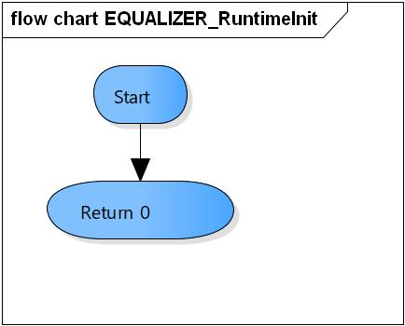

Figure 3‑2 EQUALIZER_RuntimeInit flowchart

### EQUALIZER_GetParam

DD_API_EQZ_01_003

|  |  |  |  |  |
| --- | --- | --- | --- | --- |
| **Syntax** | static s32 EQUALIZER_GetParam(XAOMXCodecBase *pBase,  xf_get_param_msg_t *msg,  u32 length) | | | |
| **Function** | Check the message length is 0. | | | |
| **Arguments** | Type | Name | I/O | Description |
| XAOMXCodecBase* | pBase | I | Pointer to base codec structure of Equalizer component. |
| xf_get_param_msg_t * | msg | I | Message receive from Equalizer plugin. |
| u32 | length | I | Length of message. |
| **Return value** | 0 | | Normal return. | |
| -EBADF | | The message length is invalid. | |
| **Description** | * EQUALIZER_GetParam processing:   - Check the message length is 0. | | | |

[Covers: FD_API_EQZ_003]

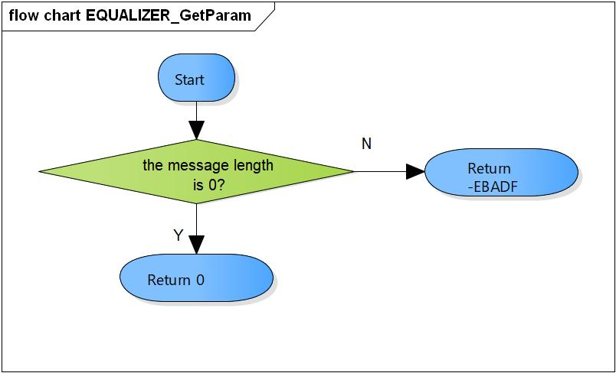

Figure 3‑3 EQUALIZER_GetParam flowchart

### EQUALIZER_TimeStamp

DD_API_EQZ_01_004

|  |  |  |  |  |
| --- | --- | --- | --- | --- |
| **Syntax** | static void EQUALIZER_TimeStamp(XAOMXCodecBase *pBase,  OMX_BUFFERHEADERTYPE *pBufHdr) | | | |
| **Function** | Calculate timestamp for current output buffer and next buffer. | | | |
| **Arguments** | Type | Name | I/O | Description |
| XAOMXCodecBase* | pBase | I/O | Pointer to base codec structure of Equalizer component. |
| OMX_BUFFERHEADERTYPE* | msg | I | Output buffer. |
| **Return value** | None. | | | |
| **Description** | * EQUALIZER_TimeStamp processing:   - Add current timestamp to the output buffer.  - Calculate timestamp for the next buffer. | | | |

[Covers: FD_API_EQZ_003]

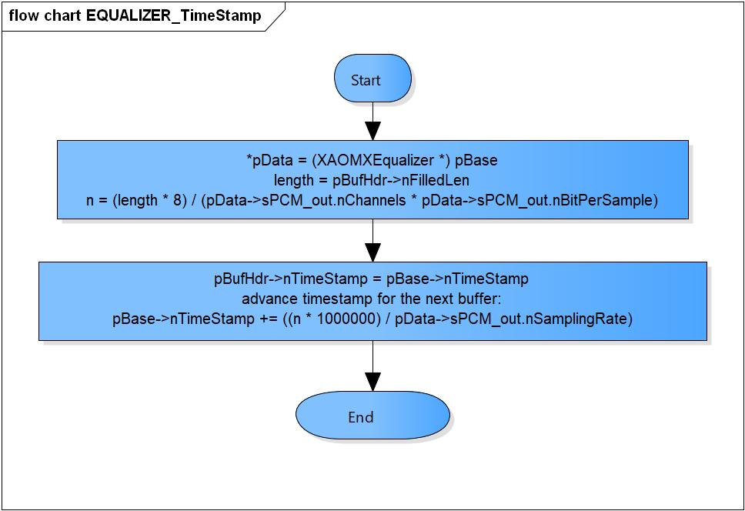

Figure 3‑4 EQUALIZER_TimeStamp flowchart

### EQUALIZER_GetParameter

DD_API_EQZ_01_005

|  |  |  |  |  |
| --- | --- | --- | --- | --- |
| **Syntax** | static OMX_ERRORTYPE EQUALIZER_GetParameter(XAOMXCodecBase *pBase,  OMX_INDEXTYPE nIndex,  OMX_PTR pParam) | | | |
| **Function** | Get parameter and save to pParam. | | | |
| **Arguments** | Type | Name | I/O | Description |
| XAOMXCodecBase* | pBase | I | Pointer to base codec structure of Equalizer component. |
| OMX_INDEXTYPE | nIndex | I | Index of parameter structure.  Supported range:  OMX_IndexParamAudioPcm  XAOMX_IndexParamAudioEqualizer  OMX_IndexParamCompBufferSupplier |
| OMX_PTR | pParam | O | Pointer to parameter structure want to save. |
| **Return value** | OMX_ErrorNone | | Normal return. | |
| OMX_ErrorUnsupportedIndex | | Wrong Index of structure. | |
| **Description** | * EQUALIZER_GetParameter processing:   - Get parameters of OMX_AUDIO_PARAM_PCMMODETYPE, XAOMX_AUDIO_PARAM_EQUALIZER, OMX_PARAM_BUFFERSUPPLIERTYPE structure base on nIndex. | | | |

[Covers: FD_API_EQZ_004]

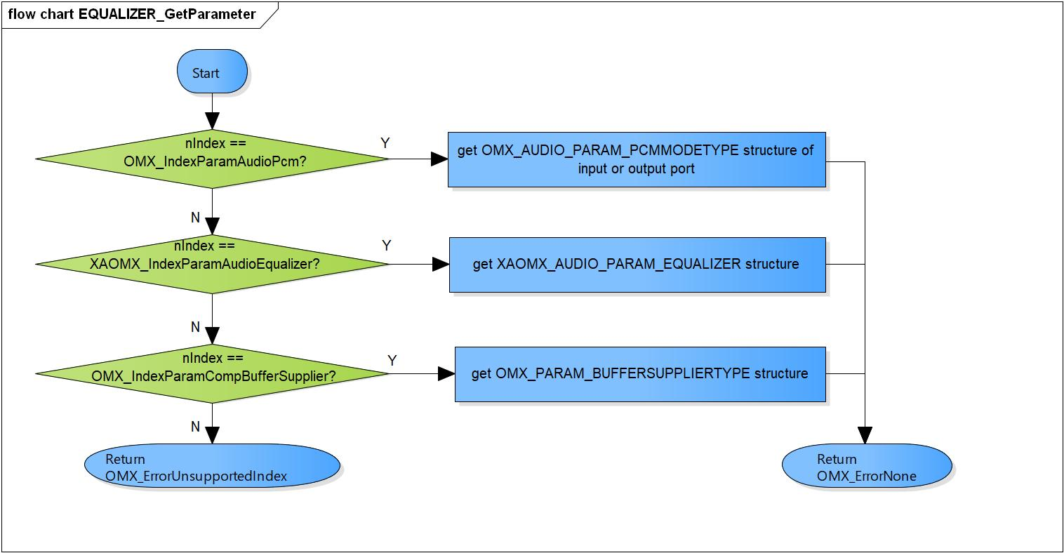

Figure 3‑5 EQUALIZER_GetParameter flowchart

### EQUALIZER_SetParameter

DD_API_EQZ_01_006

|  |  |  |  |  |
| --- | --- | --- | --- | --- |
| **Syntax** | static OMX_ERRORTYPE EQUALIZER_SetParameter(XAOMXCodecBase *pBase,  OMX_INDEXTYPE nIndex,  OMX_PTR pParam) | | | |
| **Function** | Set parameter from pParam and save to parameter structure. | | | |
| **Arguments** | Type | Name | I/O | Description |
| XAOMXCodecBase* | pBase | I/O | Pointer to base codec structure of Equalizer component. |
| OMX_INDEXTYPE | nIndex | I | Index of parameter structure.  Supported range:  OMX_IndexParamAudioPcm  XAOMX_IndexParamAudioEqualizer  OMX_IndexParamCompBufferSupplier |
| OMX_PTR | pParam | O | Pointer to parameter structure want to set. |
| **Return value** | OMX_ErrorNone | | Normal return. | |
| OMX_ErrorUnsupportedIndex | | Wrong Index of structure. | |
| OMX_ErrorBadPortIndex | | Port index is invalid | |
| **Description** | * EQUALIZER_SetParameter processing:   - Set parameters of OMX_AUDIO_PARAM_PCMMODETYPE, XAOMX_AUDIO_PARAM_EQUALIZER, OMX_PARAM_BUFFERSUPPLIERTYPE structure base on nIndex. | | | |

[Covers: FD_API_EQZ_005]

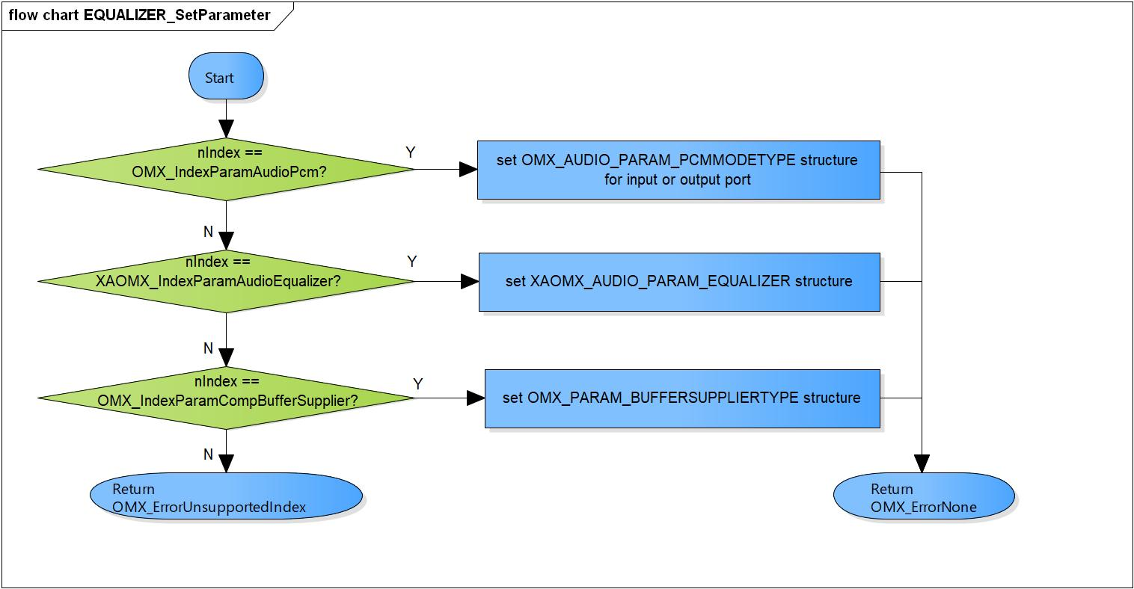

Figure 3‑6 EQUALIZER_SetParameter flowchart

### EQUALIZER_ComponentInit

DD_API_EQZ_01_007

|  |  |  |  |  |
| --- | --- | --- | --- | --- |
| **Syntax** | static OMX_ERRORTYPE EQUALIZER_ComponentInit(xf_proxy_t *proxy,  OMX_HANDLETYPE hComponent,  OMX_PTR pAppData,  OMX_CALLBACKTYPE *pCallbacks) | | | |
| **Function** | Initialize base codec interface, parameters, PCM and Equalizer format. | | | |
| **Arguments** | Type | Name | I/O | Description |
| xf_proxy_t* | proxy | O | OpenMAX interface proxy. |
| OMX_HANDLETYPE | hComponent | O | Pointer to Equalizer component handle. |
| OMX_PTR | pAppData | I | Pointer to pAppData of Equalizer component. |
| OMX_CALLBACKTYPE | pCallbacks | I | Pointer to Callbacks of Equalizer component. |
| **Return value** | OMX_ErrorNone | | Normal return. | |
| OMX_ErrorInsufficientResources | | Initialize base codec interface is fail. | |
| **Description** | * EQUALIZER_ComponentInit processing:   - Initialize base codec interface, parameters, PCM and Equalizer format. | | | |

[Covers: FD_API_EQZ_001]

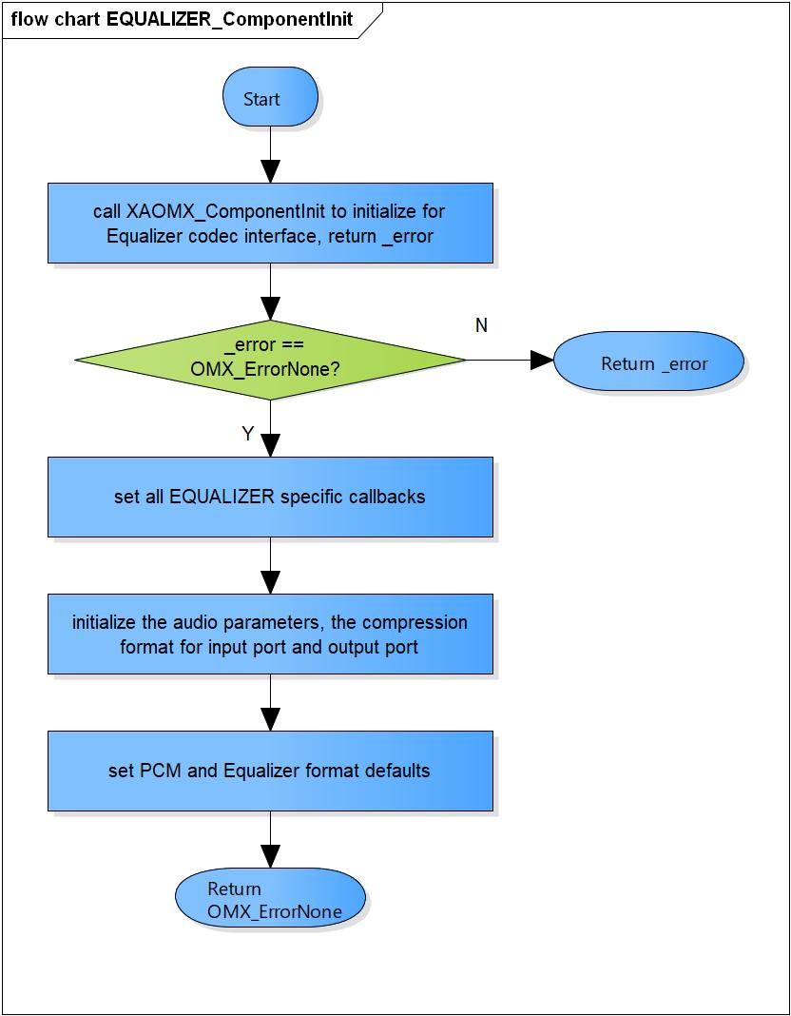

Figure 3‑7 EQUALIZER_ComponentInit flowchart

### EQUALIZER_ComponentDeInit

DD_API_EQZ_01_008

|  |  |  |  |  |
| --- | --- | --- | --- | --- |
| **Syntax** | static OMX_ERRORTYPE EQUALIZER_ComponentDeInit(OMX_HANDLETYPE hComponent) | | | |
| **Function** | Destroy Equalizer component and private data. | | | |
| **Arguments** | Type | Name | I/O | Description |
| OMX_HANDLETYPE | hComponent | O | Pointer to Equalizer component handle. |
| **Return value** | OMX_ErrorNone | | Normal return. | |
| OMX_ErrorBadParameter | | Private data is NULL. | |
| **Description** | * EQUALIZER_ComponentDeInit processing:   - Destroy Equalizer component and private data. | | | |

[Covers: FD_API_EQZ_002]

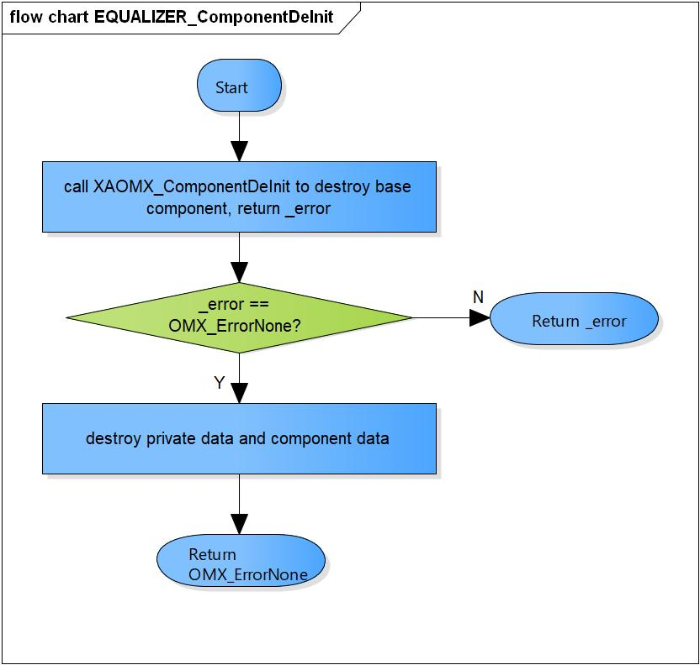

Figure 3‑8 EQUALIZER_ComponentDeInit flowchart

### EQUALIZER_ComponentCreate

DD_API_EQZ_01_009

|  |  |  |  |  |
| --- | --- | --- | --- | --- |
| **Syntax** | OMX_ERRORTYPE EQUALIZER_ComponentCreate(xf_proxy_t *proxy, OMX_HANDLETYPE *hComponent, OMX_PTR pAppData, OMX_CALLBACKTYPE *pCallbacks) | | | |
| **Function** | Create base component and initialize the Equalizer component. | | | |
| **Arguments** | Type | Name | I/O | Description |
| xf_proxy_t* | proxy | O | OpenMAX interface proxy |
| OMX_HANDLETYPE* | hComponent | O | Pointer to Equalizer component handle |
| OMX_PTR | pAppData | I | Pointer to pAppData of Equalizer component |
| OMX_CALLBACKTYPE* | pCallbacks | I | Pointer to Callbacks of Equalizer component |
| **Return value** | OMX_ErrorNone | | Normal return. | |
| OMX_ErrorInsufficientResources | | Cannot create the base component.  Cannot allocate private memory.  Initialize the Equalizer component is fail. | |
| **Description** | * EQUALIZER_ComponentCreate processing:   - Create the base component.  - Allocate the private memory.  - Initialize the Equalizer component. | | | |

[Covers: FD_API_EQZ_001]

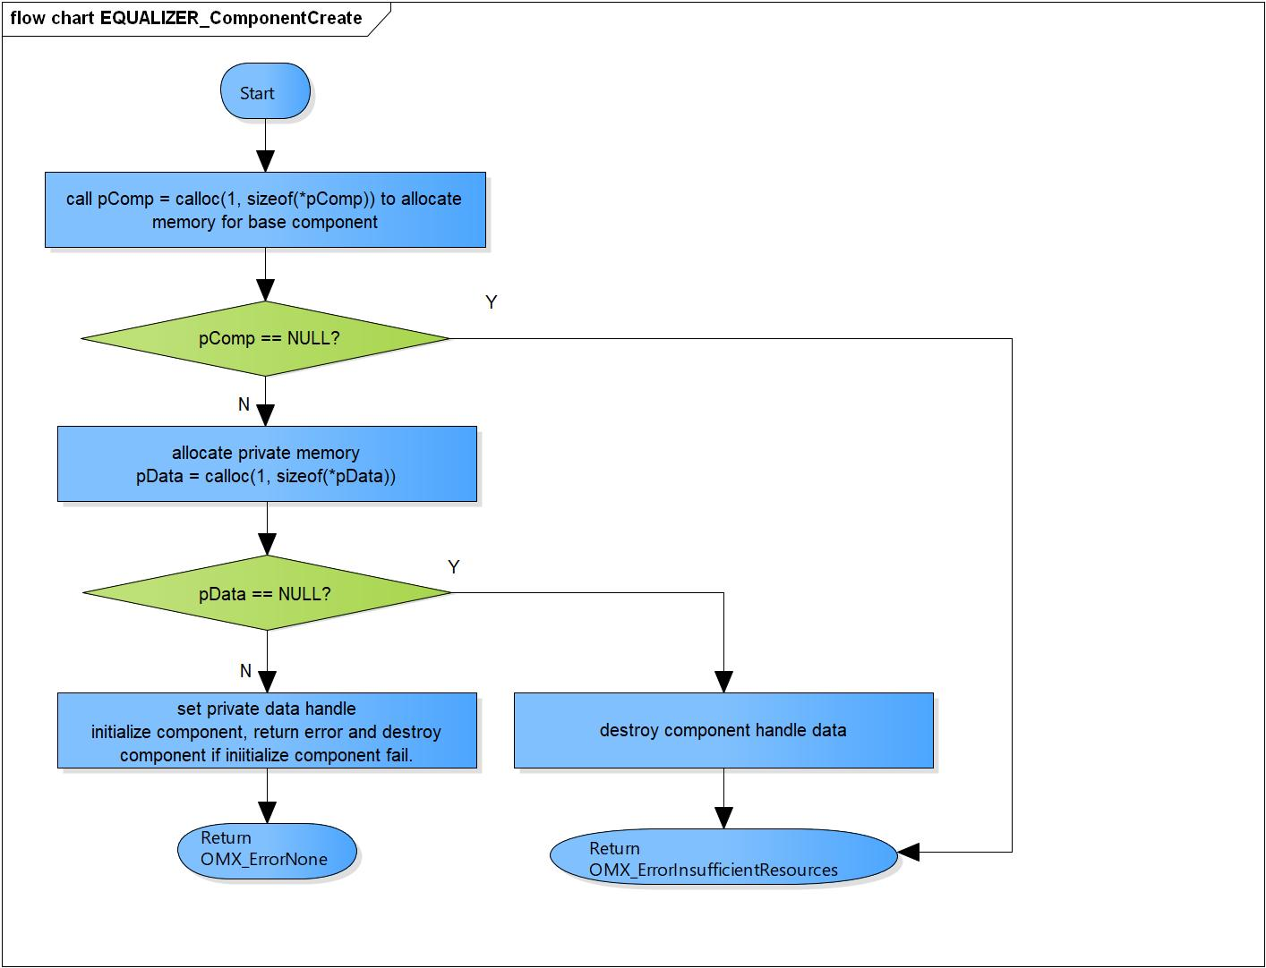

Figure 3‑9 EQUALIZER_ComponentCreate flowchart

# Revision history

|  |  |  |  |  |  |
| --- | --- | --- | --- | --- | --- |
| **Version** | **Date** | **Page** | **Content** | **Approved** | **Changed** |
| 1.0.0 | Nov 14 2018 | - | First Edition issued | Vu Phan | Vu Phan |
| 1.1.0 | Dec 10 2018 | - | Add traceability ID | Vu Phan | Ngu Pham |
| 1.2.0 | Jan 03, 2019 | - | Add range for input parameters | Vu Phan | Tien Tran |