**Document Type: Detail Design**

**Document Name:**

**ADSP FRAMEWORK: CAPTURE CLASS**

Renesas Design Vietnam Co. Ltd

R-Car Software Solution 2 Group

Middleware 1 Team

Renesas Electronics Corporation

Table of Contents

1. Overview 3

2. Function list 4

3. Detail information 5

3.1 Data type and Macro definition 5

3.2 Globle variable 6

3.3 Function definition 7

3.3.1 xa_capture_prepare_runtime 7

3.3.2 xa_capture_empty_this_buffer 9

3.3.3 xa_capture_fill_this_buffer 10

3.3.4 xa_capture_memtab 12

3.3.5 xa_capture_port_route 14

3.3.6 xa_capture_port_unroute 16

3.3.7 xa_capture_preprocess 17

3.3.8 xa_capture_postprocess 19

3.3.9 xa_capture_flush 21

3.3.10 xa_capture_cleanup 23

3.3.11 xa_capture_terminate 25

3.3.12 xa_capture_destroy 26

3.3.13 xa_capture_factory 27

4. Revision history 28

List of Figures

Figure 1‑1 The software architecture 3

Figure 3‑1 xa_capture_prepare_runtime flowchart 8

Figure 3‑2 xa_capture_empty_this_buffer flowchart 9

Figure 3‑3 xa_capture_fill_this_buffer flowchart 11

Figure 3‑4 xa_capture_memtab flowchart 13

Figure 3‑5 xa_capture_port_route flowchart 15

Figure 3‑6 xa_capture_port_unroute flowchart 16

Figure 3‑7 xa_capture_preprocess flowchart 18

Figure 3‑8 xa_capture_postprocess flowchart 20

Figure 3‑9 xa_capture_flush flowchart 22

Figure 3‑10 xa_capture_cleanup flowchart 24

Figure 3‑11 xa_capture_terminate flowchart 25

Figure 3‑12 xa_capture_destroy flowchart 26

Figure 3‑13 xa_capture_factory flowchart 27

List of Table

Table 2‑1 Function list 4

Table 3‑1 XACapture type structure information 5

Table 3‑2 Macro definitions 5

Table 3‑3 Globle variable xa_capture_cmd 6

# Overview

This section provides an overview of the software architecture.

User Application

ADSP Interface

Kernel Space

User Space

ADSP Driver

ARM

Audio HW

**ADSP Framework**

TDM class

Equalizer class

Capture class

Renderer class

ADSP

Plugin

Equalizer Plugin*

TDM Plugin

Capture Plugin

Renderer Plugin

This document’s target is in side of red square

* not connect to SCU/SSI ADMA block

SCU/ SSI/

ADMA

DAC/

ADC

Figure 1‑1 ****The software architecture****

# Function list

The following is list of functions:

Table 2‑1 Function list

|  |  |  |
| --- | --- | --- |
| **Type** | **Function Name** | **Outline** |
| API | xa_capture_factory | This API is to construct generic audio component and set functions pointer for internal functions. |
| Internal functions | xa_capture_prepare_runtime | This function is to prepare capture for steady operation. |
| xa_capture_empty_this_buffer | This function is to check end of stream for input port. |
| xa_capture_fill_this_buffer | This function is to place message into output port. |
| xa_capture_flush | This function is to purge port queue. |
| xa_capture_memtab | This function is to initialize output port. |
| xa_capture_port_route | This function is to route output port - allocate buffers. |
| xa_capture_port_unroute | This function is to unroute output port and destroy all buffers allocated. |
| xa_capture_preprocess | This function is to set the output buffer pointer. |
| xa_capture_postprocess | This function is to get number of produced bytes and reschedule processing. |
| xa_capture_terminate | This is capture termination-state command processor function. |
| xa_capture_destroy | This function is to destroy component. |
| xa_capture_cleanup | This function is to purge port queue and cancel component task execution. |

# Detail information

This section describes detail information of data types, macro definitions, implemented APIs and internal function units, global variable.

## Data type and Macro definition

The XACapture type structure is the work area used by the capture class. When using this class, secure the area with the application program. It’s not necessary to refer to this area because it only contains the internal variables and working buffers of the class. Make sure not to change the value of this area with the application program.

Table 3‑1 XACapture type structure information

|  |  |
| --- | --- |
| Member name | Outline |
| XACodecBase base | Generic audio codec data |
| xf_input_port_t input | Input port queue |
| xf_output_port_t output | Output port queue |
| WORD32 out_idx | Output port index |
| u32 factor | Time conversion factor (input byte "duration" in timebase units) |
| u32 sample_size | Sample size in bytes |
| u32 produced | Total number of samples which produced from plugin since last execution |

Table 3‑2 Macro definitions

|  |  |  |
| --- | --- | --- |
| Macro | Value | Outline |
| XA_CAP_FLAG_ RUNNING | __XA_BASE_FLAG(1 << 0) | Capture is performed |
| XA_CAP_FLAG_SILENCE | __XA_BASE_FLAG(1 << 1) | Capture is idle and produces silence |
| XA_CAP_FLAG_INPUT_READY | __XA_BASE_FLAG(1 << 2) | Input data is ready |

Note: Macro __XA_BASE_FLAG(f) ((f) << 6) is in xa-class-base.h file.

## Globle variable

Table 3‑3 Globle variable xa_capture_cmd

|  |  |
| --- | --- |
| static XA_ERRORCODE (* const xa_capture_cmd[])(XACodecBase *base, xf_message_t *m) | |
| Description: variable stores function pointers according to opcode index to run in runtime operation. | |
| Array index | Value (function pointer) |
| XF_OPCODE_TYPE(XF_SET_PARAM) | xa_base_set_param |
| XF_OPCODE_TYPE(XF_GET_PARAM) | xa_base_get_param |
| XF_OPCODE_TYPE(XF_ROUTE) | xa_capture_port_route |
| XF_OPCODE_TYPE(XF_UNROUTE) | xa_capture_port_unroute |
| XF_OPCODE_TYPE(XF_EMPTY_THIS_BUFFER) | xa_capture_empty_this_buffer |
| XF_OPCODE_TYPE(XF_FILL_THIS_BUFFER) | xa_capture_fill_this_buffer |
| XF_OPCODE_TYPE(XF_FLUSH) | xa_capture_flush |

Note: Marco XF_OPCODE_TYPE(opcode) : ((opcode) & (0x3F)) in xf-opcode.h file.

## Function definition

### xa_capture_prepare_runtime

DD_FWK_RDR_01_001

|  |  |  |  |  |
| --- | --- | --- | --- | --- |
| **Syntax** | static inline XA_ERRORCODE xa_capture_prepare_runtime(XACapture *capture) | | | |
| **Function** | This function is to prepare capture for steady operation. | | | |
| **Arguments** | Type | Name | I/O | Description |
| XACapture | capture | I/O | Pointer to codec instance structure (struct XACapture). |
| **Return value** | XA_API_FATAL_MEM_ALLOC | | API structure is NULL (error from plugin). | |
| XA_API_FATAL_MEM_ALIGN | | API structure is not aligned to 4 bytes (error from plugin). | |
| XA_CAP_CONFIG_FATAL_STATE | | Pre-initialization is not completed yet (error from plugin). | |
| XA_CAP_CONFIG_NONFATAL_ERR_PCM_WIDTH | | PCM width is not 16 or 24 bit. | |
| XA_CAP_CONFIG_NONFATAL_ERR_SAMPLE_RATE | | Sample rate is invalid. | |
| XA_NO_ERROR | | Nomally end. | |
| **Description** | * xa_equlizer_prepare_runtime command processing:   - Get config parameters: sample rate, pcm width, channels.  - Set capture timestamp factor. | | | |

[Covers: FD_FWK_CMN_002]

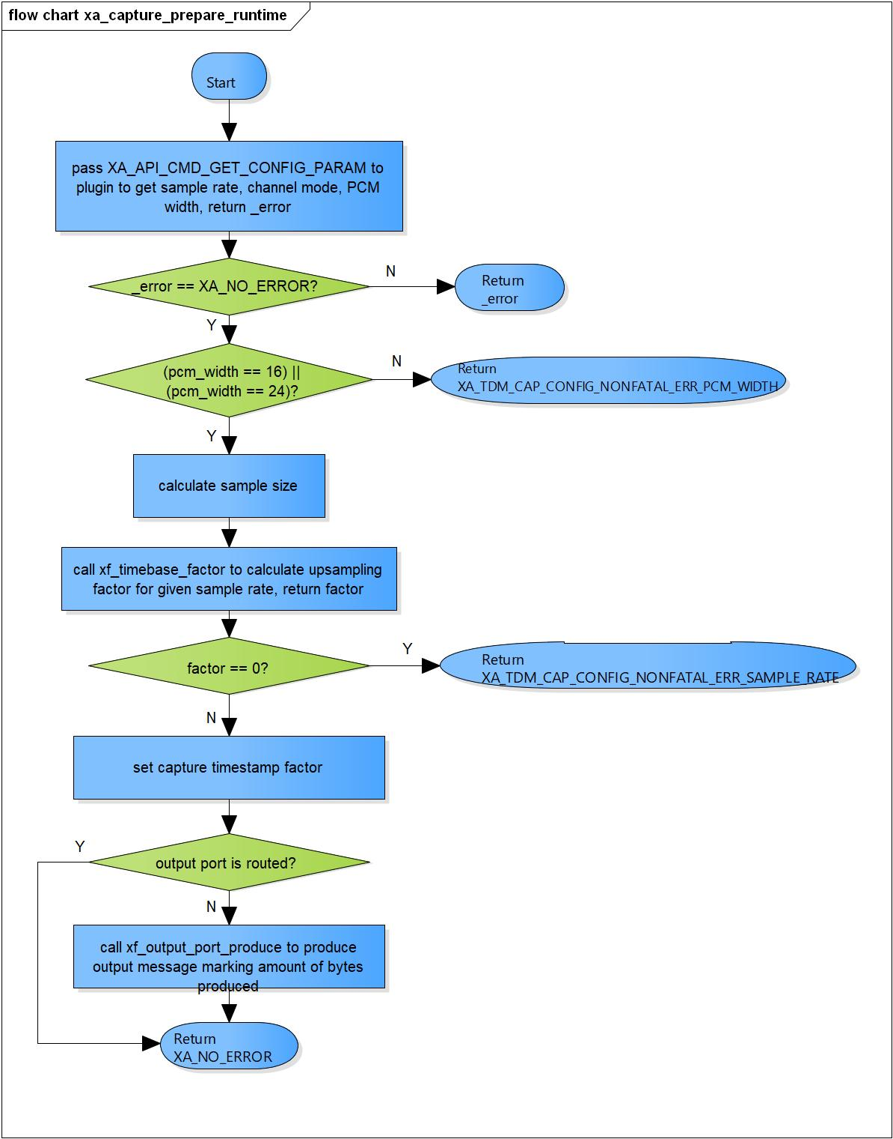

Figure 3‑1 xa_capture_prepare_runtime flowchart

### xa_capture_empty_this_buffer

DD_FWK_RDR_01_002

|  |  |  |  |  |
| --- | --- | --- | --- | --- |
| **Syntax** | static XA_ERRORCODE xa_capture_empty_this_buffer(XACodecBase *base,  xf_message_t *m); | | | |
| **Function** | This function is to check end of stream for input port. | | | |
| **Arguments** | Type | Name | I/O | Description |
| XACodecBase | base | I | Pointer to codec instance structure (struct XACodecBase). |
| xf_message_t | m | I | Pointer to audio message (struct xf_message). |
| **Return value** | XA_NO_ERROR | | Nomally end. | |
| **Description** | * xa_capture_empty_this_buffer command processing:   - Check if buffer is end of stream.  - Response message back to user. | | | |

[Covers: FD_FWK_CMN_005, FD_FWK_CMN_010]

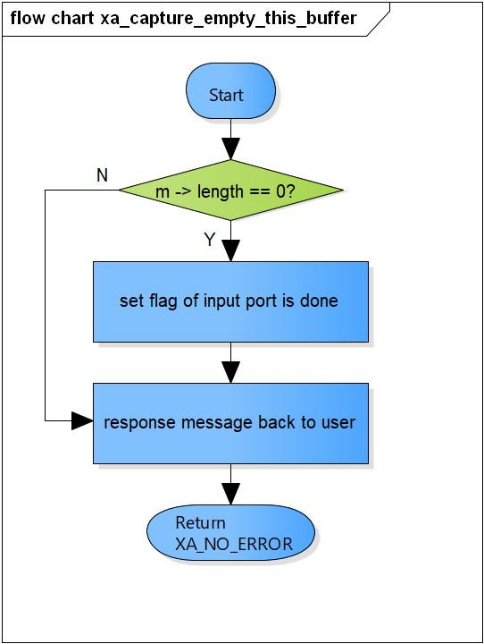

Figure 3‑2 xa_capture_empty_this_buffer flowchart

### xa_capture_fill_this_buffer

DD_FWK_RDR_01_003

|  |  |  |  |  |
| --- | --- | --- | --- | --- |
| **Syntax** | static XA_ERRORCODE xa_capture_fill_this_buffer(XACodecBase *base,  xf_message_t *m); | | | |
| **Function** | This function is to place message into output port. | | | |
| **Arguments** | Type | Name | I/O | Description |
| XACodecBase | base | I/O | Pointer to codec instance structure (struct XACodecBase). |
| xf_message_t | m | I/O | Pointer to audio message (struct xf_message). |
| **Return value** | XA_NO_ERROR | | Nomally end. | |
| XA_API_FATAL_INVALID_CMD_TYPE | | The port is not an output port. | |
| XA_API_FATAL_INVALID_CMD | | Post initialization state is not completed yet. | |
| XA_CAP_EXEC_FATAL_STATE | | Receive message with non-zero length in runtime initialization state.  Execution state is not completed yet. | |
| **Description** | * xa_capture_fill_this_buffer command processing:   - Special handling of zero-length buffer.  - Adjust message length.  - Put message into output port. | | | |

[Covers: FD_FWK_CMN_005, FD_FWK_CMN_011]

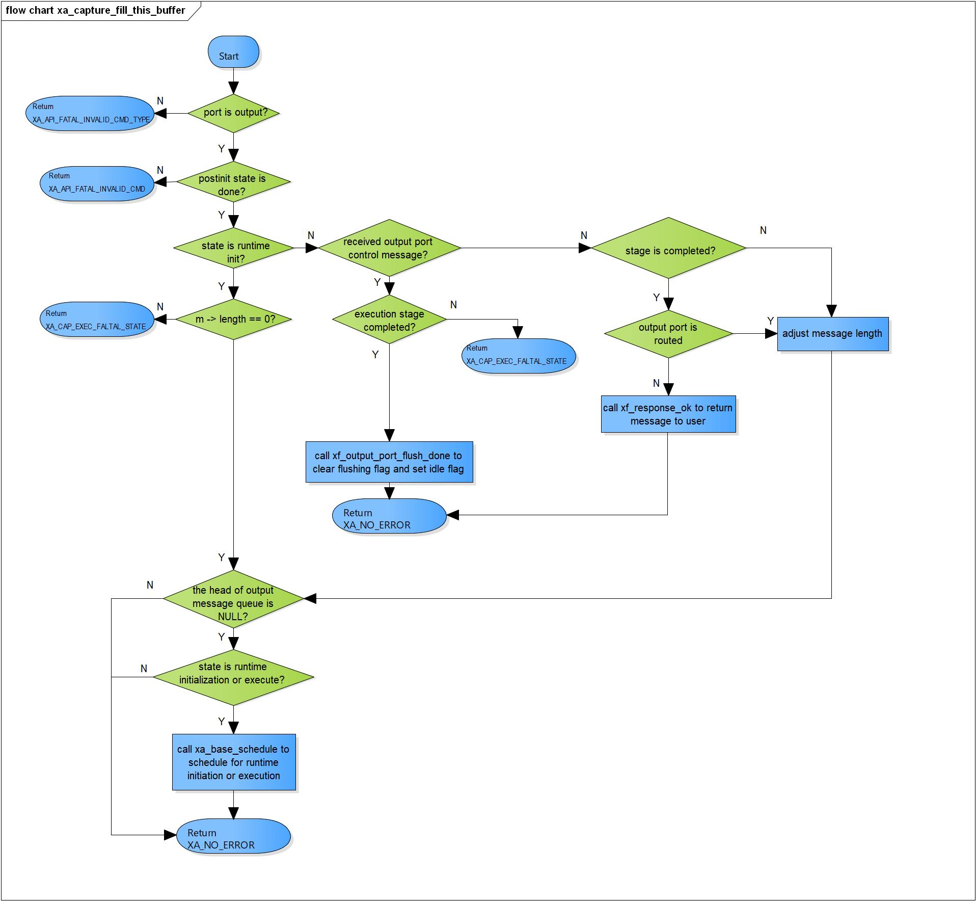

Figure 3‑3 xa_capture_fill_this_buffer flowchart

### xa_capture_memtab

DD_FWK_RDR_01_004

|  |  |  |  |  |
| --- | --- | --- | --- | --- |
| **Syntax** | static XA_ERRORCODE xa_capture_memtab(XACodecBase *base, WORD32 idx,  WORD32 type, WORD32 size, WORD32 align, u32 core) | | | |
| **Function** | This function is to initialize output port. | | | |
| **Arguments** | Type | Name | I/O | Description |
| XACodecBase | base | I/O | Pointer to codec instance structure (struct XACodecBase). |
| WORD32 | idx | I | Port index.  Valid value: 1 |
| WORD32 | type | I | Port type (input or output port).  Valid value: XA_MEMTYPE_OUTPUT |
| WORD32 | size | I | Buffer size of port. |
| WORD32 | align | x | Port alignment. |
| u32 | core | x | Core index of ADSP framework. |
| **Return value** | XA_NO_ERROR | | Nomally end. | |
| XA_API_FATAL_INVALID_CMD_TYPE | | Port type is not an output port.  Port index is invalid. | |
| XA_API_FATAL_MEM_ALLOC | | Initialize output port is fail. | |
| **Description** | * Memtab command processing:   - Initialize output port structure.  - Mark capture input buffer is ready. | | | |

[Covers: FD_FWK_CMN_008, FD_FWK_CMN_005, FD_FWK_CMN_001]

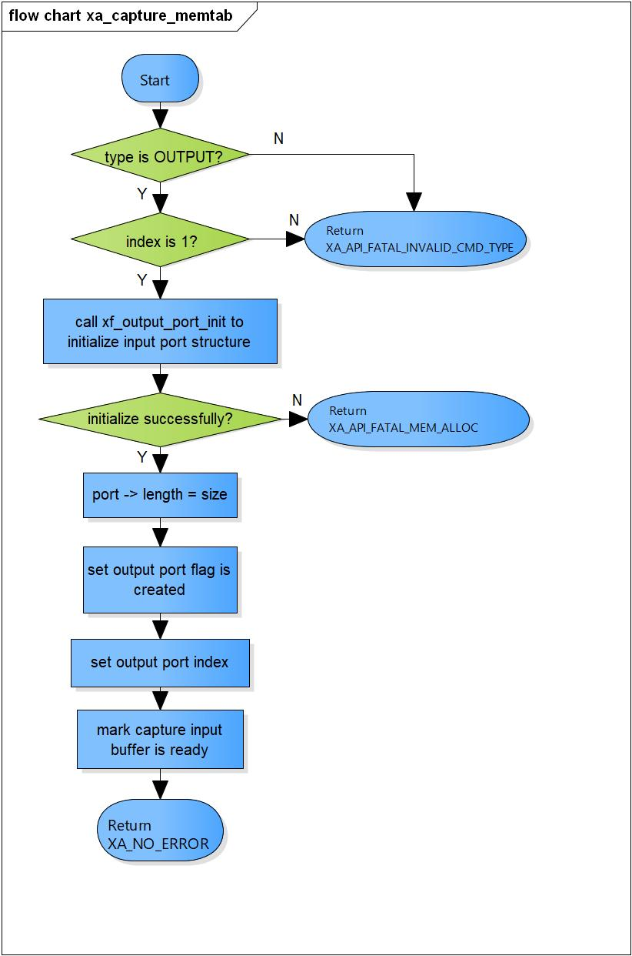

Figure 3‑4 xa_capture_memtab flowchart

### xa_capture_port_route

DD_FWK_RDR_01_005

|  |  |  |  |  |
| --- | --- | --- | --- | --- |
| **Syntax** | static XA_ERRORCODE xa_capture_port_route(XACodecBase *base, xf_message_t *m) | | | |
| **Function** | This function is to route output port - allocate memory buffers. | | | |
| **Arguments** | Type | Name | I/O | Description |
| XACodecBase | base | I/O | Pointer to codec instance structure (struct XACodecBase). |
| xf_message_t | m | I | Pointer to audio message (struct xf_message). |
| **Return value** | XA_NO_ERROR | | Nomally end. | |
| XA_API_FATAL_INVALID_CMD_TYPE | | Ports have been routed before yet.  Port is not an output. | |
| XA_API_FATAL_INVALID_CMD | | Post initialization state is not completed yet. | |
| XA_API_FATAL_MEM_ALLOC | | Route port is not successful. | |
| **Description** | * Output port routing command processing:   - Make sure port is not routed yet.  - Route output port - allocate memory for buffers.  - Schedule processing. | | | |

[Covers: FD_FWK_CMN_005, FD_FWK_CMN_006]

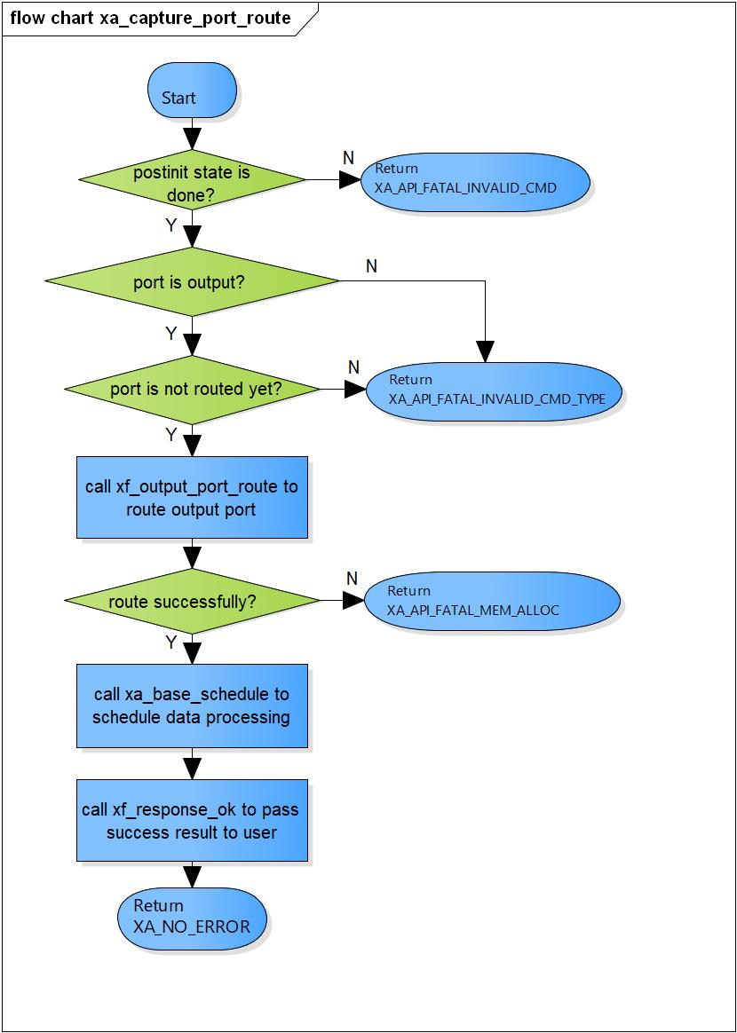

Figure 3‑5 xa_capture_port_route flowchart

### xa_capture_port_unroute

DD_FWK_RDR_01_006

|  |  |  |  |  |
| --- | --- | --- | --- | --- |
| **Syntax** | static XA_ERRORCODE xa_capture_port_unroute(XACodecBase *base, xf_message_t *m) | | | |
| **Function** | This function is to unroute output port and destroy all buffers allocated. | | | |
| **Arguments** | Type | Name | I/O | Description |
| XACodecBase | base | I/O | Pointer to codec instance structure  (struct XACodecBase). |
| xf_message_t | m | I | Pointer to audio message (struct xf_message). |
| **Return value** | XA_NO_ERROR | | Nomally end. | |
| XA_API_FATAL_INVALID_CMD_TYPE | | Port is not an output port. | |
| XA_API_FATAL_INVALID_CMD | | Post initialization state is not completed yet. | |
| **Description** | * Port unroute command command processing:   - Cancel any pending processing.  - Unroute output port. | | | |

[Covers: FD_FWK_CMN_005, FD_FWK_CMN_007]

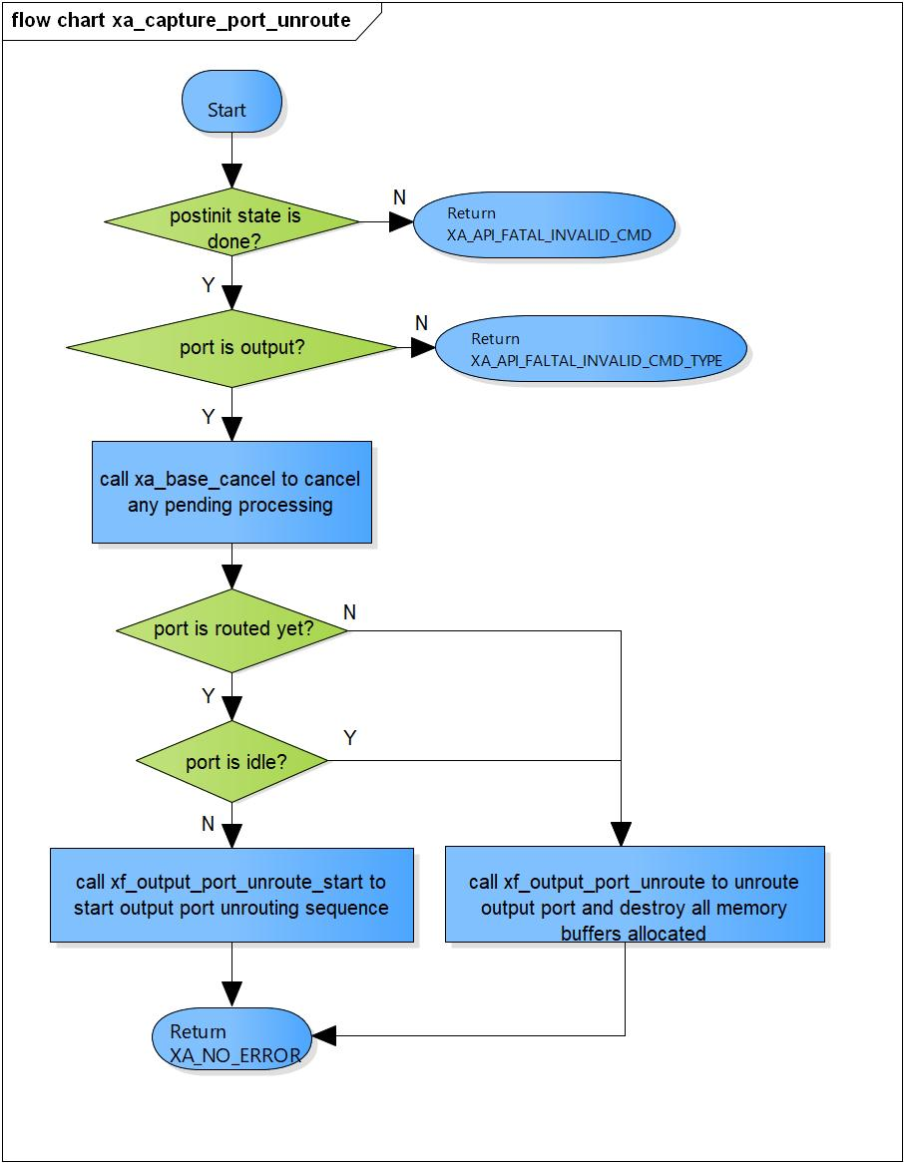

Figure 3‑6 xa_capture_port_unroute flowchart

### xa_capture_preprocess

DD_FWK_RDR_01_007

|  |  |  |  |  |
| --- | --- | --- | --- | --- |
| **Syntax** | static XA_ERRORCODE xa_capture_preprocess(XACodecBase *base) | | | |
| **Function** | This function is to set the output buffer pointer. | | | |
| **Arguments** | Type | Name | I/O | Description |
| XACodecBase | base | I | Pointer to codec instance structure (struct XACodecBase). |
| **Return value** | XA_NO_ERROR | | Nomally end. | |
| XA_CAP_EXEC_NONFATAL_OUTPUT | | No output buffer available. | |
| XA_API_FATAL_MEM_ALLOC | | API structure or output buffer is NULL (error from plugin). | |
| XA_API_FATAL_MEM_ALIGN | | API structure is not aligned to 4 bytes (error from plugin). | |
| XA_API_FATAL_INVALID_CMD_TYPE | | Output port index is an invalid memory index (error from plugin). | |
| XA_CAP_CONFIG_FATAL_STATE | | Capture is not in post-init state (error from plugin). | |
| **Description** | * Preprocess command processing:   - Check current execution stage is runtime intialization.  - Set the output buffer pointer.  - Check if input buffer is over.  - Set total number of bytes we have in buffer. | | | |

[Covers: FD_FWK_CMN_005, FD_FWK_CMN_002, FD_FWK_CMN_003]

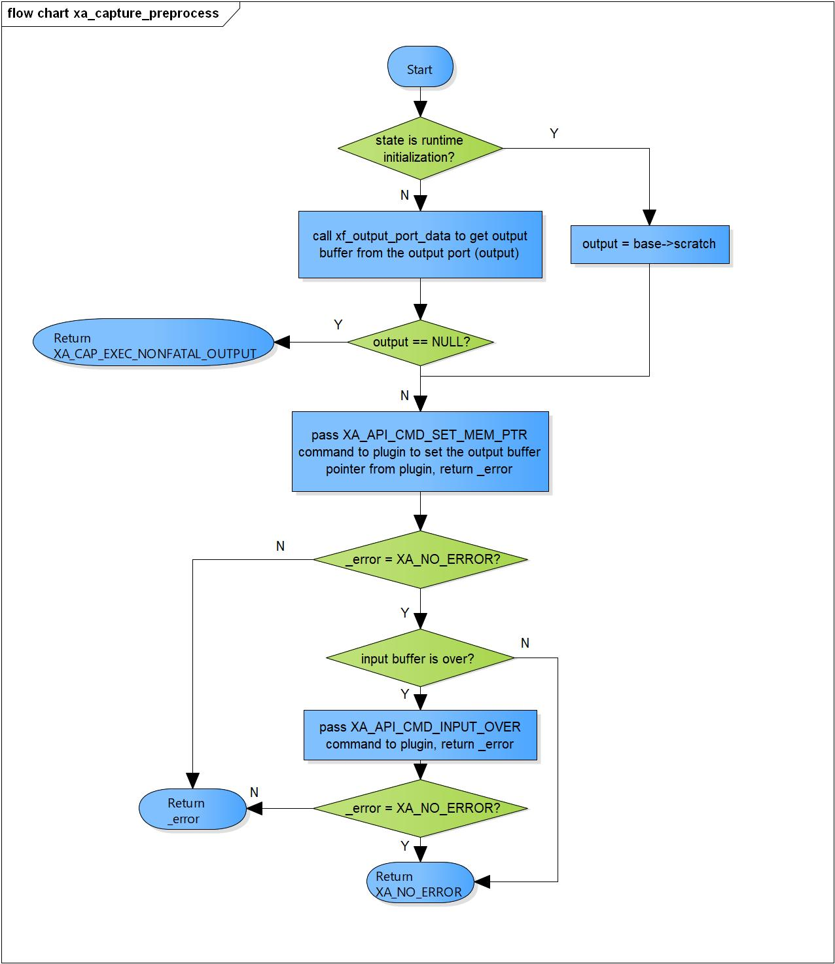

Figure 3‑7 xa_capture_preprocess flowchart

|  |  |  |  |  |
| --- | --- | --- | --- | --- |
| **Syntax** | static XA_ERRORCODE xa_capture_postprocess(XACodecBase *base, s32 done) | | | |
| **Function** | This function is to get number of produced bytes and reschedule processing. | | | |
| **Arguments** | Type | Name | I/O | Description |
| XACodecBase | base | I/O | Pointer to codec instance structure (struct XACodecBase). |
| s32 | done | I | State of processing of plugin. |
| **Return value** | XA_NO_ERROR | | Nomally end. | |
| XA_API_FATAL_MEM_ALLOC | | API structure is invalid (error from plugin). | |
| XA_CAP_EXEC_FATAL_STATE | | Capture is not in running state (error from plugin).  Ring-buffer is invalid (error from plugin). | |
| **Description** | * xa_capture_postprocess command processing:   - Get number of produced samples from plugin.  - Check state if process is done.  - Reschedule execution if we have pending output. | | | |

### xa_capture_postprocess

DD_FWK_RDR_01_008

[Covers: FD_FWK_CMN_005, FD_FWK_CMN_002, FD_FWK_CMN_003]

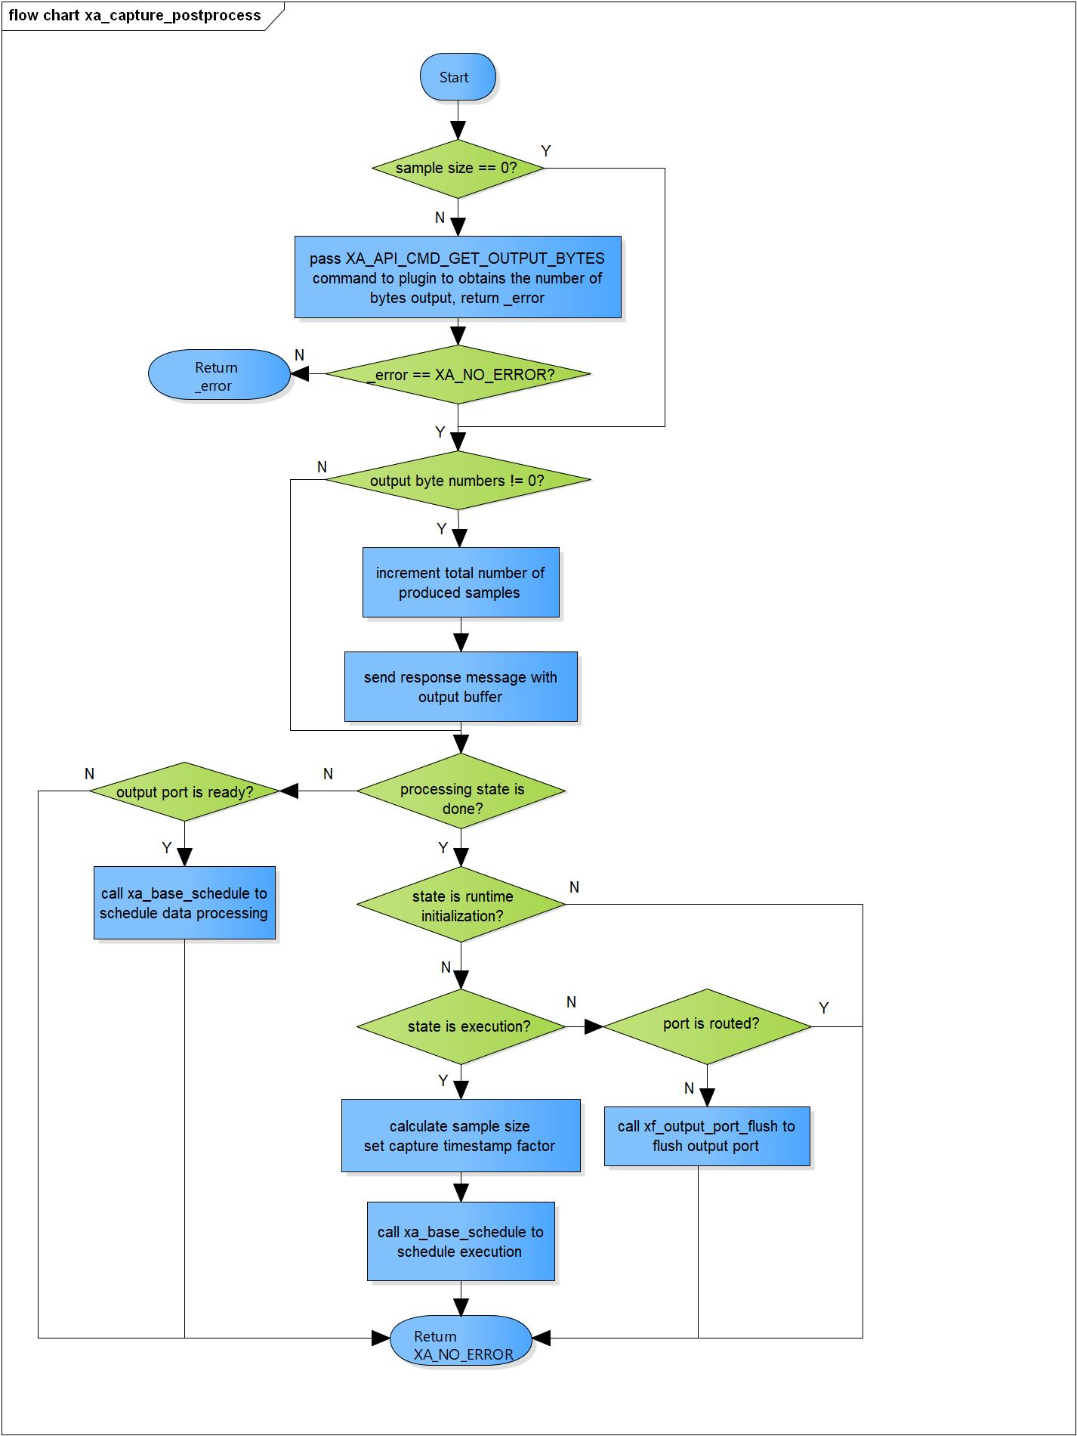

Figure 3‑8 xa_capture_postprocess flowchart

### xa_capture_flush

DD_FWK_RDR_01_009

|  |  |  |  |  |
| --- | --- | --- | --- | --- |
| **Syntax** | static XA_ERRORCODE xa_capture_flush(XACodecBase *base, xf_message_t *m) | | | |
| **Function** | This function is to purge port queue. | | | |
| **Arguments** | Type | Name | I/O | Description |
| XACodecBase | base | I | Pointer to codec instance structure (struct XACodecBase). |
| xf_message_t | m | I | Pointer to audio message (struct xf_message). |
| **Return value** | XA_NO_ERROR | | Nomally end. | |
| XA_API_FATAL_INVALID_CMD | | Post initialization state is not completed yet. | |
| XA_API_FATAL_INVALID_CMD_TYPE | | Message length is not zero. | |
| **Description** | * xa_capture_flush command processing:   - Check if post initialization state is not completed yet.  - Ensure input parameter length is zero.  - Cancel data processing if needed.  - Output port flushing; purge content of output buffer. | | | |

[Covers: FD_FWK_CMN_005, FD_FWK_CMN_012]

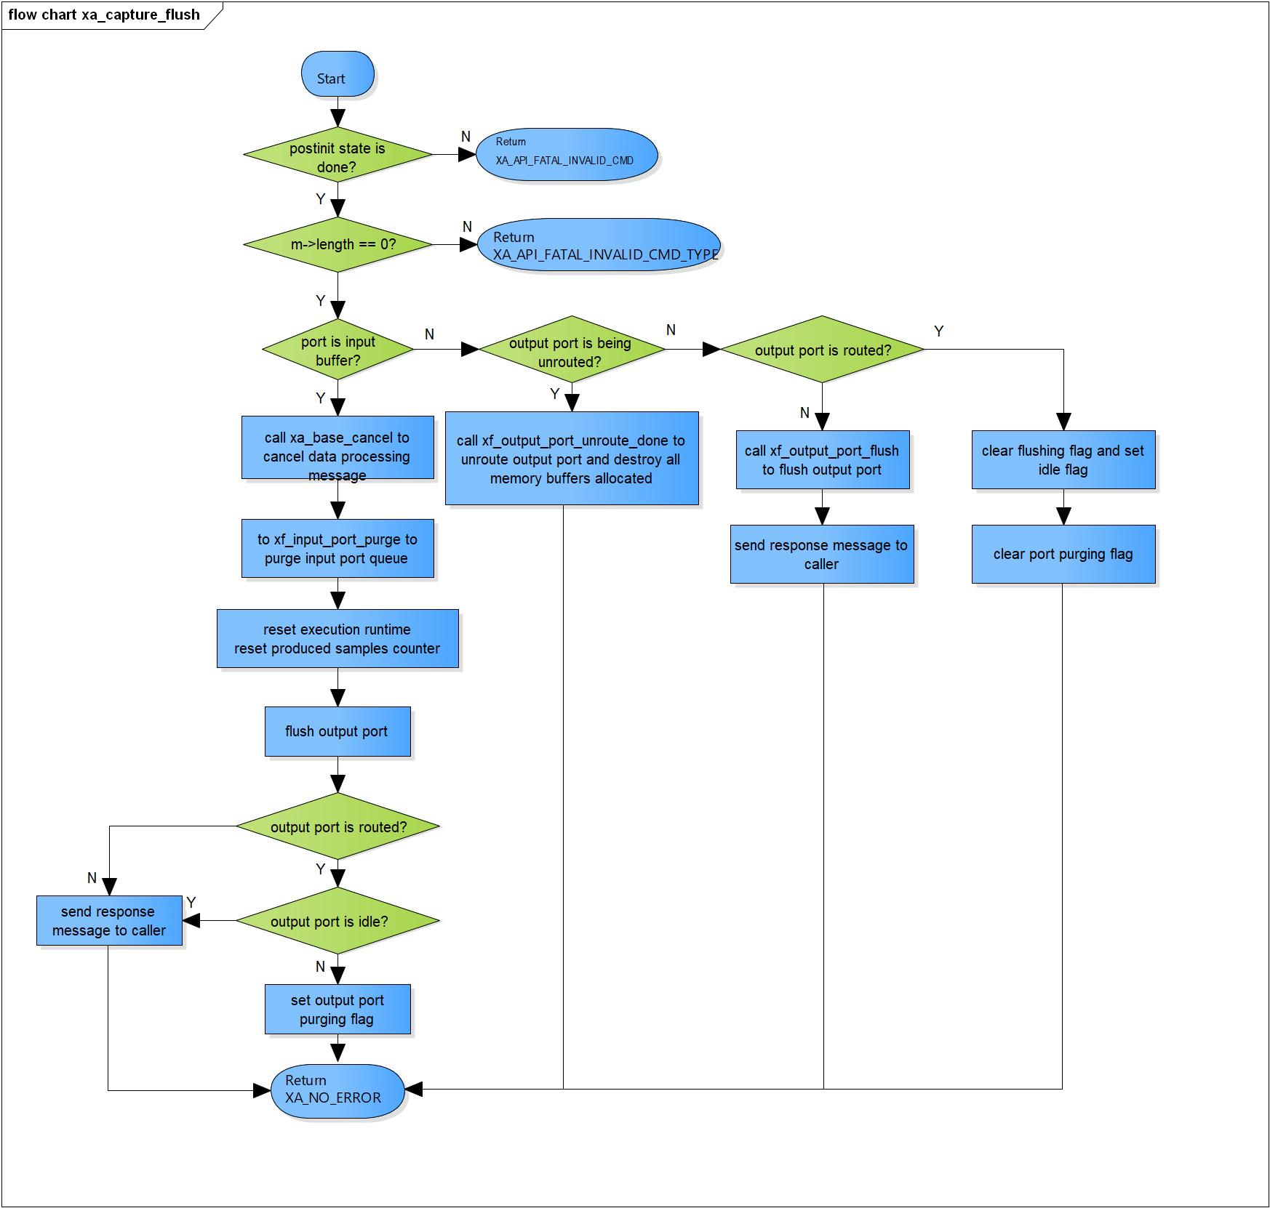

Figure 3‑9 xa_capture_flush flowchart

### xa_capture_cleanup

DD_FWK_RDR_01_010

|  |  |  |  |  |
| --- | --- | --- | --- | --- |
| **Syntax** | static s32 xa_capture_cleanup(xf_component_t *component, xf_message_t *m) | | | |
| **Function** | This function is to purge port queue and cancel component task execution. | | | |
| **Arguments** | Type | Name | I/O | Description |
| xf_component_t | component | I/O | Pointer to codec instance structure (struct xf_component ). |
| xf_message_t | m | I/O | Pointer to audio message (struct xf_message). |
| **Return value** | 1 | | Capture component cannot be destroyed. | |
| 0 | | Capture component has been destroyed totally. | |
| **Description** | * xa_capture_cleanup command processing:   - Complete message with error result code.  - Cancel component task execution if needed.  - Stop hardware capture if it's running.  - Destroy capture. | | | |

[Covers: FD_FWK_CMN_005, FD_FWK_CMN_004]

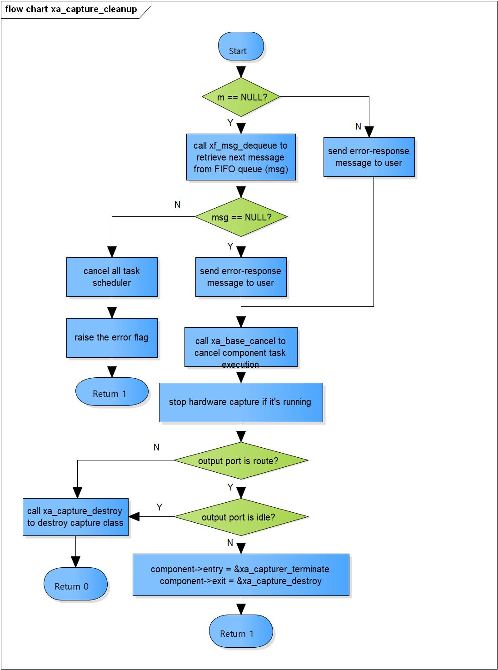

Figure 3‑10 xa_capture_cleanup flowchart

### xa_capture_terminate

DD_FWK_RDR_01_011

|  |  |  |  |  |
| --- | --- | --- | --- | --- |
| **Syntax** | static s32 xa_capture_terminate(xf_component_t *component, xf_message_t *m) | | | |
| **Function** | Capture termination-state command processor. | | | |
| **Arguments** | Type | Name | I/O | Description |
| xf_component_t | component | I/O | Pointer to codec instance structure (struct xf_component ). |
| xf_message_t | m | I/O | Pointer to audio message (struct xf_message). |
| **Return value** | -1 | Output port flushing is completed. Component ready to destroy. | | |
| 0 | Normal end. | | |
| **Description** | * xa_capture_terminate command processing:   - Check if we received output port control message. | | | |

[Covers: FD_FWK_CMN_004]

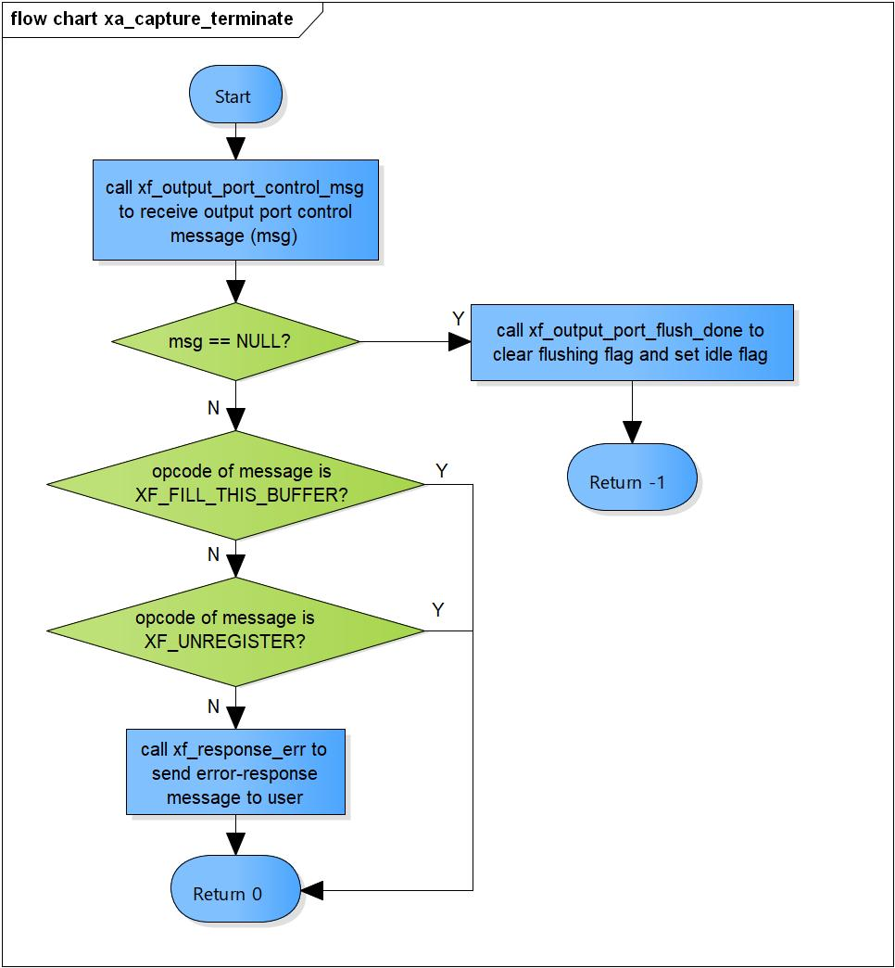

Figure 3‑11 xa_capture_terminate flowchart

### xa_capture_destroy

DD_FWK_RDR_01_012

|  |  |  |  |  |
| --- | --- | --- | --- | --- |
| **Syntax** | static s32 xa_capture_destroy(xf_component_t *component, xf_message_t *m) | | | |
| **Function** | This function is to destroy component. | | | |
| **Arguments** | Type | Name | I/O | Description |
| xf_component_t | component | I | Pointer to codec instance structure (struct xf_component ). |
| xf_message_t | m | x | Pointer to audio message (struct xf_message). |
| **Return value** | 0 | | Indicate the component is destroyed. | |
| **Description** | * xa_capture_destroy command processing:   - Destroy output port.  - Destroy base object. | | | |

[Covers: FD_FWK_CMN_004]

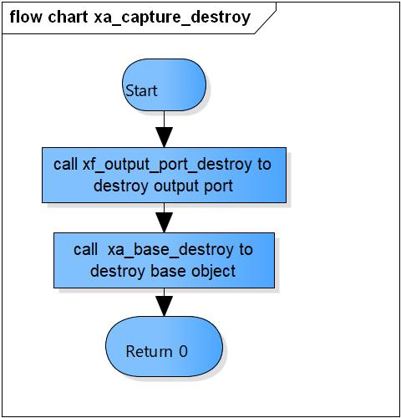

Figure 3‑12 xa_capture_destroy flowchart

### xa_capture_factory

DD_FWK_RDR_01_013

|  |  |  |  |  |
| --- | --- | --- | --- | --- |
| **Syntax** | xf_component_t * xa_capture_factory(u32 core, xa_codec_func_t process) | | | |
| **Function** | This function is to initialize Capture component. | | | |
| **Arguments** | Type | Name | I/O | Description |
| u32 | core | I | Core index of ADSP framework. |
| xa_codec_func_t | process | I | Codec API entry point (function). |
| **Return Value** | Return handle to component. | | | |
| **Description** | * xa_capture_factory command processing:   - Initialize Capture component. | | | |

[Covers: FD_FWK_CMN_005, FD_FWK_CMN_008, FD_FWK_CMN_009]

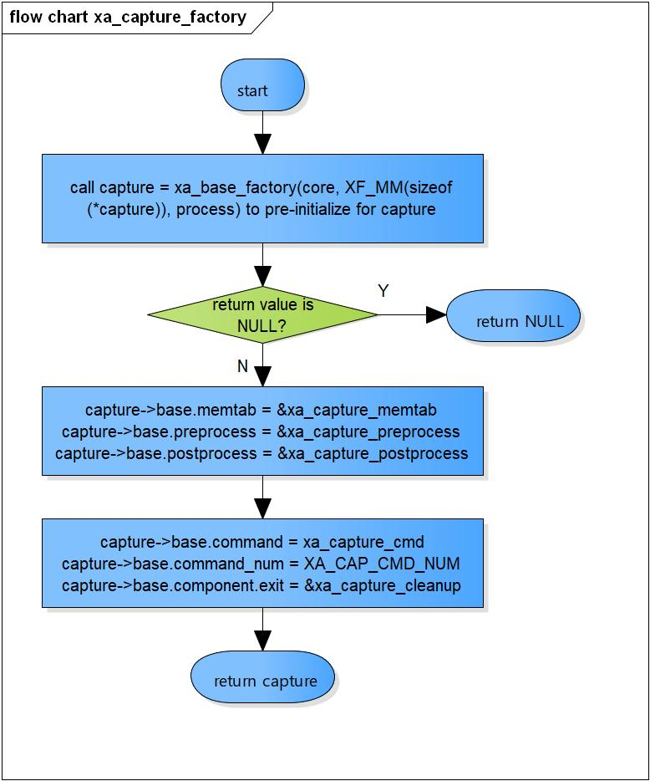

Figure 3‑13 xa_capture_factory flowchart

# Revision history

|  |  |  |  |  |  |
| --- | --- | --- | --- | --- | --- |
| **Version** | **Date** | **Page** | **Content** | **Approved** | **Changed** |
| 1.0.0 | Nov 14, 2018 | - | First Edition issued | Vu Phan | Vu Phan |
| 1.1.0 | Dec 10, 2018 | - | Add traceability ID | Vu Phan | Ngu Pham |
| 1.2.0 | Jan 03, 2019 | - | Add range for input parameters | Vu Phan | Tien Tran |