**Document Type: Detail Design**

**Document Name:**

**ADSP FRAMEWORK: EQUALIZER CLASS**

Renesas Design Vietnam Co. Ltd

R-Car Software Solution 2 Group

Middleware 1 Team

Renesas Electronics Corporation

Table of Contents

1. Overview 3

2. Function list 4

3. Detail information 5

3.1 Data type and Macro definition 5

3.2 Globle variable 6

3.3 Function definition 7

3.3.1 xa_equalizer_prepare_runtime 7

3.3.2 xa_equalizer_empty_this_buffer 9

3.3.3 xa_equalizer_fill_this_buffer 11

3.3.4 xa_equalizer_memtab 13

3.3.5 xa_equalizer_port_route 14

3.3.6 xa_equalizer_port_unroute 16

3.3.7 xa_equalizer_preprocess 17

3.3.8 xa_equalizer_postprocess 19

3.3.9 xa_equalizer_flush 21

3.3.10 xa_equalizer_cleanup 23

3.3.11 xa_equalizer_terminate 24

3.3.12 xa_equalizer_destroy 25

3.3.13 xa_equalizer_factory 26

4. Revision history 27

List of Figures

Figure 1‑1 The software architecture 3

Figure 3‑1 xa_equalizer_prepare_runtime flowchart 8

Figure 3‑2 xa_equalizer_empty_this_buffer flowchart 10

Figure 3‑3 xa_equalizer_fill_this_buffer flowchart 12

Figure 3‑4 xa_equalizer_memtab flowchart 13

Figure 3‑5 xa_equalizer_port_route flowchart 15

Figure 3‑6 xa_equalizer_port_unroute flowchart 16

Figure 3‑7 xa_equalizer_preprocess flowchart 18

Figure 3‑8 xa_equalizer_postprocess flowchart 20

Figure 3‑9 xa_equalizer_flush flowchart 22

Figure 3‑10 xa_equalizer_cleanup flowchart 23

Figure 3‑11 xa_equalizer_terminate flowchart 24

Figure 3‑12 xa_equalizer_destroy flowchart 25

Figure 3‑13 xa_equalizer_factory flowchart 26

List of Table

Table 2‑1 Function list 4

Table 3‑1 XAEqualizer type structure information 5

Table 3‑2 Macro definitions 5

Table 3‑3 Globle variable xa_equalizer_cmd 6

# Overview

This section provides an overview of the software architecture.

User Application

ADSP Interface

Kernel Space

User Space

ADSP Driver

ARM

Audio HW

**ADSP Framework**

TDM class

Equalizer class

Capture class

Renderer class

ADSP

Plugin

Equalizer Plugin*

TDM Plugin

Capture Plugin

Renderer Plugin

This document’s target is in side of red square

* not connect to SCU/SSI ADMA block

SCU/ SSI/

ADMA

DAC/

ADC

Figure 1‑1 ****The software architecture****

# Function list

The following is list of functions:

Table 2‑1 Function list

|  |  |  |
| --- | --- | --- |
| **Type** | **Function Name** | **Outline** |
| API | xa_equalizer_factory | This API is to construct generic audio component and set functions pointer for internal functions. |
| Internal functions | xa_equalizer_prepare_runtime | This function is to prepare equalizer for steady operation. |
| xa_equalizer_empty_this_buffer | This function is to put message into input port queue. |
| xa_equalizer_fill_this_buffer | This function is to place message into output port. |
| xa_equalizer_flush | This function is to purge input port queue. |
| xa_equalizer_memtab | This function is to initialize output/input port. |
| xa_equalizer_port_route | This function is to route output port - allocate buffers. |
| xa_equalizer_port_unroute | This function is to unroute output port and destroy all buffers allocated. |
| xa_equalizer_preprocess | This function is to prepare data for input/output buffer. |
| xa_equalizer_postprocess | This function is to consume bytes from input buffer and reschedule processing. |
| xa_equalizer_terminate | This is equalizer termination-state command processor function. |
| xa_equalizer_destroy | This function is to destroy component. |
| xa_equalizer_cleanup | This function is to purge input port queue and cancel internal scheduling. |

# Detail information

This section describes detail information of data types, macro definitions, implemented APIs and internal function units, globle variable.

## Data type and Macro definition

The XAEqualizer type structure is the work area used by the equalizer class. When using this class, secure the area with the application program. It’s not necessary to refer to this area because it only contains the internal variables and working buffers of the class. Make sure not to change the value of this area with the application program.

Table 3‑1 XAEqualizer type structure information

|  |  |
| --- | --- |
| Member name | Outline |
| XACodecBase base | Generic audio codec data |
| xf_input_port_t input | Input port queue |
| u32 in_idx | The index of input |
| xf_output_port_t output | Output port queue |
| u32 out_idx | The index of output |
| u32 factor | Time conversion factor (input byte "duration" in timebase units) |
| u32 sample_size | Sample size in bytes |
| u32 produced | Total number of produced audio frames since last reset |

Table 3‑2 Macro definitions

|  |  |  |
| --- | --- | --- |
| Macro | Value | Outline |
| XA_EQZ_FLAG_INPUT_SETUP | __XA_BASE_FLAG(1 << 0) | Input port setup condition |
| XA_EQZ_FLAG_OUTPUT_SETUP | __XA_BASE_FLAG(1 << 1) | Output port setup condition |

Note: Macro __XA_BASE_FLAG(f) ((f) << 6) is in xa-class-base.h file.

## Globle variable

Table 3‑3 Globle variable xa_equalizer_cmd

|  |  |
| --- | --- |
| static XA_ERRORCODE (* const xa_equalizer_cmd[])(XACodecBase *base, xf_message_t *m) | |
| Description: variable stores function pointers arcoding to opcode index to run in runtime operation. | |
| Array index | Value (function pointer) |
| XF_OPCODE_TYPE(XF_SET_PARAM) | xa_base_set_param |
| XF_OPCODE_TYPE(XF_GET_PARAM) | xa_base_get_param |
| XF_OPCODE_TYPE(XF_ROUTE) | xa_equalizer_port_route |
| XF_OPCODE_TYPE(XF_UNROUTE) | xa_equalizer_port_unroute |
| XF_OPCODE_TYPE(XF_EMPTY_THIS_BUFFER) | xa_equalizer_empty_this_buffer |
| XF_OPCODE_TYPE(XF_FILL_THIS_BUFFER) | xa_equalizer_fill_this_buffer |
| XF_OPCODE_TYPE(XF_FLUSH) | xa_equalizer_flush |

Note: Marco XF_OPCODE_TYPE(opcode) : ((opcode) & (0x3F)) in xf-opcode.h file.

## Function definition

### xa_equalizer_prepare_runtime

DD_FWK_EQZ_01_001

|  |  |  |  |  |
| --- | --- | --- | --- | --- |
| **Syntax** | static inline XA_ERRORCODE xa_equalizer_prepare_runtime(XAEqualizer *equalizer) | | | |
| **Function** | This function is to prepare equalizer for steady operation. | | | |
| **Arguments** | Type | Name | I/O | Description |
| XAEqualizer | Equalizer | I/O | Pointer to codec instance structure (struct XARenderer) |
| **Return value** | XA_API_FATAL_MEM_ALLOC | | API structure is NULL (error from plugin). | |
| XA_API_FATAL_MEM_ALIGN | | API structure is not aligned to 4 bytes (error from plugin). | |
| XA_EQZ_CONFIG_FATAL_STATE | | Pre-initialization is not completed yet (error from plugin). | |
| XA_API_FATAL_INVALID_CMD_TYPE | | Sample rate is invalid. | |
| XA_NO_ERROR | | Nomally end. | |
| **Description** | * xa_euqualizer_prepare_runtime command processing:   - Get config parameters: sample rate, pcm width, channels, size of input/output buffer.  - Set equalizer timestamp factor | | | |

[Covers: FD_FWK_CMN_002]

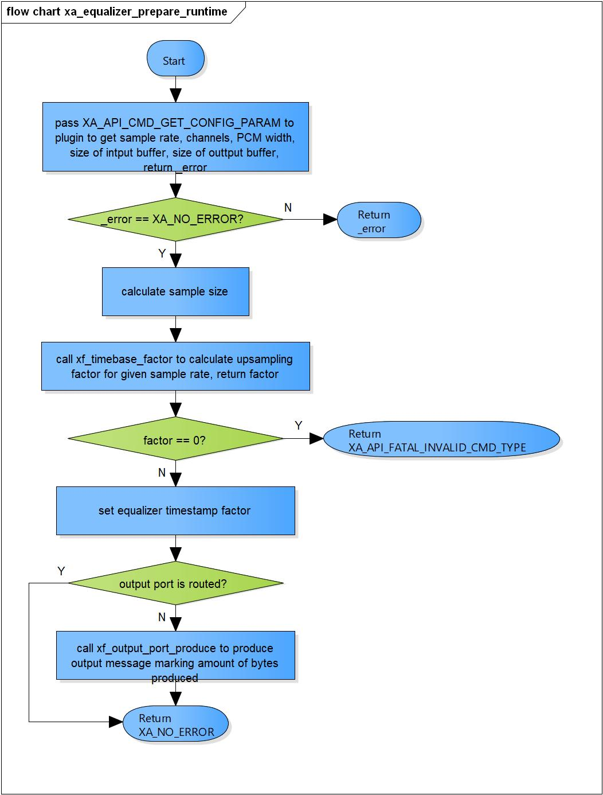

Figure 3‑1 xa_equalizer_prepare_runtime flowchart

### xa_equalizer_empty_this_buffer

DD_FWK_EQZ_01_002

|  |  |  |  |  |
| --- | --- | --- | --- | --- |
| **Syntax** | static XA_ERRORCODE xa_equalizer_empty_this_buffer(XACodecBase *base,  xf_message_t *m); | | | |
| **Function** | This function is to put message into input port queue. | | | |
| **Arguments** | Type | Name | I/O | Description |
| XACodecBase | base | I/O | Pointer to codec instance structure (struct XACodecBase). |
| xf_message_t | m | I | Pointer to audio message (struct xf_message). |
| **Return value** | XA_NO_ERROR | | Nomally end. | |
| XA_API_FATAL_INVALID_CMD | | Port is not a input port.  Post initialization state is not completed yet.  State of equalizer is not runtime initialization or execution. | |
| **Description** | * xa_equalizer_empty_this_buffer command processing:   - Put message into input queue. | | | |

[Covers: FD_FWK_CMN_005, FD_FWK_CMN_010]

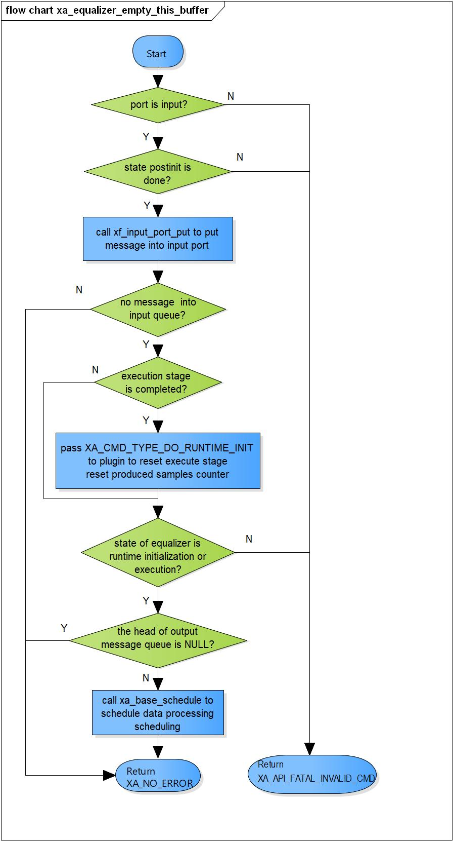

Figure 3‑2 xa_equalizer_empty_this_buffer flowchart

### xa_equalizer_fill_this_buffer

DD_FWK_EQZ_01_003

|  |  |  |  |  |
| --- | --- | --- | --- | --- |
| **Syntax** | static XA_ERRORCODE xa_equalizer_fill_this_buffer(XACodecBase *base,  xf_message_t *m); | | | |
| **Function** | This function is to place message into output port. | | | |
| **Arguments** | Type | Name | I/O | Description |
| XACodecBase | base | I/O | Pointer to codec instance structure (struct XACodecBase). |
| xf_message_t | m | I/O | Pointer to audio message (struct xf_message). |
| **Return value** | XA_NO_ERROR | | Nomally end. | |
| XA_API_FATAL_INVALID_CMD | | Port is not an output port.  Post initialization state is not completed yet. | |
| **Description** | * xa_equalizer_fill_this_buffer command processing:   - Adjust message length.  - Place message into output port. | | | |

[Covers: FD_FWK_CMN_005, FD_FWK_CMN_011]

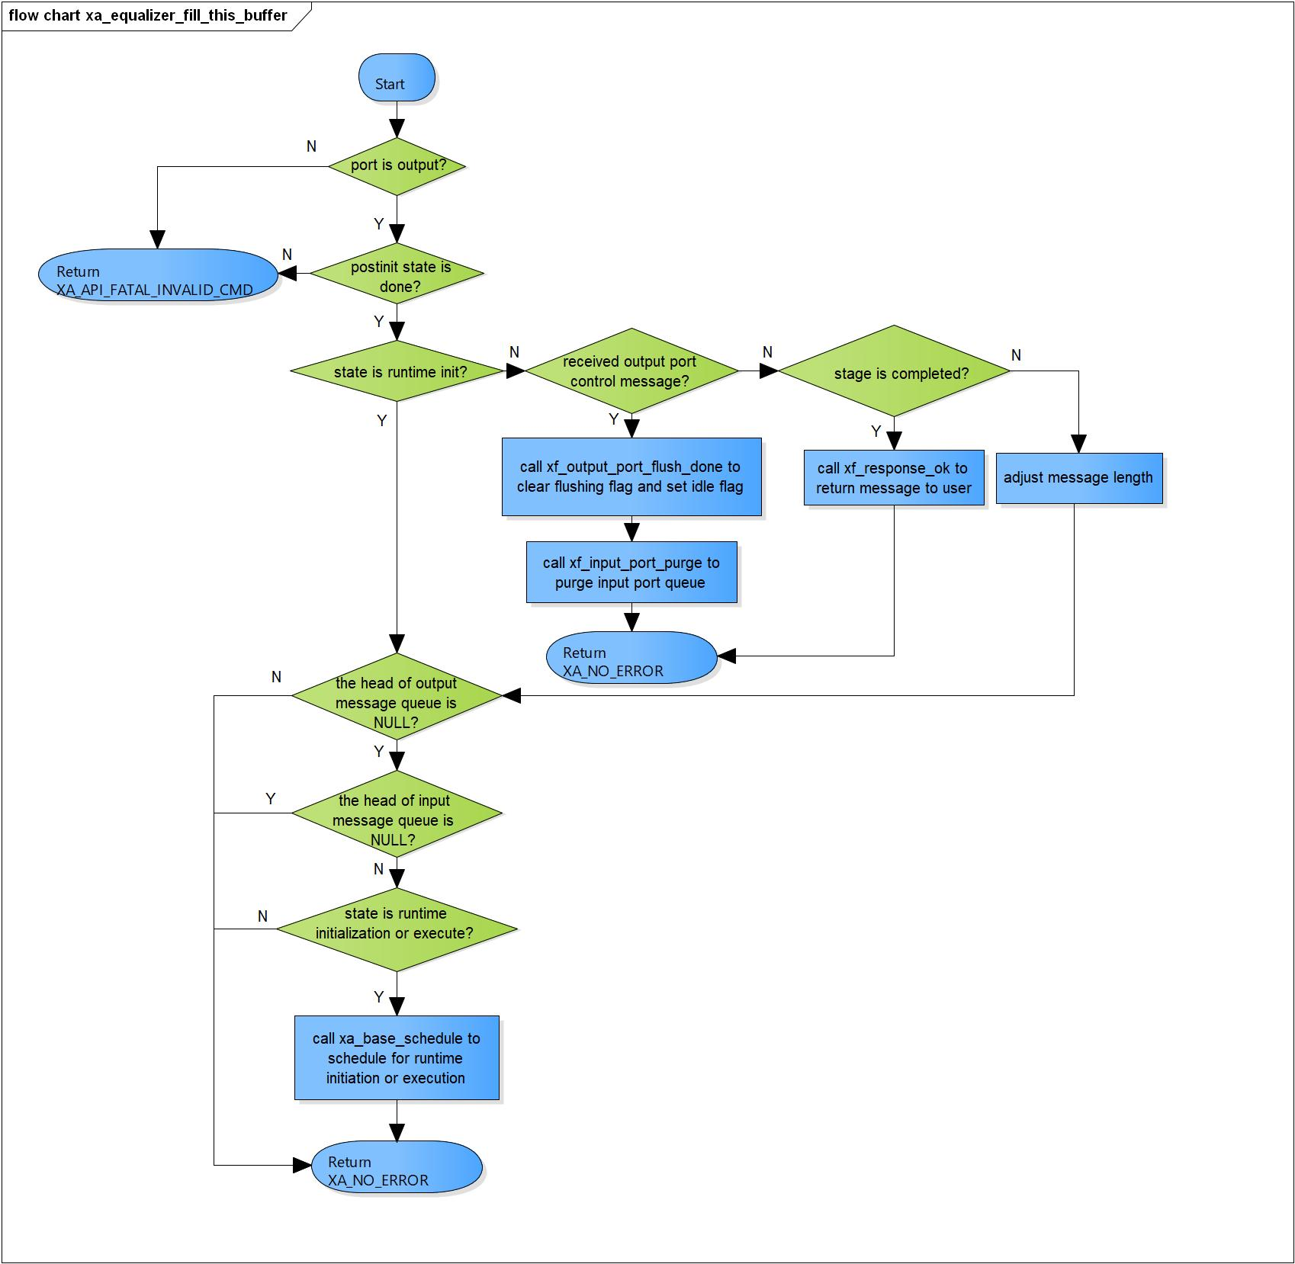Figure 3‑3 xa_equalizer_fill_this_buffer flowchart

### xa_equalizer_memtab

DD_FWK_EQZ_01_004

|  |  |  |  |  |
| --- | --- | --- | --- | --- |
| **Syntax** | static XA_ERRORCODE xa_equalizer_memtab(XACodecBase *base, WORD32 idx, WORD32 type, WORD32 size, WORD32 align, u32 core) | | | |
| **Function** | This function is to initialize input/output port. | | | |
| **Arguments** | Type | Name | I/O | Description |
| XACodecBase | base | I/O | Pointer to codec instance structure (struct XACodecBase). |
| WORD32 | idx | I | Port index. |
| WORD32 | type | I | Port type (input or output port)  Valid values:  XA_MEMTYPE_INPUT  XA_MEMTYPE_OUTPUT |
| WORD32 | size | I | Buffer size of port. |
| WORD32 | align | I | Port alignment. |
| u32 | core | I | Core index of ADSP framework. |
| **Return value** | XA_NO_ERROR | | Nomally end. | |
| XA_API_FATAL_INVALID_CMD_TYPE | | Port is invalid. | |
| XA_API_FATAL_MEM_ALLOC | | Initialize input/ouput port is fail | |
| **Description** | * Memtab command processing:   - Initialize Input/Output port specification and allocate internal buffer. | | | |

[Covers: FD_FWK_CMN_008, FD_FWK_CMN_005, FD_FWK_CMN_001]

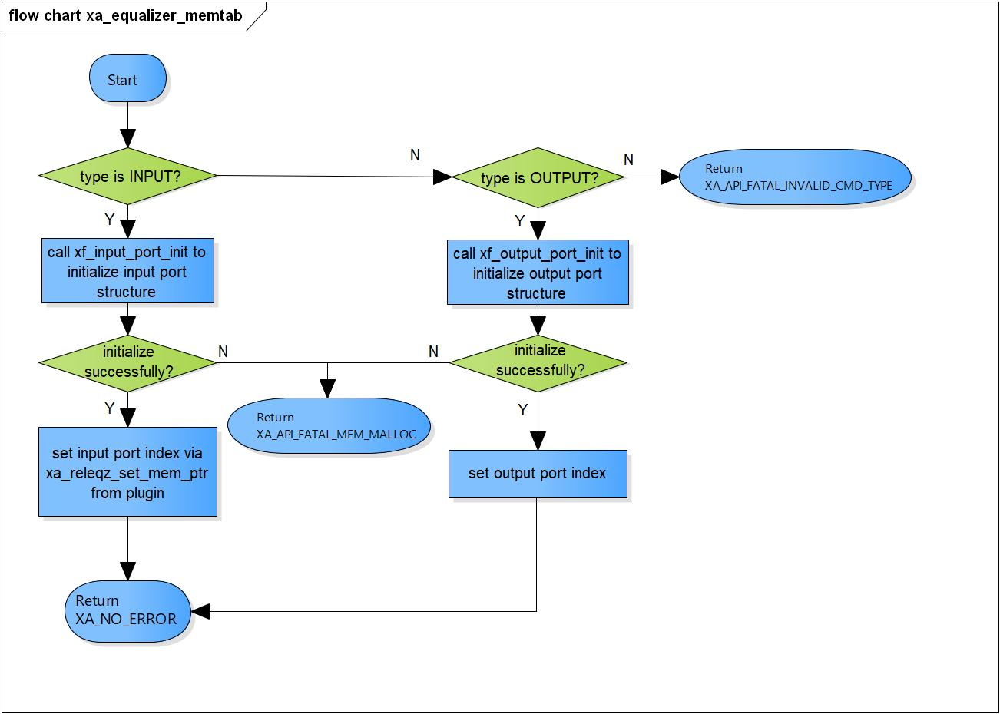

Figure 3‑4 xa_equalizer_memtab flowchart

### xa_equalizer_port_route

DD_FWK_EQZ_01_005

|  |  |  |  |  |
| --- | --- | --- | --- | --- |
| **Syntax** | static XA_ERRORCODE xa_equalizer_port_route(XACodecBase *base,  xf_message_t *m) | | | |
| **Function** | This function is to route output port - allocate memory buffers. | | | |
| **Arguments** | Type | Name | I/O | Description |
| XACodecBase | base | I | Pointer to codec instance structure (struct XACodecBase). |
| xf_message_t | m | I | Pointer to audio message (struct xf_message). |
| **Return value** | XA_NO_ERROR | | Nomally end. | |
| XA_API_FATAL_INVALID_CMD_TYPE | | Ports have been routed before yet.  Port is not an output. | |
| XA_API_FATAL_INVALID_CMD | | Post initialization state is not completed yet. | |
|  | XA_API_FATAL_MEM_ALLOC | | Route output port is failed. | |
| **Description** | * Output port routing command processing:   - Make sure port is not routed yet.  - Route output port - allocate buffers.  - Schedule processing. | | | |

[Covers: FD_FWK_CMN_005, FD_FWK_CMN_006]

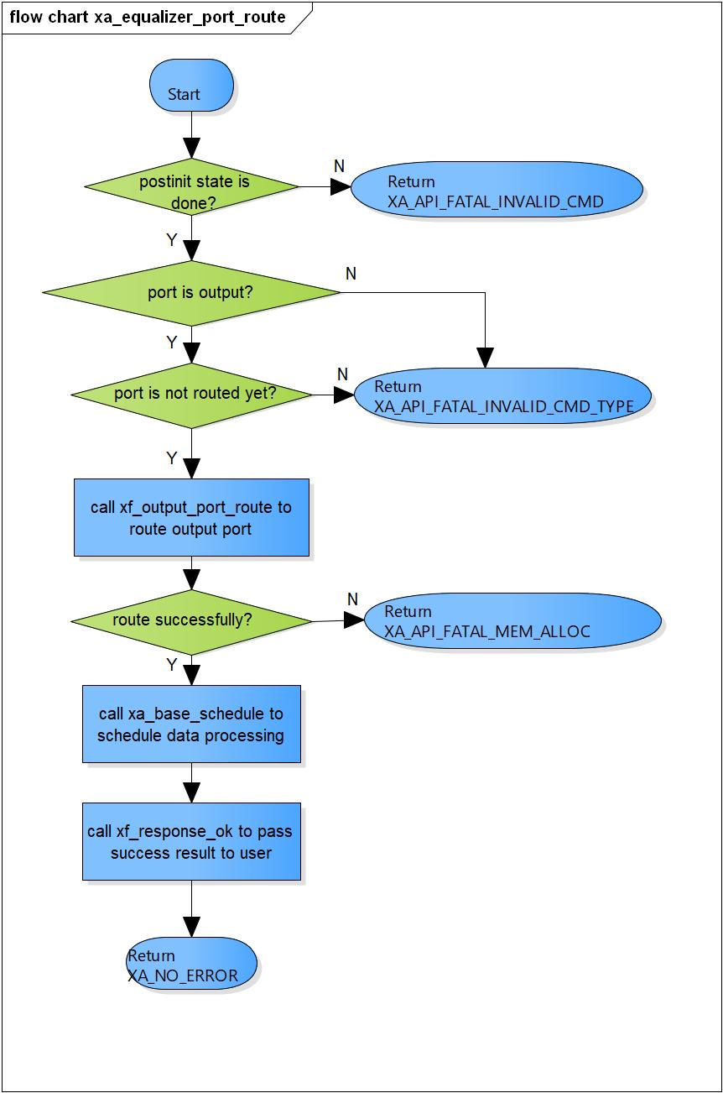

Figure 3‑5 xa_equalizer_port_route flowchart

### xa_equalizer_port_unroute

DD_FWK_EQZ_01_006

|  |  |  |  |  |
| --- | --- | --- | --- | --- |
| **Syntax** | static XA_ERRORCODE xa_equalizer_port_unroute(XACodecBase *base, xf_message_t *m) | | | |
| **Function** | This function is to unroute output port and destroy all memory buffers allocated. | | | |
| **Arguments** | Type | Name | I/O | Description |
| XACodecBase | base | I/O | Pointer to codec instance structure  (struct XACodecBase). |
| xf_message_t | m | I | Pointer to audio message (struct xf_message). |
| **Return value** | XA_NO_ERROR | | Nomally end. | |
| XA_API_FATAL_INVALID_CMD_TYPE | | Port is not an output. | |
| XA_API_FATAL_INVALID_CMD | | Post initialization state is not completed yet. | |
| **Description** | * Port unroute command command processing:   - Cancel any pending processing  - Clear output-port-setup condition  - Unroute output port | | | |

[Covers: FD_FWK_CMN_005, FD_FWK_CMN_007]

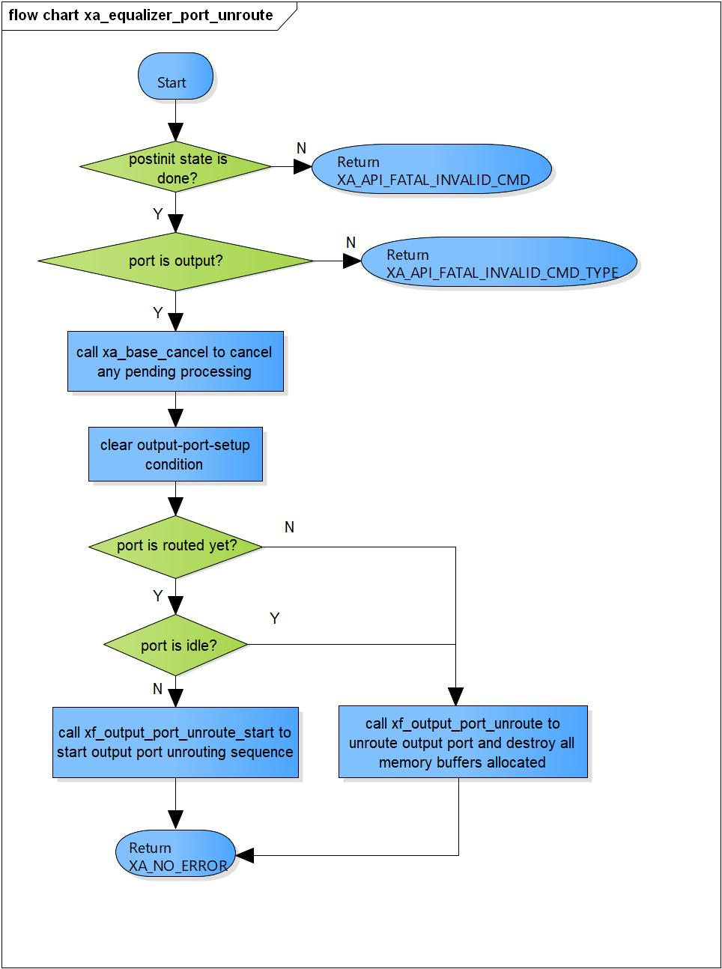

Figure 3‑6 xa_equalizer_port_unroute flowchart

### xa_equalizer_preprocess

DD_FWK_EQZ_01_007

|  |  |  |  |  |
| --- | --- | --- | --- | --- |
| **Syntax** | static XA_ERRORCODE xa_equalizer_preprocess(XACodecBase *base) | | | |
| **Function** | This function is to prepare data for input/output buffer. | | | |
| **Arguments** | Type | Name | I/O | Description |
| XACodecBase | base | I/O | Pointer to codec instance structure (struct XACodecBase). |
| **Return value** | XA_NO_ERROR | | Nomally end. | |
| XA_CODEC_EXEC_NO_DATA | | No output buffer available | |
| XA_API_FATAL_MEM_ALLOC | | API structure or output buffer is NULL (error from plugin). | |
| XA_API_FATAL_MEM_ALIGN | | API structure or output buffer is not aligned 4 bytes (error from plugin). | |
| XA_API_FATAL_INVALID_CMD_TYPE | | The index of output is wrong (error from plugin). | |
| XA_EQZ_CONFIG_FATAL_STATE | | Post initialization state is not completed yet (error from plugin). | |
| **Description** | * Preprocess command processing:   - Prepare output buffer  - Set output buffer pointer  - Mark output port is setup  - Prepare input buffer  - Check if input stream is over | | | |

[Covers: FD_FWK_CMN_005, FD_FWK_CMN_002, FD_FWK_CMN_003]

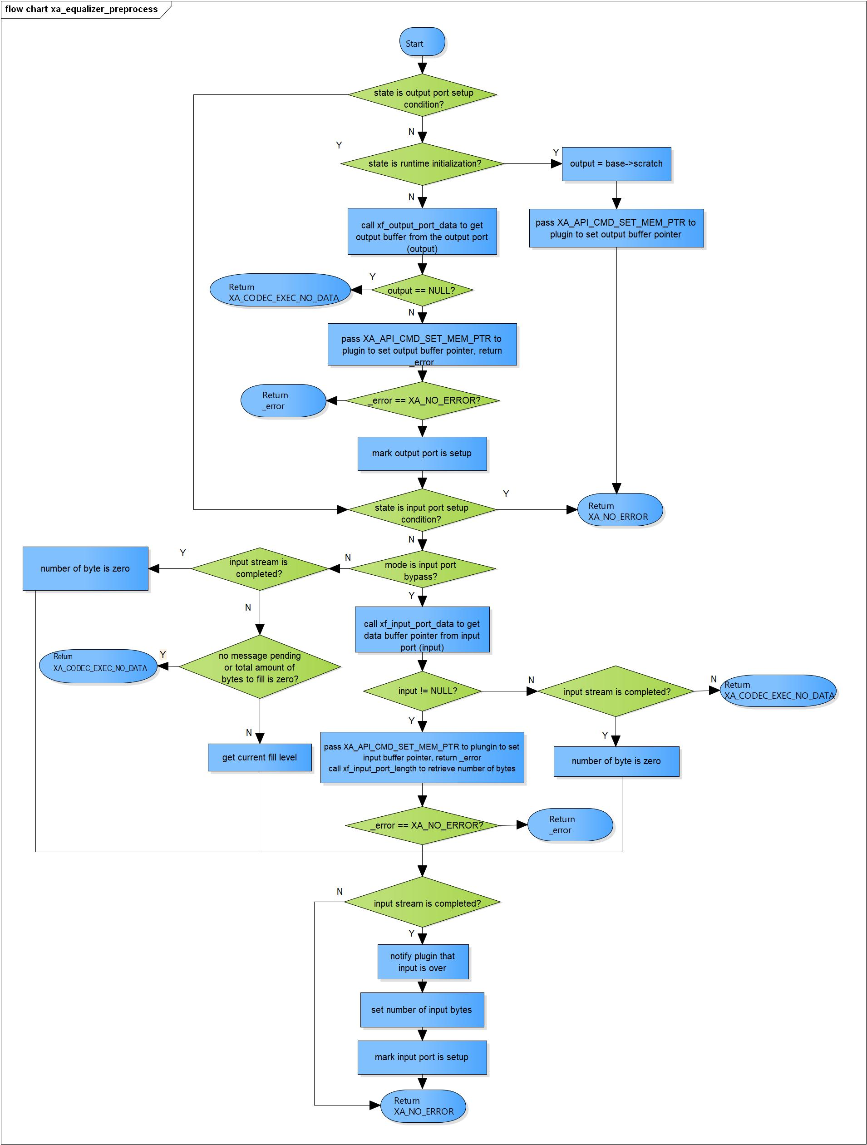

Figure 3‑7 xa_equalizer_preprocess flowchart

### xa_equalizer_postprocess

DD_FWK_EQZ_01_008

|  |  |  |  |  |
| --- | --- | --- | --- | --- |
| **Syntax** | static XA_ERRORCODE xa_equalizer_postprocess(XACodecBase *base,  WORD32 i_done) | | | |
| **Function** | This function is to consume bytes from input buffer and reschedule processing. | | | |
| **Arguments** | Type | Name | I/O | Description |
| XACodecBase | base | I/O | Pointer to codec instance structure (struct XACodecBase). |
| WORD32 | i_done | I | State of processing of plugin |
| **Return value** | XA_NO_ERROR | | Nomally end. | |
| XA_API_FATAL_MEM_ALLOC | | API structure is NULL (error from plugin). | |
| XA_API_FATAL_MEM_ALIGN | | API structure is not aligned 4 bytes (error from plugin). | |
| **Description** | * Postprocess command processing:   - Get number of produced samples from plugin, consume specified number of bytes from input port.  - Check state if process is done  - Get number of output bytes  - Reschedule execution if we have pending output message | | | |

[Covers: FD_FWK_CMN_005, FD_FWK_CMN_002, FD_FWK_CMN_003]

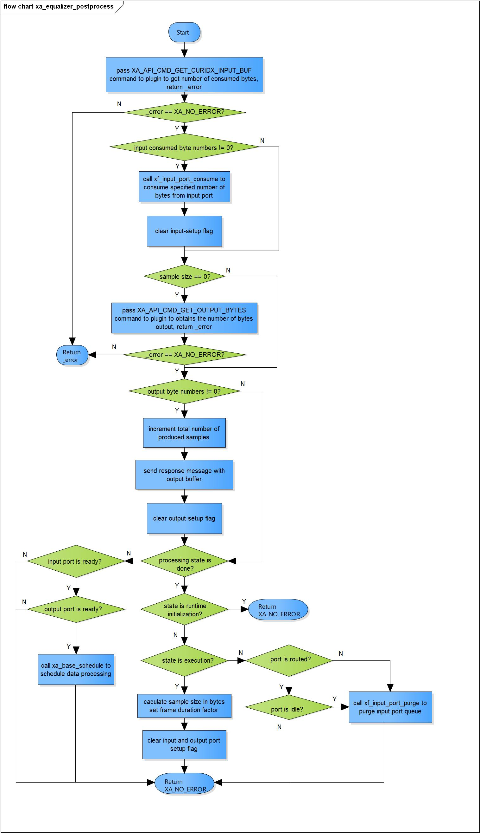

Figure 3‑8 xa_equalizer_postprocess flowchart

### xa_equalizer_flush

DD_FWK_EQZ_01_009

|  |  |  |  |  |
| --- | --- | --- | --- | --- |
| **Syntax** | static XA_ERRORCODE xa_equalizer_flush(XACodecBase *base, xf_message_t *m) | | | |
| **Function** | This function is to purge input port queue. | | | |
| **Arguments** | Type | Name | I/O | Description |
| XACodecBase | base | I/O | Pointer to codec instance structure (struct XACodecBase). |
| xf_message_t | m | I | Pointer to audio message (struct xf_message). |
| **Return value** | XA_NO_ERROR | | Nomally end. | |
| XA_API_FATAL_INVALID_CMD | | Post initialization state is not completed yet | |
| XA_API_FATAL_INVALID_CMD_TYPE | | Message length is zero. | |
| **Description** | * xa_equalizer_flush command processing:   - Check if post initialization state is not completed yet  - Ensure input parameter length is zero  - Flush ouput port | | | |

[Covers: FD_FWK_CMN_005, FD_FWK_CMN_012]

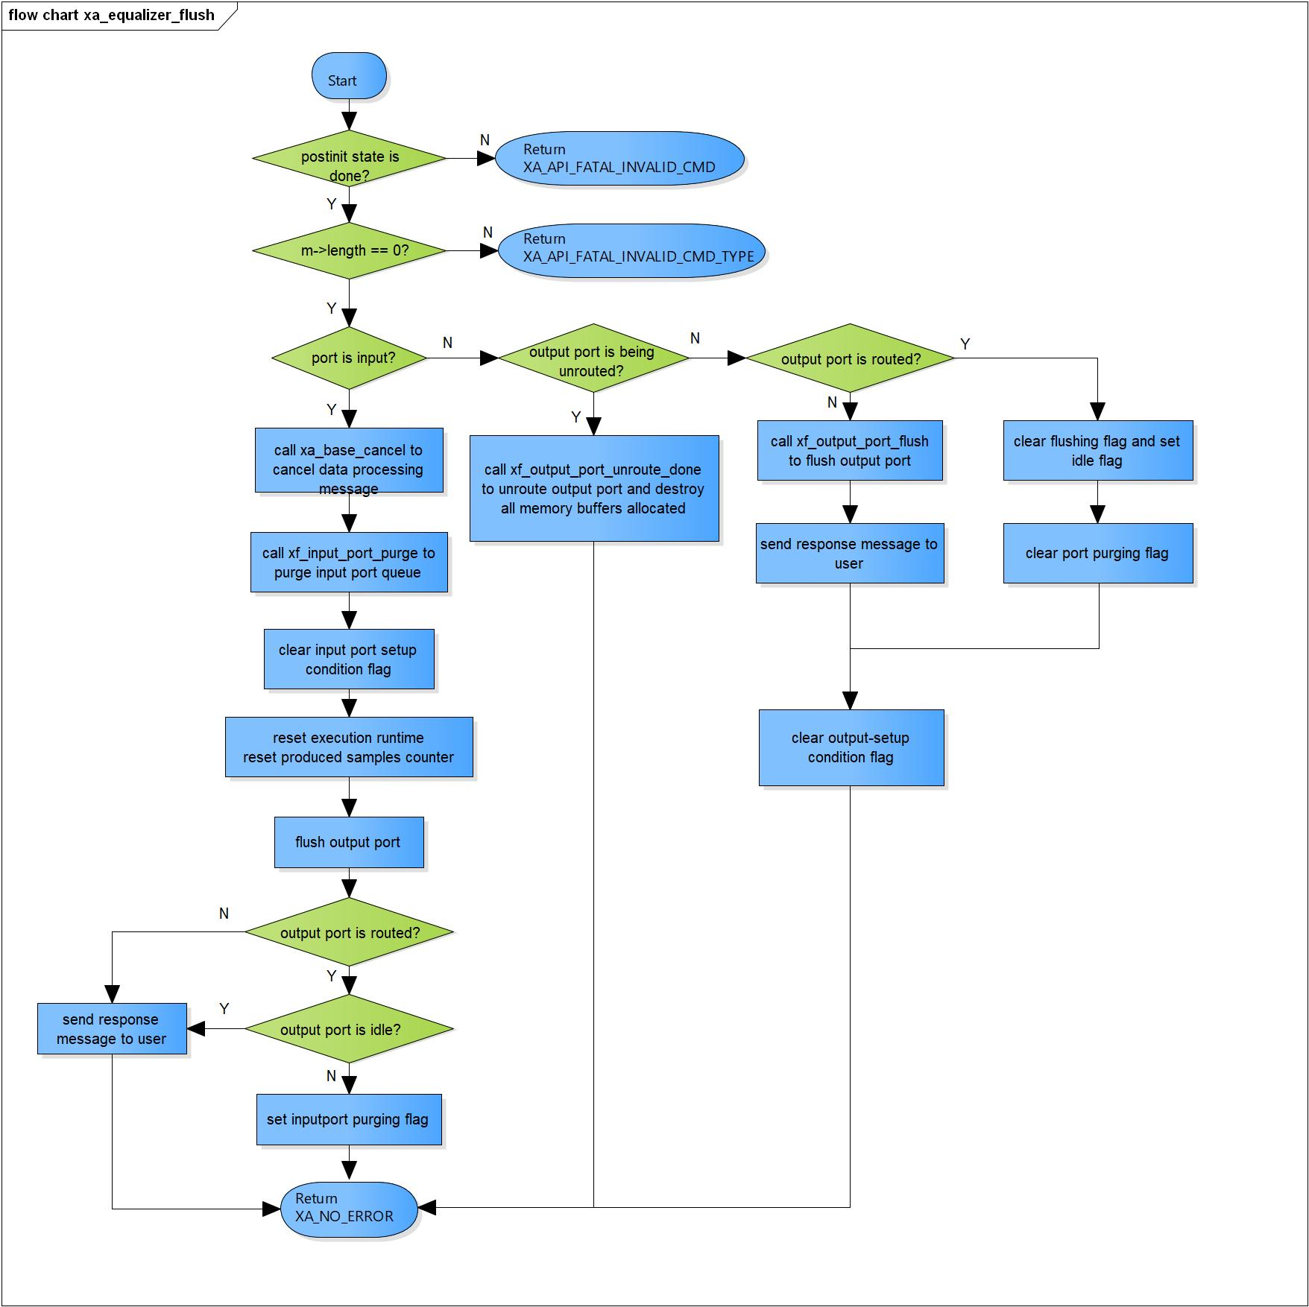

Figure 3‑9 xa_equalizer_flush flowchart

### xa_equalizer_cleanup

DD_FWK_EQZ_01_010

|  |  |  |  |  |
| --- | --- | --- | --- | --- |
| **Syntax** | static s32 xa_equalizer_cleanup(xf_component_t *component, xf_message_t *m) | | | |
| **Function** | This function is to purge input port queue and cancel internal scheduling. | | | |
| **Arguments** | Type | Name | I/O | Description |
| xf_component_t | component | I/O | Pointer to codec instance structure (struct xf_component ). |
| xf_message_t | m | I/O | Pointer to audio message (struct xf_message). |
| **Return value** | 1 | Equalizer component cannot be destroyed. | | |
| 0 | Equalizer component has been destroyed totally. | | |
| **Description** | * xa_equalizer_cleanup command processing:   - Complete message with error response.  - Cancel internal scheduling message if needed.  - Purge input port queue.  - Flush output port then destroy component. | | | |

[Covers: FD_FWK_CMN_005, FD_FWK_CMN_004]

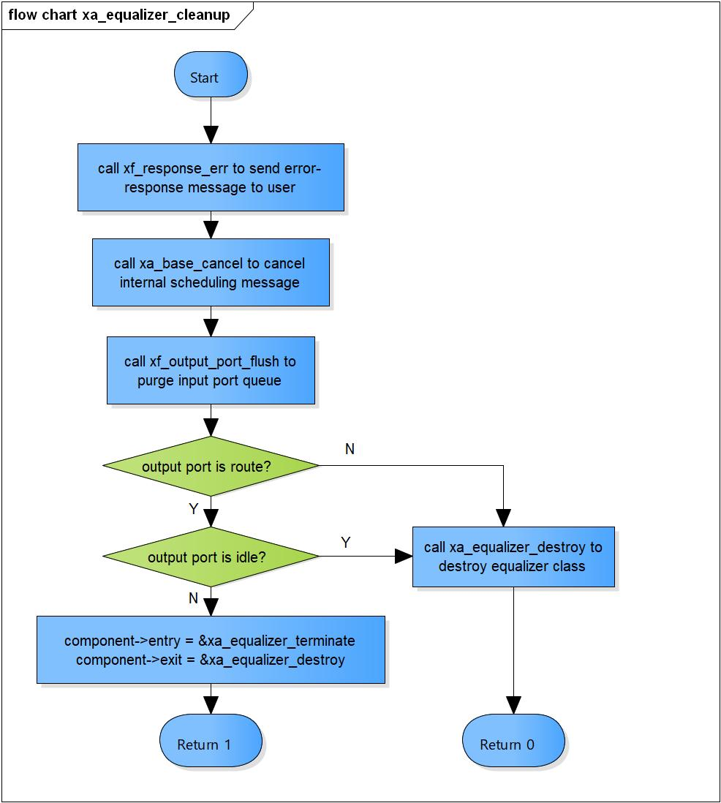

Figure 3‑10 xa_equalizer_cleanup flowchart

### xa_equalizer_terminate

DD_FWK_EQZ_01_011

|  |  |  |  |  |
| --- | --- | --- | --- | --- |
| **Syntax** | static s32 xa_equalizer_terminate(xf_component_t *component,  xf_message_t *m) | | | |
| **Function** | This is equalizer termination-state command processor function. | | | |
| **Arguments** | Type | Name | I/O | Description |
| xf_component_t | component | I/O | Pointer to codec instance structure (struct xf_component ). |
| xf_message_t | m | I/O | Pointer to audio message (struct xf_message). |
| **Return value** | -1 | Output port flushing is completed, component ready to destroy. | | |
| 0 | Normal end | | |
| **Description** | * xa_equalizer_terminate command processing:   - Check if we received output port control message. | | | |

[Covers: FD_FWK_CMN_004]

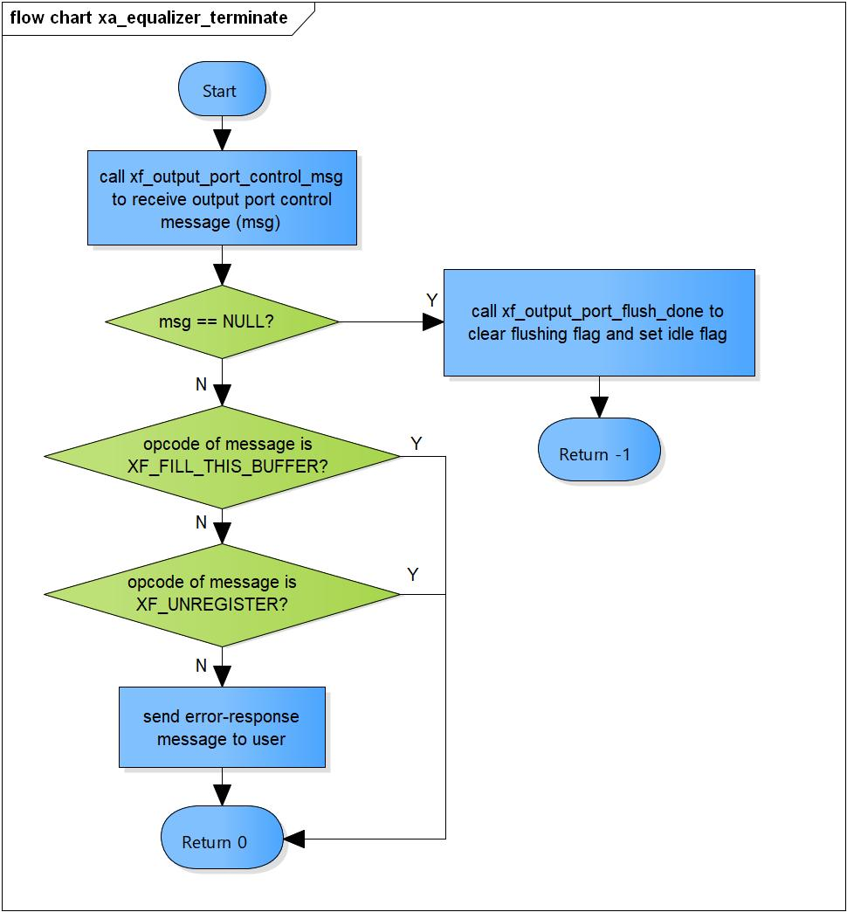

Figure 3‑11 xa_equalizer_terminate flowchart

### xa_equalizer_destroy

DD_FWK_EQZ_01_012

|  |  |  |  |  |
| --- | --- | --- | --- | --- |
| **Syntax** | static s32 xa_equalizer_destroy(xf_component_t *component, xf_message_t *m) | | | |
| **Function** | This function is to destroy component. | | | |
| **Arguments** | Type | Name | I/O | Description |
| xf_component_t | component | I/O | Pointer to codec instance structure (struct xf_component ). |
| xf_message_t | m | x | Pointer to audio message (struct xf_message). |
| 0 | | Indicate the component is destroyed. | |
| **Description** | * xa_equalizer_destrocommand processing:   - Destroy input port.  - Destroy output port.  - Destroy base object. | | | |

[Covers: FD_FWK_CMN_004]

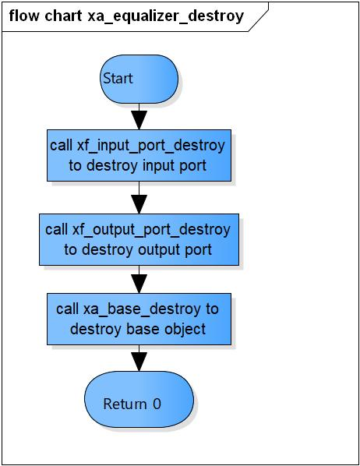

Figure 3‑12 xa_equalizer_destroy flowchart

### xa_equalizer_factory

DD_FWK_EQZ_01_013

|  |  |  |  |  |
| --- | --- | --- | --- | --- |
| **Syntax** | xf_component_t * xa_equalizer_factory(u32 core, xa_codec_func_t process) | | | |
| **Function** | This function is to initialize Equalizer component. | | | |
| **Arguments** | Type | Name | I/O | Description |
| u32 | core | I | Core index of ADSP framework. |
| xa_codec_func_t | process | I | Codec API entry point (function). |
| **Return Value** | Return handle to component. | | | |
| **Description** | * xa_equalizer_factory command processing:   - Initialize Equalizer component. | | | |

[Covers: FD_FWK_CMN_005, FD_FWK_CMN_008, FD_FWK_CMN_009]

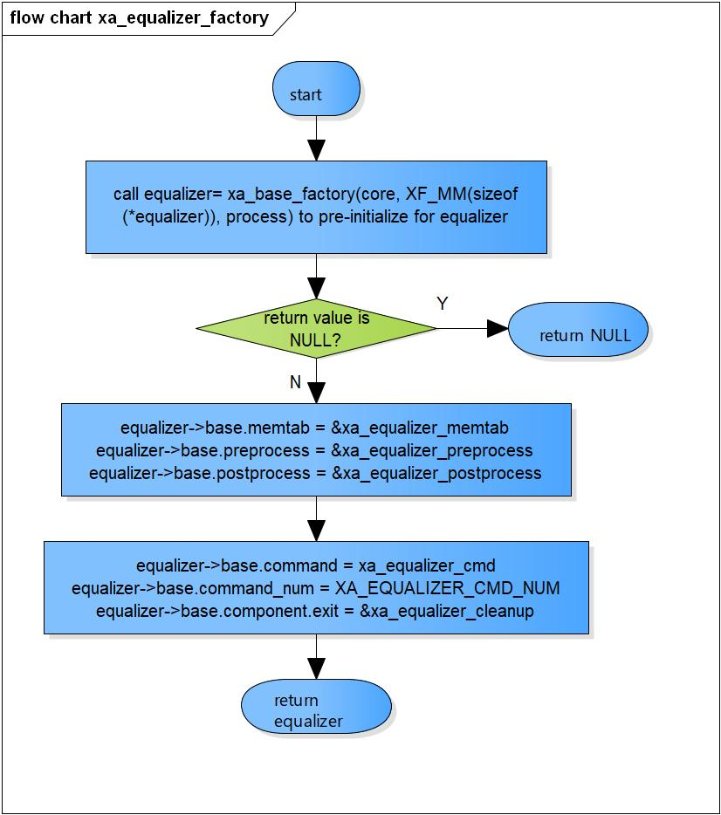

Figure 3‑13 xa_equalizer_factory flowchart

# Revision history

|  |  |  |  |  |  |
| --- | --- | --- | --- | --- | --- |
| **Version** | **Date** | **Page** | **Content** | **Approved** | **Changed** |
| 1.0.0 | Nov 14 2018 | - | First Edition issued | Vu Phan | Vu Phan |
| 1.1.0 | Dec 10 2018 | - | Add traceability ID | Vu Phan | Ngu Pham |
| 1.2.0 | Jan 03, 2019 | - | Add range for input parameters | Vu Phan | Tien Tran |