**Document Type: Detail Design**

**Document Name:**

**ADSP FRAMEWORK: RENDERER CLASS**

Renesas Electronics Corporation

Renesas Design Vietnam Co. Ltd

R-Car Software Solution 2 Group

Middleware 1 Team

Table of Contents

1. Overview 3

2. Function list 4

3. Detail information 5

3.1 Data type and Macro definition 5

3.2 Globle variable 6

3.3 Function definition 6

3.3.1 xa_renderer_prepare_runtime 6

3.3.2 xa_renderer_empty_this_buffer 8

3.3.3 xa_renderer_fill_this_buffer 10

3.3.4 xa_renderer_memtab 11

3.3.5 xa_renderer_preprocess 13

3.3.6 xa_renderer_postprocess 15

3.3.7 xa_renderer_flush 17

3.3.8 xa_renderer_cleanup 18

3.3.9 xa_renderer_destroy 20

3.3.10 xa_renderer_factory 21

4. Revision history 22

List of Figures

Figure 1‑1 The software architecture 3

Figure 3‑1 xa_renderer_prepare_runtime flowchart 7

Figure 3‑2 xa_renderer_empty_this_buffer flowchart 9

Figure 3‑3 xa_renderer_fill_this_buffer flowchart 10

Figure 3‑4 xa_renderer_memtab flowchart 12

Figure 3‑5 xa_renderer_preprocess flowchart 14

Figure 3‑6 xa_renderer_postprocess flowchart 16

Figure 3‑7 xa_renderer_flush flowchart 17

Figure 3‑8 xa_renderer_cleanup flowchart 19

Figure 3‑9 xa_renderer_destroy flowchart 20

Figure 3‑10 xa_renderer_factory flowchart 21

List of Table

Table 2‑1 Function list 4

Table 3‑1 XARenderer type structure information 5

Table 3‑2 Macro definitions 5

Table 3‑3 Global variable xa_renderer_cmd 6

# Overview

This section provides an overview of software architecture..

User Application

ADSP Interface

Kernel Space

User Space

ADSP Driver

ARM

Audio HW

**ADSP Framework**

TDM class

Equalizer class

Capture class

Renderer class

ADSP

Plugin

Equalizer Plugin*

TDM Plugin

Capture Plugin

Renderer Plugin

This document’s target is in side of red square

* not connect to SCU/SSI ADMA block

SCU/ SSI/

ADMA

DAC/

ADC

Figure 1‑1 ****The software architecture****

# Function list

The following is list of functions:

Table 2‑1 Function list

|  |  |  |
| --- | --- | --- |
| **Type** | **Function Name** | **Outline** |
| API | xa_renderer_factory | This API is to construct generic audio component and set functions pointer for internal functions. |
| Internal functions | xa_renderer_prepare_runtime | This function is to prepare renderer for steady operation. |
| xa_renderer_empty_this_buffer | This function is to put message into input port queue. |
| xa_renderer_fill_this_buffer | This function is dummy function to send respond message to user. |
| xa_renderer_flush | This function is to cancel data processing and purge input port queue. |
| xa_renderer_memtab | This function is to initialize input port structure. |
| xa_renderer_preprocess | This function is to prepare data for input buffer. |
| xa_renderer_postprocess | This function is to consume bytes from input buffer. |
| xa_renderer_terminate | This function is to check if it received internal message. |
| xa_renderer_destroy | This function is to destroy input port and renderer component. |
| xa_renderer_cleanup | This function is to purge input port and cancel data processing. |

# Detail information

This section describes detail information of data types, macro definitions, implemented APIs and internal function units, globle variable.

## Data type and Macro definition

The XARenderer type structure is the work area used by the renderer class. When using this class, secure the area with the application program. It’s not necessary to refer to this area because it only contains the internal variables and working buffers of the class. Make sure not to change the value of this area with the application program.

Table 3‑1 XARenderer type structure information

|  |  |
| --- | --- |
| Member name | Outline |
| XACodecBase base | Generic audio codec data |
| xf_input_port_t input | Input port queue |
| xf_output_port_t output | Output port queue |
| xa_renderer_cb_t cdata | Buffer completion hook |
| xf_message_t msg | Output ready message |
| u32 factor | Time conversion factor (input byte "duration" in timebase units) |
| u32 schedule | Internal message scheduling flag (shared with interrupt) |

Table 3‑2 Macro definitions

|  |  |  |
| --- | --- | --- |
| Macro | Value | Outline |
| XA_RENDERER_FLAG_ RUNNING | __XA_BASE_FLAG(1 << 0) | Rendering is performed |
| XA_RENDERER_FLAG_SILENCE | __XA_BASE_FLAG(1 << 1) | Renderer is idle and produces silence |
| XA_RENDERER_FLAG_OUTPUT_READY | __XA_BASE_FLAG(1 << 2) | Ouput data is ready |

Note: Macro __XA_BASE_FLAG(f) ((f) << 6) is in xa-class-base.h file.

## Globle variable

Table 3‑3 Global variable xa_renderer_cmd

|  |  |
| --- | --- |
| static XA_ERRORCODE (* const xa_renderer_cmd[])(XACodecBase *base, xf_message_t *m) | |
| Description: variable stores function pointers according to opcode index to run in runtime operation. | |
| Array index | Value (function pointer) |
| XF_OPCODE_TYPE(XF_SET_PARAM) | xa_base_set_param |
| XF_OPCODE_TYPE(XF_GET_PARAM) | xa_base_get_param |
| XF_OPCODE_TYPE(XF_EMPTY_THIS_BUFFER) | xa_renderer_empty_this_buffer |
| XF_OPCODE_TYPE(XF_FILL_THIS_BUFFER) | xa_renderer_fill_this_buffer |
| XF_OPCODE_TYPE(XF_FLUSH) | xa_renderer_flush |

Note: Marco XF_OPCODE_TYPE(opcode) : ((opcode) & (0x3F)) in xf-opcode.h file.

## Function definition

### xa_renderer_prepare_runtime

DD_FWK_RDR_02_001

|  |  |  |  |  |
| --- | --- | --- | --- | --- |
| **Syntax** | static inline XA_ERRORCODE xa_renderer_prepare_runtime(XARenderer *renderer) | | | |
| **Function** | This function is to prepare renderer for steady operation. | | | |
| **Arguments** | Type | Name | I/O | Description |
| XARenderer | renderer | I/O | Pointer to codec instance structure (struct XARenderer) |
| **Return value** | XA_API_FATAL_MEM_ALLOC | | API structure is NULL (error from plugin). | |
| XA_API_FATAL_MEM_ALIGN | | API structure is not aligned to 4 bytes (error from plugin). | |
| XA_RDR_CONFIG_FATAL_STATE | | Pre-initialization is not completed yet (error from plugin). | |
| XA_RDR_CONFIG_FATAL_RANGE | | Sample rate is invalid. | |
| XA_NO_ERROR | | Normally end. | |
| **Description** | * xa_renderer_prepare_runtime command processing:   - Get config parameters: sample rate, pcm width and channels.  - Set renderer timestamp factor. | | | |

[Covers: FD_FWK_CMN_002]

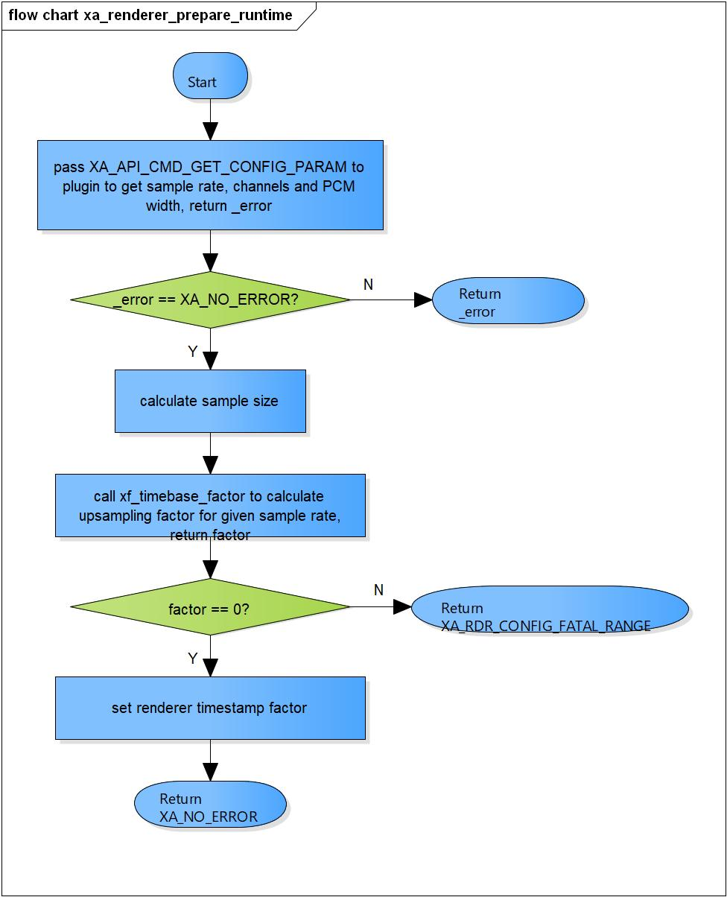

Figure 3‑1 xa_renderer_prepare_runtime flowchart

### xa_renderer_empty_this_buffer

DD_FWK_RDR_02_002

|  |  |  |  |  |
| --- | --- | --- | --- | --- |
| **Syntax** | static XA_ERRORCODE xa_renderer_empty_this_buffer(XACodecBase *base,  xf_message_t *m) | | | |
| **Function** | This function is to put message into the input port. | | | |
| **Arguments** | Type | Name | I/O | Description |
| XACodecBase | base | I/O | Pointer to codec instance structure (struct XACodecBase) |
| xf_message_t | m | I | Pointer to audio message (struct xf_message) |
| **Return value** | XA_API_FATAL_INVALID_CMD_TYPE | | Port is not an input port. | |
| XA_API_FATAL_INVALID_CMD | | Post initialization state is not completed yet. | |
| XA_NO_ERROR | | Normally end. | |
| **Description** | * xa_renderer_empty_this_buffer command processing:   - Make sure the port is an input port.  - Check if post initialization state is not completed yet  - Put message into the input port. | | | |

[Covers: FD_FWK_CMN_010, FD_FWK_CMN_005]

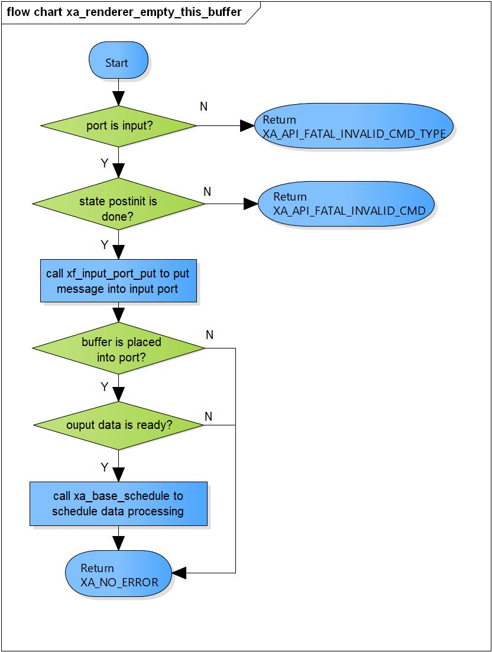

Figure 3‑2 xa_renderer_empty_this_buffer flowchart

### xa_renderer_fill_this_buffer

DD_FWK_RDR_02_003

|  |  |  |  |  |
| --- | --- | --- | --- | --- |
| **Syntax** | static XA_ERRORCODE xa_renderer_fill_this_buffer(XACodecBase *base,  xf_message_t *m) | | | |
| **Function** | This is a dummy function. | | | |
| **Arguments** | Type | Name | I/O | Description |
| XACodecBase | base | x | Pointer to codec instance structure (struct XACodecBase). |
| xf_message_t | m | I/O | Pointer to audio message (struct xf_message). |
| **Return value** | XA_NO_ERROR | | Normally end. | |
| **Description** | * xa_renderer_fill_this_buffer command processing:   - This is a dummy function send message to user. | | | |

[Covers: FD_FWK_CMN_011, FD_FWK_CMN_005]

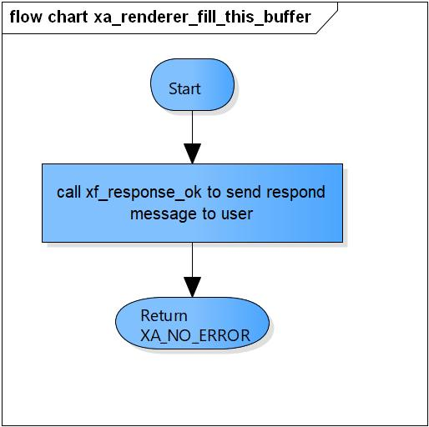

Figure 3‑3 xa_renderer_fill_this_buffer flowchart

### xa_renderer_memtab

DD_FWK_RDR_02_004

|  |  |  |  |  |
| --- | --- | --- | --- | --- |
| **Syntax** | static XA_ERRORCODE xa_renderer_memtab(XACodecBase *base, WORD32 idx, WORD32 type, WORD32 size, WORD32 align, u32 core) | | | |
| **Function** | This function is to initialize input port structure. | | | |
| **Arguments** | Type | Name | I/O | Description |
| XACodecBase | base | I/O | Pointer to codec instance structure (struct XACodecBase). |
| WORD32 | idx | I | Port index  Valid value: 1 |
| WORD32 | type | I | Port type (input or output port)  Valid value: XA_MEMTYPE_INPUT |
| WORD32 | size | I | Buffer size of port |
| WORD32 | align | I | Port alignment |
| u32 | core | I | Core index of ADSP framework |
| **Return value** | XA_NO_ERROR | | Normally end. | |
| XA_API_FATAL_INVALID_CMD_TYPE | | Port type is not an input port.  Port index are invalid.  idx is an invalid memory index (error from plugin). | |
| XA_API_FATAL_MEM_ALLOC | | Initialize input port is fail.  API structure is NULL (error from plugin). | |
| XA_API_FATAL_MEM_ALIGN | | API structure is not aligned to 4 bytes (error from plugin). | |
| XA_CAP_CONFIG_FATAL_STATE | | Post initialization state is not completed yet (error from plugin). | |
| **Description** | * xa_renderer_memtab command processing:   - Initialize input port structure.  - Mark renderer output buffer is ready. | | | |

[Covers: FD_FWK_CMN_008, FD_FWK_CMN_005, FD_FWK_CMN_001]

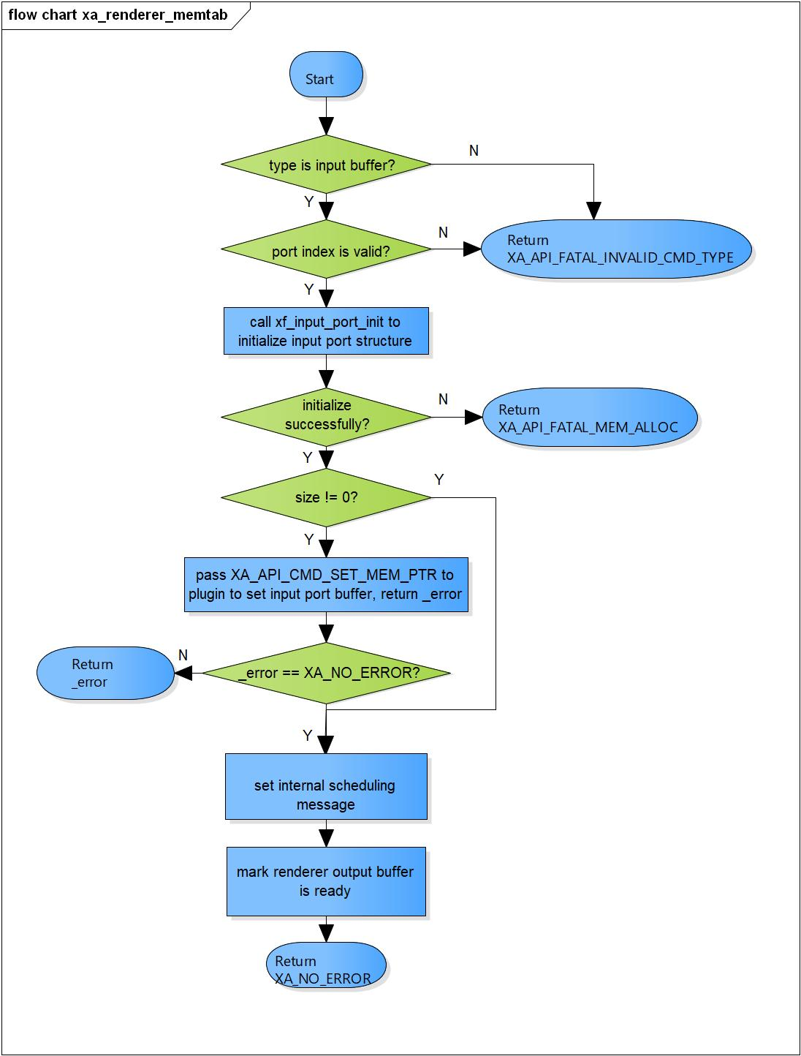

Figure 3‑4 xa_renderer_memtab flowchart

### xa_renderer_preprocess

DD_FWK_RDR_02_005

|  |  |  |  |  |
| --- | --- | --- | --- | --- |
| **Syntax** | static XA_ERRORCODE xa_renderer_preprocess(XACodecBase *base) | | | |
| **Function** | This function is to prepare data for input buffer. | | | |
| **Arguments** | Type | Name | I/O | Description |
| XACodecBase | base | I | Pointer to codec instance structure (struct XACodecBase) |
| **Return value** | XA_NO_ERROR | | Normally end | |
| XA_RDR_EXEC_NONFATAL_INPUT | | No input data available.  Input data is insufficient. | |
| XA_API_FATAL_MEM_ALLOC | | API structure is NULL (error from plugin). | |
| XA_API_FATAL_MEM_ALIGN | | API structure is not aligned to 4 bytes (error from plugin). | |
| XA_RDR_EXEC_FATAL_STATE | | Initialization state is not completed yet (error from plugin). | |
| **Description** | * Preprocess command processing:   - Check current execution stage is runtime initialization.  - Check if input stream is over.  - Submit input buffer to the renderer.  - Set total number of bytes we have in buffer. | | | |

[Covers: FD_FWK_CMN_005, FD_FWK_CMN_002, FD_FWK_CMN_003]

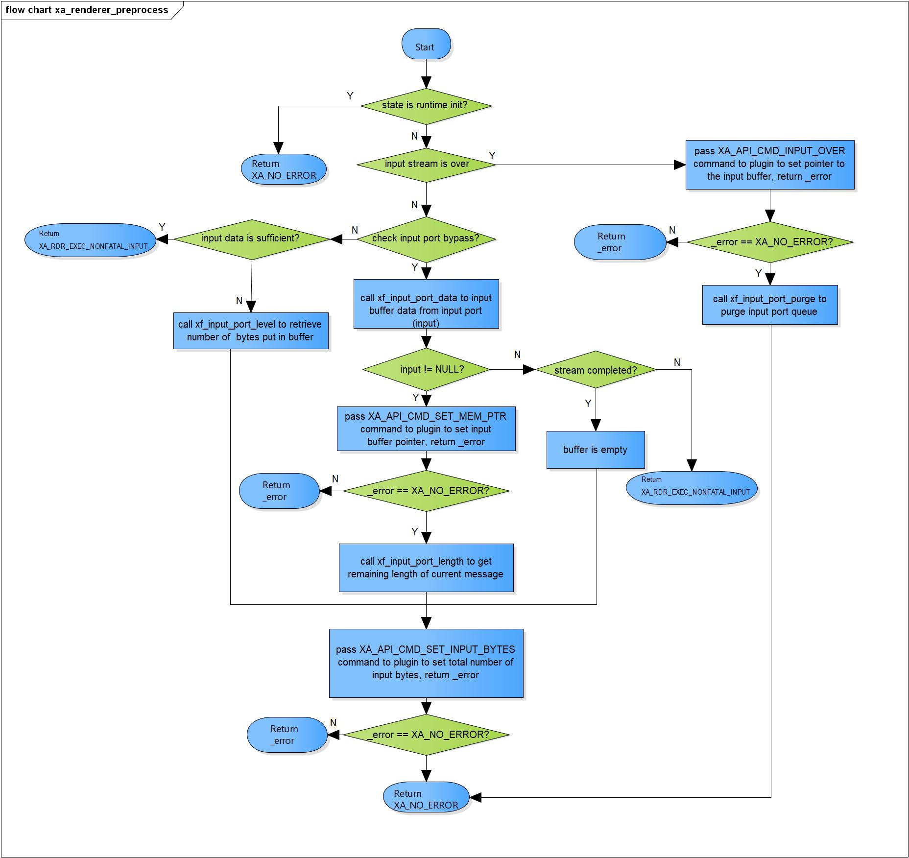

Figure 3‑5 xa_renderer_preprocess flowchart

### xa_renderer_postprocess

DD_FWK_RDR_02_006

|  |  |  |  |  |
| --- | --- | --- | --- | --- |
| **Syntax** | static XA_ERRORCODE xa_renderer_postprocess(XACodecBase *base, s32 done) | | | |
| **Function** | This function is to consume bytes from input buffer. | | | |
| **Arguments** | Type | Name | I/O | Description |
| XACodecBase | base | I/O | Pointer to codec instance structure (struct XACodecBase). |
| s32 | done | I | State of processing of plugin. |
| **Return value** | XA_NO_ERROR | | Normally end. | |
| XA_API_FATAL_MEM_ALLOC | | API structure is NULL (error from plugin). | |
| XA_API_FATAL_MEM_ALIGN | | API structure is not aligned to 4 bytes (error from plugin). | |
| XA_RDR_EXEC_FATAL_STATE | | Input buffer is not exist (error from plugin). | |
| **Description** | * Postprocess command processing:   - Check state if process is done.  - Get total amount of consumed samples from plugin.  - Consume bytes from input buffer.  - Reschedule execution if we have pending input. | | | |

[Covers: FD_FWK_CMN_005, FD_FWK_CMN_002, FD_FWK_CMN_003]

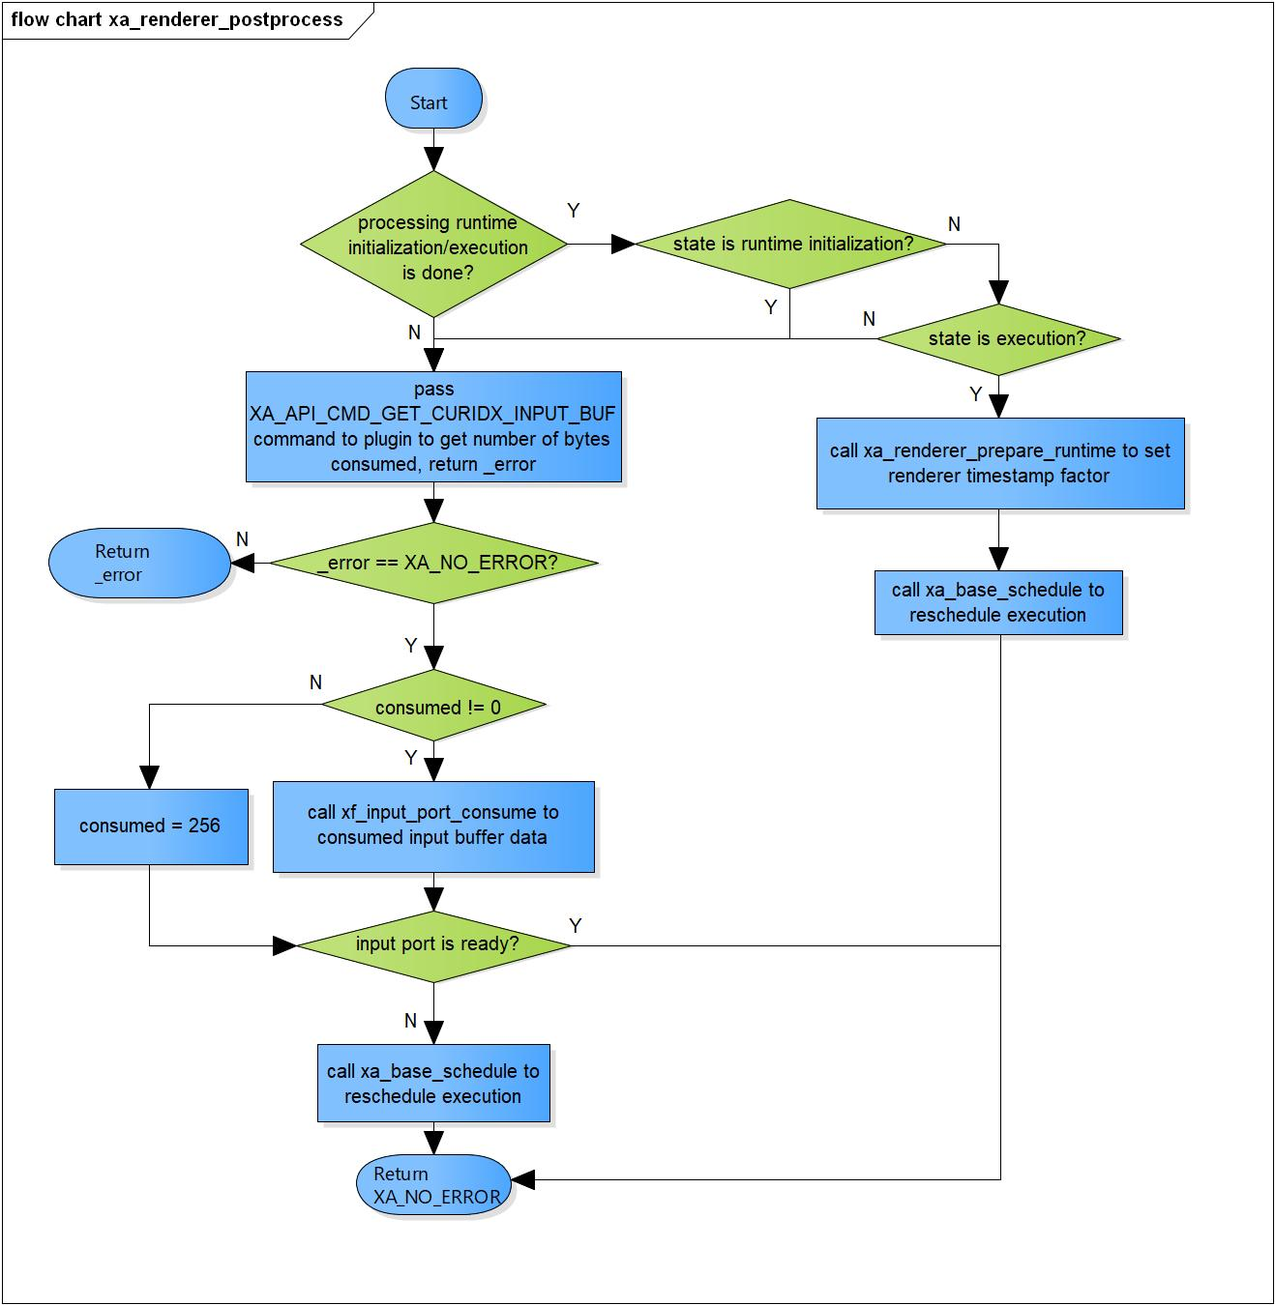

Figure 3‑6 xa_renderer_postprocess flowchart

### xa_renderer_flush

DD_FWK_RDR_02_007

|  |  |  |  |  |
| --- | --- | --- | --- | --- |
| **Syntax** | static XA_ERRORCODE xa_renderer_flush(XACodecBase *base, xf_message_t *m) | | | |
| **Function** | This function is to cancel data processing and purge input port queue. | | | |
| **Arguments** | Type | Name | I/O | Description |
| XACodecBase | base | I/O | Pointer to codec instance structure (struct XACodecBase). |
| xf_message_t | m | I | Pointer to audio message (struct xf_message). |
| **Return value** | XA_NO_ERROR | | Normally end. | |
| XA_API_FATAL_INVALID_CMD | | Processing is not in execution state. | |
| XA_API_FATAL_INVALID_CMD_TYPE | | Message length is not zero. | |
| **Description** | * xa_renderer_flush command processing:   - Check if process is in execution state.  - Ensure input parameter length is zero.  - Cancel data processing if needed.  - Input port flushing; purge content of input buffer. | | | |

[Covers: FD_FWK_CMN_012, FD_FWK_CMN_005]

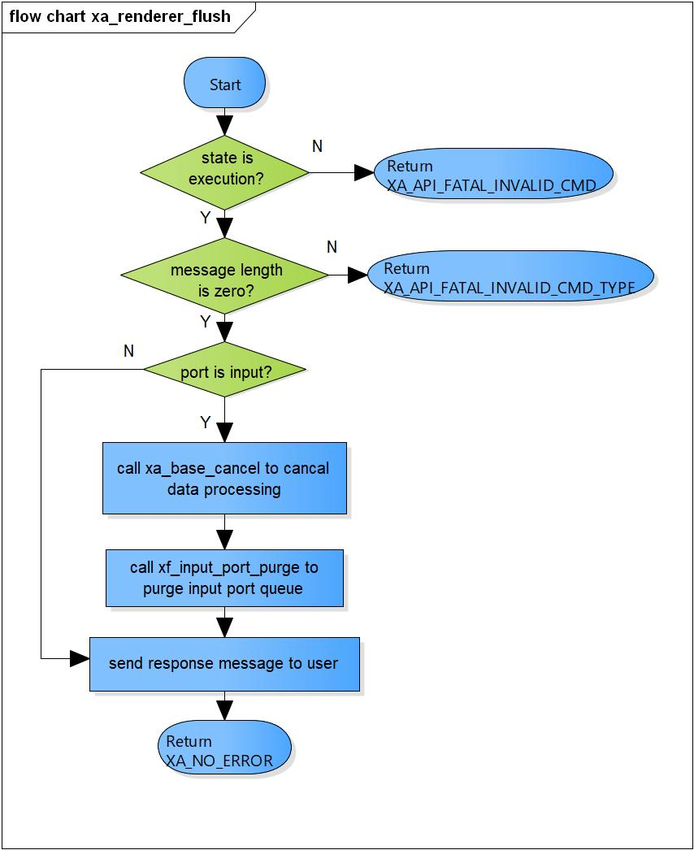

Figure 3‑7 xa_renderer_flush flowchart

### xa_renderer_cleanup

DD_FWK_RDR_02_008

|  |  |  |  |  |
| --- | --- | --- | --- | --- |
| **Syntax** | static s32 xa_renderer_cleanup(xf_component_t *component, xf_message_t *m) | | | |
| **Function** | This function is to purge input port and cancel data processing. | | | |
| **Arguments** | Type | Name | I/O | Description |
| xf_component_t | component | I/O | Pointer to codec instance structure (struct xf_component ). |
| xf_message_t | m | I | Pointer to audio message  (struct xf_message). |
| **Return value** | 1 | | Renderer component cannot be destroyed. | |
| 0 | | Renderer component has been destroyed totally. | |
| **Description** | * xa_renderer_cleanup command processing:   - Complete message with error result code.  - Cancel component task execution if needed.  - Pass XA_CAP_CONFIG_PARAM_STATE command to plugin with state is idle.  - Purge input port.  - Check if we have internal message scheduled. | | | |

[Covers: FD_FWK_CMN_005, FD_FWK_CMN_004]

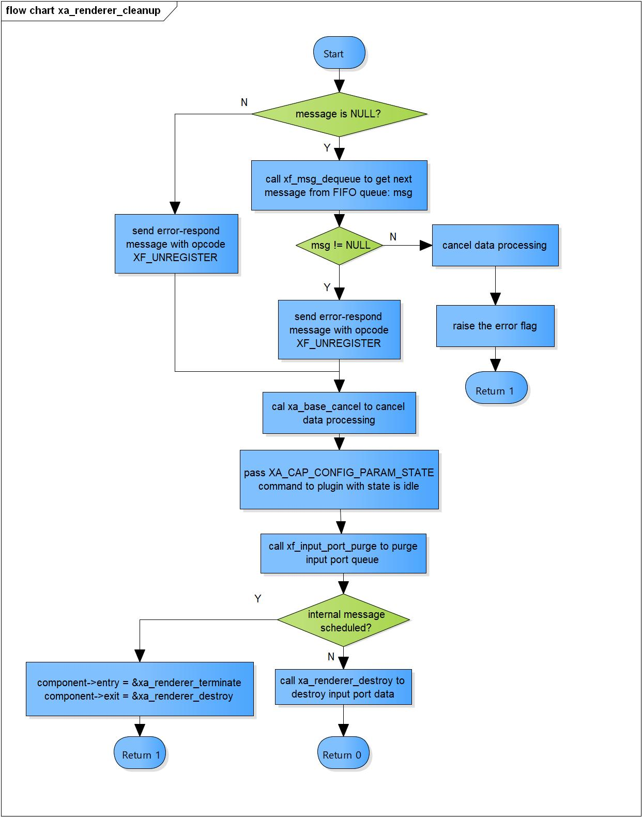

Figure 3‑8 xa_renderer_cleanup flowchart

### xa_renderer_destroy

DD_FWK_RDR_02_009

|  |  |  |  |  |
| --- | --- | --- | --- | --- |
| **Syntax** | static s32 xa_renderer_destroy(xf_component_t *component, xf_message_t *m) | | | |
| **Function** | This function is to destroy input port and renderer component. | | | |
| **Arguments** | Type | Name | I/O | Description |
| xf_component_t | component | I | Pointer to codec instance structure (struct xf_component). |
| xf_message_t | m | x | Pointer to audio message (struct xf_message). |
| 0 | | Indicate the component is destroyed. | |
| **Description** | * xa_renderer_terminate command processing:   - Destroy input port.  - Destroy base object. | | | |

[Covers: FD_FWK_CMN_004]

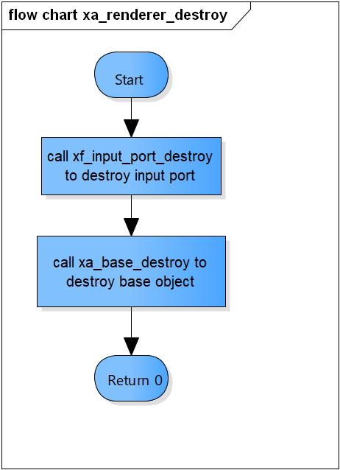

Figure 3‑9 xa_renderer_destroy flowchart

### xa_renderer_factory

DD_FWK_RDR_02_010

|  |  |  |  |  |
| --- | --- | --- | --- | --- |
| **Syntax** | xf_component_t * xa_renderer_factory(u32 core, xa_codec_func_t process) | | | |
| **Function** | This function is to initialize Renderer component. | | | |
| **Arguments** | Type | Name | I/O | Description |
| u32 | core | I | Core index of ADSP framework. |
| xa_codec_func_t | process | I | Codec API entry point (function). |
| **Return Value** | Return handle to component. | | | |
| **Description** | * xa_renderer_factory command processing:   - Initialize Renderer component. | | | |

[Covers: FD_FWK_CMN_005, FD_FWK_CMN_008, FD_FWK_CMN_009]

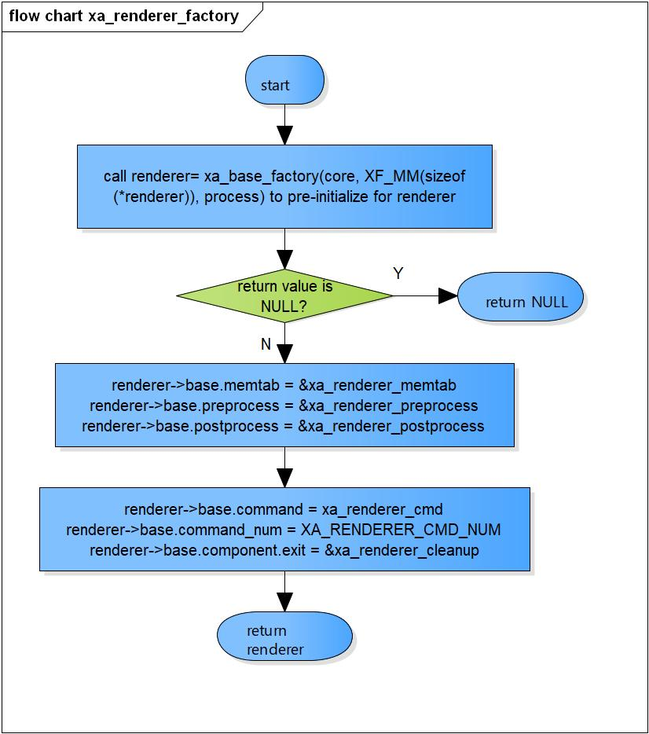

Figure 3‑10 xa_renderer_factory flowchart

# Revision history

|  |  |  |  |  |  |
| --- | --- | --- | --- | --- | --- |
| **Version** | **Date** | **Page** | **Content** | **Approved** | **Changed** |
| 1.0.0 | Nov 14 2018 | - | First Edition issued | Vu Phan | Vu Phan |
| 1.1.0 | Dec 10 2018 | - | Add traceability ID | Vu Phan | Ngu Pham |
| 1.2.0 | Jan 03, 2019 | - | Add range for input parameters | Vu Phan | Tien Tran |