**Document Type: Detail Design**

**Document Name:**

**ADSP FRAMEWORK: TDM CAPTURE CLASS**

Renesas Design Vietnam Co. Ltd

R-Car Software Solution 2 Group

Middleware 1 Team

Renesas Electronics Corporation

Table of Contents

1. Overview 3

2. Function list 4

3. Detail information 5

3.1 Data type and Macro definition 5

3.2 Globle variable 6

3.3 Function definition 6

3.3.1 xa_tdm_capture_prepare_runtime 6

3.3.2 xa_tdm_capture_sufficient_outport_check 8

3.3.3 xa_tdm_capture_empty_this_buffer 9

3.3.4 xa_tdm_capture_fill_this_buffer 11

3.3.5 xa_tdm_capture_memtab 13

3.3.6 xa_tdm_capture_preprocess 15

3.3.7 xa_tdm_capture_postprocess 17

3.3.8 xa_tdm_capture_flush 19

3.3.9 xa_tdm_capture_cleanup 21

3.3.10 xa_tdm_capture_terminate 23

3.3.11 xa_tdm_capture_destroy 24

3.3.12 xa_tdm_capture_factory 25

4. Revision history 26

List of Figures

Figure 1‑1 The software architecture 3

Figure 3‑1 xa_tdm_capture_prepare_runtime flowchart 7

Figure 3‑2 xa_tdm_capture_sufficient_outport_check flowchart 8

Figure 3‑3 xa_tdm_capture_empty_this_buffer flowchart 10

Figure 3‑4 xa_tdm_capture_fill_this_buffer flowchart 12

Figure 3‑5 xa_tdm_capture_memtab flowchart 14

Figure 3‑6 xa_tdm_capture_preprocess flowchart 16

Figure 3‑7 xa_tdm_capture_postprocess flowchart 18

Figure 3‑8 xa_tdm_capture_flush flowchart 20

Figure 3‑9 xa_tdm_capture_cleanup flowchart 22

Figure 3‑10 xa_tdm_capture_terminate flowchart 23

Figure 3‑11 xa_tdm_capture_destroy flowchart 24

Figure 3‑12 xa_tmd_capture_factory flowchart 25

List of Table

Table 2‑1 Function list 4

Table 3‑1 XATDMCapture type structure information 5

Table 3‑2 Macro definitions 5

Table 3‑3 Globle variable xa_tdm_capture_cmd 6

# Overview

This section provides an overview of the software architecture.

User Application

ADSP Interface

Kernel Space

User Space

ADSP Driver

ARM

Audio HW

**ADSP Framework**

TDM class

Equalizer class

Capture class

Renderer class

ADSP

Plugin

Equalizer Plugin*

TDM Plugin

Capture Plugin

Renderer Plugin

This document’s target is in side of red square

* not connect to SCU/SSI ADMA block

SCU/ SSI/

ADMA

DAC/

ADC

Figure 1‑1 ****The software architecture****

# Function list

The following is list of functions:

Table 2‑1 Function list

|  |  |  |
| --- | --- | --- |
| **Type** | **Function Name** | **Outline** |
| API | xa_tdm_capture_factory | This API is to construct generic audio component and set functions pointer for internal functions |
| Internal functions | xa_tdm_capture_prepare_runtime | This function is to prepare TDM capture for steady operation. |
| xa_tdm_capture_sufficient_outport_check | This function is to check the sufficient output port. |
| xa_tdm_capture_empty_this_buffer | This function is to handle end of stream and respond message back to user. |
| xa_tdm_capture_fill_this_buffer | This function is to put message into all output port. |
| xa_tdm_capture_flush | This function is to flush output port queue. |
| xa_tdm_capture_memtab | This function is to initialize all output port. |
| xa_tdm_capture_preprocess | This function is to prepare data for output buffer. |
| xa_tdm_capture_postprocess | This function is to get number of produced bytes and reschedule processing. |
| xa_tdm_capture_terminate | This is to check if we received output port control message. |
| xa_tdm_capture_destroy | This function is to destroy component. |
| xa_tdm_capture_cleanup | This function is to flush output port queue and cancel internal scheduling. |

# Detail information

This section describes detail information of data types, macro definitions, implemented APIs and internal function units, global variable.

## Data type and Macro definition

The XATDMCapture type structure is the work area used by the TDM capture class. When using this class, secure the area with the application program. It’s not necessary to refer to this area because it only contains the internal variables and working buffers of the class. Make sure not to change the value of this area with the application program.

Table 3‑1 XATDMCapture type structure information

|  |  |
| --- | --- |
| Member name | Outline |
| XACodecBase base | Generic audio codec data |
| xf_output_port_t output[XA_MEMCNT_OUTPUT] | Array of output port queue |
| u32 out_idx[XA_MEMCNT_OUTPUT] | Array of output port index |
| u32 output_total | The number of total output port |
| u32 factor | Time conversion factor (input byte "duration" in timebase units) |

Note: Marro XA_MEMCNT_OUTPUT: 4 (number of ouput memory block) in xa-tdm-capture-api.h

Table 3‑2 Macro definitions

|  |  |  |
| --- | --- | --- |
| Macro | Value | Outline |
| XA_TDM_CAP_FLAG_OUTPUT_PORT_INIT_DONE | __XA_BASE_FLAG(1 << 0) | Output port init done flag |
| XA_TDM_CAP_FLAG_INPUT_DATA_OVER | __XA_BASE_FLAG(1 << 1) | Signal over flag |

Note: Macro __XA_BASE_FLAG(f) ((f) << 6) is in xa-class-base.h file.

## Globle variable

Table 3‑3 Globle variable xa_tdm_capture_cmd

|  |  |
| --- | --- |
| static XA_ERRORCODE (* const xa_tdm_capture_cmd[])(XACodecBase *base, xf_message_t *m) | |
| Description: variable stores function pointers arcoding to opcode index to run in runtime operation. | |
| Array index | Value (function pointer) |
| XF_OPCODE_TYPE(XF_SET_PARAM) | xa_base_set_param |
| XF_OPCODE_TYPE(XF_GET_PARAM) | xa_base_get_param |
| XF_OPCODE_TYPE(XF_EMPTY_THIS_BUFFER) | xa_tdm_capture_empty_this_buffer |
| XF_OPCODE_TYPE(XF_FILL_THIS_BUFFER) | xa_tdm_capture_fill_this_buffer |
| XF_OPCODE_TYPE(XF_FLUSH) | xa_tdm_capture_flush |

Note: Marco XF_OPCODE_TYPE(opcode) : ((opcode) & (0x3F)) in xf-opcode.h file.

## Function definition

### xa_tdm_capture_prepare_runtime

DD_FWK_TDM_01_001

|  |  |  |  |  |
| --- | --- | --- | --- | --- |
| **Syntax** | static inline XA_ERRORCODE xa_tdm_capture_prepare_runtime(XATDMCapture *tdm_cap) | | | |
| **Function** | This function is to prepare TDM capture for steady operation. | | | |
| **Arguments** | Type | Name | I/O | Description |
| XATDMCapture | tdm_cap | I/O | Pointer to codec instance structure (struct XATDMCapure). |
| **Return value** | XA_NO_ERROR | | Nomally end. | |
| XA_TDM_CAP_CONFIG_FATAL_PCM_WIDTH | | PCM width is not 16 and 24. | |
| XA_TDM_CAP_CONFIG_FATAL_CHANNEL_MODE | | Channel mode is invalid. | |
| XA_TDM_CAP_CONFIG_FATAL_SAMPLE_RATE | | Sample rate is invalid. | |
| XA_API_FATAL_MEM_ALLOC | | API structure is NULL (error from plugin). | |
| XA_API_FATAL_MEM_ALIGN | | API structure is not aligned to 4 bytes (error from plugin). | |
| XA_TDM_CAP_CONFIG_FATAL_STATE | | Plugin has not pre-init yet (error from plugin). | |
| **Description** | * xa_tdm_capture_prepare_runtime command processing:   - Get config parameters: sample rate, pcm width, channels, frame size.  - Calculate sample size.  - Set capture timestamp factor. | | | |

[Covers: FD_FWK_CMN_002]

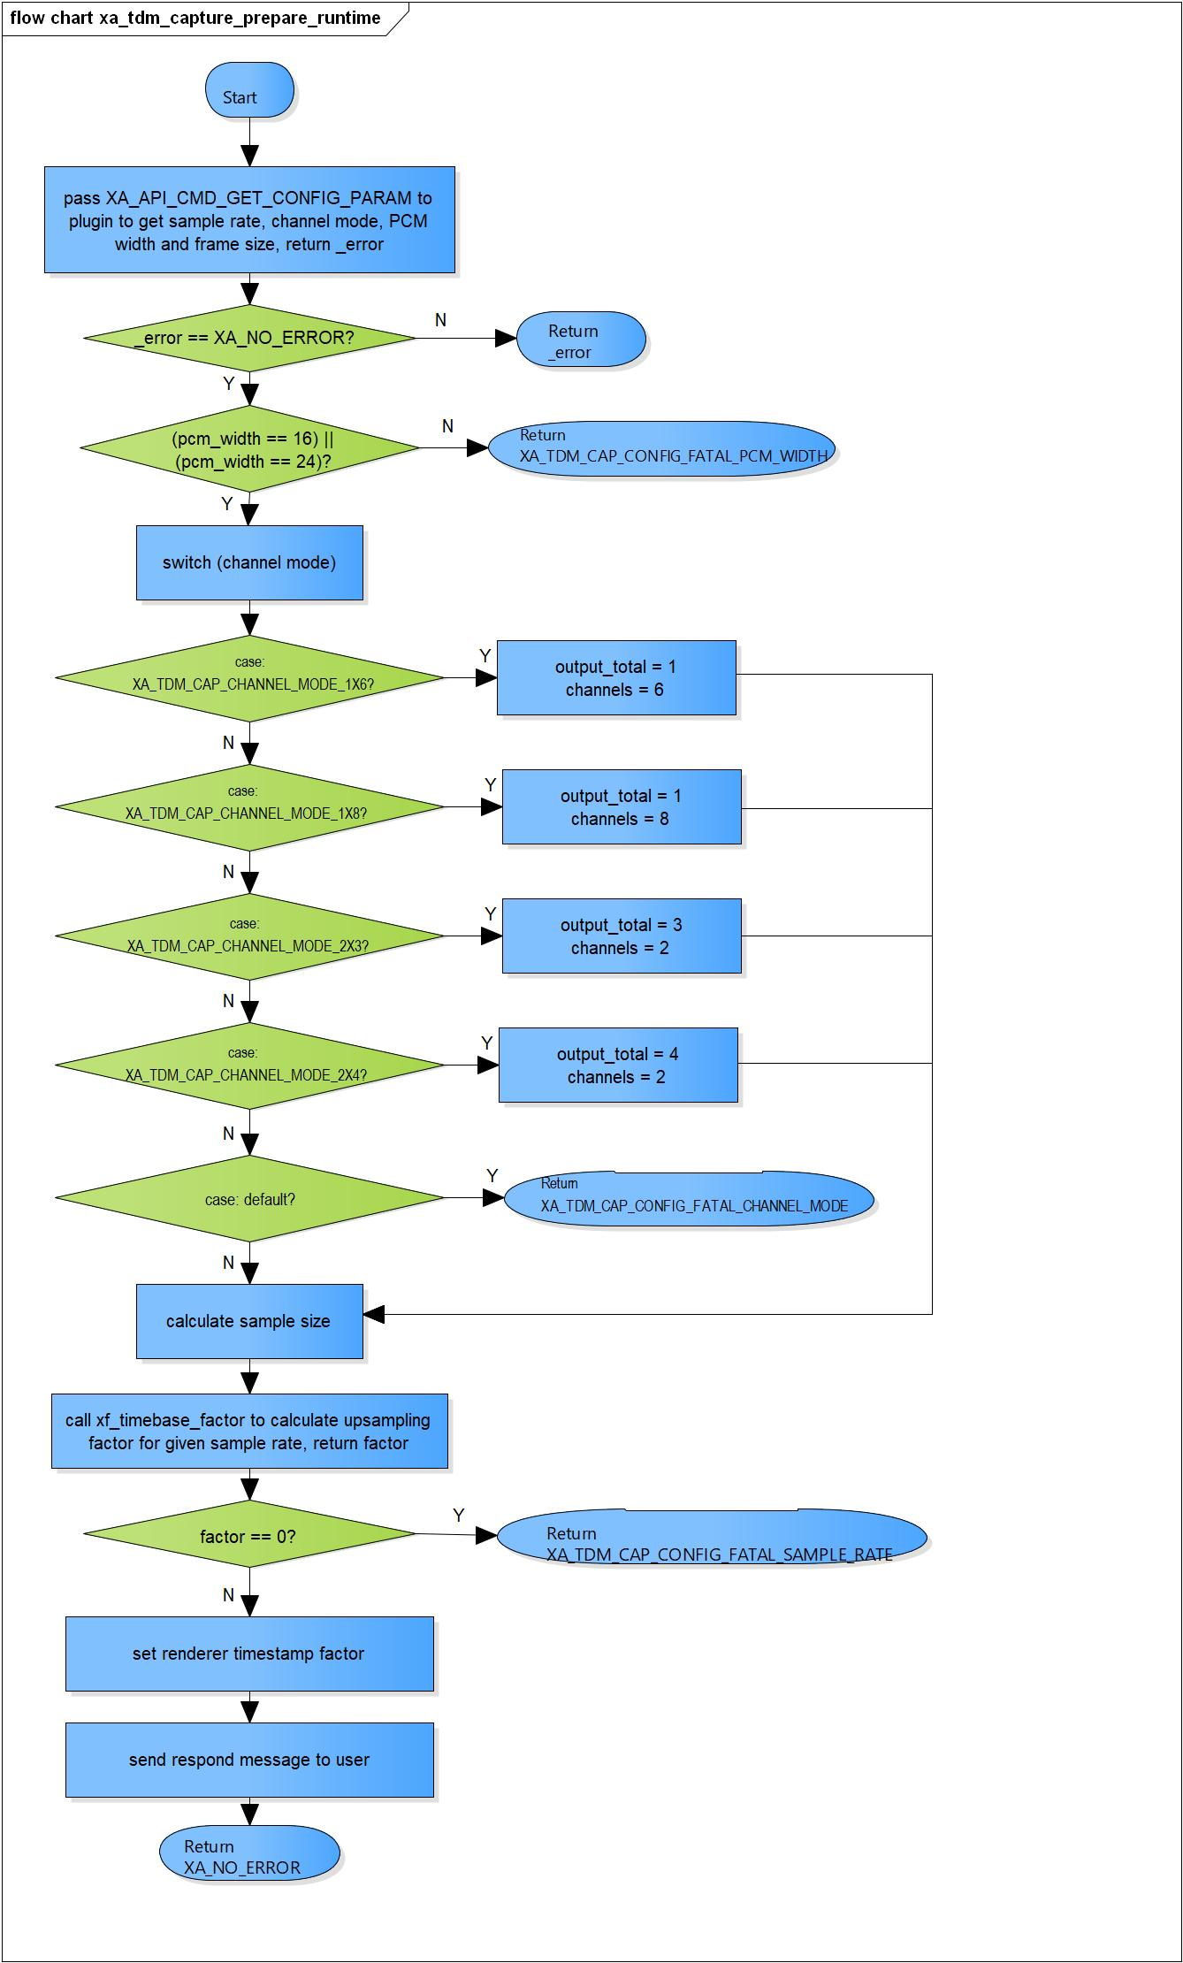

Figure 3‑1 xa_tdm_capture_prepare_runtime flowchart

### xa_tdm_capture_sufficient_outport_check

DD_FWK_TDM_01_002

|  |  |  |  |  |
| --- | --- | --- | --- | --- |
| **Syntax** | static inline s32 xa_tdm_capture_sufficient_outport_check(XACodecBase *base) | | | |
| **Function** | This function is to check the sufficient output port. | | | |
| **Arguments** | Type | Name | I/O | Description |
| XACodecBase | base | I/O | Pointer to codec instance structure (struct XACodecBase). |
| **Return value** | 0 | | Indicate ports are not ready yet. | |
| 1 | | Indicate all ports are ready. | |
| **Description** | * xa_tdm_capture_sufficient_outport_check command processing:   - Check the sufficient port, if have any port is not ready return 0. | | | |

[Covers: FD_FWK_CMN_003, FD_FWK_CMN_011]

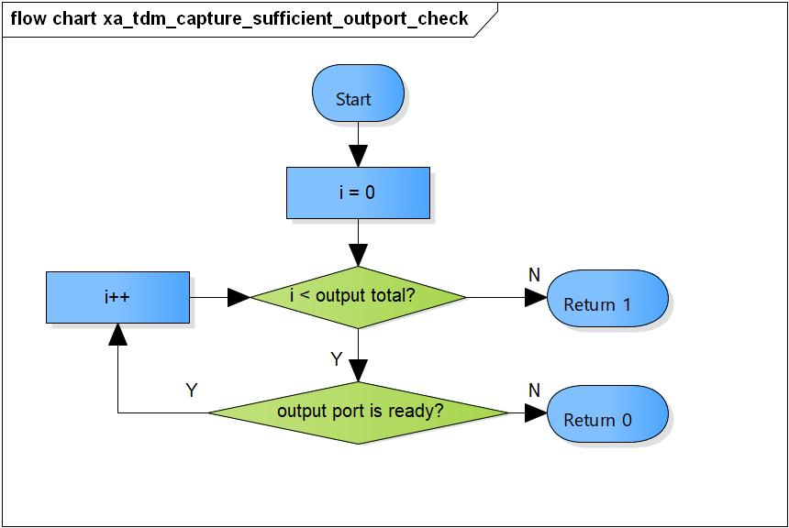

Figure 3‑2 xa_tdm_capture_sufficient_outport_check flowchart

### xa_tdm_capture_empty_this_buffer

DD_FWK_TDM_01_003

|  |  |  |  |  |
| --- | --- | --- | --- | --- |
| **Syntax** | static XA_ERRORCODE xa_tdm_capture_empty_this_buffer(XACodecBase *base,  xf_message_t *m) | | | |
| **Function** | This function is to check end of stream for input port. | | | |
| **Arguments** | Type | Name | I/O | Description |
| XACodecBase | base | I/O | Pointer to codec instance structure (struct XACodecBase). |
| xf_message_t | m | I | Pointer to audio message (struct xf_message). |
| **Return value** | XA_NO_ERROR | | Nomally end. | |
| XA_API_FATAL_INVALID_CMD_TYPE | | Port is not an input port queue. | |
| XA_TDM_CAP_EXEC_FATAL_STATE | | Post initialization state is not completed yet. | |
| **Description** | * xa_tdm_capture_empty_this_buffer command processing:   - Check if buffer is end of stream.  - Respond message back to user. | | | |

[Covers: FD_FWK_CMN_005, FD_FWK_CMN_010]

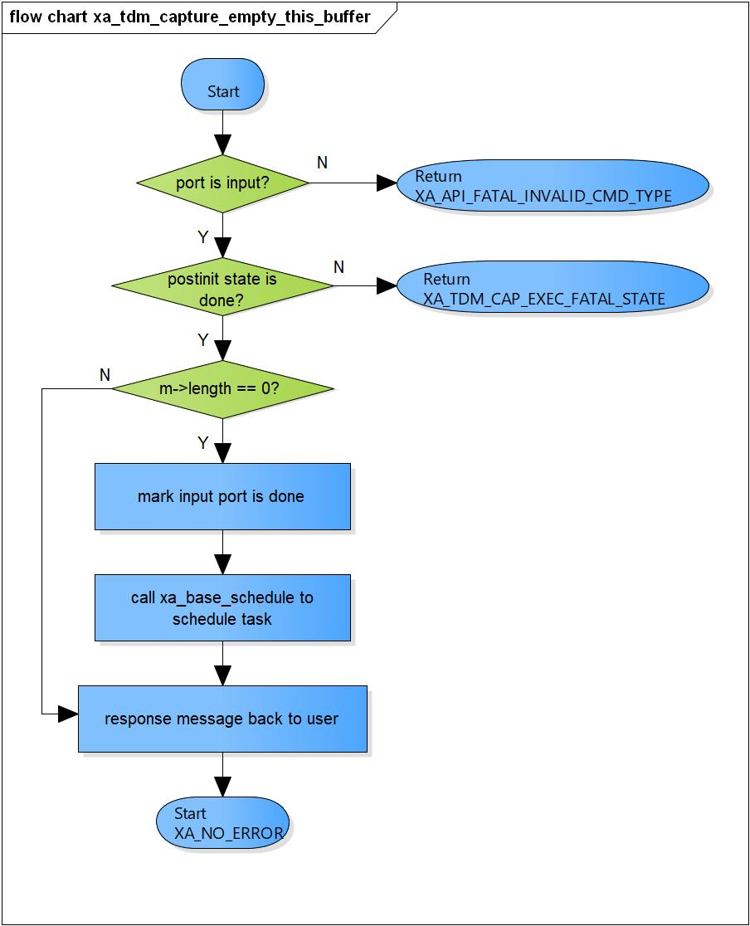

Figure 3‑3 xa_tdm_capture_empty_this_buffer flowchart

### xa_tdm_capture_fill_this_buffer

DD_FWK_TDM_01_004

|  |  |  |  |  |
| --- | --- | --- | --- | --- |
| **Syntax** | static XA_ERRORCODE xa_tdm_capture_fill_this_buffer(XACodecBase *base,  xf_message_t *m) | | | |
| **Function** | This function is to put message into all output port. | | | |
| **Arguments** | Type | Name | I/O | Description |
| XACodecBase | base | I/O | Pointer to codec instance structure (struct XACodecBase). |
| xf_message_t | m | I/O | Pointer to audio message (struct xf_message). |
| **Return value** | XA_NO_ERROR | | Nomally end. | |
| XA_API_FATAL_INVALID_CMD_TYPE | | Port is invalid. | |
| XA_CAP_EXEC_FATAL_STATE | | Receive message with non-zero length in runtime initialization state.  Post initialization state is not completed yet.  If receive output port contol message and excution state is not completed yet. | |
| **Description** | * xa_tdm_capture_fill_this_buffer command processing:   - Special handling of zero-length buffer.  - Adjust message length.  - Place message into all output port. | | | |

[Covers: FD_FWK_CMN_005, FD_FWK_CMN_011]

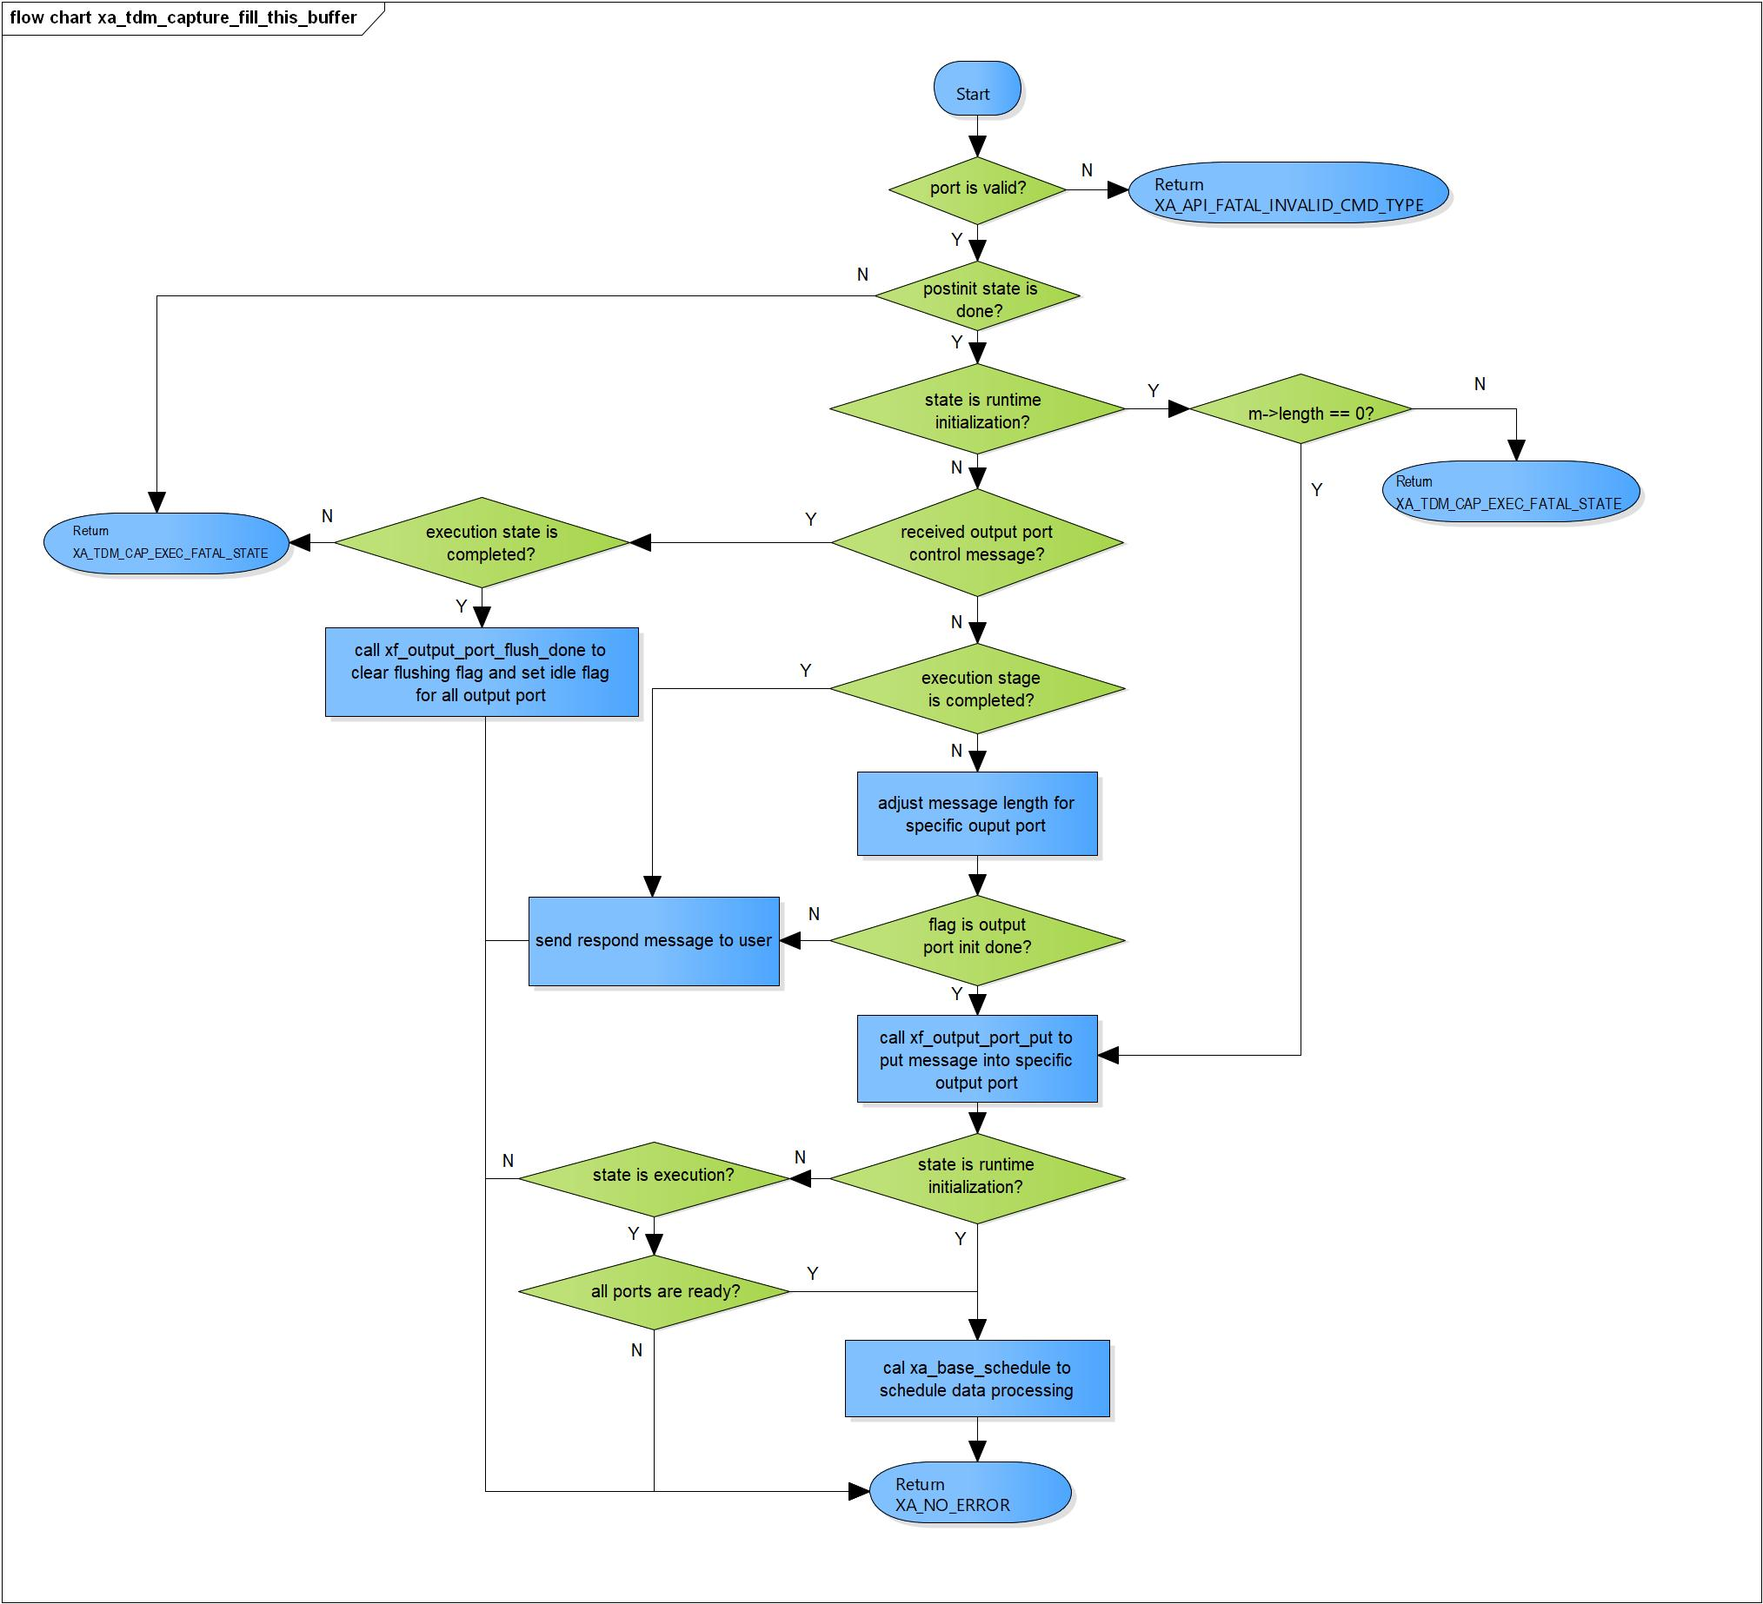

Figure 3‑4 xa_tdm_capture_fill_this_buffer flowchart

### xa_tdm_capture_memtab

DD_FWK_TDM_01_005

|  |  |  |  |  |
| --- | --- | --- | --- | --- |
| **Syntax** | static XA_ERRORCODE xa_tdm_capture_memtab(XACodecBase *base, WORD32 idx, WORD32 type, WORD32 size, WORD32 align, u32 core) | | | |
| **Function** | This function is to initialize all output port. | | | |
| **Arguments** | Type | Name | I/O | Description |
| XACodecBase | base | I/O | Pointer to codec instance structure (struct XACodecBase) |
| WORD32 | idx | I | Port index  Valid range: [0; 3] |
| WORD32 | type | I | Port type (input or output port)  Valid value: XA_MEMTYPE_OUTPUT |
| WORD32 | size | I | Buffer size of port |
| WORD32 | align | x | Port alignment |
| u32 | core | x | Core index of ADSP framework |
| **Return value** | XA_NO_ERROR | | Nomally end. | |
| XA_API_FATAL_INVALID_CMD_TYPE | | Port type is not an output port.  Ports index are invalid. | |
| XA_API_FATAL_MEM_ALLOC | | Initialize output port is fail. | |
| **Description** | * Memtab command processing:   - Initialize all output port. | | | |

[Covers: FD_FWK_CMN_008, FD_FWK_CMN_005, FD_FWK_CMN_001]

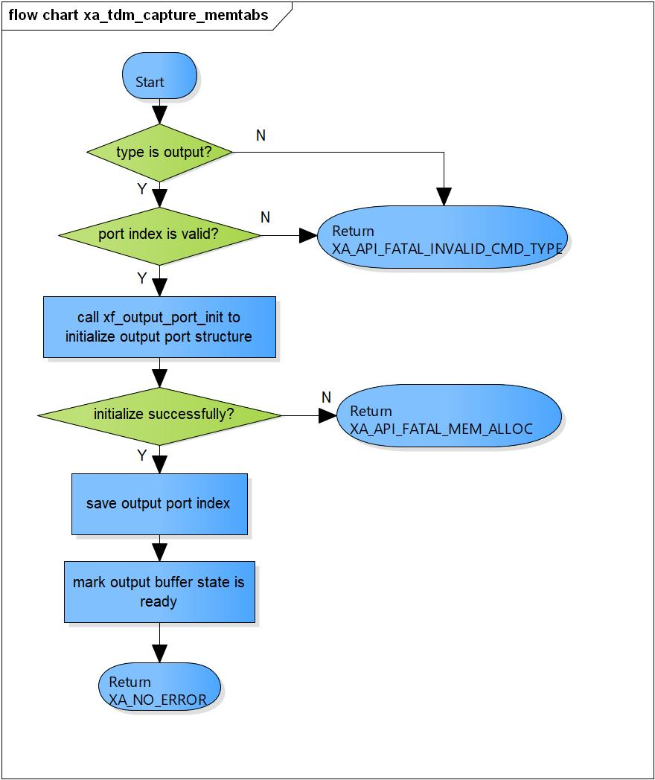

Figure 3‑5 xa_tdm_capture_memtab flowchart

### xa_tdm_capture_preprocess

DD_FWK_TDM_01_006

|  |  |  |  |  |
| --- | --- | --- | --- | --- |
| **Syntax** | static XA_ERRORCODE xa_tdm_capture_preprocess(XACodecBase *base) | | | |
| **Function** | This function is to prepare data for output buffer. | | | |
| **Arguments** | Type | Name | I/O | Description |
| XACodecBase | base | I | Pointer to codec instance structure (struct XACodecBase) |
| **Return value** | XA_NO_ERROR | | Nomally end. | |
| XA_TDM_CAP_EXEC_NONFATAL_OUTPUT | | No output buffer available. | |
| XA_API_FATAL_MEM_ALLOC | | API structure is NULL (error from plugin). | |
| XA_API_FATAL_MEM_ALIGN | | API object is not aligned to 4 bytes (error from plugin). | |
| XA_TDM_CAP_EXEC_FATAL_STATE | | TDM-capture is not init yet (error from plugin). | |
| XA_TDM_CAP_CONFIG_FATAL_STATE | | TDM-capture is not in post-init yet (error from plugin). | |
| **Description** | * Preprocess command processing:   - Get output pointer from output port queue.  - Set the output buffer pointer. | | | |

[Covers: FD_FWK_CMN_005, FD_FWK_CMN_002, FD_FWK_CMN_003]

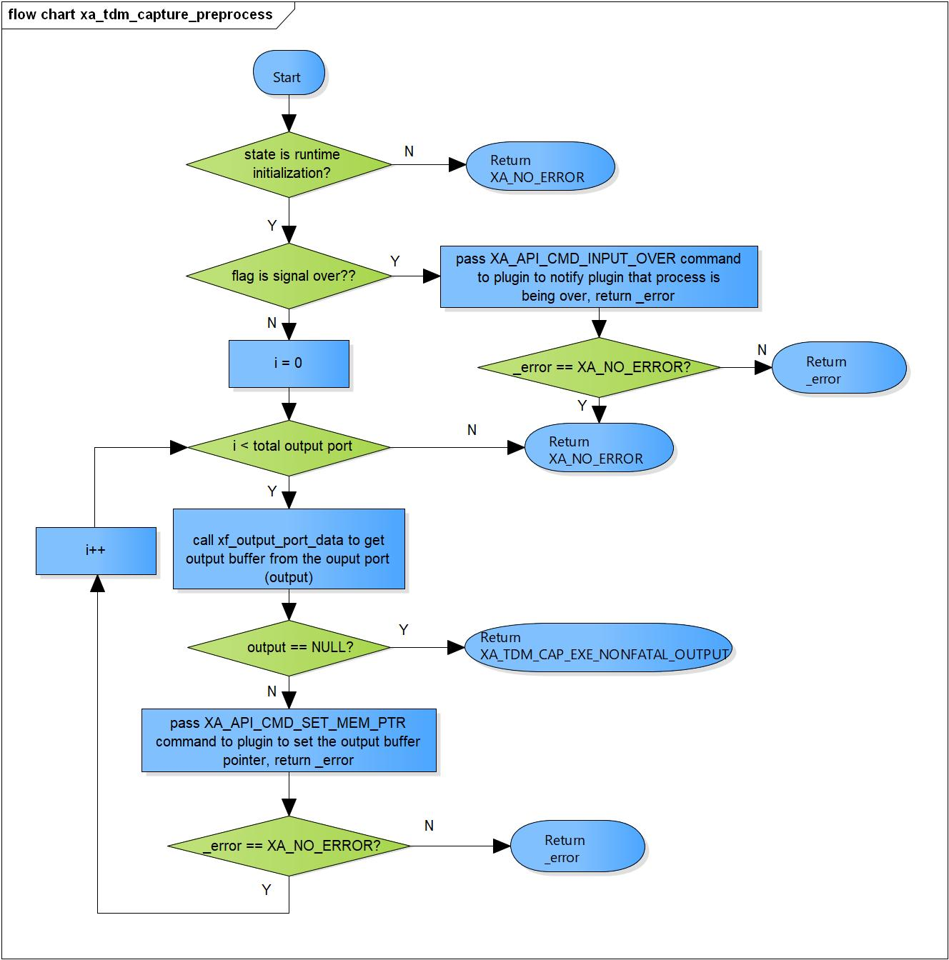

Figure 3‑6 xa_tdm_capture_preprocess flowchart

### xa_tdm_capture_postprocess

DD_FWK_TDM_01_007

|  |  |  |  |  |
| --- | --- | --- | --- | --- |
| **Syntax** | static XA_ERRORCODE xa_tdm_capture_postprocess(XACodecBase *base,  WORD32 done) | | | |
| **Function** | This function is to get number of produced bytes and reschedule processing. | | | |
| **Arguments** | Type | Name | I/O | Description |
| XACodecBase | base | I/O | Pointer to codec instance structure (struct XACodecBase). |
| WORD32 | done | I | State of processing of plugin. |
| **Return value** | XA_NO_ERROR | | Nomally end. | |
| XA_API_FATAL_MEM_ALLOC | | API structure is NULL (error from plugin). | |
| XA_API_FATAL_MEM_ALIGN | | API object is not aligned to 4 bytes (error from plugin). | |
| XA_TDM_CAP_EXEC_FATAL_STATE | | TDM_Capture has not init yet (error from plugin).  Output buffer is not ready (error from plugin). | |
| **Description** | * xa_tdm_capture_postprocess command processing:   - Check state if process is done.  - Get number of produced samples from plugin.  - Reschedule execution if we have pending input. | | | |

[Covers: FD_FWK_CMN_005, FD_FWK_CMN_002, FD_FWK_CMN_003]

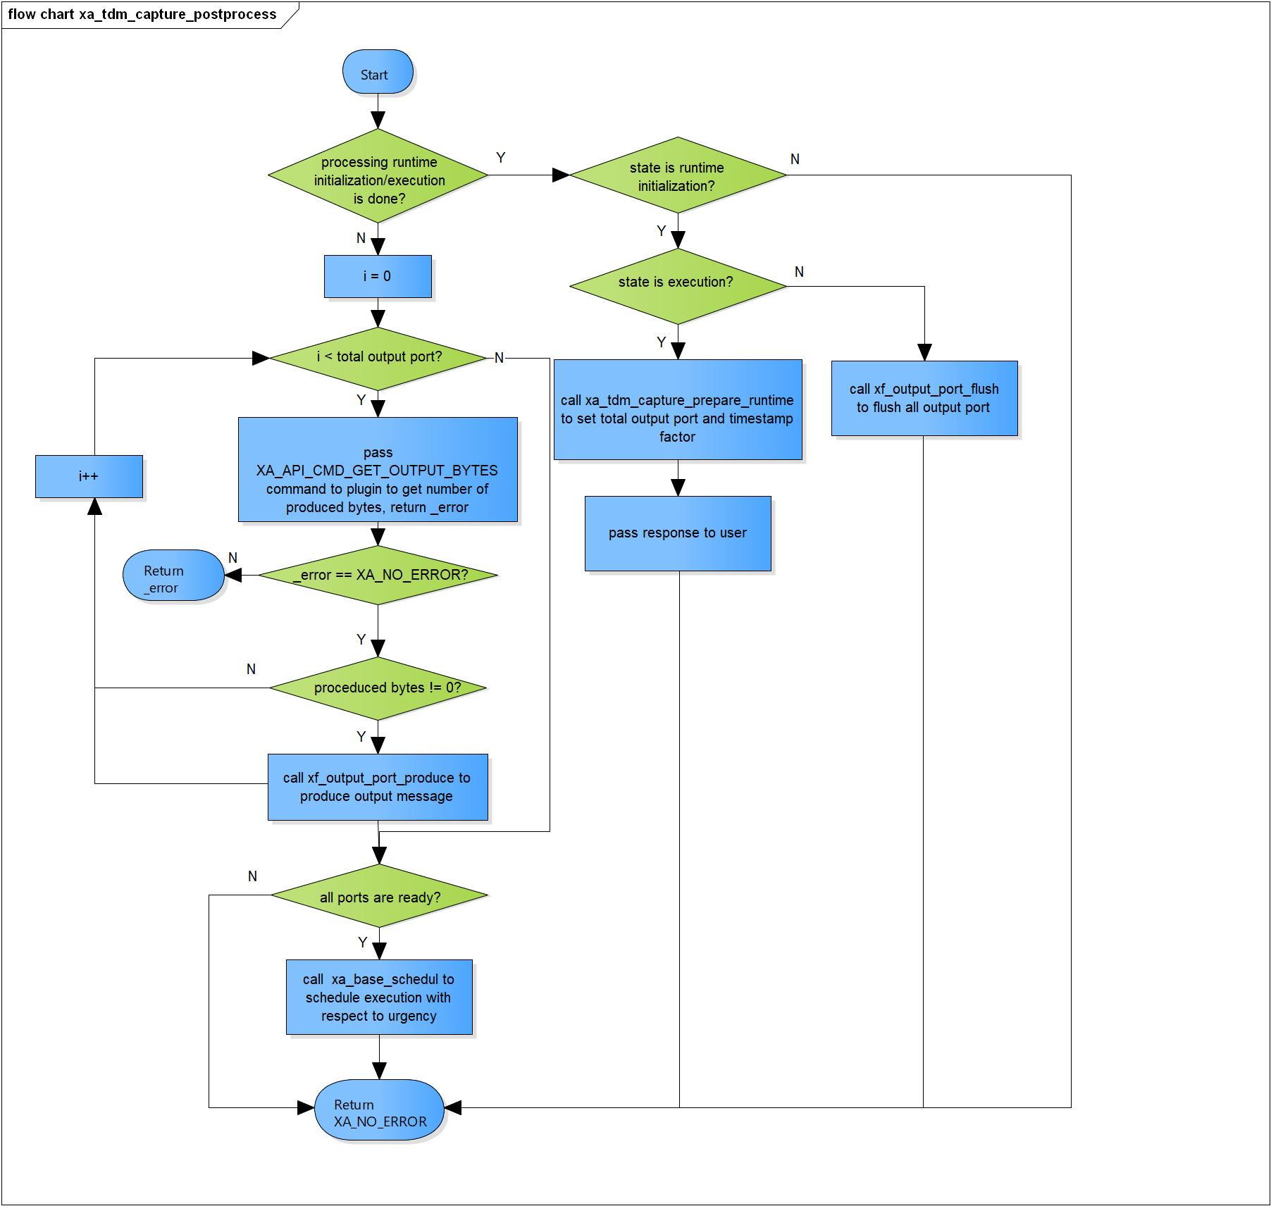

Figure 3‑7 xa_tdm_capture_postprocess flowchart

### xa_tdm_capture_flush

DD_FWK_TDM_01_008

|  |  |  |  |  |
| --- | --- | --- | --- | --- |
| **Syntax** | static XA_ERRORCODE xa_tdm_capture_flush(XACodecBase *base, xf_message_t *m) | | | |
| **Function** | This function is to flush output port queue. | | | |
| **Arguments** | Type | Name | I/O | Description |
| XACodecBase | base | I/O | Pointer to codec instance structure (struct XACodecBase). |
| xf_message_t | m | I | Pointer to audio message (struct xf_message). |
| **Return value** | XA_NO_ERROR | | Nomally end. | |
| XA_API_FATAL_INVALID_CMD | | Post initialization state is not completed yet. | |
| XA_API_FATAL_INVALID_CMD_TYPE | | Message length is not zero.  Port index is invalid. | |
| **Description** | * xa_tdm_capture_flush command processing:   - Check if post initialization state is not completed yet.  - Ensure input message length is zero.  - Flush all output port queue. | | | |

[Covers: FD_FWK_CMN_005, FD_FWK_CMN_012]

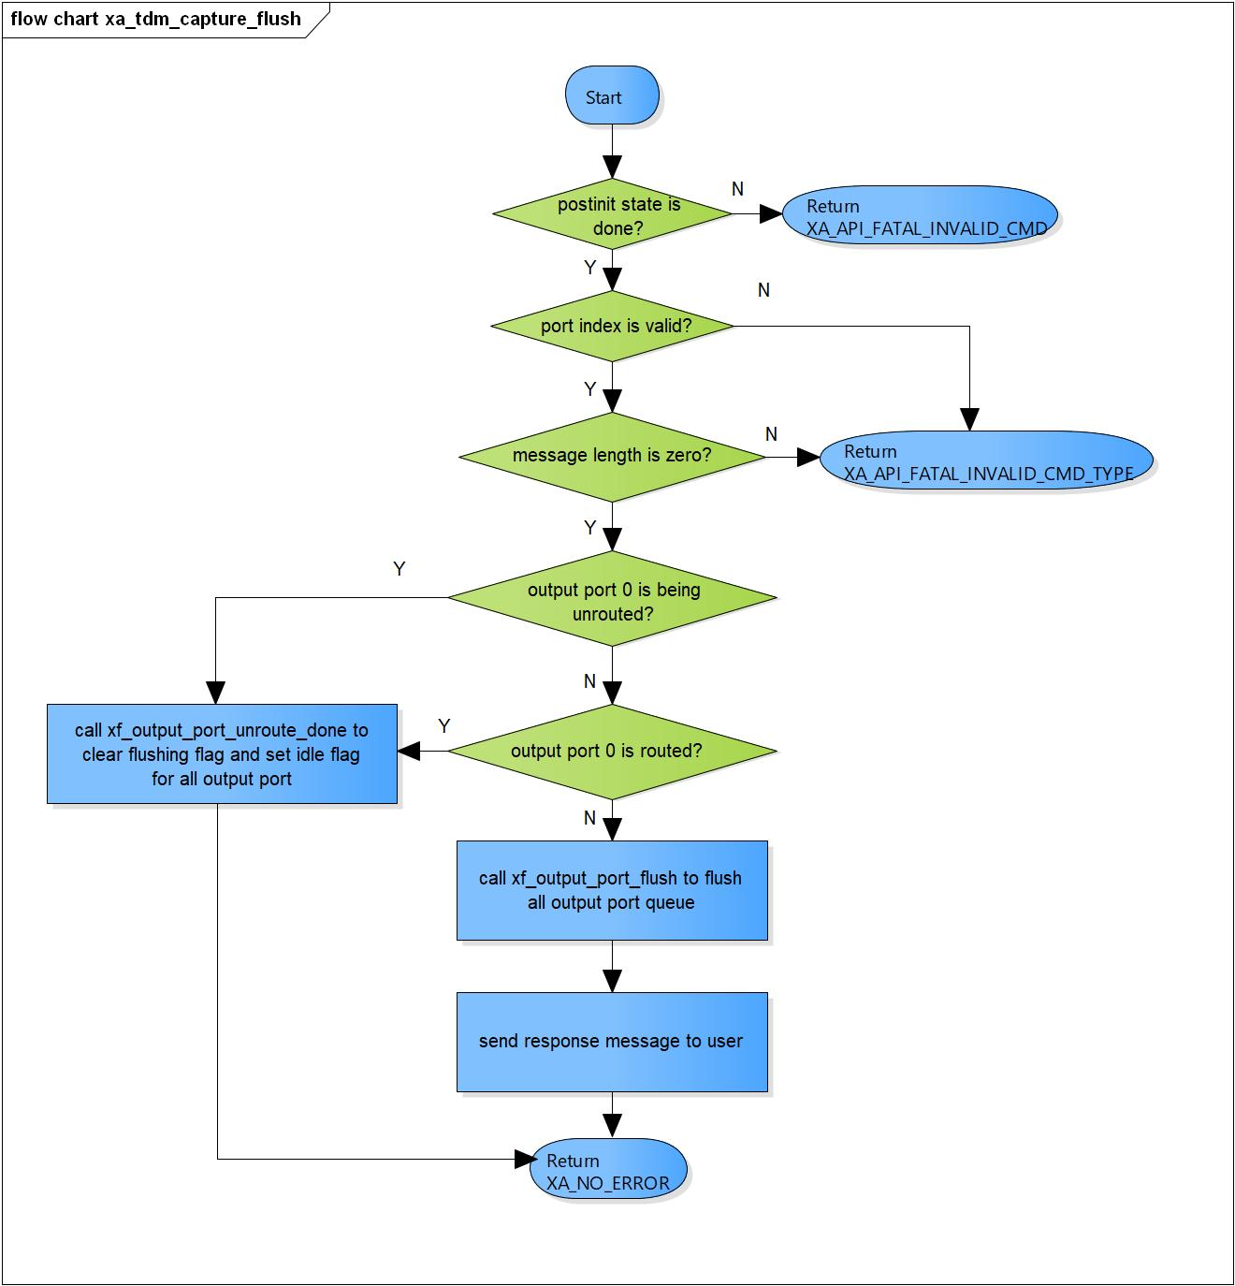

Figure 3‑8 xa_tdm_capture_flush flowchart

### xa_tdm_capture_cleanup

DD_FWK_TDM_01_009

|  |  |  |  |  |
| --- | --- | --- | --- | --- |
| **Syntax** | static s32 xa_tdm_capture_cleanup(xf_component_t *component, xf_message_t *m) | | | |
| **Function** | This function is to flush output port queue and cancel internal scheduling. | | | |
| **Arguments** | Type | Name | I/O | Description |
| xf_component_t | component | I/O | Pointer to codec instance structure  (struct xf_component ). |
| xf_message_t | m | I | Pointer to audio message (struct xf_message). |
| **Return value** | 1 | TDM capture component cannot be destroyed. | | |
| 0 | TDM capture component has been destroyed totally. | | |
| **Description** | * xa_tdm_capture_cleanup command processing:   - Complete message with error response.  - Cancel internal scheduling message if needed.  - Flush and destroy output port. | | | |

[Covers: FD_FWK_CMN_005, FD_FWK_CMN_004]

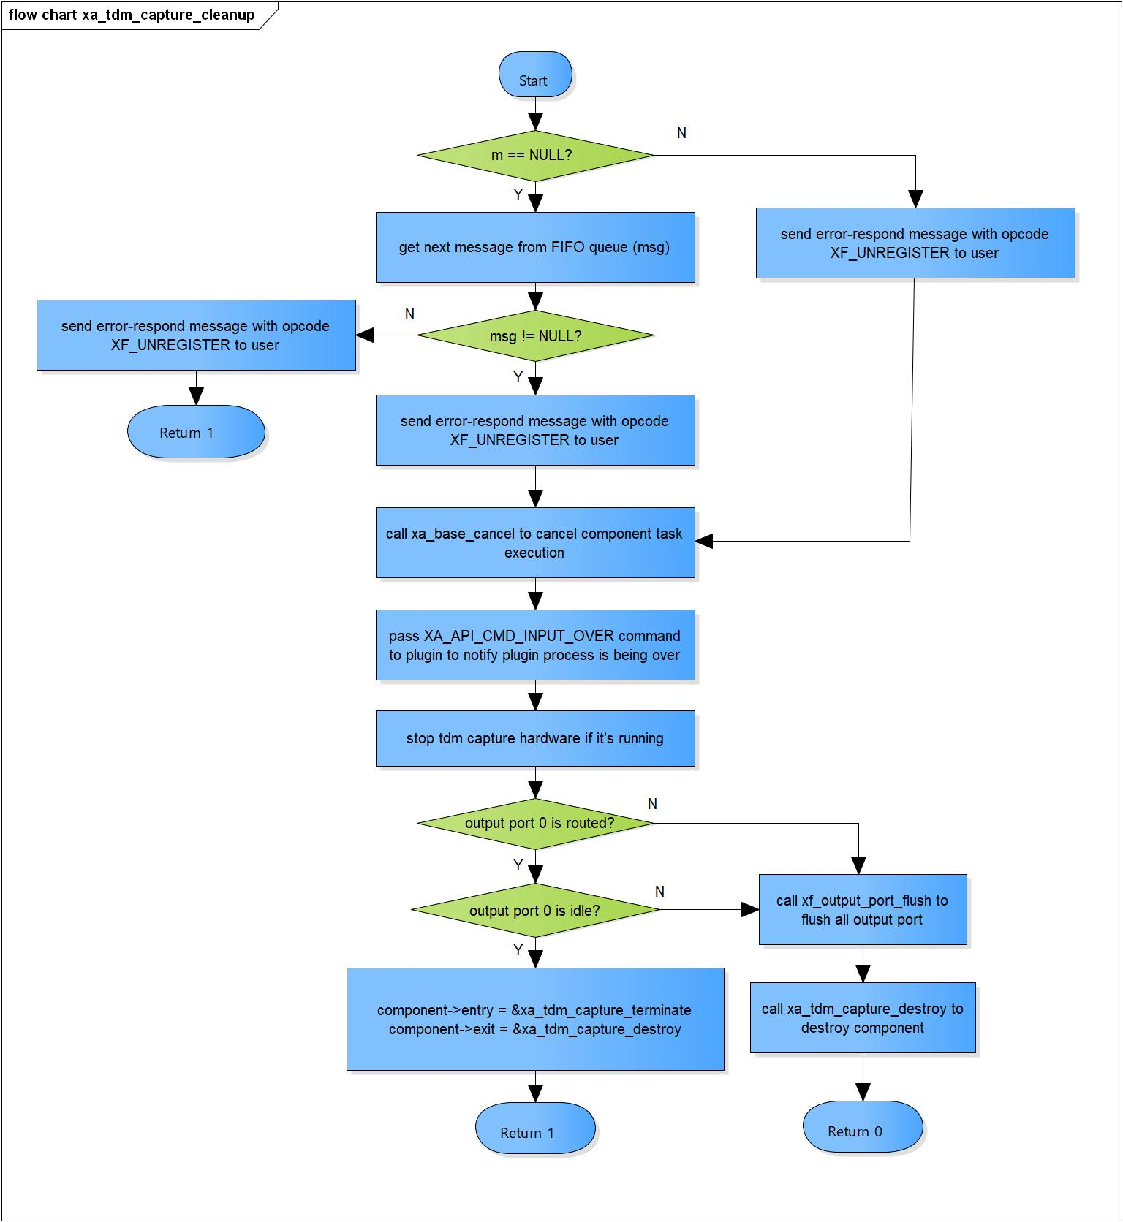

Figure 3‑9 xa_tdm_capture_cleanup flowchart

### xa_tdm_capture_terminate

DD_FWK_TDM_01_010

|  |  |  |  |  |
| --- | --- | --- | --- | --- |
| **Syntax** | static s32 xa_tdm_capture_terminate(xf_component_t *component, xf_message_t *m) | | | |
| **Function** | This is to check if we received output port control message. | | | |
| **Arguments** | Type | Name | I/O | Description |
| xf_component_t | component | I | Pointer to codec instance structure  (struct xf_component ). |
| xf_message_t | m | I/O | Pointer to audio message (struct xf_message). |
| **Return value** | -1 | Output port flushing is completed, component ready to destroy. | | |
| 0 | Normal end. | | |
| **Description** | * xa_tdm_capture_terminate command processing:   - Check if we received output port control message. | | | |

[Covers: FD_FWK_CMN_004]

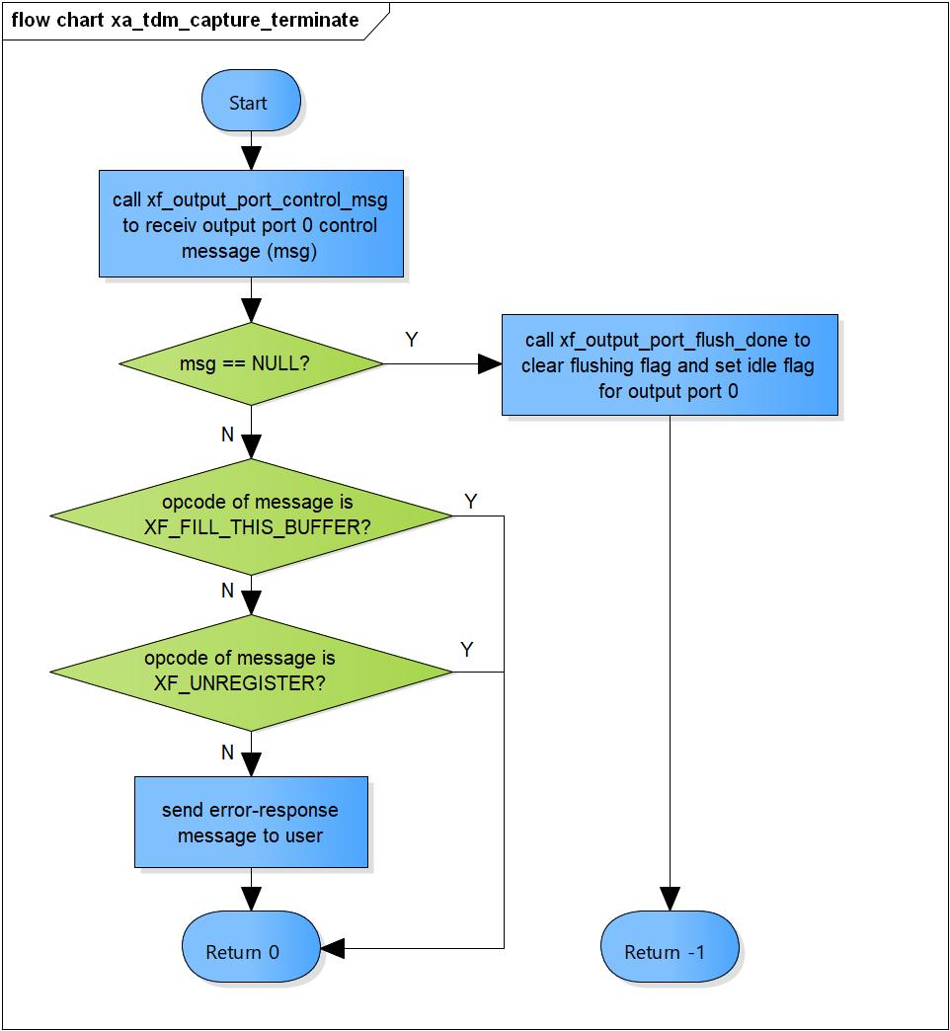

Figure 3‑10 xa_tdm_capture_terminate flowchart

### xa_tdm_capture_destroy

DD_FWK_TDM_01_011

|  |  |  |  |  |
| --- | --- | --- | --- | --- |
| **Syntax** | static s32 xa_tdm_capture_destroy(xf_component_t *component, xf_message_t *m) | | | |
| **Function** | This function is to destroy component. | | | |
| **Arguments** | Type | Name | I/O | Description |
| xf_component_t | component | I/O | Pointer to codec instance structure  (struct xf_component ). |
| xf_message_t | m | x | Pointer to audio message (struct xf_message). |
| 0 | | Indicate the component is destroyed. | |
| **Description** | * xa_tdm_capture_destroy command processing:   - Destroy all output port.  - Destroy base object. | | | |

[Covers: FD_FWK_CMN_004]

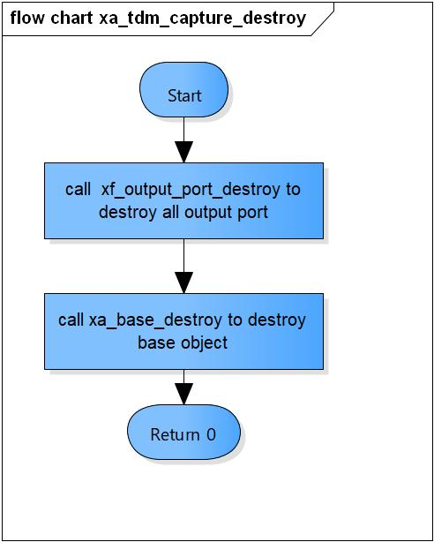

Figure 3‑11 xa_tdm_capture_destroy flowchart

### xa_tdm_capture_factory

DD_FWK_TDM_01_012

|  |  |  |  |  |
| --- | --- | --- | --- | --- |
| **Syntax** | xf_component_t * xa_tdm_capture_factory(u32 core, xa_codec_func_t process) | | | |
| **Function** | This function is to initialize TDM Capture component. | | | |
| **Arguments** | Type | Name | I/O | Description |
| u32 | core | I | Core index of ADSP framework. |
| xa_codec_func_t | process | I | Codec API entry point (function). |
| **Return Value** | Return handle to component. | | | |
| **Description** | * xa_tdm_capture_factory command processing:   - Initialize TDM Capture component. | | | |

[Covers: FD_FWK_CMN_005, FD_FWK_CMN_008, FD_FWK_CMN_009]

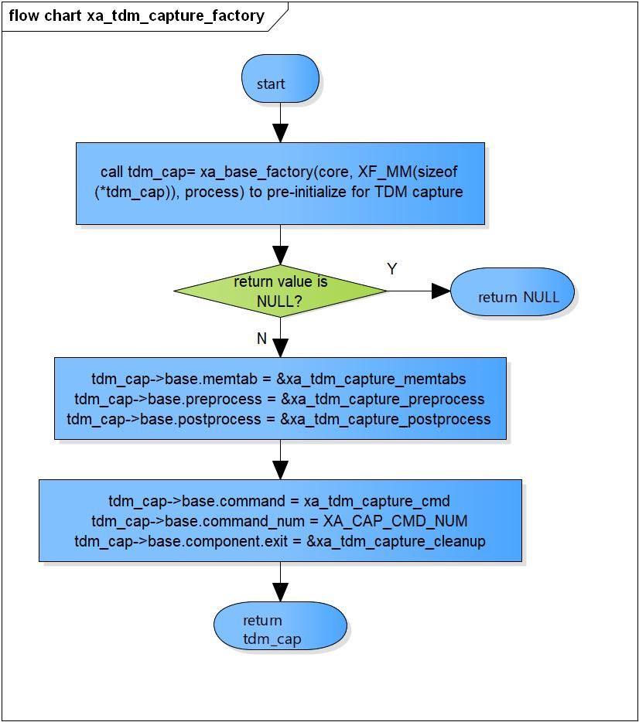

Figure 3‑12 xa_tmd_capture_factory flowchart

# Revision history

|  |  |  |  |  |  |
| --- | --- | --- | --- | --- | --- |
| **Version** | **Date** | **Page** | **Content** | **Approved** | **Changed** |
| 1.0.0 | Nov 14 2018 | - | First Edition issued | Vu Phan | Vu Phan |
| 1.1.0 | Dec 10 2018 | - | Add traceability ID | Vu Phan | Ngu Pham |
| 1.2.0 | Jan 03, 2019 | - | Add range for input parameters | Vu Phan | Tien Tran |