**Document Type: Detail Design**

**Document Name:**

**ADSP FRAMEWORK: TDM RENDERER CLASS**

Renesas Design Vietnam Co. Ltd

R-Car Software Solution 2 Group

Middleware 1 Team

Renesas Electronics Corporation

Table of Contents

1. Overview 3

2. Function list 4

3. Detail information 5

3.1 Data type and Macro definition 5

3.2 Globle variable 6

3.3 Function definition 6

3.3.1 xa_tdm_renderer_prepare_runtime 6

3.3.2 xa_tdm_renderer_sufficient_inport_check 8

3.3.3 xa_tdm_renderer_empty_this_buffer 9

3.3.4 xa_tdm_renderer_fill_this_buffer 11

3.3.5 xa_tdm_renderer_memtab 12

3.3.6 xa_tdm_renderer_preprocess 14

3.3.7 xa_tdm_renderer_postprocess 16

3.3.8 xa_tdm_renderer_flush 18

3.3.9 xa_tdm_renderer_cleanup 19

3.3.10 xa_tdm_renderer_destroy 21

3.3.11 xa_tdm_renderer_factory 22

4. Revision history 23

List of Figures

Figure 1‑1 The software architecture 3

Figure 3‑1 xa_tdm_renderer_prepare_runtime flowchart 7

Figure 3‑2 xa_tdm_renderer_sufficient_inport_check flowchart 8

Figure 3‑3 xa_tdm_renderer_empty_this_buffer flowchart 10

Figure 3‑4 xa_tdm_renderer_fill_this_buffer flowchart 11

Figure 3‑5 xa_tdm_renderer_memtab flowchart 13

Figure 3‑6 xa_tdm_renderer_preprocess flowchart 15

Figure 3‑7 xa_tdm_renderer_postprocess flowchart 17

Figure 3‑8 xa_tdm_renderer_flush flowchart 18

Figure 3‑9 xa_tdm_renderer_cleanup flowchart 20

Figure 3‑10 xa_tdm_renderer_destroy flowchart 21

Figure 3‑11 xa_tmd_renderer_factory flowchart 22

List of Table

Table 2‑1 Function list 4

Table 3‑1 XATDMRenderer type structure information 5

Table 3‑2 Macro definitions 5

Table 3‑3 Globle variable xa_tdm_renderer_cmd 6

# Overview

This section provides an overview of the software architecture.

User Application

ADSP Interface

Kernel Space

User Space

ADSP Driver

ARM

Audio HW

**ADSP Framework**

TDM class

Equalizer class

Capture class

Renderer class

ADSP

Plugin

Equalizer Plugin*

TDM Plugin

Capture Plugin

Renderer Plugin

This document’s target is in side of red square

* not connect to SCU/SSI ADMA block

SCU/ SSI/

ADMA

DAC/

ADC

Figure 1‑1 ****The software architecture****

# Function list

The following is list of functions:

Table 2‑1 Function list

|  |  |  |
| --- | --- | --- |
| **Type** | **Function Name** | **Outline** |
| API | xa_tdm_renderer_factory | This API is to construct generic audio component and set functions pointer for internal functions. |
| Internal functions | xa_tdm_capture_prepare_runtime | This function is to prepare TDM renderer for steady operation. |
| xa_tdm_capture_sufficient_outport_check | This function is to check the sufficient input port. |
| xa_tdm_renderer_empty_this_buffer | This function is to put message into all input port. |
| xa_tdm_renderer_fill_this_buffer | This is a dummy function. |
| xa_tdm_renderer_flush | This function is to purge input port queue and cancel data processing. |
| xa_tdm_renderer_memtab | This function is to initialize input port structure. |
| xa_tdm_renderer_preprocess | This function is to prepare data for all input buffer. |
| xa_tdm_renderer_postprocess | This function is to consume bytes from all input buffer and reschedule processing. |
| xa_tdm_renderer_destroy | This function is to destroy component. |
| xa_tdm_renderer_cleanup | This function is to purge input port queue and cancel internal scheduling. |

# Detail information

This section describes detail information of data types, macro definitions, implemented APIs and internal function units, globle variable.

## Data type and Macro definition

The XATDMRenderer type structure is the work area used by the TDM renderer class. When using this class, secure the area with the application program. It’s not necessary to refer to this area because it only contains the internal variables and working buffers of the class. Make sure not to change the value of this area with the application program.

Table 3‑1 XATDMRenderer type structure information

|  |  |
| --- | --- |
| Member name | Outline |
| XACodecBase base | Generic audio codec data |
| xf_output_port_t output[XA_MEMCNT_OUTPUT] | Array of output port queue |
| u32 out_idx[XA_MEMCNT_OUTPUT] | Array of output port index |
| u32 input_total | The number of total input port |
| u32 factor | Time conversion factor (input byte "duration" in timebase units) |

Note: Marro XA_MEMCNT_OUTPUT: 4 (number of ouput memory block) in xa-tdm-renderer-api.h

Table 3‑2 Macro definitions

|  |  |  |
| --- | --- | --- |
| Macro | Value | Outline |
| XA_TDM_RDR_FLAG_INPUT_PORT_INIT_DONE | __XA_BASE_FLAG(1 << 0) | Input port init done flag |
| XA_TDM_RDR_FLAG_EOS | __XA_BASE_FLAG(1 << 1) | End of stream signal |

Note: Macro __XA_BASE_FLAG(f) ((f) << 6) is in xa-class-base.h file.

## Globle variable

Table 3‑3 Globle variable xa_tdm_renderer_cmd

|  |  |
| --- | --- |
| static XA_ERRORCODE (* const xa_tdm_renderer_cmd[])(XACodecBase *base, xf_message_t *m) | |
| Description: variable stores function pointers arcoding to opcode index to run in runtime operation. | |
| Array index | Value (function pointer) |
| XF_OPCODE_TYPE(XF_SET_PARAM) | xa_base_set_param |
| XF_OPCODE_TYPE(XF_GET_PARAM) | xa_base_get_param |
| XF_OPCODE_TYPE(XF_EMPTY_THIS_BUFFER) | xa_tdm_renderer_empty_this_buffer |
| XF_OPCODE_TYPE(XF_FILL_THIS_BUFFER) | xa_tdm_renderer_fill_this_buffer |
| XF_OPCODE_TYPE(XF_FLUSH) | xa_tdm_renderer_flush |

Note: Marco XF_OPCODE_TYPE(opcode) : ((opcode) & (0x3F)) in xf-opcode.h file.

## Function definition

### xa_tdm_renderer_prepare_runtime

DD_FWK_TDM_02_001

|  |  |  |  |  |
| --- | --- | --- | --- | --- |
| **Syntax** | static inline XA_ERRORCODE xa_tdm_renderer_prepare_runtime(XATDMRenderer *tdm_rdr) | | | |
| **Function** | This function is to prepare TDM renderer for steady operation. | | | |
| **Arguments** | Type | Name | I/O | Description |
| XATDMRenderer | tdm_rdr | I/O | Pointer to codec instance structure (struct XATDMRenderer). |
| **Return value** | XA_NO_ERROR | | Nomally end. | |
| XA_TDM_RDR_CONFIG_FATAL_CHANNEL_MODE | | Channel mode is invalid. | |
| XA_TDM_RDR_CONFIG_FATAL_SAMPLE_RATE | | Sample rate is invalid. | |
| XA_API_FATAL_MEM_ALLOC | | API structure is NULL (error from plugin). | |
| XA_API_FATAL_MEM_ALIGN | | API structure is not aligned to 4 bytes (error from plugin). | |
| XA_TDM_RDR_CONFIG_FATAL_STATE | | Plugin has not pre-init yet (error from plugin). | |
| **Description** | * xa_tdm_renderer_prepare_runtime command processing:   - Get config parameters: sample rate, pcm width, channels.  - Calculate sample size.  - Set renderer timestamp factor. | | | |

[Covers: FD_FWK_CMN_002]

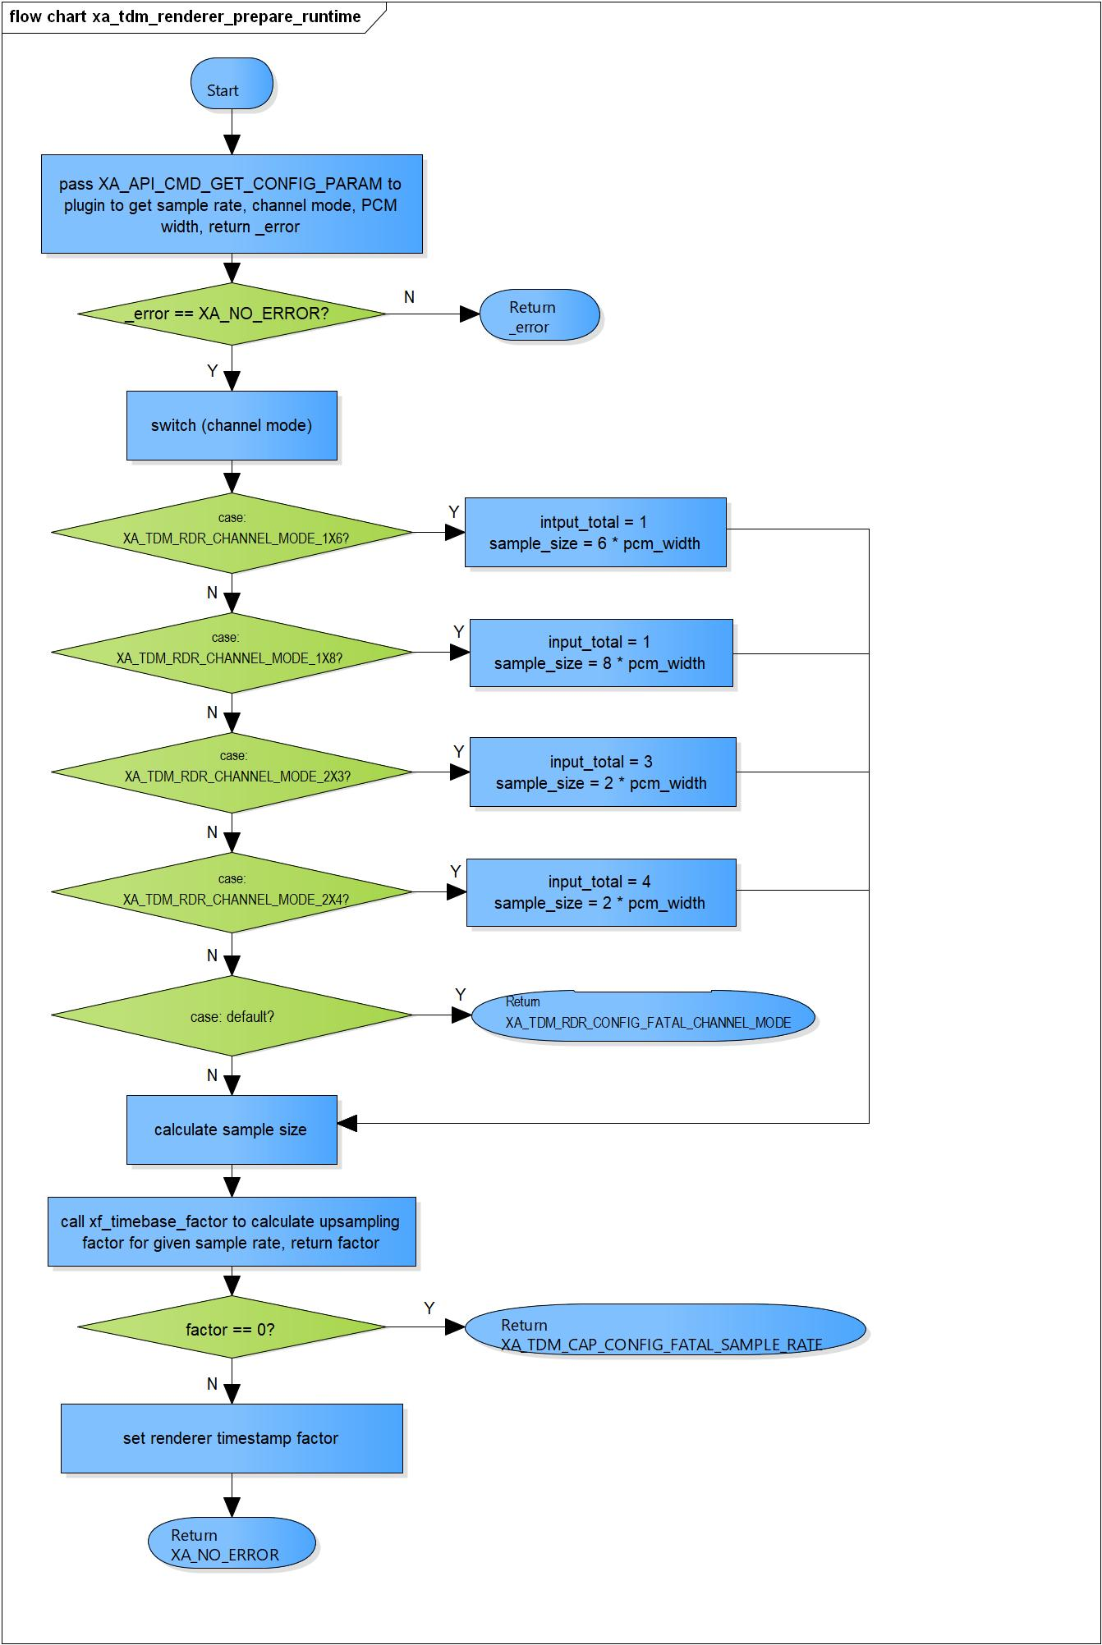

Figure 3‑1 xa_tdm_renderer_prepare_runtime flowchart

### xa_tdm_renderer_sufficient_inport_check

DD_FWK_TDM_02_002

|  |  |  |  |  |
| --- | --- | --- | --- | --- |
| **Syntax** | static inline s32 xa_tdm_renderer_sufficient_outport_check(XACodecBase *base) | | | |
| **Function** | This function is to check the sufficient input port. | | | |
| **Arguments** | Type | Name | I/O | Description |
| XACodecBase | base | I/O | Pointer to codec instance structure (struct XACodecBase). |
| **Return value** | 0 | | Indicate ports are not ready yet . | |
| 1 | | Indicate all ports are ready. | |
| **Description** | * xa_tdm_capture_sufficient_outport_check command processing:   - Check the sufficient port, if have any port is not ready return 0. | | | |

[Covers: FD_FWK_CMN_002, FD_FWK_CMN_003, FD_FWK_CMN_010]

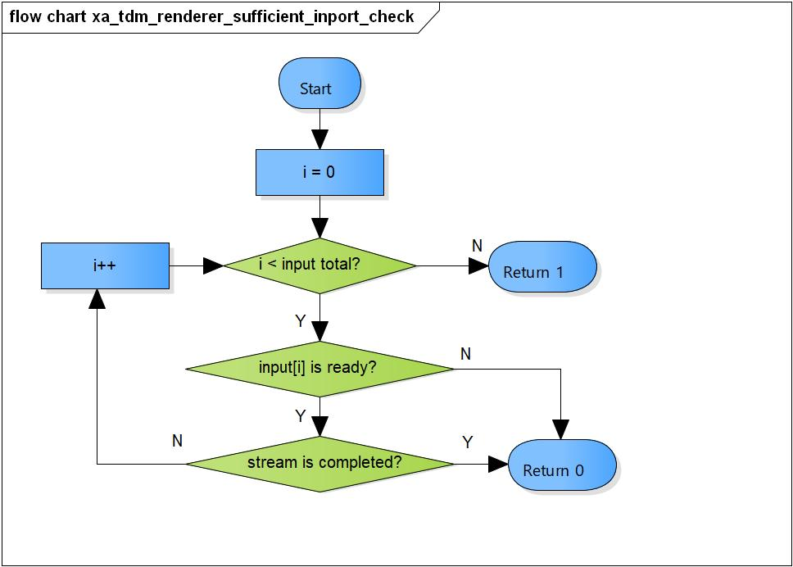

Figure 3‑2 xa_tdm_renderer_sufficient_inport_check flowchart

### xa_tdm_renderer_empty_this_buffer

DD_FWK_TDM_02_003

|  |  |  |  |  |
| --- | --- | --- | --- | --- |
| **Syntax** | static XA_ERRORCODE xa_tdm_renderer_empty_this_buffer(XACodecBase *base,  xf_message_t *m) | | | |
| **Function** | This function is to put message into all input port. | | | |
| **Arguments** | Type | Name | I/O | Description |
| XACodecBase | base | I/O | Pointer to codec instance structure (struct XACodecBase). |
| xf_message_t | m | I | Pointer to audio message (struct xf_message). |
| **Return value** | XA_API_FATAL_INVALID_CMD_TYPE | | Port is invalid. | |
| XA_API_FATAL_INVALID_CMD | | Post initialization state is not completed yet. | |
| XA_NO_ERROR | | Nomally end. | |
| **Description** | * xa_tdm_renderer_empty_this_buffer command processing:   - Make sure the port is valid.  - Check if post initialization state is completed.  - Put message into the input port. | | | |

[Covers: FD_FWK_CMN_005, FD_FWK_CMN_010]

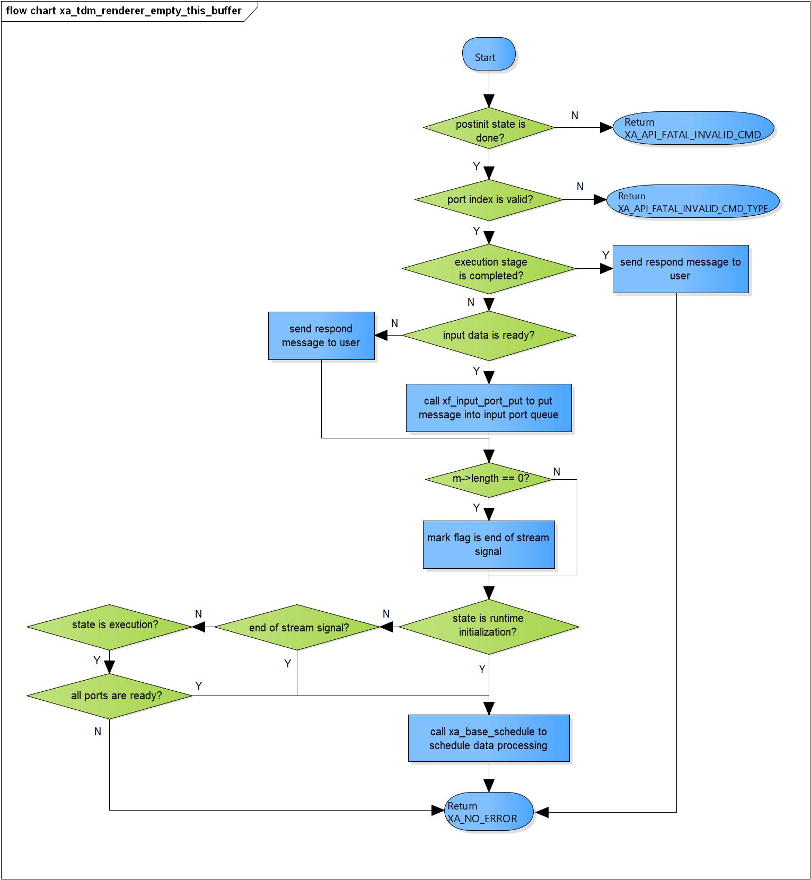

Figure 3‑3 xa_tdm_renderer_empty_this_buffer flowchart

### xa_tdm_renderer_fill_this_buffer

DD_FWK_TDM_02_004

|  |  |  |  |  |
| --- | --- | --- | --- | --- |
| **Syntax** | static XA_ERRORCODE xa_tdm_renderer_fill_this_buffer(XACodecBase *base,  xf_message_t *m) | | | |
| **Function** | This is a dummy function to send message back to user. | | | |
| **Arguments** | Type | Name | I/O | Description |
| XACodecBase | base | X | Pointer to codec instance structure (struct XACodecBase). |
| xf_message_t | m | I | Pointer to audio message (struct xf_message). |
| **Return value** | XA_NO_ERROR | | Nomally end. | |
| XA_API_FATAL_INVALID_CMD_TYPE | | If have any port is invalid. | |
| **Description** | * xa_tdm_renderer_fill_this_buffer command processing:   - Send respond message back to user. | | | |

[Covers: FD_FWK_CMN_005, FD_FWK_CMN_011]

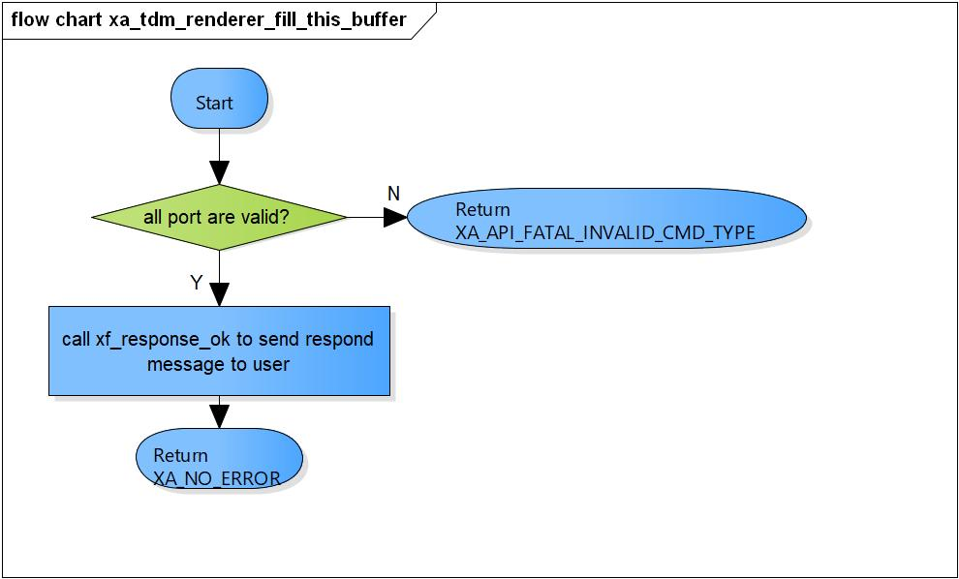

Figure 3‑4 xa_tdm_renderer_fill_this_buffer flowchart

### xa_tdm_renderer_memtab

DD_FWK_TDM_02_005

|  |  |  |  |  |
| --- | --- | --- | --- | --- |
| **Syntax** | static XA_ERRORCODE xa_tdm_renderer_memtab(XACodecBase *base, WORD32 idx, WORD32 type, WORD32 size, WORD32 align, u32 core) | | | |
| **Function** | This function is to initialize input port structure | | | |
| **Arguments** | Type | Name | I/O | Description |
| XACodecBase | base | I/O | Pointer to codec instance structure (struct XACodecBase). |
| WORD32 | idx | I | Port index  Valid range: [0; 3] |
| WORD32 | type | I | Port type (input or output port)  Valid value: XA_MEMTYPE_INPUT |
| WORD32 | size | I | Buffer size of port |
| WORD32 | align | I | Port alignment |
| u32 | core | I | Core index of ADSP framework |
| **Return value** | XA_NO_ERROR | | Nomally end. | |
| XA_API_FATAL_INVALID_CMD_TYPE | | Port type is not a input port.  Port index are invalid. | |
| XA_API_FATAL_MEM_ALLOC | | Initialize input port is fail.  API structure is NULL (error from plugin). | |
| XA_API_FATAL_MEM_ALIGN | | API structure is not aligned to 4 bytes (error from plugin). | |
| XA_TDM_RDR_CONFIG_FATAL_STATE | | TDM-Renderer is not in post-init state (error from plugin). | |
| **Description** | * Memtab command processing:   - Initialize input port for a track.  - Set input port buffer. | | | |

[Covers: FD_FWK_CMN_008, FD_FWK_CMN_005, FD_FWK_CMN_001]

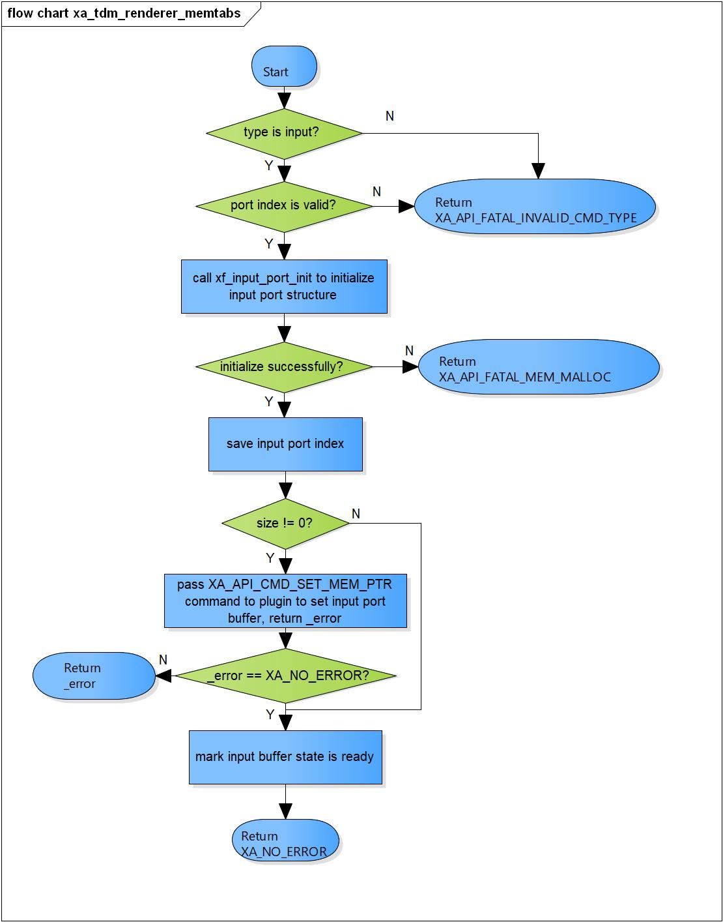

Figure 3‑5 xa_tdm_renderer_memtab flowchart

### xa_tdm_renderer_preprocess

DD_FWK_TDM_02_006

|  |  |  |  |  |
| --- | --- | --- | --- | --- |
| **Syntax** | static XA_ERRORCODE xa_tdm_renderer_preprocess(XACodecBase *base) | | | |
| **Function** | This function is to prepare data for all input buffer. | | | |
| **Arguments** | Type | Name | I/O | Description |
| XACodecBase | base | I/O | Pointer to codec instance structure (struct XACodecBase). |
| **Return value** | XA_NO_ERROR | | Nomally end. | |
| XA_API_FATAL_MEM_ALLOC | | API structure is NULL (error from plugin). | |
| XA_API_FATAL_MEM_ALIGN | | API structure is not aligned to 4 bytes (error from plugin). | |
| XA_TDM_RDR_CONFIG_FATAL_STATE | | TDM-Renderer is not in init state (error from plugin).  TDM-Renderer is not in post-init state (error from plugin). | |
| XA_TDM_RDR_EXEC_FATAL_STATE | | Input area is not ready (error from plugin). | |
| XA_TDM_RDR_EXEC_FATAL_INPUT | | Invalid number of submitted data (error from plugin). | |
| **Description** | * Preprocess command processing:   - Submit all input buffer.  - Set total number of bytes we have in buffer. | | | |

[Covers: FD_FWK_CMN_005, FD_FWK_CMN_002, FD_FWK_CMN_003]

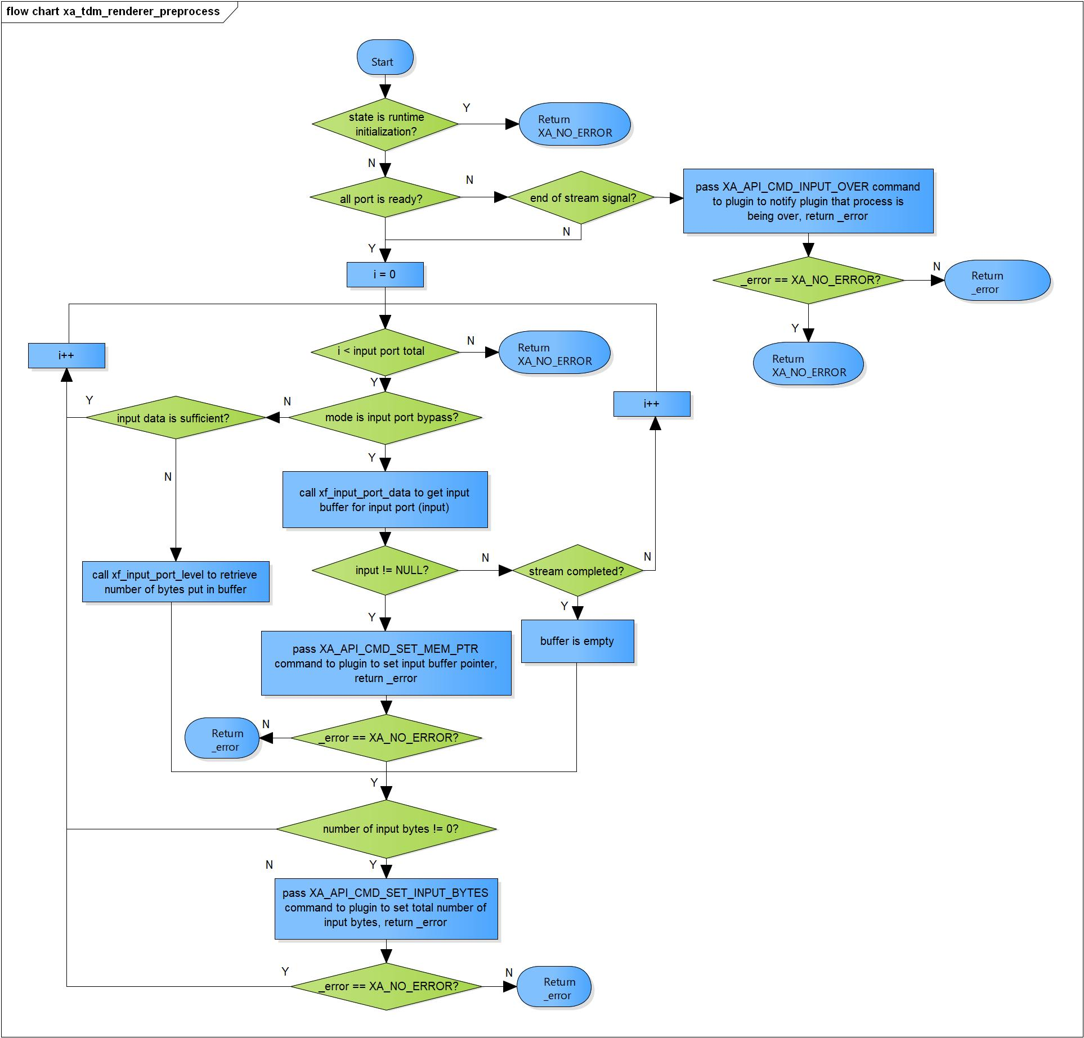

Figure 3‑6 xa_tdm_renderer_preprocess flowchart

### xa_tdm_renderer_postprocess

DD_FWK_TDM_02_007

|  |  |  |  |  |
| --- | --- | --- | --- | --- |
| **Syntax** | static XA_ERRORCODE xa_tdm_renderer_postprocess(XACodecBase *base,  WORD32 done) | | | |
| **Function** | This function is to consume bytes from all input buffer and reschedule processing. | | | |
| **Arguments** | Type | Name | I/O | Description |
| XACodecBase | base | I/O | Pointer to codec instance structure (struct XACodecBase). |
| WORD32 | done | I | State of processing of plugin. |
| **Return value** | XA_NO_ERROR | | Nomally end. | |
| XA_API_FATAL_MEM_ALLOC | | API structure is NULL (error from plugin). | |
| XA_API_FATAL_MEM_ALIGN | | API structure is not aligned to 4 bytes (error from plugin). | |
| XA_TDM_RDR_EXEC_FATAL_STATE | | Input area is not ready. | |
| **Description** | * xa_tdm_renderer_postprocess command processing:   - Check state if processing is done.  - Get total amount of consumed sample from plugin, consume bytes from input buffer.  - Reschedule execution if we have pending input. | | | |

[Covers: FD_FWK_CMN_005, FD_FWK_CMN_002, FD_FWK_CMN_003]

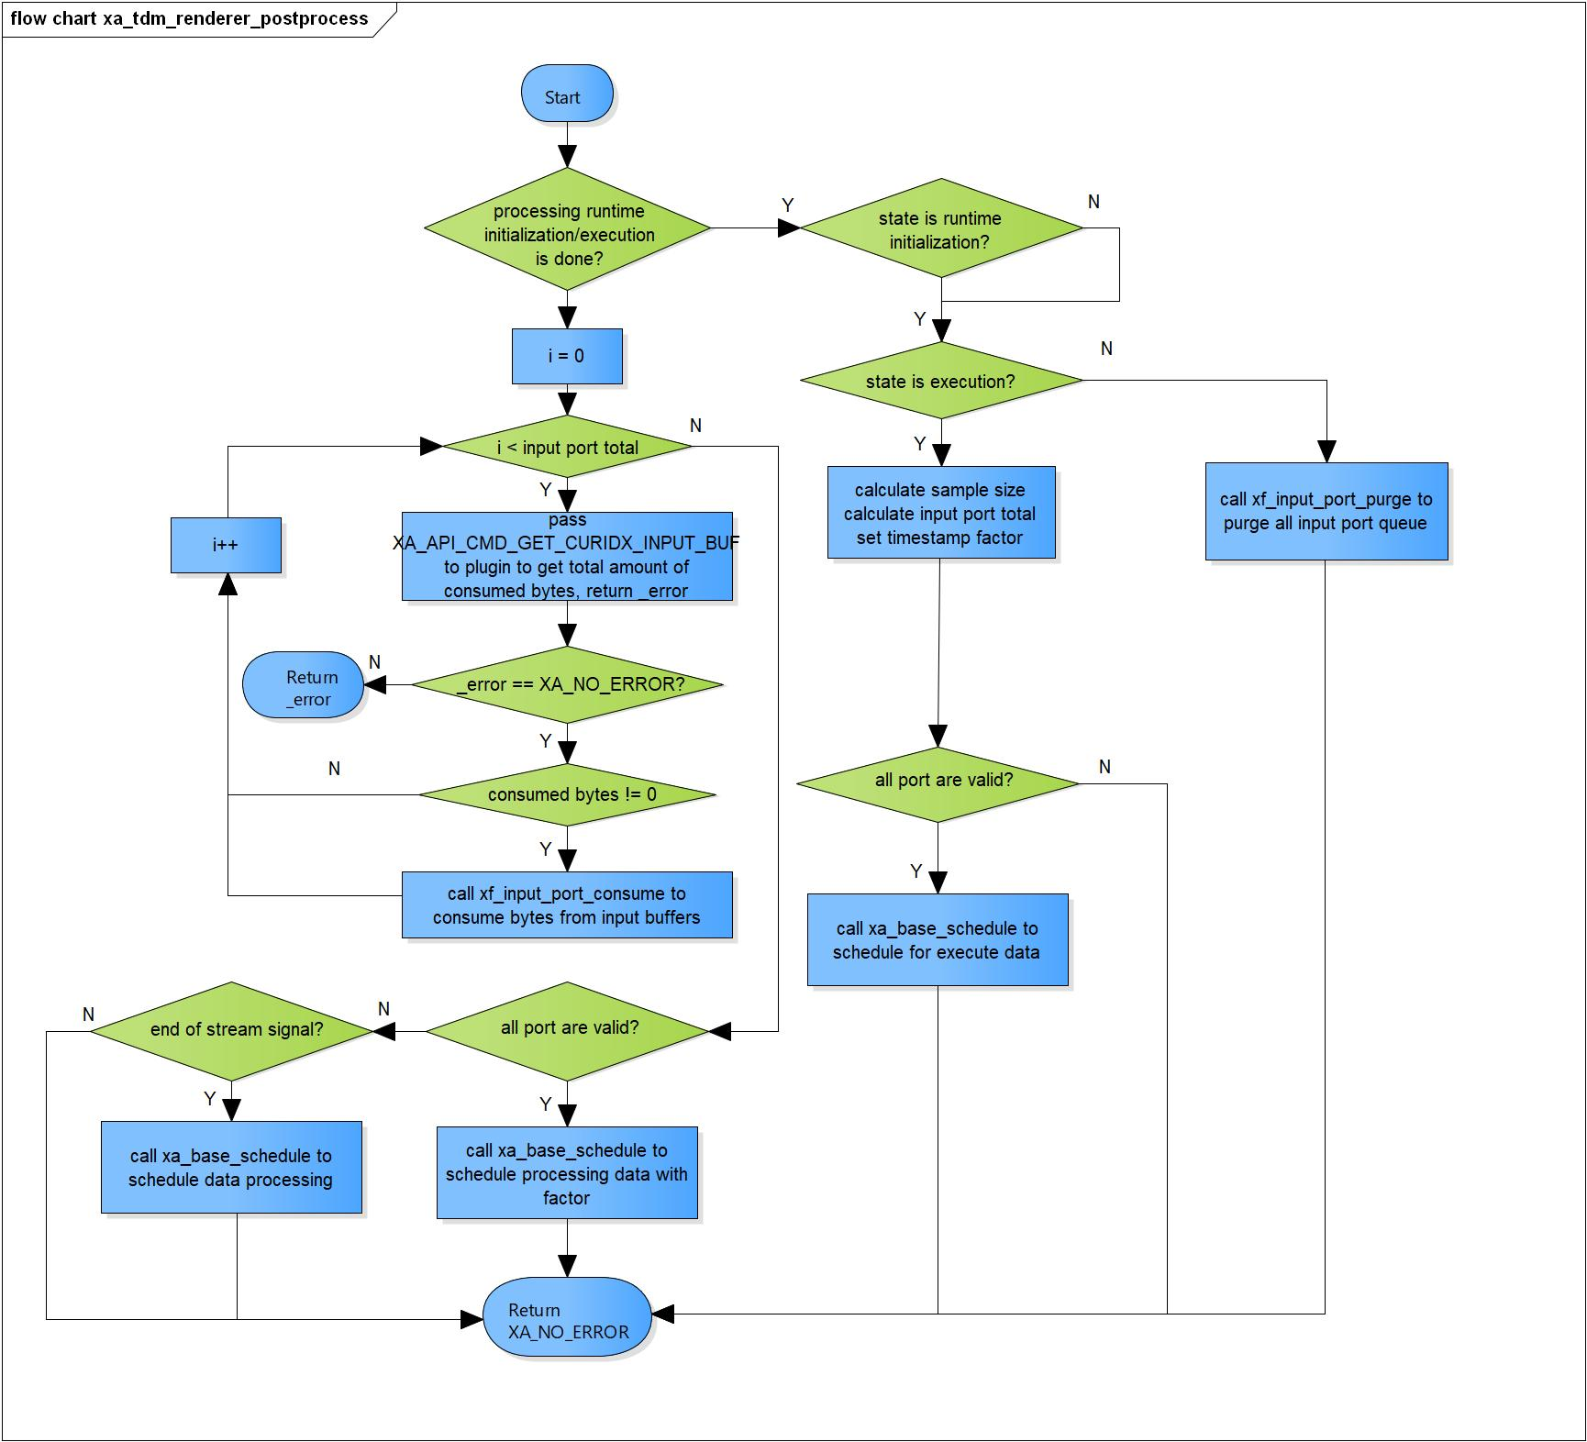

Figure 3‑7 xa_tdm_renderer_postprocess flowchart

### xa_tdm_renderer_flush

DD_FWK_TDM_02_008

|  |  |  |  |  |
| --- | --- | --- | --- | --- |
| **Syntax** | static XA_ERRORCODE xa_tdm_renderer_flush(XACodecBase *base, xf_message_t *m) | | | |
| **Function** | This function is to purge input port queue and cancel data processing. | | | |
| **Arguments** | Type | Name | I/O | Description |
| XACodecBase | base | I/O | Pointer to codec instance structure  (struct XACodecBase). |
| xf_message_t | m | I | Pointer to audio message (struct xf_message). |
| **Return value** | XA_NO_ERROR | | Nomally end. | |
| XA_API_FATAL_INVALID_CMD_TYPE | | Message length is not zero. | |
| **Description** | * xa_tdm_renderer_flush command processing:   - Ensure input parameter length is zero.  - Cancel data processing.  - Purge all input port queue.  - Send respond message to user | | | |

[Covers: FD_FWK_CMN_005, FD_FWK_CMN_012]

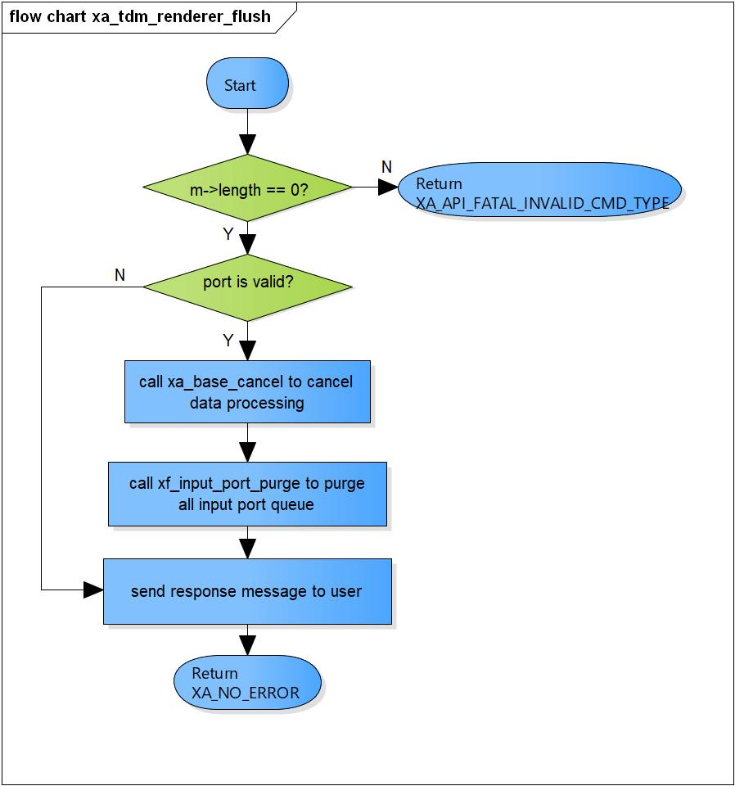

Figure 3‑8 xa_tdm_renderer_flush flowchart

### xa_tdm_renderer_cleanup

DD_FWK_TDM_02_009

|  |  |  |  |  |
| --- | --- | --- | --- | --- |
| **Syntax** | static s32 xa_tdm_renderer_cleanup(xf_component_t *component, xf_message_t *m) | | | |
| **Function** | This function is to purge input port queue and cancel internal scheduling. | | | |
| **Arguments** | Type | Name | I/O | Description |
| xf_component_t | component | I/O | Pointer to codec instance structure  (struct xf_component ). |
| xf_message_t | m | I/O | Pointer to audio message (struct xf_message). |
| **Return value** | 1 | TDM renderer component cannot be destroyed. | | |
| 0 | TDM renderre component has been destroyed totally. | | |
| XA_API_FATAL_MEM_ALLOC | API structure is NULL (error from plugin). | | |
| XA_API_FATAL_MEM_ALIGN | API structure is not aligned to 4 bytes (error from plugin). | | |
| XA_TDM_RDR_CONFIG_FATAL_STATE | TDM-Renderer is not init yet (error from plugin). | | |
| **Description** | * xa_tdm_renderer_cleanup command processing:   - Complete message with error response.  - Cancel internal scheduling message if needed.  - Purge all input port. | | | |

[Covers: FD_FWK_CMN_005, FD_FWK_CMN_004]

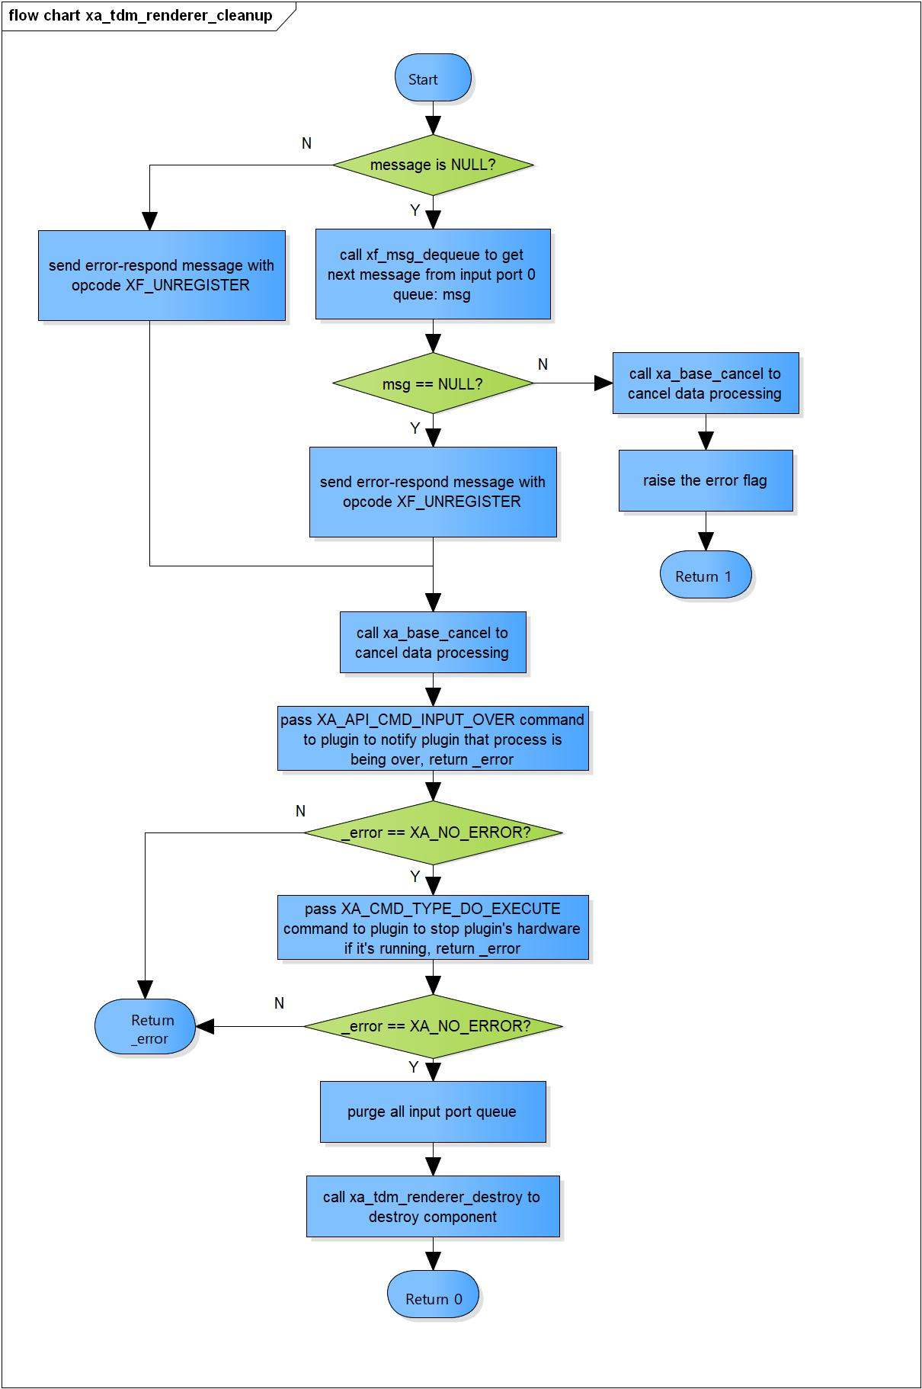

Figure 3‑9 xa_tdm_renderer_cleanup flowchart

### xa_tdm_renderer_destroy

DD_FWK_TDM_02_010

|  |  |  |  |  |
| --- | --- | --- | --- | --- |
| **Syntax** | static s32 xa_tdm_renderer_destroy(xf_component_t *component,  xf_message_t *m) | | | |
| **Function** | This function is to destroy component. | | | |
| **Arguments** | Type | Name | I/O | Description |
| xf_component_t | component | I | Pointer to codec instance structure (struct xf_component ). |
| xf_message_t | m | I | Pointer to audio message (struct xf_message). |
| 0 | | Indicate the component is destroyed. | |
| **Description** | * xa_tdm_renderer_destroy command processing:   - Destroy all input port.  - Destroy base object. | | | |

[Covers: FD_FWK_CMN_004]

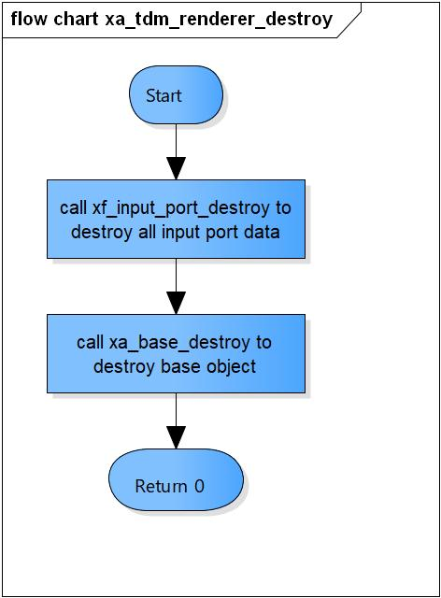

Figure 3‑10 xa_tdm_renderer_destroy flowchart

### xa_tdm_renderer_factory

DD_FWK_TDM_02_011

|  |  |  |  |  |
| --- | --- | --- | --- | --- |
| **Syntax** | xf_component_t * xa_tdm_renderer_factory(u32 core, xa_codec_func_t process) | | | |
| **Function** | This function is to initialize TDM Renderer component. | | | |
| **Arguments** | Type | Name | I/O | Description |
| u32 | core | I | Core index of ADSP framework. |
| xa_codec_func_t | process | I | Codec API entry point (function). |
| **Return Value** | Return handle to component. | | | |
| **Description** | * xa_tdm_renderer_factory command processing:   - Initialize TDM Renderer component. | | | |

[Covers: FD_FWK_CMN_005, FD_FWK_CMN_008, FD_FWK_CMN_009]

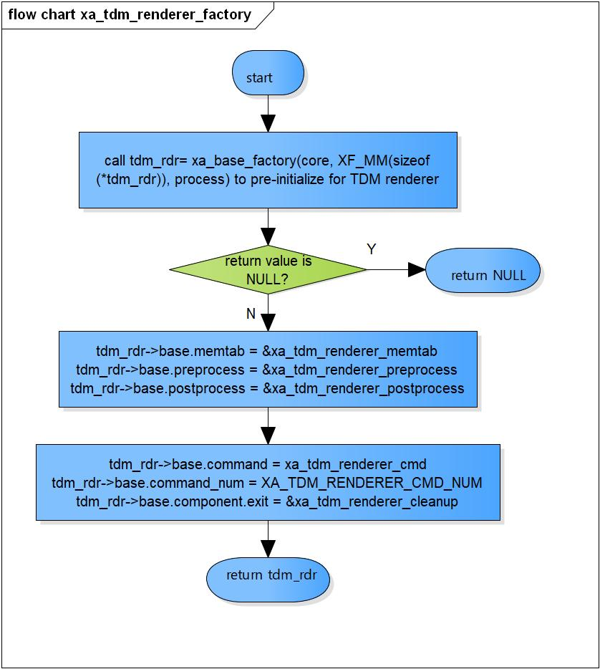

Figure 3‑11 xa_tmd_renderer_factory flowchart

# Revision history

|  |  |  |  |  |  |
| --- | --- | --- | --- | --- | --- |
| **Version** | **Date** | **Page** | **Content** | **Approved** | **Changed** |
| 1.0.0 | - | - | First Edition issued | Vu Phan | Vu Phan |
| 1.1.0 | Dec 10 2018 | - | Add traceability ID | Vu Phan | Ngu Pham |
| 1.2.0 | Jan 03, 2019 | - | Add range for input parameters | Vu Phan | Tien Tran |