**Document Type: Detail Design**

**Document Name:**

**ADSP FRAMEWORK: ADMA DRIVER**

Renesas Electronics Corporation

Renesas Design Vietnam Co. Ltd

R-Car Software Solution 2 Group

Middleware 1 Team

Table of Contents

1. Overview 3

2. Function list 4

3. Detail information 5

3.1 Data type definition 5

3.1.1 ADMA_CH 5

3.1.2 dmac_error_code 6

3.1.3 ADMA_STAGE 6

3.1.4 DMAC_SRCDST 7

3.1.5 ADMAC_MODE 10

3.1.6 DMAC_SETTING 10

3.1.7 DMAC_AUDIO_MODULE_SETTING 11

3.2 Macro definition 12

3.3 Register definition 14

3.4 Global variable definition 15

3.5 Function definition 18

3.5.1 admac_get_register_addr 18

3.5.2 admac_set_stage_number 20

3.5.3 admac_reset_descriptor 21

3.5.4 admac_start_descriptor 22

3.5.5 admac_enable_ch 23

3.5.6 admac_disable_ch 24

3.5.7 admac_enable_module 25

3.5.8 admac_clear_channel 26

3.5.9 admac_check_stage 27

3.5.10 admac_check_and_clear_interrupt 28

3.5.11 admac_start 29

3.5.12 admac_stop 30

3.5.13 admac_descriptor_setup 31

3.5.14 admac_stage_config 32

3.5.15 admac_pre_config 33

3.5.16 admac_post_config 35

3.5.17 admac_check_valid_channel 37

3.5.18 admac_setting_use_descriptor 39

3.5.19 admac_setting_nouse_descriptor 40

3.5.20 admac_resetup 42

3.5.21 admac_pause 43

4. Revision history 44

List of Figures

Figure 1‑1 The software architecture 3

Figure 3‑1 admac_get_register_addr flowchart 19

Figure 3‑2 admac_set_stage_number flowchart 20

Figure 3‑3 admac_reset_descriptor flowchart 21

Figure 3‑4 admac_start_desciptor flowchart 22

Figure 3‑5 admac_enable_ch flowchart 23

Figure 3‑6 admac_disable_ch flowchart 24

Figure 3‑7 admac_enable_module flowchart 25

Figure 3‑8 admac_clear_channel flowchart 26

Figure 3‑9 admac_check_stage flowchart 27

Figure 3‑10 admac_check_and_clear_interrupt flowchart 28

Figure 3‑11admac_start flowchart 29

Figure 3‑12 admac_stop flowchart 30

Figure 3‑13 admac_descriptor_setup flowchart 31

Figure 3‑14 admac_stage_config flowchart 32

Figure 3‑15 admac_pre_config flowchart 34

Figure 3‑16 admac_post_config flowchart 35

Figure 3‑17 admac_check_valid_channel flowchart 38

Figure 3‑18 admac_setting_use_descriptor flowchart 39

Figure 3‑19 admac_setting_nouse_descriptor flowchart 41

Figure 3‑20 admac_resetup flowchart 42

Figure 3‑21 admac_pause flowchart 43

List of Table

Table 2‑1 Function list 4

Table 3‑1 ADMA_CH type information 5

Table 3‑2 dmac_error_code type information 6

Table 3‑3 ADMA_STAGE type information 6

Table 3‑4 DMAC_SRCDST type information 7

Table 3‑5 ADMAC_MODE type information 10

Table 3‑6 DMAC_SETTING type information 10

Table 3‑7 DMAC_AUDIO_MODULE_SETTING type information 11

Table 2‑1 Function list 4

Table 3‑1 ADMA_CH type information 5

Table 3‑2 dmac_error_code type information 6

Table 3‑3 ADMA_STAGE type information 6

Table 3‑4 DMAC_SRCDST type information 7

Table 3‑5 ADMAC_MODE type information 10

Table 3‑6 DMAC_SETTING type information 10

Table 3‑7 DMAC_AUDIO_MODULE_SETTING type information 11

# Overview

This section provides an overview of software architecture.

User Application

ADSP Interface

Kernel Space

User Space

ADSP Driver

ARM

Audio HW

**ADSP Framework**

TDM class

Renderer class

Equalizer class

Capture class

TDM Plugin

ADSP

Plugin

Equalizer Plugin*

Capture Plugin

Renderer Plugin

This document’s target is in side of red square

* not connect to hardware modules

DAC/

ADC

FIFO

SCU

PDMA

SSI

SSIU

ADMA

Figure 1‑1 ****The software architecture****

# Function list

The following is list of functions:

Table 2‑1 Function list

|  |  |  |
| --- | --- | --- |
| **Type** | **Function Name** | **Outline** |
| API | admac_get_register_addr | This API is to get DMAC channel N register’s address |
| admac_check_stage | This API is to check the current stage of DMAC module |
| admac_check_and_clear_interrupt | This API is to check and clear interrupt of DMAC channel N |
| admac_start | This API is to start DMAC channel N |
| admac_stop | This API is to stop DMAC channel N |
| admac_check_valid_channel | This API is to check availability of DMAC module and choose an available one |
| admac_setting_use_descriptor | This API is to set DMAC module using descriptor memory |
| admac_setting_nouse_descriptor | This API is to set DMAC module not using descriptor memory |
| admac_resetup | This API is to re-setup DMAC module |
| admac_pause | This API is to pause ADMAC channel N |
| Internal function | admac_set_stage_number | This function is to set stage number |
| admac_reset_descriptor | This function is to reset descriptor |
| admac_start_descriptor | This function is to start descriptor |
| admac_enable_ch | This function is to enable a channel |
| admac_disable_ch | This function is to disable a channel |
| admac_enable_module | This function is to enable DMAC module |
| admac_clear_channel | This function is to clear value set in DMAC channel N register |
| admac_descriptor_setup | This function is to set up DMAC descriptor |
| admac_stage_config | This function is to set DMAC stage |
| admac_pre_config | This function is to set DMAC parameters |
| admac_post_config | This function is to post-set DMAC parameters |

# Detail information

This section describes detail information of data types, macro definitions, implemented APIs and internal function units, global variables.

## Data type definition

### ADMA_CH

The data type ADMA_CH is a type-defined enumeration that lists all supported ADMAC channels.

Table 3‑1 ADMA_CH type information

|  |  |  |
| --- | --- | --- |
| **Member name** | **Value** | **Outline** |
| ADMAC_CH00 | 0 | ADMAC channel 0 |
| ADMAC_CH01 | 1 | ADMAC channel 1 |
| ADMAC_CH02 | 2 | ADMAC channel 2 |
| ADMAC_CH03 | 3 | ADMAC channel 3 |
| ADMAC_CH04 | 4 | ADMAC channel 4 |
| ADMAC_CH05 | 5 | ADMAC channel 5 |
| ADMAC_CH06 | 6 | ADMAC channel 6 |
| ADMAC_CH07 | 7 | ADMAC channel 7 |
| ADMAC_CH08 | 8 | ADMAC channel 8 |
| ADMAC_CH09 | 9 | ADMAC channel 9 |
| ADMAC_CH10 | 10 | ADMAC channel 10 |
| ADMAC_CH11 | 11 | ADMAC channel 11 |
| ADMAC_CH12 | 12 | ADMAC channel 12 |
| ADMAC_CH13 | 13 | ADMAC channel 13 |
| ADMAC_CH14 | 14 | ADMAC channel 14 |
| ADMAC_CH15 | 15 | ADMAC channel 15 |
| ADMAC_CH16 | 16 | ADMAC channel 16 |
| ADMAC_CH17 | 17 | ADMAC channel 17 |
| ADMAC_CH18 | 18 | ADMAC channel 18 |
| ADMAC_CH19 | 19 | ADMAC channel 19 |
| ADMAC_CH20 | 20 | ADMAC channel 20 |
| ADMAC_CH21 | 21 | ADMAC channel 21 |
| ADMAC_CH22 | 22 | ADMAC channel 22 |
| ADMAC_CH23 | 23 | ADMAC channel 23 |
| ADMAC_CH24 | 24 | ADMAC channel 24 |
| ADMAC_CH25 | 25 | ADMAC channel 25 |
| ADMAC_CH26 | 26 | ADMAC channel 26 |
| ADMAC_CH27 | 27 | ADMAC channel 27 |
| ADMAC_CH28 | 28 | ADMAC channel 28 |
| ADMAC_CH29 | 29 | ADMAC channel 29 |
| ADMAC_CH30 | 30 | ADMAC channel 30 |
| ADMAC_CH31 | 31 | ADMAC channel 31 |
| ADMAC_CHMAX | 32 | Total number of ADMAC channels |

### dmac_error_code

The data type dmac_error_code is a type-defined enumeration that lists all error codes for ADMAC.

Table 3‑2 dmac_error_code type information

|  |  |
| --- | --- |
| **Member name** | **Value** |
| DMAC_ERROR_NONE | 0 |
| DMAC_ERROR_BUSY | -1 |
| DMAC_ERROR_INVALID | -2 |
| DMAC_ERROR_OUT_RANGE | -3 |

### ADMA_STAGE

The data type ADMA_STAGE is a type-defined enumeration of stages of ADMAC.

Table 3‑3 ADMA_STAGE type information

|  |  |  |
| --- | --- | --- |
| **Member name** | **Value** | **Outline** |
| ADMAC_STAGE0 | 0 | ADMAC stage 0 |
| ADMAC_STAGE1 | 1 | ADMAC stage 1 |
| ADMAC_STAGEMAX | 2 | Total stages of ADMAC |

### DMAC_SRCDST

The data type DMAC_SRCDST is a type-defined enumeration that shows connections between ADMAC and other devices.

Table 3‑4 DMAC_SRCDST type information

|  |  |
| --- | --- |
| **Member name** | **Value** |
| DMAC_SSI00 | DMAC_SSI_MODULE_MIN |
| DMAC_SSI01 | 1 |
| DMAC_SSI02 | 2 |
| DMAC_SSI03 | 3 |
| DMAC_SSI04 | 4 |
| DMAC_SSI05 | 5 |
| DMAC_SSI06 | 6 |
| DMAC_SSI07 | 7 |
| DMAC_SSI10 | 10 |
| DMAC_SSI11 | 11 |
| DMAC_SSI12 | 12 |
| DMAC_SSI13 | 13 |
| DMAC_SSI14 | 14 |
| DMAC_SSI15 | 15 |
| DMAC_SSI16 | 16 |
| DMAC_SSI17 | 17 |
| DMAC_SSI20 | 20 |
| DMAC_SSI21 | 21 |
| DMAC_SSI22 | 22 |
| DMAC_SSI23 | 23 |
| DMAC_SSI24 | 24 |
| DMAC_SSI25 | 25 |
| DMAC_SSI26 | 26 |
| DMAC_SSI27 | 27 |
| DMAC_SSI30 | 30 |
| DMAC_SSI31 | 31 |
| DMAC_SSI32 | 32 |
| DMAC_SSI33 | 33 |
| DMAC_SSI34 | 34 |
| DMAC_SSI35 | 35 |
| DMAC_SSI36 | 36 |
| DMAC_SSI37 | 37 |
| DMAC_SSI40 | 40 |
| DMAC_SSI41 | 41 |
| DMAC_SSI42 | 42 |
| DMAC_SSI43 | 43 |
| DMAC_SSI44 | 44 |
| DMAC_SSI45 | 45 |
| DMAC_SSI46 | 46 |
| DMAC_SSI47 | 47 |
| DMAC_SSI5 | 50 |
| DMAC_SSI6 | 60 |
| DMAC_SSI7 | 70 |
| DMAC_SSI8 | 80 |
| DMAC_SSI90 | 90 |
| DMAC_SSI91 | 91 |
| DMAC_SSI92 | 92 |
| DMAC_SSI93 | 93 |
| DMAC_SSI94 | 94 |
| DMAC_SSI95 | 95 |
| DMAC_SSI96 | 96 |
| DMAC_SSI97 | DMAC_SSI_MODULE_MAX |
| DMAC_DTCPPP0 | 98 |
| DMAC_DTCPPP1 | 99 |
| DMAC_DTCPCP0 | 100 |
| DMAC_DTCPCP1 | 101 |
| DMAC_SCU_SRCI0 | DMAC_SCU_SRC_INPUT_MODULE_MIN |
| DMAC_SCU_SRCI1 | 111 |
| DMAC_SCU_SRCI2 | 112 |
| DMAC_SCU_SRCI3 | 113 |
| DMAC_SCU_SRCI4 | 114 |
| DMAC_SCU_SRCI5 | 115 |
| DMAC_SCU_SRCI6 | 116 |
| DMAC_SCU_SRCI7 | 117 |
| DMAC_SCU_SRCI8 | 118 |
| DMAC_SCU_SRCI9 | DMAC_SCU_SRC_INPUT_MODULE_MAX |
| DMAC_SCU_SRCO0 | DMAC_SCU_SRC_OUTPUT_MODULE_MIN |
| DMAC_SCU_SRCO1 | 121 |
| DMAC_SCU_SRCO2 | 122 |
| DMAC_SCU_SRCO3 | 123 |
| DMAC_SCU_SRCO4 | 124 |
| DMAC_SCU_SRCO5 | 125 |
| DMAC_SCU_SRCO6 | 126 |
| DMAC_SCU_SRCO7 | 127 |
| DMAC_SCU_SRCO8 | 128 |
| DMAC_SCU_SRCO9 | DMAC_SCU_SRC_OUTPUT_MODULE_MAX |
| DMAC_SCU_CMD0 | DMAC_SCU_CMD_MODULE_MIN |
| DMAC_SCU_CMD1 | DMAC_SCU_CMD_MODULE_MAX |
| DMAC_MLM0 | 132 |
| DMAC_MLM1 | 133 |
| DMAC_MLM2 | 134 |
| DMAC_MLM3 | 135 |
| DMAC_MLM4 | 136 |
| DMAC_MLM5 | 137 |
| DMAC_MLM6 | 138 |
| DMAC_MLM7 | 139 |
| DMAC_NONCONTROL | 140 |
| DMAC_MAX | 141 |

### ADMAC_MODE

The data type ADMAC_MODE is a type-defined enumeration of ADMAC operation mode.

Table 3‑5 ADMAC_MODE type information

|  |  |  |
| --- | --- | --- |
| **Member name** | **Value** | **Outline** |
| ADMAC_NORMAL_MODE | 1 | ADMAC normal mode |
| ADMAC_REPEAT_MODE | 2 | ADMAC repeating mode |

### DMAC_SETTING

The data type DMAC_SETTING is a type-defined structure that possesses necessary parameters for DMAC module.

Table 3‑6 DMAC_SETTING type information

|  |  |  |
| --- | --- | --- |
| **Member name** | **Data type** | **Outline** |
| dst | WORD32 | Destination address |
| src | WORD32 | Source address |
| transmem | pVOID | Transmission memory address |
| trans_num | WORD32 | Transfer number |
| stg_num | WORD32 | Stage number |
| stg_size | WORD32 | Stage memory size |
| buf_size | WORD32 | Ring buffer size |
| trans_mode | WORD32 | Indicator of transfer/receive mode |
| mode | ADMAC_MODE | Operation mode |
| dma_ch | UWORD32 | ADMAC channel |
| src_reqst | UWORD32 | Source request |
| trans_size | UWORD32 | Transfer size |

### DMAC_AUDIO_MODULE_SETTING

The data type DMAC_AUDIO_MODULE_SETTING is a type-defined structure of ADMAC device information.

Table 3‑7 DMAC_AUDIO_MODULE_SETTING type information

|  |  |  |
| --- | --- | --- |
| **Member name** | **Data type** | **Outline** |
| module_address | UWORD32 | Destination address |
| trans | UWORD32 | Source address |
| recei | UWORD32 | Transmission memory address |

## Macro definition

|  |  |  |
| --- | --- | --- |
| **Macros** | **Value** | **Outline** |
| DMAC_SSI_MODULE_MIN | 0 | SSI module min index |
| DMAC_SSI_MODULE_MAX | 97 | SSI module max index |
| DMAC_SCU_SRC_INPUT_MODULE_MIN | 110 | SCU input module min index |
| DMAC_SCU_SRC_INPUT_MODULE_MAX | 119 | SCU input module max index |
| DMAC_SCU_SRC_OUTPUT_MODULE_MIN | 120 | SCU output module min index |
| DMAC_SCU_SRC_OUTPUT_MODULE_MAX | 129 | SCU output module max index |
| DMAC_SCU_CMD_MODULE_MIN | 130 | CMD module min index |
| DMAC_SCU_CMD_MODULE_MAX | 131 | CMD module max index |
| XF_RCAR_DMAOR_L | XF_RCAR_REG_DMAOR_L | DMA operation register (for lower-numbered channels) |
| XF_RCAR_DMAOR_U | XF_RCAR_REG_DMAOR_U | DMA channel clear register (for lower-numbered channels) |
| XF_DMACHCLR_L | XF_RCAR_REG_DMACHCLR_L | DMA channel clear register (for lower-numbered channels) |
| XF_DMACHCLR_U | XF_RCAR_REG_DMACHCLR_U | DMA channel clear register (for higher-numbered channels) |
| XF_RCAR_DMARS_0 | XF_RCAR_REG_DMARS_0 | Channel 0 DMA Extended Resource Selectors Register |
| XF_RCAR_DMADPBASE_0 | XF_RCAR_REG_DMADPBASE_0 | Channel 0 DMA Descriptor Base Address Register |
| XF_RCAR_DMACHCRB_0 | XF_RCAR_REG_DMACHCRB_0 | Channel 0 DMA channel control register B |
| XF_RCAR_DMACHCR_0 | XF_RCAR_REG_DMACHCR_0 | Channel 0 DMA Channel Control Register |
| XF_RCAR_DMATCR_0 | XF_RCAR_REG_DMATCR_0 | Channel 0 DMA Transfer Count Register |
| XF_RCAR_DMABUFCR_0 | XF_RCAR_REG_DMABUFCR_0 | Channel 0 DMA Buffer Control register |
| XF_RCAR_DMASAR_0 | XF_RCAR_REG_DMASAR_0 | Channel 0 Source Address register |
| XF_RCAR_DMADAR_0 | XF_RCAR_REG_DMADAR_0 | Channel 0 Destination Address register |
| DMAC_TRANSMIT_REQ | 1 | source request is source |
| DMAC_RECEIVE_REQ | 2 | source request is destination |

## Register definition

Below is the table listing all items that are macros representing register addresses located in repository s492d/include/sys/xt-shmem/board-rcar/xf-registers.h

|  |  |
| --- | --- |
| **Register** | **Outline** |
| XF_RCAR_REG_DMAOR_L | DMA operation register (for lower-numbered channels) |
| XF_RCAR_REG_DMAOR_U | DMA channel clear register (for lower-numbered channels) |
| XF_RCAR_REG_DMACHCLR_L | DMA channel clear register (for lower-numbered channels) |
| XF_RCAR_REG_DMACHCLR_U | DMA channel clear register (for higher-numbered channels) |
| XF_RCAR_REG_DMARS_0 | Channel 0 DMA Extended Resource Selectors Register |
| XF_RCAR_REG_DMADPBASE_0 | Channel 0 DMA Descriptor Base Address Register |
| XF_RCAR_REG_DMACHCRB_0 | Channel 0 DMA channel control register B |
| XF_RCAR_REG_DMACHCR_0 | Channel 0 DMA Channel Control Register |
| XF_RCAR_REG_DMATCR_0 | Channel 0 DMA Transfer Count Register |
| XF_RCAR_REG_DMABUFCR_0 | Channel 0 DMA Buffer Control register |
| XF_RCAR_REG_DMASAR_0 | Channel 0 Source Address register |
| XF_RCAR_REG_DMADAR_0 | Channel 0 Destination Address register |

## Global variable definition

Below is the array of struct DMAC_AUDIO_MODULE_SETTING-datatype admac_set_value holds 141 (DMAC_MAX) elements representing settings for ADMAC data transfer

|  |  |  |  |
| --- | --- | --- | --- |
| static DMAC_AUDIO_MODULE_SETTING admac_set_value[DMAC_MAX] | | | |
| Array’s index | module_address | trans | recei |
| DMAC_SSI00 | 0xEC100000 | 0x15 | 0x16 |
| DMAC_SSI01 | 0xEC100400 | 0x35 | 0x36 |
| DMAC_SSI02 | 0xEC100800 | 0x37 | 0x38 |
| DMAC_SSI03 | 0xEC100C00 | 0x47 | 0x48 |
| DMAC_SSI04 | 0xEC10A000 | 0x3F | 0x40 |
| DMAC_SSI05 | 0xEC10A400 | 0x43 | 0x44 |
| DMAC_SSI06 | 0xEC10A800 | 0x4F | 0x50 |
| DMAC_SSI07 | 0xEC10AC00 | 0x53 | 0x54 |
| DMAC_SSI10 | 0xEC101000 | 0x49 | 0x4A |
| DMAC_SSI11 | 0xEC101400 | 0x4B | 0x4C |
| DMAC_SSI12 | 0xEC101800 | 0x57 | 0x58 |
| DMAC_SSI13 | 0xEC101C00 | 0x59 | 0x5A |
| DMAC_SSI14 | 0xEC10B000 | 0x5F | 0x60 |
| DMAC_SSI15 | 0xEC10B400 | 0xC3 | 0xC4 |
| DMAC_SSI16 | 0xEC10B800 | 0xC7 | 0xC8 |
| DMAC_SSI17 | 0xEC10BC00 | 0xCB | 0xCC |
| DMAC_SSI20 | 0xEC102000 | 0x63 | 0x64 |
| DMAC_SSI21 | 0xEC102400 | 0x67 | 0x68 |
| DMAC_SSI22 | 0xEC102800 | 0x6B | 0x6C |
| DMAC_SSI23 | 0xEC102C00 | 0x6D | 0x6E |
| DMAC_SSI24 | 0xEC10C000 | 0xCF | 0xCE |
| DMAC_SSI25 | 0xEC10C400 | 0xEB | 0xEC |
| DMAC_SSI26 | 0xEC10C800 | 0xED | 0xEE |
| DMAC_SSI27 | 0xEC10CC00 | 0xEF | 0xF0 |
| DMAC_SSI30 | 0xEC103000 | 0x6F | 0x70 |
| DMAC_SSI31 | 0xEC103400 | 0x21 | 0x22 |
| DMAC_SSI32 | 0xEC103800 | 0x23 | 0x24 |
| DMAC_SSI33 | 0xEC103C00 | 0x25 | 0x26 |
| DMAC_SSI34 | 0xEC10D000 | 0x27 | 0x28 |
| DMAC_SSI35 | 0xEC10D400 | 0x29 | 0x2A |
| DMAC_SSI36 | 0xEC10D800 | 0x2B | 0x2C |
| DMAC_SSI37 | 0xEC10DC00 | 0x2D | 0x2E |
| DMAC_SSI40 | 0xEC104000 | 0x71 | 0x72 |
| DMAC_SSI41 | 0xEC104400 | 0x17 | 0x18 |
| DMAC_SSI42 | 0xEC104800 | 0x19 | 0x1A |
| DMAC_SSI43 | 0xEC104C00 | 0x1B | 0x1C |
| DMAC_SSI44 | 0xEC10E000 | 0x1D | 0x1E |
| DMAC_SSI45 | 0xEC10E400 | 0x1F | 0x20 |
| DMAC_SSI46 | 0xEC10E800 | 0x31 | 0x32 |
| DMAC_SSI47 | 0xEC10EC00 | 0x33 | 0x34 |
| DMAC_SSI5 | 0xEC105000 | 0x73 | 0x74 |
| DMAC_SSI6 | 0xEC106000 | 0x75 | 0x76 |
| DMAC_SSI7 | 0xEC107000 | 0x79 | 0x7A |
| DMAC_SSI8 | 0xEC108000 | 0x7B | 0x7C |
| DMAC_SSI90 | 0xEC109000 | 0x7D | 0x7E |
| DMAC_SSI91 | 0xEC109400 | 0x7F | 0x80 |
| DMAC_SSI92 | 0xEC109800 | 0x81 | 0x82 |
| DMAC_SSI93 | 0xEC109C00 | 0x83 | 0x84 |
| DMAC_SSI94 | 0xEC10F000 | 0xA3 | 0xA4 |
| DMAC_SSI95 | 0xEC10F400 | 0xA5 | 0xA6 |
| DMAC_SSI96 | 0xEC10F800 | 0xA7 | 0xA8 |
| DMAC_SSI97 | 0xEC10FC00 | 0xA9 | 0xAA |
| DMAC_DTCPPP0 | 0xEC120000 | 0xBF | 0xC0 |
| DMAC_DTCPPP1 | 0xEC120400 | 0xD5 | 0xD6 |
| DMAC_DTCPCP0 | 0xEC124000 | 0xD7 | 0xD8 |
| DMAC_DTCPCP1 | 0xEC124400 | 0xD9 | 0xDA |
| DMAC_SCU_SRCI0 | 0xEC000000 | 0x85 | 0xff |
| DMAC_SCU_SRCI1 | 0xEC000400 | 0x87 | 0xff |
| DMAC_SCU_SRCI2 | 0xEC000800 | 0x89 | 0xff |
| DMAC_SCU_SRCI3 | 0xEC000C00 | 0x8B | 0xff |
| DMAC_SCU_SRCI4 | 0xEC001000 | 0x8D | 0xff |
| DMAC_SCU_SRCI5 | 0xEC001400 | 0x8F | 0xff |
| DMAC_SCU_SRCI6 | 0xEC001800 | 0x91 | 0xff |
| DMAC_SCU_SRCI7 | 0xEC001C00 | 0x93 | 0xff |
| DMAC_SCU_SRCI8 | 0xEC002000 | 0x95 | 0xff |
| DMAC_SCU_SRCI9 | 0xEC002400 | 0x97 | 0xff |
| DMAC_SCU_SRCO0 | 0xEC004000 | 0xff | 0x9A |
| DMAC_SCU_SRCO1 | 0xEC004400 | 0xff | 0x9C |
| DMAC_SCU_SRCO2 | 0xEC004800 | 0xff | 0x9E |
| DMAC_SCU_SRCO3 | 0xEC004C00 | 0xff | 0xA0 |
| DMAC_SCU_SRCO4 | 0xEC005000 | 0xff | 0xB0 |
| DMAC_SCU_SRCO5 | 0xEC005400 | 0xff | 0xB2 |
| DMAC_SCU_SRCO6 | 0xEC005800 | 0xff | 0xB4 |
| DMAC_SCU_SRCO7 | 0xEC005C00 | 0xff | 0xB6 |
| DMAC_SCU_SRCO8 | 0xEC006000 | 0xff | 0xB8 |
| DMAC_SCU_SRCO9 | 0xEC006400 | 0xff | 0xBA |
| DMAC_SCU_CMD0 | 0xEC008000 | 0xff | 0xBC |
| DMAC_SCU_CMD1 | 0xEC008400 | 0xff | 0xBE |
| DMAC_MLM0 | 0xEC020000 | 0xDB | 0xDC |
| DMAC_MLM1 | 0xEC020400 | 0xE3 | 0xE4 |
| DMAC_MLM2 | 0xEC020800 | 0xE5 | 0xE6 |
| DMAC_MLM3 | 0xEC020C00 | 0xE7 | 0xE8 |
| DMAC_MLM4 | 0xEC021000 | 0xF3 | 0xF4 |
| DMAC_MLM5 | 0xEC021400 | 0xF5 | 0xF6 |
| DMAC_MLM6 | 0xEC021800 | 0xF7 | 0xF8 |
| DMAC_MLM7 | 0xEC021C00 | 0xF9 | 0xFA |

## Function definition

### admac_get_register_addr

DD_PLG_RDR_07_001

|  |  |  |  |  |
| --- | --- | --- | --- | --- |
| **Syntax** | inline UWORD32 admac_get_register_addr(UWORD32 reg_addr0, ADMA_CH n) | | | |
| **Function** | This function is to get DMAC channel N register’s address. | | | |
| **Arguments** | Type | Name | I/O | Description |
| UWORD32 | reg_addr0 | I | Pointer to register of channel 0 |
| ADMA_CH | n | I | Channel number  Valid range: [0: 31] |
| **Return value** | The value of register channel N | | | |
| **Description** | * admac_get_register_addr command processing:   - Get DMAC channel N register’s address | | | |

[Covers: FD_PLG_RDR_005, FD_PLG_RDR_014, FD_PLG_RDR_015, FD_PLG_RDR_017, FD_PLG_RDR_032, FD_PLG_RDR_043]

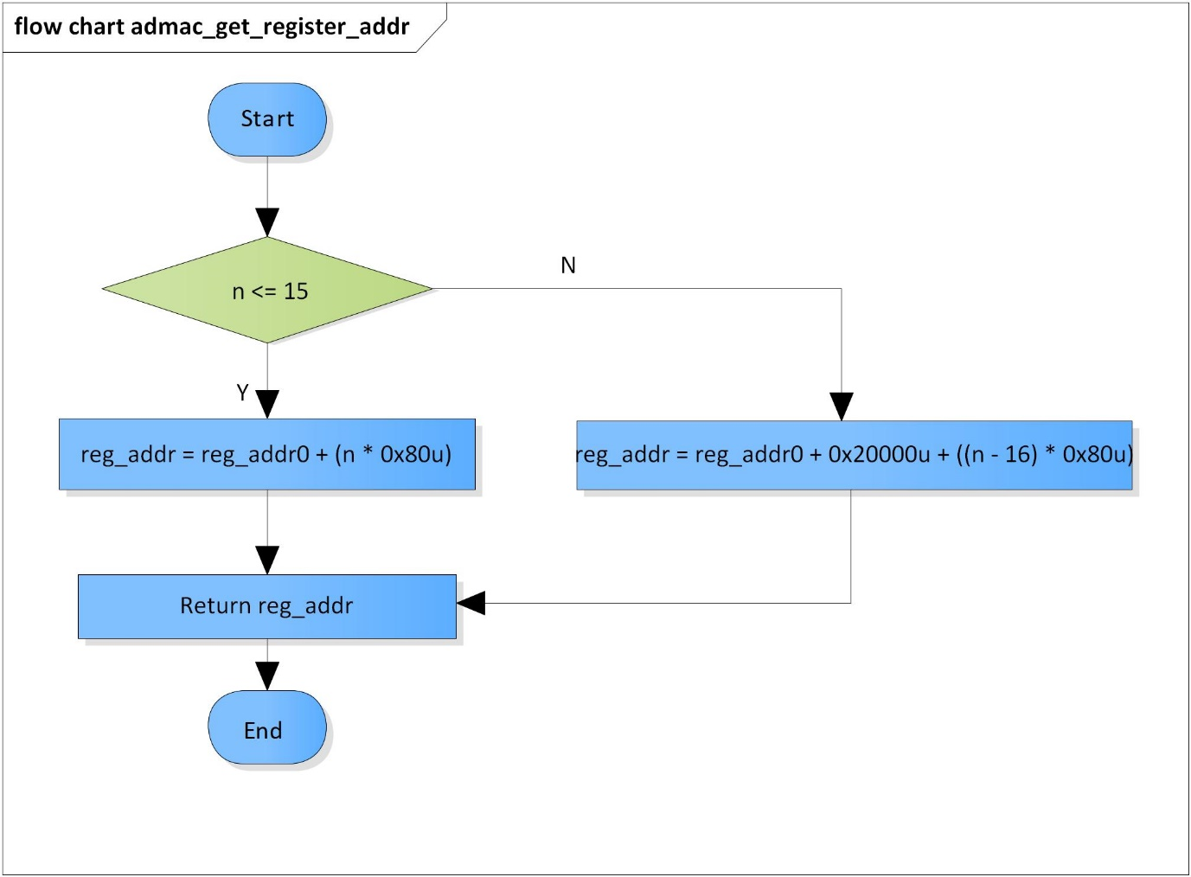

Figure 3‑1 admac_get_register_addr flowchart

### admac_set_stage_number

DD_PLG_RDR_07_002

|  |  |  |  |  |
| --- | --- | --- | --- | --- |
| **Syntax** | static inline void admac_set_stage_number(UWORD32 n, UWORD32 stg_num) | | | |
| **Function** | This function is to set stage number. | | | |
| **Arguments** | Type | Name | I/O | Description |
| UWORD32 | n | I | Channel number |
| UWORD32 | stg_num | I | Stage number |
| **Return value** | None | | | |
| **Description** | * admac_set_stage_number command processing:   - Set stage for DMA channel N | | | |

[Covers: FD_PLG_RDR_005]

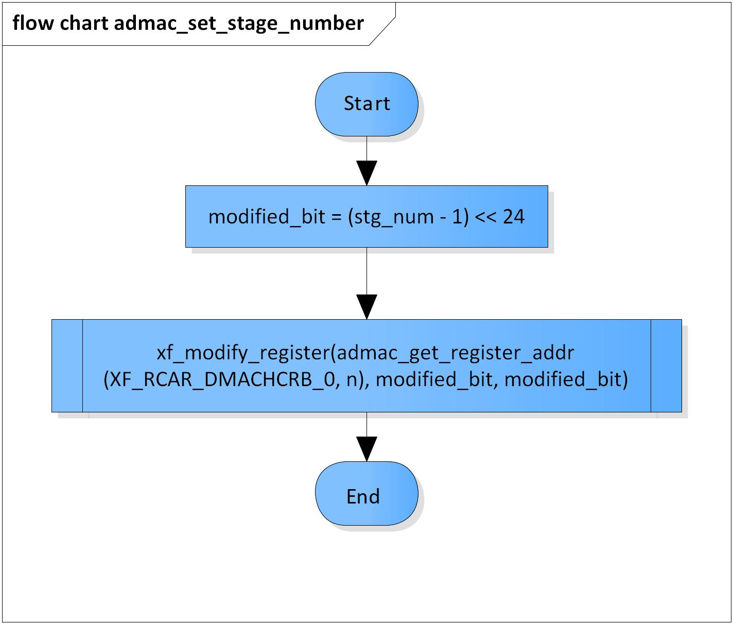

Figure 3‑2 admac_set_stage_number flowchart

### admac_reset_descriptor

DD_PLG_RDR_07_003

|  |  |  |  |  |
| --- | --- | --- | --- | --- |
| **Syntax** | static inline void admac_reset_descriptor(ADMA_CH n) | | | |
| **Function** | This function is to reset descriptor of DMA channel N. | | | |
| **Arguments** | Type | Name | I/O | Description |
| ADMA_CH | n | I | Channel number  Valid range: [0: 31] |
| **Return value** | None | | | |
| **Description** | * admac_reset_descriptor command processing:   - Reset descriptor of DMA channel N | | | |

[Covers: FD_PLG_RDR_005]

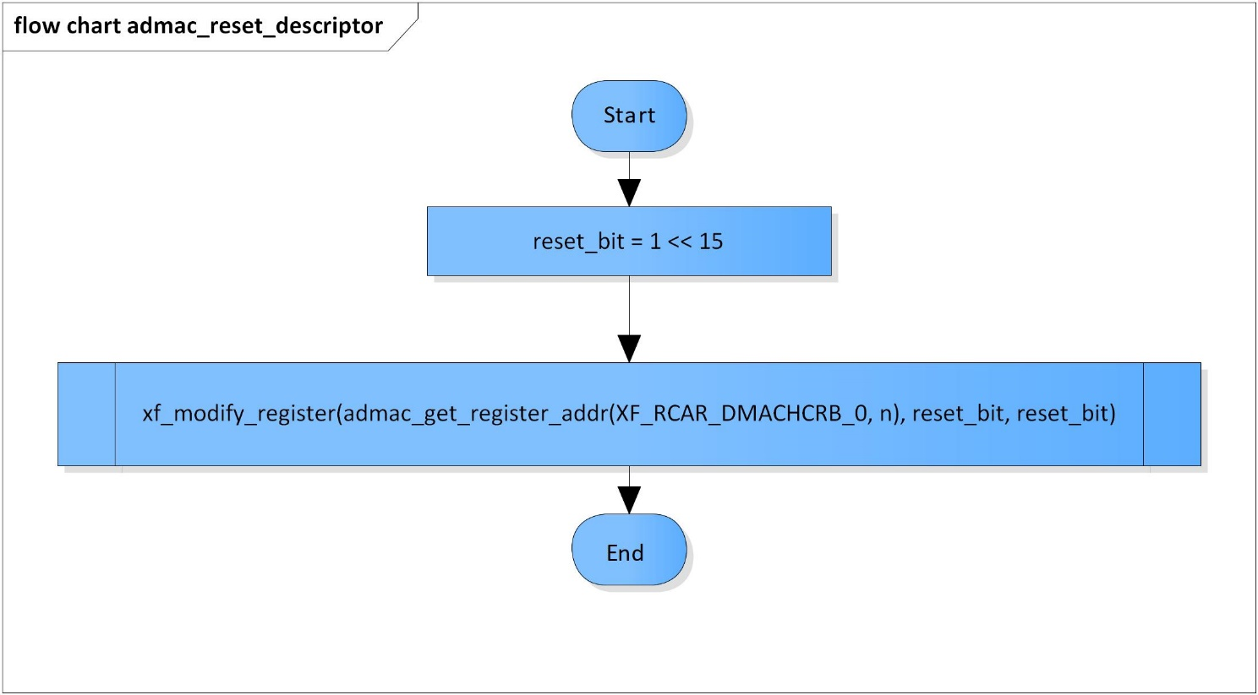

Figure 3‑3 admac_reset_descriptor flowchart

### admac_start_descriptor

DD_PLG_RDR_07_004

|  |  |  |  |  |
| --- | --- | --- | --- | --- |
| **Syntax** | static inline void admac_start_descriptor(ADMA_CH n) | | | |
| **Function** | This function is to start descriptor of DMA channel N. | | | |
| **Arguments** | Type | Name | I/O | Description |
| ADMA_CH | n | I | Channel number  Valid range: [0: 31] |
| **Return value** | None | | | |
| **Description** | * admac_start_descriptor command processing:   - Start descriptor of DMA channel N | | | |

[Covers: FD_PLG_RDR_005]

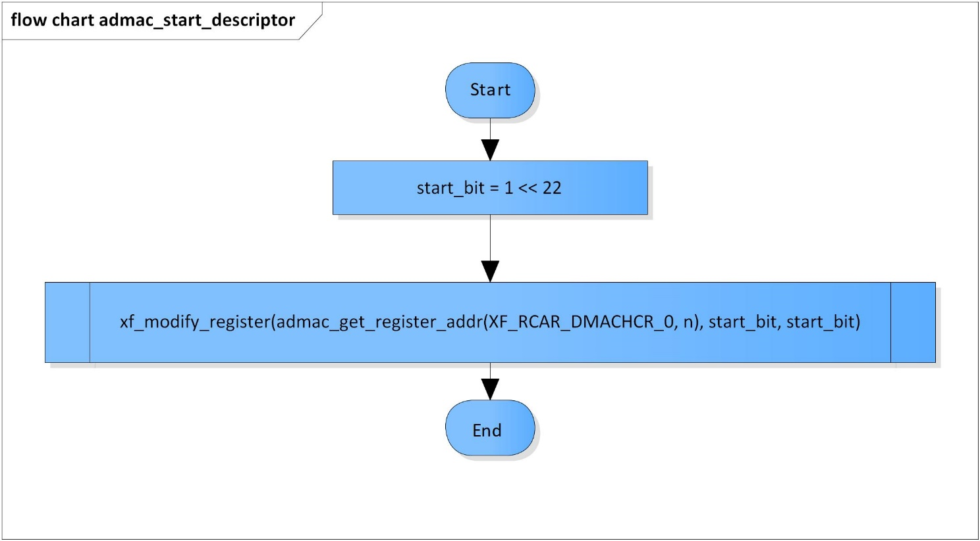

Figure 3‑4 admac_start_desciptor flowchart

### admac_enable_ch

DD_PLG_RDR_07_005

|  |  |  |  |  |
| --- | --- | --- | --- | --- |
| **Syntax** | static inline void admac_enable_ch(ADMA_CH n) | | | |
| **Function** | This function is to enable DMA channel N. | | | |
| **Arguments** | Type | Name | I/O | Description |
| ADMA_CH | n | I | Channel number  Valid range: [0: 31] |
| **Return value** | None | | | |
| **Description** | * admac_enable_ch command processing:   - Enable DMA channel N | | | |

[Covers: FD_PLG_RDR_005, FD_PLG_RDR_014, FD_PLG_RDR_015, FD_PLG_RDR_017, FD_PLG_RDR_032, FD_PLG_RDR_043]

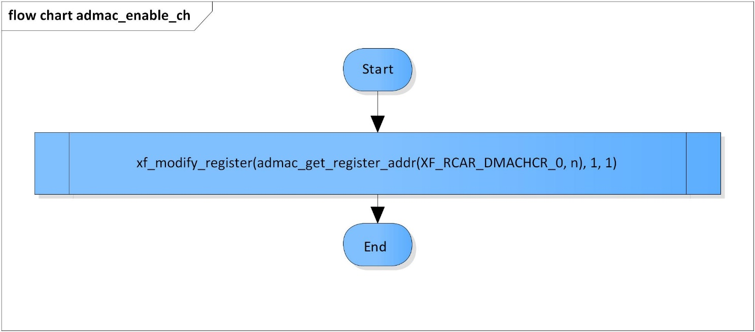

Figure 3‑5 admac_enable_ch flowchart

### admac_disable_ch

DD_PLG_RDR_07_006

|  |  |  |  |  |
| --- | --- | --- | --- | --- |
| **Syntax** | static inline void admac_disable_ch(ADMA_CH n) | | | |
| **Function** | This function is to disable DMA channel N. | | | |
| **Arguments** | Type | Name | I/O | Description |
| ADMA_CH | n | I | Channel number  Valid range: [0: 31] |
| **Return value** | None | | | |
| **Description** | * admac_disable_ch command processing:   - Disable DMA channel N | | | |

[Covers: FD_PLG_RDR_005, FD_PLG_RDR_014, FD_PLG_RDR_015, FD_PLG_RDR_017, FD_PLG_RDR_032, FD_PLG_RDR_043]

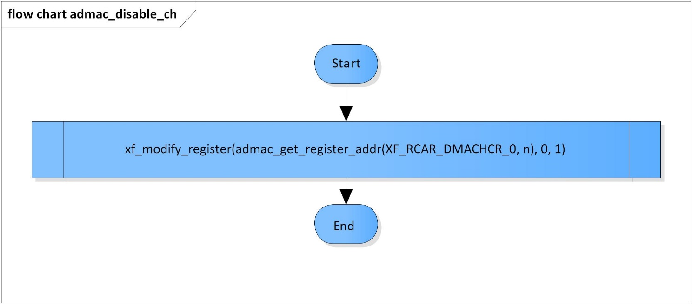

Figure 3‑6 admac_disable_ch flowchart

### admac_enable_module

DD_PLG_RDR_07_007

|  |  |  |  |  |
| --- | --- | --- | --- | --- |
| **Syntax** | static inline dmac_error_code admac_enable_module(ADMA_CH n) | | | |
| **Function** | This function is to enable DMAC module. | | | |
| **Arguments** | Type | Name | I/O | Description |
| ADMA_CH | n | I | Channel number  Valid range: [0: 31] |
| **Return value** | DMAC_ERROR_OUT_RANGE | | DMAC module is invalid | |
| DMAC_ERROR_NONE | | Normal end | |
| **Description** | * admac_enable_module command processing:   - Set ‘1’ to DE bit of register XF_RCAR_DMAOR_L or XF_RCAR_DMAOR_U depending channel number to enable DMAC module | | | |

[Covers: FD_PLG_RDR_005, FD_PLG_RDR_015, FD_PLG_RDR_017, FD_PLG_RDR_032, FD_PLG_RDR_043]

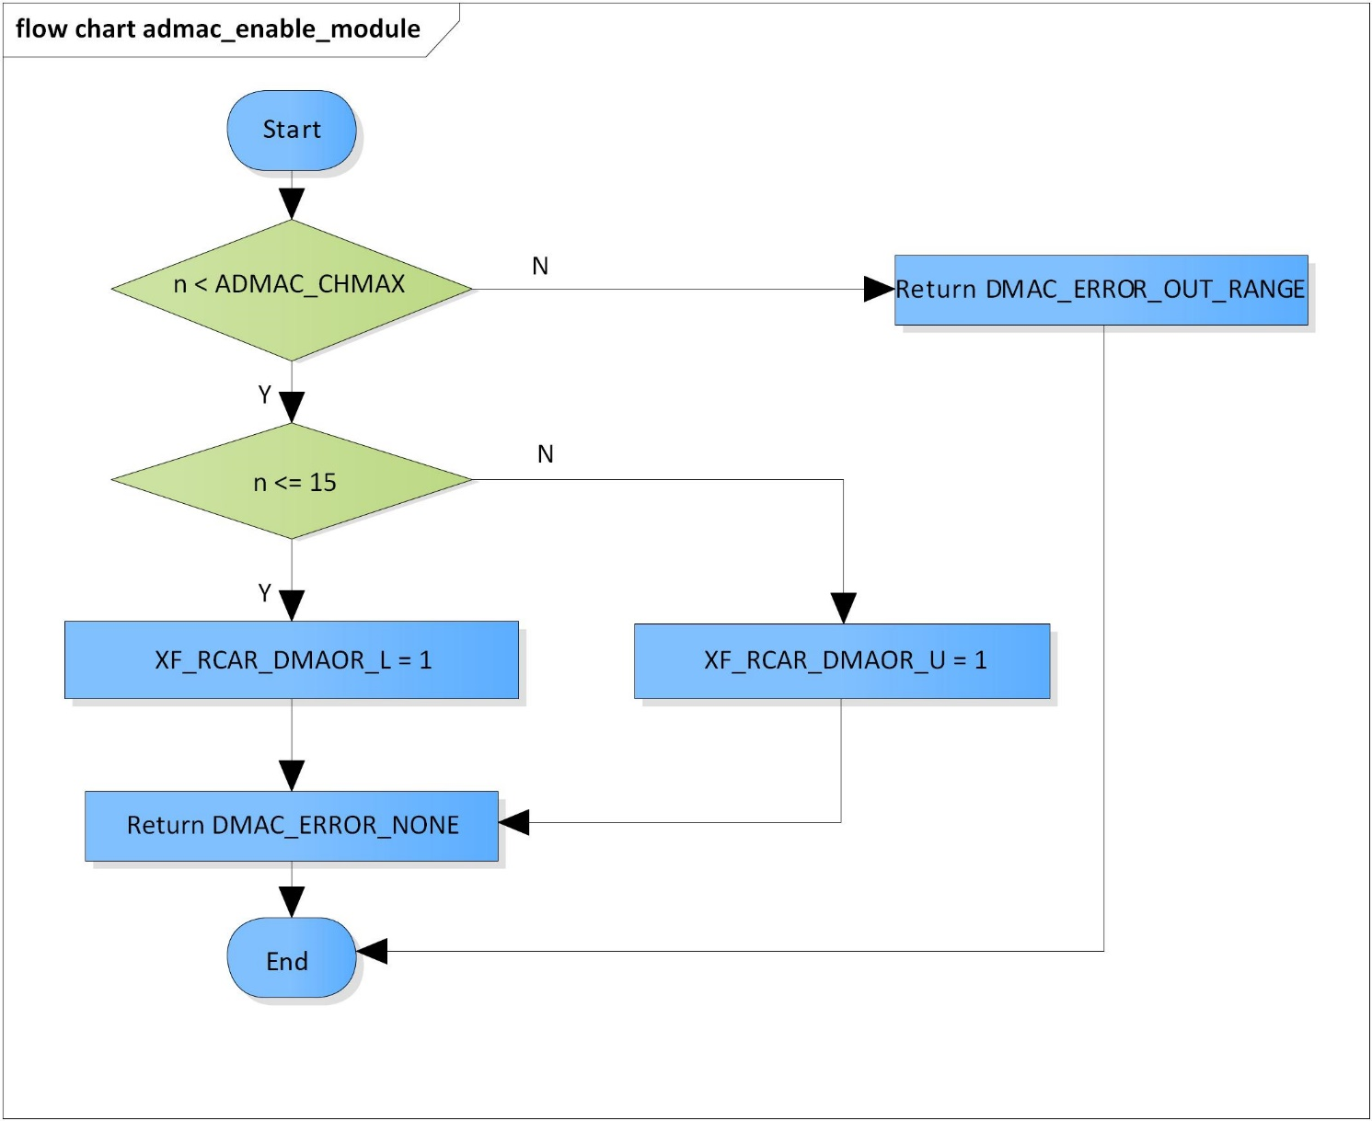

Figure 3‑7 admac_enable_module flowchart

### admac_clear_channel

DD_PLG_RDR_07_008

|  |  |  |  |  |
| --- | --- | --- | --- | --- |
| **Syntax** | static inline dmac_error_code admac_clear_module(ADMA_CH n) | | | |
| **Function** | This function is to clear value set in DMAC channel N registers. | | | |
| **Arguments** | Type | Name | I/O | Description |
| ADMA_CH | n | I | Channel number  Valid range: [0: 31] |
| **Return value** | DMAC_ERROR_OUT_RANGE | | DMAC module is invalid | |
| DMAC_ERROR_NONE | | Normal end | |
| **Description** | * admac_clear_channel command processing:   - Clear value set in DMAC channel N registers | | | |

[Covers: FD_PLG_RDR_005, FD_PLG_RDR_014, FD_PLG_RDR_032, FD_PLG_RDR_043]

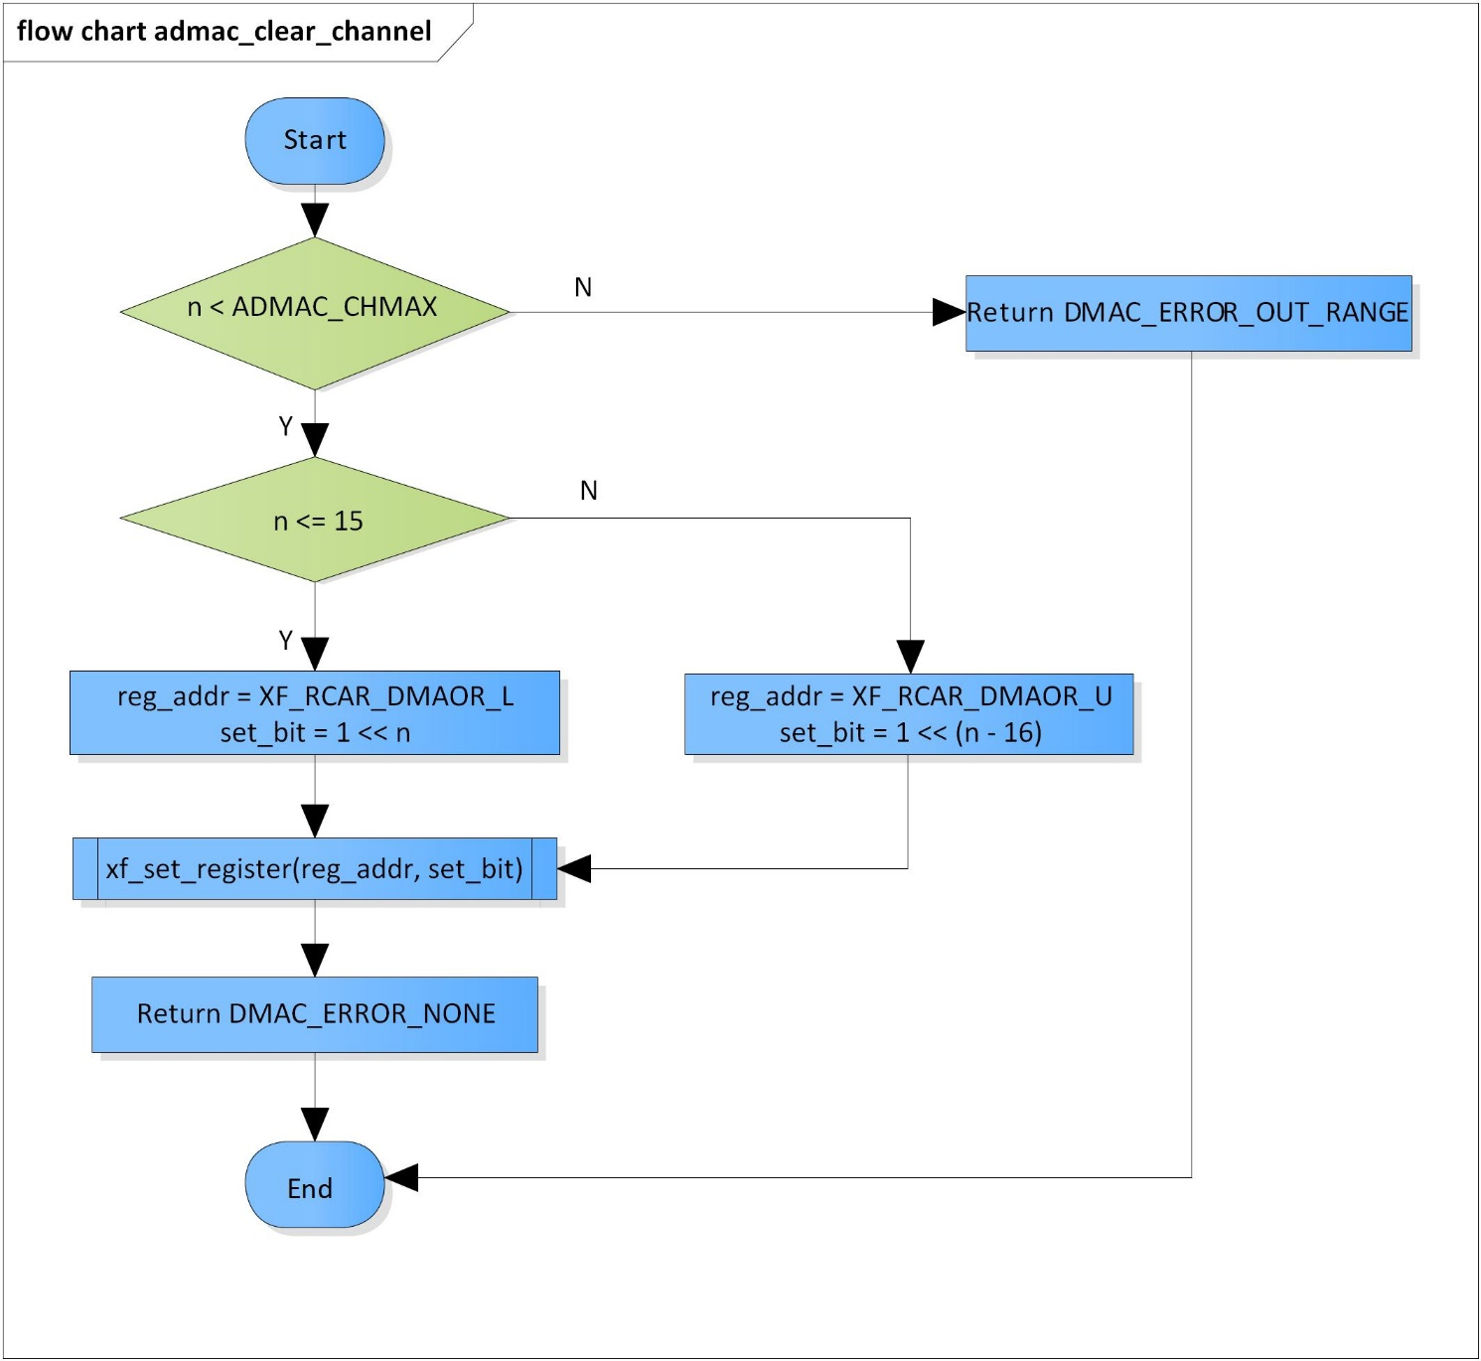

Figure 3‑8 admac_clear_channel flowchart

### admac_check_stage

DD_PLG_RDR_07_009

|  |  |  |  |  |
| --- | --- | --- | --- | --- |
| **Syntax** | inline WORD32 admac_check_stage(ADMA_CH n) | | | |
| **Function** | This function is to check the current stage of DMAC module. | | | |
| **Arguments** | Type | Name | I/O | Description |
| ADMA_CH | n | I | Channel number  Valid range: [0: 31] |
| **Return value** | The stage of ADMAC module | | | |
| **Description** | * admac_check_stage command processing:   - Check the current stage of DMAC module | | | |

[Covers: FD_PLG_RDR_015, FD_PLG_RDR_017]

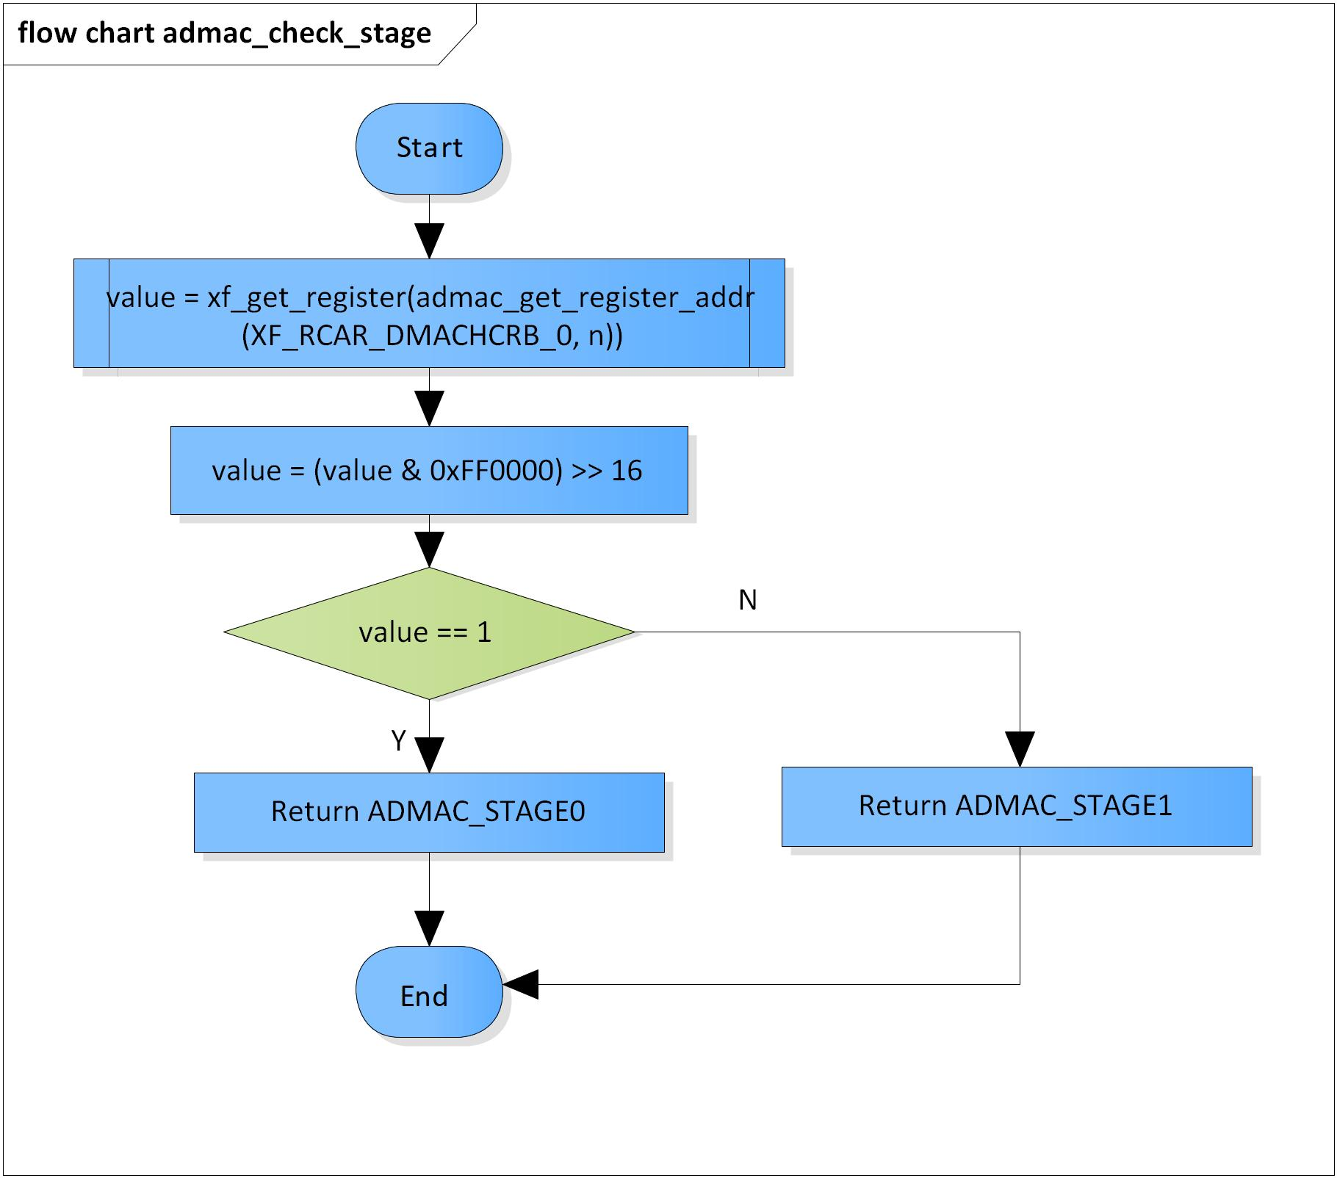

Figure 3‑9 admac_check_stage flowchart

### admac_check_and_clear_interrupt

DD_PLG_RDR_07_010

|  |  |  |  |  |
| --- | --- | --- | --- | --- |
| **Syntax** | inline WORD32 admac_check_and_clear_interrupt(ADMA_CH n) | | | |
| **Function** | This function is to check and clear interrupt of DMAC channel N. | | | |
| **Arguments** | Type | Name | I/O | Description |
| ADMA_CH | n | I | Channel number  Valid range: [0: 31] |
| **Return value** | The interrupt_flag | | | |
| **Description** | * admac_check_and_clear_interrupt command processing:   - Check and clear the interrupt of DMAC channel N | | | |

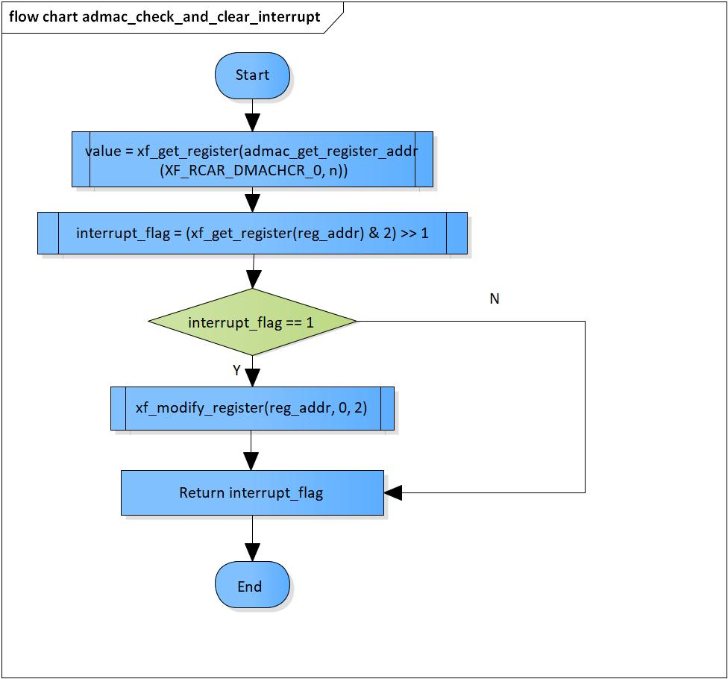[Covers: FD_PLG_RDR_015, FD_PLG_RDR_017]

Figure 3‑10 admac_check_and_clear_interrupt flowchart

### admac_start

DD_PLG_RDR_07_011

|  |  |  |  |  |
| --- | --- | --- | --- | --- |
| **Syntax** | inline dmac_error_code admac_start(ADMA_CH n) | | | |
| **Function** | This function is to start DMAC channel N. | | | |
| **Arguments** | Type | Name | I/O | Description |
| ADMA_CH | n | I | Channel number  Valid range: [0: 31] |
| **Return value** | DMAC_ERROR_OUT_RANGE | | DMAC module is invalid | |
| DMAC_ERROR_NONE | | Normal end | |
| **Description** | * admac_start command processing:   - Start the DMAC channel N | | | |

[Covers: FD_PLG_RDR_005, FD_PLG_RDR_015, FD_PLG_RDR_017, FD_PLG_RDR_032, FD_PLG_RDR_043]

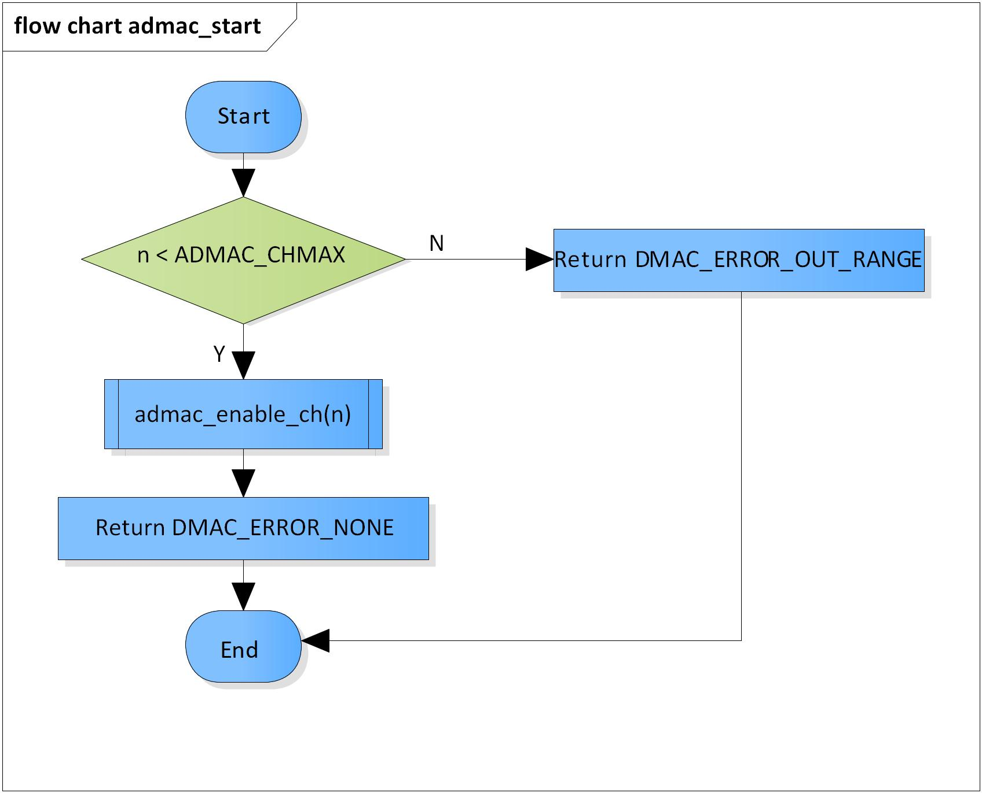

Figure 3‑11admac_start flowchart

### admac_stop

DD_PLG_RDR_07_012

|  |  |  |  |  |
| --- | --- | --- | --- | --- |
| **Syntax** | inline dmac_error_code admac_stop(ADMA_CH n) | | | |
| **Function** | This function is to stop DMAC channel N. | | | |
| **Arguments** | Type | Name | I/O | Description |
| ADMA_CH | n | I | Channel number  Valid range: [0: 31] |
| **Return value** | DMAC_ERROR_OUT_RANGE | | DMAC module is invalid | |
| DMAC_ERROR_NONE | | Normal end | |
| **Description** | * admac_stop command processing:   - Stop the DMAC channel N and clear value set on all of its registers | | | |

[Covers: FD_PLG_RDR_005, FD_PLG_RDR_014, FD_PLG_RDR_032, FD_PLG_RDR_043]

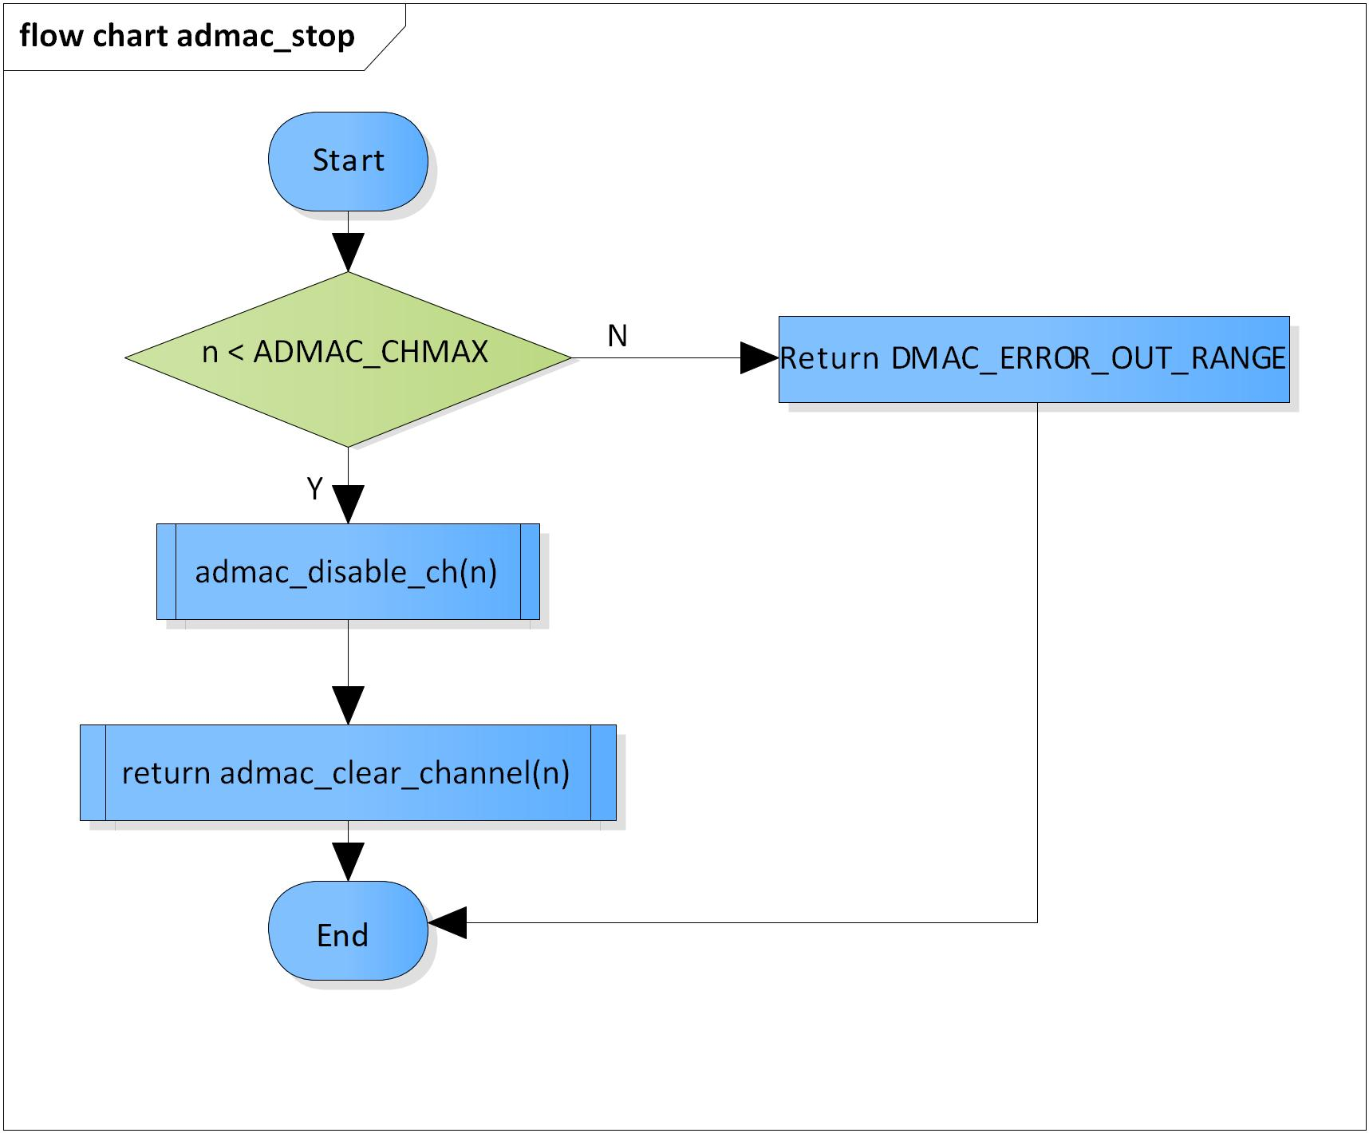

Figure 3‑12 admac_stop flowchart

### admac_descriptor_setup

DD_PLG_RDR_07_013

|  |  |  |  |  |
| --- | --- | --- | --- | --- |
| **Syntax** | static inline VOID admac_descriptor_setup(ADMA_CH n, const void *descript_mem) | | | |
| **Function** | This function is to set DMAC channel N’s descriptor. | | | |
| **Arguments** | Type | Name | I/O | Description |
| ADMA_CH | n | I | Channel number  Valid range: [0: 31] |
| const void * | descript_mem | I | Pointer to descriptor memory |
| **Return value** | None | | | |
| **Description** | * admac_descriptor_setup command processing:   - Set DMAC channel N’s descriptor | | | |

[Covers: FD_PLG_RDR_005]

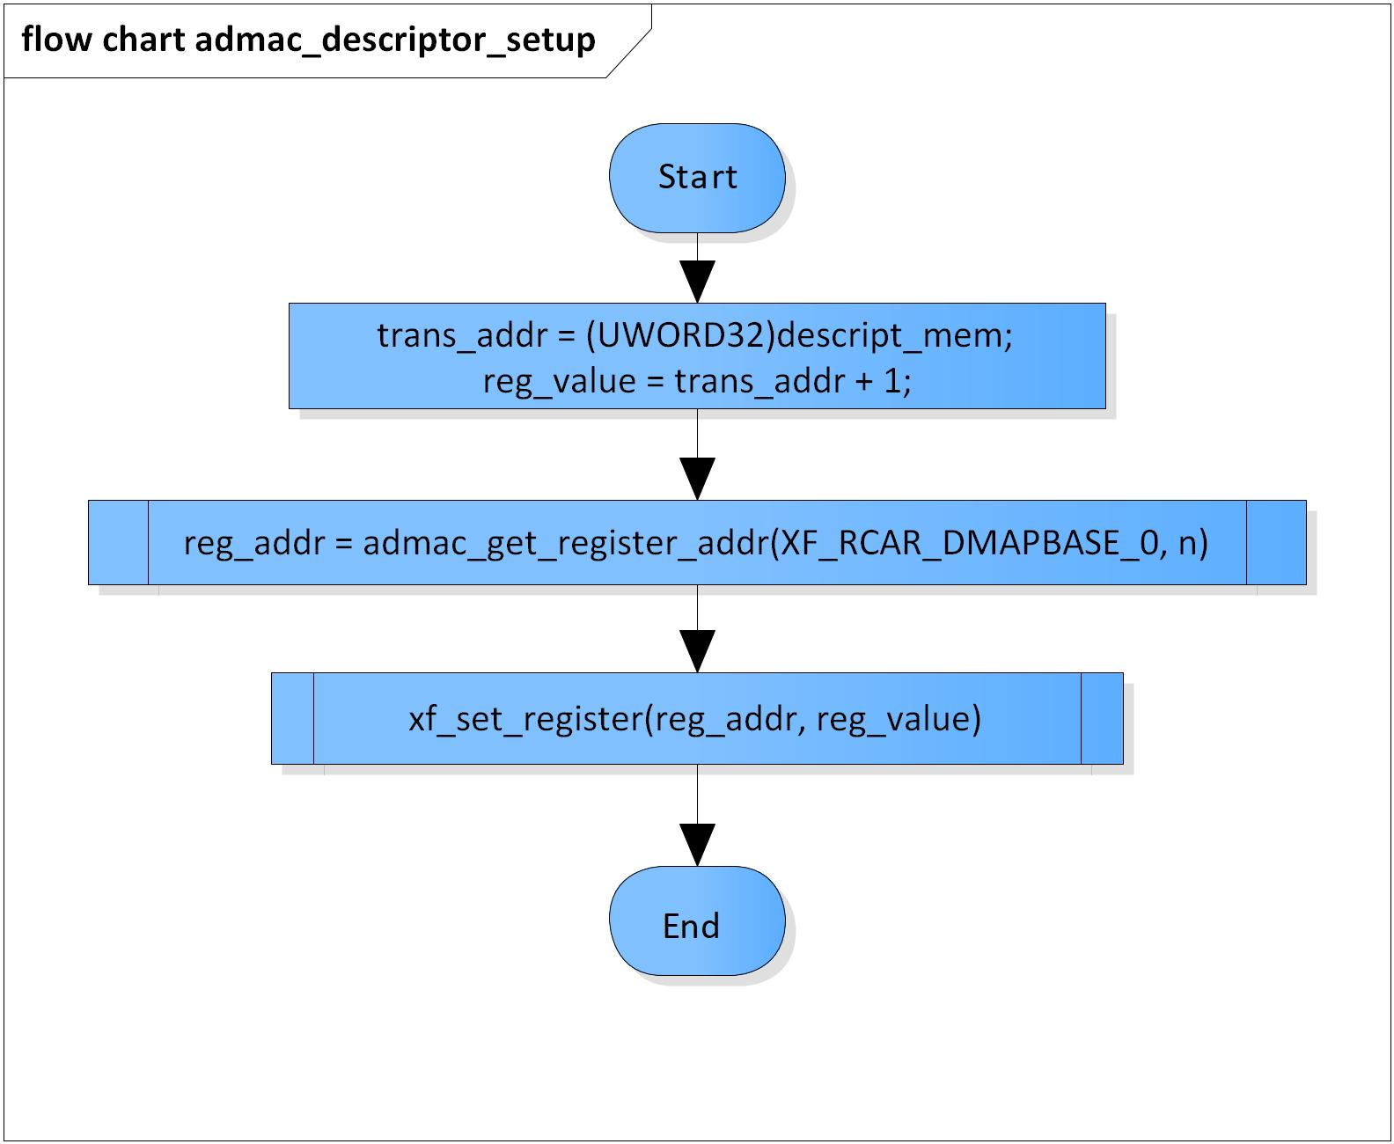

Figure 3‑13 admac_descriptor_setup flowchart

### admac_stage_config

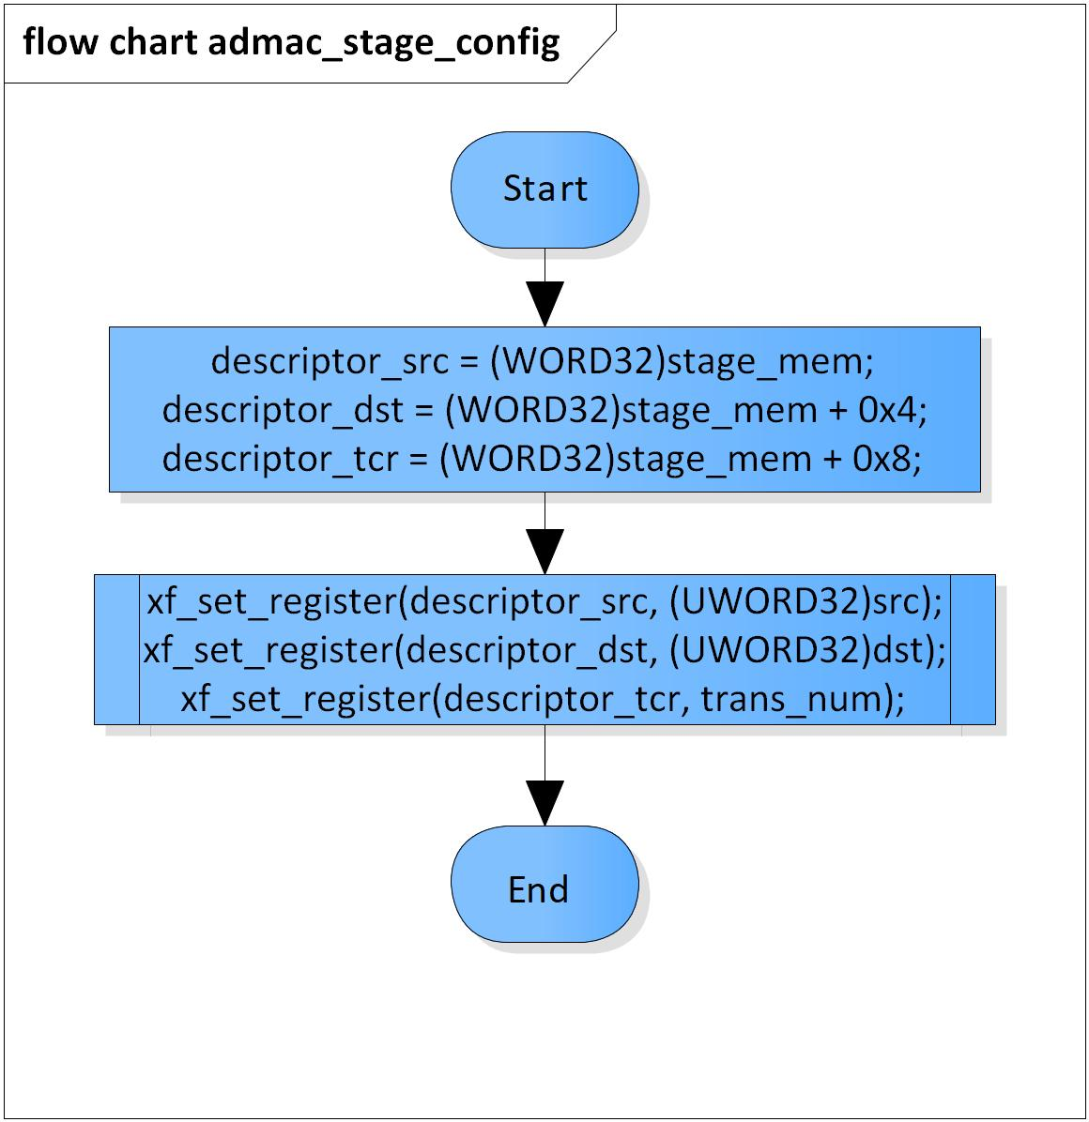DD_PLG_RDR_07_014

|  |  |  |  |  |
| --- | --- | --- | --- | --- |
| **Syntax** | static inline VOID admac_stage_config(const void *src, const void *dst, const void *stage_mem, UWORD32 trans_num) | | | |
| **Function** | This function is to set DMAC stage. | | | |
| **Arguments** | Type | Name | I/O | Description |
| const void * | src | I | Source address |
| const void * | dst | I | Destination address |
| const void * | stage_mem | I | Stage memory |
| UWORD32 | trans_num | I | Transmission number in a time |
| **Return value** | None | | | |
| **Description** | * admac_stage_config command processing:   - Set DMAC stage | | | |

[Covers: FD_PLG_RDR_005]

Figure 3‑14 admac_stage_config flowchart

### admac_pre_config

DD_PLG_RDR_07_015

|  |  |  |  |  |  |
| --- | --- | --- | --- | --- | --- |
| **Syntax** | static inline dmac_error_code admac_pre_config(ADMA_CH dma_channel, UWORD32 src_reqst, UWORD32 reqst_flag, const void *descript_mem, UWORD32 stg_num, ADMAC_MODE mode, UWORD32 transfer_size) | | | | |
| **Function** | This function is to set DMAC parameters. | | | | |
| **Arguments** | Type | Name | I/O | | Description |
| ADMA_CH | dma_channel | I | | DMAC channel  Valid range: [0: 31] |
| UWORD32 | src_reqst | I | | Source request |
| UWORD32 | reqst_flag | I | | Source or destination is requested  Valid values:  DMAC_RECEIVE_REQ  DMAC_TRANSMIT_REQ |
| const void * | descript_mem | I | | Descriptor memory address |
| UWORD32 | stg_num | I | | Stage number  Valid values: greater than zero |
| ADMAC_MODE | mode | I | | Operating mode |
| UWORD32 | transfer_size | I | | Transmission unit  Valid values: [4] |
| **Return value** | DMAC_ERROR_OUT_RANGE | | | DMAC module is invalid | |
| DMAC_ERROR_INVALID | | | Stage number is invalid  Request address is invalid  Transfer size is invalid | |
| DMAC_ERROR_NONE | | | Normal end | |
| **Description** | * admac_pre_config command processing:   - Set DMAC parameters | | | | |

[Covers: FD_PLG_RDR_005]

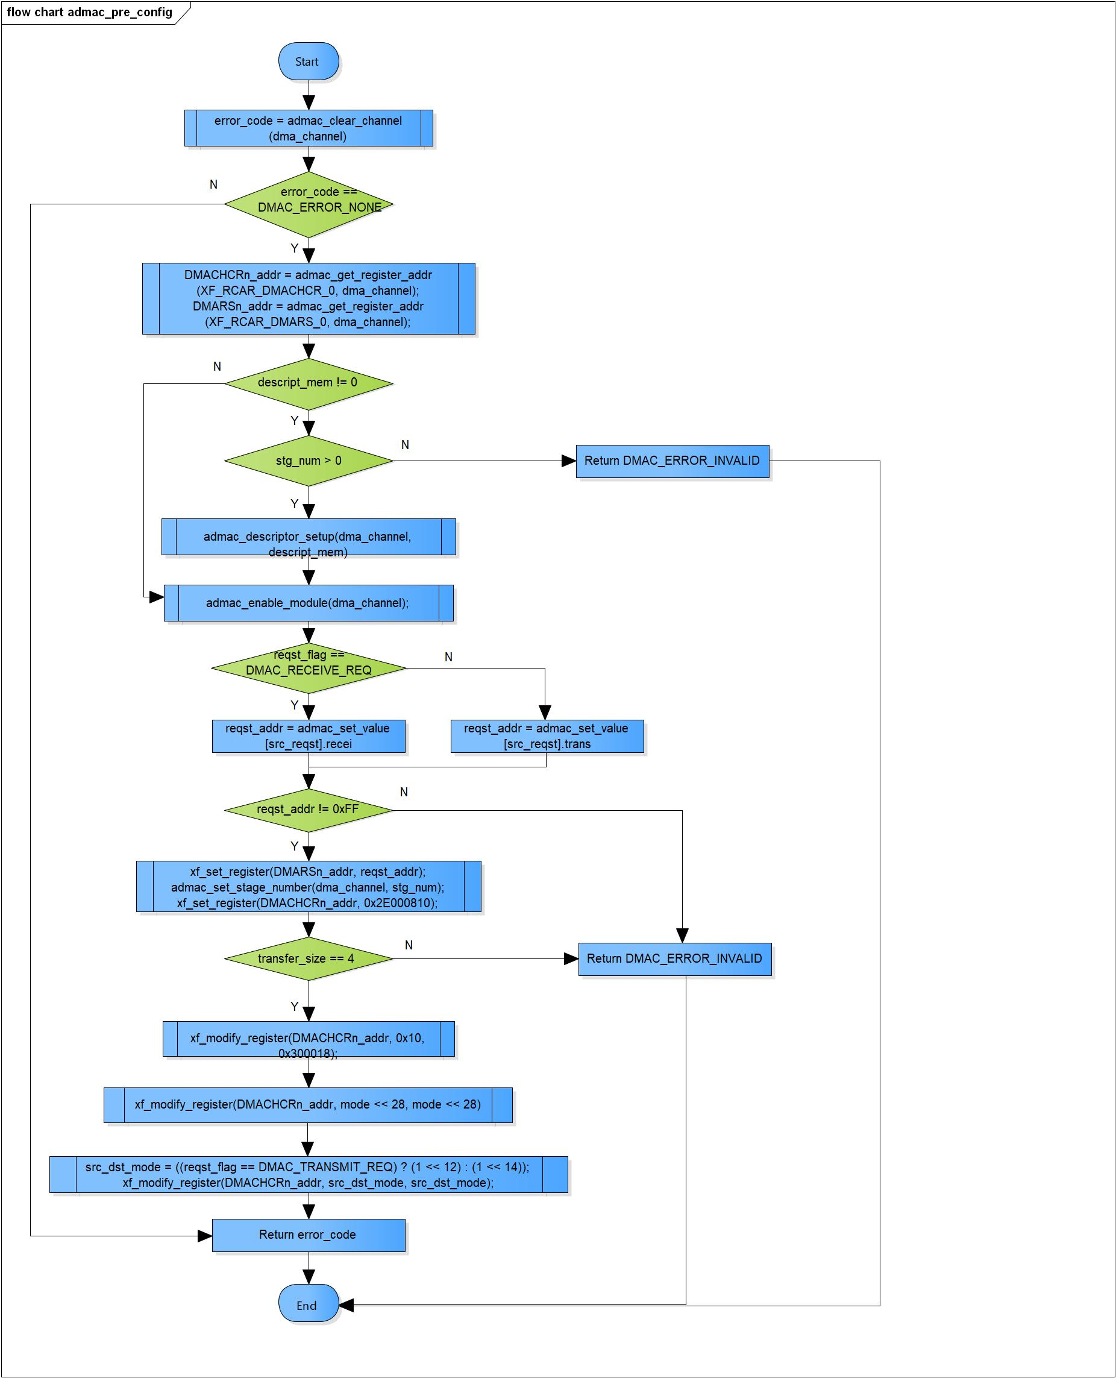

Figure 3‑15 admac_pre_config flowchart

### admac_post_config

DD_PLG_RDR_07_016

|  |  |  |  |  |
| --- | --- | --- | --- | --- |
| **Syntax** | static inline VOID admac_post_config(ADMA_CH n) | | | |
| **Function** | This function is to post set DMAC parameters for DMAC channel N | | | |
| **Arguments** | Type | Name | I/O | Description |
| ADMA_CH | n | I | Channel number  Valid range: [0: 31] |
| **Return value** | None | | | |
| **Description** | * admac_post_config command processing:   - Reset the descriptor and then start it | | | |

[Covers: FD_PLG_RDR_005]

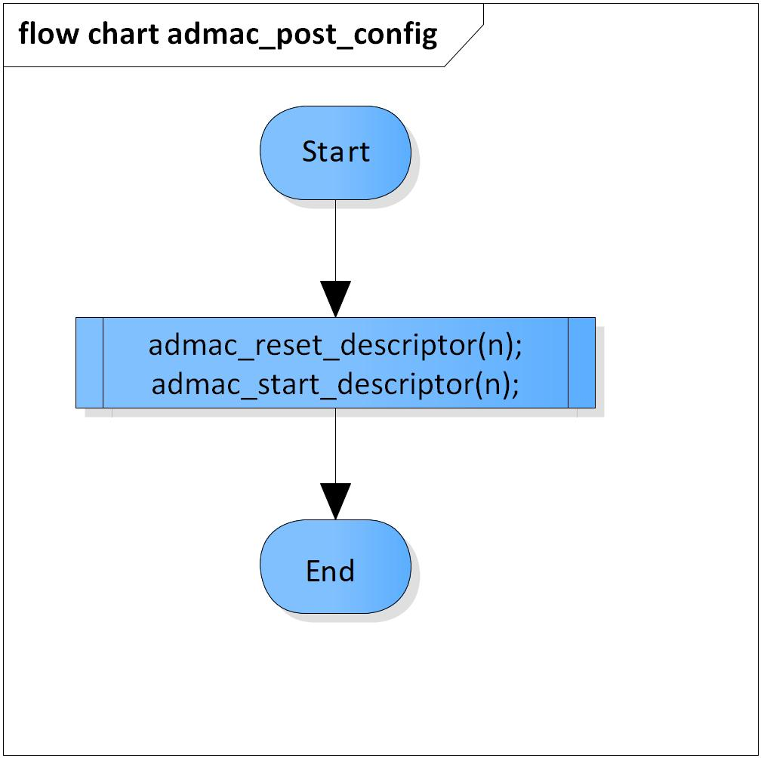

Figure 3‑16 admac_post_config flowchart

### admac_check_valid_channel

DD_PLG_RDR_07_017

|  |  |  |  |  |
| --- | --- | --- | --- | --- |
| **Syntax** | inline dmac_error_code admac_check_valid_channel(pVOID pch) | | | |
| **Function** | This function is to check availability of DMACs and choose an available one for operation. | | | |
| **Arguments** | Type | Name | I/O | Description |
| pVOID | pch | I/O | Pointer to channel of DMAC  Valid range: [0: 31] |
| **Return value** | DMAC_ERROR_OUT_RANGE | | DMAC module is invalid | |
| DMAC_ERROR_BUSY | | No available DMAC module | |
| DMAC_ERROR_NONE | | Normal end | |
| **Description** | * admac_check_valid_channel command processing:   - Check availability of DMACs  - Choose an available one for operation | | | |

[Covers: FD_PLG_RDR_005]

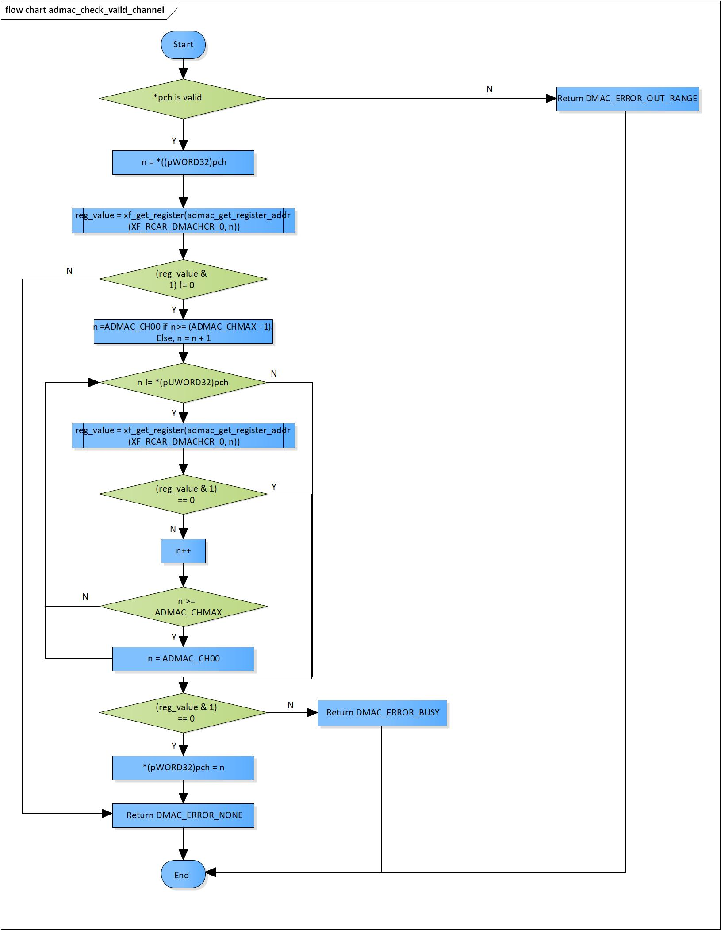

Figure 3‑17 admac_check_valid_channel flowchart

### admac_setting_use_descriptor

DD_PLG_RDR_07_018

|  |  |  |  |  |
| --- | --- | --- | --- | --- |
| **Syntax** | inline dmac_error_code admac_setting_use_descriptor(const DMAC_SETTING *dmac_set) | | | |
| **Function** | This function is to set DMAC module using descriptor memory. | | | |
| **Arguments** | Type | Name | I/O | Description |
| const DMAC_SETTING * | dmac_set | I | Pointer to DMAC parameter structure |
| **Return value** | Error returned from function admac_pre_config if failed | | | |
| **Description** | * admac_setting_use_descriptor command processing:   - Pre set up DMAC module  - Set up all stages based on transmission mode  - Post set up DMAC module | | | |

[Covers: FD_PLG_RDR_005]

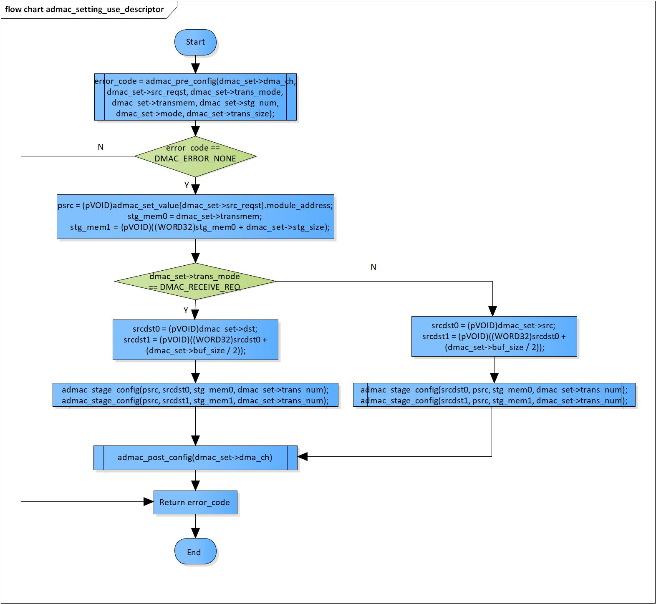

Figure 3‑18 admac_setting_use_descriptor flowchart

### admac_setting_nouse_descriptor

DD_PLG_RDR_07_019

|  |  |  |  |  |
| --- | --- | --- | --- | --- |
| **Syntax** | inline dmac_error_code admac_setting_nouse_descriptor(const DMAC_SETTING *dmac_set) | | | |
| **Function** | This function is to set DMAC module without using descriptor memory. | | | |
| **Arguments** | Type | Name | I/O | Description |
| const DMAC_SETTING * | dmac_set | I | Pointer to DMAC parameter structure |
| **Return value** | DMAC_ERROR_OUT_RANGE | | Cannot clear value in DMAC’s registers  Cannot enable DMAC module | |
| DMAC_ERROR_NONE | | Normal end | |
| **Description** | * admac_setting_nouse_descriptor command processing:   - Set necessary registers for ADMAC not using descriptor memory | | | |

[Covers: FD_PLG_RDR_005]

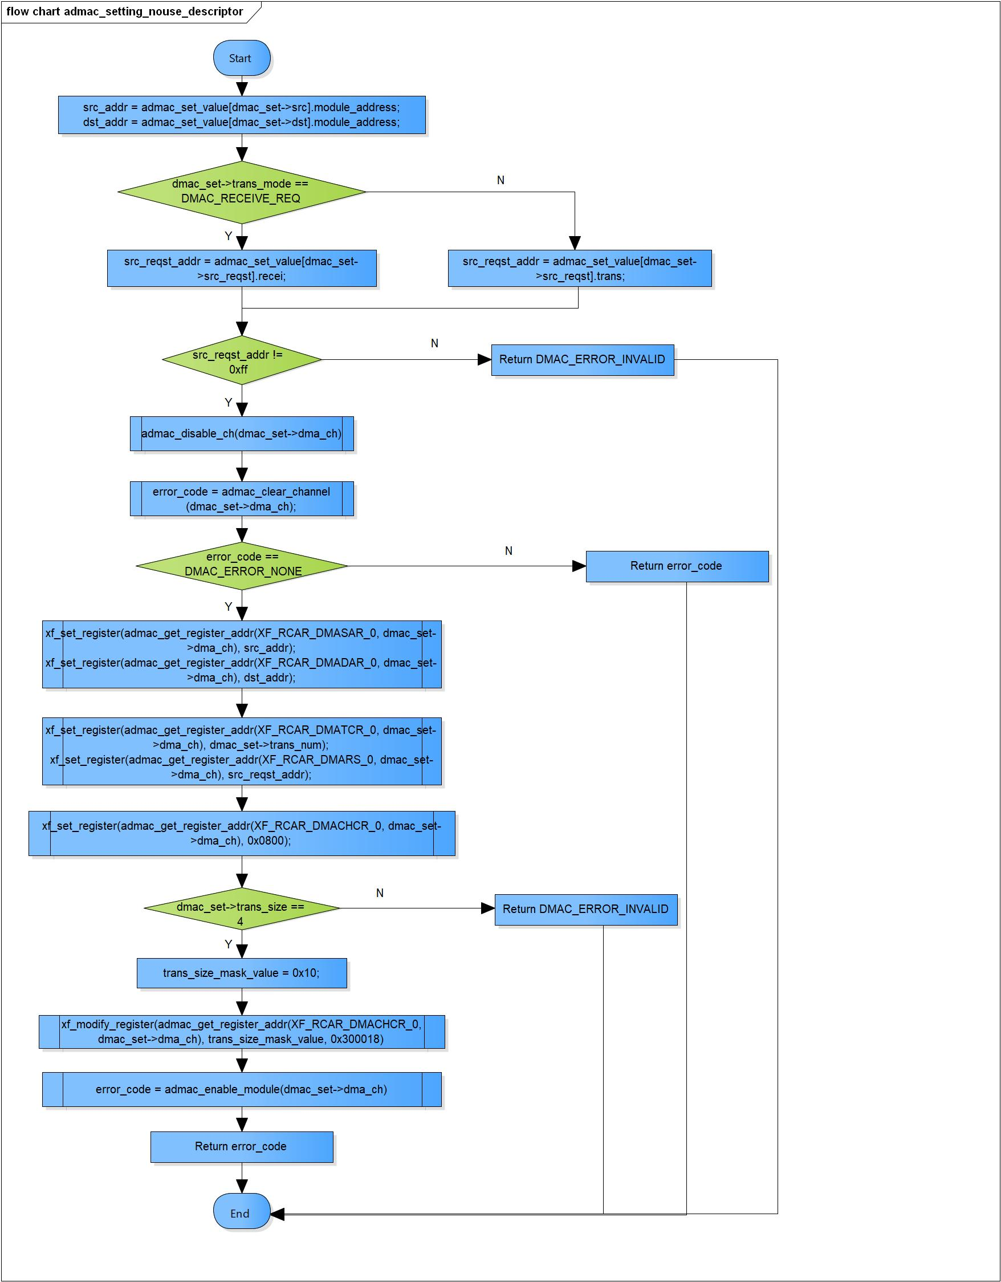Figure 3‑19 admac_setting_nouse_descriptor flowchart

### admac_resetup

DD_PLG_RDR_07_020

|  |  |  |  |  |  |
| --- | --- | --- | --- | --- | --- |
| **Syntax** | inline dmac_error_code admac_resetup(DMAC_SETTING dmac_set)s | | | | |
| **Function** | This function is to re-setup DMAC module. | | | | |
| **Arguments** | Type | Name | I/O | | Description |
| DMAC_SETTING | dmac_set | I | | DMAC parameter structure |
| **Return value** | DMAC_ERROR_OUT_RANGE | | | Cannot enable DMAC module | |
| DMAC_ERROR_NONE | | | Normal end | |
| **Description** | * admac_resetup command processing:   - Re-setup DMAC module | | | | |

[Covers: FD_PLG_RDR_015, FD_PLG_RDR_017]

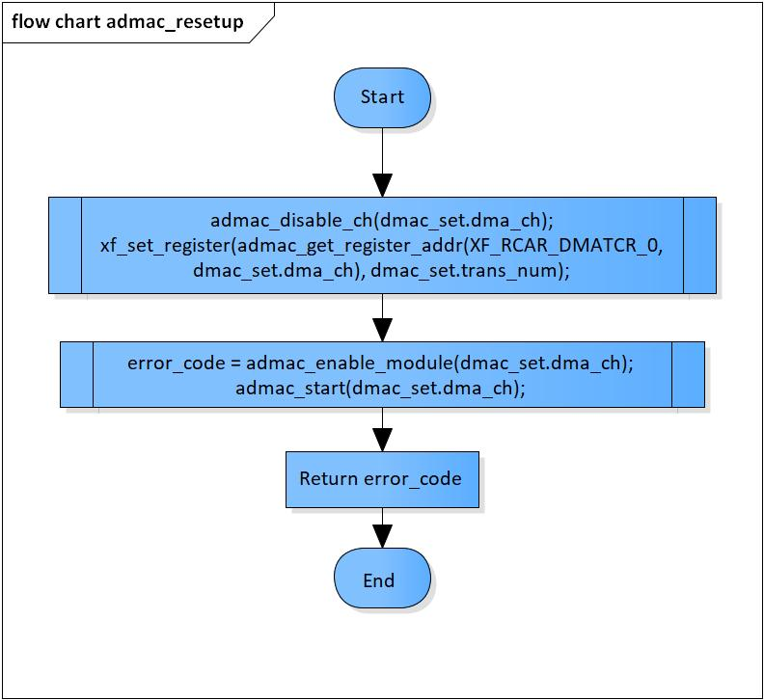

Figure 3‑20 admac_resetup flowchart

### admac_pause

DD_PLG_RDR_07_021

|  |  |  |  |  |
| --- | --- | --- | --- | --- |
| **Syntax** | VOID admac_pause(ADMA_CH n) | | | |
| **Function** | This function is to pause DMAC channel N | | | |
| **Arguments** | Type | Name | I/O | Description |
| ADMA_CH | n | I | Channel number  Valid range: [0: 31] |
| **Return value** | None | | | |
| **Description** | * admac_pause command processing:   - Disable DMAC channel N | | | |

[Covers: FD_PLG_RDR_014, FD_PLG_RDR_032, FD_PLG_RDR_043]

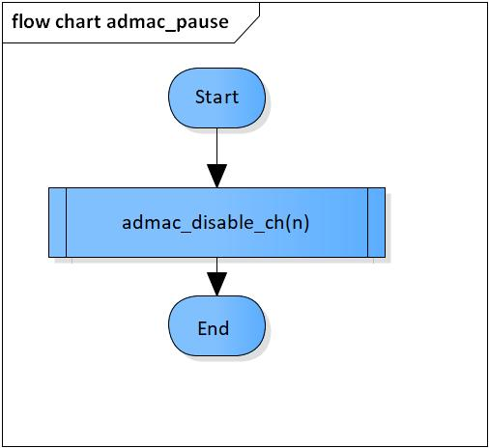

Figure 3‑21 admac_pause flowchart

# Revision history

|  |  |  |  |  |  |
| --- | --- | --- | --- | --- | --- |
| **Version** | **Date** | **Page** | **Content** | **Approved** | **Changed** |
| 1.0.0 | Nov 14 2018 | - | First Edition issued | Vu Phan | Vu Phan |
| 1.1.0 | Dec 10 2018 | - | Add traceability ID | Vu Phan | Ngu Pham |
| 1.2.0 | Jan 03, 2019 | - | Add range for input parameters | Vu Phan | Tien Tran |
| 1.3.0 | Mar 20, 2019 | 33, 34 | Modify transfer size correct to swap channel issue |  | Ngu Pham |