**Document Type: Detail Design**

**Document Name:**

**ADSP FRAMEWORK: FIFO DRIVER**

Renesas Electronics Corporation

Renesas Design Vietnam Co. Ltd

R-Car Software Solution 2 Group

Middleware 1 Team

Table of Contents

1. Overview 3

2. Function list 4

3. Detail information 5

3.1 Data type definition 5

3.1.1 fifo_modules 5

3.1.2 fifo_error_code 5

3.1.3 fifo_type 5

3.1.4 FIFO_PARAM 6

3.2 Macro definition 7

3.3 Register definition 8

3.4 Function definition 10

3.4.1 fifo_disable 10

3.4.2 fifo_enable 12

3.4.3 fifo_config 14

3.4.4 fifo_get_int_num 18

3.4.5 fifo_register_interrupt_handler 19

3.4.6 fifo_unregister_interrupt_handler 21

3.4.7 fifo_disable_interrupt 23

3.4.8 fifo_enable_interrupt 25

3.4.9 fifo_clear_interrupt 27

3.4.10 fifo_stop 29

3.4.11 fifo_check_available 31

4. Revision history 33

List of Figures

Figure 1‑1 The software architecture 3

Figure 3‑1 fifo_disable flowchart 11

Figure 3‑2 fifo_enable flowchart 13

Figure 3‑3 fifo_config flowchart 17

Figure 3‑4 fifo_get_int_num flowchart 18

Figure 3‑5 fifo_register_interrupt_handler flowchart 20

Figure 3‑6 fifo_unregister_interrupt_handler flowchart 22

Figure 3‑7 fifo_disable_interrupt flowchart 24

Figure 3‑8 fifo_enable_interrupt flowchart 26

Figure 3‑9 fifo_clear_interrupt flowchart 28

Figure 3‑10 fifo_stop flowchart 30

Figure 3‑11 fifo_check_available flowchart 32

List of Table

Table 2‑1 Function list 4

Table 3‑1 fifo_modules type information 5

Table 3‑2 fifo_error_code type information 5

Table 3‑3 fifo_type type information 5

Table 3‑4 FIFO_PARAM type information 6

Table 3‑5 Setting registers OF_EN and IF_EN to disable FIFO 10

Table 3‑6 Setting registers OF_EN and IF_EN to enable FIFO 12

Table 2‑1 Function list 4

Table 3‑1 fifo_modules type information 5

Table 3‑2 fifo_error_code type information 5

Table 3‑3 fifo_type type information 5

Table 3‑4 FIFO_PARAM type information 6

Table 3‑5 Setting registers OF_EN and IF_EN to disable FIFO 10

Table 3‑6 Setting registers OF_EN and IF_EN to enable FIFO 12

# Overview

This section provides an overview of software architecture.

User Application

ADSP Interface

Kernel Space

User Space

ADSP Driver

ARM

Audio HW

**ADSP Framework**

TDM class

Renderer class

Equalizer class

Capture class

TDM Plugin

ADSP

Plugin

Equalizer Plugin*

Capture Plugin

Renderer Plugin

This document’s target is in side of red square

* not connect to hardware modules

DAC/

ADC

FIFO

SCU

PDMA

SSI

SSIU

ADMA

Figure 1‑1 ****The software architecture****

# Function list

The following is list of functions:

Table 2‑1 Function list

|  |  |  |
| --- | --- | --- |
| **Type** | **Function Name** | **Outline** |
| API | fifo_enable | This API is to enable the input/output of FIFO |
| fifo_disable | This API is to disable the input/output of FIFO |
| fifo_config | This API is to set up registers necessary for FIFO module execution |
| fifo_register_interrupt_handler | This API is to register interrupt handler for FIFO |
| fifo_unregister_interrupt_handler | This API is to unregister interrupt handler for FIFO |
| fifo_disable_interrupt | This API is to disable FIFO interrupt |
| fifo_enable_interrupt | This API is to enable FIFO interrupt |
| fifo_clear_interrupt | This API is to clear FIFO interrupt |
| fifo_stop | This API is to stop FIFO operation |
| fifo_check_available | This API is to check availability of FIFO module and choose an available one |
| Internal function | fifo_get_int_num | This function is to get the interrupt number |

# Detail information

This section describes detail information of data types, macro definitions, implemented APIs and internal function units, global variable.

## Data type definition

### fifo_modules

The data type fifo_modules is a type-defined enumeration that lists all supported FIFO modules.

Table 3‑1 fifo_modules type information

|  |  |  |
| --- | --- | --- |
| **Member name** | **Value** | **Outline** |
| FIFO0 | 0 | 1st FIFO |
| FIFO1 | 1 | 2nd FIFO |
| FIFO2 | 2 | 3rd FIFO |
| FIFO3 | 3 | 4th FIFO |
| FIFOMAX | 4 | Number of FIFO modules |

### fifo_error_code

The data type fifo_error_code is a type-defined enumeration that lists all error codes for FIFO.

Table 3‑2 fifo_error_code type information

|  |  |
| --- | --- |
| **Member name** | **Value** |
| FIFO_ERROR_NONE | 0 |
| FIFO_ERROR_INVALID | -1 |
| FIFO_ERROR_INTERNAL | -2 |
| FIFO_ERROR_BUSY | -3 |
| FIFO_ERROR_OUT_RANGE | -4 |

### fifo_type

The data type fifo_type is a type-defined enumeration of indicators of whether FIFO’s input or output is used.

Table 3‑3 fifo_type type information

|  |  |  |
| --- | --- | --- |
| **Member name** | **Value** | **Outline** |
| FIFO_INPUT | 0 | FIFO input is used |
| FIFO_OUTPUT | 1 | FIFO output is used |

### FIFO_PARAM

The data type FIFO_PARAM is a type-defined structure that possesses necessary parameters for FIFO module.

Table 3‑4 FIFO_PARAM type information

|  |  |  |
| --- | --- | --- |
| **Member name** | **Data type** | **Outline** |
| channel | UWORD32 | channel of data used for FIFO module |
| pcm_width | UWORD32 | PCM width of data used for FIFO module |
| sample_rate | UWORD32 | Sampling rate of data used for FIFO module |
| fifo_num | fifo_modules | FIFO module |
| type | fifo_type | FIFO type |
| dev_connect | UWORD32 | Indicator to show which module FIFO connects |

## Macro definition

|  |  |  |
| --- | --- | --- |
| **Macros** | **Value** | **Outline** |
| XA_FIFO_FULL | 1024 | FIFO full size |
| XA_FIFO_NEARFULL | 768 | FIFO nearly full size |
| XA_FIFO_NEAREMPTY | 64 | FIFO nearly empty size |
| XA_FIFO_EMPTY | 0 | FIFO empty size |
| XA_FIFO_CONNECT_SRC | 0 | FIFO is connected to SRC |
| XA_FIFO_CONNECT_SSI | 1 | FIFO is connected to SSI |

## Register definition

Below is the table listing all items that are macros representing register addresses located in repository s492d/include/sys/xt-shmem/board-rcar/xf-registers.h

|  |  |
| --- | --- |
| **Register** | **Outline** |
| XF_RCAR_REG_OF_EN | Register OF_EN |
| XF_RCAR_REG_IF_EN | Register IF_EN |
| XF_RCAR_REG_ADSP_TIMSEL | ADSP Output Timing Select Register |
| XF_RCAR_REG_ADSP_TIMSEL1 | ADSP Output Timing Select Register 1 |
| XF_RCAR_REG_ADSP_TIMSEL2 | ADSP Output Timing Select Register 2 |
| XF_RCAR_REG_ADSP_TIMSEL3 | ADSP Output Timing Select Register 3 |
| XF_RCAR_REG_OF_MSTP | Output FIFO Module Stop Register |
| XF_RCAR_REG_OF_PTRRST | Output FIFO Pointer Reset Register |
| XF_RCAR_REG_OF0_CH | Output FIFO0 Channel Register |
| XF_RCAR_REG_OF1_CH | Output FIFO1 Channel Register |
| XF_RCAR_REG_OF2_CH | Output FIFO2 Channel Register |
| XF_RCAR_REG_OF3_CH | Output FIFO3 Channel Register |
| XF_RCAR_REG_OF_ADINR | Output FIFO0 Audio Information Register |
| XF_RCAR_REG_OF1_ADINR | Output FIFO1 Audio Information Register |
| XF_RCAR_REG_OF2_ADINR | Output FIFO2 Audio Information Register |
| XF_RCAR_REG_OF3_ADINR | Output FIFO3 Audio Information Register |
| XF_RCAR_REG_OF0_INT_TH | Output FIFO0 Interrupt Threshold Register |
| XF_RCAR_REG_OF1_INT_TH | Output FIFO1 Interrupt Threshold Register |
| XF_RCAR_REG_OF2_INT_TH | Output FIFO2 Interrupt Threshold Register |
| XF_RCAR_REG_OF3_INT_TH | Output FIFO3 Interrupt Threshold Register |
| XF_RCAR_REG_OF_INT_CLR | Output FIFO Interrupt Clear Register |
| XF_RCAR_REG_IF_MSTP | Input FIFO Module Stop Register |
| XF_RCAR_REG_IF_PTRRST | Input FIFO Pointer Reset Register |
| XF_RCAR_REG_IF0_CH | Input FIFO0 Channel Register |
| XF_RCAR_REG_IF1_CH | Input FIFO1 Channel Register |
| XF_RCAR_REG_IF2_CH | Input FIFO2 Channel Register |
| XF_RCAR_REG_IF3_CH | Input FIFO3 Channel Register |
| XF_RCAR_REG_IF_ADINR | Input FIFO0 Audio Information Register |
| XF_RCAR_REG_IF1_ADINR | Input FIFO1 Audio Information Register |
| XF_RCAR_REG_IF2_ADINR | Input FIFO2 Audio Information Register |
| XF_RCAR_REG_IF3_ADINR | Input FIFO3 Audio Information Register |
| XF_RCAR_REG_IF0_INT_TH | Input FIFO0 Interrupt Threshold Register |
| XF_RCAR_REG_IF1_INT_TH | Input FIFO1 Interrupt Threshold Register |
| XF_RCAR_REG_IF2_INT_TH | Input FIFO2 Interrupt Threshold Register |
| XF_RCAR_REG_IF3_INT_TH | Input FIFO3 Interrupt Threshold Register |
| XF_RCAR_REG_IF_INT_CLR | Input FIFO Interrupt Clear Register |

## Function definition

### fifo_disable

DD_PLG_RDR_06_001

|  |  |  |  |  |
| --- | --- | --- | --- | --- |
| **Syntax** | inline fifo_error_code fifo_disable(fifo_modules fifo_num, fifo_type type) | | | |
| **Function** | This function is to disable the input/output of FIFO. | | | |
| **Arguments** | Type | Name | I/O | Description |
| fifo_modules | fifo_num | I | FIFO module  Valid range: [0: 3] |
| fifo_type | type | I | FIFO uses its input or output  Valid values:  FIFO_OUTPUT  FIFO_INPUT |
| **Return value** | FIFO_ERROR_OUT_RANGE | | FIFO module is invalid | |
| FIFO_ERROR_INVALID | | FIFO type is neither FIFO_INPUT nor FIFO_OUTPUT | |
| FIFO_ERROR_NONE | | Normal end | |
| **Description** | * fifo_disable command processing:   - Set either register OF_EN or IF_EN based on FIFO type | | | |

[Covers: FD_PLG_RDR_005, FD_PLG_RDR_014, FD_PLG_RDR_032, FD_PLG_RDR_043]

Table 3‑5 Setting registers OF_EN and IF_EN to disable FIFO

|  |  |  |  |  |
| --- | --- | --- | --- | --- |
| **fifo_num** | **type** | **Register** | **Bit** | **Value** |
| FIFO0 | FIFO_OUTPUT | XF_RCAR_REG_OF_EN | 0 | 0 |
| FIFO_INPUT | XF_RCAR_REG_IF_EN | 0 | 0 |
| FIFO1 | FIFO_OUTPUT | XF_RCAR_REG_OF_EN | 1 | 0 |
| FIFO_INPUT | XF_RCAR_REG_IF_EN | 1 | 0 |
| FIFO2 | FIFO_OUTPUT | XF_RCAR_REG_OF_EN | 2 | 0 |
| FIFO_INPUT | XF_RCAR_REG_IF_EN | 2 | 0 |
| FIFO3 | FIFO_OUTPUT | XF_RCAR_REG_OF_EN | 3 | 0 |
| FIFO_INPUT | XF_RCAR_REG_IF_EN | 3 | 0 |

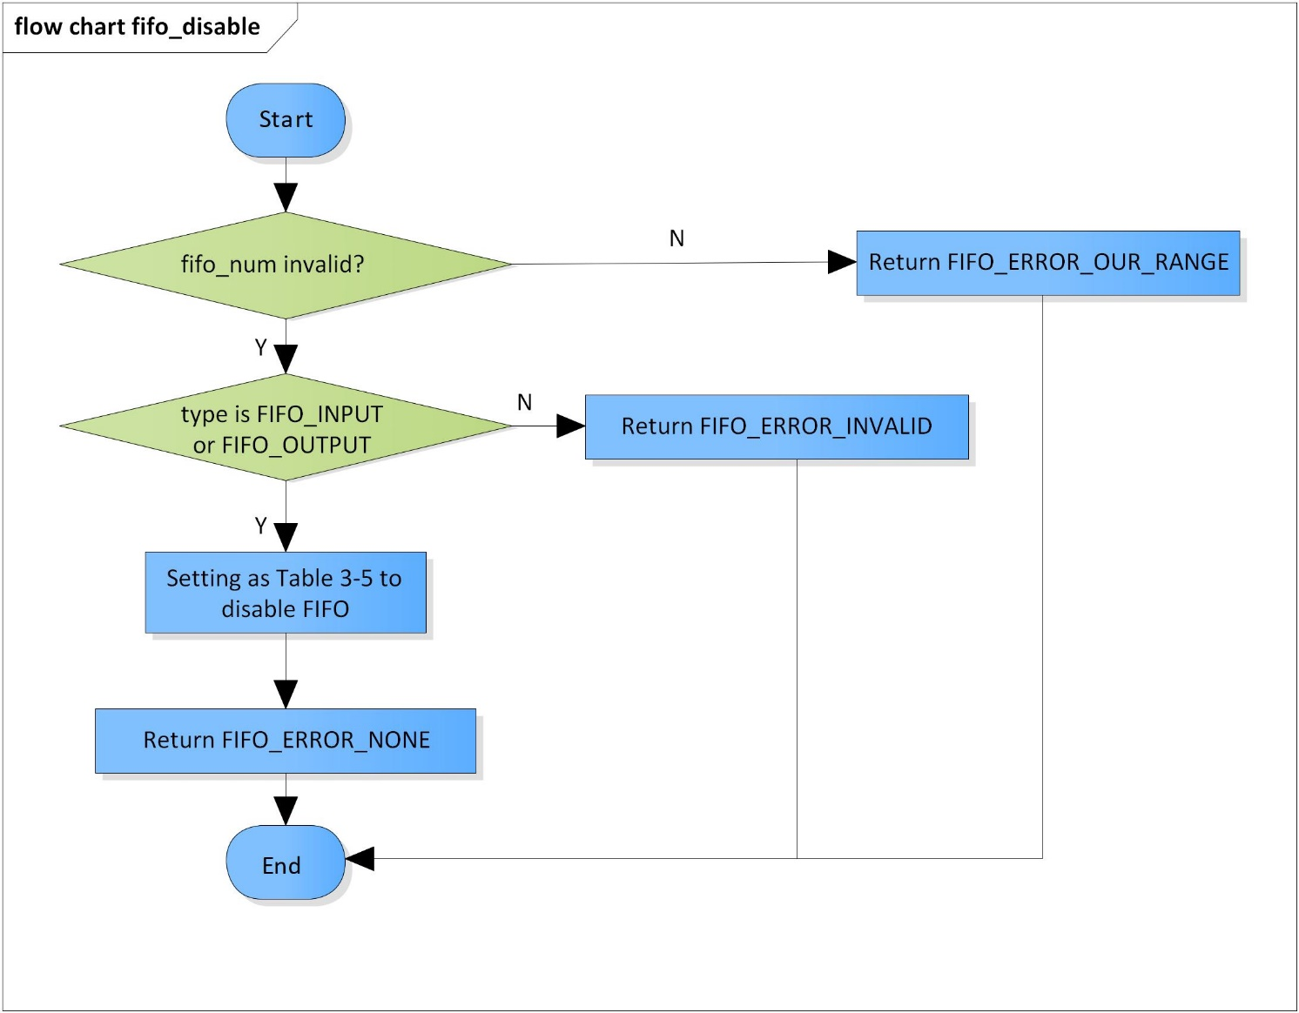Figure 3‑1 fifo_disable flowchart

### fifo_enable

DD_PLG_RDR_06_002

|  |  |  |  |  |
| --- | --- | --- | --- | --- |
| **Syntax** | inline fifo_error_code fifo_enable(fifo_modules fifo_num, fifo_type type) | | | |
| **Function** | This function is to enable the input/output of FIFO. | | | |
| **Arguments** | Type | Name | I/O | Description |
| fifo_modules | fifo_num | I | FIFO module  Valid range: [0: 3] |
| fifo_type | type | I | FIFO uses its input or output  Valid values:  FIFO_OUTPUT  FIFO_INPUT |
| **Return value** | FIFO_ERROR_OUT_RANGE | | FIFO module is invalid | |
| FIFO_ERROR_INVALID | | FIFO type is neither FIFO_INPUT nor FIFO_OUTPUT | |
| FIFO_ERROR_NONE | | Normal end | |
| **Description** | * fifo_enable command processing:   - Set either register OF_EN or IF_EN based on FIFO type | | | |

[Covers: FD_PLG_RDR_005, FD_PLG_RDR_014, FD_PLG_RDR_032, FD_PLG_RDR_043]

Table 3‑6 Setting registers OF_EN and IF_EN to enable FIFO

|  |  |  |  |  |
| --- | --- | --- | --- | --- |
| **fifo_num** | **type** | **Register** | **Bit** | **Value** |
| FIFO0 | FIFO_OUTPUT | XF_RCAR_REG_OF_EN | 0 | 1 |
| FIFO_INPUT | XF_RCAR_REG_IF_EN | 0 | 1 |
| FIFO1 | FIFO_OUTPUT | XF_RCAR_REG_OF_EN | 1 | 1 |
| FIFO_INPUT | XF_RCAR_REG_IF_EN | 1 | 1 |
| FIFO2 | FIFO_OUTPUT | XF_RCAR_REG_OF_EN | 2 | 1 |
| FIFO_INPUT | XF_RCAR_REG_IF_EN | 2 | 1 |
| FIFO3 | FIFO_OUTPUT | XF_RCAR_REG_OF_EN | 3 | 1 |
| FIFO_INPUT | XF_RCAR_REG_IF_EN | 3 | 1 |

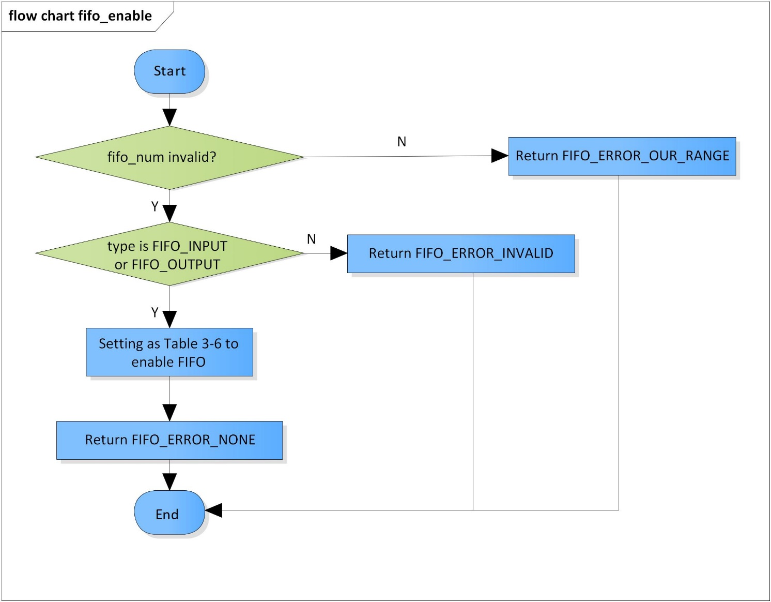

Figure 3‑2 fifo_enable flowchart

### fifo_config

DD_PLG_RDR_06_003

|  |  |  |  |  |
| --- | --- | --- | --- | --- |
| **Syntax** | inline fifo_error_code fifo_config(FIFO_PARAM fifo_param) | | | |
| **Function** | This function is to set up registers necessary for FIFO module execution. | | | |
| **Arguments** | Type | Name | I/O | Description |
| FIFO_PARAM | fifo_param | I | Struct of parameters of FIFO |
| **Return value** | FIFO_ERROR_OUT_RANGE | | FIFO module is invalid | |
| FIFO_ERROR_INVALID | | FIFO type is invalid  Channel is invalid  PCM width is invalid  Sampling rate is invalid when FIFO type is FIFO_OUTPUT  FIFO is not connected to and hardware module when FIFO type is FIFO_OUTPUT | |
| FIFO_ERROR_NONE | | Normal end | |
| **Description** | * fifo_config command processing:   - Set registers SSI_BUSIF_MODE, SSI_BUSIF_ADINR, SSI mode register | | | |

[Covers: FD_PLG_RDR_005]

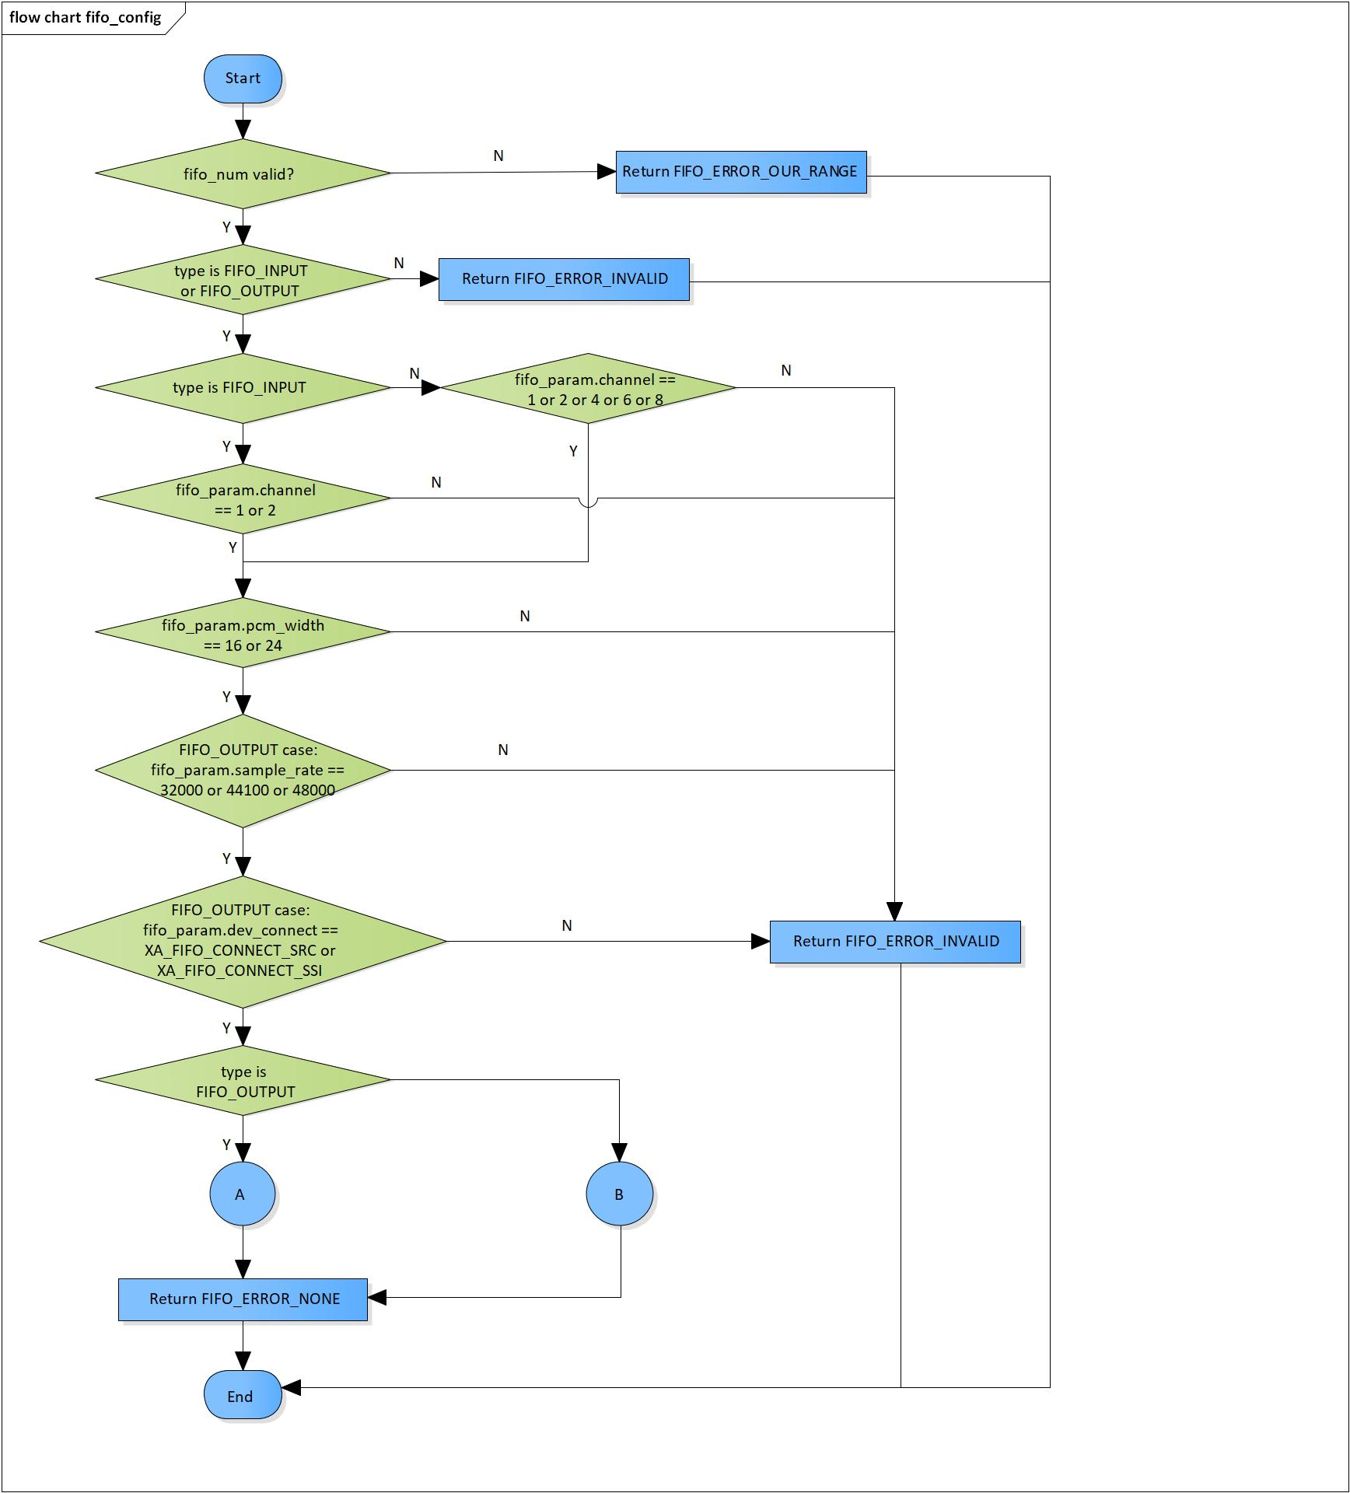

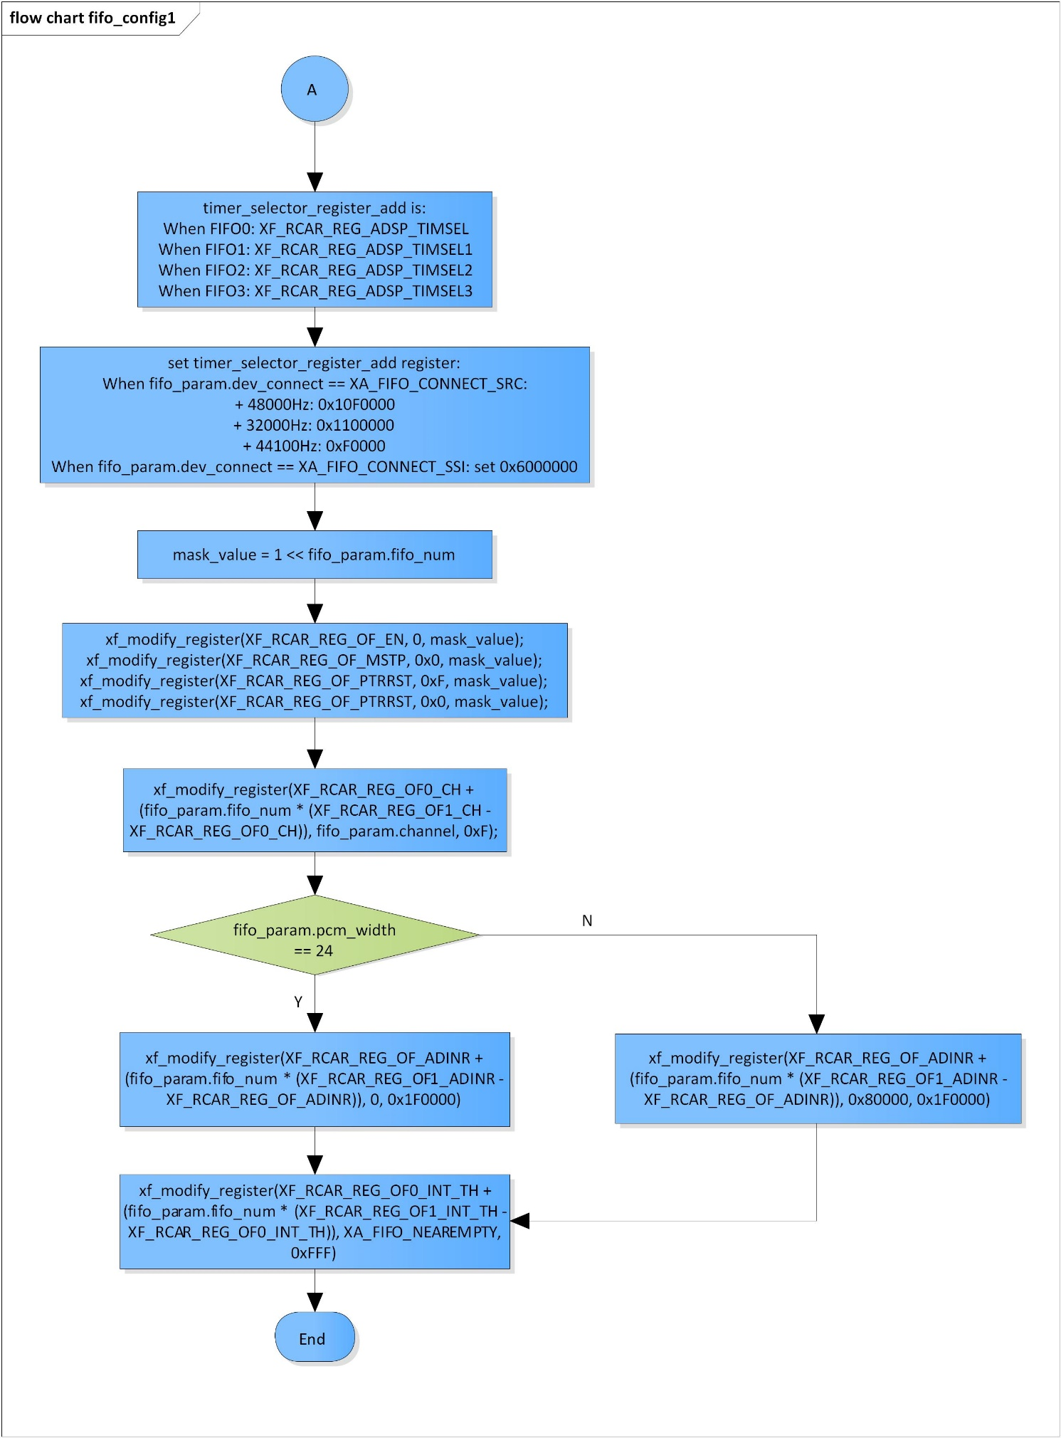

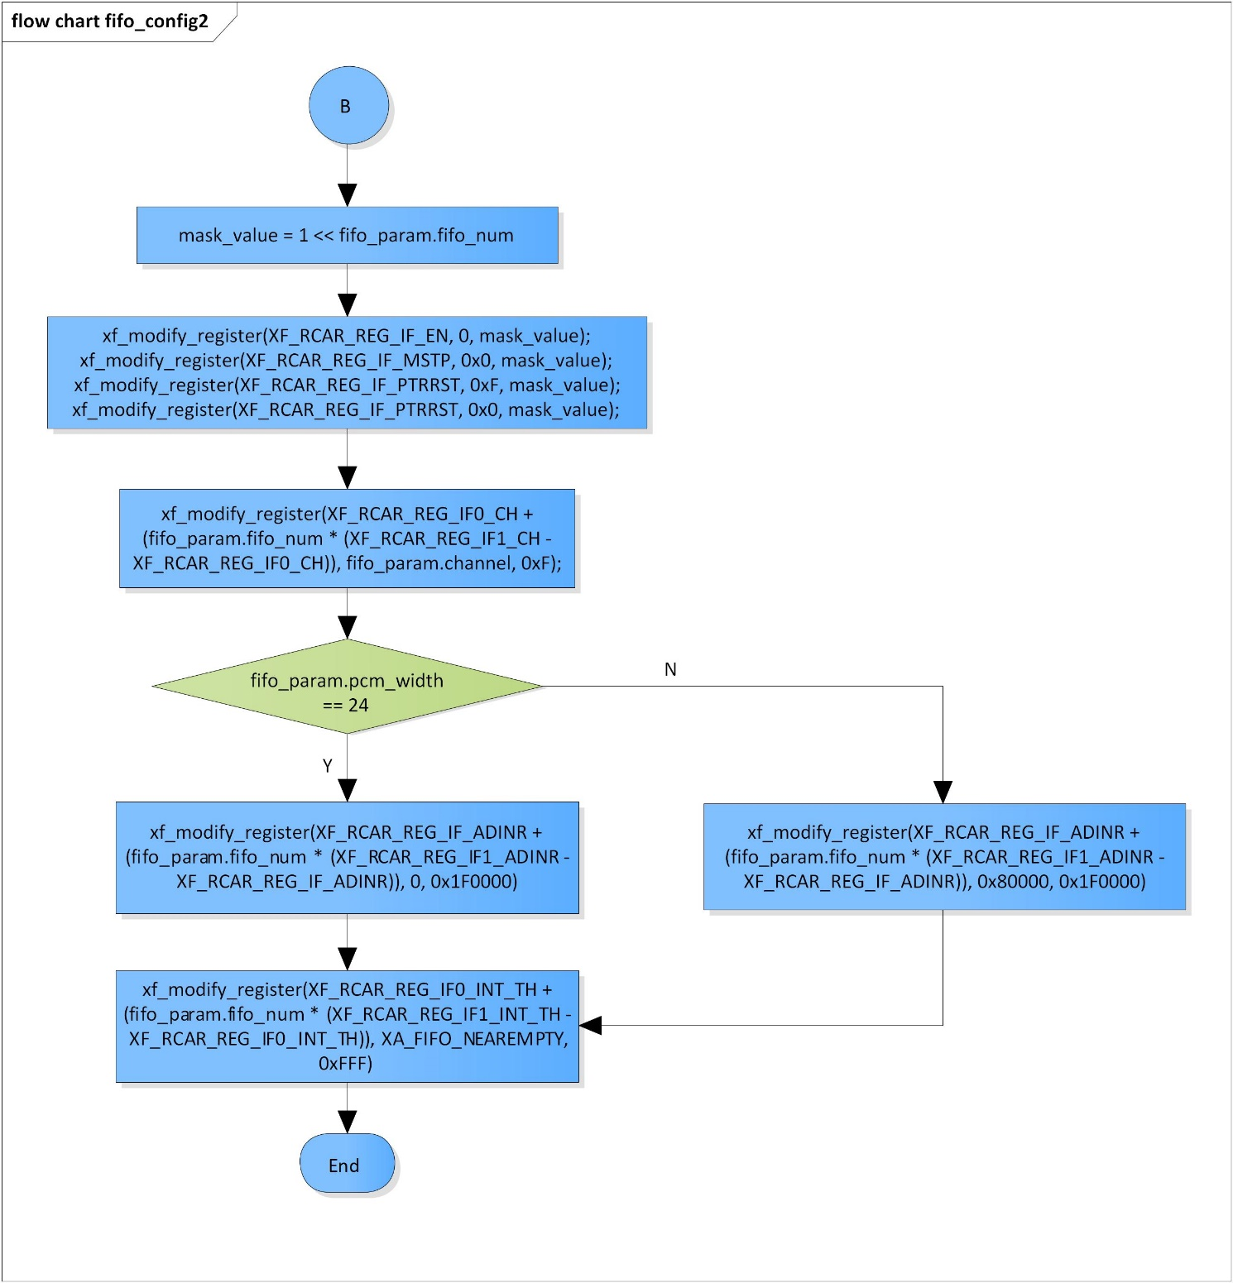

Figure 3‑3 fifo_config flowchart

### fifo_get_int_num

DD_PLG_RDR_06_004

|  |  |  |  |  |
| --- | --- | --- | --- | --- |
| **Syntax** | static inline fifo_error_code fifo_get_int_num(fifo_modules module, fifo_type type, pUWORD32 num) | | | |
| **Function** | This function is to get the interrupt number of FIFO module. | | | |
| **Arguments** | Type | Name | I/O | Description |
| fifo_modules | fifo_num | I | FIFO module  Valid range: [0: 3] |
| fifo_type | type | I | FIFO type  Valid values:  FIFO_OUTPUT  FIFO_INPUT |
| pUWORD32 | num | I/O | Interrupt number |
| **Return value** | FIFO_ERROR_NONE | | Normal end | |
| **Description** | * fifo_get_int_num command processing:   - Get interrupt number based on FIFO module and its type (FIFO_INPUT or FIFO_OUTPUT) | | | |

[Covers: FD_PLG_RDR_005, FD_PLG_RDR_014, FD_PLG_RDR_032, FD_PLG_RDR_043]

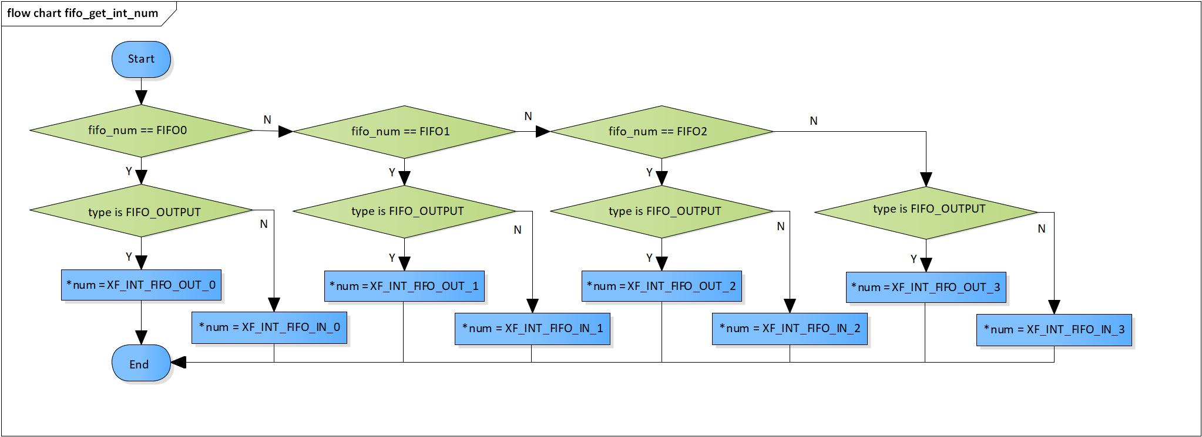

Figure 3‑4 fifo_get_int_num flowchart

### fifo_register_interrupt_handler

DD_PLG_RDR_06_005

|  |  |  |  |  |
| --- | --- | --- | --- | --- |
| **Syntax** | inline fifo_error_code fifo_register_interrupt_handler(fifo_modules fifo_num, fifo_type type, pVOID function_addr, pVOID arg) | | | |
| **Function** | This function is to register interrupt handler for FIFO. | | | |
| **Arguments** | Type | Name | I/O | Description |
| fifo_modules | fifo_num | I | FIFO module  Valid range: [0: 3] |
| fifo_type | type | I | FIFO type  Valid values:  FIFO_OUTPUT  FIFO_INPUT |
| pVOID | function_addr | I | Pointer to handler function |
| pVOID | arg | I | Argument passed to handler |
| **Return value** | FIFO_ERROR_OUT_RANGE | | FIFO module is invalid | |
| FIFO_ERROR_INVALID | | FIFO type or function_addr is invalid | |
| FIFO_ERROR_NONE | | Normal end | |
| **Description** | * fifo_register_interrupt_handler command processing:   - Register interrupt handler for FIFO | | | |

[Covers: FD_PLG_RDR_005]

Figure 3‑5 fifo_register_interrupt_handler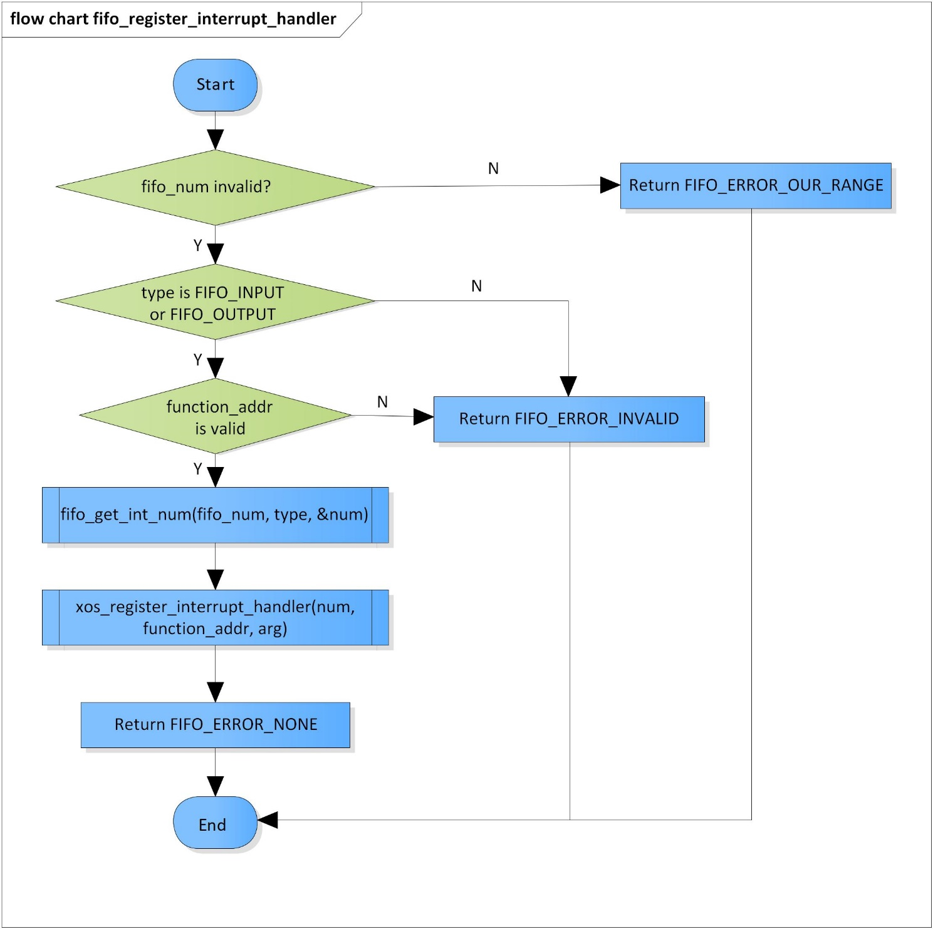 flowchart

### fifo_unregister_interrupt_handler

DD_PLG_RDR_06_006

|  |  |  |  |  |
| --- | --- | --- | --- | --- |
| **Syntax** | inline fifo_error_code fifo_unregister_interrupt_handler(fifo_modules fifo_num, fifo_type type) | | | |
| **Function** | This function is to unregister interrupt handler for FIFO. | | | |
| **Arguments** | Type | Name | I/O | Description |
| fifo_modules | fifo_num | I | FIFO module  Valid range: [0: 3] |
| fifo_type | type | I | FIFO type  Valid values:  FIFO_OUTPUT  FIFO_INPUT |
| **Return value** | FIFO_ERROR_OUT_RANGE | | FIFO module is invalid | |
| FIFO_ERROR_INVALID | | FIFO type is invalid | |
| FIFO_ERROR_NONE | | Normal end | |
| **Description** | * fifo_unregister_interrupt_handler command processing:   - Unregister interrupt handler for FIFO | | | |

[Covers: FD_PLG_RDR_005, FD_PLG_RDR_014, FD_PLG_RDR_032, FD_PLG_RDR_043]

Figure 3‑6 fifo_unregister_interrupt_handler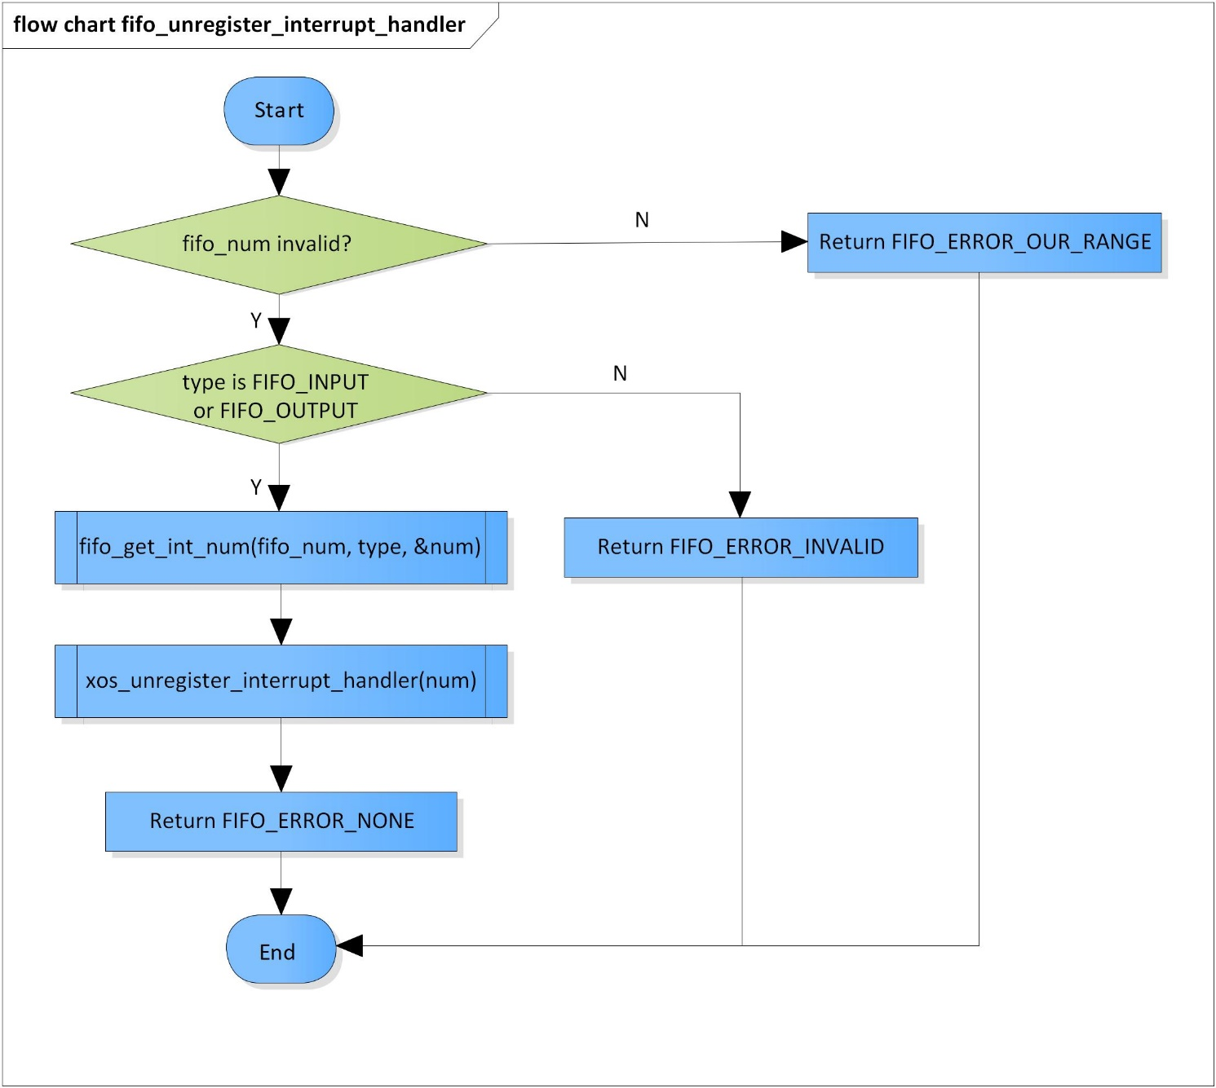 flowchart

### fifo_disable_interrupt

DD_PLG_RDR_06_007

|  |  |  |  |  |
| --- | --- | --- | --- | --- |
| **Syntax** | inline fifo_error_code fifo_disable_interrupt(fifo_modules fifo_num, fifo_type type) | | | |
| **Function** | This function is to disable interrupt for FIFO. | | | |
| **Arguments** | Type | Name | I/O | Description |
| fifo_modules | fifo_num | I | FIFO module  Valid range: [0: 3] |
| fifo_type | type | I | FIFO type  Valid values:  FIFO_OUTPUT  FIFO_INPUT |
| **Return value** | FIFO_ERROR_OUT_RANGE | | FIFO module is invalid | |
| FIFO_ERROR_INVALID | | FIFO type is invalid | |
| FIFO_ERROR_NONE | | Normal end | |
| **Description** | * fifo_disable_interrupt command processing:   - Disable FIFO interrupt | | | |

[Covers: FD_PLG_RDR_005, FD_PLG_RDR_014, FD_PLG_RDR_032, FD_PLG_RDR_043]

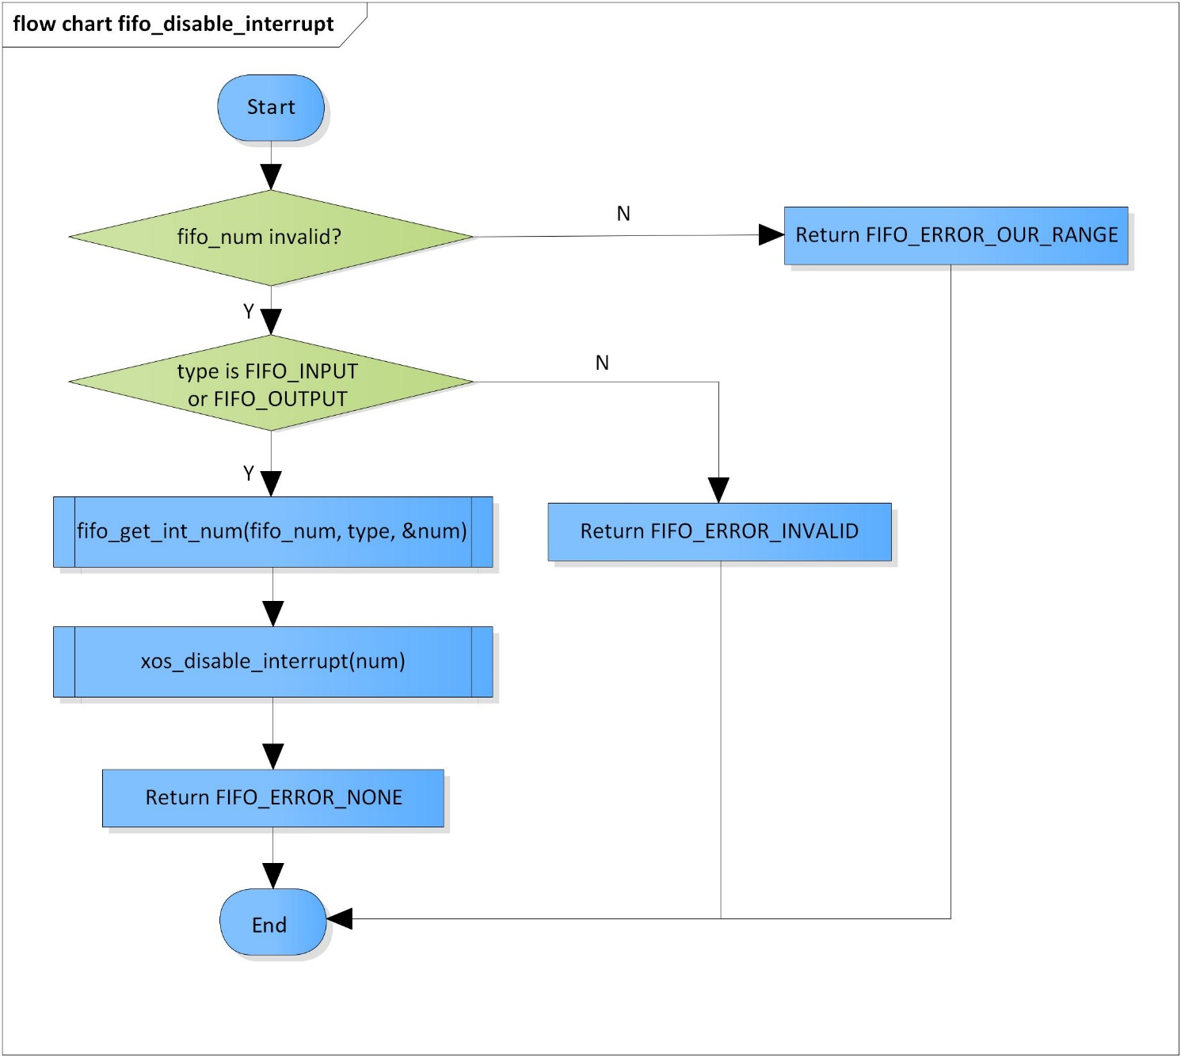

Figure 3‑7 fifo_disable_interrupt flowchart

### fifo_enable_interrupt

DD_PLG_RDR_06_008

|  |  |  |  |  |
| --- | --- | --- | --- | --- |
| **Syntax** | inline fifo_error_code fifo_enable_interrupt(fifo_modules fifo_num, fifo_type type) | | | |
| **Function** | This function is to enable interrupt for FIFO. | | | |
| **Arguments** | Type | Name | I/O | Description |
| fifo_modules | fifo_num | I | FIFO module  Valid range: [0: 3] |
| fifo_type | type | I | FIFO type  Valid values:  FIFO_OUTPUT  FIFO_INPUT |
| **Return value** | FIFO_ERROR_OUT_RANGE | | FIFO module is invalid | |
| FIFO_ERROR_INVALID | | FIFO type is invalid | |
| FIFO_ERROR_NONE | | Normal end | |
| **Description** | * fifo_enable_interrupt command processing:   - Enable FIFO interrupt | | | |

[Covers: FD_PLG_RDR_005]

Figure 3‑8 fifo_enable_interrupt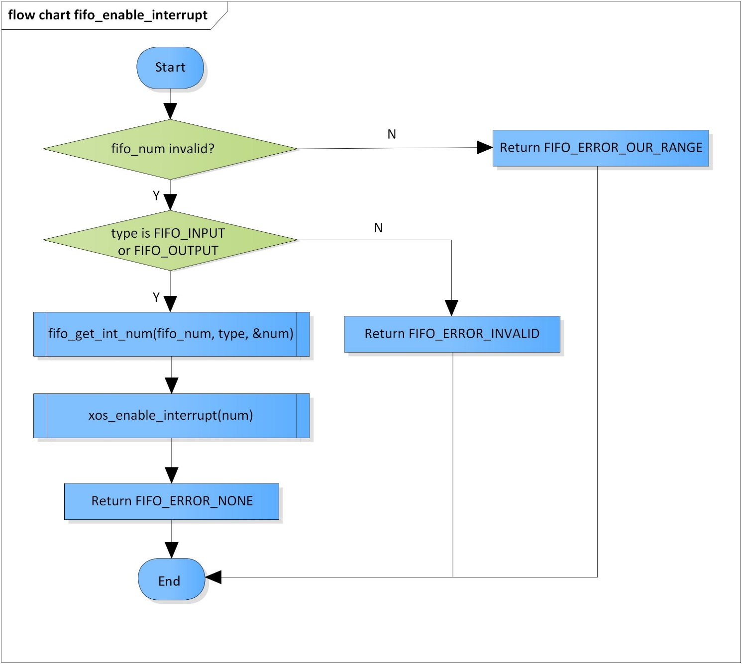 flowchart

### fifo_clear_interrupt

DD_PLG_RDR_06_009

|  |  |  |  |  |
| --- | --- | --- | --- | --- |
| **Syntax** | inline fifo_error_code fifo_clear_interrupt(fifo_modules fifo_num, fifo_type type) | | | |
| **Function** | This function is to clear FIFO interrupt. | | | |
| **Arguments** | Type | Name | I/O | Description |
| fifo_modules | fifo_num | I | FIFO module  Valid range: [0: 3] |
| fifo_type | type | I | FIFO type  Valid values:  FIFO_OUTPUT  FIFO_INPUT |
| **Return value** | FIFO_ERROR_OUT_RANGE | | FIFO module is invalid | |
| FIFO_ERROR_INVALID | | FIFO type is invalid | |
| FIFO_ERROR_NONE | | Normal end | |
| **Description** | * fifo_clear_interrupt command processing:   - Clear FIFO interrupt | | | |

[Covers: FD_PLG_RDR_005]

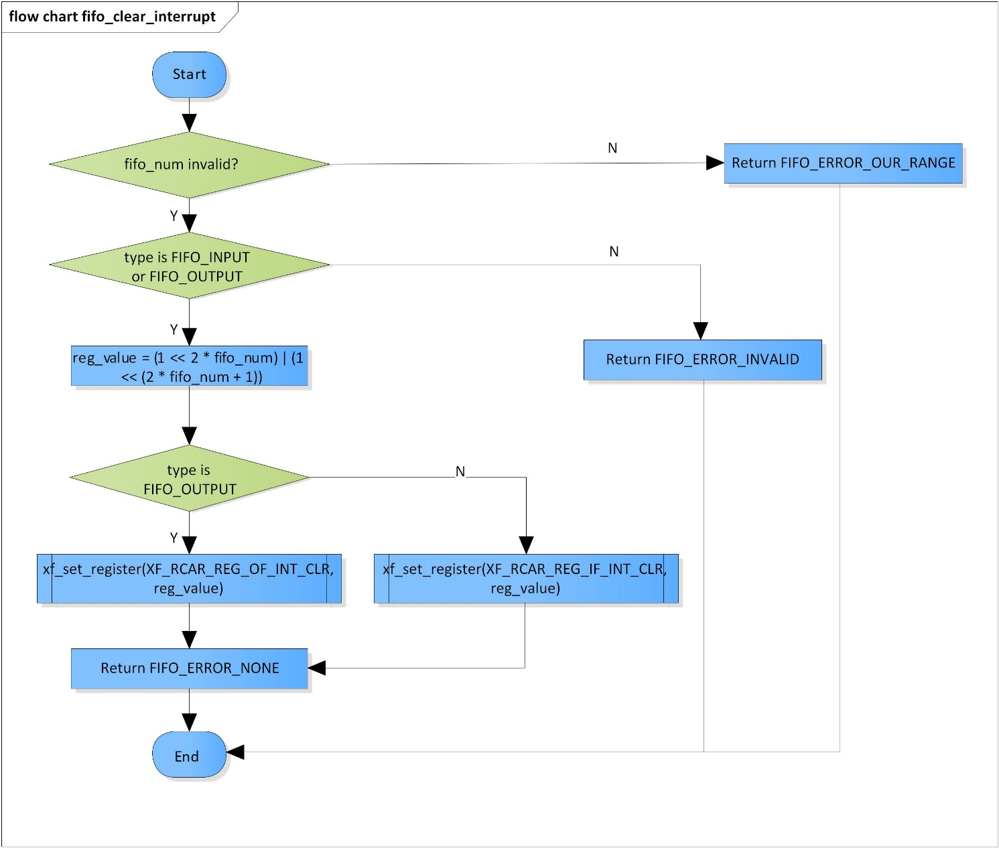

Figure 3‑9 fifo_clear_interrupt flowchart

### fifo_stop

DD_PLG_RDR_06_010

|  |  |  |  |  |
| --- | --- | --- | --- | --- |
| **Syntax** | inline fifo_error_code fifo_stop(fifo_modules fifo_num, fifo_type type) | | | |
| **Function** | This function is to stop FIFO. | | | |
| **Arguments** | Type | Name | I/O | Description |
| fifo_modules | fifo_num | I | FIFO module  Valid range: [0: 3] |
| fifo_type | type | I | FIFO type  Valid values:  FIFO_OUTPUT  FIFO_INPUT |
| **Return value** | FIFO_ERROR_OUT_RANGE | | FIFO module is invalid | |
| FIFO_ERROR_INVALID | | FIFO type is invalid | |
| FIFO_ERROR_NONE | | Normal end | |
| **Description** | * fifo_stop command processing:   - Stop FIFO operation | | | |

[Covers: FD_PLG_RDR_005, FD_PLG_RDR_014, FD_PLG_RDR_032, FD_PLG_RDR_043]

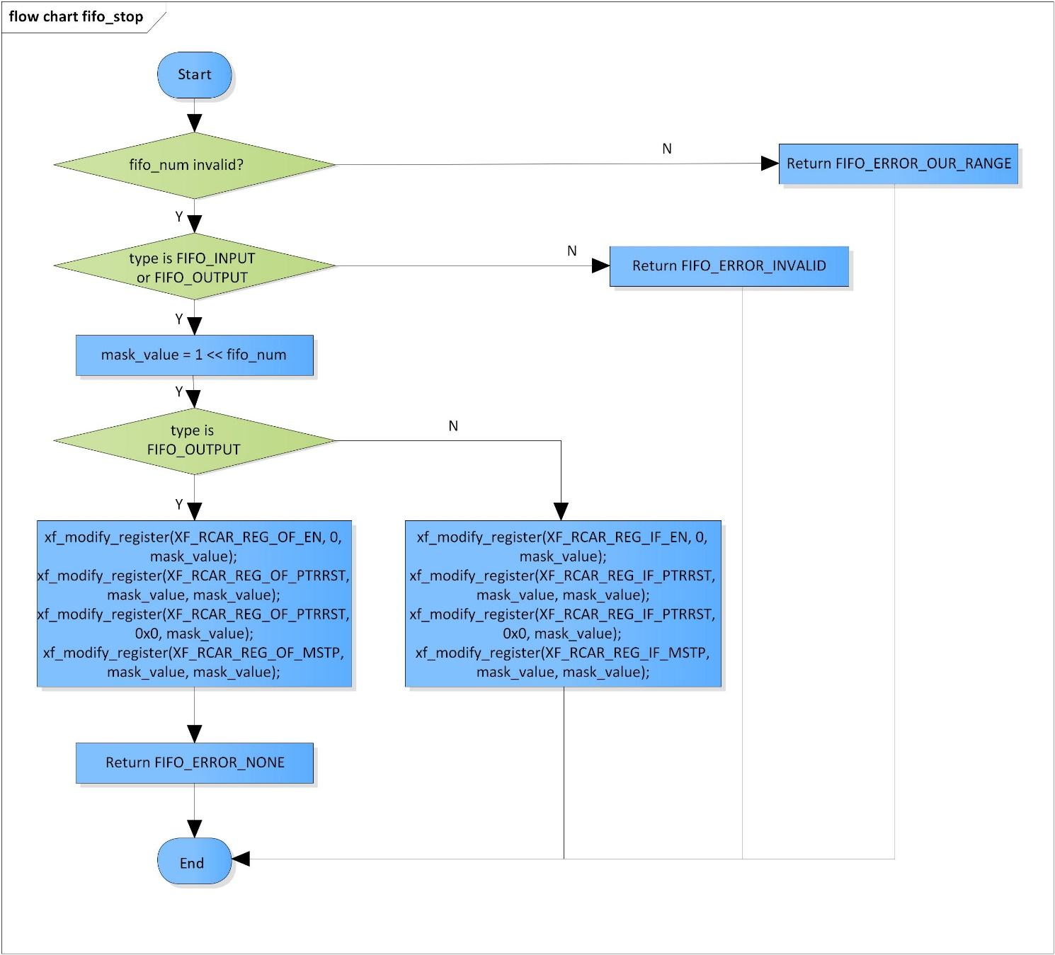

Figure 3‑10 fifo_stop flowchart

### fifo_check_available

DD_PLG_RDR_06_011

|  |  |  |  |  |
| --- | --- | --- | --- | --- |
| **Syntax** | inline fifo_error_code fifo_check_available(UWORD32 *fifo_num, fifo_type type) | | | |
| **Function** | This function is to check availability of FIFOs and choose an available one for operation. | | | |
| **Arguments** | Type | Name | I/O | Description |
| UWORD32 * | fifo_num | I/O | Pointer to FIFO number  Valid range: [0: 3] |
| fifo_type | type | I | FIFO type  Valid values:  FIFO_OUTPUT  FIFO_INPUT |
| **Return value** | FIFO_ERROR_OUT_RANGE | | FIFO module is invalid | |
| FIFO_ERROR_INVALID | | FIFO type is invalid | |
| FIFO_ERROR_BUSY | | No available FIFO module | |
| FIFO_ERROR_NONE | | Normal end | |
| **Description** | * fifo_check_available command processing:   - Check availability of FIFOs  - Choose an available one for operation | | | |

[Covers: FD_PLG_RDR_005]

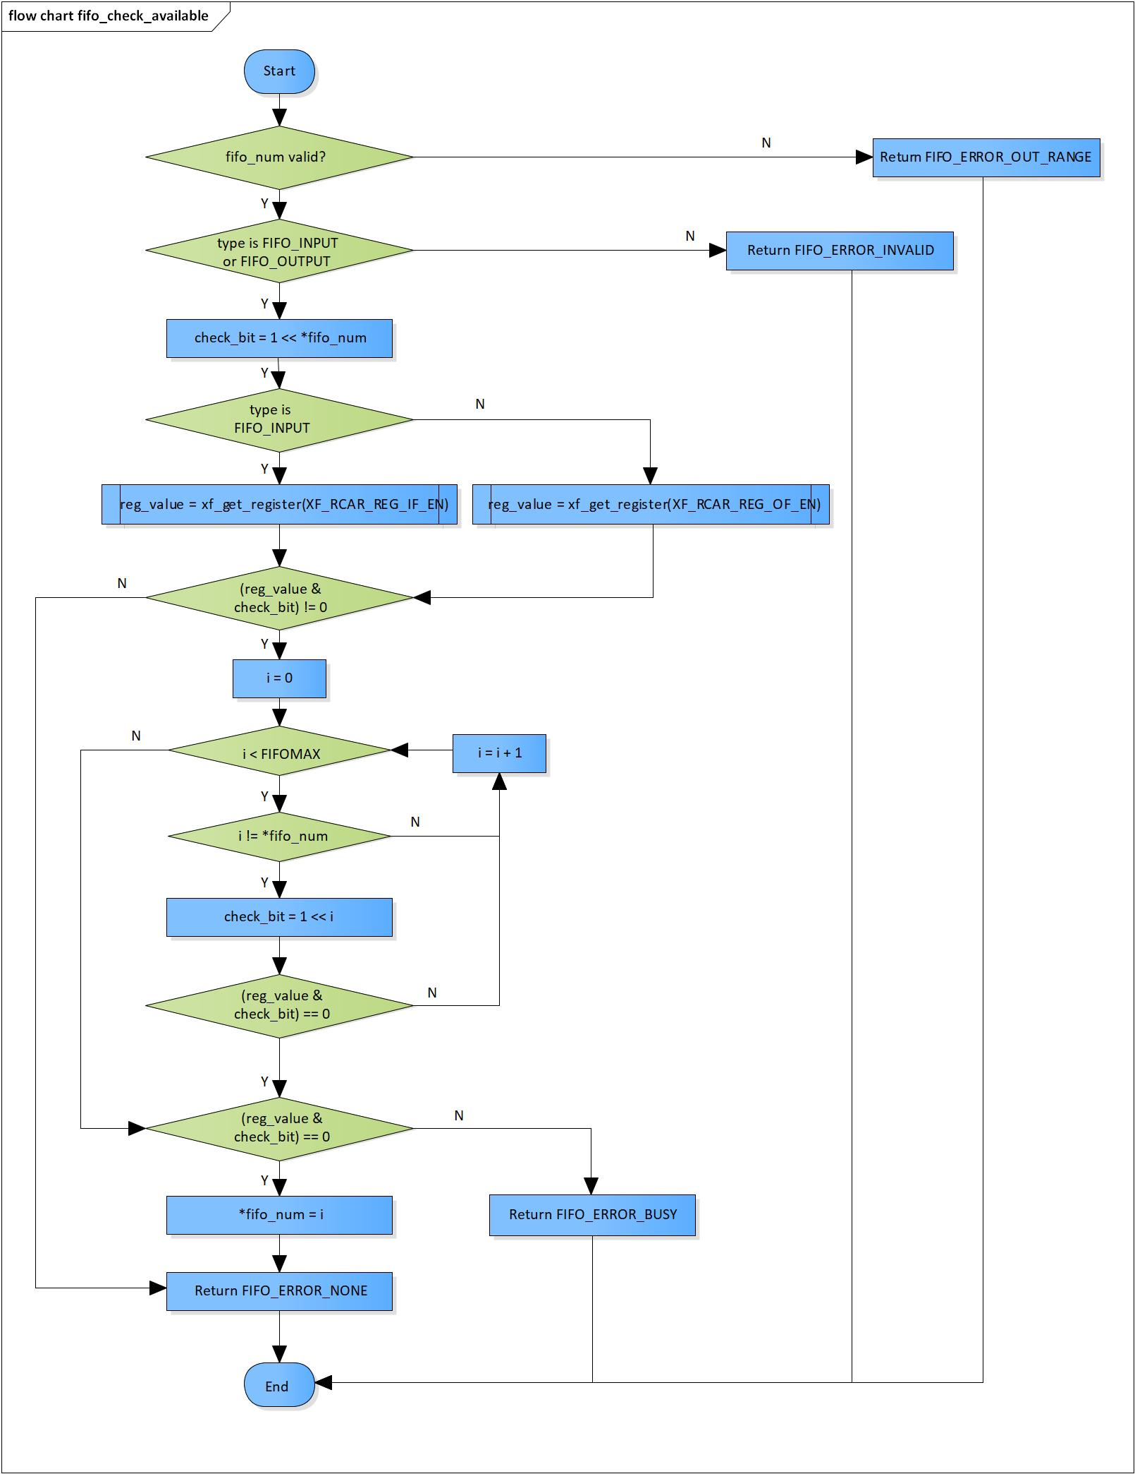

Figure 3‑11 fifo_check_available flowchart

# Revision history

|  |  |  |  |  |  |
| --- | --- | --- | --- | --- | --- |
| **Version** | **Date** | **Page** | **Content** | **Approved** | **Changed** |
| 1.0.0 | Nov 14 2018 | - | First Edition issued | Vu Phan | Vu Phan |
| 1.1.0 | Dec 10 2018 | - | Add traceability ID | Vu Phan | Ngu Pham |
| 1.2.0 | Jan 03, 2019 | - | Add range for input parameters | Vu Phan | Tien Tran |