**Document Type: Detail Design**

**Document Name:**

**ADSP FRAMEWORK: SSI DRIVER**

Renesas Electronics Corporation

Renesas Design Vietnam Co. Ltd

R-Car Software Solution 2 Group

Middleware 1 Team

Table of Contents

1. Overview 3

2. Function list 4

3. Detail information 5

3.1 Data type definition 5

3.1.1 SSI_MODULES 5

3.1.2 ADG_CLK_TYPE 5

3.1.3 SSI_DATA_MODE 6

3.1.4 SSI_CLK_MODE 6

3.1.5 SSI_ERR_CODE 6

3.1.6 SSI_PARAMS 6

3.2 Function definition 8

3.2.1 ssi_pcm_width_get 8

3.2.2 ssi_setup 9

3.2.3 ssi_start 12

3.2.4 ssi_stop 13

3.2.5 ssi_check_available_module 14

3.2.6 ssi_get_register_base 15

3.2.7 ssi_master_get 17

4. Revision history 18

List of Figures

Figure 1‑1 The software architecture 3

Figure 3‑1 ssi_pcm_width_get flowchart 8

Figure 3‑2 ssi_setup flowchart 11

Figure 3‑3 ssi_start flowchart 12

Figure 3‑4 ssi_stop flowchart 13

Figure 3‑5 ssi_check_available_module flowchart 14

Figure 3‑6 ssi_get_register_base flowchart 16

Figure 3‑7 ssi_master_get flowchart 17

List of Table

Table 2‑1 Function list 4

Table 3‑1 SSI_MODULES type information 5

Table 3‑2 ADG_CLK_TYPE type information 5

Table 3‑3 SSI_DATA_MODE type information 6

Table 3‑4 SSI_CLK_MODE type information 6

Table 3‑5 SSI_ERR_CODE type information 6

Table 3‑6 SSI_PARAMS type information 6

Table 3‑7 Setting of clock supplier for SSI 9

Table 3‑8 Setting SSICR based on PCM width 10

Table 3‑9 Array ssi_register_base[SSIMAX] 15

Table 2‑1 Function list 4

Table 3‑1 SSI_MODULES type information 5

Table 3‑2 ADG_CLK_TYPE type information 5

Table 3‑3 SSI_DATA_MODE type information 6

Table 3‑4 SSI_CLK_MODE type information 6

Table 3‑5 SSI_ERR_CODE type information 6

Table 3‑6 SSI_PARAMS type information 6

Table 3‑7 SSI_CONTROL type information 7

Table 3‑8 Setting of clock supplier for SSI 9

Table 3‑9 Setting SSICR based on PCM width 10

Table 3‑9 Array ssi_register_base[SSIMAX] 15

# Overview

This section provides an overview of software architecture.

User Application

ADSP Interface

Kernel Space

User Space

ADSP Driver

ARM

Audio HW

**ADSP Framework**

TDM class

Renderer class

Equalizer class

Capture class

TDM Plugin

ADSP

Plugin

Equalizer Plugin*

Capture Plugin

Renderer Plugin

This document’s target is in side of red square

* not connect to hardware modules

DAC/

ADC

SCU

PDMA

FIFO

SSI

SSIU

ADMA

Figure 1‑1 ****The software architecture****

# Function list

The following is list of functions:

Table 2‑1 Function list

|  |  |  |
| --- | --- | --- |
| **Type** | **Function Name** | **Outline** |
| API | ssi_pcm_width_get | This API is to get the PCM width based on values stored in bits 21 to 19 of Control Register SSICR |
| ssi_setup | This API is to set up registers necessary for SSI module execution |
| ssi_start | This API is to start SSI module |
| ssi_stop | This API is to stop SSI module |
| ssi_check_available_module | This API is to check availability of SSI module |
| ssi_get_register_base | This API is to get base address of registers of SSI module |
| ssi_master_get | This API is to get master SSI module of the current one |

# Detail information

This section describes detail information of data types, macro definitions, implemented APIs and internal function units, global variable.

## Data type definition

### SSI_MODULES

The data type SSI_MODULES is a type-defined enumeration that lists all supported SSI modules. It starts with SSI0 to SSIMAX.

Table 3‑1 SSI_MODULES type information

|  |  |  |
| --- | --- | --- |
| **Member name** | **Value** | **Outline** |
| SSI0 | 0 | SSI0 |
| SSI1 | 1 | SSI1 |
| SSI2 | 2 | SSI2 |
| SSI3 | 3 | SSI3 |
| SSI4 | 4 | SSI4 |
| SSI5 | 5 | SSI5 |
| SSI6 | 6 | SSI6 |
| SSI7 | 7 | SSI7 |
| SSI8 | 8 | SSI8 |
| SSI9 | 9 | SSI9 |
| SSIMAX | 10 | Number of SSI modules |

### ADG_CLK_TYPE

The data type ADG_CLK_TYPE is a type-defined enumeration that lists all supported ADG Clocks.

Table 3‑2 ADG_CLK_TYPE type information

|  |  |  |
| --- | --- | --- |
| **Member name** | **Value** | **Outline** |
| ADG_CLKA | 0 | ADG Clock A, frequency is 22.5792MHz |
| ADG_CLKB | 1 | ADG Clock B, frequency is 24.576MHz |
| ADG_CLKC | 2 | ADG Clock C, frequency is 14.7456MHz |

### SSI_DATA_MODE

The data type SSI_DATA_MODE is a type-defined enumeration that lists all supported SSI modes: Transfer mode/Receive mode.

Table 3‑3 SSI_DATA_MODE type information

|  |  |  |
| --- | --- | --- |
| **Member name** | **Value** | **Outline** |
| SSI_RCV_MODE | 0 | SSI’s Receive mode |
| SSI_TR_MODE | 1 | SSI’s Transfer mode |

### SSI_CLK_MODE

The data type SSI_CLK_MODE is a type-defined enumeration that lists all supported SSI clock modes: Master/Slave.

Table 3‑4 SSI_CLK_MODE type information

|  |  |  |
| --- | --- | --- |
| **Member name** | **Value** | **Outline** |
| SSI_MASTER_MODE | 0 | SSI clock mode Master |
| SSI_SLAVE_MODE | 1 | SSI clock mode Slave |

### SSI_ERR_CODE

The data type SSI_ERR_CODE is a type-defined enumeration that lists all error-codes used for SSI.

Table 3‑5 SSI_ERR_CODE type information

|  |  |  |
| --- | --- | --- |
| **Member name** | **Value** | **Outline** |
| SSI_ERR_NONE | 0 | No errors |
| SSI_ERR_OUT_RANGE | -1 | SSI module is out of range |
| SSI_ERR_BUSY | -2 | SSI module is busy |

### SSI_PARAMS

The data type SSI_PARAMS is a type-defined structure that possesses necessary parameters for SSI module.

Table 3‑6 SSI_PARAMS type information

|  |  |  |
| --- | --- | --- |
| **Member name** | **Data type** | **Outline** |
| channel | UWORD32 | channel of data used for SSI module |
| pcm_width | UWORD32 | PCM width of data used for SSI module |
| fs | UWORD32 | Sampling rate of data used for SSI module |
| clock_type | ADG_CLK_MODE | Clock type (Clock A, B, C) |
| data_mode | SSI_DATA_MODE | SSI data mode |
| clock_mode | SSI_CLK_MODE | SSI clock mode |

### SSI_CONTROL

The data type SSI_CONTROL is a type-defined structure that lists registers for SSI modules.

Table 3‑7 SSI_CONTROL type information

|  |  |  |
| --- | --- | --- |
| **Member name** | **Data type** | **Registers** |
| SSICR | volatile UWORD32 | SSICR |
| SSISR | volatile UWORD32 | SSISR |
| SSITDR | volatile UWORD32 | SSITDR |
| SSIRDR | volatile UWORD32 | SSIRDR |
| dummy[4] | volatile UWORD32 | No registers |
| SSIWSR | volatile UWORD32 | SSIWSR |
| SSIFMR | volatile UWORD32 | SSIFMR |
| SSIFSR | volatile UWORD32 | SSIFSR |
| SSICRE | volatile UWORD32 | SSICRE |

## Function definition

### ssi_pcm_width_get

DD_PLG_RDR_05_001

|  |  |  |  |  |
| --- | --- | --- | --- | --- |
| **Syntax** | inline UWORD32 ssi_pcm_width_get(const SSI_MODULES module) | | | |
| **Function** | This function is to get the PCM width based on values stored in bits 21 to 19 of Control Register SSICR. | | | |
| **Arguments** | Type | Name | I/O | Description |
| SSI_MODULES | module | I | SSI module  Valid range: [0: 9] |
| **Return value** | pcm_width | | PCM width’s value | |
| **Description** | * ssi_pcm_width_get command processing:   - SSICR’s bits [21:19] is 1 and 5, then PCM width is 16 and 24, respectively. Otherwise, PCM width is 0. | | | |

[Covers: FD_PLG_RDR_005]

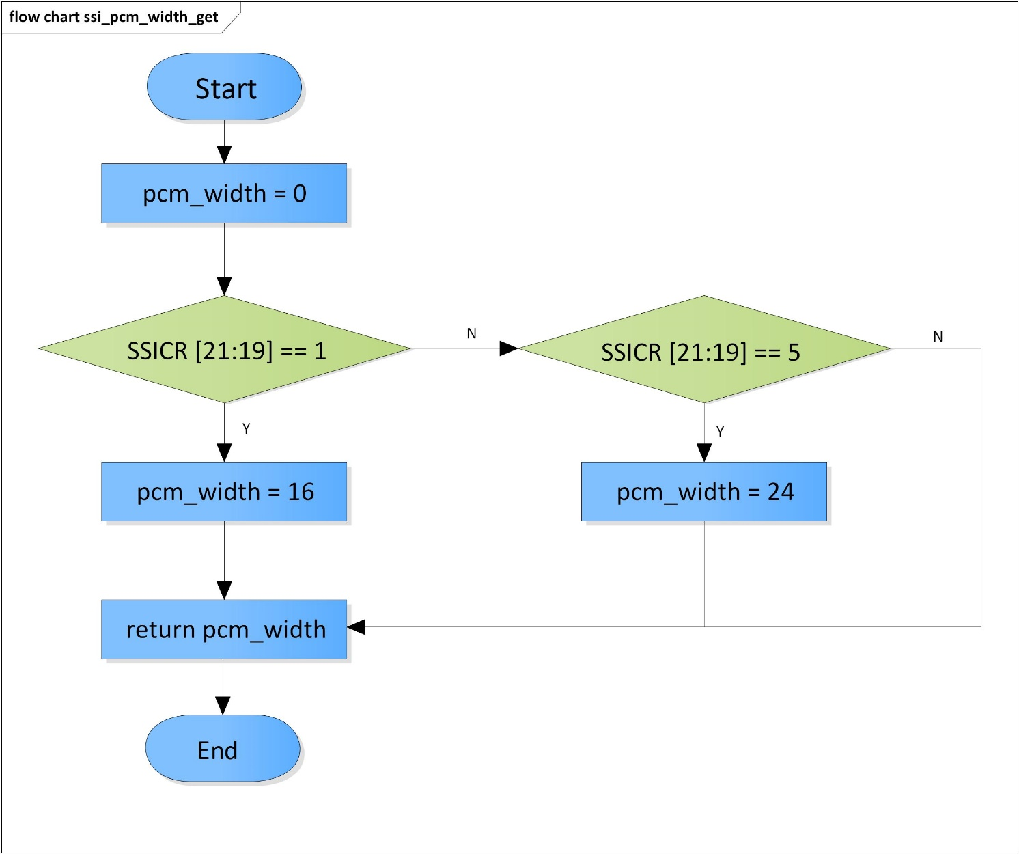

Figure 3‑1 ssi_pcm_width_get flowchart

### ssi_setup

DD_PLG_RDR_05_002

|  |  |  |  |  |
| --- | --- | --- | --- | --- |
| **Syntax** | SSI_ERR_CODE ssi_setup(SSI_MODULES module, SSI_PARAMS params) | | | |
| **Function** | This function is to set up registers necessary for SSI module execution. | | | |
| **Arguments** | Type | Name | I/O | Description |
| SSI_MODULES | module | I | SSI module  Valid range: [0: 9] |
| SSI_PARAMS | params | I | Struct of parameters to set |
| **Return value** | SSI_ERR_OUT_RANGE | | SSI module is invalid  Clock type is invalid  Sampling rate is invalid  PCM width is invalid  Clock mode is invalid  Data mode is invalid | |
| SSI_ERR_NONE | | Normal end | |
| **Description** | * ssi_setup command processing:   - Set register AUDIO_CLK_SEL0/1/2 based on which SSI module and sampling rate  - Set register SSIWSR (in master mode)  - Set register SSICR | | | |

[Covers: FD_PLG_RDR_005]

Table 3‑8 Setting of clock supplier for SSI

|  |  |  |  |  |
| --- | --- | --- | --- | --- |
| **SSI module** | **Sampling rate** | **Register** | **Bits** | **Value** |
| SSI0 | 32000 | AUDIO_CLK_SEL0 | [7:0] | 0x20 |
| 48000 |
| 44100 | 0x10 |
| SSI1 | 32000 | AUDIO_CLK_SEL0 | [15:8] | 0x20 |
| 48000 |
| 44100 | 0x10 |
| SSI2 | 32000 | AUDIO_CLK_SEL0 | [23:16] | 0x20 |
| 48000 |
| 44100 | 0x10 |
| SSI3 | 32000 | AUDIO_CLK_SEL0 | [31:24] | 0x20 |
| 48000 |
| 44100 | 0x10 |
| SSI4 | 32000 | AUDIO_CLK_SEL1 | [7:0] | 0x20 |
| 48000 |
| 44100 | 0x10 |
| SSI5 | 32000 | AUDIO_CLK_SEL1 | [15:8] | 0x20 |
| 48000 |
| 44100 | 0x10 |
| SSI6 | 32000 | AUDIO_CLK_SEL1 | [23:16] | 0x20 |
| 48000 |
| 44100 | 0x10 |
| SSI7 | 32000 | AUDIO_CLK_SEL1 | [31:24] | 0x20 |
| 48000 |
| 44100 | 0x10 |
| SSI8 | No clock supplier | | | |
| SSI9 | 32000 | AUDIO_CLK_SEL2 | [15:8] | 0x20 |
| 48000 |
| 44100 | 0x10 |

Table 3‑9 Setting SSICR based on PCM width

|  |  |
| --- | --- |
| **PCM width** | **SSICR[21:19]** |
| 8 | b’000 |
| 16 | b’001 |
| 18 | b’010 |
| 20 | b’011 |
| 22 | b’100 |
| 24 | b’101 |
| 32 | b’110 |

Note: setting SSI_Control register base on the specific codec

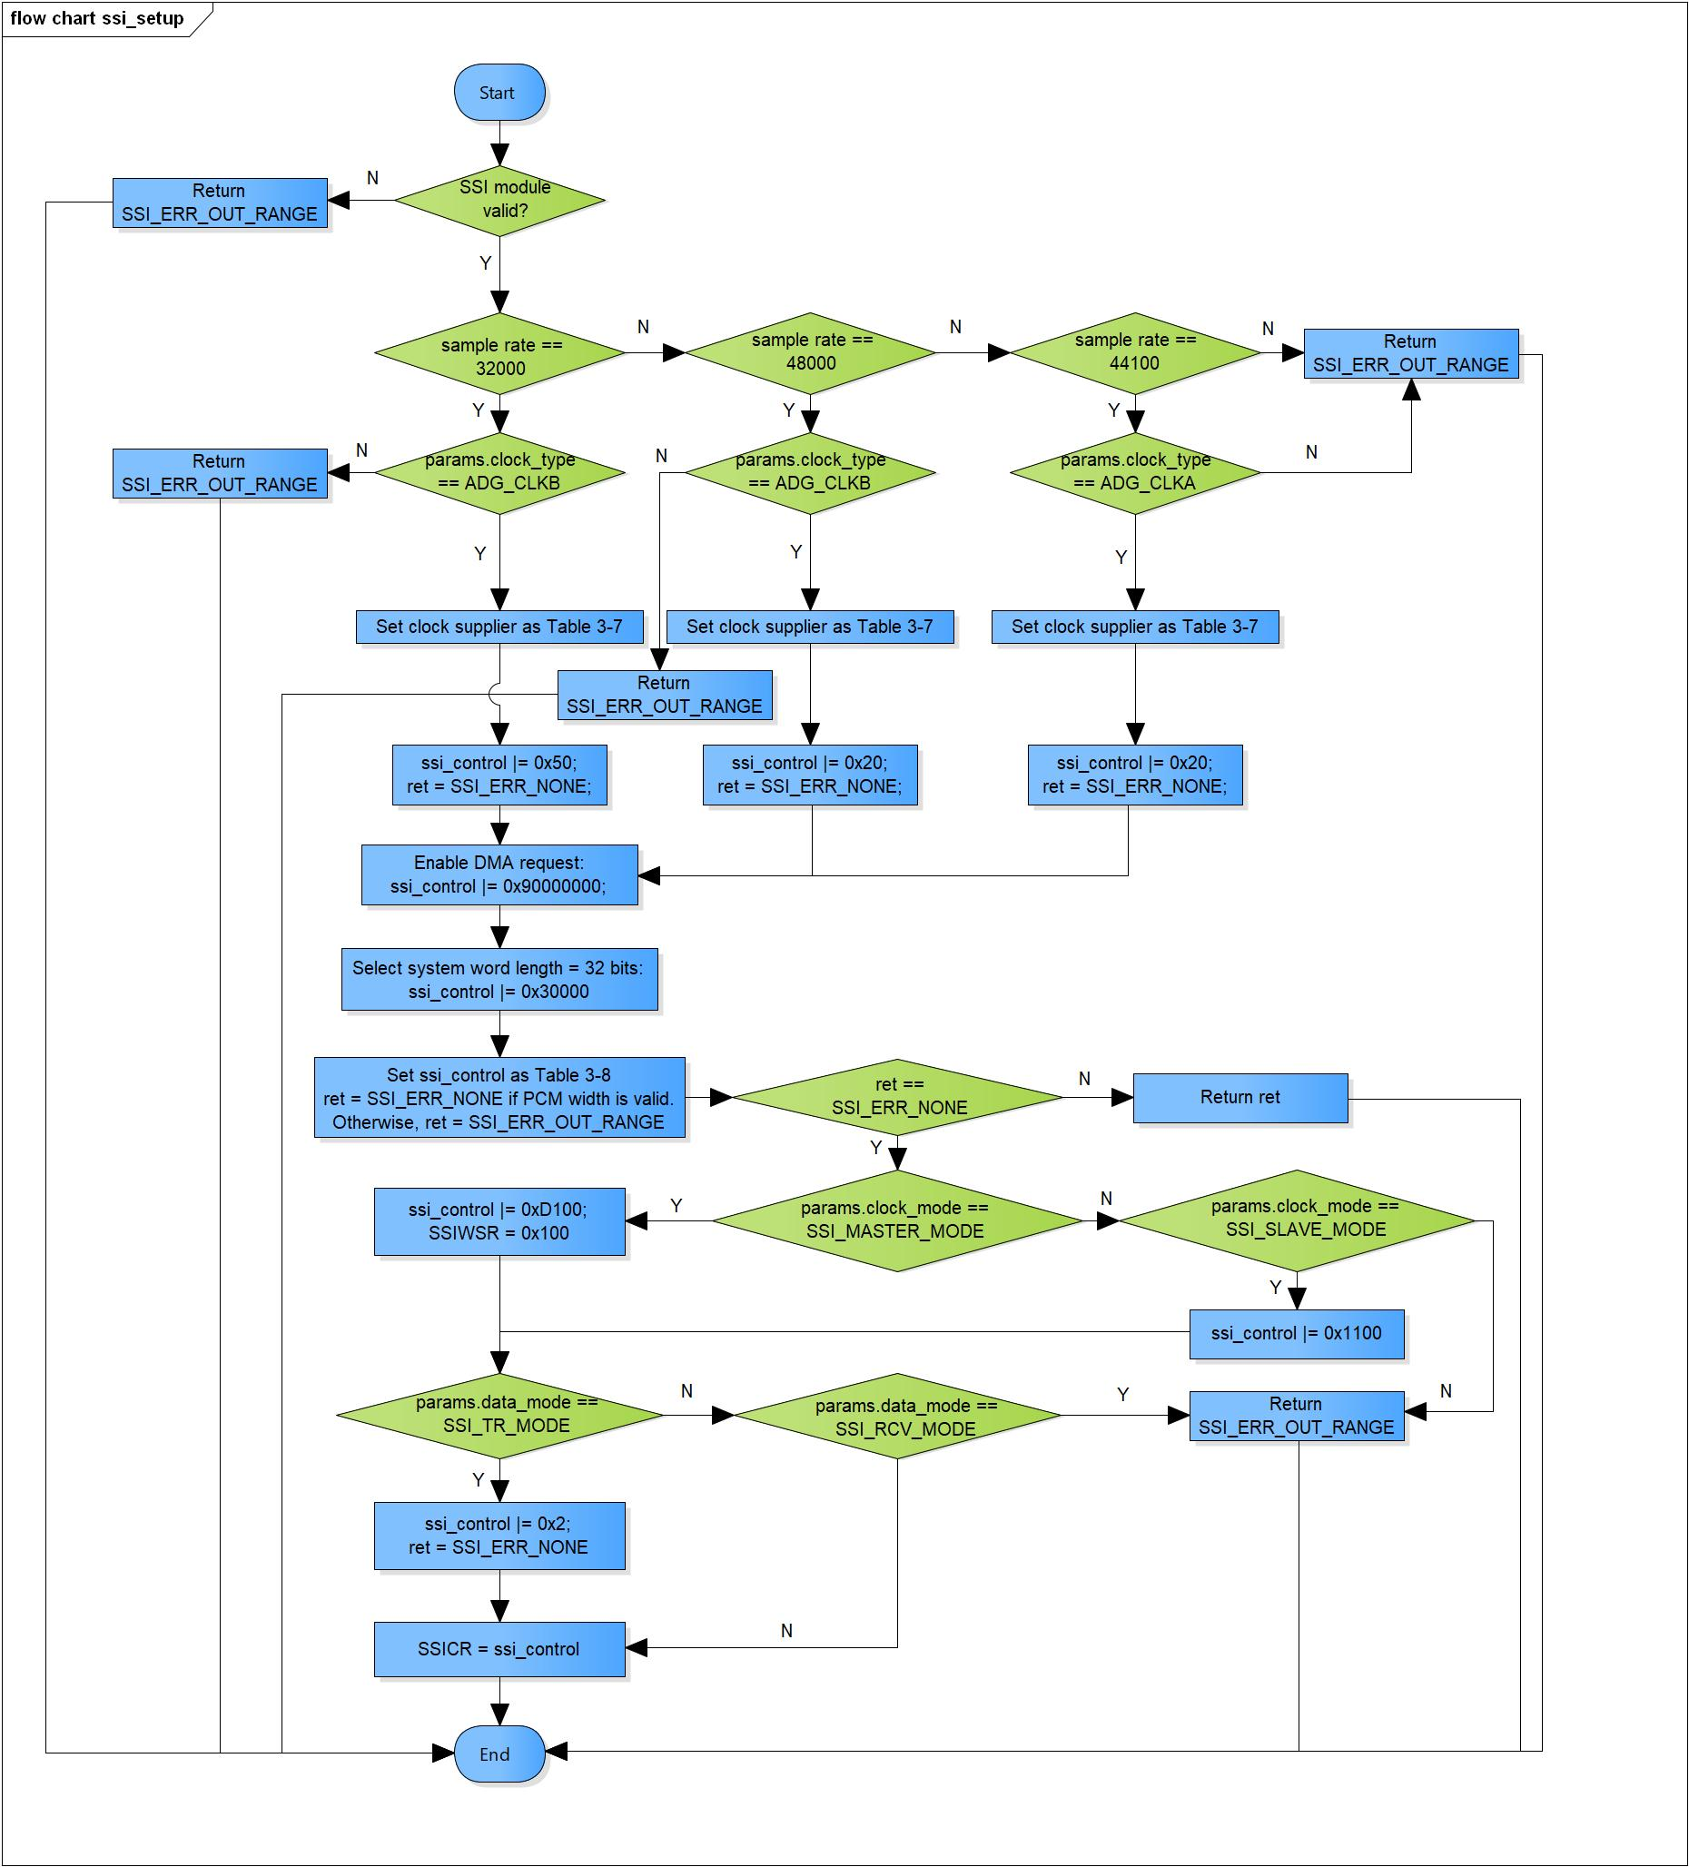

Figure 3‑2 ssi_setup flowchart

### ssi_start

DD_PLG_RDR_05_003

|  |  |  |  |  |
| --- | --- | --- | --- | --- |
| **Syntax** | SSI_ERR_CODE ssi_start(SSI_MODULES module) | | | |
| **Function** | This function is to start SSI module. | | | |
| **Arguments** | Type | Name | I/O | Description |
| SSI_MODULES | module | I | SSI module  Valid range: [0: 9] |
| **Return value** | SSI_ERR_OUT_RANGE | | SSI module is invalid | |
| SSI_ERR_NONE | | Normal end | |
| **Description** | * ssi_start command processing:   - Set ‘1’ to SSICR’s bit 0 to start SSI | | | |

[Covers: FD_PLG_RDR_005]

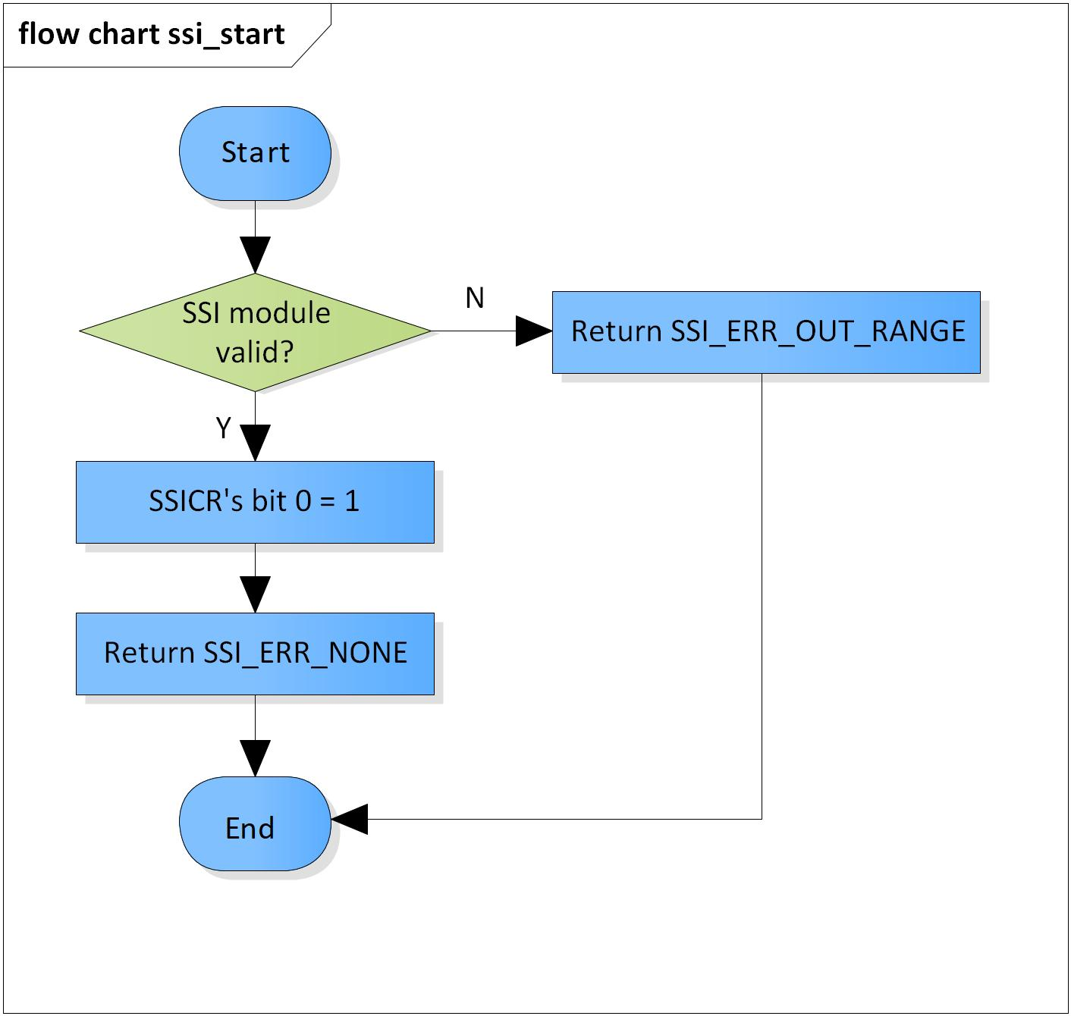

Figure 3‑3 ssi_start flowchart

### ssi_stop

DD_PLG_RDR_05_004

|  |  |  |  |  |
| --- | --- | --- | --- | --- |
| **Syntax** | SSI_ERR_CODE ssi_stop(SSI_MODULES module) | | | |
| **Function** | This function is to stop SSI module. | | | |
| **Arguments** | Type | Name | I/O | Description |
| SSI_MODULES | module | I | SSI module  Valid range: [0: 9] |
| **Return value** | SSI_ERR_OUT_RANGE | | SSI module is invalid | |
| SSI_ERR_NONE | | Normal end | |
| **Description** | * ssi_start command processing:   - Set ‘0’ to SSICR’s bit 0 to stop SSI | | | |

[Covers: FD_PLG_RDR_005, FD_PLG_RDR_014, FD_PLG_RDR_032, FD_PLG_RDR_043]

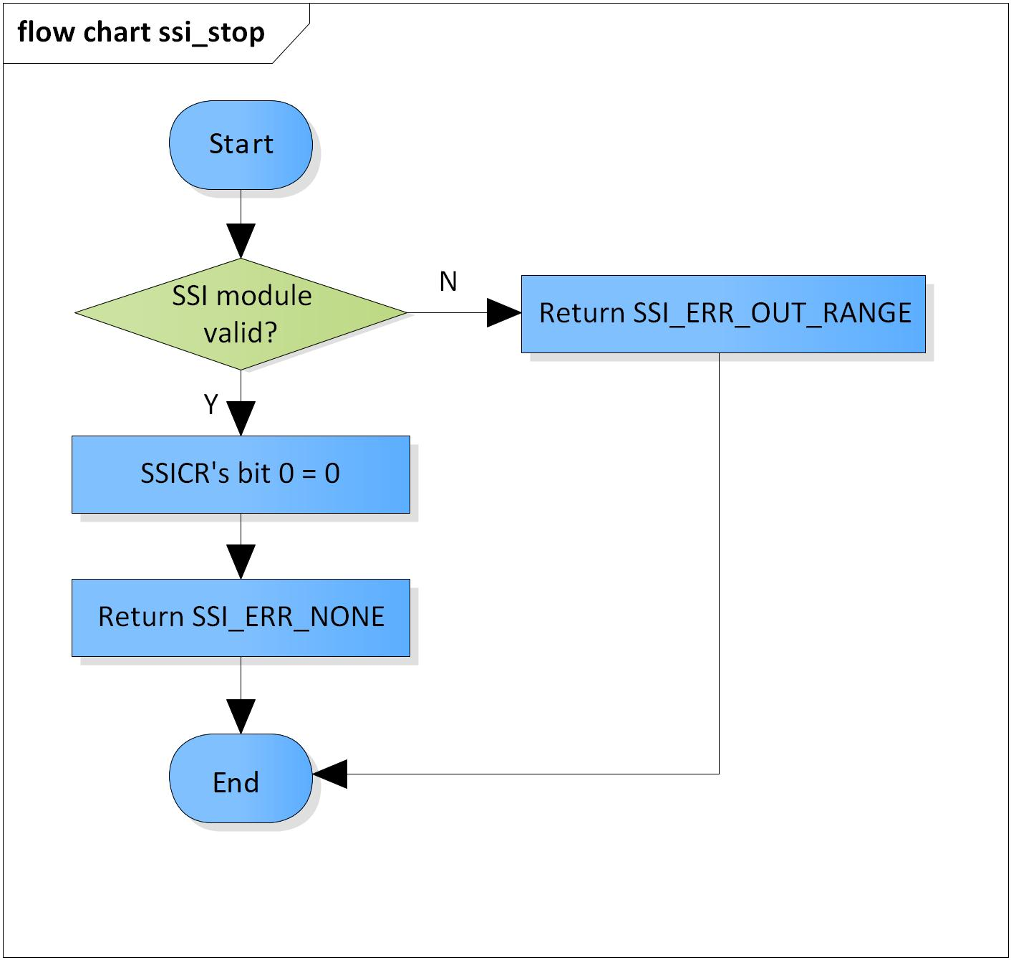

Figure 3‑4 ssi_stop flowchart

### ssi_check_available_module

DD_PLG_RDR_05_005

|  |  |  |  |  |
| --- | --- | --- | --- | --- |
| **Syntax** | SSI_ERR_CODE ssi_check_available_module(UWORD32 module) | | | |
| **Function** | This function is check availability of SSI module. | | | |
| **Arguments** | Type | Name | I/O | Description |
| UWORD32 | module | I | SSI module  Valid range: [0: 9] |
| **Return value** | SSI_ERR_OUT_RANGE | | SSI module is invalid | |
| SSI_ERR_BUSY | | SSI module is busy | |
| SSI_ERR_NONE | | Normal end | |
| **Description** | * ssi_check_available_module command processing:   - Check if the current SSI module is running or not | | | |

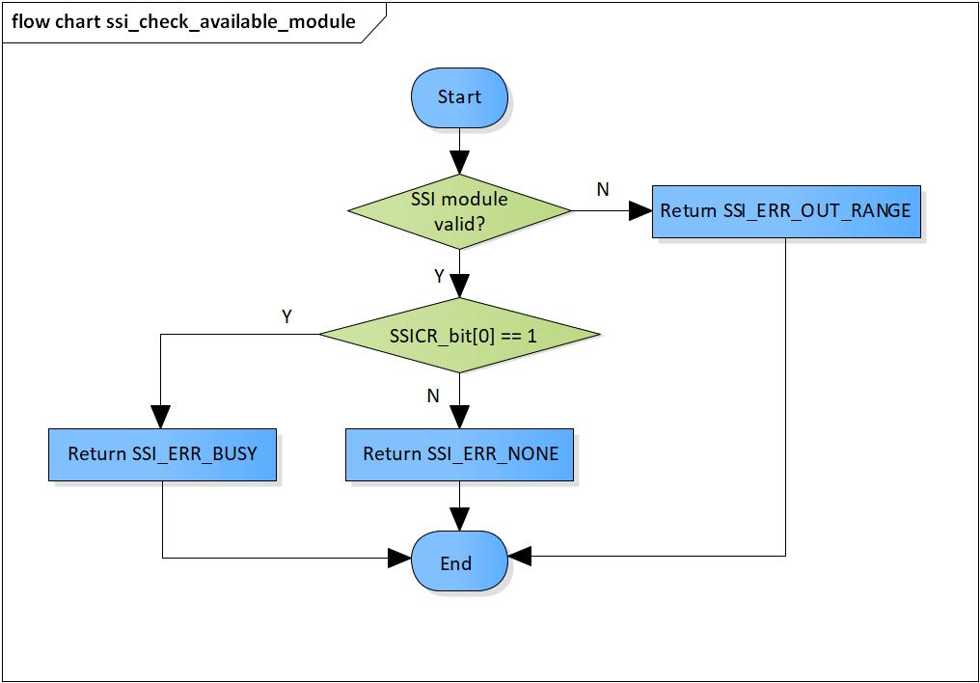[Covers: FD_PLG_RDR_005]

Figure 3‑5 ssi_check_available_module flowchart

### ssi_get_register_base

DD_PLG_RDR_05_006

|  |  |  |  |  |
| --- | --- | --- | --- | --- |
| **Syntax** | static volatile inline SSI_CONTROL *ssi_get_register_base(SSI_MODULES module) | | | |
| **Function** | This function is to get base address of registers of SSI module. | | | |
| **Arguments** | Type | Name | I/O | Description |
| SSI_MODULES | module | I | SSI module  Valid range: [0: 9] |
| **Return value** | 0 | | SSI module is invalid | |
| ssi_register_base[module] | | Base address of register | |
| **Description** | * ssi_get_register_base command processing:   - Get the base address of registers of the current SSI module | | | |

[Covers: FD_PLG_RDR_005, FD_PLG_RDR_014, FD_PLG_RDR_032, FD_PLG_RDR_043]

Table 3‑10 Array ssi_register_base[SSIMAX]

|  |  |
| --- | --- |
| **Index** | **Values** |
| SSI0 | XF_RCAR_REG_SSICR0 |
| SSI1 | XF_RCAR_REG_SSICR1 |
| SSI2 | XF_RCAR_REG_SSICR2 |
| SSI3 | XF_RCAR_REG_SSICR3 |
| SSI4 | XF_RCAR_REG_SSICR4 |
| SSI5 | XF_RCAR_REG_SSICR5 |
| SSI6 | XF_RCAR_REG_SSICR6 |
| SSI7 | XF_RCAR_REG_SSICR7 |
| SSI8 | XF_RCAR_REG_SSICR8 |
| SSI9 | XF_RCAR_REG_SSICR9 |

[Note]: The Values column of Table 3-9 are macros for registers defined in xf-register.h

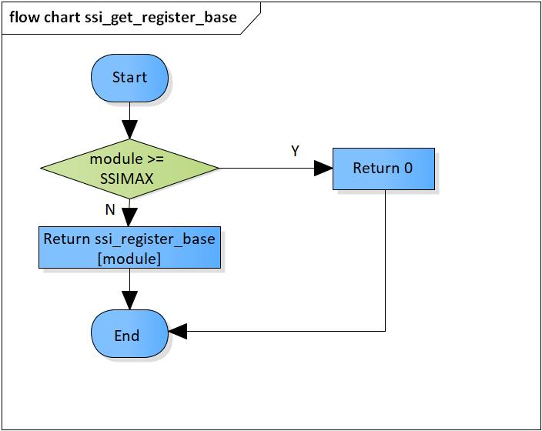

Figure 3‑6 ssi_get_register_base flowchart

### ssi_master_get

DD_PLG_RDR_05_007

|  |  |  |  |  |
| --- | --- | --- | --- | --- |
| **Syntax** | SSI_MODULES ssi_master_get(const SSI_MODULES module) | | | |
| **Function** | This function is to get the PCM width based on values stored in bits 21 to 19 of Control Register SSICR. | | | |
| **Arguments** | Type | Name | I/O | Description |
| const SSI_MODULE | module | I | SSI module  Valid range: [0: 9] |
| **Return value** | ssi_master | | Master SSI module | |
| **Description** | * ssi_master_get command processing:   - Get master module based on current SSI module | | | |

[Covers: FD_PLG_RDR_005, FD_PLG_RDR_014, FD_PLG_RDR_032, FD_PLG_RDR_043]

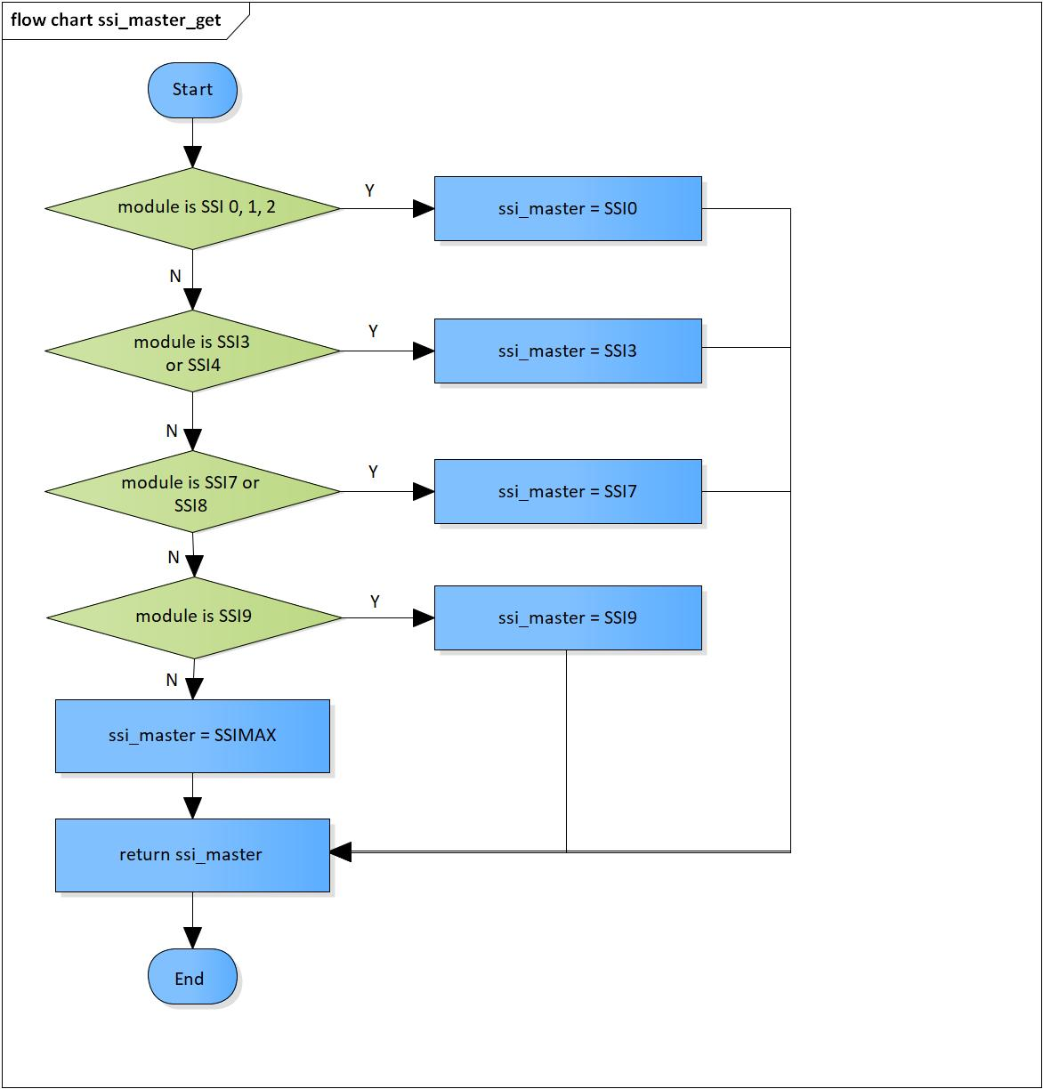

Figure 3‑7 ssi_master_get flowchart

# Revision history

|  |  |  |  |  |  |
| --- | --- | --- | --- | --- | --- |
| **Version** | **Date** | **Page** | **Content** | **Approved** | **Changed** |
| 1.0.0 | Nov 14 2018 | - | First Edition issued | Vu Phan | Vu Phan |
| 1.1.0 | Dec 10 2018 | - | Add traceability ID | Vu Phan | Ngu Pham |
| 1.2.0 | Jan 03, 2019 | - | Add range for input parameters | Vu Phan | Tien Tran |
| 1.3.0 | Mar 20, 2019 | 11 | Modify SSI control register correct to swap channel issue |  | Ngu Pham |