**Document Type: Detail Design**

**Document Name:**

**ADSP FRAMEWORK: SSIU DRIVER**

Renesas Electronics Corporation

Renesas Design Vietnam Co. Ltd

R-Car Software Solution 2 Group

Middleware 1 Team

Table of Contents

1. Overview 3

2. Function list 4

3. Detail information 5

3.1 Data type definition 5

3.1.1 SSIU_SSI_MODULE 5

3.1.2 SSIU_PIN_MODE 5

3.1.3 SSIU_SWAP_FUNC 6

3.1.4 SSIU_PARAMS 6

3.1.5 SSIU_ERR_CODE 6

3.1.6 SSIU_PARAMS 6

3.1.7 SSIU_CONTROL 7

3.2 Macro definition 8

3.3 Function definition 9

3.3.1 ssiu_setup 9

3.3.2 ssiu_start 12

3.3.3 ssiu_stop 13

3.3.5 ssiu_get_register_base 14

4. Revision history 15

List of Figures

Figure 1‑1 The software architecture 3

Figure 3‑1 ssiu_setup flowchart 11

Figure 3‑2 ssiu_start flowchart 12

Figure 3‑3 ssiu_stop flowchart 13

Figure 3‑4 ssiu_get_register_base flowchart 14

List of Table

Table 2‑1 Function list 4

Table 3‑1 SSIU_SSI_MODULE type information 5

Table 3‑2 SSIU_PIN_MODE type information 5

Table 3‑3 SSIU_SWAP_FUNC type information 6

Table 3‑4 SSIU_PARAMS type information 6

Table 3‑5 SSIU_ERR_CODE type information 6

Table 3‑6 SSIU_PARAMS type information 6

Table 3‑7 SSIU_CONTROL type information 7

Table 3‑8 Setting of SSI_BUSIF_ADINR based on PCM width 9

Table 3‑9 Setting of SSI_BUSIF_ADINR based on channel 9

Table 3‑10 Setting pin mode 10

# Overview

This section provides an overview of software architecture.

User Application

ADSP Interface

Kernel Space

User Space

ADSP Driver

ARM

Audio HW

**ADSP Framework**

Renderer class

TDM class

Equalizer class

Capture class

ADSP

Plugin

Equalizer Plugin*

TDM Plugin

Capture Plugin

Renderer Plugin

This document’s target is in side of red square

* not connect to hardware modules

DAC/

ADC

SCU

PDMA

FIFO

SSI

SSIUU

ADMA

Figure 1‑1 ****The software architecture****

# Function list

The following is list of functions:

Table 2‑1 Function list

|  |  |  |
| --- | --- | --- |
| **Type** | **Function Name** | **Outline** |
| API | ssiu_setup | This API is to set up registers necessary for SSIU module execution |
| ssiu_start | This API is to start SSIU module |
| ssiu_stop | This API is to stop SSIU module |
| Internal functions | ssiu_get_register_base | This function is to get base address of registers for SSIU module |

# Detail information

This section describes detail information of data types, macro definitions, implemented APIs and internal function units, global variable.

## Data type definition

### SSIU_SSI_MODULE

The data type SSIU_SSI_MODULE is a type-defined structure that lists SSIU’s properties: module index and bus index.

Table 3‑1 SSIU_SSI_MODULE type information

|  |  |  |
| --- | --- | --- |
| **Member name** | **Data type** | **Outline** |
| module_index | UWORD32 | SSIU module index |
| bus_index | UWORD32 | SSIU bus index |

### SSIU_PIN_MODE

The data type SSIU_PIN_MODE is a type-defined enumeration that lists all supported pin modes for SSIU.

Table 3‑2 SSIU_PIN_MODE type information

|  |  |  |
| --- | --- | --- |
| **Member name** | **Value** | **Outline** |
| SSIU_NON_PIN_MODE | 0 | No setting pin mode for SSIU |
| SSIU_S3_S4_PIN_MODE | 1 | SSI3 works as slave and SSI4 works as slave |
| SSIU_M3_S4_PIN_MODE | 2 | SSI3 works as master and SSI4 works as slave |
| SSIU_S0_S2_PIN_MODE | 3 | SSI0 works as slave and SSI2 works as slave |
| SSIU_M0_S2_PIN_MODE | 4 | SSI0 works as master and SSI2 works as slave |
| SSIU_S0_S1_PIN_MODE | 5 | SSI0 works as slave and SSI1 works as slave |
| SSIU_M0_S1_PIN_MODE | 6 | SSI0 works as master and SSI1 works as slave |
| SSIU_S0_S9_PIN_MODE | 7 | SSI0 works as slave and SSI9 works as slave |
| SSIU_M0_S9_PIN_MODE | 8 | SSI0 works as master and SSI9 works as slave |
| SSIU_S3_S9_PIN_MODE | 9 | SSI3 works as slave and SSI9 works as slave |
| SSIU_M3_S9_PIN_MODE | 10 | SSI3 works as master and SSI9 works as slave |
| SSIU_S0_S3_PIN_MODE | 11 | SSI0 works as slave and SSI3 works as slave |
| SSIU_M0_S3_PIN_MODE | 12 | SSI0 works as master and SSI3 works as slave |

### SSIU_SWAP_FUNC

The data type SSIU_SWAP_FUNC is a type-defined enumeration of indicators of whether swap function is enabled or not.

Table 3‑3 SSIU_SWAP_FUNC type information

|  |  |  |
| --- | --- | --- |
| **Member name** | **Value** | **Outline** |
| SSIU_WORD_SWAP_DISABLE | 0 | Swap function is disabled |
| SSIU_WORD_SWAP_ENABLE | 1 | Swap function is enabled |

### SSIU_PARAMS

The data type SSIU_PARAMS is a type-defined structure that possesses necessary parameters for SSIU module.

Table 3‑4 SSIU_PARAMS type information

|  |  |  |
| --- | --- | --- |
| **Member name** | **Data type** | **Outline** |
| channel | UWORD32 | channel of data used for SSIU module |
| pcm_width | UWORD32 | PCM width of data used for SSIU module |
| pin_mode | SSIU_PIN_MODE | pin mode for SSIU module |
| swap_func | SSIU_SWAP_FUNC | Swap function indicator |

### SSIU_ERR_CODE

The data type SSIU_ERR_CODE is a type-defined enumeration that lists all error codes for SSIU module.

Table 3‑5 SSIU_ERR_CODE type information

|  |  |
| --- | --- |
| **Member name** | **Value** |
| SSIU_ERR_NONE | 0 |
| SSIU_ERR_OUT_RANGE | -1 |

### SSIU_PARAMS

The data type SSIU_PARAMS is a type-defined structure that possesses necessary parameters for SSIU module.

Table 3‑6 SSIU_PARAMS type information

|  |  |  |
| --- | --- | --- |
| **Member name** | **Data type** | **Outline** |
| channel | UWORD32 | channel of data used for SSIU module |
| pcm_width | UWORD32 | PCM width of data used for SSIU module |
| pin_mode | SSIU_PIN_MODE | pin mode for SSIU module |
| swap_func | SSIU_SWAP_FUNC | Swap function indicator |

### SSIU_CONTROL

The data type SSIU_CONTROL is a type-defined structure that lists registers of SSIU module.

Table 3‑7 SSIU_CONTROL type information

|  |  |  |
| --- | --- | --- |
| **Member name** | **Data type** | **Register** |
| SSIn_BUSIF_MODE | volatile UWORD32 | SSI_BUSIF_MODE |
| SSIn_BUSIF_ADINR | volatile UWORD32 | SSI_BUSIF_ADINR |
| SSIn_BUSIF_DALIGN | volatile UWORD32 | SSI_BUSIF_DALIGN |
| SSIn_MODE | volatile UWORD32 | SSI_MODE |
| SSIn_CONTROL | volatile UWORD32 | SSI_CONTROL |
| SSIn_STATUS | volatile UWORD32 | SSI_STATUS |
| SSIn_INT_ENABLE_MAIN | volatile UWORD32 | SSI_INT_ENABLE_MAIN |

## Macro definition

|  |  |  |
| --- | --- | --- |
| **Macros** | **Value** | **Outline** |
| SSI_MODE0 | XF_RCAR_REG_SSI_MODE0 | SSI Mode Register 0 |
| SSI_MODE1 | XF_RCAR_REG_SSI_MODE1 | SSI Mode Register 1 |
| SSI_MODE2 | XF_RCAR_REG_SSI_MODE2 | SSI Mode Register 2 |
| SSI_MODE3 | XF_RCAR_REG_SSI_MODE3 | SSI Mode Register 3 |

Note: XF_RCAR_REG_SSI_MODEn (n = 0, 1, 2, 3) is in repository s492d/include/sys/xt-shmem/board-rcar/xf-registers.h

## Function definition

### ssiu_setup

DD_PLG_RDR_04_001

|  |  |  |  |  |
| --- | --- | --- | --- | --- |
| **Syntax** | SSIU_ERR_CODE ssiu_setup(SSIU_SSI_MODULE module, SSIU_PARAMS params) | | | |
| **Function** | This function is to set up registers necessary for SSIU module execution. | | | |
| **Arguments** | Type | Name | I/O | Description |
| SSIU_SSI_MODULE | module | I | SSIU module |
| SSIU_PARAMS | params | I | Struct of parameters to set |
| **Return value** | SSIU_ERR_OUT_RANGE | | Module index is invalid  Bus index is invalid  Channel is invalid  Pin mode is invalid  PCM width is invalid | |
| SSIU_ERR_NONE | | Normal end | |
| **Description** | * ssiu_setup command processing:   - Set registers SSI_BUSIF_MODE, SSI_BUSIF_ADINR, SSI mode register | | | |

[Covers: FD_PLG_RDR_005]

Table 3‑8 Setting of SSI_BUSIF_ADINR based on PCM width

|  |  |
| --- | --- |
| **PCM width** | **SSI_BUSIF_ADINR[20:16]** |
| 8 | 0x10 |
| 16 | 0x08 |
| 18 | 0x06 |
| 20 | 0x04 |
| 22 | 0x02 |
| 24 | 0x00 |

Table 3‑9 Setting of SSI_BUSIF_ADINR based on channel

|  |  |
| --- | --- |
| **Channels** | **SSI_BUSIF_ADINR[4:0]** |
| 1 | 1 |
| 2 | 2 |
| 4 | 4 |
| 6 | 6 |
| 8 | 8 |

Table 3‑10 Setting pin mode

|  |  |  |  |
| --- | --- | --- | --- |
| **Pin mode** | **Register** | **Bits** | **Value to set** |
| SSIU_S3_S4_PIN_MODE | SSI_MODE1 | [20:16] | 0x11 |
| SSIU_M3_S4_PIN_MODE | SSI_MODE1 | [20:16] | 0x12 |
| SSIU_S0_S2_PIN_MODE | SSI_MODE1 | [4:0] | 0x04 |
| SSIU_M0_S2_PIN_MODE | SSI_MODE1 | [4:0] | 0x08 |
| SSIU_S0_S1_PIN_MODE | SSI_MODE1 | [4:0] | 0x01 |
| SSIU_M0_S1_PIN_MODE | SSI_MODE1 | [4:0] | 0x02 |
| SSIU_S0_S9_PIN_MODE | SSI_MODE2 | [4:0] | 0x01 |
| SSIU_M0_S9_PIN_MODE | SSI_MODE2 | [4:0] | 0x02 |
| SSIU_S3_S9_PIN_MODE | SSI_MODE2 | [4:0] | 0x05 |
| SSIU_S3_S9_PIN_MODE | SSI_MODE2 | [4:0] | 0x06 |
| SSIU_M3_S9_PIN_MODE | SSI_MODE3 | [4:0] | 0x01 |
| SSIU_S0_S3_PIN_MODE | SSI_MODE3 | [4:0] | 0x02 |

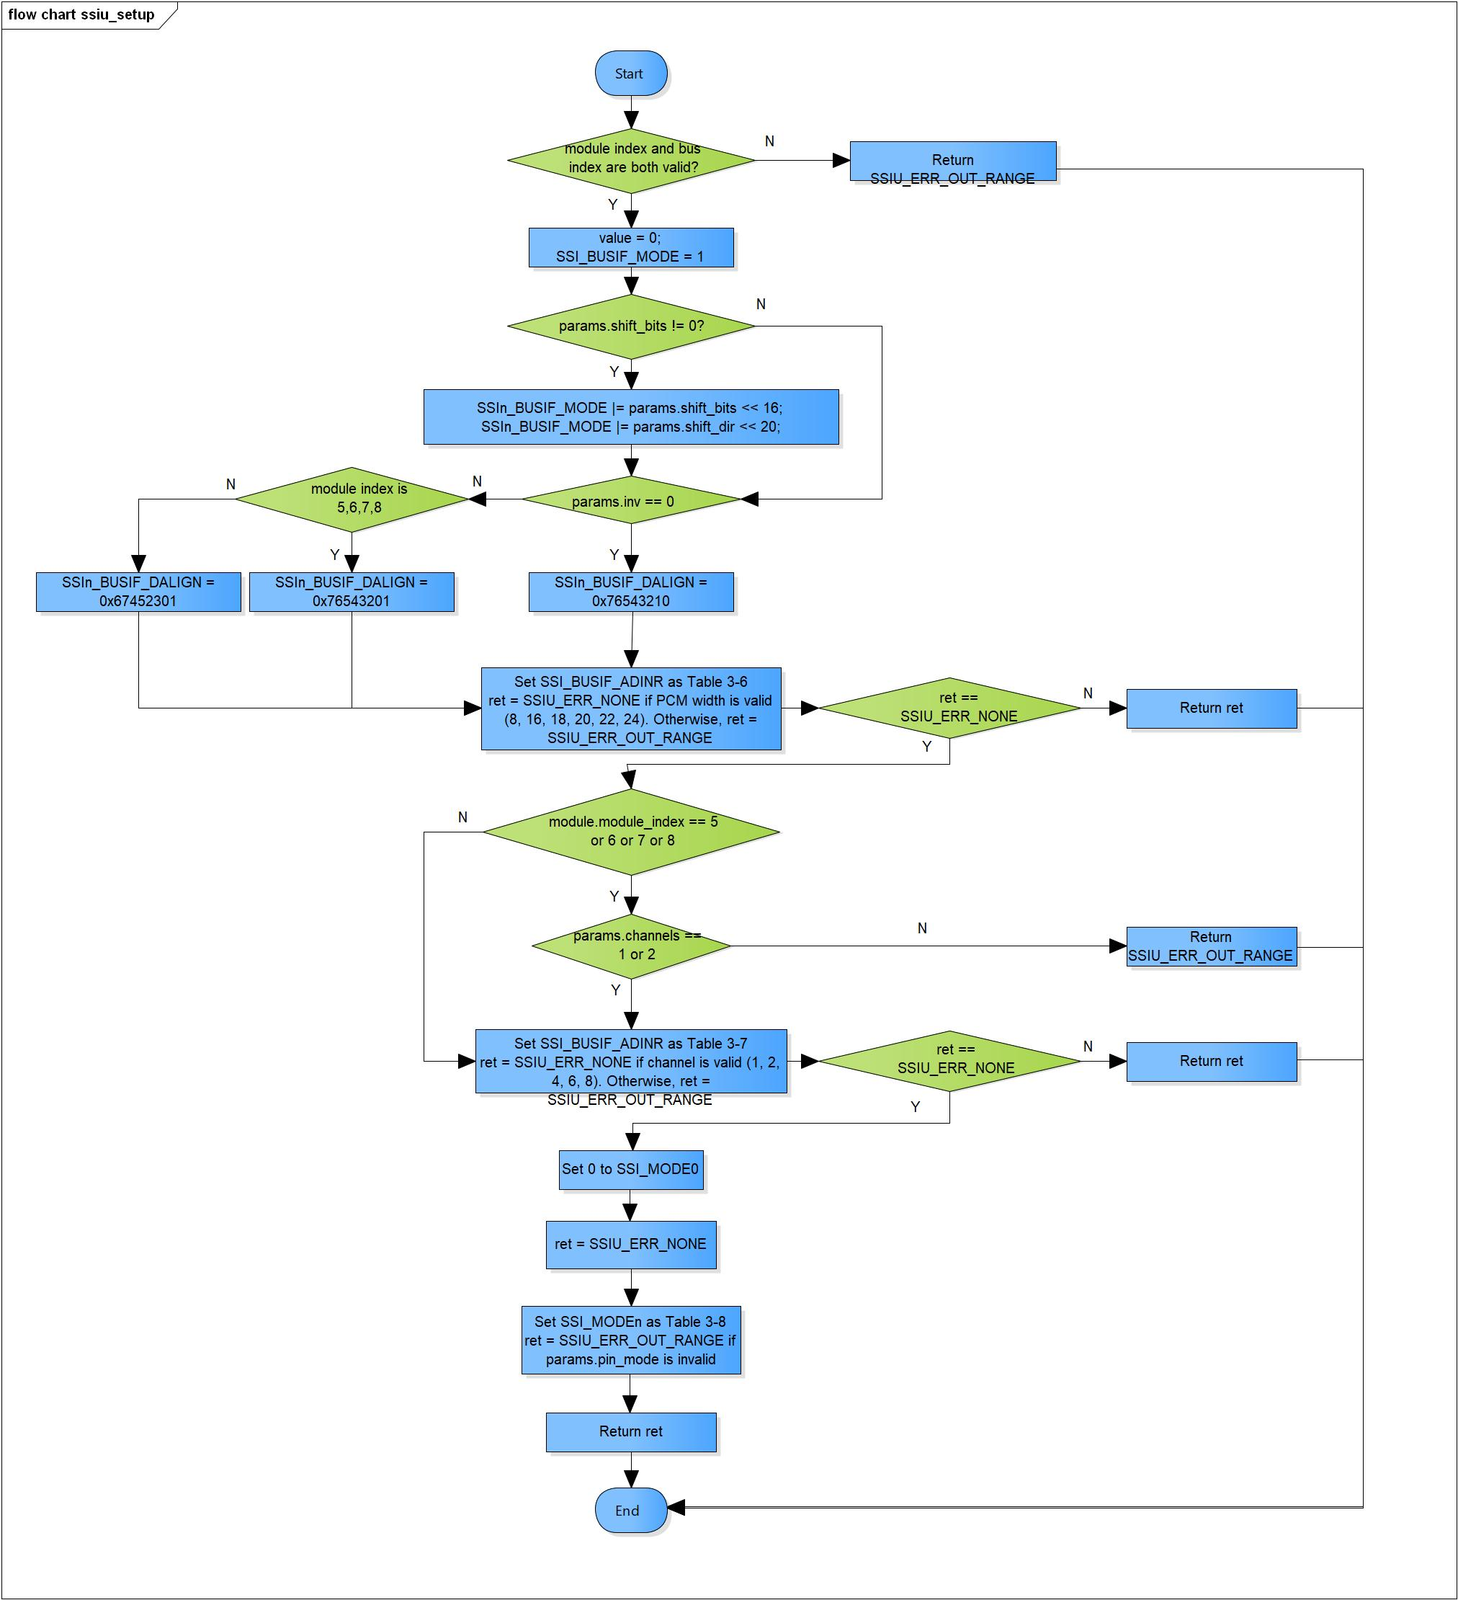Figure 3‑1 ssiu_setup flowchart

### ssiu_start

DD_PLG_RDR_04_002

|  |  |  |  |  |
| --- | --- | --- | --- | --- |
| **Syntax** | SSIU_ERR_CODE ssiu_start(SSIU_SSI_MODULE module) | | | |
| **Function** | This function is to start SSIU module. | | | |
| **Arguments** | Type | Name | I/O | Description |
| SSIU_SSI_MODULE | module | I | SSIU module |
| **Return value** | SSIU_ERR_OUT_RANGE | | Module index or bus index is invalid | |
| SSIU_ERR_NONE | | Normal end | |
| **Description** | * ssiu_start command processing:   - Set SSI_CONTROL register based on the bus index | | | |

[Covers: FD_PLG_RDR_005]

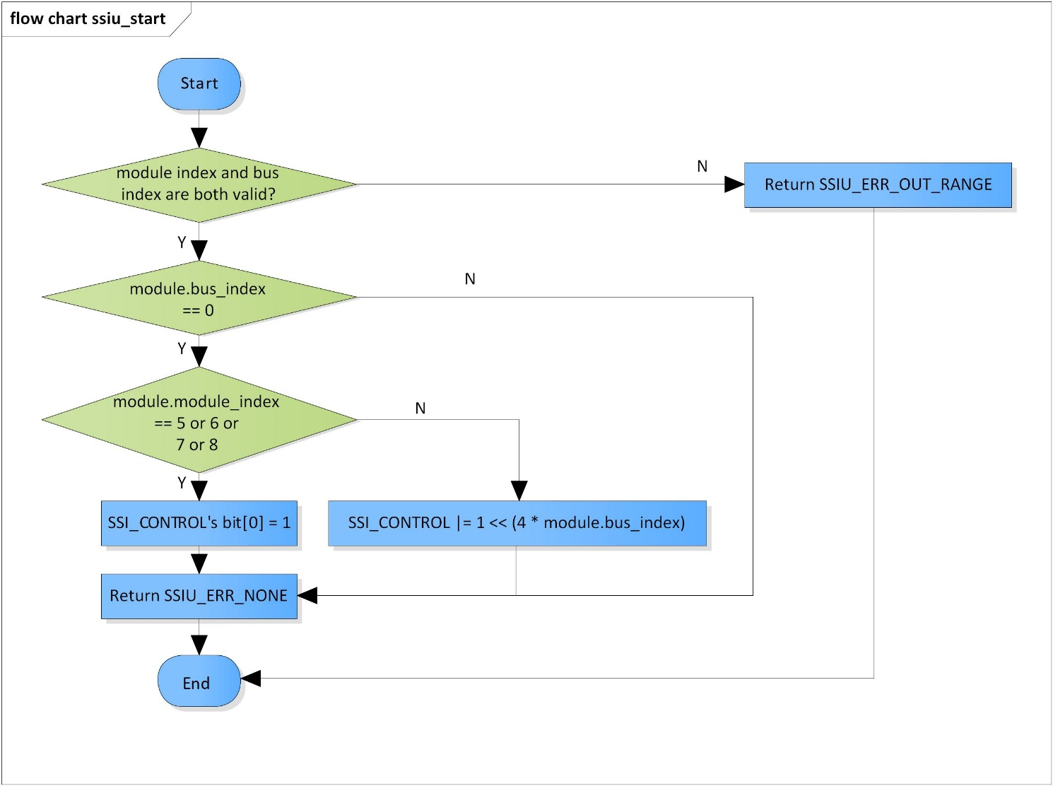Figure 3‑2 ssiu_start flowchart

### ssiu_stop

DD_PLG_RDR_04_003

|  |  |  |  |  |
| --- | --- | --- | --- | --- |
| **Syntax** | SSIU_ERR_CODE ssiu_stop(SSIU_SSI_MODULE module) | | | |
| **Function** | This function is to stop SSIU module. | | | |
| **Arguments** | Type | Name | I/O | Description |
| SSIU_SSI_MODULE | module | I | SSIU module |
| **Return value** | SSIU_ERR_OUT_RANGE | | Module index or bus index is invalid | |
| SSIU_ERR_NONE | | Normal end | |
| **Description** | * ssiu_stop command processing:   - Set SSI_CONTROL register based on the bus index | | | |

[Covers: FD_PLG_RDR_005, FD_PLG_RDR_014, FD_PLG_RDR_032, FD_PLG_RDR_043]

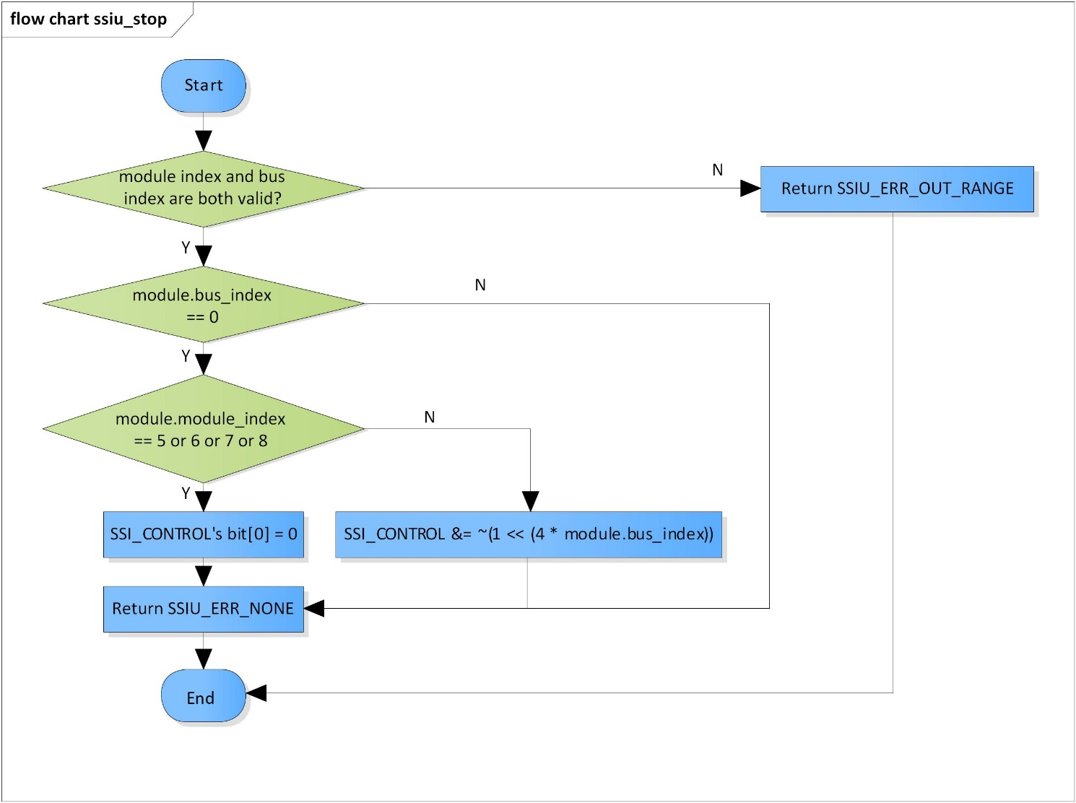

Figure 3‑3 ssiu_stop flowchart

### ssiu_get_register_base

DD_PLG_RDR_04_004

|  |  |  |  |  |
| --- | --- | --- | --- | --- |
| **Syntax** | static inline SSIU_CONTROL *ssiu_get_register_base(SSIU_SSI_MODULE module) | | | |
| **Function** | This function is to get base address of registers for SSIU module. | | | |
| **Arguments** | Type | Name | I/O | Description |
| SSIU_SSI_MODULE | module | I | SSIU module |
| **Return value** | 0 | | Module index is invalid | |
| ssiu_base | | Base address of registers for SSIU module | |
| **Description** | * ssiu_get_register_base command processing:   - Get base address of registers for SSIU module | | | |

[Covers: FD_PLG_RDR_005, FD_PLG_RDR_014, FD_PLG_RDR_032, FD_PLG_RDR_043]

[Note]: XF_RCAR_REG_SSI_BUSIF_MODE(n) is defined in xf-registers.h

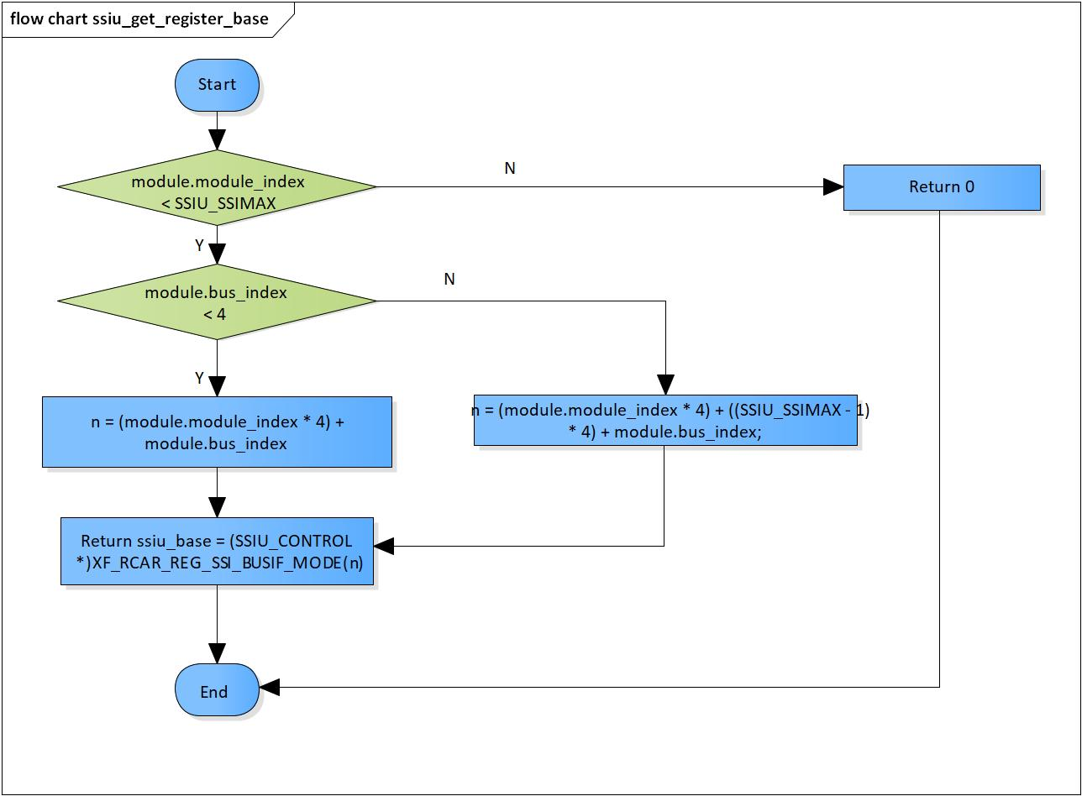

Figure 3‑4 ssiu_get_register_base flowchart

# Revision history

|  |  |  |  |  |  |
| --- | --- | --- | --- | --- | --- |
| **Version** | **Date** | **Page** | **Content** | **Approved** | **Changed** |
| 1.0.0 | Nov 14 2018 | - | First Edition issued | Vu Phan | Nguyen Dang |
| 1.1.0 | Dec 10 2018 | - | Add traceability ID | Vu Phan | Ngu Pham |